UBND HUYỆN CÁT HẢI  TRƯỜNG TH NGUYỄN VĂN TRỖI |  |  | ĐỀ KIỂM TRA CUỐI KÌ I  Năm học: 2024 - 2025  Môn: Tiếng Anh 3 Thời gian: 35 phút
 | Listening, reading and writing | Speaking | Total | Giám khảo | Số phách
Mark
Comments

I.LISTENING
Task 1. Listen and number . 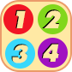

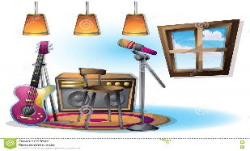  a. |   b. |   c. |   d.
Task 2. Listen and tick . 

  1.  a. |   b. |   c.
2.    a. | 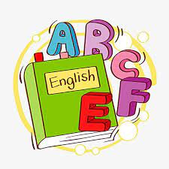  b. |   c.
II. READING AND WRITING
Task 1. Read and match.
0. May I go out? Please! | 0. e | a. I play table volleyball.
1. What’s your hobby? | 1. | b. They are yellow.
2. Do you have a pencil? | 2. | c. Yes, I do.
3. What do you do at break time? | 3. | d. I like dancing and singing.
4. What colour are your pencils? | 4. | e. No, you can’t

Task 2. Read and circle
- ___________colour are your pencils.

- When b. What c. where

- I play basketball __________ break time.

- in b.on c. at

Task 3. Read and complete with the given words.
room | Minh | school | playground

Hi, I am Nam . I’m in Class 3B. This is my (1)___________ . It’s big. My classroom is big too. Now it is break time. Many of my friends are in the (2)____________. I’m in the computer (3)____________ with my friend (4)____________
Task 4: Look and write. There is one example. (1 point)

  - Let’s go to the ____________ |   2. A. What do you do at break time?  B. I play ____________

Task 5. Reorder the words to make sentences
- name? / What / is / your
What is your name ?
- Let’s / go/music room./ the / to
____________________________________
- is/ This / computer / game./ my
____________________________________
- play/ break time./I / word / badminton / do /and / puzzles / at
_________________________________________________

