UBND HUYỆN VĨNH BẢO  TRƯỜNG TIỂU HỌC TAM ĐA | ĐỀ KHẢO SÁT CHẤT LƯỢNG HỌC KỲ II  MÔN: TIẾNG ANH LỚP 1  NĂM HỌC 2024 - 2025  (Thời gian làm bài:40 phút)
Name: ……………………………….. Class: …………………………………
PART I: Listening
Question 1: Listen and tick (V) (2pts)
1. | A. 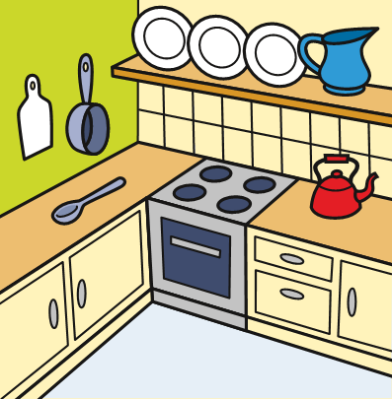 |   B.
2. | A. 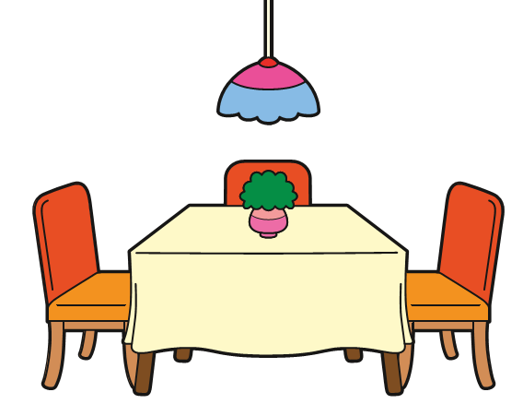 | B. 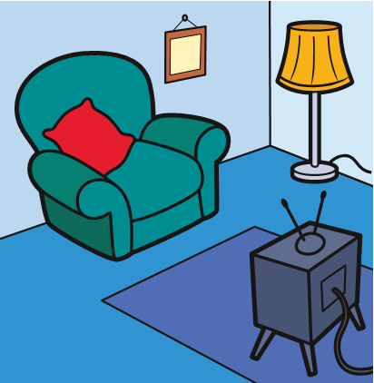
3. | A. 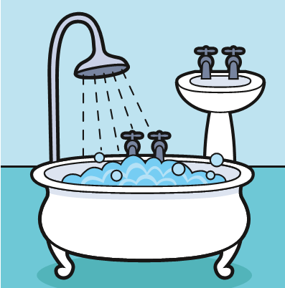 | B.
4. | A. 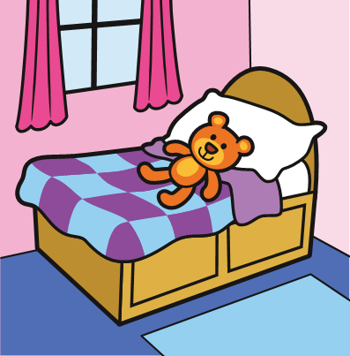 | B.
Question 2: Listen and circle (2pts)

1. A B 2. A B



3. A B 4. A B

PART II. READING
Question 3: Read and match (2pts)

thirsty bedroom window tired

Question 4: Read and circle (2pts)
1.  a. It’s a cat.  b. It’s a duck. | 2.  - She’s got a dog.  - She’s got a parrot.
3.  a. She’s scare  b. She’s sad | 4.  a. He’s happy  b. He’s hungry
Question 5: Fill in the blanks (2pts)
- 2
Ch…..ese to….toise

3. 4.
mi….k ……… abbit

Key
Question 1: Listen and tick (2pts)
1- A, 2 –B, 3 – A , 4 – A
Question 2: Listen and circle (2pts)
1- A , 2 –A , 3- B , 4 – B
Question 3: Read and match (2pts)

Thirsty bedroom window tired

Question 4: Read and circle (2pts)
1 – A , 2 – B , 3 - A , 4- B
Question 5: Fill in the blanks (2pts)
1. ch 2. t 3. i 4 .a

