Name: __________________________ Class: ____________________
PHẦN I. LISTENING
Question 1: Listen and tick (2 points)
1 | 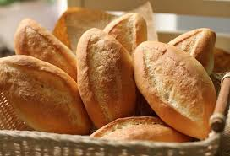 | 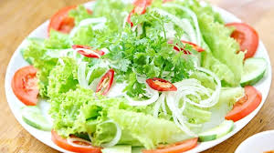 | 2 |  | 
1 | a  | b | 2 | a | b
3 | 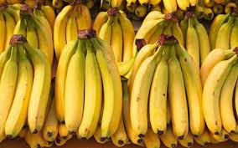 |  | 4 | 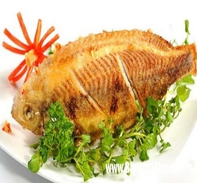 | 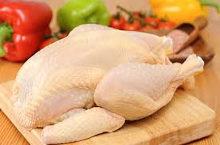
3 | a | b | 4 | a | b
Question 2: Listen and complete (1pt)
1. Do you like _________ day? – No, I don’t.
2. Do you like ________ days? – Yes, I do.
3. Do you like ________ days? – Yes, I do.
4. Do you like ________ days? - Yes, I do.
PHẦN II: READING
Question 3. Odd one out. (2 pts)
1. A. animals B. horse C. goat D. cow
2. A. apples B. burgers C. eggs D. hot dogs
3. A. turkeys B. hen C. dogs D. cats
4. A. rice B. eggs C. hot dogs D. food
Question 4: Read and match: (2 points)
 |  |  | 
1 | 2 | 3 | 4

rainy | cloudy | snowy | windy

Question 5: Look and write (2 pt)

1. ____________ 2. _____________ 3. ____________ 4. ____________

Question 6: Reorder the sentences. (1 pt)
- wearing / I’m / blue / a / T- shirt/ .
…………………………………………………………………………………………..
- got / She / has / dress / a /./ pink / It’s/
…………………………………………………………………………………………..
- you / Do / like / days / sunny/ ?/
…………………………………………………………………………………………..
- is / It / windy / a / . /
…………………………………………………………………………………………..
ANSWER
Question 1: Listen and tick (2 pts)
- b 2. b 3. b 4.a
Question 2: Listen and complete (1pt)
1. Do you like _________ day? – No, I don’t.
A. windy B. snowy
2. Do you like ________ days? – Yes, I do.
A. sunny B. rainy
3. Do you like ________ days? – Yes, I do.
A. snowy B. sunny
4. Do you like ________ days? - Yes, I do.
A. windy B. sunny

Question 3. Odd one out. (2 pt)
1. A. animails B. horse C. goat D. cow
2. A. apples B. burgers C. eggs D. hot dogs
3. A. turkeys B. hen C. dogs D. cats
4. A. rice B. eggs C. hot dogs D. food

Question 4: Read and match: (2 pts)
Picture 1 - snowy Picture 2- windy Picture 3 - rainy Picture 4 - cloudy
Question 5: Look and write (2 pt)
1. Cat 2. Goat 3. Hot dogs 4. Bananas

Question 6: Reoder the sentences. (1 pt)

1. I’m wearing a blue T- shirt.

2. She has got a dress . It’s pink.

3. Do you like sunny days?

4. It is a windy.

