UBND HUYỆN VĨNH BẢO  TRƯỜNG TIỂU HỌC AN HÒA | ĐỀ KHẢO SÁT CHẤT LƯỢNG HỌC KÌ I  MÔN TIẾNG ANH LỚP 2  NĂM HỌC 2024- 2025  ( Thời gian làm bài: 40 phút)
Name: __________________________ Class: ____________________
PHẦN I. LISTENING
Question 1: Listen and tick (2 points)

1 | 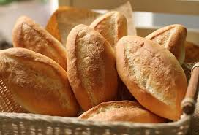 |  | 2 |  | 
1 | a  | b | 2 | a | b
3 |  |  | 4 | 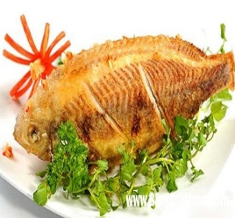 | 
3 | a | b | 4 | a | b

Question 2: Listen and complete (1 point)
- Take …….. your pyjamas.
- Put on your ………….
- Put on your ………….
- It’s time for …………
PHẦN II:READING
Question 3: Odd one out (2 points)
1.a. chicken b. pizza c. fish d. purple
2.a. family b.banana c. apple d. egg
3.a. sheep b. goat c. duck d. white
4.a. horse b. feet c. turkey d. cow
Question 4: Read and match: (2 points)
 |  |  | 
1 | 2 | 3 | 4

rainy | cloudy | snowy | windy

PHẦN III. WRITING:
Question 5 : Look and write ( 2 points)
 |  | 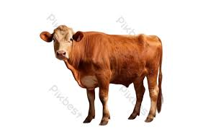 | 
……………. | ……………. | ……………. | …………….

Question 6: Reorder the sentences ( 1 point)
- wearing/a/ I’m/ jumper.
- I’m wearing a jumper.
- I’m not wearing a jumper.
- I’m wearing a T - shirt.
- days/ snowy/ like/ I/./
- I don’t like snowy days.
- I like cloudy days.
- I like snowy days.
- for/this/you/ is/./shoes/
- This shoes is not for you.
- This shoes is for you.
- This dress is for you.
- hat/a/ white/ wearing/ I’m/./
- I’m wearing a white hat.
- I’m wearing a blue hat.
- I’m not wearing a white hat.

PHẦN 2: ĐÁP ÁN

UBND HUYỆN VĨNH BẢO  TRƯỜNG TIỂU HỌC AN HÒA | ĐỀ KHẢO SÁT CHẤT LƯỢNG HỌC KÌ II  MÔN TIẾNG ANH LỚP 2  NĂM HỌC 2024 - 2025  ( Thời gian làm bài: 40 phút)

Question 1: Listen and tick (2 pts)
- b 2. b 3. b 4.a
Question 2 : Listen and compete (1pt)
- off 2. T – shirt 3. shoes 4. school
Question 3: Odd one out (2 pts)
1. d 2. a 3. d 4. b
Question 4: Read and match: (2 pts)
Picture 1 - snowy Picture 2- windy Picture 3 - rainy Picture 4 - cloudy

Question 5 : Look and write ( 2 points)
1. horse 2. duck 3. cow 4. hen
Question 6: Reorder the sentences ( 1pt)
- I’m wearing a jumper.
- I like cloudy days.
- This shoes is for you.
- I’m wearing a white hat.

