PART I: LISTENING:
Question 1: Listen and tick (2 points)
1. a 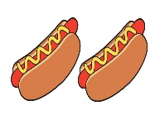 b  | 2. a  b 
3. a  b  | 4. a 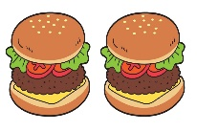 b 

Question 2: Listen and complete (1 point)
- Do you like …………… days?
- Do you like …………… days?
- Do you like …………… days?
- Do you like …………… days?
PART II: READING
Question 3: Odd one out (2 points)
1. a. cow b. goat c. sheep d. animals
2. a. hen b. cat c. dog d. horse
3. a. apples b. fish c. food d. pizza
4. a. lunch b. burgers c. milk d. salad

Question 4: Read and match: (2 points)

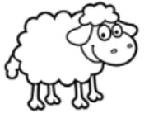

rainy | snowy | goat | sheep

PHẦN III. WRITING:
Question 5: Look and write ( 2 points)
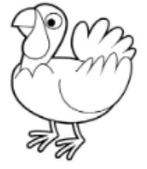

……………. ……………. …………… ……………..

Question 6: Reorder the sentences ( 1 point)
- Take / your/ shoes / off /.
………………………………………………………………
- wearing / I’m / a / dress / yellow /.
……………………………………………………..……….
- you / like / Do / days / sunny / ?
…………………………………………………..………….
- It’s / cloudy / a / day/.
……………………………………………..……………….

KEYS

Question 1: Listen and tick (2 pts)
- A 2. A 3. B 4. A

Question 2 : Listen and compete (1pt)
- windy 2. rainy 3. snowy 4. sunny

Question 3: Odd one out (2 pts)
- d 2. a 3. c 4. a

Question 4: Read and match (2 pts):

rainy | snowy | goat | sheep

Question 5 : Look and write ( 2 pts)
- turkey 2. horse 3. chicken 4. fish

Question 6: Reorder the sentences (1 pt)
- Take off your shoes .
- I’m wearing a yellow dress.
- Do you like sunny days?
- It’s a cloudy day.

