Question 1. Listen and number. (1pt)
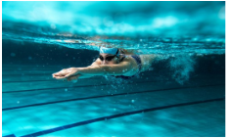 |  | 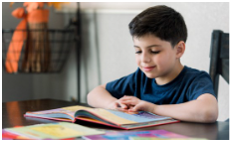 | 

Question 2. Listen and tick the correct sentences. (1pt)
1. A. I go to school on Thursdays.
B. I go to school on Tuesdays.
C. I colour a picture on Tuesdays.
2. A. I go to school with my parents.
B. I go to school with my brother.
C. I go to school with my friends.
3. A. What do you do on Saturdays?
B. What do you do on Thursdays?
C. What do you do on Wednesdays?
4. A. Where’s the market?
B. Where’s the theatre?
C. Where’s the library?
Question 3. Listen and circle the correct pictures. (1pt)
1. 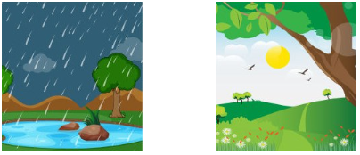 | 3. 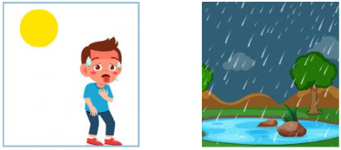
A B | A B
2. 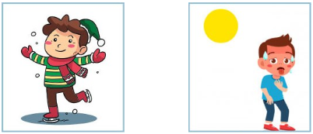 | 4. 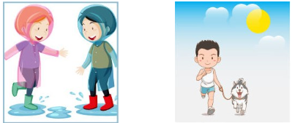
A B | A B
Question 4. Odd one out. (1.25pts)
1. A. read B. paint C. tennis D. climb
2. A. piano B. water C. drums D. guitar
3. A. winter B. rainy C. wet D. cold
4. A. swim B. hobby C. colour D. write
5. A. hot B. autumn C. spring D. summer
Question 5. Choose the best answer. (1.25pts)
1. Let’s go to the zoo and _________.
A. buy some drink B. watch giraffes C. read books D. see the paintings
2. There are _________ apples on the table.
A. an B. a lot C. a D. some
3. _________ is the juice? – It’s in the jug.
A. How B. What C. There D. Where
4. May I _________ photos? – Yes, you can.
A. take B. make C. play D. ride
5. _________ sweets are there? – Eleven.
A. How old B. Where C. How many D. How some
Question 6. Read and match. (1.25pts)
1. Do they swim in summer? A. in the river. 1-____
2. Who do you have lunch with? B. I play basketball. 2-____
3. We swim C. Yes, they do. 3-____
4. What do you do on Sundays? D. By motorbike. 4-____
5. How do you go to school? E. My friends. 5-____
Question 7. Read and circle the correct answer. (1pt)
Kate: Hi, Tom.
Tom: Hi, Kate. What are you doing?
Kate: I’m buying a teddy bear at the toy shop. There are nice teddy bears there.
Tom: Cool!
Kate: And you?
Tom: I’m in the park. We’ve got a new bike. My brother is riding it. It’s fun.
1. Where is Kate?
A. At the playground. B. At the toy shop. C. In the park. D. In the museum
2. What is Kate doing?
A. She’s riding a bike. C. She’s buying a teddy bear.
B. She’s buying a bike. D. She’s swimming in the river.
3. Where is Tom?
A. In the park. B. At the zoo C. At the toy shop D. In the library
4. Who is riding a bike?
A. Kate B. Her brother C. Tom D. His brother
Question 8. Arrange the words to make sentences. (1.25pts)
1. can / I / play / sing, / the / I / can't / but / guitar / .  a. I can sing, but I can’t play the guitar.  b. I can play, but I can’t sing the guitar.  c. I can sing, and I can’t play the guitar. | 2. jug / the / in / some / is / milk / There / .  a. There is some jug in the milk.  b. There is some milk in the jug.  c. Is there some milk in the jug.
3. and / ride / the / go / Let's / a / park / bike / to / .  a. Let’s go and to ride a bike the park.  b. Let’s and ride a bike go to the park .  c. Let’s go to the park and ride a bike. | 4. a / is / kite / with / flying / friends / her / She / .  a. She is with her friends flying a kite.  b. She is flying a kite with her friends.  c. Is she flying a kite with her friends.
5. at / the / May / I / the / in / museum / paintings / look / ?
a. May I look at the paintings in the museum?
b. I may look at the paintings in the museum?
c. May I at the paintings look in the museum?

Question 9. Look at the picture and write ONE word in each blank. (1pt)
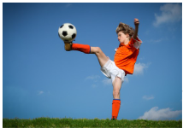 | 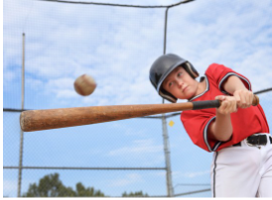
1. He is ___________________ the ball. | 2. I’m playing ___________________.
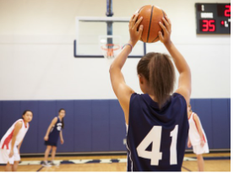 | 
3. She’s playing ___________________. | 4. I’m ___________________ a kite.

ĐÁP ÁN TIẾNG ANH 3 CK2
Question 1. Listen and number. (1pt)
2-4-1-3
Question 2. Listen and tick the correct sentences. (1pt)
1. B 2. C 3. A 4. C
Question 3. Listen and circle the correct pictures. (1pt)
1. A 2. A 3. A 4. B
Question 4. Odd one out. (1.25pts)
1. C 2. B 3. A 4. B 5. A
Question 5. Choose the best answer. (1.25pts)
1. B 2. D 3. D 4. A 5. C
Question 6. Read and match. (1.25pts)
1-C 2-E 3-A 4-B 5-D
Question 7. Read and circle the correct answer. (1pt)
1. B 2. C 3. A 4. D
Question 8. Arrange the words to make sentences. (1.25pts)
1. I can sing, but I can’t play the guitar.
2. There is some milk in the jug.
3. Let’s go to the park and ride a bike.
4. She is flying a kite with her friends.
5. May I look at the paintings in the museum?
Question 9. Look at the picture and write ONE word in each blank. (1pt)
1. kicking
2. baseball
3. basketball
4. flying

