PART I. LISTENING
Question 1. Listen and number (1pt)
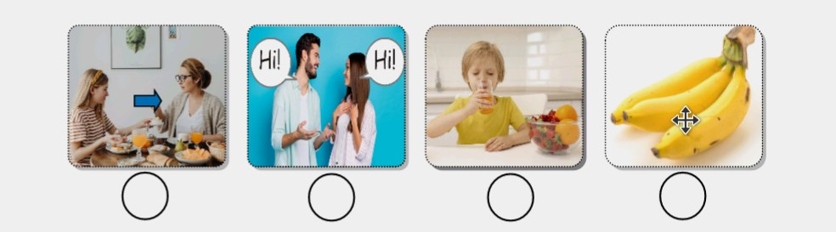

Question 2. Listen and tick (1pt)
1.
A. Let’s go to the theatre! B. Let’s go to the museum!
2.
A. Is she watching TV? B. Is she watching a match?
3.
A. I swim on Mondays. B. I run on Mondays.
4.
A. There are some tomatoes. B. There are many tomatoes

Question 3. Listen and circle the correct pictures (1pt)
1. What are you doing?


2. How many sweets are there?
3. Who do you go the the park with?


4. What do you do on Mondays?


Part II: reading and writing.
Question 4: Circle the odd one out. (1,0pt)
1. a. Violin | b. Guitar | c. Student
2. a. Hockey | b. Green | c. Yellow
3. a. Football | b. Uncle | c. Tennis
4. a. Lunch | b. Dinner | c. Train
5. a. Sister | b. Summer | c. Brother

Question 5. Choose the best answers (1.5pt)
1. I can swim in the ____________.
A. pool B. museum C. library
2. Let’s ____________ apples and pears.
A. go B. drink C. buy
3. __________ is the pen?  Its on the book.

A. Where B. What C. How many
4. May I run in the park? - Yes, you __________.”

A. can’t B. can C. are
5. May I talk in the library?  No, you can’t. ___________ talk, please.

A. Let’s B. We’re C. Don’t
Question 6: Read and Match (1.5pt)
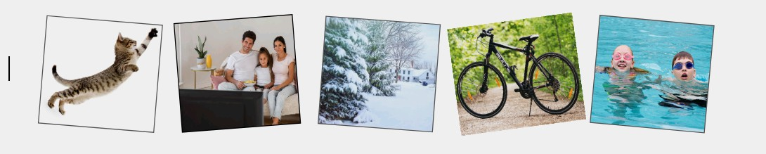
1.What’s this? | A. I watch TV with my family.
2. Who do you watch TV with? | B. No, it isn’t.
3. Is it hot in winter? | C. It’s a cat.
4. How do you go to the library? | D. Yes, they do.
5. Do they swim in summer? | E. I go to the library by bike.
Question 7: Read the text and choose the best answers (1pt)
I’m Lisa. It’s my birthday today. I’m in the living room with my sister. There is a lot of food here. There are five apples and ten pears on the table. There are many biscuits in the box. My dad is buying a birthday cake. My mum is making a chicken pizza in the kitchen. That’s great!

1. Where is Lisa?
A. She is at school.
B. She is the living room.
C.She is in the kitchen.
2. How many pears are there?
A. There aren’t any pears.
B. There are five pears.
C. There are ten pears.
3. Where are the biscuits?
A.They are in the box.
B.They are on the box.
C.They are under the box.
4. What’s her father doing?
A. He’s making a chicken pizza.
B.He’s buying a birthday cake.
C. He’s making a birthday cake
Question 8. Arrange the words to make the meaningful sentences (1pt)
1. Can/ speak/ you/ English?
a. You can speak English? b. Can you English speak?
c. Can you speak English? d. You can English speak?
2. Are/ playing/ you/ tennis?
a. Are you playing tennis? b. You are playing tennis?
c. You playing are tennis? d. Are tennis playing you?
3. Play/can/ you/ the guitar?
a. Play can you the guitar? b. Can you play the guitar?
c. Can you the guitar play? d. You can play the guitar?
4. There/ is/ some/ milk?
a. Is there milk some? b. There is some milk?
c. There is milk some? d. Is there some milk?
5. Are/ there/ thirteen/ tomatoes.
a. Are there thirteen tomatoes. b. There are thirteen tomatoes.
c. Are there tomatoes thirteen. d. There are tomatoes thirteen.
Question 9: Look at the pictures and write the words (1pt)

_____________ _____________ ______________ ______________

