Question 1 : Listen and number (1pt)
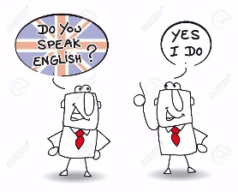
a. b. c. d.

Question 2.Listen and circle.(1 pt)
1. 2. 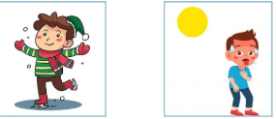
A B A B
3.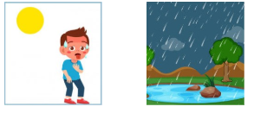 4. 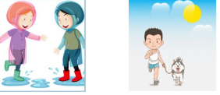
A B A B
Question 3. Listen and tick .(1 pt)
T F
1. Bossaball is an old sport
i

2. A player is jumping and kicking the ball

3. He isn’t running or catching the ball

4 Sometimes, people can play the drums and dance during
bossaball games.
Question 4: Odd one out (1,25 pt)
1. | A. hot | B. cold | C. rock | D. rainy
2. | A. spring | B. river | C. winter | D. summer
3. | A. Tuesday | B. Friday | C. autumn | D. Monday
4. | A. climb | B. tree | C. river | D. rock
5. | A. wet | B. have breakfast | C. get up | D. go to school
Question 5. Choose the best answer (1,25pt)
1. | Can you______ a bike? - No, I can’t
 | A. ride | B. drive | C. riding
2. | What are you doing?
 | A. I’m playing tennis | B. She’s playing tennis | C. I’m play tennis
3. | We_________ a movie at the theater.
 | A. is watch | B. is watching | C. are watching
4. | The crayons are ____ my bed.
 | A. in | B. on | C. at
5. | How many ………are there? There are ten  A. apples B.an apple C. apple
Question 6. Read and matchcolumn A with B (1,25 pt)
1 Do they play football ? a. No,they don’t. They drink milk
2.What do you on Monday? b No,they don’t. They play tennis
3.How do you go to school? c I go to school
4. Who do you watch TV with ? d I go to school by bike
5. Do they drink apple juice? e I watch TV with my sister
1.............. 2............ 3............... 4.............. 5.................
Question 7. Read the text and circle the correct answer (1 pt)
My name is Tom. I’m in the park with my friends .We are doing sport and games .Some of boys and Iare plaing football.My friend Kate is cycling.Peter and Ken are reading a book.We are happy in the park.
1.Where are Tom and his friends ?
a.in the park b. In the school c. At the toy shop
2.What’s Tom doing ?
a.playing tennis b. Playing football c cycling
3.What are Peter and Ken doing?
a.playing football b.reading a book c.skipping
4.Are they happy in the park?
a.Yes,they are b.Yes,we are c. No, they aren’t
Question 8. Arrange the words to make sentences (1,25 pt)
1. go/ zoo/ Let’s/ the/ to/  a. Let’s go to the zoo.  b. Go to the let’s zoo.  c. Go to the zoo let’s. | 2. toyshop/buy /at/I/toy/the/ a/.  a. I buy a toyshop at the toy.  b. I buy a toy at the toyshop.  c. I toy a buy at the toyshop.
3. shoes/are/My/ expensive/ new/and/.  a. My shoes and expensive are new.  b. New my shoes are expensive and  c. My shoes are expensive and new. | 4. My/sport/is/favourite/hockey/.  a. My favourite sport is hockey.  b. Hockey is sport my favourite.  c. My sport favourite is hockey.
5. In/take/Let’s/the/photos/park/.
a. Let’s take photos in the park.
b. Let’s take the photos in park.
c. Let’s photos take in the park.
Question 9. Look and write (1 pt)
1.  | 2.  | 3. 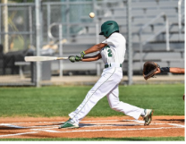 | 4.  

PHẦN 2: ĐÁP ÁN
UBND HUYỆN VĨNH BẢO  TRƯỜNG TH&THCS  HƯNG NHÂN  (Đề đề xuất) | ĐỀ KHẢO SÁT CHẤT LƯỢNG HỌC KÌ 2  MÔN TIẾNG ANH LỚP 3  NĂM HỌC 2024 - 2025  (Thời gian làm bài : 40 phút)
PART I : Listening
Question 1:Listen and number (1pt)
4 câu x 0,25 = 1đ
1. d 2. a 3. c 4. b
Question 2:Listen and circle )
4 câu x 0,25 = 1đ
1. a 2. a 3. a 4. b
Question 3:Listen and tick (1pt)
4 câu x 0,25 = 1đ
1. F 2. T 3. T 4. F
PART II : Pronunciation
Question 4: Odd one out (1,25đ)
1. c 2. b 3. c 4. a 5. a
PART III : Reading
Question 5. Choose the best answer (1,25pt)
a 2. a 3. c 4. b 5. a

Question 6. Read and matchcolumn A with B (1,25 p
- b 2. c 3. d 4. e 5. a
Question 7: Read the text and circle the correct answer (1 pt)
1-a 2. b 3 b 4.a
PART IV : Writing
Question 8: Arrange the words to make sentenmces (1,5pt)
6 câu x 0,25 = 1,5đ
- Let’s go to the zoo.
- I buy toy at the toyshop.
- My shoes are expensive and new.
- My favourite sport is hockey(Hockey is my favourite sport)
- Let’t the take photos in the park
Question 9: Look at the picture and write the word (1pt)
4 câu x 0,25 = 1đ
1.tennis 2. hockey 3. baseball 4 basketball

