PART I : Listening
Question 1 Listen and number. ( 1,0 point)
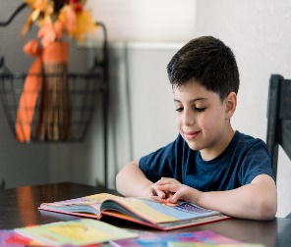 |  |  |   hi Hi
a. | b. | c. | d.
Question 2 Listen and tick the correct sentences( 1,0 point)
- a: He is in the library . 2. a: she is in the village.
b: He is in the museum . b: she is in the museum.
3, a: Lan is at the zoo. 4. a : Minh is at the park.
b: Lan is at the theatre. b : Minh is at the zoo.
Question 3 Listen and tick the correct pictures. ( 1,0 point)
1 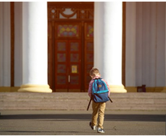  2.  

3. 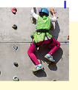  4. 

Part II : Reading and Writing
Question 4: Odd one out ( 1,25 point)
1.a. cook b. swim c. tree d. write
2. a, cold b. hot c. summer d. rainy
3. a. winter b. wet c. spring d. autumn
4. a. sea b, park c, go d, school
5. a. rock b. tree c. water d. drink
Question 5: Choose the best answer ( 1,25 point)
- There is ……….banana.( a, some, an )
- There are ………apples .( an ,a, many)
- There are some ……….( a tomato ,tomatos, tomato)
- What are you doing ? ( I am read a book , I read a book , I am reading a book.)
- May I jumb at the museum ? ( Yes, I can . Yes ,You can . Yes , she can )
Question 6: Read and match column A with B( 1,25 Point)
A | B | C
1. Can you swim? | a. I go to school on Tuesdays.
2. Do you go to school in Summer? | b. She visits her grandparents on Sundays.
3. What do you do on Mondays? | c. Yes, I can.
4. What does Lien do on Sundays? | d. No , I don’t.
5. What do you do on Tuesdays ? | e. I go to the library on Mondays.
Question 7 :Read the text and circle True or False( 1 point)
I’m Nam. It’s my birthday today. I’m in the dinning room with my brother. There is a lot of food here. There are some oranges and ten bananas on the table. There are many tomatoes in the box. My father is buying a birthday cake. My mother is making a chicken pizza in the kitchen. That’s great!

1. Where is Nam?
A. He is at school. B. He is the dining room. C. He is in the kitchen.
2. How many oranges are there?
A. There aren’t any oranges B. There are some oranges C. There are ten oranges
3. Where are the tomatoes?
A. They are in the box. B. They are on the box. C. They are under the box.
4. What’s her father doing?
A. He’s making a chicken pizza. B. He’s buying a birthday cake. C. He’s making a birthday cake
Question 8: Arrange the words to make sentences( 1,25 point)
- Can’t / My / ride /dog /bike. /a /
- My dog ride can’t a bike. B. can’t My dog ride a bike. C. My dog can’t ride a bike.
- go /Don’t /the/ to/ / pool. /
a . Don’t to go the pool. b. Don’t go to the pool. c. go to the pool don’t.
- can /You /buy / apples/ pears / here. /and /
a. You can buy and pears apples here. b. You buy can pears and apples here.
c. You can buy apples and pears here.
- are /There / tomatoes /the/ at /market. / some/
a. There are some tomatoes at the market. b. There are tomatoes some at the market.
c. There are at the market some tomatoes.
- is/She / in /cooking / kitchen ./the /
a.is she kitchen cooking in the. b. She is cooking the in kitchen .
c. She is cooking in the kitchen.
Question 9: Look at the picture and write one word in the blank( 1 point)
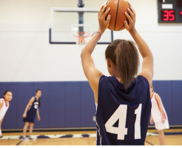
1. He is playing______ 2. She is _________3.She is ____________ 4. She is playing__________

KEY
Question 1:
1.c 2.d 3.a 4. B
Question 2:
1.a 2.b 3.b 4. b
Question 3:
1.a 2.a 3.a 4. A
Question 4:
1.c 2.c 3.b 4. C 5. d
Question 5:
1.a 2.c 3.b 4. C 5. D
Question 6:
1.c 2.d 3.e 4. b 5. a
Question 7:
1. b 2.b 3.a 4. a
Question 8:
- My dog can’t ride a bike .
- Don’t go to the pool.
- You can’t buy apples and pears here.
- There are some tomatoes.
- She is cooking in the kitchen.
Question 9:
- baseball 2. running 3.jumping 4. basketball

