ANH 4

Name: ……………………………….. Class: …………………………………
LISTENING
Question 1. Listen and number (1pt)
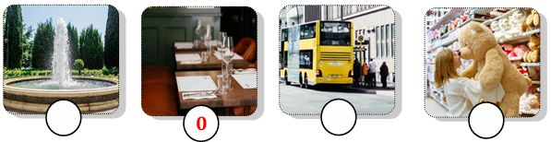
Question 2. Listen and tick the correct sentence (1pt)
1. |  | A. They are doing homework. | 2. |  | A. It’s my new smartphone.
1. |  | B. They are learning English. | 2. |  | B. It’s my new tablet.
3. |  | A. His trip to Vietnam was exciting. | 4. |  | A. They were at a bridge in America.
3. |  | B. My trip to Turkey was exciting. | 4. |  | B. They were at a temple in Vietnam.
Question 3. Listen and circle the correct picture (1pt)
1. 2.
3.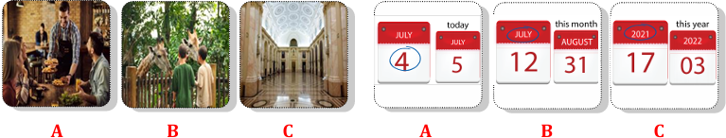4.
READING AND WRITING
Question 4. Odd one out (1.25pts)
- a. firefighter b. chef c. job d. doctor
- a. put b. feed c. photo d. take
- a. clinic b. hospital c. work d. studio
- a. yesterday b. huge c. strong d. scary
- a. small b. clever c. big d. mammoth
Question 5. Choose the best answer (1.25pts)
- Can we _______________ the tablet? – No, you can’t.
A. use B. do C. look D. have
- ______________ smart phone is it? – It’s her smartphone.
A. What B. Who C. Whose D. How
- The teacher wants her students to work in ____________.
A. books B. two C. class D. pairs
- The cinema is ______________ to the library.
A. next B. in front D. near D. opposite
- They are ______________ in the supermarket.
A. crossing B. swimming D. dancing D. shopping
Question 6. Match column A – B (1.25pts)
A | B
1. What do you like doing? | A. It was great. | 1 -
2. What was a mammoth? | B. I like buying presents. | 2 -
3. Where is he flying to? | C. I can see many big dinosaur bones. | 3 -
4. How was your history lesson? | D. It was a big elephant. | 4 -
5. What can you see at the museum? | E. He’s flying to Da Lat City. | 5 -
Question 7. Read the text and choose the best answer (1pt)
Ms. Jane: Today, we are going to use the (1) _____________lab in my class. Are you ready?
Class: Yes, teacher!
Tom: Can we use smartphones in class?
Ms. Jane: No, you can’t. But you can use books and tablets to look at the (2) ________ list.
Tim: Look at the computer, Rose! Who can (3) _____________ the password?
Rose: I think teachers can. But don’t use the computer! The teacher is talking!
Ms. Jane: Quiet, please! I can use the speaker if you can’t hear me. You can work in (4) __________________, understand?
Class: Yes, teacher!
- A. computer B. smartphones C. tablets D. class
- A. tablets B. computer C. emails D. word
- A. make B. write C. use D. change
- A. pair B. two C. groups D. books
Question 8. Reorder the words to make meaningful sentences (1.25pts)
1. sister/ does/ What/ do/ your/? | A. What does sister your do?  B. What does your sister do?  C. What do your sister does?
2. Jack/ vet/ because/ animals/ he/ wants/ become/ a/ loves/ to/. | A. Because Jack wants to become a vet he loves animals.  B. Jack wants animals because he loves to become a vet.  C. Jack wants to become a vet because he loves animals.
3. video/ class/ games/ can/ we/ in/ play/? | A. Can we play video games in class?  B. In class we can play video games?  C. Play video game in class can we?
4. books/ I/ buy/ comic/ bookshop/ the/ at/. | - I at the bookshop comic books buy.  - At the bookshop I buy books comic.  - I buy comic books at the bookshop.
5. on/ Which/ would/ like/ visit/ place/ you/ to/ holiday/? | - Which would you like to visit place on holiday?  - Which place would you like to visit on holiday?  - On holiday to which place would you like visit?
Question 9. Look and write the word (1pt)

______________ ___________________ ______________________ ______________

Answer key
LISTENING
Question 1. Listen and number (1pt)
2 – 4 – 1 - 3
Question 2. Listen and tick the correct sentence (1pt)
- A 2. B 3. B 4. A
Question 3. Listen and circle the correct picture (1pt)
- B 2. C 3. B 4. A
READING
Question 4. Odd one out (1.25pts)
- C 2. C 3. C 4. A 5. D
Question 5. Choose the best answer (1.25pts)
- A 2. C 3. D 4. A 5. D
Question 6. Match column A – B (1.25pts)
- B 2. D 3. E 4. A 5. C
Question 7. Read the text and choose the best answer (1pt)
- A 2. D 3. D 4. C
Question 8. Reorder the words to make meaningful sentences (1.25pts)
- B 2. C 3. A 4. C 5. B
WRITING
Question 9. Look and write the word (1pt)
- Firefighter
- In a studio
- Feed animals
- Photographer

