ĐỀ TIẾNG ANH 4
PART I: Listening

Question 1: Listen and number (1pt)


a. b. c. d.
Question 2: Listen and tick (1pt)
T F
- Were you at the temple last Saturday?

- Was your mum at the bridge yesterday?

- Were your cuosins in the library last Monday?

- Was Minh at his English class last Wednesday?
Question 3: Listen and circle (1pt)
1. 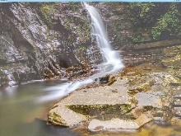   a b | 2.    a b
3.    a b | 4.    a b
Part II: READING AND WRITING
Question 4. Odd one out (1,25pt)
1 | a. famer | b. photographer | c. father | d. chef
2 | a. hospital | b. field | c. work | d. clinic
3 | a. today | b. yesterday | c.last year | d. last week
4 | a. am | b. was | c. is | d. are
5 | a. strong | b. scary | c. huge | d. dinosaur
Questions 5: choose the best the answer a,b,c or d (1.25 pts)
1.She sometimes makes videos on ______________ smartphone.
A. his B. her C. your D. my
2. Is the fountain in front of ____________ behind the restaurant?
A. or B. and C.with D. near
3. ________ can we do on a computer?
A. when B. where C.what D. who
4. He always __________ the internet on his comuter.
A. surfing B. surfs C. surf D. is surfing
5. How ________ we get to the ciname ?
A. did B. does C. do D. doing
Questions 6: Read and match column A with B (1,25pts)
A | B | A - B
1.What do you like doing _____ | a.__ at the shopping centre yesterday. | 1 -
2. Which place would you like ____ | b.________ on holiday? | 2 -
3. I’d like to visit ______________ | c.____________ dinosaur park. | 3 -
4.My siter was _________________ | d.____ to visit in summer ? | 4 -
5.We were at the ____________ | e. ______ Cuc Phuong national park. | 5 -
Questions 7 : Read the text and circle the correct anwser ( 1 pts)
My name’s Tom . I have new smartphone. I always (1) ________ English on my samrphone. I can (2) _______ photos and ( 3) _________ videos on my phone.I sometimes (4) _________ game,too .
- a. to learn b. learns c. learn d. learing
- a. take b. takes c. taking d. took
- a. maked b. making c. make d. makes
- a. palying b. play c. plays d. played
Questions 8 : Arrange the words to make sentences(1pt)
1. works / Loe / clinic / in / a / . / animals / He / feeds /./  a. Loe works in clinic. He feeds a animals.  b. Loe works in a clinic. He feeds animals.  c. He feeds animals. Loe works in a clinic | 2. phones / use / students / Can / their / calss / in / ?/  a. Can students use thier phones in class?  b. Can students use their phones in class?  c. Students can use their phones in class?
3. vergetables / supermarket / We / at / buy / the / ./  a. We buy the vergetables at supermarket  b. We buy supermarket at the vergetables  c. We buy vergetables at the supermarket | 4. holiday / place / would / like / Which / to / you / visit / on / ?/  a. Which place would you like to visit on holiday?  b. Which would you like place to visit on holiday?  c. Which place would you to like visit on holiday?
5. lab/ computer/ Who/ can/ use/ the?
a. Who can use the lab computer?
b. Who can use the computer lab?
c. Who use can the computer lab?
Questions 9: Look at the pictures and write one word in the blank (1pt)
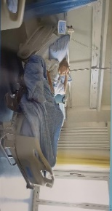 | 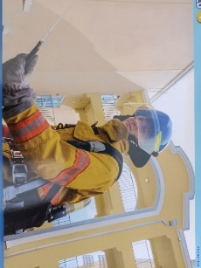 |  | 
1. ___________. | 2.______________. | 3. _____________. | 4._______________.

