ANH 4 – THANH LƯƠNG
PART I. LISTENING
Question 1: Listen and number. (1pt)
 | 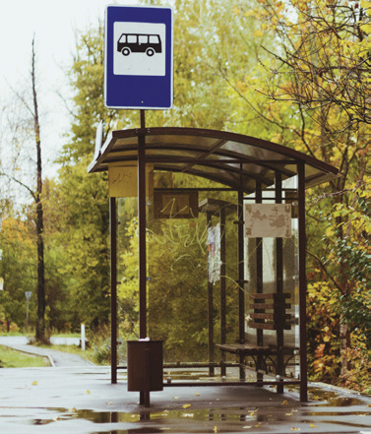 |  | 
a. | b. | c. | d.
Question 2. Listen and tick the correct words/ sentences. (1pt)
1. My mother was in the old …… ( a. village b. city c. town)
2. I was in ………… . (a. Vietnam b. Egypt c. Spain)
3. My grandfather and grandmother were in the old city in ……
( a. Turkey b. Vietnam c. Singapore )
4. My brother was in ……. last year. ( a. Turkey b. America c. Britain)
Question 3: Listen and circle the correct pictures. (1pt)
  1. a | 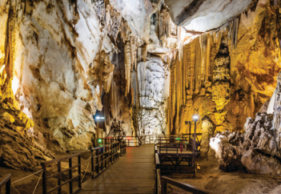  b |   2. a |   b
  3. a |   b |   4. a |   b
PART II. READING AND WRITING
Question 4: Odd one out. (1,25 pts)
1. a. doctor b. farmer c. sea lion d. chef
2. a. restaurant b. firefighter c. hospital d. clinic
3. a. dinosaur b. yesterday c. last week d. two days ago
4. a. scary b. studio c. huge d. strong
5. a. mammoth b. put out fires c. take care of d. feed animals
Question 5: Choose the best answer. (1,25pts)
1. She sometimes ______ videos on her smartphone.
A. make B. makes C. making D. makeing
2. A: Who can use the projector? B: ________ can.
A. Students B. Farmers C. Teachers D. Workers
3. The bookshop is ________ the toy shop and the museum.
A. between. B. on C. under. D. in.
4. We go shopping at the ________ .
A. bus stop B. supermarket C. hospital D. stadium
5. A: ________ do we get to the post office? B: Go straight ahead and turn right. It’s opposite the park.
A. What B. Why C. How D. When
Question 6: Read and match column A with B. (1.25pts)
A | B | Key
1. Which place would you like to visit on holiday? | a. but she doesn’t like walking a lot. | 1 -
2. Where were you last weekend? | b. I was at the shopping centre. | 2 -
3. My sister likes going to the forest on holiday, | c. I’d like to visit Phu Quoc Island. | 3 -
4. What do you like doing on summer holiday? | d. Yes, they were. | 4 -
5. Were dinosaurs big and scary? | e. We like going to the beach. | 5 -
Question 7: Read the text and circle the correct answer. (1pt)
I’m Laura and I’m nine years old. My friends and I always learn English together. We work in groups and do our homework. There are nice photos and videos in the units. I love them a lot. We sometimes use the computer or tablet to learn English, too. It’s fun.
1. Laura and her friends ______ learn English together. (a. sometimes b. don’t c. always )
2. They work ______ and do their homework. (a. in pairs b. in groups c. in class )
3. There are nice photos and ______ in the units. (a. videos b. lessons c. colour )
4. They sometimes use the _____or tablet to learn English, too. (a. book b. computer c. phone)
Question 8: Arrange the words to make sentences. (1,25 pts)
1. students/ use/ Can/ their/ in/ phones/ class?  a. Students can use their phones in class?  b. Can students use their phones in class?  c. Can students use phones their in class? | 2. hospital / My / a / works / father / in.  a. My father works in a hospital.  b. My father in works a hospital.  c. My father works a in hospital.
3. My/ always/ mother/ a /./ takes/ is/ doctor/ she/ care / people/ of./  a. My mother is a doctor. She always takes care of people.  b. She always takes care of people. My mother is a doctor  c. My mother is doctor. She always takes care of a people. | 4. like/ I /, / going/ but / don’t/ sightseeing/ I/ like/ photos/ taking/.  a. I like going sightseeing, but I don’t like taking photos.  b. I like taking sightseeing, but I don’t like going photos.  c. But I like going sightseeing, I don’t like taking photos.
5. the/ Is/ opposite/ train station/ the/ in front of/ or/ bus stop?
a. The train station is opposite or in front of the bus stop?
b. Is the train station opposite or the in front of bus stop?
c. Is the train station opposite or in front of the bus stop?
Question 9: Look at the picture and write ONE word in the blank. (1pt)
  1. A vet takes care of ……………… |   2. A: What does he do?  B: He is a ……………..……
  3. A: What does a chef do?  B: A chef cooks good ……….. |   4. A: Where does a teacher work?  B: A teacher works in a ………… .

PHẦN 2: ĐÁP ÁN
UBND HUYỆN VĨNH BẢO  TRƯỜNG TH THANH LƯƠNG  (Đề đề xuất) | ĐÁP ÁN ĐỀ KHẢO SÁT CHẤT LƯỢNG HK II  MÔN TIẾNG ANH LỚP 4  NĂM HỌC 2024 - 2025  (Thời gian làm bài: 40 phút)
Question 1: Listen and number. (1pt)
a -> 2 b -> 3 c -> 4 d -> 1
Question 2. Listen and tick the correct words/ sentences. (1pt)
1 -> a 2 -> b 3 -> b 4 -> a
Question 3: Listen and circle the correct pictures. (1pt)
1 -> a 2 -> b 3 -> b 4 -> a
Question 4: Odd one out. (1,25 pts)
1 -> c 2 -> b 3 -> a 4 -> b 5 -> a
Question 5: Choose the best answer. (1,25pts)
1 -> B 2 -> C 3 -> A 4 -> B 5 -> C
Question 6: Read and match column A with B. (1.25pts)
1 -> c 2 -> b 3 -> a 4 -> e 5 -> d
Question 7: Read the text and circle the correct answer. (1pt)
I’m Laura and I’m nine years old. My friends and I always learn English together. We work in groups and do our homework. There are nice photos and videos in the units. I love them a lot. We sometimes use the computer or tablet to learn English, too. It’s fun.
1. Laura and her friends ______ learn English together. (a. sometimes b. don’t c. always )
2. They work ______ and do their homework. (a. in pairs b. in groups c. in class )
3. There are nice photos and ______ in the units. (a. videos b. lessons c. colour )
4. They sometimes use the _____or tablet to learn English, too. (a. book b. computer c. phone)
Question 8: Arrange the words to make sentences. (1,25 pts)
1. students/ use/ Can/ their/ in/ phones/ class?
-> Can students use their phones in class?
2. place/ you/ to/ holiday/ Which/ would/ on/ like/ visit?
-> Which place would you like to visit on holiday?
3. My/ always/ mother/ a /./ takes/ is/ doctor/ she/ care / people/ of.
-> My mother is a doctor. She always takes care of people.
4. like/ I /, / going/ but / don’t/ sightseeing/ I/ like/ photos/ taking/.
-> I like going sightseeing, but I don’t like taking photos.
5. the/ Is/ opposite/ train station/ the/ in front of/ or/ bus stop?
-> Is the train station opposite or in front of the bus stop?
Question 9: Look at the picture and write ONE word in the blank. (1pt)
1. A vet takes care of animals. | 2. A: What does he do?  B: He is a photographer.
3. A: What does a chef do?  B: A chef cooks good food. | 4. A: Where does a teacher work?  B: A teacher works in a school .

