UBND HUYỆN VĨNH BẢO  TRƯỜNG TH VĨNH PHONG TIỀN PHONG | ĐỀ KHẢO SÁT CHẤT LƯỢNG HỌC KỲ II  TIẾNG ANH LỚP 5  NĂM HỌC 2024 - 2025  (Thời gian làm bài: 40 phút)
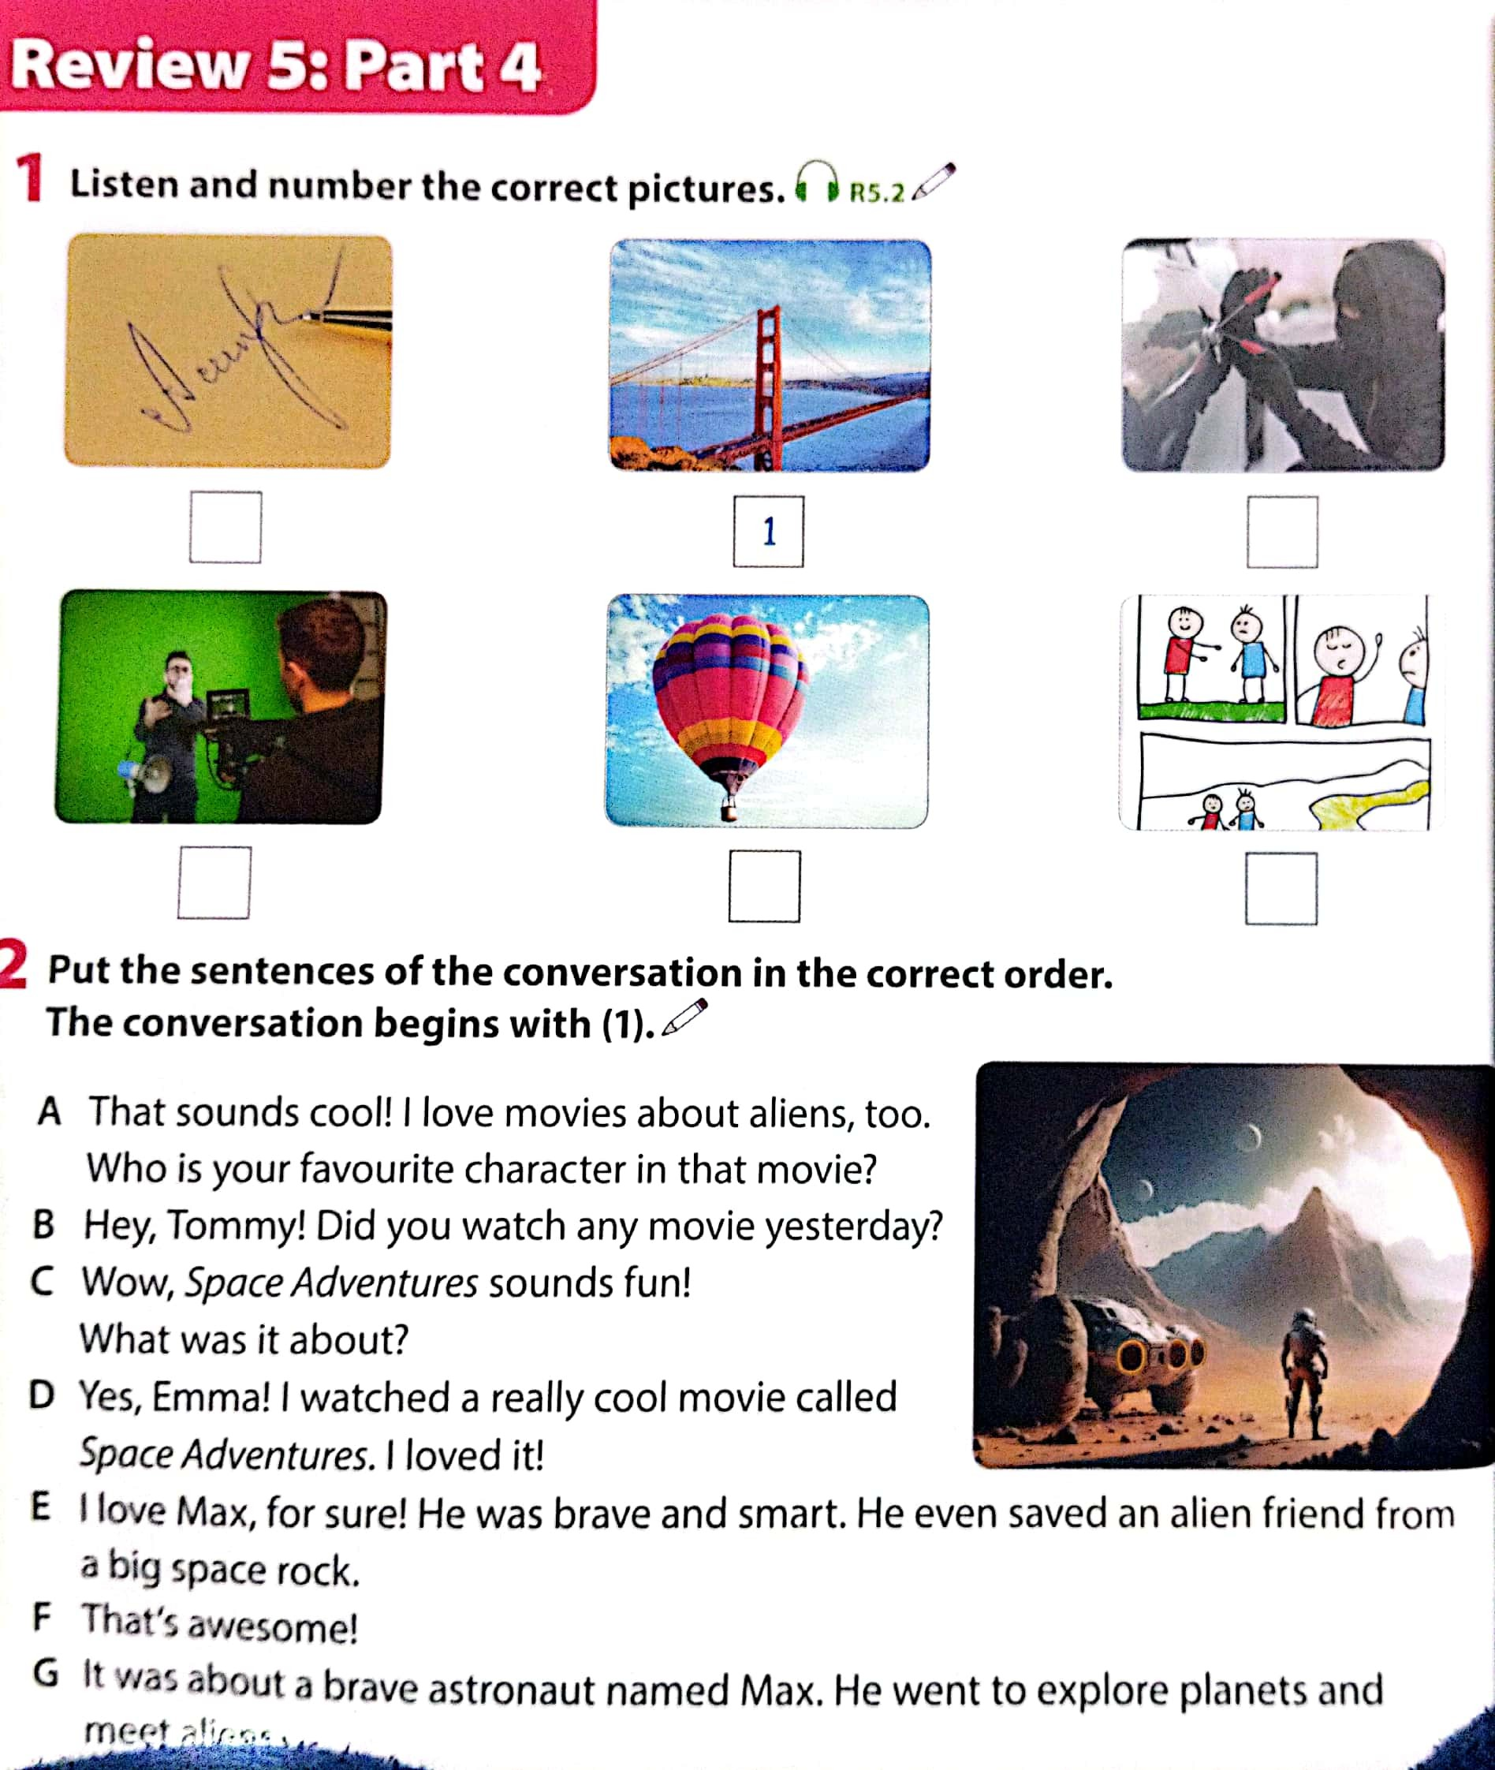
Question 1: Listen and number (1 points)


Question 2. Listen to talk about Barcelona. Tick T for True or F for False (1pt)
 | T | F
1. Barcelona is a large city in Spain.
2. La Rambla is a small street in Barcelona’s city centre
3. In La Rambla, you can go shopping or have a snack in a café.
4. The Sangrada Familia is a large church in Barcelon.
Question 3: Listen and circle the correct answers.(1pt)
1. Which animal is she talking about? | 2. How long are crocodiles?
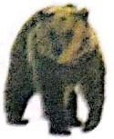      a.  - b c
  6 metres | 7 metres | 8 metres
 | a b c
3. What do crocodiles eat? | 4. Where do they live?
  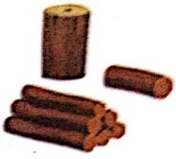  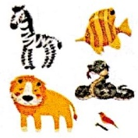  a b c |       a b c
Question 4: Circle the odd one out. (1,25pts)
1.a. stopped b. wanted c. talked d. watched
2.a. liked b. needed c. visited d. waited
3.a. laughed b. listened c. jumped d. looked
4.a. repeated b. started c. played d. pointed
5. a. enjoyed b. learned c. travelled d. worked
Question 5: Choose the best answer A, B or C to complete the sentences( 1,25 points):
1. …………… to the concert yesterday?
a. Did Stella not go b. Stella went c. Did Stella go
2. Melina and I bought some burgers, but we …………….. any chips.
a. did not buy b. bought c. didn’t bought
3. The film is ……………….
a. interesting very b. very interesting c. very interesting film
4. Linda ………………. in the pool at present.
a. swimming b. is swimming c. swims
5. Children shouldn’t ……….. TV many hours a day.
a. watch b. watching c. watched
Question 6: Read the passage and circle the correct answer (1,25pts)
Deep underground, there is a special heat geothermal energy (geo means “earth” and thermal means “heat” in Greek). We need energy to light our homes and cook. The sun and wind provide clean energy, but geothermal energy can help people even more.
The Boiling River, deep in the Amazon rainforest, has very hot water (up to 99°C). This water is dangerous for animals. Scientists are studying the river to understand geothermal energy better. They also protect other parts of the Amazon. They don’t want people to cut down trees and destroy the rainforest. We hope that people will save the environment and save geothermal energy.
- What do you call special energy deep underground?
- Geothermal energy b. Heat c. Earth
- What do we need energy to?
- light our homes b. cook c. Both a and b
- Where is the Boiling River?
A.in the Amazon rainforest B. Amazon rainforest C. the Amazon rainforest.
- How hot is the water in the Boiling River ?
- up to 99 b. very hot c. a hot water
- Why are scientists studying the Boiling River?
- to understand geothermal energy better B, to understand geothermal energy
C,understand geothermal energy better
Question 7: Find and circle the mistakes. (1pt)
- My family watch an interesting TV show last night.
A B C D
- I traveled to Thailand with my friends last year.
A B C D
- When did you do yesterday? I played the piano.
A B C D
- Two days last, my uncle visited a farm to buy some strawberries and cherries.
A B C D
Question 8: Arrange the words to make sentences (1,25pt)
1.giraffes / than / lions / are / taller / .
A. Giraffes are taller than lions B. Lions are taller than giraffes
- Giraffes taller than are lions
2,use / I / see / to / birds / binoculars / the / well / .
A.I use binoculars to see birds the well B. I use binoculars to see the birds well
C. I binoculars use the bird to see well
3. park / this / interesting / to / place / visit / really / is / a / .
A. This park is a really interesting place to visit
B. This park is a interesting really place to visit
C. This place is really a interesting park to visit
4. really / her / loves / She / cat / .
a. She really her loves cat. b. She loves her really cat. c. She really loves her cat
5. elephant / is / a / an / stronger / rabbit / than / .
a. A elephant is stronger than an rabbit b. An elephant is stronger than a rabbit
c. An elephant stronger is than a rabbit


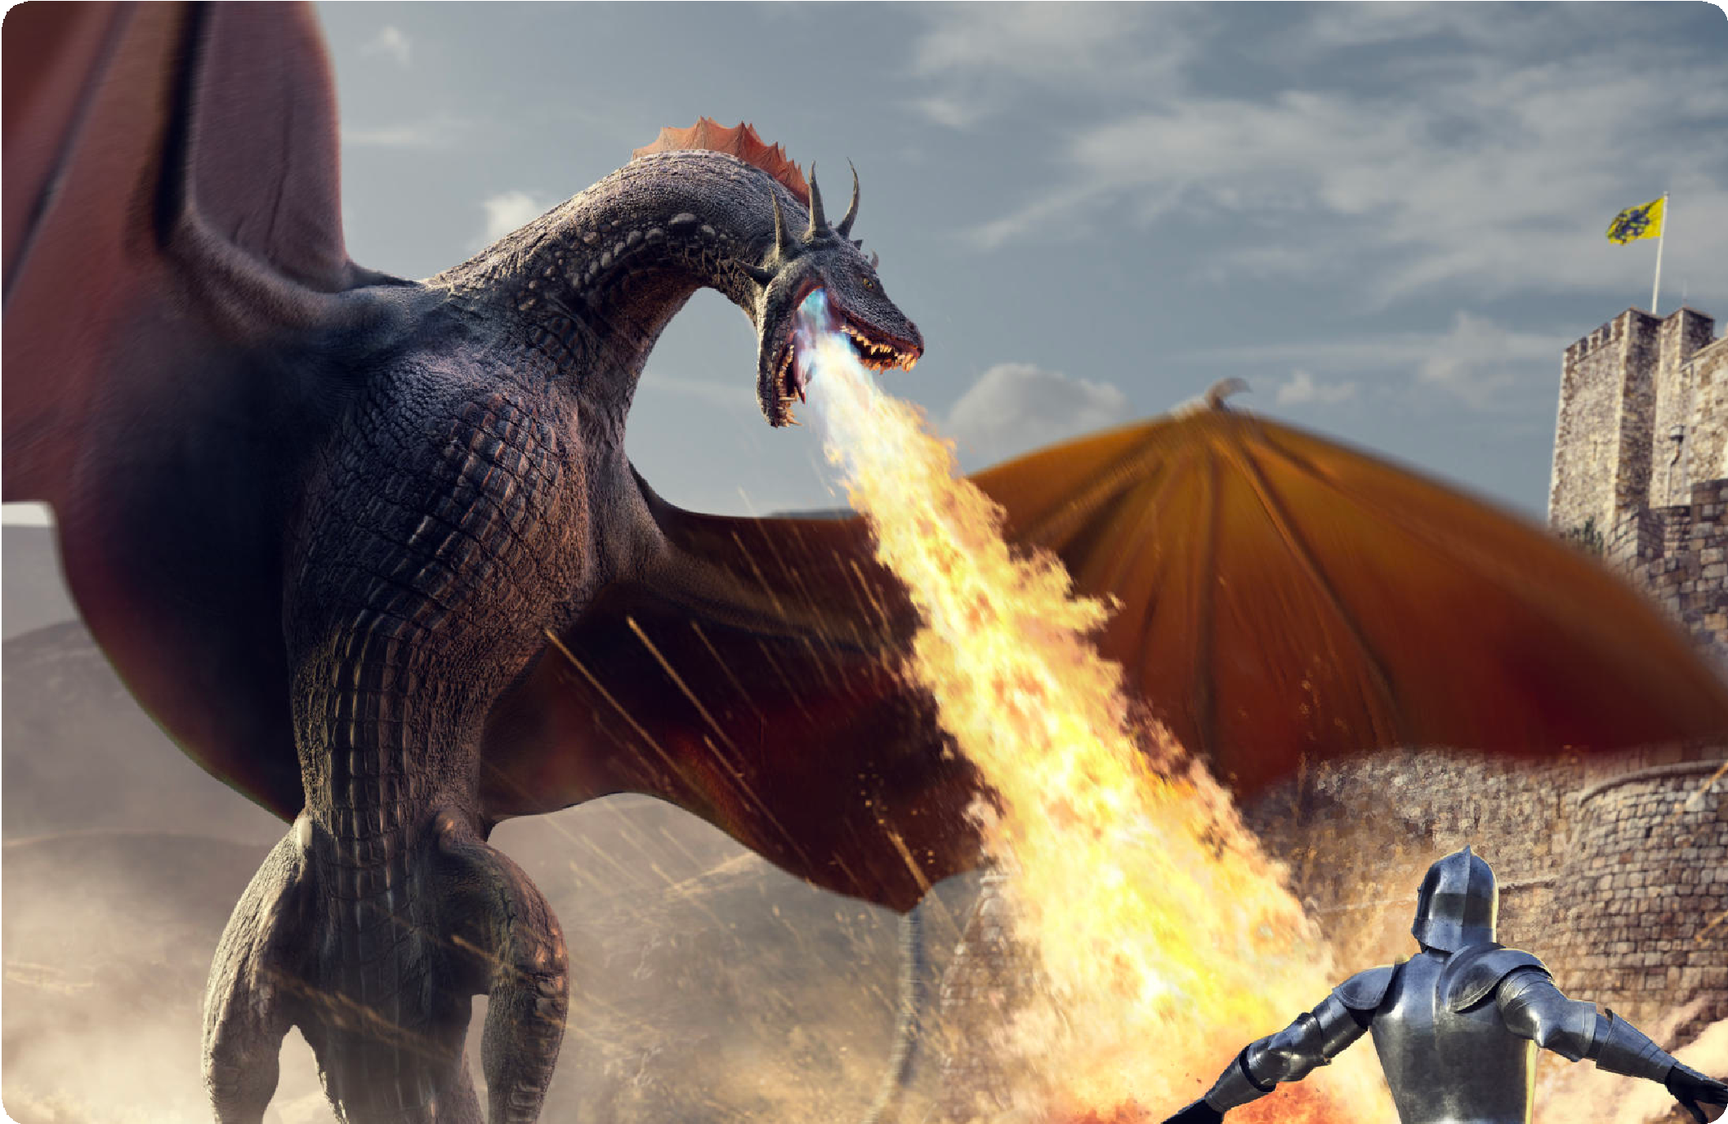
Question 9: Look at the picture and write the words (1pt)

- ……………….. 2. ………………… 3. ………………… 4. …………………

ĐÁP ÁN
UBND HUYỆN VĨNH BẢO  TRƯỜNG TH VĨNH PHONG – TIỀN PHONG  (Đề đề xuất) | ĐỀ KHẢO SÁT CHẤT LƯỢNG HỌC KÌ II  MÔN TIẾNG ANH LỚP 5  NĂM HỌC 2024 - 2025  (Thời gian làm bài : 40 phút)
Question 1 : Listen and number (1pt)
1 – b 2 – c 3 – d 4 – a
Question 2. Listen to talk about Barcelona. Tick T for True or F for False (1pt)
1 – T 2 – F 3 – T 4 – T
Question 3: Listen and circle the correct answers.(1pt)
1. b | 2. a | 3. a | 4. c
Question 4: Circle the odd one out. (1,25pts)
1. b 2. a 3. b 4. c 5. d
Question 5: Choose the best answer A, B or C to complete the sentences( 1,25 points)
1 – c 2 – a 3 – b 4 – b 5. a
Question 6: Read the passage and circle the correct answer (1,25pts)
- a 2. c 3. a 4. b 5. a
Question 7: Find and circle the mistakes. (1pt)
1. a 2. a 3. a 4. b
Question 8: Arrange the words to make sentences (1,25pt)
1. a 2.b 3.a 4.c 5.b
Question 9: Look at the picture and write the words (1pt)
- autograph 2. director 3. fantascy 4. cartoon

