ANH 5- AN HOÀ
PART I: Listening
Question 1: Listen and number (1pt) review 5 part 4 b1
 | 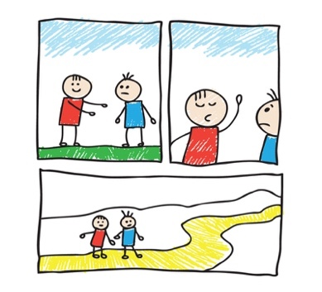 |  | 
A | B | C | D
Question 2: Listen and write T for True or F for False (1pt)
1. Barcelona is a large city in Spain. ……………….
2. La Rambla is a small street in Barcelona’s city center. ……………….
3. In La Rambla, you can go shopping or have a snack in a café. ……………….
4. The Sagrada Familia is a large church in Barcelona. ……………….
Question 3: Listen and circle the correct answers (1pt)
1. What animal is she talking about?
A. | B. | C.
2. How long are crocodiles?
a. 6 meters b. 7 meters c. 8 metres
3. What do the crocodiles eat?
A. | B. | C.
4. Where do you live?
A. | B. | C.
PART II. PRONUNCIATION
Question 4: Circle the odd one out. (1.25pts)
1. a. looked | b. watched | c. liked | d. visited
2. a. needed | b. wanted | c. started | d. talked
3. a. waited | b. touched | c. worked | d. walked
4. stopped | b. asked | c. jumped | d. pointed
5. a. visited | b. needed | c. wanted | d. listened
PART III. READING AND WRITING
Question 5: Choose the best answer (1.25pts)
1. Because she has a broken arm, she……………….play volleyball.
a. can b. should c. shouldn’t d. may
2. Anita……………….for her school running race now.
a. is prepare b. prepare c. prepares d. is preparing
3. ………………. (Stella/ go) to the concert yesterday?
a. Did Stella – went b. Do Stella – go
c. Did Stella – go d. does Stella – went
4. Charlie Chaplin was a……………….actor and film director
a. famous b. interesting c. exciting d. boring
5. Doreamon is a famous……………….character.
a. drama b. cartoon c. actor d. director
Question 6: Read the passage and circle the correct answer (1.25pts)
Deep underground, there is a special heat: geothermal energy (geo means ‘’earth’’ and thermal means ‘’heat’’ in Greek). We need energy to light our homes and cook. The sun and wind provide clean energy, but geothermal energy can help people even more.
The Boiling River, deep in the Amazon rainforest, has very hot water (up to 99°C). This water is dangerous for animals. Scientists are studying the river to understand geothermal energy better. They also protect other parts of the Amazon. They don’t want people to cut down trees and destroy the rainforest. We hope that people will save the environment and save geothermal energy.
1. What do you call the special energy deep underground?
a. Boiling River b. Geothermal energy c. Amazon
2. Where is the Boiling River?
a. in the Amazon rainforest b. in the Tongass rainforest c. in the Daintree rainforest
3. How hot is the water in the Boiling River?
a. up to 99°C b. under 99°C c. about 99°C
4. Why are scientists studying the Boiling River?
a. To save the environment and save geothermal energy.
b. To protect geothermal energy better. c. To understand geothermal energy better.
5. What do the scientists hope people will to do?
a. They hope that people will save the environment and save geothermal energy.
b. They hope that people will cut down trees and destroy the rainforest.
c. They hope that people will protect other parts of the Amazon.
Question 7: Find and circle the mistakes (1pt)
1. Last weekend, I play basketball with my classmates.
A B C
2. I traveled to Thailand with my friends last year.
A B C
3. What do you do two days ago?
A B C
4. There was no locks on the bank in this village.
A B C
Question 8: Arrange the words to make sentences (1.25pts)
1. elephant / than / An / stronger / rabbit / is / a
a. A rabbit is stronger than an elephant. b. An elephant is stronger than a rabbit
c. An elephant is than stronger a rabbit. d. A rabbit than stronger an elephant.
2. runs / My / everyday / keep / father / healthy / to.
a. My father runs everyday to keep healthy. b. My father runs healthy to keep everyday.
c. My father keep to run healthy everyday. d. My father keep to run healthy every day.
3. really / cat / She / her / loves .
a. She really her loves cat. b. She really loves her cat.
c. She love really her cat. d. She loves really her cat.
4. is/ a / really / It / film / watch/ to / interesting.
a. It is a interesting really film to watch. b. It is a really film interesting to watch.
c. It is a really interesting film to watch. d. It really is a interesting film to watch.
5. Snakes / longer / worms / are / than
a. Snakes are longer than worms. b. Snakes longer are than worms.
c. Worms are longer than snakes. d. Worms longer than are snakes.
Question 9: Look at the picture and write the words (1pt)
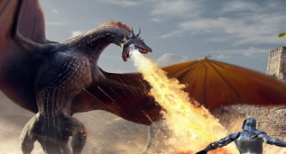 |  | 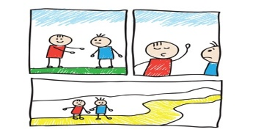 | 
1. | 2. | 3. | 4.

