ĐỀ TAM ĐA LỚP 5

PART I. LISTENING
Question 1. Listen and number (1pt)

a. | b. | c. | 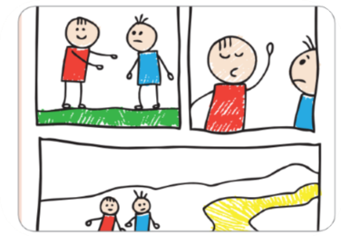d.
Question 2. Listen and write T or F (1pt)
 | T | F
1. Barcelona is a large city in Spain.
2. In La Rambla, you can go shopping or have a snack in a cafe.
3. The Sagrada Familia is a small church in Barcelona.
4. In Parc de la Cuitadella, you can walk, ride a bike or take a boat ride on the lake.
Question 3. Listen and circle the correct answers (1pt)
1. Which animal is she talking about?
a. tiger | b. crocodile | c. bear | d. lion
2. How long are crocodiles?
a. 6 metres | b. 16 metres | c. 7 metres | d. 8 .metres
3. Where do they live?
a. lake | b. house | c. canal | d. pond
4. How long do they usually live?
a. 70 years | b. 60 years | c. 80 years | d. 90 years
PART II. READING AND WRITING
Question 4. Odd one out (1.25pt)
1. a. looked | b. visited | c. wanted | d. needed
2. a.watched | b. liked | c. touched | d. played
3. a. stopped | b. waited | c. jumped | d. worked
4. a. asked | b. talked | c. laughed | d. pointed
5. a. enjoyed | b. walked | c. travelled | d. played
Question 5. Read and choose the best answer (1.25pts)
1. He ___________________ his bike so fast at the moment.
a. rides b. is riding c. rode d. ride
2. She ___________________ on to the train at present.
a. step b. steps c.is stepping d. is steping
3. ______Stella _______to the concert yesterday?
a. Do/go b. Does/go c. Did/go d. Is/going
4. Minh ___________________ some new comic books two week ago.
a. bought b. buys c. buyed d. is buying
5. He_______________in the deep end of the pool.
a. swim b. can't swim c. swam d. is swimming
Question 6: Read the passage and circle the correct answer. (1.25pt)
Once upon a time, there was a treasure with a lot of golden coins. It stayed on an island covered by the sea. An adventurer started his treasure hunt to be rich. On the way, a storm came with rain and big winds. The storm didn’t stop, so he used a magic coat to go through the storm. When he almost had the treasure, a dragon appeared from the underground to eat him. It was not friendly at all. He won the dragon and took all the coins. However, the coins were boiling hot and they melted.
1. The treasure with a lot of ____________.  A. golden coins.  B. money.  C. golden. | 2. He met a storm and ____________.  A. he used magic to stop it  B. he flew through it on a dragon  C. he used a magic coat to protect him
3. The dragon was not ___________.  A. careful.  B. friendly.  C. kind. | 4. Finally, ______________.  A. he took all the coins and became rich.  B. all the coins were boiling hot and melted  C. he was hot and melted
5. He won the dragon and
- Took all the coins
- he used magic to stop it
C. he flew through it on a dragon
Question 7: Find and circle the mistakes. (1pt)ok
1. My mother learns to play the piano when she was a child.
A B C D
2. There was many smoke because he started a fire.
A B C D
3. When I was a child, my mom tells me many bedtime stories.
A B C D
4. I had a small birthday party in my class next month.
A B C D
Question 8. Arrange the words to make sentences (1,25pt)
1. elephant/is/an/stronger/a/rabbit/than.  A. An elephant is stronger than a rabbit.  B. An rabbit is stronger than a elephant.  C. An elephant is than stronger a rabbit.  2. horses/faster/are/than/turtles?  A. Horses are faster than turtles.  B. Are horses faster than turtles?  C. Are horses than faster turtles?  3. plays/the/she/after/school/to/piano/relax.  A. She plays the piano to relax after school.  B. She plays the piano to relax school after.  C. She plays the piano relax to after school. | 4. some/bought/a/eggs/make/to/cake/he.  A. He bought eggs some to make a cake.  B. He bought eggs to a make some cake.  C. He bought some eggs to make a cake.  5. like / I /because / tigers / they’re /colourful/ really / fearthers.  A. I like tigers because they’re colourful really fearthers.  B. I like tigers because they’re really colourful fearthers.  C. I like tigers because they’re really fearthers colourful.
Question 9. Look at the picture and write the words (1pt)
. 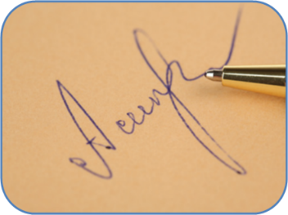 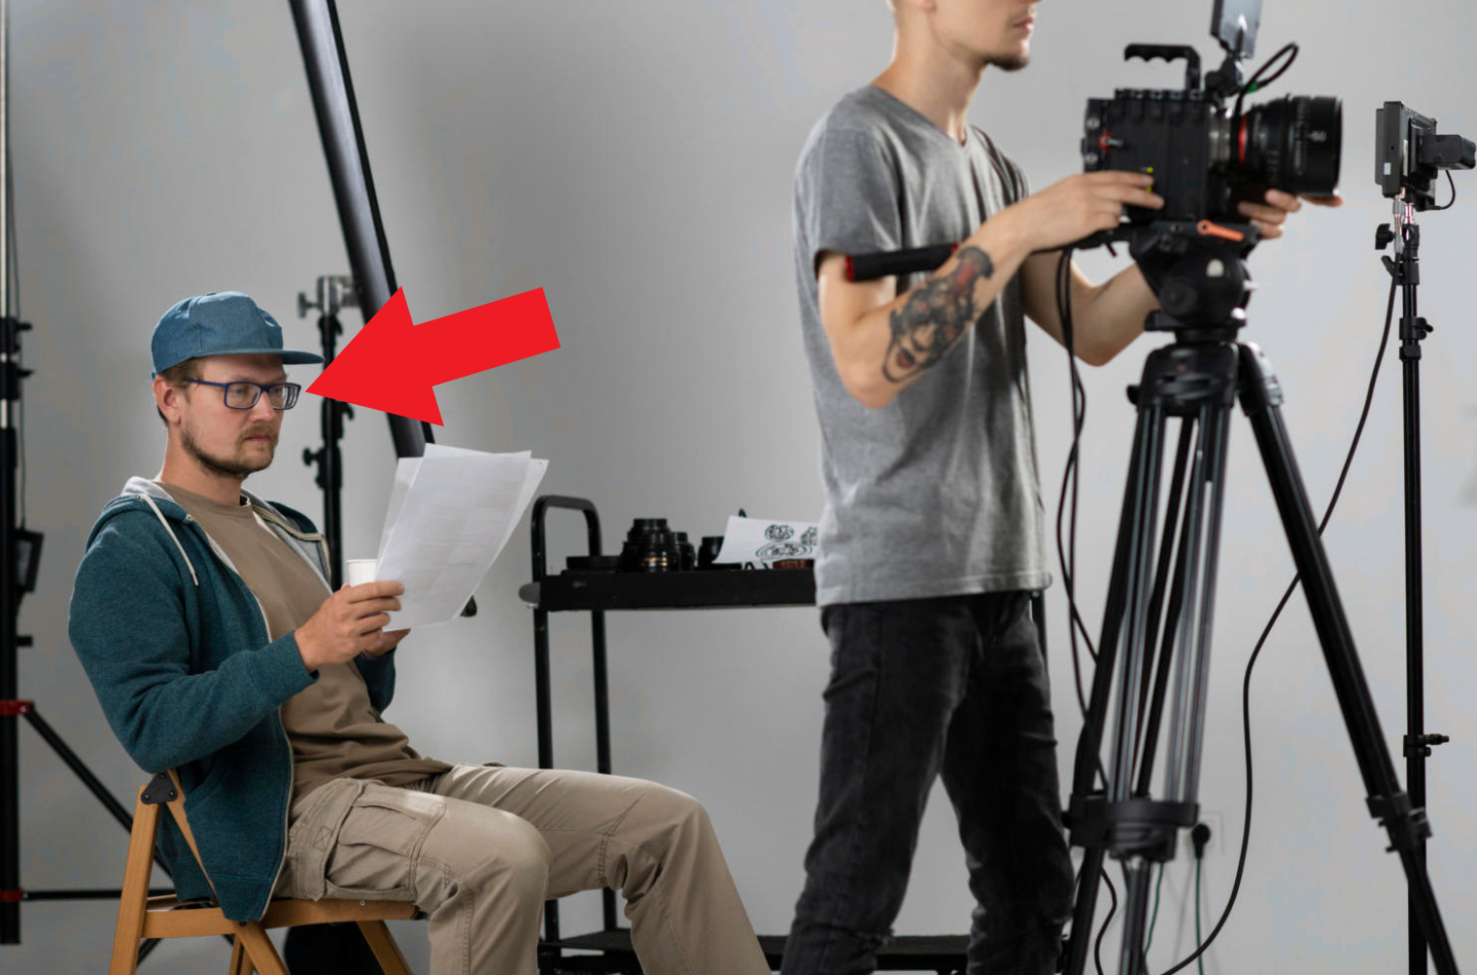  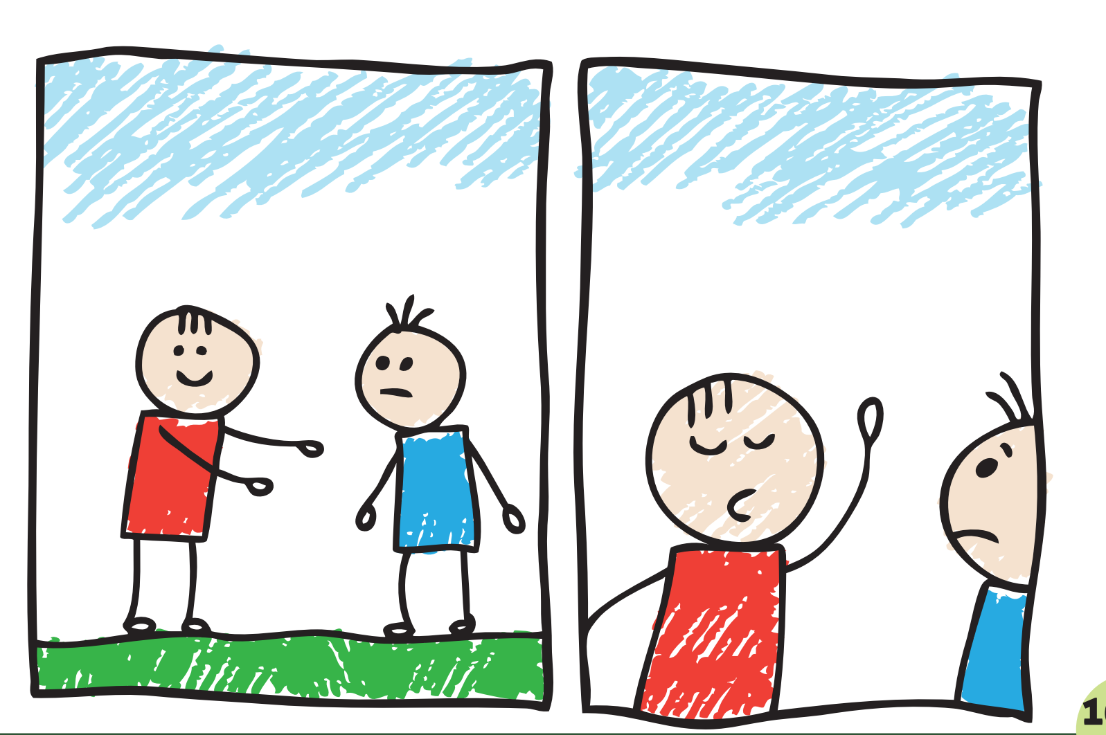
1. 2. 3. 4.

ĐÁP ÁN
PART I : Listening
Question 1: (1pt)
4 câu x 0,25 = 1đ
1.c 2. a 3. d 4. b
Question 2: (1pt)
4 câu x 0,25 = 1đ
1.T 2. T 3. F 4. T
Question 3: (1pt)
4 câu x 0,25 = 1đ
1. b 2. a 3. a 4. b
PART III : Reading and writing
Question 4: (1.25pt)
5 câu x 0,25 = 1.25 đ
1a 2.d 3.b 4. d 5.b
Question 5: (1,25pt)
6 câu x 0,25 = 1,5đ
1.b 2.c 3. c 4. a 5. b
Question 6: (1,25pts)
c
1. a 2. c 3. b 4. b 5. a
Question 7: (1pt)
4 câu x 0,25 = 1đ
1. a 2. b 3. c 4. d
Question 8: (1,25 pt)
5 câu x 0,25 = 1,25đ
1. A.2. B 3. A4. C 5.B

Question 9: (1pt)
4 câu x 0,25 = 1đ
1. autograph 2. Director 3. Make up 4.cartoon

