UBND HUYỆN VĨNH BẢO  TRƯỜNG TH TÂN HƯNG  (Đề đề xuất) | ĐỀ KHẢO SÁT CHẤT LƯỢNG HỌC KỲ II  MÔN TIẾNG ANH LỚP 5  NĂM HỌC 2024 - 2025  (Thời gian làm bài: 40 phút)
Part I . Listening
Question 1.Listen and number(1pt)
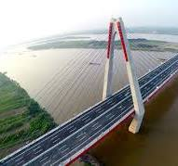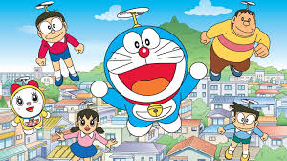

Question 2.Listen and write T for True or F for False(1pt)
1,Barcelona is a large city in Spain..............
2,La Rambla is a small street in Barcelona’s city centre...............
3,Every year,2 milion people visit this church............
4,In Parc de la Ciutadella,you can walk,ride a bike or take a boat ride on the lake.........
Question 3.Listen and circle the correct answers.(1pt)
1,Which animal is she talking about?
A,lion B,crocodiles C,bear.
2,How long are crocodiles?
A,6 metres B,7 metres C,8 metres
3,What do crocodiles eat?
A,lion,fish,snakes,birds,. B,vetgetables C,fruits
4,Where are they live?
A,sea B,lake C,river
Part II. Pronunciation
Question 4 Circle the odd one out.(1,25pt)
1,a. looked b. watched c. liked d.visited
2,a. needed b. wanted c. started d. talked
3,a. waited b. touched c. worked d. walked
4,a. stopped b. asked c. jumped d. pointed
5,a. washed b. used c. watched d. needed
Part III Reading and Writing
Question 5 Choose the best answer(1,25pt)
1,He is ..................(run) in the road ,now.
a,runs b,running c,runing d,runed
2,I got the singer’s autograph,but I.............
a,didn’t get b,don’t get c,get d,got
3,John is having fun with her new helmet,.....................
a,last week b,yesterday c,at present d,last moth
4,She is a.......................princess.
.a,lot of b,beautifully c,well d,beautiful
5,Where did he go..............he was 21?
a,when b,what c,who d,which
Question 6 Read the passage and circle the correct answer(1pt)
Tomorrow is Saturday and it is so cold outside, so I’m not going to go to the park. Dad and Mum are going to stay at home too, so we are going to play some board games indoors. Dad isn’t going to win because he always loses. Mum is a better player, but she’s going to lose in the end because I’m the best player in the family. Well, I hope I am.
1,Tomorrow,the weather will /won’t be cold.
2, We are going/aren’t going stay at home.
3,My parents and I is /are going to play some board games.
4,My dad is/is n’t going to win.
Question 7 Find and circle the mistakes.
1,Yesterday,my family go to the zoo.
A B C
2,Two days ago, she tell me many bedtime stories.
A B C D
3,When I am a child, I liked many dolls.
A B C D
4,What do you do, last week?
A B C
Question 8. Arrange the words to make the meaningful sentences (1pt)
1,is/than/stronger/the/The/bird/elephant. 2,than/Crocodiles/are/lizards/longer.
a.The elephant is stronger than the bird. a. Crocodiles are longer than lizards.
b.Lizards are longer than crocodiles. b. The elephant is than stronger the bird.
c.The bird is stronger than the elephant. c. Lizards are than longer crocodiles.
3,are/They/really/butterflies/beautiful.
a.They are really butterflies beautiful.
b.They are really beautiful butterflies.
c.They are beautiful butterflies really.
4,student/The/very hard/the exams/to/studies/pass.
a.The student studies very hard the exams to pass.
b.The student pass very hard to studies the exams.
c.The student studies very hard to pass the exams.
Question 9 Look at the picture and write the words
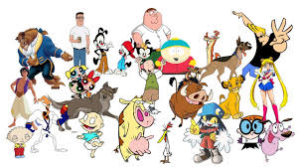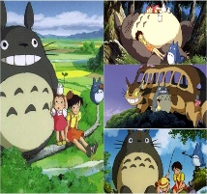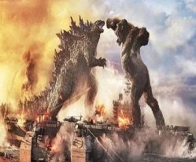

............................... ................................ ............................... ...................................

PHẦN 2: ĐÁP ÁN

UBND HUYỆN VĨNH BẢO  TRƯỜNG TH.TÂN HƯNG  (Đề đề xuất) | ĐÁP ÁN ĐỀ KHẢO SÁT CLHK II  MÔN TIẾNG ANH LỚP 5  NĂM HỌC 2024 - 2025  (Thời gian làm bài: 40 phút)
Part I . Listening
Question 1.Listen and number(1pt)
2
4
1
3

Question 2.Listen and write T for True or F for False(1pt)
1,Barcelona is a large city in Spain.......T.......
2,La Rambla is a small street in Barcelona’s city centre...........F....
3,Every year,2 milion people visit this church.........F...
4,In Parc de la Ciutadella,you can walk,ride a bike or take a boat ride on the lake...T......
Question 3.Listen and circle the correct answers.(1pt)
1,Which animal is she talking about?
A,lion B,crocodiles C,bear.
2,How long are crocodiles?
A,6 metres B,7 metres C,8 metres
3,What do crocodiles eat?
A,lion,fish,snakes,birds,. B,vetgetables C,fruits
4,Where are they live?
A,sea B,lake C,river
Part II Pronunciation
Question 4 Circle the odd one out.(1,25pt)
1,looked watched liked visited
2,needed wanted started talked
3,waited touched worked walked
4,stopped asked jumped pointed
5,washed used watched needed
Part III Reading and Writing
Question 5 Choose the best answer(1,25pt)
1,He is ..................(run) in the road ,now.
a,runs b,running c,runing d,runed
2,I got the singer’s autograph,but I.............
a,didn’t get b,don’t get c,get d,got
3,John is having fun with her new helmet,.....................
a,last week b,yesterday c,at present d,last moth
4,She is a.......................princess.
.a,lot of b,beautifully c,well d,beautiful
5,Where did he go..............he was 21?
a,when b,what c,who d,which
Question 6 Read the passage and circle the correct answer(1pt)
Tomorrow is Saturday and it is so cold outside, so I’m not going to go to the park.Dad and Mum are going to stay at home too,so we are going to play some board games indoors.Dad isn’t going to win because he always loses.Mum is a better player,but she’s going to lose in the end because I’m the best player in the family.Well,I hope I am.
1,Tomorrow,the weather will /won’t be cold.
2,My family are going/aren’t going stay at home.
3,My parents and I is /are going to play some board games.
4,My dad is/is n’t going to win.
Question 7 Find and circle the mistakes.
1,Yesterday,my family go to the zoo.
2,Two day ago,she told me many bedtime stories.
3,When I am a child,I liked many dolls.
4,What do you do,last week?
Question 8 Arrange the words to make sentences
1,is/than/stronger/the/The/bird/elephant.
The elephant is stronger than the bird.
2,than/Crocodiles/are/lizards/longer.
Crocodiles are longer than lizards.
3,are/They/really/butterflies/beautiful.
They are really beautiful butterflies.
4,student/The/very hard/the exams/to/studies/pass.
The student studies very hard to pass the exams.
Question 9 Look at the picture and write the words
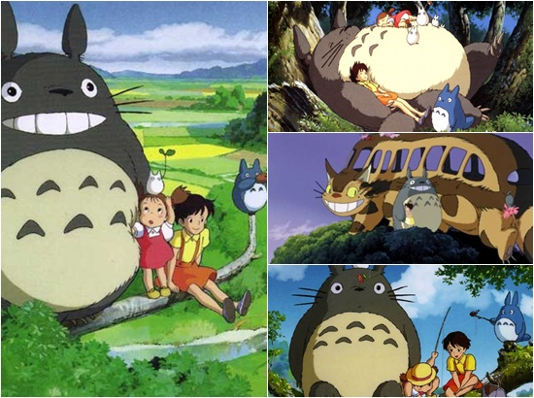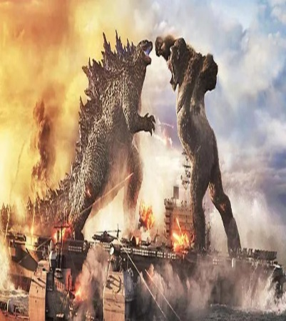

Character cartoon director fantasy

