UBND HUYỆN VĨNH BẢO  TRƯỜNG TH Tân Liên | ĐỀ KHẢO SÁT CHẤT LƯỢNG HỌC KỲ II  TIẾNG ANH LỚP 5  NĂM HỌC 2024 - 2025  (Thời gian làm bài: 40 phút)
PART I. LISTENING
Question 1. Listen and number (1pt)

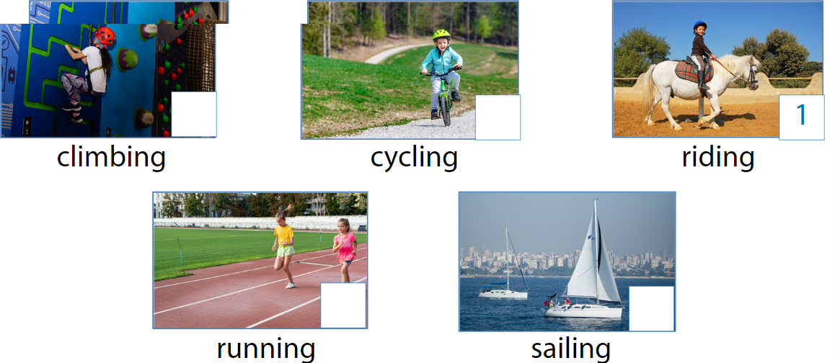

Question 2. Listen and write T (True) or F (False) (1pt)
0. Tim usually plays outside with his family. | F
1. He woke up at 9 o’clock yesterday.
2. He stayed in his room to play online games after lunch.
3. Tim played football at the playground.
4. He stayed up late to play video games.
Question 3. Listen and circle the correct answers (1pt)
- What animals is taking about? A. Tiger B. Crocodiles C. Panda
- How long are crocodiles? A. 6 metres B. 7 metres C. 8 metres
- What do crocodiles eat? A. fish, bird, horse …. B. leaves C. wood
- Where do they live? A. sea B. house C. Field
PART II. READING AND WRITING
Question 4. Odd one out (1.25pt)
1. a. invited | b. listened | c. wanted | d. needed
2. a.watched | b. finished | c. visited | d. worked
3. a. looked | b. touched | c. talked | d. played
4. a. listened  5. a. enjoyed | b. stopped  b. returned | c. liked  c. painted | d. asked  d. called
Question 5. Read and choose the best answer (1.25pts)
1. People do exercises ______________ day.
a. movement b. every c. without d. and
2. When we play football, we should learn to _______________ our movement.
a. learn b. kick c. has d. haves
3. She goes to the playground three _____________ a week.
a. time b. last c. times d. made
4. He became famous when he (be) 25 years old.
a. have b. was c. were d. Is
5. Many years ago , We watch the news on TV
a. do b. didn’t c. did d. not

Question 6. Read the passage and circle the best answer(1.25pt)
Once upon a time, there was a treasure with a lot of golden coins. It stayed on an island covered by the sea. An adventurer started his treasure hunt to be rich. On the way, a storm came with rain and big winds. The storm didn’t stop, so he used a magic coat to go through the storm. When he almost had the treasure, a dragon appeared from the underground to eat him. It was not friendly at all. He won the dragon and took all the coins. However, the coins were boiling hot and they melted.
1. The treasure was ____________.
A. on an island B. on the sea C. in the underground
2. He met a storm and ____________.
A. he used magic to stop it B. he flew through it on a dragon
C. he used a magic coat to go through the storm
4. Finally, ______________.
A. he took all the coins and became rich. B. all the coins were boiling hot and melted
C. he was hot and melted
- He won the dragon and
- took all the coins B he used magic to stop it C. he flew through it on a dragon
Question 7: Find and circle the mistakes. (1pt)
1. When I am a child, I wanted to go on a hot-air balloon ride.
A B C D
2. The first hot air-balloon flight got up and stay in the air for nine minutes.
A B C D
3. Jim buys some orange juice from the restaurant yesterday.
A B C D
4. When I was a child, my mum bought me a lot of toys in my birthdays.
A B C D
Question 8. Arrange the words to make sentences (1.25pt)
1.elephant / An / a bird / than/stronger /is/  A. An elephant is stronger than a bird.  B. An bird is stronger than an elephant.  C. A elephant is than stronger an bird. | 3.cheetahs / TV,/ On / faster /than / tigers /run  A. On TV, cheetahs faster than run tigers  B. On TV, tigers faster than run cheetahs  C. On TV , cheetahs run faster than tigers
2. like / I /because / peacocks / they’re colourful/ really / feathers /./  A. because I like peacocks, they’re really colourful feathears.  B. I like peacocks because they’re really colourful feathears.  C. Because they’re really colourful feathears , I peacock like | 4.likes / She / milk / drinking / ./  A. She likes drinking milk  B. She likes milk drinking  C. She milk like drinking  5. your / favourite / What/ animal / is/?/  A. What your is favourite animal?  B. What is your animal favourite?  C. What is your favourite animal?

Question 9: Look at the picture and write a word (1pt)
. 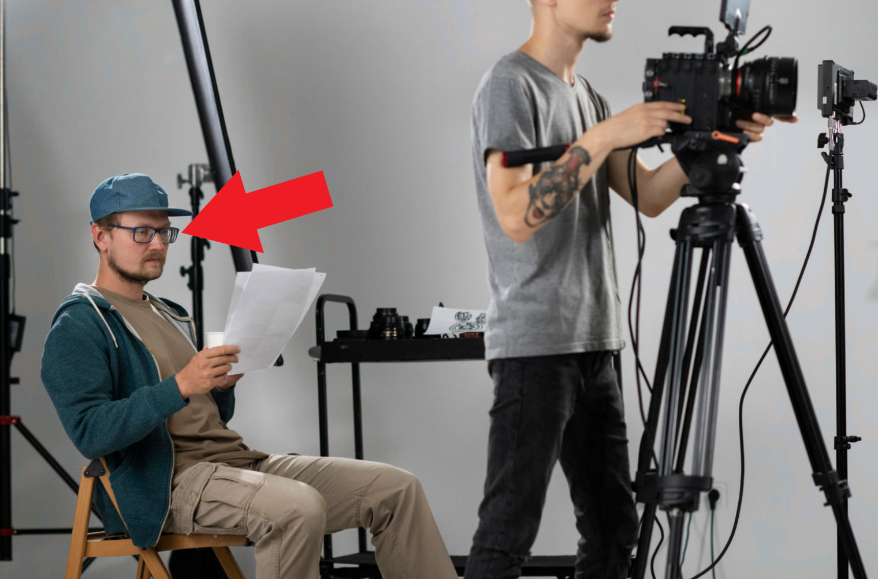  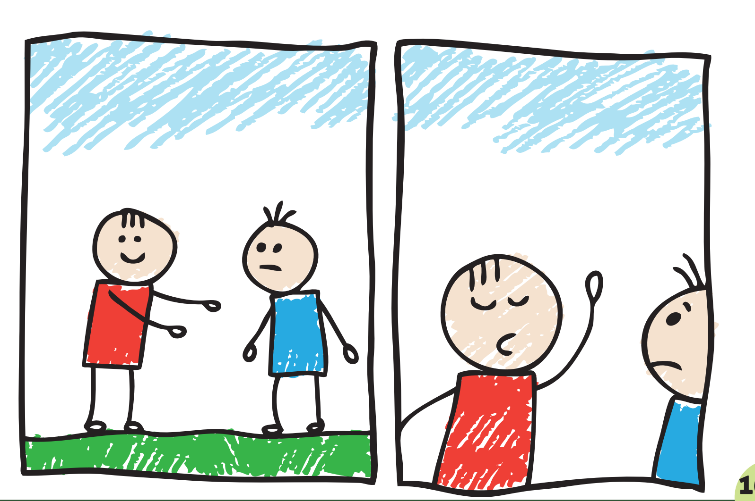
1. 2. 3. 4.

ĐÁP ÁN
PART I : Listening
Question 1: (1pt)

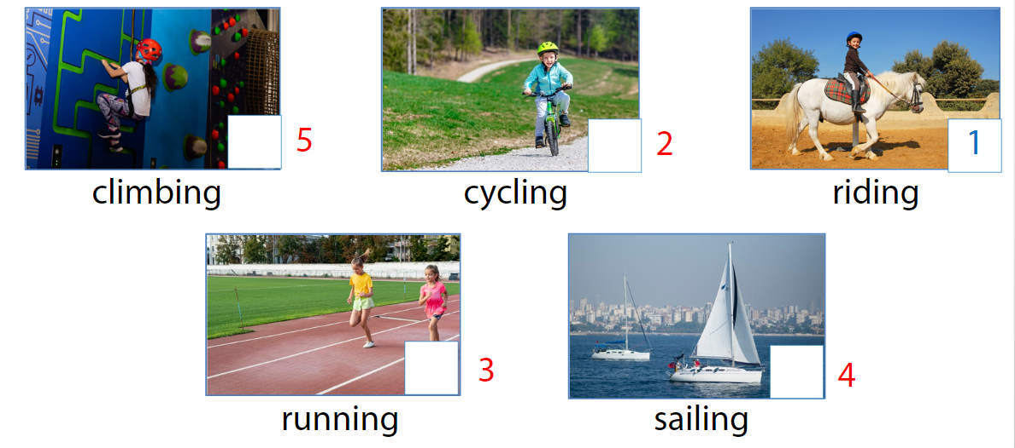
Question 2: (1pt)
1. T 2.T 3. F 4. F
Question 3: (1pt)
1. b 2. a 3. a 4. a
PART III : Reading and writing
Question 4: (1.25pt)
1b 2. c 3.d 4. a 5. b
Question 5: (1.25pt)
1.b 2.b 3. c 4. b 5.b
Question 6: (1.25pt)
1. a 2. c 3. a 4. b 5.b
Question 7: (1pt)
1. b 2. c 3. a 4. d
Question 8: (1.25 pt)
- A , 2- B , 3-C , 4- A , 5 - C
Question 9: (1pt)
- Advert
- Director
- Make up
- Cartoon

