UBND HUYỆN VĨNH BẢO  TRƯỜNG TH VĨNH AN | ĐỀ KHẢO SÁT CHẤT LƯỢNG HỌC KỲ II  TIẾNG ANH LỚP 5  NĂM HỌC 2024 - 2025  (Thời gian làm bài: 40 phút)
PART I. LISTENING
Question 1. Listen and number (1pt)
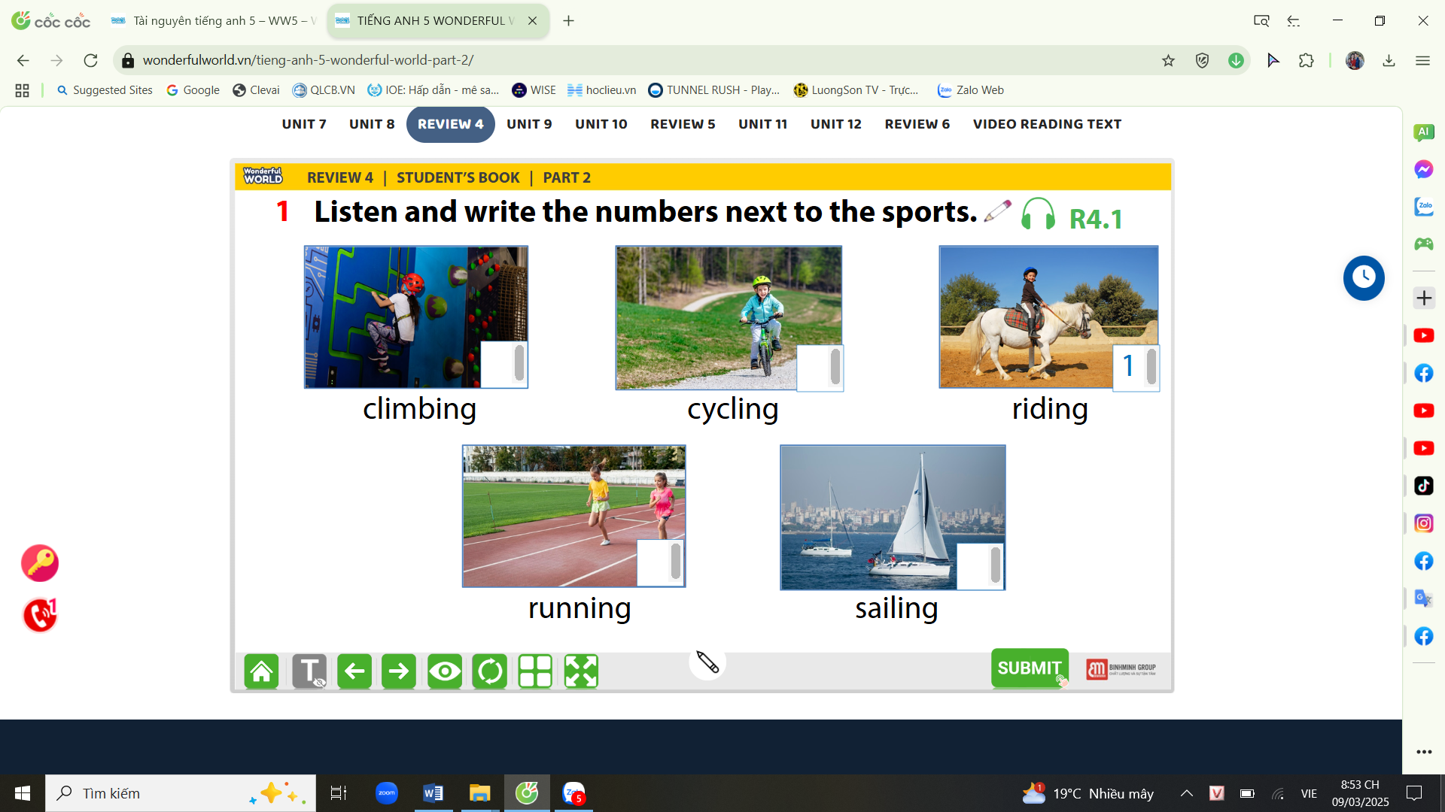
Question 2. Listen and tick True (T) or False (F) (1pt)
T | 1. Barcelona is the large city in Spain
 | 2. La Rambla is a small street in Barcelona’s city centre.
 | 3. In La Rambla, you can go shopping or have a snack in a café
 | 4. The Sagrada Familia is a large church in Barcelona.
 | 5. Every year, 2 million people visit this church
Question 3. Listen and circle the correct answers (1pt)
1. Which animal is she talking about?
a. lion b. crocodile c. bear d. tiger
2. How long are crocodiles?
a. 6 metres b. 5 metres c. 7 metres d. 8 metres
3. What do crocodiles eat?
a. vegetables b. animals c. leaves d. sausages
4. Where do they live? - They live in the _____________
a. sea b. house c. field d. forest
Part II: Pronunciation
Question 4:Circle the word which has pronounced differently.(1,5pts)
1. a. touched | b. watched | c. played | d. walked
2. a. waited | b. needed | c. wanted | d. travelled
3. a. asked | b. pointed | c. jumped | d. stopped
4. a. worked | b. listened | c. liked | d. danced
5. a. cycled | b. climbed | c. visited | d. loved
PART III. READING AND WRITING
Question 5. Read and choose the best answer (1.5pts)
1. He __________at the moment.
a. running b. is running c. runs d. is runing
2. Children shouldn’t _______________________ swim in the river without their parents.
a. go b. going c. goes d. went
3. Mary ______________________the film, but she _____________ the play.
a. see/ didn’t see b. saw/ didn’t see c. saw/ didn’t saw d. saw/see
4. Did Stella______________________ a lot of vegetables?
a. buy b. bought c. buys d. buyed
5. A basketball player____________________ prastice everyday and ______________eat junk food.
a. must/ must b. mustn’t/ must c. must/ mustn’t d. mustn’t/ mustn’t
Question 6: Read and choose the best answer
Janine : Hey, Kevin! My family and I are going on a hike this weekend. We are going geocaching. Want to come with us?
Kevin: What's Geocaching?
Janine : It’s like a treasure hunt. We use a special app on our phones and GPS to find hidden treasure boxes.
Kevin: That sounds exciting! I love treasure hunts!
Janine : Well, it’s not real treasure, just a box with a notebook and some objects. We can take something and leave a toy for the next person. We’ll also write our names in the notebook.
Kevin: Are there Geocaches nearby?
Janine : Yes, they’re everywhere! The app shows nine hide and geocaches in the forest near our house.
Kevin : Great! I'm in! What time should I be ready?
Janine : We’ll leave at 8:30 AM.
Kevin : Will it rain? Will we need to bring umbrellas and raincoats?
Janine : It won't rain so we don't need those.
1. What are Janine’s family going to do this weekend?
a. going geocaching b. going on a hike c. going on a picnic d. going jogging
2. What do they use to find hidden treasure boxes?
a. special app b. GPS c. special app and GPS d. phone
3. What are there in the box?
a. a notebook b. some objects c. a treasure d. all A and B
4. Is there a real treasure?
a. Yes, there is b. No, there isn’t c. It’s everywhere d. Yes, it is
5. What time will we leave?
a. at eight fifty b. at a quarter past eight c. at half past eight d. at thirty eight
Question 7: Find and circle the mistakes. (1pt)
1. Did you watched the film with your friends last night?
A B C D
2. Melina and I bought some burgers, but we didn’t bought any chips.
A B C D
3. My mother learned to play the piano when she is a child
A B C D
4. Walt Disney was a creative man, He could draw very good.
A B C D
Question 8. Arrange the words to make the meaningful sentences (1pt)
1. elephant / than / An / stronger / rabbit / is / a
a. A rabbit is stronger than an elephant. b. An elephant is stronger than a rabbit
c. An elephant is than stronger a rabbit. d. A rabbit than stronger an elephant.
2. runs / My / everyday / keep / father / healthy / to.
a. My father runs everyday to keep healthy. b. My father runs healthy to keep everyday.
c. My father keep to run healthy everyday. d. My father keep to run healthy every day.
3. really / cat / She / her / love.
a. She really her loves cat b. She really loves her cat
c. She love really her cat d. She loves really her cat
4. is/ a / really / It / film / watch / interesting.
a. It is a interesting really film to watch b. It is a really film interesting to watch
c. It is a really interesting film to watch d. It really is a interesting film to watch
5. Snakes / longer / worms / are / than
a. Snakes are longer than worms b. Snakes longer are than worms
c. Worms are longer than snakes d. Worms longer than are snakes
Question 9: Look at the pictures and write the words
 |  |  | 

ĐÁP ÁN
UBND HUYỆN VĨNH BẢO  TRƯỜNG TIỂU HỌC VĨNH AN  (Đề đề xuất) | ĐỀ KHẢO SÁT CHẤT LƯỢNG HỌC KÌ II  MÔN TIẾNG ANH LỚP 5  NĂM HỌC 2024 - 2025  (Thời gian làm bài : 40 phút)
PART I : Listening
Question 1: (1pt)
4 câu x 0,25 = 1đ
5-2-1-3-4
Question 2: (1pt)
4 câu x 0,25 = 1đ
1.T 2.F 3. T 4. T 5.F
Question 3: (1pt)
4 câu x 0,25 = 1đ
1. b 2. a 3. b 4. a
Part II: Pronunciation
Question 4: (1,25pt)
5 câu x 0,25 = 1,25đ
1c 2.d 3.b 4. b 5. c
PART III : Reading and writing
Question 5: (1,25pt)
5 câu x 0,25 = 1,25đ
1.b 2.a 3. b 4. a 5. c
Question 6: (1,25pts)
- câu x 0,25 = 1,25đ
1. b 2. c 3. d 4. b 5. c
Question 7: (1pt)
4 câu x 0,25 = 1đ
1. b 2. c 3. d 4. d
Question 8: (1,25 pt)
5 câu x 0,25 = 1,25đ
1 b 2 a 3 b 4 c 5 a
Question 9: Arrange the words to make sentenmces (1,5pt)
4 câu x 0,25 = 1đ
1. autograph 2. award 3. adventure 4. director

