ANH 5- CỘNG HIỀN
Part 1 : Listening.
Question 1 : Listen and number.
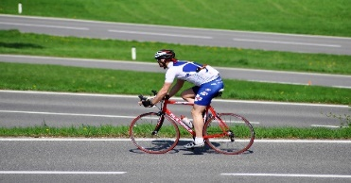 | 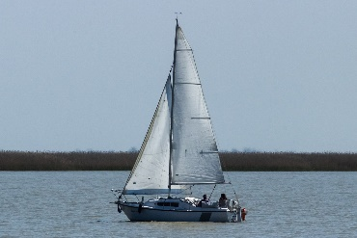 | 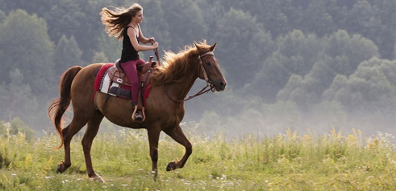 | 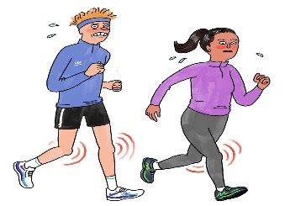
Question 2 : Listen and write True (T) or False ( F)
1. Barcelona is a small city in Spain
2. La Rambla is a large street in Barcelona’s city centre.
3. The Sagrada Familia is a large church in Barcelona.
4. Every year 2 million people visit this church.
Question 3 : Listen and cỉrcle the correct answers.
1. Which animal is she talking about : a. lion b. crocodile c. elephant
2. How long are crocodiles ? a. 7 metres b. 8 metres c. 6 metres
3. What do crocodiles eat ? a. animals b. leaves c. branches
4. How long do they usually live ? a. 90 years b. 80 years c. 60 years
Part II. Pronuciation.
Question 4. Circle the odd one out.
1. | a. needed | b. wanted | c. worked | d. visited
2. | a. touched | b. stopped | c. jumped | d. pointed
3. | a. liked | b. played | c. travelled | d. stayed
4. | a. touched | b. asked | c. laughed | d. learned
5. | a. looked | b. danced | c. needed | d. talked
Part III. Reading and writing
Question 5. Choose the best answer.
1. Mary …………. to the amusement park last weekend.
A. go B. went C. didn’t went D. did go
2. Did your mother buy a new shirt yesterday ?
A. Yes, he did B. No, she did C. Yes, my mother did D. No, she didn’t
3. They watch cortoons ……………………..
A. twice a week B. one a day C. lastnight D. two a week
4. John is…………… a horse at the moment.
A. running B. riding C. walking D. going
5. When did you see that film ? A. two years ago B. It’s interesting
C. It’s a comedy D. in the cinema
Question 6. Read the passage and circle the correct answer
One day last year, a tornado destroyed my house. There was a strong wind so I looked outside and I saw a very scary thing.” Mum !” I shouted. “ There’s a tornado and and It’s coming towards us”. We hid in the bathroom. Suddenly, the tornado lifted a house off the ground. It threw it into a field near our house. We then ran to our car and Dad drove away fast! It was very dangerous but we were all ok in the end.
1. What destroyed his house last year ?
A. flood B. storm C. tornado D. wind
2. Where did his family hide first ?
A. In his bedroom B. In a car C. In a field D. In the bathroom
3. Dis the wind lift a house off the ground ?
A. No, it didn’t B. Yes, it did C. No, she didn’t D. Yes, he did
4. Was the tornado strong ? A. Yes. It was very dangerous B.No, it wasn’t
C. No. It was very strong D. Yes, he was
5. How were all the people in his family ?
A. They are Ok B. He was Ok C. They were Ok D. They weren’t Ok
Question 7 : Find and circle the mistakes
1. Lastnight, I go to the cinema with my family
A B C D
2. My uncle’s family travelled to Thailand by plane every year
A B C D
3. What is the inventor of the plane ?
A B C D
4. There are no locks on the bank when we came to this village.
A B C D
Question 8. Arrange the words to make sentences.
1. snakes / than / are / worns / longer
a. Worms are longer than snakes. b. Snacks are longer than worms c. Snacks are than longer worms
2. to the beach / to swim / They / often / go
a. They go often to swim to the beach. b. They often go to swim to the beach.
c. They often go to the beach to swim.
3. some / bought / a / eggs / to make / cake / He / birthday
a. He bought some eggs to make a birthday cake. b. He bought some eggs to make a cake birthday.\
c. He bought a birthday cake to make some eggs.
4. really / her / She / cat / loves
a. She really loves her cat b. She loves her cat really. c. She loves really her cat.
5. dog / really / my / smart / is
a. My dog is smart really. b. My dog really is smart c. My dog is really smart.
Question 9. Look at the picture and write the words.
 |  |  | 
1. …………………….. 2. ………………. 3. …………………….. 4. ………………….

Answer keys
Part I. Listening
Question 1 : Listen and number : 4 câu x 0,25 = 1 đ
2 – 4 – 1 – 3
Question 2 : Listen and write True (T) or False ( F) : 4 câu x 0,25 = 1 đ
1 – F 2 – F 3 – T 4 – F
Question 3 : Listen and cỉrcle the correct answers. : 4 câu x 0,25 = 1 đ
1. b 2 – c 3 – a 4 - c
Part II. Pronuciation.
Question 4. Circle the odd one out : 4 câu x 0,25 = 1,25 đ
1 – c 2 – d 3 – a 4 – d 5 – c
Part III. Reading and writing
Question 5. Choose the best answer. : 5 câu x 0,25 = 1,25 đ
1- B 2 – D 3 – A 4 – B 5 – A
Question 6. Read the passage and circle the correct answer : 5 câu x 0,25 = 1,25 đ
1 – C 2 – D 3 – B 4 – A 5 – A
Question 7 : Find and circle the mistakes : 4 câu x 0,25 = 1 đ
1 – B 2 – B 3 – A 4 - A
Question 8. Arrange the words to make sentences.5 câu x 0,25 = 1,25 đ
1. Snakes are longer than worns
2. They often go to the beach to swim
3. He bought some eggs to make a birthday cake
4. She really loves her cat.
5, My dog is really smart.
Question 9. Look at the picture and write the words: 4 caau x 0,25 = 1 đ
1. cartoon 2. award 3. film studio 4. science fiction

