UBND HUYỆN VĨNH BẢO  TRƯỜNG TH LIÊN AM – LÝ HỌC | ĐỀ KHẢO SÁT CHẤT LƯỢNG HỌC KỲ II  MÔN TIẾNG ANH LỚP 5  NĂM HỌC 2024 - 2025  (Thời gian làm bài: 40 phút)
PART I: LISTENING
Question 1. Listen and number (1pt)
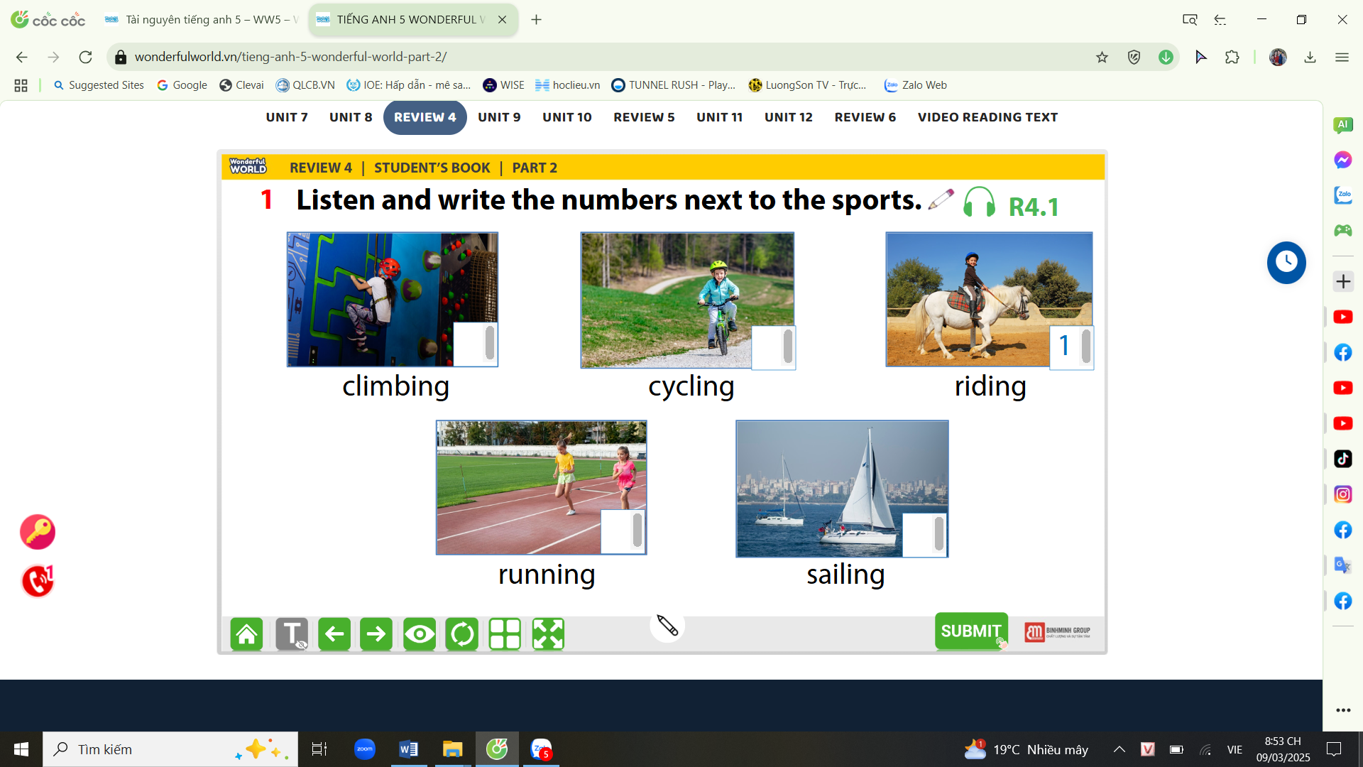 |  | 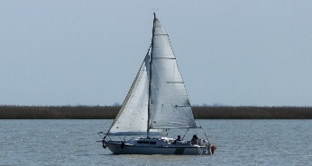 | 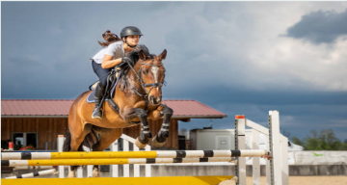
a. | b. | c. | d.
Question 2. Listen and write T for True or F for False (1pt)
1. Last Sunday, my family slept in a hotel.
2. Mary went shopping with her mother last weekend.
3. Tom bought a pizza from Little Italy restaurant last night.
4. When I was a child, my mum tell me many bedtime stories.
Question 3. Listen and circle the correct answers(1pt)
1. Which animal is she talking about?
a. | b. | c.
2. How long are crocodiles?
a. 6 metres | b. 7 metres | c. 8 metres
3. What do crocodiles eat?
a. | b. | c.
4. Where do they live?
a. | b. | c.
PART II: PRONUNCIATION
Question 4. Circle the odd one out(1,25pt)
1 | a. visited | b. looked | c. liked | d. watched
2 | a. wanted | b. started | c. talked | d. needed
3 | a. stopped | b. walked | c. worked | d. waited
4 | a. touched | b. pointed | c. asked | d. jumped
5 | a. walked | b. needed | c. looked | d. worked
PART III: READING AND WRITING
Question 5. Choose the best answer (1,25pt)
1. | 1. People should ………….. exercise everyday.
 | a. do | b. doing | c. did | d. to do
2. | Nam and Phong are ……….. football at the moment.
 | a. play | b. playing | c. to play | d. plays
3. | She …………… go to the cinema …………. her friend last night.
 | a. did/ about | b. didn’t/ on | c. didn’t / with | d. do / at
4. | We saw a concert on TV, but we ……………. a film.
 | a. don’t see | b. doesn’t see | c. to see | d. didn’t see
5. | We ………… fall asleep ………… school
 | a. must/on | b. mustn’t /at | c. mustn’t /with | d. must / under
Question 6: Read the passage and circle the correct answer (1,25pt)
Deep underground, there is a special heat: geothermal energy( geo means “earth” and thermal means “ heat” in Greek). We need energy to light our homes and cook. The sun and wind provide clean energy, but geothermal energy can help people even more.
The Boiling River, deep in the Amazon rainforest, has very hot water ( up to 99⁰C). This water is dangerous for animals. Scientists are studying the river to understand geothermal energy better. They also protect other parts of the Amazon. They don’t want people to cut down trees and destroy the rainforest. We hope that people will save the environment and save geothermal energy.
1. What does the word “geo” mean?
a. earth b. land c. moon d. mar
2. What does the word “ thermal” mean
a. air b. fire c. water d. heat
3. Where is the Boiling River?
a. in the Red River b. in the Nile River c. in the Amazon rainforest d. in the highlands
4. Is this water dangerous for animals?
a. No, it is b. Yes, it is c. No, it isn’t d. Yes, it does
5. Scientists hope that people will .................. the environment and save geothermal energy.
a. saving b. saved c. saves d. save
Question 7: Find and circle the mistakes. (1pt)
1. My family don’t watched an interesting TV show last night.
A B C D
2. Mai not did go to the cinema with her friends yesterday.
A B C D
3. He play chess with his father at home last night .
A B C D
4. Did you going to Ha Noi by train last Sunday?
A B C D
Question 8. Arrange the words to make sentences (1,25 pt)
1. to / the zoo / They / see / went / to / animals / last week/.
a. They went to the zoo to see animals last week.  c. They went to the zoo see to animals last week | b. They went to see the animals to zoo last week  d. last week They went to the zoo see to animals
2. elephant / stronger / An / is / a / than / rabbit/.
a. A rabbit is than stronger an elephant.  c. An elephant is than stronger a rabbit. | b. A rabbit is stronger than an elephant.  d. An elephant is stronger than a rabbit.
3. animal / is / a / shark / Which / stronger, / or / a butterfly ?/
a. Which animal is a shark stronger, or a butterfly?  c. Which is animal a shark stronger, or a butterfly? | b. Which animal is stronger, a shark or a butterfly?  d. Which is a shark stronger animal, or a butterfly?
4. don’t / to have / I / really / a pet / want /.
a. I really don’t want to have a pet.  c. I don’t really want to have a pet. | b. I don’t want to really have a pet.  d. I don’t really have want to want a pet.
5. plays / after school / She / to / piano / relax / the /
a. She plays the piano to relax after school.  b. She plays to relax the piano after school. | c. She relax to plays the piano after school.  d. She plays the piano after school to relax.
Question 9. Look at the picture and write the words(1pt)
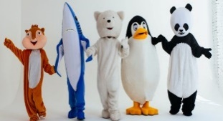 | 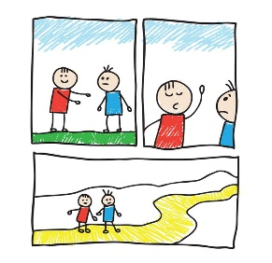 | 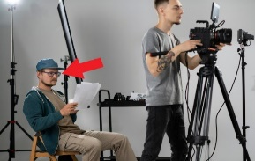 | 
1. | 2. | 3. | 4.

ĐÁP ÁN LỚP 5
PART I: LISTENING
Question 1. Listen and number (1pt)
 |  | 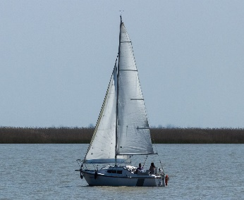 | 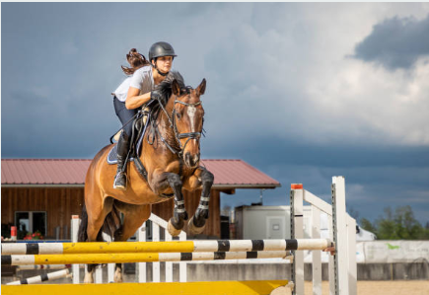
a.  3 | b.  2 | c.  4 | d.  1
Question 2. Listen and write T for True or F for False (1pt)
1. Last Sunday, my family slept in a hotel. | F
2. Mary went shopping with her mother last weekend. | T
3. Tom bought a pizza from Little Italy restaurant last night. | T
4. When I was a child, my mum tell me many bedtime stories. | F
Question 3. Listen and circle the correct answers(1pt)
1. Which animal is she talking about?
a. | b. | (c.)
2. How long are crocodiles?
(a.) 6 metres | b. 7 metres | c. 8 metres
3. What do crocodiles eat?
(a.) | b. | c.
4. Where do they live?
a. | (b.) | c.

PART II: PRONUNCIATION
Question 4. Circle the odd one out(1,25pt)
1 | (a). visited | b. looked | c. liked | d. watched
2 | a. wanted | b. started | (c). talked | d. needed
3 | a. stopped | b. walked | c. worked | (D). waited
4 | a. touched | (b). pointed | c. asked | d. jumped
5 | a. walked | (b). needed | c. looked | d. worked
PART III: READING AND WRITING
Question 5. Choose the best answer (1,25pt)
1. | 1. People should ………….. exercise everyday.
 | a. do | b. doing | c. did | d. to do
2. | Nam and Phong are ……….. football at the moment.
 | a. play | b. playing | c. to play | d. plays
3. | She …………… go to the cinema …………. her friend last night.
 | a. did/ about | b. didn’t/ on | c. didn’t / with | d. do / at
4. | We saw a concert on TV, but we ……………. a film.
 | a. don’t see | b. doesn’t see | c. do not see | d. didn’t see
5. | We ………… fall asleep ………… school
 | a. must/on | b. mustn’t / at | c. mustn’t /with | d. must / under
Question 6: Read the passage and circle the correct answer (1,25pt)
1. What does the word “geo” mean?
(a). earth b. land c. moon d. mar
2. What does the word “ thermal” mean
a. air b. fire water c. water (d). heat
3. Where is the Boiling River?
a. in the Red River b. in the Nile River (c). in the Amazon rainforest d. in the highlands
4. Is this water dangerous for animals?
a. No, it is (b). Yes, it is c. No, it isn’t d. Yes, it does
5. Scientists hope that people will .................. the environment and save geothermal energy.
a. saving b. saved c. saves (d). save
Question 7: Find and circle the mistakes. (1pt)
1. My family don’t watched an interesting TV show last night.
A (B) C D
2. Mai not did go to the cinema with her friends yesterday.
A (B) C D
3. He play chess with his father at home last night ?
(A) B C D
4. Did you going to HaNoi by train last Sunday?
A (B ) C D
Question 8. Arrange the words to make sentences (1,25 pt)
1. to / the zoo / They / see / went / to / animals / last week/.
(a). They went to the zoo to see animals last week.
2. elephant / stronger / An / is / a / than / rabbit/.
(d). An elephant is stronger than a rabbit.
3. animal / is / a / shark / Which / stronger, / or / a butterfly ?/
(b). Which animal is stronger, a shark or a butterfly?
4. don’t / to have / I / really / a pet / want /.
(c). I don’t really want to have a pet.
5. plays / after school / She / to / piano / relax / the /
(a). She plays the piano to relax after school.
Question 9. Look at the picture and write the words(1pt)
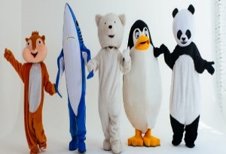 |  | 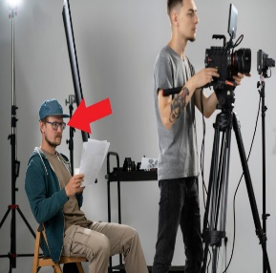 | 
1. character | 2. cartoon | 3. director | 4. advert

