PART I. LISTENING
Question 1. Listen and number (1pt)
 |  |  | 

Question 2. Listen and tick (1pt)

1. |  | A. I’m swimming in the pool. | 2. |  | A. She’s jumping at the playground.
1. |  | B. I’m reading in the library. | 2. |  | B. He’s jumping at the playground.
3. |  | A. I go to the park with my friends. | 4. |  | A. I go to school with my friends.
3. |  | B. I go to school with my friends. | 4. |  | B. I have dinner with my family.
Question 3. Listen and circle the correct pictures (1pt)
1 | 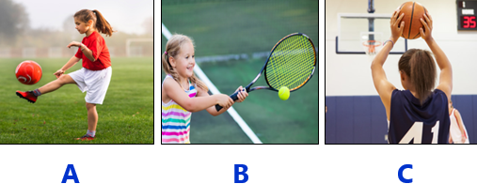
2 | 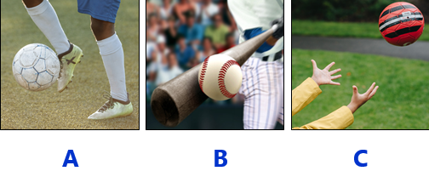
3 | 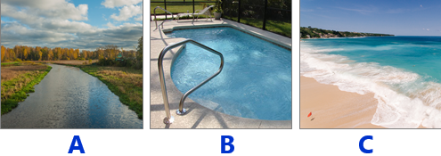
4 | 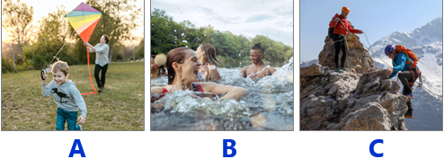
Part II: READING
Question 4: Odd one out.(1,25pts)
1. a. cook | b. read | c. swim | d. pool
2. a. play the drums | b. play football | c. play the guitar | d. play the piano
3. a. cold | b. rainy | c. summer | d. sunny
4. a. summer | b. spring | c. autumn | d. rainy
5. a. buy | b. dance | c. guitar | d. sing
Question 5. Choose the best answer (1.25pts)
1. He …………………… at the playground.
a. running b. is running c. jumping d. is runing
2. ________ I jump in the museum? – No, you can’t.
a. May b. Can c. Could d. Should
3. There are ……………. bananas.
a. lot of b. a c. much d. a lot of
4. Let’s go to the museum and __________ the paintings there.
a. buy b. see c. draw d. look
5. There is some ________.
a. rice b. Apple c. bananas d. pear
Question 6: Match A with B
- I go to | - dry and sunny. | 1-
- In summer, it’s | - rocks with his dad. | 2
- He climbs | - breakfast with her family. | 3-
- How do | - the park with my friends. | 4-
- She has | - you go to the museum? | 5-
Question 7: Read and choose the best answer
Kate: Hi, Toom.
Tom: Hi, Kate. What are you doing?
Kate: I’m buying a teddy bear at the toy shop. There are nice teddy bears here.
Tom: Cool!
Kate: And you?
Tom: I’m in the park. We’ve got a new bike. My brother is riding it. It’s fun!
- Is Kate at the toy shop?
a. Yes, she is b. Yes, she are c. No, she is d. No, she in’t
- What’s she doing?
a. She is buying a bike. b. He is buying a teddy bear.
c. She is buying a teddy bear. d. She is riding a bike.
- What is Tom’s brother doing?
a. He is buying a tedddy bear. b. He’s riding a bike.
c. He’s buying a new bike. d. He is going to the toy shop.
- Is Tom at the toy shop, too?
a. Yes, he is b. No, he isn’t c. No, he is d. Yes, it is
Question 8. Arrange the words to make the meaningful sentences (1pt)
1.Let’s / at / have / playground / the / fun/.  - Let’s have playground at the fun.  - Let’s have fun at the playground.  - Let’s at the playground have fun. | 2.watching / the / on / TV / is / My father / match/.  a.My father is on TV watching the match.  b.My father watching the match is on TV.  c.My father is watching the match on TV.
3.My sister / English / at / isn’t / learning / school/.  a.My sister isn’t learning at school English.  b.My sister isn’t learning English at school.  c.My sister isn’t at English learning school. | 4.go / Let’t / to / zoo / the.  - Let’s go to the zoo.  - Let’s the go to zoo.  - Let’s zoo go to the.
5.You / play, / and / can / run / climb / here.
- You can here and play, run climb.
- You can play, here run and climb.
- You can play, run and climb here.
Question 9: Look at the pictures and write the words
 |  |  | 
.............................. | .......................................... | ....................................... | ..........................................

UBND HUYỆN VĨNH BẢO  TRƯỜNG TH VĨNH AN | ĐỀ KHẢO SÁT CHẤT LƯỢNG HỌC KỲ II  TIẾNG ANH LỚP 3  NĂM HỌC 2024 - 2025  (Thời gian làm bài: 40 phút)
PART I. LISTENING
Question 1. Listen and number (1pt)
3
2
4
1

Question 2. Listen and tick (1pt)

1. | x | A. I’m swimming in the pool. | 2. | x | A. She’s jumping at the playground.
1. |  | B. I’m reading in the library. | 2. |  | B. He’s jumping at the playground.
3. |  | A. I go to the park with my friends. | 4. |  | A. I go to school with my friends.
3. | x | B. I go to school with my friends. | 4. | x | B. I have dinner with my family.
Question 3. Listen and circle the correct pictures (1pt)
1 | B
2 | A
3 | B
4 | C

Part II: READING
Question 4: Odd one out.(1,25pts)
1. a. cook | b. read | c. swim | d. pool
2. a. play the drums | b. play football | c. play the guitar | d. play the piano
3. a. cold | b. rainy | c. summer | d. sunny
4. a. summer | b. spring | c. autumn | d. rainy
5. a. buy | b. dance | c. giutar | d. sing
Question 5. Choose the best answer (1.25pts)
1. He _____________ at the playground.
a. running b. is running c. jumping d. is runing
2. ________ I jump in the museum? – No, you can’t.
a. May b. Can c. Could d. Should
3. There are __________ bananas.
a. lot of b. a c. much d. a lot of
4. Let’s go to the museum and __________ the paintings there.
a. buy b. see c. draw d. look
5. There is some ________.
a. rice b. Apple c. bananas d. pear
Question 6: Match A with B
- I go to | - dry and sunny. | - D
- In summer, it’s | - rocks with his dad. | - A
- He climbs | - breakfast with her family. | - B
- How do | - the park with my friends. | - E
- She has | - you go to the museum? | - C
Question 7: Read and choose the best answer
Kate: Hi, Toom.
Tom: Hi, Kate. What are you doing?
Kate: I’m buying a teddy bear at the toy shop. There are nice teddy bears here.
Tom: Cool!
Kate: And you?
Tom: I’m in the park. We’ve got a new bike. My brother is riding it. It’s fun!
- Is Kate at the toy shop?
a. Yes, she is b. Yes, she are
c. No, she is d. No, she in’t
- What’s she doing?
a. She is buying a bike. b. He is buying a teddy bear.
c. She is buying a teddy bear. d. She is riding a bike.
- What is Tom’s broter doing?
a. He is buying a tedddy bear. b. He’s riding a bike.
c. He’s buying a new bike. d. He is going to the toy shop.
- Is Tom at the toy shop, too?
a. Yes, he is b. No, he isn’t
c. No, he is d. Yes, it is
Question 8. Arrange the words to make the meaningful sentences (1pt)
- Let’s / at / have / playground / the / fun/.
- Let’s have playground at the fun.
- Let’s have fun at the playground.
- Let’s at the playground have fun.
- watching / the / on / TV / is / My father / match/.
- My father is on TV watching the match.
- My father watching the match is on TV.
- My father is watching the match on TV.
- My sister / English / at / isn’t / learning / school/.
- My sister isn’t learning at school English.
- My sister isn’t learning English at school.
- My sister isn’t at English learning school.
- go / Let’t / to / zoo / the.
- Let’s go to the zoo.
- Let’s the go to zoo.
- Let’s zoo go to the.
- You / play, / and / can / run / climb / here.
a.You can here and play, run climb.
- You can play, here run and climb.
- You can play, run and climb here.
Question 9: Look at the pictures and write the words
......basketball............. | ...........football.............. | ...........hockey................. | .............catching.................

