PART I. LISTENING
Question 1. Listen and number (1pt)
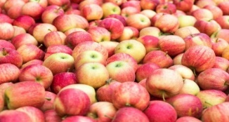 |  |  | 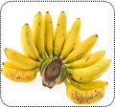

Question 2. Listen and tick (1pt)
1. |  | A. I’m swimming in the pool. | 2. |  | A. She’s jumping at the playground.
1. |  | B. I’m running in the park. | 2. |  | B. He’s jumping at the playground.
3. |  | A. I go to school on Mondays. | 4. |  | A. I swim in the pool on Saturdays.
3. |  | B. I go to school on Sundays. | 4. |  | B. I go to the park on Sundays
Question 3. Listen and circle the correct pictures (1pt) 7=10
1 | 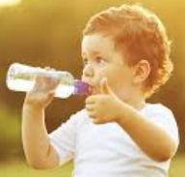  A |   B |   C
2 | 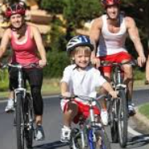  A | 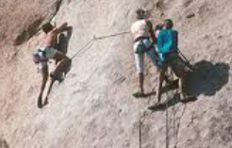  B | 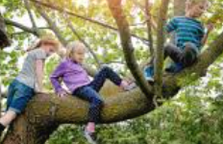  C
3 | 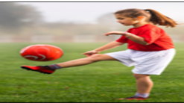  A |   B |   C
4 |   A |   B |   C
Part II: READING
Question 4: Odd one out.(1,25pts)
1. a. cook | b. sing | c. swim | d. summer
2. a. Speak English | b. rock | c. play the guitar | d. play the drums
3. a. cold | b. rainy | c. winter | d. sunny
4. a. summer | b. hot | c. autumn | d. spring
5. a. drums | b. play | c. colour | d. paint
Question 5. Choose the best answer (1.25pts)
1. He ….........................at the playground.
a. running b. is running c. swimming d. is runing
2. ........................... I jump in the museum? – No, you can’t.
a. Are b. Can c. Is d. May
3. There are …............. bananas.
a. a lot of b. a c. an d. lot of
4. Let’s go to the ….............................and ride a bike there.
a. toy shop b. park c. pool d. zoo
5. Where is the apple? 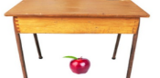
- It’s ….......................... the table.
a. in b. on c. under d. at
Question 6: Match A with B
- I climb | - cold and wet. | 1-
- In winter, it’s | - big rocks with my friends | 2-
- I go to | - dinner with her family. | 3-
- How do | - the sea in summer. | 4-
- He has | - you go to the park? | 5-
Question 7: Read and choose the best answer
I’m Tania, I’m from Thessaloniki, Greece. There’re nice parks and markets. There’s a cool toy shop. There’s a big pool. My favourite part of my town is the playground. My friends and I can run, jump and play at the playground.
- In Thessaloniki, there are nice ….......................... and ________ .
- playgrounds and pools | - parks and pools
- parks and markets | - toy shops and parks
- There is a cool __________________ .
- market | - toy shop
- park | - zoo
- There is a big ______________ .
- pool | - market
- playground | - park
- Her favourite part of town is the __________
- swimming pool | - market
- playground | - park
- Tania and her friends can run, .......................and play at the playground.
- do | - jump
- dance | - swim
Question 8. Arrange the words to make the meaningful sentences (1pt)
- grandpa /a /reading/ is/ My/ book/.
- My grandpa reading is a book.
- My is grandpa reading a book.
- My grandpa is reading a book
- Playing/ video / Nhi / with / is / games/ brother/ her/ .
- Nhi is playing with brother her video games
- Nhi is playing video games with her brother
- Nhi is playing with her brother video games
- am/ watching/ match/ I/ on/ the/ TV/.
- I am watching the match on TV
- I am watching match the on TV
- I am watching match on the TV
- can/ apples/ here/ and/ pears/ You/ buy/.
- You can buy here apples and pears.
- You can here apples and pears here.
- You can buy apples and pears here.
- have/ at / Let’s / the/ fun/ zoo/.
- Let’s have at the fun zoo.
- Let’s have fun at the zoo.
- Let’s have at the fun zoo.
Question 9: Look at the pictures and write the words
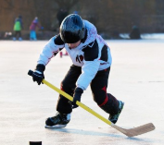 |  |   
      

