Part I. Listening
Question 1. Listen and number(1pt)
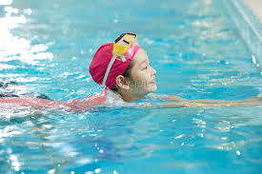

Question 2. Listen and tick the correct sentences(1pt)
1, a. I go to school by bus with my friends.
b. I go to school by bike with my friends.
2, a, We go to the park by train on Sundays.
b. We go to the park by motorbike on Sundays.
3, a, I go to the theatre by bus on Saturdays.
b. I go to the theatre by train on Saturdays.
4, a. I go to the market with my mum by motorbike.
b, I go to the market with my mum by bike.
Question 3. Listen and circle the correct pictures(1pt)
1.   2.  
A B A B
3,  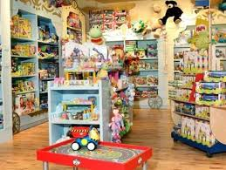 4, 
A B A B
Part II. Reading and Writing
Question 4 Odd one out(1,25pt)
1, a, piano b, cook c, swim d, paint
2, a, sing b, dance c, read d, winter
3, a, write b, speak c, hobby d, buy
4, a, river b, climb c, tree d, rock
5, a, summer b, sunny c, rainy d, cold
Question 5 Choose the best answer(1,25pt)
1.What is she doing?
a. He’s swim in the river b, She’s swimming in the pool c, I am going to the zoo.
2, May I come in ? Teacher.…………………………..
a, Yes, you can’t. b, Yes, you can. c, No, you can.
3, Let’s go to the ………and ride a bike there.
a.museum b. toy shop c. park
4, There are……………..
a.many pears b.some pears c.many pear
5, 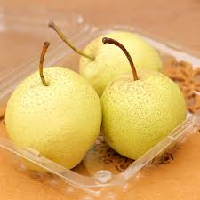Where are the pears?- They are………….the box.
a.in b.on c.under
Question 6 Read and match column A with B(1,25pt)
A B
1, Do you like winter? a, I have dinner with my family.
2, Who do you have dinner with? b, I go to the library by bike.
3, Do they play in the park in winter? c, I go with my mum and dad.
4, How do you go to the library? d, No, they don’t. It’s too cold!
5, Who do you go to the cinema with? e, Yes, I do.
1…………. 2………… 3……………… 4………… 5……………
Question 7 Read the text and circle the correct answer(1pt)
Hello, My name is Kate. I’m buying a teddy bear at the toy shop. There are nice teddy bears here. This is my brother, Tom. He has got new bike. He is riding his bike in the park. I have fun.
1, What is his brother’s name?
a. My name is Kate. b, I am Tom. c, He is Tom.
2, What is Kate doing?
a. She is buying a teddy bear at the toy shop. b. She is buying a doll at the toy shop.
c. She is buying a new bike.
3, What is Tom doing?
a. He has got new bike. b. He is riding his bike in the park. c. He is riding my bike in the park.
4, Where is Kate?
a. She is in the park. b. She is at the toy shop. c. She is at home.
Question 8 Arrange the words to make sentences(1,25pt)
1.sweets/How many/there/are?
a. How many sweets are there? b, How many are sweets there? c, How many are there sweets?
2, tomatoes/are/there/some.
a. Tomatoes are some there. b, There some are tomatoes. c. There are some tomatoes.
3, can/I/play/sing/and/the guitar.
a. I can sing play and the guitar. b. I can play the guitar and sing c. I can play the guitar and sing.
4, cooking/is/She/the kitchen/in.
a. She is cooking in the kitchen. b. She is cooking the in kitchen. c. She is in the cooking kitchen.
5, you/Are/flying/a kite?
a. Are flying you a kite? b. Are you a flying kite? c. Are you flying a kite?
Question 9 Look at the picture and write one word in the blank(1pt)    

1,………………. 2……………… 3……………… 4……………………

