PEOPLE’S COMMITTEE OF AN LAO DISTRICT THE SECOND SEMESTER TEST

TAN VIEN PRIMARY SCHOOL School year : 2024 - 2025
Subject: English 5 - Time: 35'
Name: ........................................................................................ Class: .........................

Skill | Listening | Reading | Writing | Speaking | Total
Mark
LISTENING
PART 1: Listen and number. There is one example.(1pt)
A   | B   | C  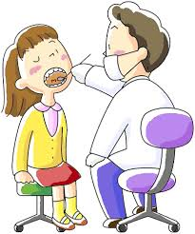 | D   | E  
0

PART 2:Listen and choose the correct answers. There is one example.(1pt)

0. | 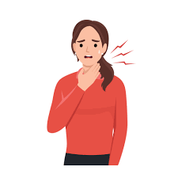 | 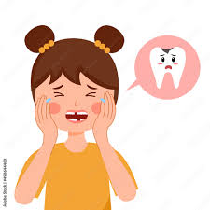 | 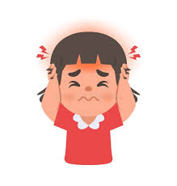
  A.
  B.
  C.
1. |  |  | 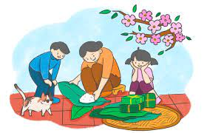
  A.
  B.
  C.
2. |  | 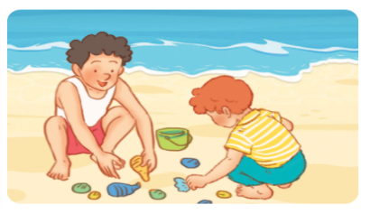 | 
  A.
  B.
  C.
3. | 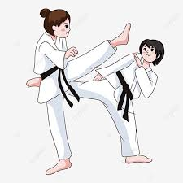 |  | 
  A.
  B.
  C.
4. | 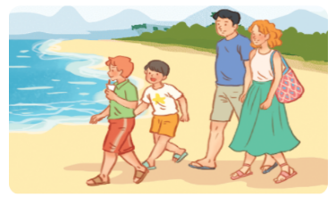 |  | 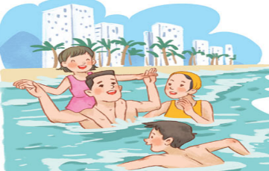
  A.
  B.
  C.
PART 3: Listen and decide True (T) or False (F). There is one example.(0,5 pts)
- David is going to visit Phong Nha Cave in Quang Binh this summer.
A. True B. False
1. What’s Tony doing? - He’s doing a project.
A. True B. False
2. I don’t want to visit the museum of history.
A. True B. False
3. What are you doing, Linh? – I’m decorating my house for Tet.
A. True B. False
4. How far is it from here to Da Nang? – It’s about ninety kilometres.
A. True B. False
READING
PART 1.Look at the pictures and match the correct answers. There is one example. (0.5 pts)
 |  | 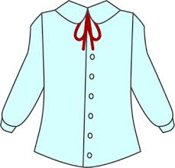 | 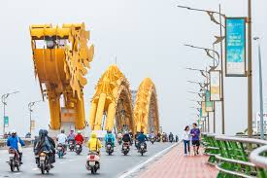 | 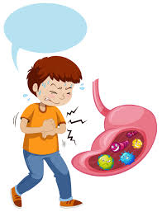
A | B | C | D | E
0.  healthy food | 1.  Dragon Bridge | 2.  peach blossoms | 3.  stomachache | 4.  blouse

PART 2. Read the questions and choose the correct answers. There is one example.
(1 pt)
0.Did you swim yesterday? | 0- c | a.Yes, I will.
1.When did you go to Tokyo? | 1__ | b.You can get there by motorbike.
2.Will you make springs rolls for Tet? | 2__ | c.Yes, I did.
3.How can I get to Thien Mu Pagoda? | 3__ | d.I think it’s exciting.
4.What do you think of Hoi An Old Town? | 4__ | e.We went there last summer.
PART 3 .Read and tick (√) True or False. There is one example .(1pt)
Hello, my name’s Mary. I and my family often stay healthy and like playing sports. We eat healthy food every day. We often drink lots of water, fresh juice and eat rice, vegetable, fish, meat, beef. We don’t eat unhealthy food and drink. We often get up early and never go to bed late. Every morning, I and my mother do exercise together. My father sometimes plays football, my mother always does yoga, my brother often plays badminton with me. Next week, my family will have a birthday party for my grandmother. We’ll have apple juice, milk, burger, chicken and pizza. We will also sing and dance together. we feel very happy.
 |  | TRUE | FALSE
0. | Mary and her family often stay healthy and like playing sports. | √
1. | They often get up early and sometimes go to bed late.
2. | Mary often plays badminton with her brother.
3 | Next week, Mary’s family will have a birthday party for her mother.
4 | They will also sing and dance together.
WRITING
PART 1.Look at the pictures and the letters. Write the words. There is one example (0.5 pts)

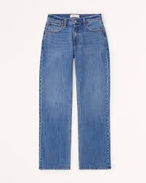 |  |  |  | 
0.sajen  Jeans | 1. ceuji  ______________ | 2. zazip  ______________ | 3. cheheada  ______________ | 4. rotyf  ______________

PART 2. Look and write. Use ONE word only for each gap. There is one example. (1pt)
(0) Example  0) I have a toothache.  - You should go to the dentist. | A
1. How often does she do yoga?  - Three ………… a week. | B 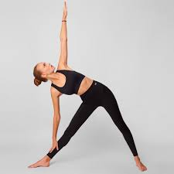 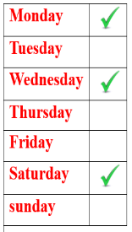
2. What food will you have at the party?  - We’ll have …………………....... | C 
3.How’s the………………...in London in winter?  -It’s snowy. | D 
4. Who are the main …………………in the story?  - They’re the fox and the crow. | E 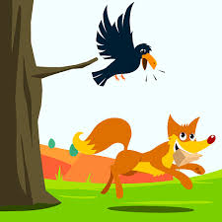
PART 3. Rearrange the words to make the complete sentences. There is one
example. (1pt)

(0). yesterday /Did /go /Ha Long /Bay /to / they/?

→ Did they go to Ha Long Bay yesterday?

1. will / fireworks /a/ We /show /watch/. /

………………………………………………………………………………………

2. flowers /give / They / teachers / will /for /their/./

………………………………………………………………………………………
3. often/ Tony /How/ lemonade /drink /does/?/

………………………………………………………………………………………

4. season /My /is /favourite /autumn /./

………………………………………………………………………………………

SPEAKING . (2.5 pts)

