PEOPLE’S COMMITTEE OF AN LAO DISTRICT THE SECOND SEMESTER TEST

TAN VIEN PRIMARY SCHOOL School year : 2024 - 2025
Subject: English 4 - Time: 35'
Name: ........................................................................................ Class: .........................

Skill: | Listening | Reading | Writing | Speaking | Total
Mark:

A- LISTENING (15 minutes)

PART 1: Question 1 – 4: Listen and tick. There is one example (1pt)

0. A  | B.  | C. 
1. A.  | B.  | C. 
2. A.  | B.  | C. 
3. A. 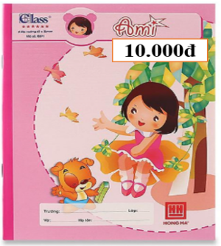 | B. 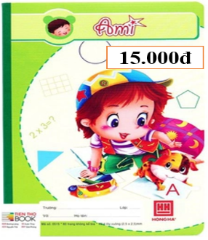 | C. 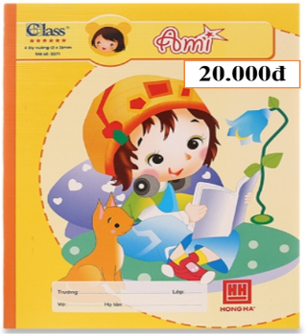
4. A.  | B.  | C. 

PART 2: Question 1 – 4: Listen and number. There is one example. (1 pt)
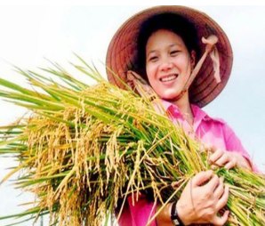  0 | 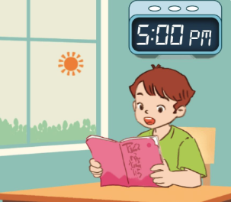  A. |   B. | 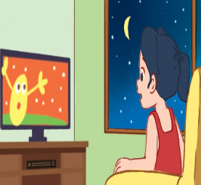  C. |   D.

PART 3: Question 1– 4: Listen and complete. There is one example. (1 pt)
- What does you mother do? – She’s a nurse.

1. What’s the street like? It’s a …………… street.

2. What does he do? He’s a ………………………

3. My brother is ……………………………..……

4. My father plays ………………… on Sundays.

B- READING (10 minutes)

PART 1: Question 1- 2: Look, read and circle the correct answer. There is one example. (0,5 pt)
0. A: Where do you live?  B: I live in ………...  a  a. London Road b. Green Road c. Le Loi Street | 
1. A: What do you do in the afternoon?  B: I wash the……..……….  a. clothes b. dishes c. watch TV | 
2. A: What does it say?  B: It says ‘…………………’  a. turn right b. turn left c.go straight | 
PART 2: Question 1- 4: Read and match. There is one example (1pt)
0. What’s the village like? |  | a. I listen to music.
1. What does your sister look like? |  | b. He works at the factory.
2. What do you do at noon? |  | c. It was sunny and windy.
3. What was the weather like yesterday? |  | d. It’s a quiet village.
4. Where does your father work? |  | e. She has a round face.
PART 3: Question 1- 4: Read and complete. There is one example (1pt)
Tom | clothes   | round   | morning   | worker  
I have a brother. His name is (0) Tom. He is tall. He has short hair and a (1) ………... face. My brother is a (2) ……………. He works at a factory. On Sundays, he stays at home. He cleans the floor in the (3) …………………. In the afternoon, he cooks meals. In the evening, he washes the (4) …………………

C- WRITING (10 minutes)
PART 1: Question 1- 5: Look at the picture and complete the sentences. There is one example. (1,25 pts)

  Example: 0. I live in a village. | 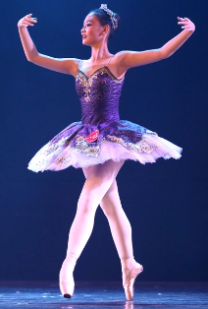  1. My sister is ………..…. and tall.
  2. I …………………..…….. in the evening. | 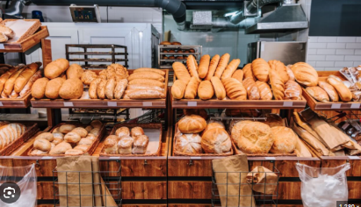  3. We want to go to the…..……………
  4. The hat is twenty………….……dong. |   5. I like ………….….. because they dance beautifully.

PART 2: Question 1- 3: Reorder the words to make a correct sentence. There is one example. (0,75 pt)
0.Yen / My / is/ name.
=> My name is Yen.

1. grandmother / on / works / a farm. / My /
=> …………………………………………………….….……..
2. want / My / to / supermarket. / to/ parents / the / go /
Giaoandethitienganh.info sưu tầm
=> …………………….……………………………………..…..
3. my / morning, / read /with / In / books / I / the / father. /
=> ………………………………………………………..……….
PART 3: Question 1- 2: Write the missing letter. There is one example. (0,5 pt)
 |  | 
- America | 1. w_ath_ _ | 2. p_ lic_m_n

D- SPEAKING TEST (2pts)

