Trường TH Tây Hưng  Họ tên: …………………….  Lớp: ……………………….  SBD: ……. Phòng: ………. | BÀI KIỂM TRA THÁNG 11  MÔN TIẾNG ANH – LỚP 5  Năm học: 2025 – 2026  Thời gian: 40 phút  (Không kể thời gian giao đề) | GT1 KÍ | SỐ PHÁCH
 |  | GT2 KÍ | SỐ PHÁCH

Điểm | Lời nhận xét | Chữ kí GK 1 | Chữ kí GK 2 | SỐ PHÁCH

PART A: LISTENING
I. Listen and number the pictures from 1 to 4.
E
A
D
C
B

0
II. Listen and circle the correct answer.
    5. How often do you go to science clubs?  MONDAY  FRIDAY  TUESDAY  A B C | 6. What do they do after school?  A B C
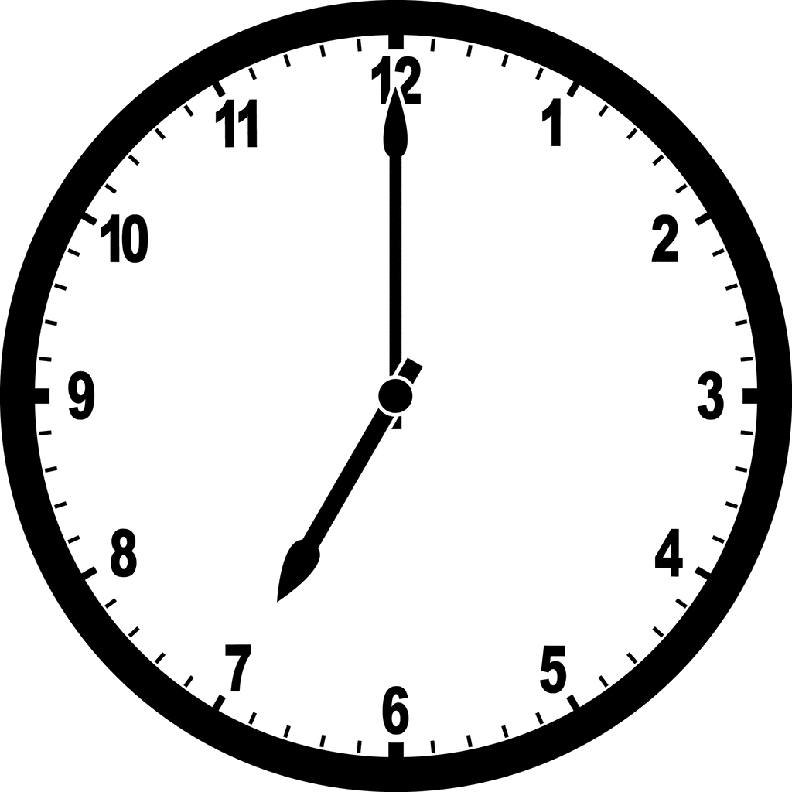  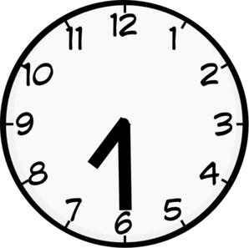  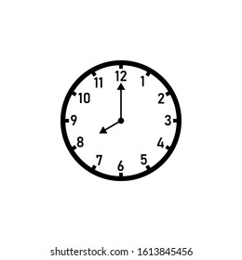  7. When does she start her Maths lessons at school?  A B C | 8. What was Anna’s favourite toy?  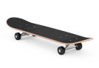    A B C
PART B: READING & WRITING
I. Odd one out.
9. A. park B. boring C. interesting D. good
10. A. Wednesday B. weekend C. Monday D. Tuesday
11. A. cold B. hot C. weather D. sunny
II. Circle the best answer A, B or C to complete the sentences.
12. The computer is interesting, ____________ it’s expensive. ( and/ or/ when/ but)
13. When I was five years old, my favourite things _____my toy cars. ( was/ were/ is/ are )
14. We have art class _________ 8 a.m every Monday. ( in/ on/ at/ for )
15. _____________ do you go to school? - At half past ten. ( What/ How/ When/ Why )
16. The students listen to their teacher ____________. ( carefully/ careful/ care/ good)
17. What do you love doing? - I love ___________ coins, but I don’t like watching movies.
( reading/ read/ collecting/ collect
18 Excuse me, ________ Minh play football this weekend? – No, he can’t. He’s busy.
(should/ could/ can /can’t
III. Read and circle the best answer.
My name is Tony. I go to school from Monday to Friday. I often start my school at 8:00 a.m. and finish at 5:30 p.m. On Mondays, I usually wear a uniform and my father drives me to school. I usually study Maths, Vietnamese, and English at school.
After school, I often play a musical instrument on Tuesdays, and go to art clubs on Thursdays in the afternoon. On Saturdays, I have a music class at 9:30 a.m. at home. On Sundays, I go to the zoo in the afternoon with my classmates. We have lots of fun there
19. When does he start his school?
A. 8:00 a.m. B. 7:00 a.m.
C. 9:00 a.m. D. 9:30 a.m.
20. Which subjects does he study at school?
A. Maths, History, and Science B. Maths, Vietnamese, and English
C. Vietnamese, Music, and Art C. Maths, Music, and Art
21. What does he do on Thursday afternoon?
A. He plays sports. B. He plays a musical instrument.
C. He goes to the zoo. D. He goes to art clubs.
22. Which of the following statements is INCORRECT?
A. He finishes his school at 5:30 p.m.
B. His father drives him to school on Mondays.
C. He has a music class at 9:30 a.m. at school on Saturday.
D. On Sundays in the afternoon, he goes to the zoo with my classmates.
IV. Reorder the words to make sentences.
23. is/ She / at/ good / the piano /playing /.=>She _______________________________.
24. I/ playing/ like/ school/ after. -> I ……………………………………………………
25. two/ There/ the/ cars/ toy/ are/ box/ outside/.=> There________________________.
The end

