Grade 3: 3C- Tiết 3
Period 84: Unit: 7 – My Favorite Sport
Lesson: 2 - Task 1, 2, 3
I. OBJECTIVES:
1. Knowledge:
Students will be able to :
- Learn and use new vocabulary: catching, hitting, kicking, jumping, running
- Learn and use new grammar: present continuous
2. Competences:
- English competences: Students will be able to say the actions ( daily activities or sports)
- Common competences: Students will have opportunity to develop the autonomy in doing tasks and communication among friends.
3. Qualities:
- Students will have opportunity to talk about the activities what they are doing so that they can use languages in everyday life.
II. EQUIPMENT AND MATERIALS:
- For Teacher: PP, TV, flashcards, music, audio track 7.4
- For students: pictures, handout
III. LESSON PROCEDURE:
Activity 1: Warm up (5 minutes)
Teacher’s activities | Student’s activities
- Let Sts warm up by the song :  - Song : What are you doing ?  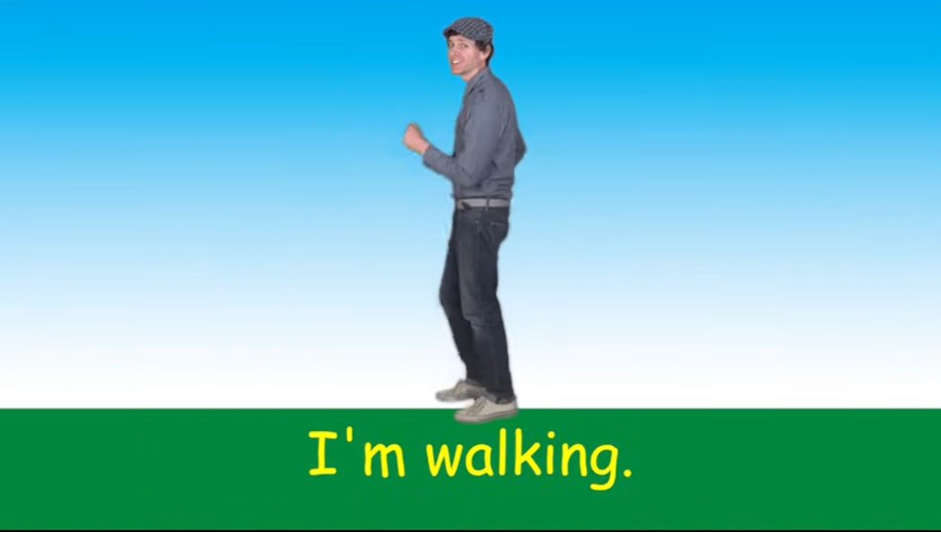 | - Sts sing along with the video.
Activity 2: Presentation (8 minutes)
Teacher’s activities | Student’s activities
Task 1. Listen and pont. Repeat. TR: 7.4  - Use the flashcards or do the action to introduce the vocabulary: catching, hitting, kicking, jumping, running  - Play the words one by one.  - Play the track 7.4 and ask students to listen and repest in chorus, groups.  - Put the 5 flashcards in 5 different corner around the room.  - Say a word for students to repeat then point.  - Vocabulary checking : MINI GAME : Listen and slap the board .  - Stick the pictures on the board.  - Let Sts listen to the sentences and slap on the correct pictures. | - Learn new words through flashcards and actions .  - Listen  - Repeat the words  - Repeat then point.  - Listen, look and say  - Sts join the game.
Activity 3: Practice (12 minutes)
Teacher’s activities | Student’s activities
Task 2 : Listen and tick.  - Ask students to look at the photo  and describe what they can see.  Then tell the students that they are  going to read about hockey.  - Point to the new words in the text.  Read them out and ask students to  repeat.  - Play the recording. Tell students to  look at the picture and follow the  text with their fingers.  - Play the recording again, pause  after each sentence and ask  students to repeat.  - Ask students to practise reading  out the text individually.  - Ask some volunteers to read it out  in front of the whole class  - 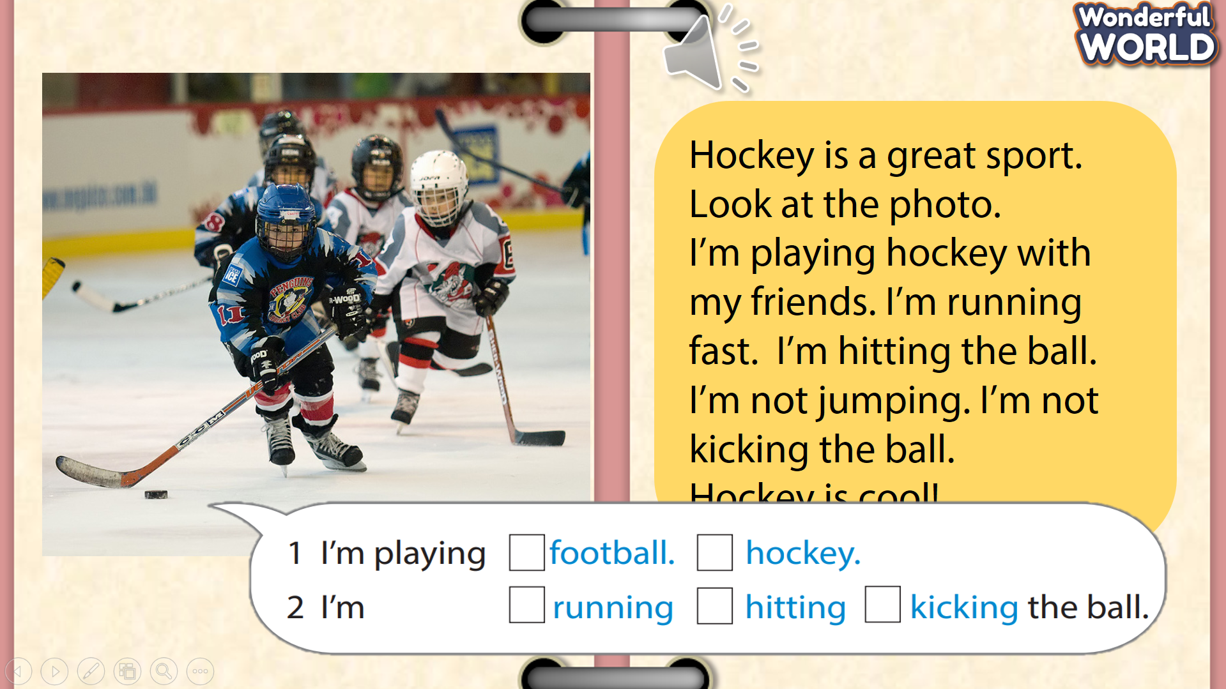 | - S answer  - Sts repeat.  - Sts practice.  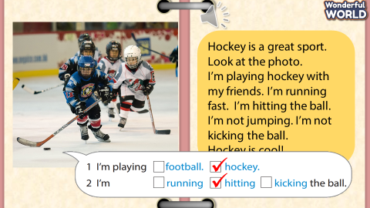
Activity 4: Production (7 minutes )
Teacher’s activities | Student’s activities
Task 3 : Let’s play. Use the words in Activity 1 :  - Let pairs of students of two teams come and roll the dice to choose the student (with the most points) who go first - is going to make a sentence with He/She’s + V-ing (e.g.: He’s catching the ball.) and they can choose the other player from the other team makes sentences “He/ She’s playing + sport” (e.g.: He’s playing baseball). The person who guesses correctly can play rock paper scissor to get the points .  - Join them by giving words in Activity 1 that they do not frequently use in the game to encourage everybody to use and familiarise themselves with all of  the words in Activity 1.  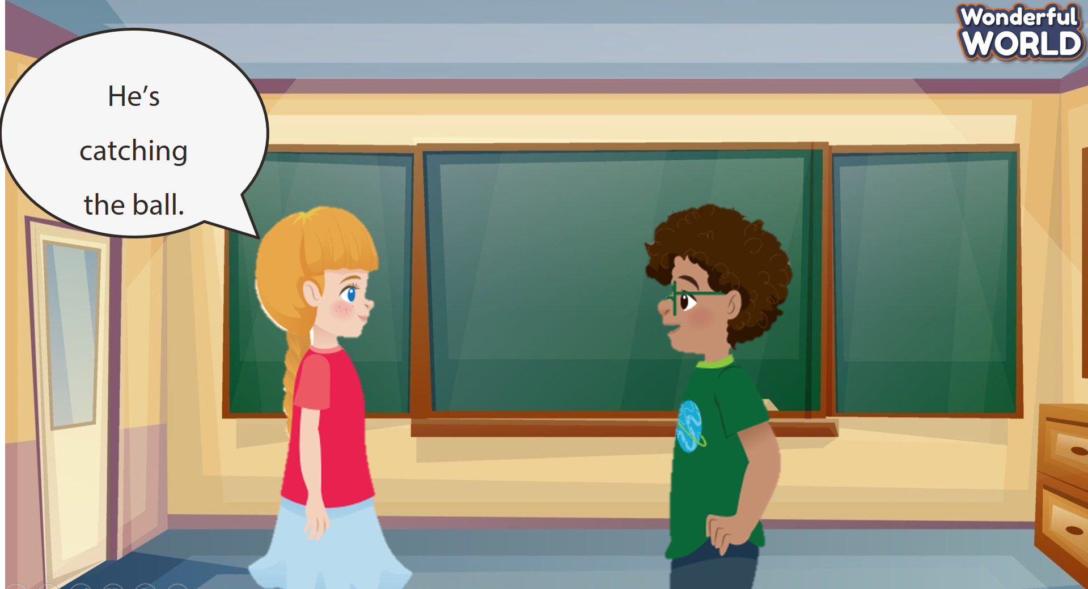  - If S say : She’s kicking the ball .  - He’s hitting the ball . | Sts join the game .  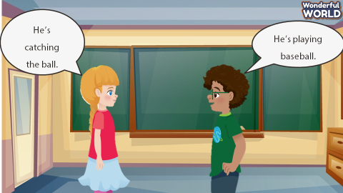  - The other answers : She’s playing football.  - He’s playing baseball.
Activity 5 : Assessemnet (3 minutes )
Teacher’s activities | Student’s activities
- Ask students to do the assessment.  - Use the words to make sentences :  - Check in pair then whole class.  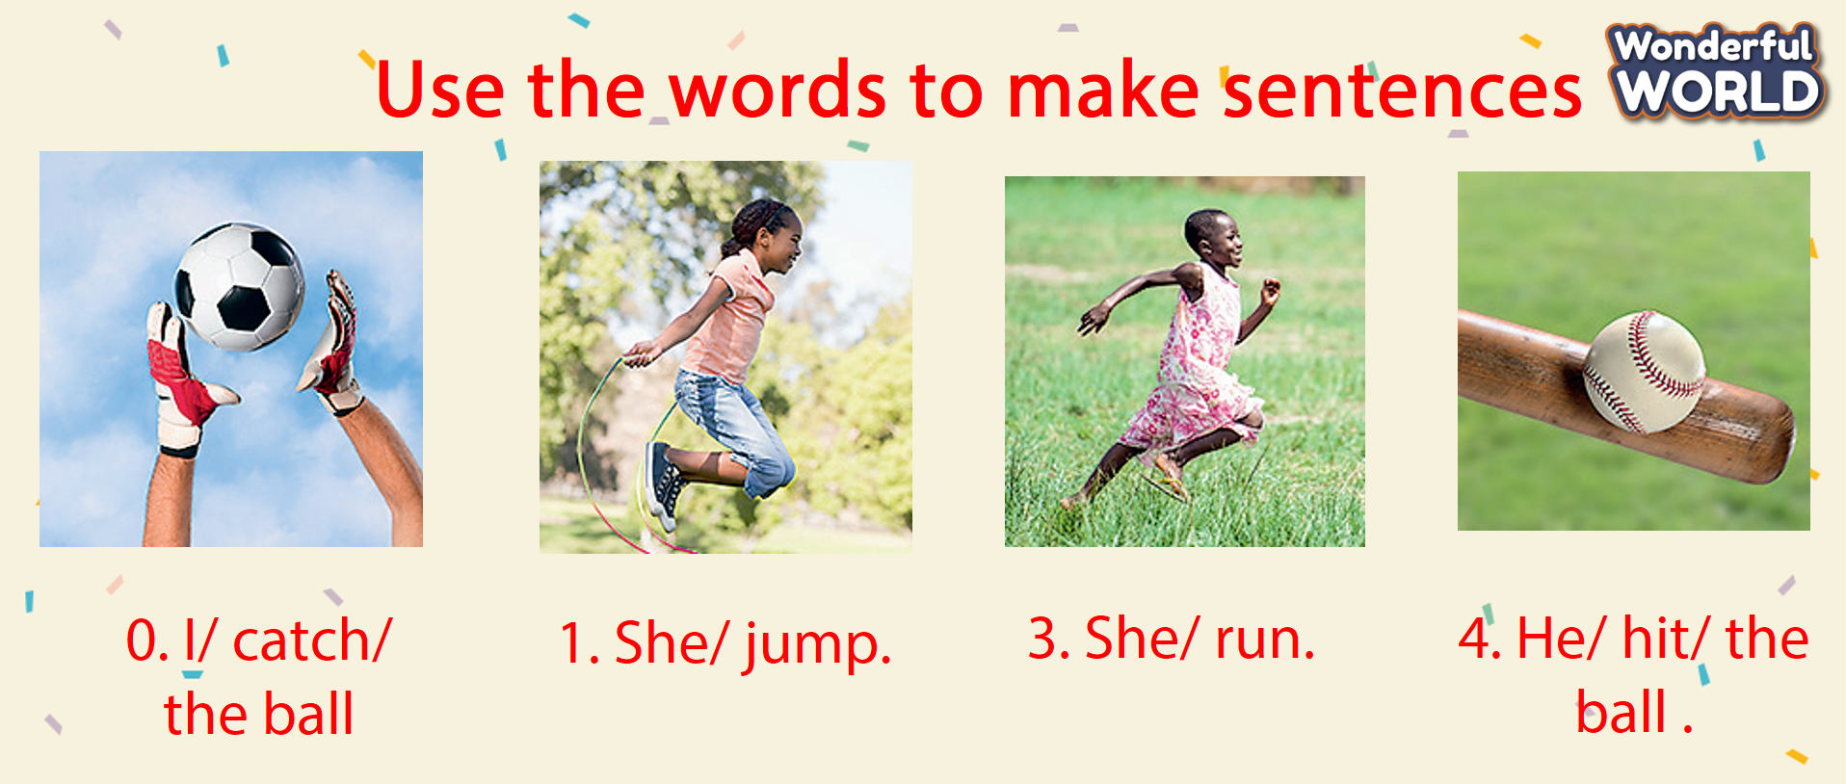  - Say goodbye | - Do the assessment.  - Check with friends and then with teacher and whole class.  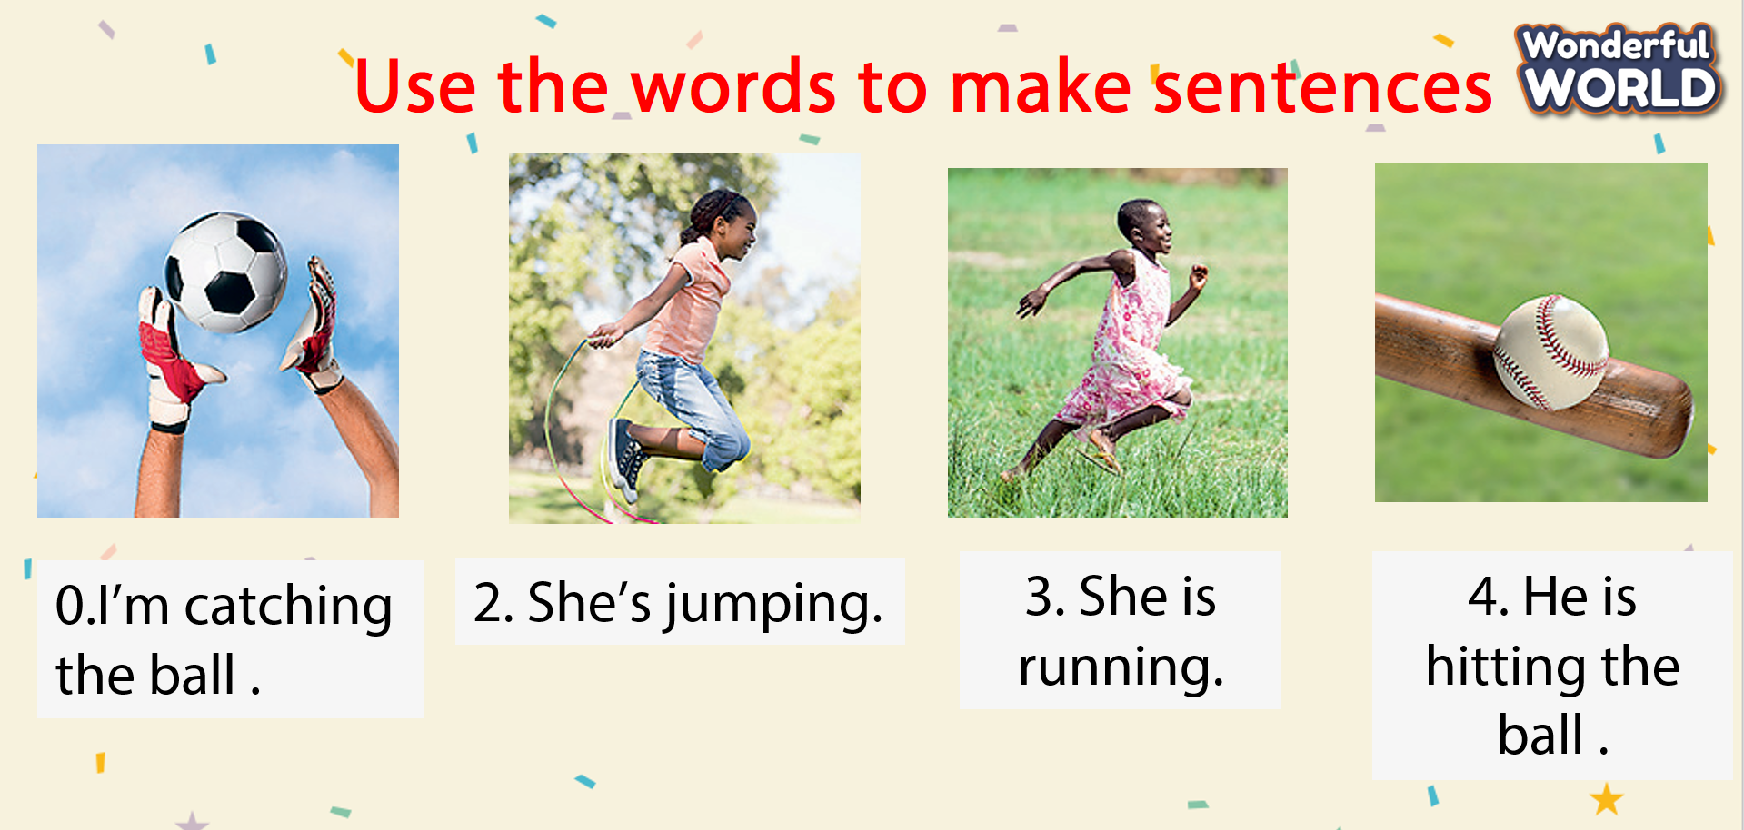  - Say goodbye

