Unit: 8 – My Town
Lesson: 1 - Task 4,5,6
I. OBJECTIVES:
1. Knowledge:
- Students will learn the comparative Listen, please; Don’t talk, please… and asking for permission May I…. Yes, you can./No, you can’t.
2. Competences:
- English competences: Students will be able to follow or make comparisons and ask for permission in English.
- Common competences:
+ Students will have the opportunity to develop creativeness in making the project (rules in public places) and communication among friends.
3. Qualities:
- Students will be aware of the importance of the rules in class and public
II. EQUIPMENT AND MATERIALS:
- Basic things: Student’s book, flashcards, A4 paper.
- Advanced things: PPT, projector/interactive whiteboard/laptop/TV.
III. LESSON PROCEDURE:
Activity 1: Warm-up (5 minutes)
Teacher’s activities |  | Student’s activities
- Greet students  - “Simon says.” Game:  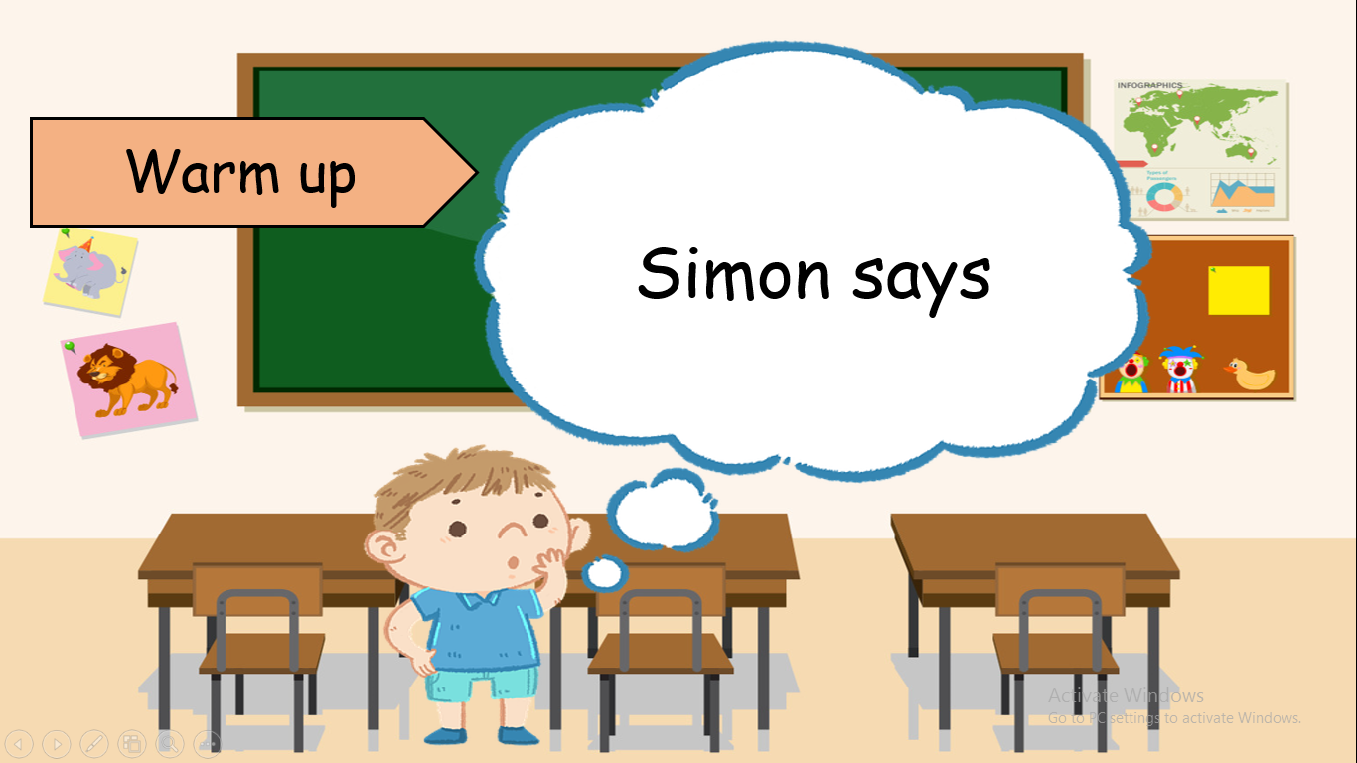  + Ss will not comply with the request if the command does not begin with the word “Simon says…”  + sit down, stand up, dance, talk, jump, run…  On the contrary, if the command sentence begins with “Simon says” but Ss do not follow the request, they will not receive stars for their team. |  | - Greet teacher  - Be quiet and listen carefully.  - Sit nicely if those Ss are the loser.
Activity 2: Presentation (7 minutes)
Teacher’s activities |  | Student’s activities
Task 4. Listen and repeat. ( P.103)  - Let Ss look at two pictures and ask Ss  - Where are they?  - How many people are there?  - What are they doing?  - Point to the pictures and teach command: Listen, please/ don’t talk, please and asking permission May I…. Yes, you can./No, you can’t.  - Play the recording. Tell Ss to  look at the pictures and follow the pictures with their fingers.  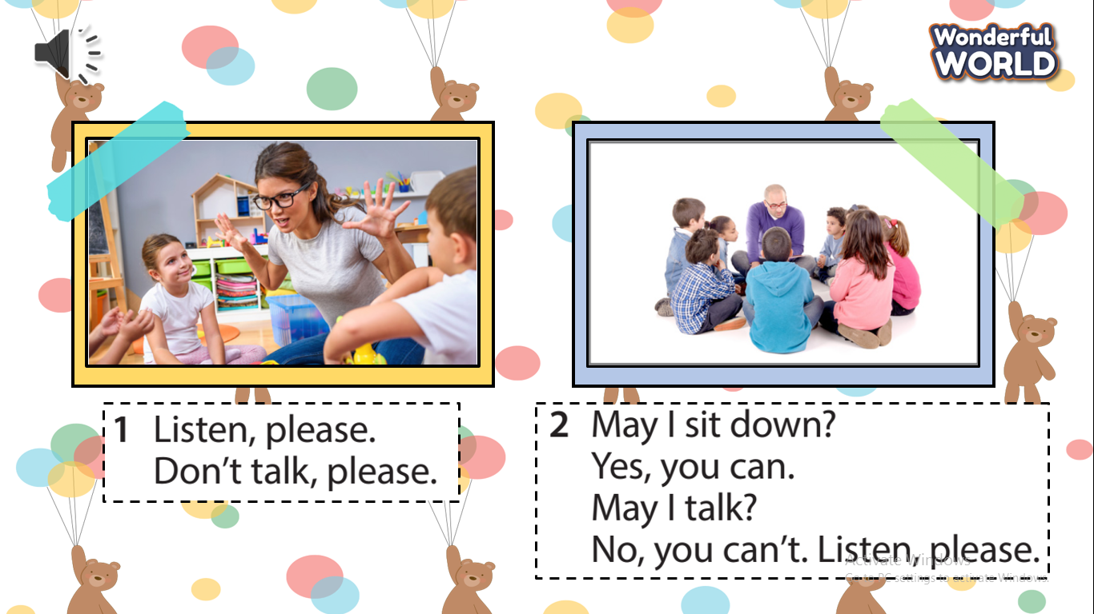  - Play the recording again. Ask Ss to repeat.  - Structure checking: “ whisper game”  + Prepare 4 sets of command cards and stick them on the board.  Listen, please  Don’t talk, please  May I talk?  May I sit down?  + T invites 3 players (The first person on each team) to go to the board and T whispers a message. Then each player whispers the message to the next player in his/her group until the last player gets the message then goes to the board and slaps the right command.  - The fastest team will be the winner. |  | - Answer T’s questions.  - Listen to understand the sentences.  - Listen to the T’s guide.  - Join the game.  - Listen carefully.  - Get stars from T.
Activity 3: Practice (10 minutes)
Teacher’s activities |  | Student’s activities
- Task 5: Look and say  - Tell Ss to look at the pictures and the prompts. Read out the prompts and ask students to repeat them.  - Tell Ss to look at the example.  Read out the example and ask  Ss to repeat.  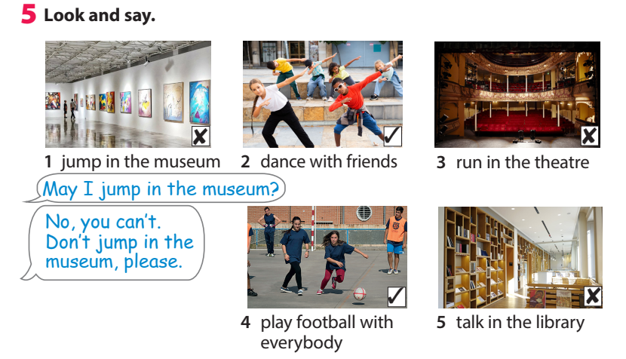  - Have Ss practice in pairs. Go  round the class helping students  where necessary.  - Ask Ss to work in pairs to say where they are and what they want their friends to do or not to do.  - Have some pairs present the conversation. |  | - Look and read aloud.  - Work in pairs and practice the dialogue.  - Read out the example
Activity 4: Production (10 minutes )
Teacher’s activities |  | Student’s activities
- Ask Ss to work in pairs to draw a table  ( place/do/don’t)  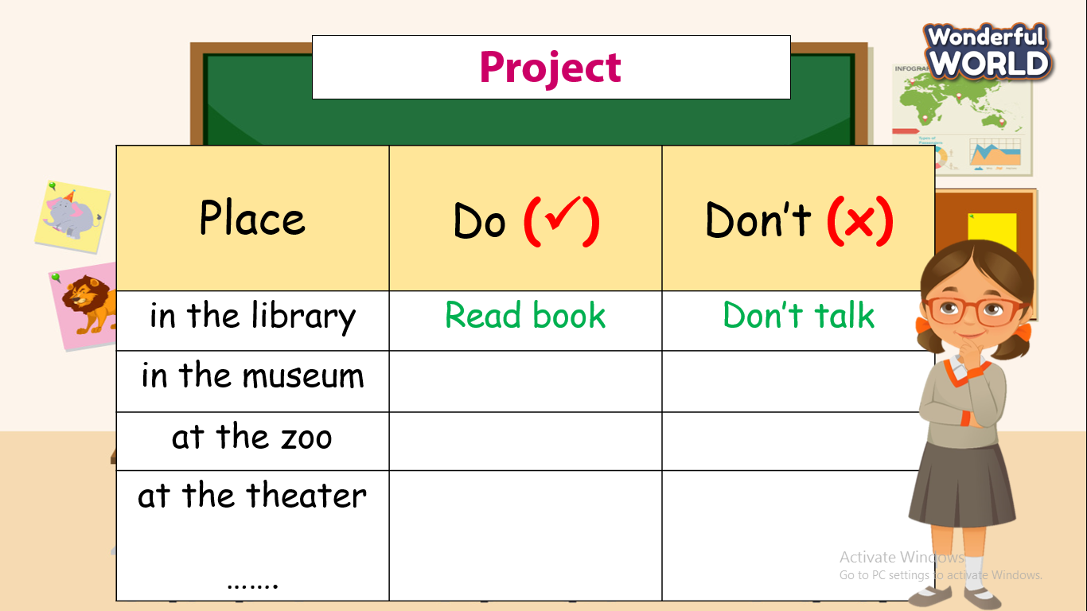  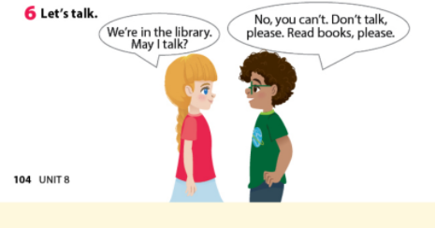  Ask Ss to work in pairs to say where they are and what they want their friends to do or not to do.  - Have some pairs present the conversation.  - fill in the blank. |  | -Work in pairs and do the project.
Activity 5 : Assessement (3 minutes )
Teacher’s activities |  | Student’s activities
-Ask Ss to do an assessment.  Look and choose  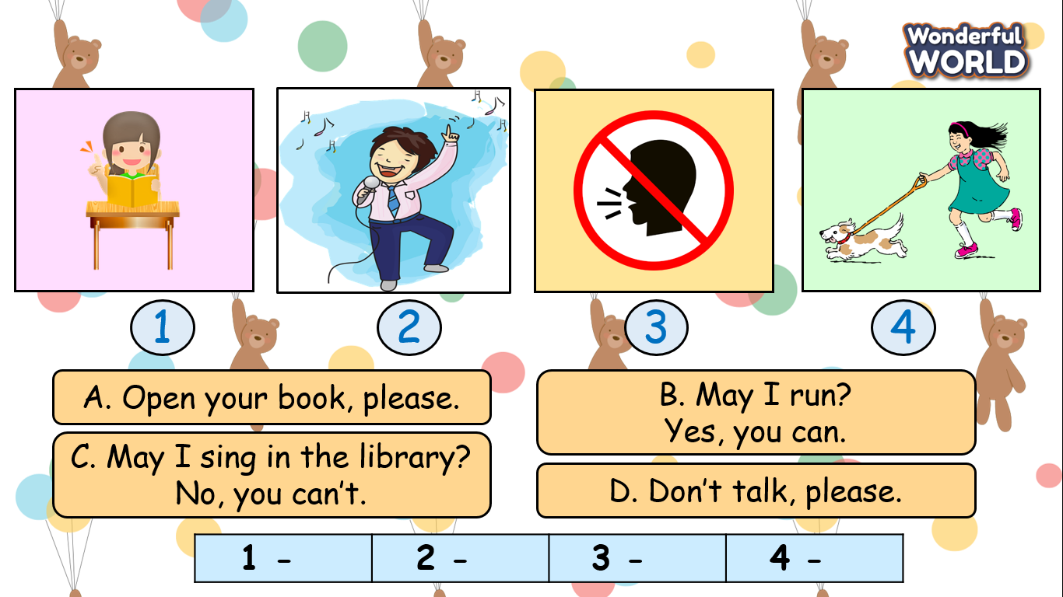  - Check in pair then the whole class.  - Say goodbye |  | -Do the assessment.  1-A  2-C  3-D  4-B  - Check with friends and then with the teacher and the whole class.  - Say goodbye by practising command:  Don’t___please!  ________Please!  May I_____ -Yes, you can/ No you can’t.

