




Exercise 1. Look and write.
1……………….. 2……………….. 3……………….. 4………………..
5
6
7
8………………..
Britain | Malaysia | Viet Nam | Australia
Thailand | America | Japan | Singapore

Exercise 2. Look and answer the questions

1. Where are you from?
- I’m from Viet Nam

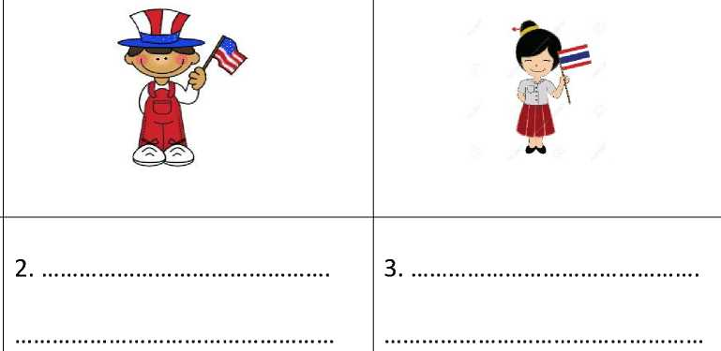

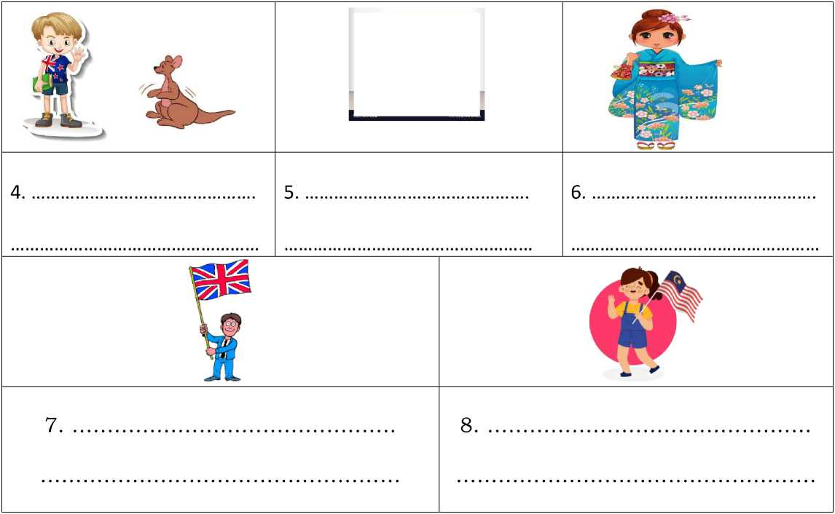


Exercise 3. Make question with he/ she then answer them.
1. |  | Where’s he from? | He is from Singapore.
2.
3.

4. |  | ………………………………… | …………………………………
5. |  | ………………………………… | …………………………………
6. |  | ………………………………… | …………………………………
7. |  | ………………………………… | …………………………………
8. |  | ………………………………… | …………………………………
9. |  | ………………………………… | …………………………………
10. |  | ………………………………… | …………………………………
11. | • | ………………………………… | …………………………………
12. |  | ………………………………… | …………………………………

13. |  | ………………………………… | …………………………………
14. |  | ………………………………… | …………………………………
15. |  | ………………………………… | …………………………………
16. |  | ………………………………… | …………………………………

Exercise 4. Read and write:
 | is |  | are | am
 |  |  |  |  | *J ¿^
1. I from  England. |  | 2. He from Japan. |  |  | 3. They from  Australia.
 |  | w
4. I from  America. |  | 5. They from Viet  Nam. |  |  | 6. She from  Thailand.

Exercise 5. Look , read and tick (/) or cross (x) in the box.






1) He’s from America.
2) She’s from Australia.
3) He’s from Japan.
4) She’s from Britain.
5) She’s from Thailand.
6) She’s from Malaysia.



7) She’s from Singapore
8) He’s from Australia
9) She’s from Thailand.



10) She’s from America
- They’re from Viet Nam
- He’s from Japan



- He’s from Britain
- He’s from Singapore
- He’s from Malaysia
Exercise 6. Write
We’re She’s He’s They’re
- .Tony is seven years old. from Britain.
- .Lily is nine years old. from Australia.
- .Nam and I are friends. from Viet Nam.
- .Anna and Lily are sisters. from America.
Exercise 7. Look at pictures, read and make sentences:
0. Mori/9/Japan | 1.Sarah/10/Australia | 2. Jessica/7/Britain
 | s^
 |  | w
3. Mai/ 8/ Viet Nam | 4. Andros/15/Singapore | 5. Anita /10/Thailand
6. Ben/12/ America | 7. Maya/ 13/ Malaysia | 8. Kenta/ 11/ Japan
0. This is Mori. She’s nine years old. She’s from Japan.

8.
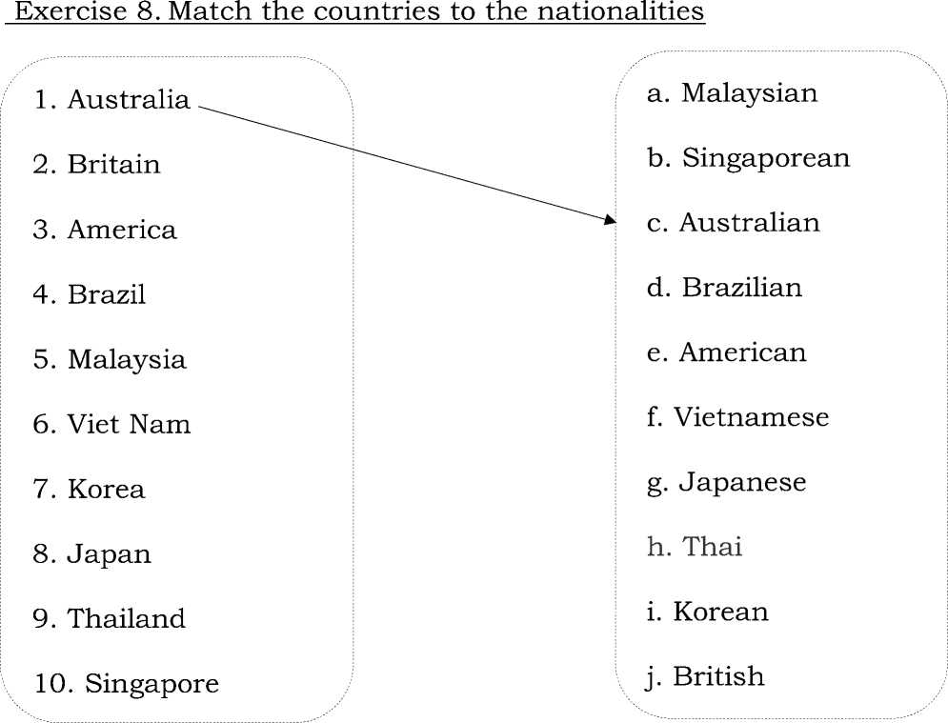
Exercise 9. Circle the correct answer.
1.They _ | from Korea. | a.is | b. are | c. isn’t | d. am
2.Anna | from Japan. | a.is | b. are | c. am | d. aren’t
3. She _ | from Brazil. | a.is | b. are | c. am | d.am not
4. There | four seasons. | a. are | b. is | c. am | d. isn’t
5. His name Anna. |  | a. are | b. am | c. aren’t | d.is
6. | she from Britain? | a. Is | b. Are | c. Am | d. aren’t
7. | _ you from Thailand? | a. isn’t | b. is | c. am | d. Are
8. I | ___ from Viet Nam. | a. am | b. is | c. isn’t | d. aren’t

Exercise 10. Read and answer:
Name: Nguyen Thi Lan | Name: John
Hometown: Ho Chi Minh City, Viet Nam | Hometown: London, England
School: Nguyen Hue Primary School | School: International Primary School
Class: 4a5 | Class: 4a1
1. What is the girl’s name?
2. Where is she from?
3. What is her school’s name?
4. What nationality is she?
5. What is the boy’s name?
- Where is he from?
- What is the name of his school?
- What nationality is he?
Exercise 11. Complete the email using the correct form of be.
Hi Peter. How (1) you? I (2) your new Pen-friend. My
name is (3) Tony. I am from America and I live in New
York city. Where (4) you from? I have only your mail address.
When (5) your birthday? What (6) your hobbies?
Please write soon!
Tony
Exercise 12. Choose the correct answer.
1. Where _ | ___ you from? | a. am | b. is | c. are
2. Where _ | ___ he from? | a. am | b. is | c. are
3. Where _ | ___ Julia and Ana? | a. am | b. is | c. are
4. Where _ | ___ Helena from? | a. am | b. is | c. are
5. Where _ | ___ they from? | a. am | b. is | c. are
6. Where _ | ___ I from? | a. am | b. is | c. are
7. Where _ | ___ she from? | a. am | b. is | c. are
8. Where _ | ___your friend from? | a. am | b. is | c. are
9. you | from Thailand? | a. am | b. is | c. are
10. she from Malaysia? |  | a. am | b. is | c. are

Exercise 13. Write questions and answers.
ft # W | 1. is/Where/Anna/from? | from/She/is/Thailand./
 | 2. is/Where/John/from? | from/He/is/Britain./
 | …………………………………… | ……………………………………
^f* | 3. they/Where/are/from? | They/are/Brazil./from/
 | 4. is/Where/Lucas/from? | from/He/is/Mexico./
 | …………………………………… | ……………………………………
r | 5. /Where/Jeong/from?/is | from/She/is/Korea./
 | …………………………………… | ……………………………………
Exercise 14. Complete the sentences with the missing nationality
and other missing words when necessary
- I am from America, so I am American.
- She is from Britain, so she
- He is from Korea, so he is
- They are from Australia, so they are
- We are from Thailand, so we are
- Helen and Sam are from England, so
- Helmut is from Brazil, so
- Bruce is from Japan, so
Exercise 15. Find the mistakes and correct them.
1. She is from Japan. ^Malaysia | 2. She is from America.^
 | o^®
3. He is from Brazil.^ | 4. They are from Thailand .^
5. We is from Viet Nam .^ | 6. She is from Japan. ^
7We are from Australia. ■=> | 8. He is from Thailand.^
Exercise 16. Match
a. What’s your name ? | 1. I’m nine years old.
b. How old are you ? | 2. My name is Lisa.
c. Where are you from ? | 3. My favorite season is fall.
d. What’s your favorite season ? | 4. I’m Korean.
e. When is your birthday ? | 5. I’m from the U.S.A

f. What nationality are you ? | 6. It's on the first of January.
g. Do you like summer ? | 7. There are four seasons.
h. How many seasons are there in a year ? | 8. Yes, I do.
i. Where is she from ? | 9. No, they aren’t
j. Are they from England ? | 10.She is from Brazil.
k. Is she from Viet Nam ? | 11.Yes, she is

a. | b. | c. | d. | e. | f. | g. | h. | i. | j. | k.

LISTENING
Part 1: Listen and write, there is one example.
- My name is Linda, I’m from America.
- This is Tom. He’s from………………….
- Where is she from? She’s from…………………….
- He’s my new friend. He’s from…………………….
- She isn’t from…………………..She’ from…………………...
- She is from……………………..
- My name’s Linh. I’m from………………………….
Part 2: Listen and draw line, there is one example.
1. |  | a
2. |  | b
3. |  | c
4. |  | d
5. |  | e
6. |  | f
7. |  | ^{g} *
8. |  | h

