Exercise 1. Look and write:
have breakfast | go to school | have dinner | get up | wash my face
do homework | have lunch | clean my teeth | go to bed | go home

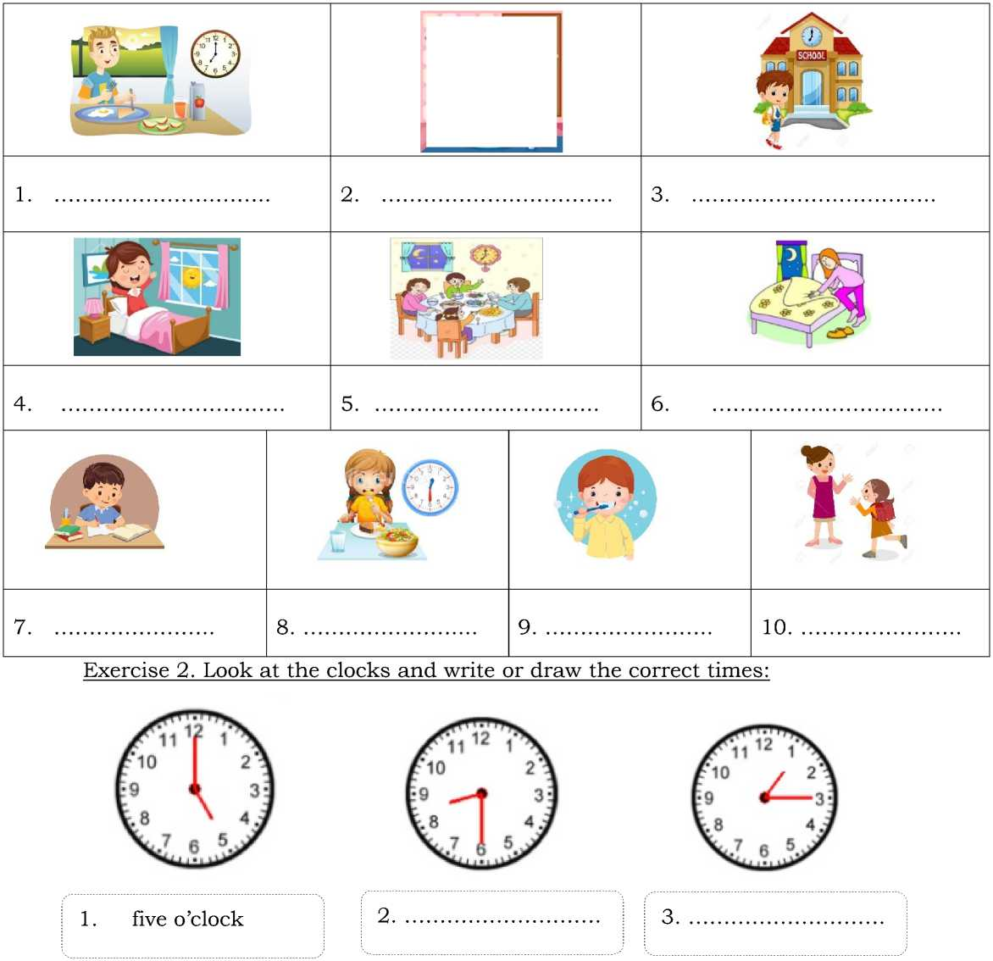


7. It’s four o’clock.
8. It’s nine fifteen.
9. It’s ten o’clock.
10. It’s five thirty.
11. It’s six forty- five.
12. It’s eight o’clock.
Exercise 3. Number the pictures
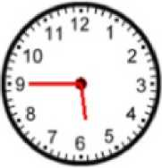
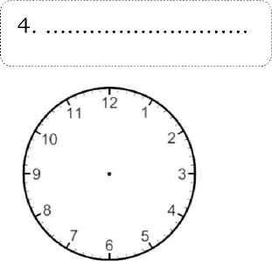
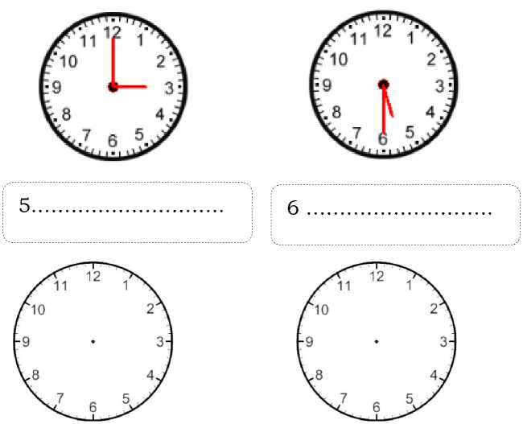
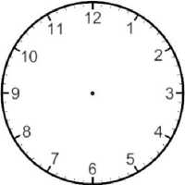
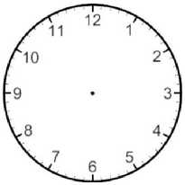
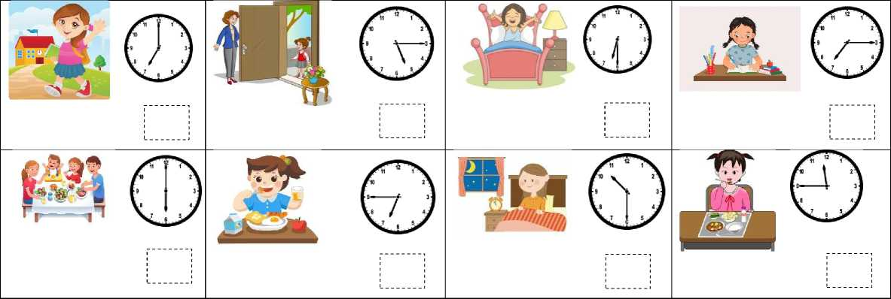

1. I have lunch at eleven forty- five. | 5. I get up at six thirty.
2. I have dinner at six o’clock. | 6. I do my homework at seven fifteen.
3. I have breakfast at six forty- five. | 7. I go home at five fifteen.
4. I go to bed at ten thirty. | 8. I go to school at seven o’clock.

Exercise 4. Look and write the routines.
 | get up | have breakfast | go to school | go home
e  Lan | 6 :00 | 6:30 | 7:00 | 4:00
Hung | 5 :00 | 6:00 | 7:15 | 5:00
Mai | 6: 45 | 7: 00 | 7: 30 | 5: 30
Phong | 6: 15 | 6: 45 | 7: 15 | 7: 45

Lan | - I get up at six o’clock.  - ………………………………………………………….  - ………………………………………………………….  - ………………………………………………………….

Hung | - ………………………………………………………….  - ………………………………………………………….  - ………………………………………………………….  - ………………………………………………………….
Mai | - ………………………………………………………….  - ………………………………………………………….  - ………………………………………………………….  - ………………………………………………………….
Phong | - ………………………………………………………….  - ………………………………………………………….  - ………………………………………………………….  - ………………………………………………………….

Exercise 5. Complete the questions and answer them.
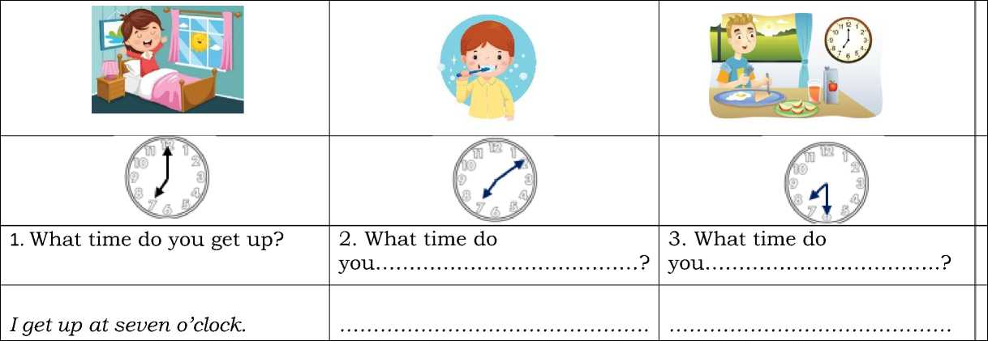

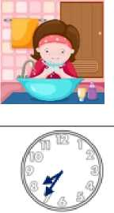

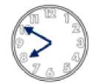
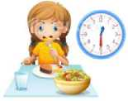
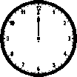

you……………………………….?
6. What time do you………………
- What time do
you…………………………………?
- What time do

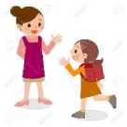
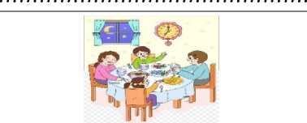

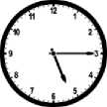
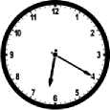
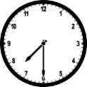

9. What time do you………………
- What time do
you……………………………….?
- What time do
you……………………………….?

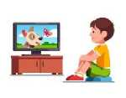
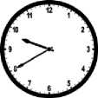
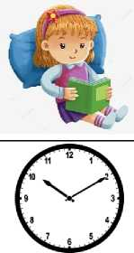
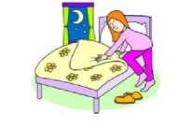
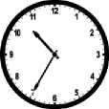

- What time do
you……………………………….?
- What time do
you……………………………….?
- What time do
you……………………………….?

Exercise 7. Put the words in the correct order to make sentences
1. I /at /7 o'clock/ in/ the /morning./get/up. | 2. I/to/go/school/at /8 o'clock/ in /the/ morning./
3. bed/to/ I/at /10 o'clock/ at night./go | 4. I /at/ 5 o'clock/ in /the/afternoon./watch/TV
5. at/ 4 o'clock/ in/do /the /afternoon./I/homework/my/ | 6. What/do/you/time /get /up ?/
7. you /have/in /the/Do /morning?/breakfast | 8. catch /the/every/I/ morning ./ bus/
9. I/ to /school /by/ car./go | 10. /up/ at/ 6:30 /on/I/ Tuesdays. /get
11. Do/go/to /school/by /bike?/you/ | 12. have /dinner/I /at/ seven/o’clock./
13. Do/swimming/you/go /on/Tuesdays?/ | 14. I /my/hair/comb/seven /o’clock./at
15. What/do/to/school?/go/time/you/ | 16. Do /breakfast/have/you/every day ?

