Exercise 1. Write the words.
Wednesday | study at school | Friday | Tuesday | listen to music
Saturday | do housework | Monday | Sunday | Thursday

» rWWMh wg s  X Ci | I1ÉÏ | |1b^ | THU
1. ………………… | 2. ………………… | 3. ………………… | 4. …………………
rO-O-O-O-O-th | Qi | ^R^ | |wt^
5. ………………… | 6. ………………… | 7. ………………… | 8. …………………
9. ………………………..… |  | 10. ……………………………

Exercise 2. Make questions and answers:
1 |  | What day is it today? | It’s ………………………..
2 | ^§= | ……………………………….. | ………………………………..
3 | ÇS^ | ……………………………….. | ………………………………..

4 | rtnnnnrlr|  M
5 | & rOHHHHHh test
6 | 0
7 | .^^r

Exercise 3: Look , read and tick (/) or cross (x) in the box.

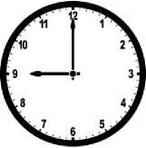

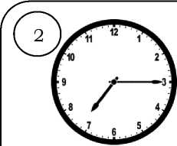

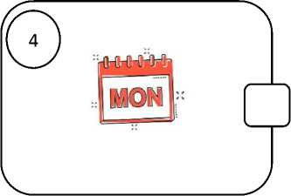
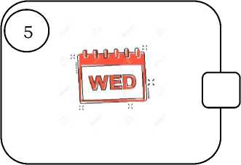

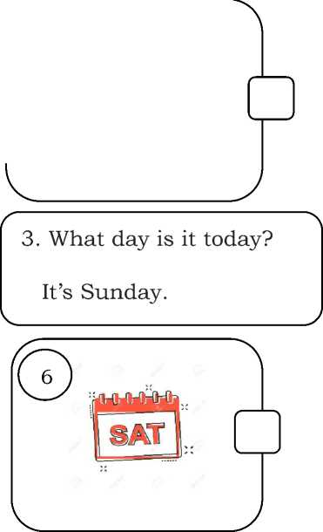

- What time is it?
It's nine o’clock.
- What time do you go home?
I go to school at 5 o’clock.
4. What day is it today?
5. What day is it today?
6. What day is it today?
It’s Monday.
It’s Friday.
It’s Thursday
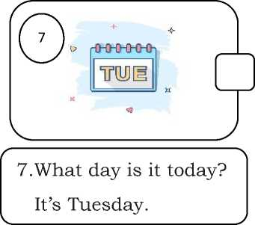
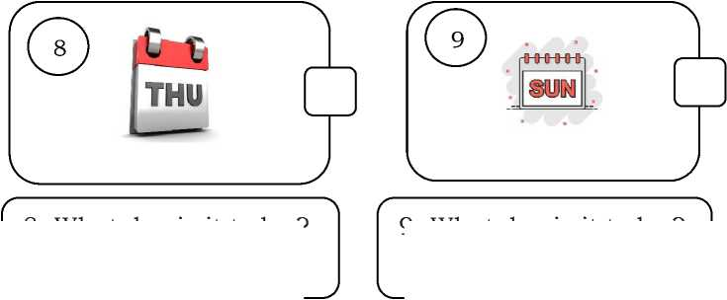
8. What day is it today?
It’s Saturday.
9. What day is it today?
It’s Sunday.
Exercise 4. Answer the questions.
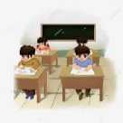





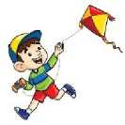

- What do you do on Mondays?
- What do you do on Tuesdays?
- What do you do on Wednesdays?
- What do you do on Thursdays?
5. What do you do on Fridays?
6. What do you do on Saturdays
We have English and Math


7. What do you do on Sundays?
8. What day is it today?
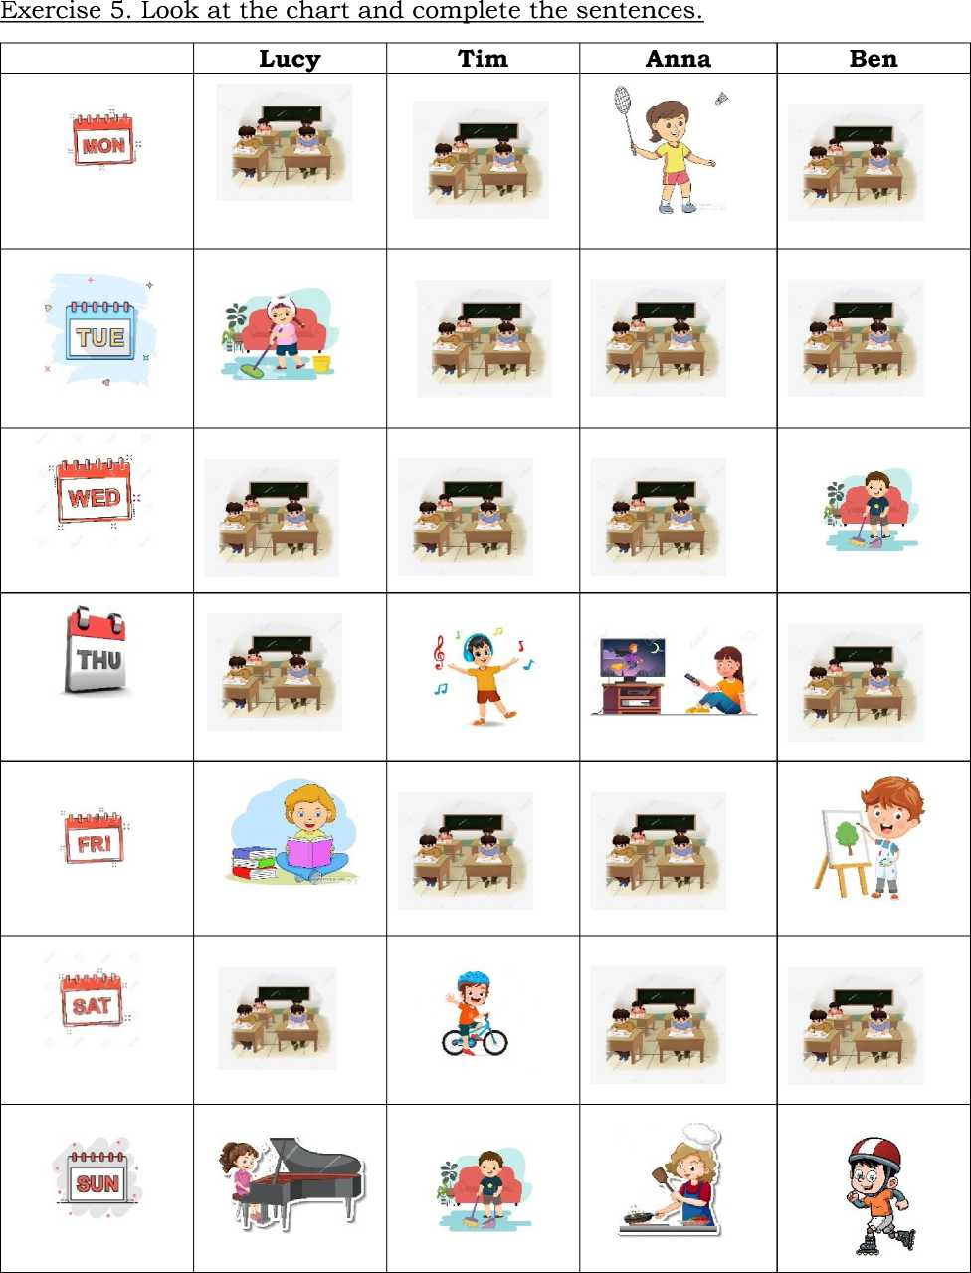
1 | Lucy | - I study at school on Mondays, Wednesdays, Thursdays and Saturdays  - ………………………………………………………………………………………….  - ………………………………………………………………………………………….  - ………………………………………………………………………………………….
2 | Tim | - ………………………………………………………………………………………….  - ………………………………………………………………………………………….  - ………………………………………………………………………………………….  - ………………………………………………………………………………………….
3 | Anna | - ………………………………………………………………………………………….  - ………………………………………………………………………………………….  - ………………………………………………………………………………………….  - ………………………………………………………………………………………….
4 | Ben | - ………………………………………………………………………………………….  - ………………………………………………………………………………………….  - ………………………………………………………………………………………….  - ………………………………………………………………………………………….
Exercise6. Reorder the words to make the correct sentences.

1. go/I /school /Mondays./on /to/ | 2. books/on/ Mondays/ read/ and/ I/ Tuesdays./
………………………………………………………… | …………………………………………………………
3. to/I /music / on/ Fridays./listen | 4. do/Thursdays./ I/ housework/ / on/
………………………………………………………… | …………………………………………………………
5. study /from// school/ to /at/Mondays/ I/Fridays | 6. kites/ Peter / and / Tony/on /Fridays/ fly
………………………………………………………… | …………………………………………………………
7. play / I /Mondays. /on/ football. | 8. a/ draw/ I/ Sundays/ picture/ on

9. watch / I /Thursdays. /on/ TV | 10. for/ on/ cook/ family/ I/ Saturdays/my/
11. my/I/ride / on/ Tuesdays/bike | 12. dance/ I/ swimming/ and/on/ go/ Wednesdays.

Exercise 7. Odd one out
1. a. black | b. grey | c. pink | d. eraser
2. a. art room | b. music room | c. school | d. classroom
3. a. bus | b. kitchen | c. bedroom | d. dining room
4. a. bird | b. kite | c. cat | d. dog
5. a. football | b. tennis | c. basketball | d. water
6. a. room | b. meat | c. bean | d. rice
7. a. swimming | b. cycling | c. face | d. climbing
8. a. bus | b. bike | c. car | d. red
9. a. bus | b. thirty | c. plane | d. train
10. a. bed | b. door | c. house | d. window
11. a. run | b. picture | c. cook | d. draw
12. a. desk | b. new | c. old | d. big
13. a. sit | b. speak | c. stand | d. teacher
14. a. Singapore | b. Malaysia | c. Australia | d. school
15. a. What | b. Malaysia | c. Do | d. Where
16. a. time | b. do housework | c. do homework | d. study at school
17. a. farmer | b. nurse | c. sister | d. doctor
Exercise 8. Write about you.
- My name is……………………………………...
- I study at school on …………………………..
- I do housework on……………………………..
- I don’t ……………………………. on Sundays.
- I listen to music on ……………………………
Exercise 9. Match
1. What time do you get up? |  |  |  |  |  |  |  | a. I go to bed at 10:00 o’clock.
2. How do you go to school? |  |  |  |  |  |  |  | b. It’s Friday.
3. Do you have breakfast every day? |  |  |  |  |  |  |  | c. It’s nine fifteen.
4. What do you do on Tuesdays? |  |  |  |  |  |  |  | d. I visit my grandmother on Saturdays.
5. What time do you go to bed? |  |  |  |  |  |  |  | e. She’s from Malaysia.
6. What do you do on Saturdays? |  |  |  |  |  |  |  | f. I go home at five o’clock.
7. What do you like doing ? |  |  |  |  |  |  |  | g. Yes, I do. I have bread and eggs for breakfast.
8. What time do you go home after school ? |  |  |  |  |  |  |  | h. I walk to school.
9. Where is she from? |  |  |  |  |  |  |  | i. I like dancing
10. What time is it? |  |  |  |  |  |  |  | j. I get up at 7:00 o’clock
11. What day is it today? |  |  |  |  |  |  |  | k. I do housework
 | 1. | 2. | 3. | 4. | 5. | 6. | 7. |  | 8. | 9. | 10. | 11.
Exercise 10. Complete questions with the information given:
- What time/get/ up?
■When time do you get up?
- What time/have/lunch?
- What/ day/ today?
- What/ time/?
- Where/pen?
- What time/go/bed/Saturdays?
- What/she/ doing?
- Where/ books?
- What/do/Thursdays
- Where/ he/ from
- What/ they/ doing
Exercise 11 : Find the mistakes and correct them.

1
Where she is from?
2
He are from Japan.
3
What time is it? It’s on 10 o’clock.
4
Where time do you go to bed?
5
What day is it today? It’s Mondays
6
What are you do on Wednesdays?
7
I do housworks on Sundays.
8
I listen to music in Thursdays.
9
I study on school on Mondays.
10. What do you doing on Saturdays?
11. I having breakfast at 7 o’clock.
12. I am read books
13. What color are the pen?
14. What would you like drink?

Exercise 12 : Make questions for these answers
- She is from Singapore? ………
- I’m from Thailand. ………
- I get up at 7 o’clock. ………
- I go to school at 7: 30. ………
- They’re green. ………
- It’ Tuesday. ………
- She is writing. ………
- I have lunch at 12 o’clock. ………
- My sister’s a teacher ………
- It’ eight o’clock. ………
- I’m watching TV ………
- I skate on Saturdays. ………
- I do housework on Thursdays. ………
- I’d like some bread. ………
- There are two chairs in the bedroom. ………
- Yes, he is a doctor. ………
- The lapms are in the living room. ………
- I have three cats. ………
- I can see a horse ………
- The birs is singing. ………
- I play basketball at break time. ………
- Yes, you can go out. ………
LISTENING
Part 1. Listen and number, there is one example.



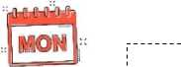


1
Part 2. Listen and tick 0 or cross 0. There is one example.
1. |  | 2.
3. |  | 4.
5. |  | 6.
 | O □ |  | ^^^
7. |  | 8.

