Exercise 1. Look at the pictures and write the words.
juice | grapes | birthday | water
chips | lemonade | Party | jam

 |  | j | ^ T. y*^
1. ………………………. | 2. ………………………. | 3. ………………………. | 4. ……………………….
 | 4 | ^^^
5. ………………………. | 6. ………………………. | 7. ………………………. | 8. ……………………….

Exercise 2: Look and circle the right word.
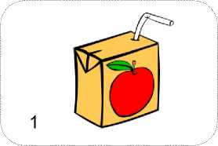
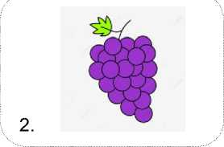
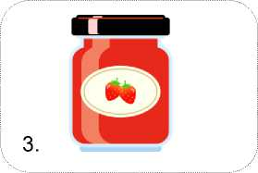
- juice.
- water.
a) apples.
b) grapes.
a) jam.
b) egg.
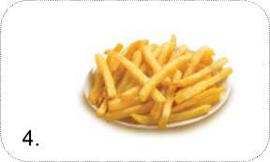
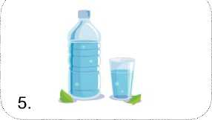
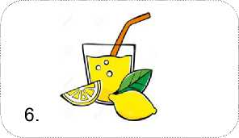

- cake.
- chips.
- lemonade.
- coffe.
- water.
- lemonade.
Exercise 3. Write and match:
1. I’m sweet, soft food, made  by cooking fruit with sugar. You can eat me with bread.  ^ |  | A
2. I’m small, round, purple or green fruit  ^ |  | B
3. I’m the liquid that comes from fruit or vegetables.  ^ |  | C
4. I’m from potatos, thin or long.  ^ |  | D
5. The day a person was born.  ^ |  | E
6. I’m a drink made with  the juice of lemons, water, and sugar.  ^ |  | F
7. An event at which  a group of people meet to talk, eat, drink, d ance…. to celebrate a special occasion.  ^ |  | G
8. I’m a clear liquid, without color or taste  ^ |  | H

Exercise 4: Complete the words and match:
 |  |  |  | J_n_ |  | 1
1 | MAY |  |  | O_tob_r |  | 2
 |  |  |  | Jul_ |  | 3
1 | MAR |  |  | _anu_r_ |  | 4
Ju4^| |  |  |  | A_ri_ |  | 5
 | NOV w |  |  | _ug_st |  | 6
 | SEP |  |  | F_b_ua_y |  | 7
 | WL' DEC |  |  | _o_em_er |  | 8
 | ^HH^ JUN |  |  | M_r_h |  | 9
 | nj-inr JAN |  |  | D_cem_e_ |  | 10
 | ^nnT  FEB |  |  | Se_te_b_r |  | 11
 | nnnr  AUG |  |  | M_y |  | 12

Exercise 5. Complete the table:
MONTHS OF A YEAR
1) | 2) | 3)
4) | 5) | 6)
7) | 8) | 9)
10) | 11) | 12)

Exercise 6. Make questions and answer them:

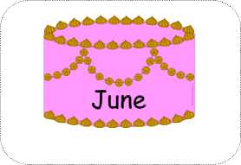
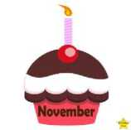
1) When’s your birthday?
2)…………………………….?
3) …………………………….?
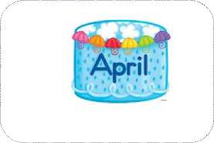
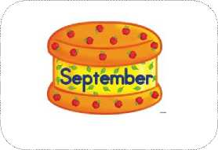
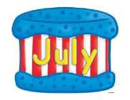
It’s in February.

- …………………………….? 5) …………………………….? 6) …………………………….?
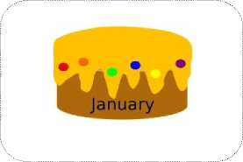
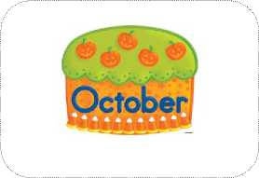
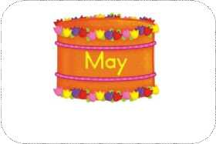
7)
…………………………….? 8)
…………………………….? 9) …………………………….?
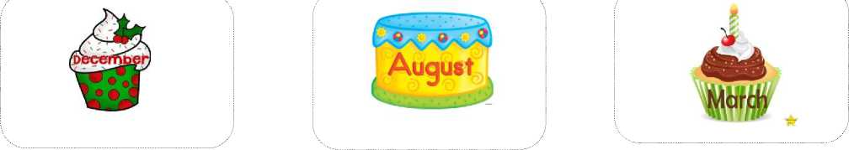
10) …………………………….? 11) …………………………….? 12)
Exercise 7. Read and number

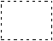
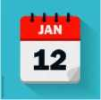
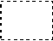
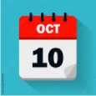
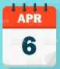
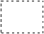
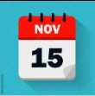
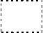

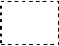
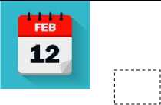


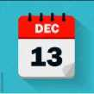
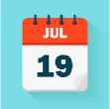
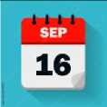


1. My birthday is in June. | 2. My birthday is in February .
3. My birthday is in October. | 4. My birthday is in August.
5. My birthday is in November. | 6. My birthday is in December.
7. My birthday is in January . | 8. My birthday is in May.
9. My birthday is in July. | 10. My birthday is in March.
11. My birthday is in April. | 12. My birthday is in September.

- What’ your name?  - How old are you?  - Where are you from?  - What class are you in?  - What animals do you like?  - What’s your favorite color?  - When’s your birthday?  - What time do you go to school?  - What do you do on Sundays?  Exercise 9. Look and write:  - I want some …………….  4. ………………………….  7. …………………………. | I want………  - …………………………. 3. ………………………….  - …………………………. 6. ………………………….  - …………………………. 9. ………………………….

Exercise 8: Answer the questions about yourself:
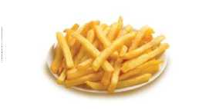
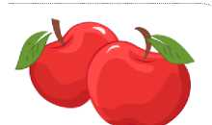


Exercise 10. Complete questions and answers
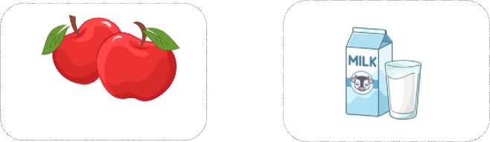
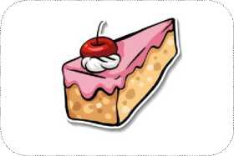
1. What do you want to eat? 2. ………………………….
3. ………………………….
eat | drink

I want some apples.

4. ………………………….
5. ………………………….
6. ………………………….
7. ………………………….
8. ………………………….
9. ………………………….
10. ………………………….
11. ………………………….
12. ………………………….
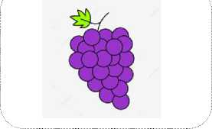
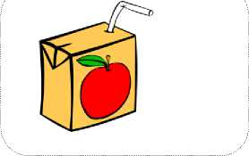
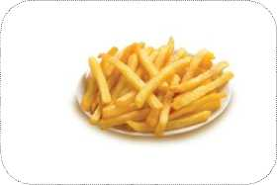
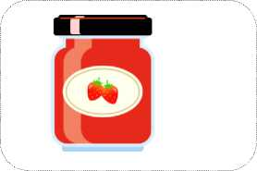
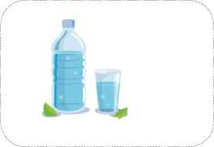
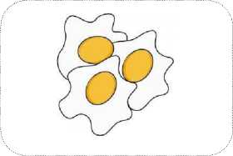
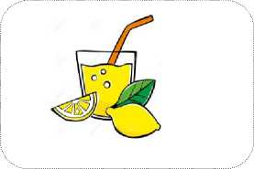
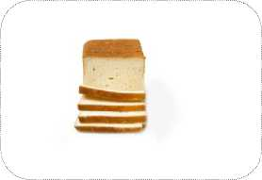
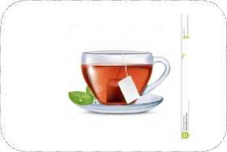

Exercise 11. Put the words in the correct column
bean chicken egg milk tomato bread grape tea chocolate jam juice apple lemon beer rice potato carrot tea cheese pizza water orange lemonade chips cake offee fish wine meat
Food | Drinks
………………………… | …………………………
………………………… | …………………………
………………………… | …………………………
………………………… | …………………………
………………………… | …………………………
………………………… | …………………………
………………………… | …………………………
………………………… | …………………………
………………………… | …………………………
………………………… | …………………………
………………………… | …………………………
………………………… | …………………………
………………………… | …………………………
………………………… | …………………………
………………………… | …………………………
………………………… | …………………………
………………………… | …………………………
………………………… | …………………………
………………………… | …………………………

Exercise 12 .Comple the sentences with the words from the box.
what some please would want drink do
Jim: What …………. you want to eat, Sally?
Sally: I want ………………..bread.
Jim: Do you ………………. some jam for your bread?
Sally: Yes, I want some jam
Jim: ………………. you like some grapes, Sally?
Sally: Yes, …………………..
Jim: ………………… do you want to ……………….?
Sally : I want some lemonade.
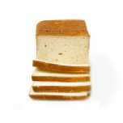
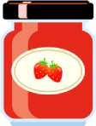
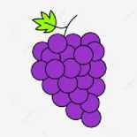
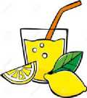
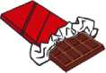
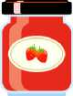
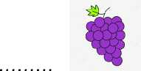
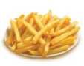
Exercise 13. Read and choose the best answer:
- I want some
A . choccolate
B. cakes C. sweets
- I want some
A. juice.
B milk. C. jam
- I want some
A. oranges
B. grapes. C. mangos
- I want some……
A. chips
9
B. pizza. C. sandwich
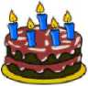
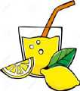
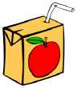
- I want some
A. cakes
B. bread
C.bean
- I want some
A. tea
B. lemonade
C milk
- I want some
A. water
B. coffee
C. juice
Exercise 14: Make questions the these answers:
- He’s from Japan
- My birthday is in May
- It’ 6 o’clock.
- I go to school at seven thirty.
- It’ Friday.
- I want some grapes.
- I want some juice.
- I go swimming on Thursdays.
- They’re playing basketball.
- She likes dancing.
Exercise 15. Write a, an or some.
^^j | 1. Do you want | fish? |  | 6. Do you want | __ rice?
 | 2. Do you want | noodles? | ^^^^^^^^^^ | 7. Do you want | ___ salad?
 | 3. Do you want | chicken? | in | 8. Do you want | ___ milk?
 | 4. Do you want | orange? | K< | 9. Do you want | __ bread?
 | 5. Do you want | grapes? | ^¡^^ | 10. Do you want __ | __ apple?
Exercise 16. Write the words in the correct order to make sentences:
- you/sandwich/like/Would /a/?
- want/ do/ What/ eat/ you/ to/?
- some/ I/ grapes/ want/
- juice/ want/ some/ I/
- to/ you/ What/ want/ drink/ do/?
- some/you/Would/like/strawberries/?
- you /chips /some /like /Would/?
11

- some/ I/ water/ want/
- lemonade/ Do/ some/ want/ you/?
- Jam/ I/ want/ some/
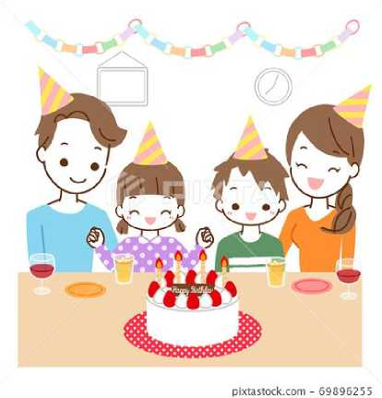
Exercise 17. Read and Circle true or false:
My name is Jane. My birthday is in October. It’s coming tomorrow. I want some hamburgers for my birthday party. My father wants some lemonade. My mother wants some grapes. My brother wants some chips and apples. My father can make cake, he is making a big birthday cake for me. My mother is cooking jam. My brother is blowing balloons for my birthday party tomorrow.
1. Her name is Jane | true/false
2. Her birthday is in September. | true/false
3. She wants some sandwiches for her birthday. | true/false
4. Her father wants some lemonade. | true/false
5. Her mother wants some oranges. | true/false
6. Her brother wants some chips and strawberries. | true/false
7. Her father is making a birthday cake. | true/false
8. Her mother is cooking fish. | true/false
9. Her brother is doing housework. | true/false
LISTENING
Part 1. Listen and write, the first one is done for you.
My name is Lona. I’m (1) 11 years old. I’m from (2)……………….. I study at school from Monday to (3)…………………. I ride a bike on (4)……………….., do (5)……………….. on Saturdays and go swimming on (6)……………….. I go to school at (7)…………… every day. My birthday is in (8)………………... It’s coming tonight. I want some (9)…………. and (10)…………….. for my birthday. My mother is cooking some (11)……………… and my sister is making some (12)………………. for the party. My father is making a birthday (13)………………. for me. Now, let’s party with my (14)………………….
Part 2. Listen and circle. There is on example.
1. | a. |  | c.
2. | a. | b. | c.
3. | a. | B  b. | c.
4. | i\i  a. | b. | c.
5. | a. | b. 1 | c.
6. | a. | b. | c.
7. | a MB a | b. | i c.

