TUẦN 19 Khối 3, 5 (Từ ngày 20/01/2025 đến ngày 24/01/2025)
THỨ | TIẾT | MÔN | TIẾT THỨ | NỘI DUNG BÀI DẠY |  | UDCNTT | ĐỒ DÙNG DẠY HỌC
Hai  20/01 | 1 | 5A | 73 | Unit 7. Sports | Lesson 2 (1, 2, 3) | Wonderfulworld | Flashcards, TV, books
Hai  20/01 | 2
Hai  20/01 | 3 | 3A | 73 | Unit 6. My body | Lesson 2 (1, 2, 3) | Wonderfulworld | Flashcards, TV, books
Hai  20/01 | 4 | 3A | 74 | Unit 6. My body | Lesson 2 (4, 5, 6) | Wonderfulworld | Flashcards, TV, books
Hai  20/01 | 5 | 5D | 73 | Unit 7. Sports | Lesson 2 (1, 2, 3) | Wonderfulworld | Flashcards, TV, books
Hai  20/01 | 6 | 3B | 73 | Unit 6. My body | Lesson 2 (1, 2, 3) | Wonderfulworld | Flashcards, TV, books
Hai  20/01 | 7
Ba  21/01 | 1 | 5C | 73 | Unit 7. Sports | Lesson 2 (1, 2, 3) | Wonderfulworld | Flashcards, TV, books
Ba  21/01 | 2 | 5B | 73 | Unit 7. Sports | Lesson 2 (1, 2, 3) | Wonderfulworld | Flashcards, TV, books
Ba  21/01 | 3 | 5A | 74 | Unit 7. Sports | Lesson 2 (4, 5, 6) | Wonderfulworld | Flashcards, TV, books
Ba  21/01 | 4
Ba  21/01 | 5 | 3A | 75 | Unit 6. My body | Lesson 2 (7, 8, 9) | Wonderfulworld | Flashcards, TV, books
Ba  21/01 | 6 | 5D | 74 | Unit 7. Sports | Lesson 2 (4, 5, 6) | Wonderfulworld | Flashcards, TV, books
Ba  21/01 | 7 | 3B | 74 | Unit 6. My body | Lesson 2 (4, 5, 6) | Wonderfulworld | Flashcards, TV, books
Tư  22/01 | 1 | 5A | 71 | Unit 7. Sports | Lesson 1 (1, 2, 3) | Wonderfulworld | Flashcards, TV, books
Tư  22/01 | 2
Tư  22/01 | 3
Tư  22/01 | 4
Tư  22/01 | 5 | 5B | 74 | Unit 7. Sports | Lesson 2 (4, 5, 6) | Wonderfulworld | Flashcards, TV, books
Tư  22/01 | 6 | 5C | 74 | Unit 7. Sports | Lesson 2 (4, 5, 6) | Wonderfulworld | Flashcards, TV, books
Tư  22/01 | 7
Năm  23/01 | 1 | 5C | 75 | Unit 7. Sports | Lesson 3 (1, 2, 3) | Wonderfulworld | Flashcards, TV, books
Năm  23/01 | 2 | 5B | 75 | Unit 7. Sports | Lesson 3 (1, 2, 3) | Wonderfulworld | Flashcards, TV, books
Năm  23/01 | 3 | 5A | 76 | Unit 7. Sports | Lesson 3 (4, 5, 6) | Wonderfulworld | Flashcards, TV, books
Năm  23/01 | 4
Năm  23/01 | 5 | 5D | 75 | Unit 7. Sports | Lesson 3 (1, 2, 3) | Wonderfulworld | Flashcards, TV, books
Năm  23/01 | 6 | 5C | 76 | Unit 7. Sports | Lesson 3 (4, 5, 6) | Wonderfulworld | Flashcards, TV, books
Năm  23/01 | 7
Sáu  24/01 | 1 | 3B | 75 | Unit 6. My body | Lesson 2 (7, 8, 9) | Wonderfulworld | Flashcards, TV, books
Sáu  24/01 | 2 | 5D | 76 | Unit 7. Sports | Lesson 3 (4, 5, 6) | Wonderfulworld | Flashcards, TV, books
Sáu  24/01 | 3 | 5B | 76 | Unit 7. Sports | Lesson 3 (4, 5, 6) | Wonderfulworld | Flashcards, TV, books
Sáu  24/01 | 4
Sáu  24/01 | 5
Sáu  24/01 | 6 | 3B | 76 | Unit 6. My body | Lesson 3 (1, 2, 3) | Wonderfulworld | Flashcards, TV, books
Sáu  24/01 | 7 | 3A | 72 | Unit 6. My body | Lesson 3 (1, 2, 3) | Wonderfulworld | Flashcards, TV, books

GRADE 3
WEEK 19 ( FROM 20/01 TO 24/01)
UNIT 6. MY HOBBY
Lesson 2. Task 1, 2, 3
Period 73
I. OBJECTIVES:
1. Knowledge:
Students will learn the words related to the topic Hobby: buy, colour, paint, dance, sing and revise the structure I/ he/ she/ we/ they can…..
2. Competences:
- English competences: Students will be able to talk about the actions they can do
- Common competences: Students will have opportunity to develop the solving problem in doing tasks and cooperation among teammates
3. Qualities:
- Students are given opportunities to think about good activities to develop their working responsibility.
II. EQUIPMENT AND MATERIALS:
- Basic things: Student’s book, flashcards, crayons.
- Advanced things: PPT, projector/interactive whiteboard/laptop/TV.
III. LESSON PROCEDURE:
Activity 1: Warm up (5 minutes)
Teacher’s activities | Student’s activities
- Greet students  Game: Find the path  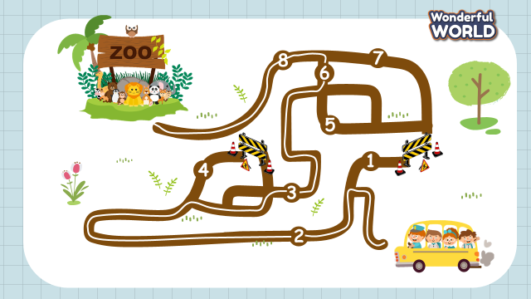  (Set context: Class 3… is going to the zoo. Students choose the correct number (1 or 2, 3 or 4, 5 or 6, 7 or 8?) and answer the question to help them find the right way.  - Set the game rules  - Play as a model  - Play game | - Greet teacher  - Listen the game rules carefully  - Look  - Join to the game
Activity 2: Presentation (8 minutes)
Teacher’s activities | Student’s activities
Lead in: Use the game to set the context: (Students talk about actions they can do on the way to the zoo) and lead in task 1  Task 1: Listen and point. Repeat. (Track 6.4)  - Use the flashcards and do the actions to introduce the vocabulary: buy, colour, dance, paint, sing  - Play the words one by one  - Play the track 6.4, ask students to listen and repeat in chorus, groups.  - Read the words at different speeds and ask students to repeat and point.  - Vocabulary checking: Whisper game: Students stand in a circle. Put the pictures in different positions in the circle. The teacher whispers a word to the student on the right. Each student whispers the word to the next person until the last person in the circle hears it. The last student find the picture that matches what he/she heard, point and say aloud. | - Learn new words through flashcards and actions  - Listen  - Repeat then point.  - Join to the activity.
Activity 3: Practice (12 minutes)
Teacher’s activities | Student’s activities
Task 2: Listen and write (Track 6.5)  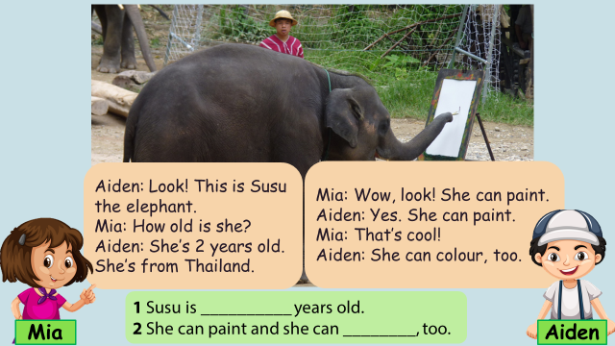  Lead-in: Introduce the listening task  - Show 2 characters Mia, Aiden again and set context that they are at the zoo.  - Show the picture of task 2  - Ask students to look at the picture and answer:  What is this?  What is she doing?  - Ask students to read 2 sentences and guess the answer before listening  - Play track 6.5 and ask students to listen.  - Play track 6.5 twice for students to give the answer  - Show the conversation and ask students to repeat  - Play role  - Some pairs perform in front of the class  Task 3: Look and say  - Show 4 pictures in task 3 and ask students to identify the actions in each picture.  - Ask students to look at the pictures and say “ He/she can….” | - Listen to the listening instruction carefully  - Listen to the audio  - Listen to the audio and write the answer  - Listen and repeat  - Play role  - Perform the dialogue with a peer  - Look and identify the actions: 1. colour, 2. dance, 3. paint, 4. sing  - Look and say  1. She can colour.  2. He can dance.  3 She can paint.  4. He can sing.
Activity 4: Production (7 minutes)
Teacher’s activities | Student’s activities
Game: Charades game  (Divide class into 6 groups. A student in each group chooses an action and acts out it for the rest of the group to guess. The rest of group have to say a full sentence He/she can…. )  - Introduce and set game rules  - Do a demo  - Play several rounds. | - Listen carefully  - Look  - Play game
Activity 5: Assessment (3 minutes)
Teacher’s activities | Student’s activities
- Ask students to do the assessment.  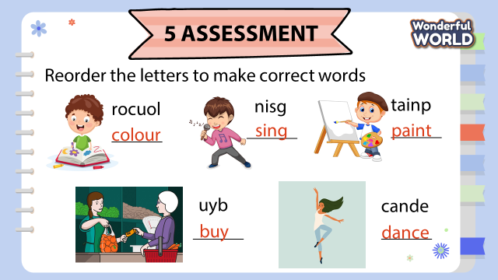  - Check in pair then whole class.  - Say goodbye | - Do the assessment.  - Check with friends and then with teacher and whole class.  - Say goodbye.
____________________________________

UNIT 6. MY HOBBY
Lesson 2. Task 4, 5, 6
Period 74
I. OBJECTIVES:
1. Knowledge:
Students will learn the structure I/ he/ she/ we/ they can’t….. and revise the words related to the topic Hobby the structure I/he/she/we/they can…
2. Competences:
- English competences: Students will be able to talk about the actions they can do and can’t do.
- Common competences: Students will have opportunity to develop the solving problem in doing tasks and the creativeness in drawing.
3. Qualities:
- Students are given opportunities to think about good activities to develop their working responsibility.
II. EQUIPMENT AND MATERIALS:
- Basic things: Student’s book, flashcards, crayons.
- Advanced things: PPT, projector/interactive whiteboard/laptop/TV.
III. LESSON PROCEDURE:
Activity 1: Warm up (5 minutes)
Teacher’s activities | Student’s activities
- Greet students  Game: Memory game.  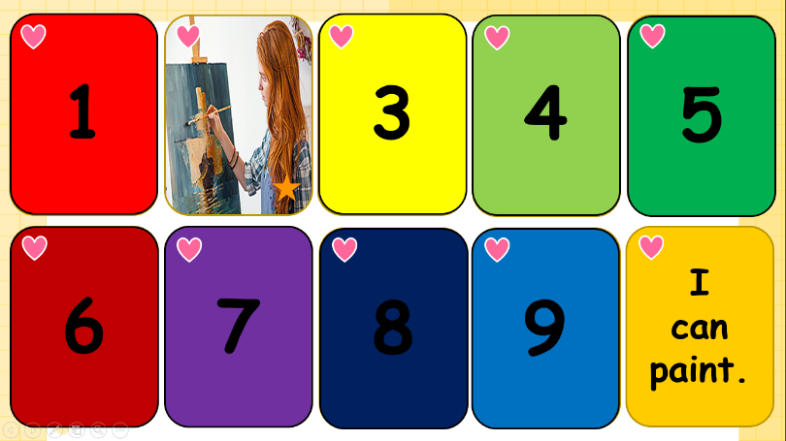  (There are 5 pairs of cards, each pair is a picture and a sentence. Students choose the numbers to find the correct pairs.)  - Set the game rules  - Play as a model  - Have students play in turns.  - Award the best groups  Suggested answers:  1- 9 He can swim  2-10 I can paint.  3- 6 She can sing  4-8 He can cook.  5-7 They can colour | - Greet teacher  - Listen the game rules carefully  - Look  - Join to the game
Activity 2: Presentation (8 minutes)
Teacher’s activities | Student’s activities
Lead in: Use a picture in the game to lead in the new structure.  Task 4: Listen and repeat. (Track 6.6)  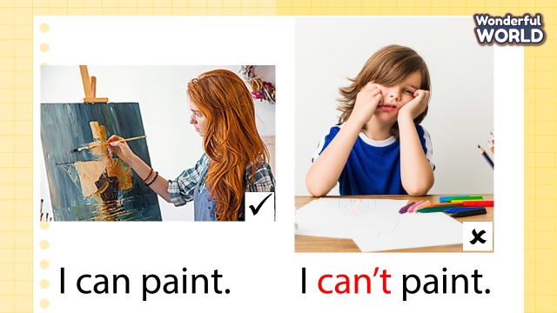  - Present the structure: I can’t….  - Ask students to point and say the actions in each picture.  - Play the track 6.6 and ask students to listen.  - Play the track 6.6 again, ask students to listen and repeat in chorus, groups.  - Structure checking:  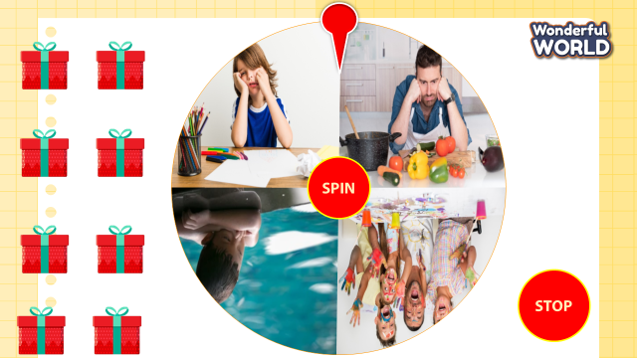  + Prepare 4 sets of sentences:  I can’t paint.  He can’t cook.  He can’t swim.  They can’t colour.  + Divide the class into 4 groups  + Set the game rules  + Hand each group a set of sentences.  + Put a chair in front of class. Teacher spin the wheel. When the arrow point to the picture, students have to pick up the sentence that corresponds to the picture. Then run to the chair and sit. The group that has a sentence correctly and fast will be the winner.  +Ask students to read the sentence again.  + Let sts open the gift box to get stars. | - Learn a new structure I can’t…  - Point and say: 1 paint, 2 cook, 3 swim, 4 colour  - Listen  - Listen and repeat  -Look and read  -Sit in 4 groups  - Listen carefully  - Receive the set of sentences  - Look at the picture and pick up the correct sentence  - Read
Activity 3: Practice (12 minutes)
Teacher’s activities | Student’s activities
Task 5: Look and say.  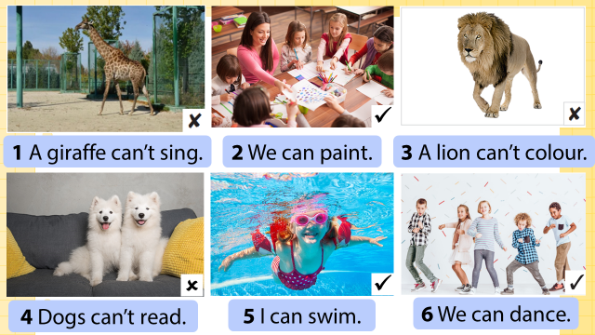  - Show the pictures in task 5  - Ask students to look at the picture and identify can or can’t in each picture.  - Ask students to read the words under each picture.  - Have students look at the pictures, point and say in chorus, group, pairs, using … can/can’t ….  Suggested answers:  1 A giraffe can’t sing.  2 We can paint.  3 A lion can colour..  4 Dogs can’t read  5 I can swim.  6 We can dance. | - Look at the picture  - Identify can or can’t: 1 can’t, 2 can, 3 can’t, 4 can’t, 5 can, 6 can  - Read the words under each picture.  - Look at the pictures, point and say in chorus, group, pairs, using … can/can’t ….

Activity 4: Production (7 minutes)
Teacher’s activities | Student’s activities
Task 6: Draw and write. Say  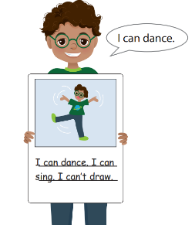  - Tell students to draw a picture of themselves doing something, like the boy in the picture.  - Ask them to show their drawings to their classmates and talk about what it is that they can do.  - Ask them to write two or three more things they can do and two or three things they can’t do.  - Ask students to hold up their books and to show each other their pictures. Ask volunteers to read out their work. | - Draw a picture of themselves doing something, like the boy in the picture.  - Show their drawings to their classmates and talk about what it is that they can do.  - Write
Activity 5: Assessment (3 minutes)
Teacher’s activities | Student’s activities
- Ask students to do the assessment.  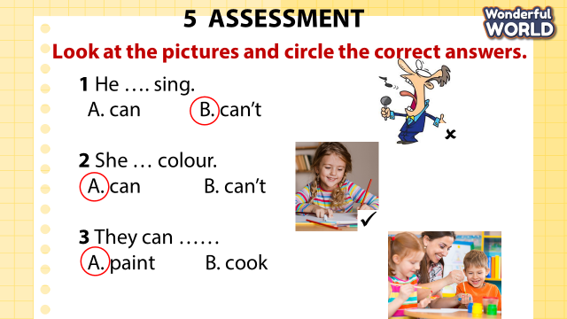  - Check in pair then whole class.  - Say goodbye | - Do the assessment.  - Check with friends and then with teacher and whole class.  - Say goodbye.
____________________________________

UNIT 6. MY HOBBY
Lesson 2. Task 7, 8, 9
Period 75
I. OBJECTIVES:
1. Knowledge:
Students will revise the structure I/ he/ she/ we/ they can/can’t….. and the words related to the topic Hobby.
2. Competences:
- English competences: Students will be able to talk about the actions they can do and can’t do, write the action words, listen and tick the answers correctly.
- Common competences: Students will have the opportunity to develop the solving problem in doing tasks and creativeness in drawing.
3. Qualities:
- Students are given opportunities to think about good activities to develop their working responsibility.
II. EQUIPMENT AND MATERIALS:
- Basic things: Student’s book, flashcards, crayons.
- Advanced things: PPT, projector/interactive whiteboard/laptop/TV.
III. LESSON PROCEDURE:
Activity 1: Warm-up (5 minutes)
Teacher’s activities | Student’s activities
- Greet students  Game: Hidden picture game.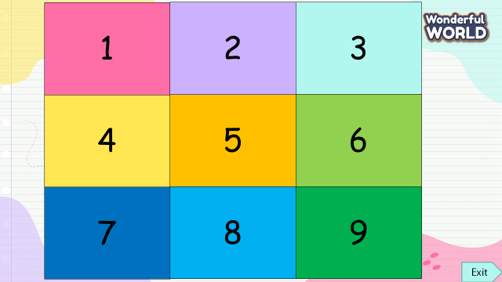  (There is a picture of a monkey covered by 9 pieces, 7 pieces are questions (1, 2, 3, 5, 6, 7, 8) and 2 pieces are lucky stars (4, 9). Students answer the questions to open these pieces and guess what is it.  - Set the game rules  - Play as a model  - Have students play in turns.  - Award the best groups  Suggested answers:  It’s a monkey. | - Greet teacher  - Listen to the game rules carefully  - Look  - Join the game
Activity 2: Practice listening (8 minutes)
Teacher’s activities | Student’s activities
Lead-in: Use the picture in the game to lead in task 7  Task 7: Listen and tick (track 6.7)  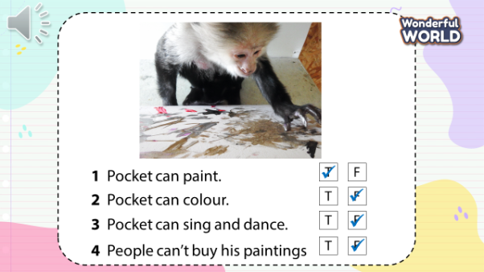  - Ask students to talk about the picture.  + What is the monkey doing?  + What can the monkey do?  - Ask students to read 4 sentences and guess the answers:  1 Pocket can paint.  2 Pocket can colour.  3 Pocket can sing and dance.  4 People can’t buy his paintings.  - Play track 6.7 and ask students to listen.  - Play track 6.7 again, ask students to listen and tick T or F  - Have students do cross-check.  - Play the audio again and check their answers.  - Show the text and the picture again  - Play the audio and ask students to repeat it. | - Look and answer  + painting  + Monkey can paint, can colour, can dance…  + Yes  - Read and guess the answers  - Listen  - Listen and tick  - Do cross-check  - Listen and check  - Look  - Listen and repeat
Activity 3: Practice writing (10 minutes)
Teacher’s activities | Student’s activities
Game: Who’s faster?  (Choose 5 students from each group and ask them to make a line. Students write the action words that they have learned on the board in a minute. Each student writes a word in each turn. The group that writes the most words correctly and fastest will be the winner.)  - Divide the class into 4 groups and choose 5 students from each group.  - Set the game rules  - Play as a model  - Have students write the action words.  - Award the best groups  Task 8: Write  - Ask students to read all the words again in the game.  - Show the sentence 1: Pocket the monkey can____ but he can’t ____ . , ask students to read and guess the missing words.  - Ask students to read the rest of the sentences and fill the blanks with their own choice.  - Ask students to show their answers and say with a friend next to them.  - Ask some students to present in front of the class. | - Sit in 4 groups and volunteer to play  - Listen carefully  - Look  - Join the game  - Read all the words on the board  - Read and guess: paint, colour.  - Read and fill in the blanks  - Say in pairs  - Present in front of the class
Activity 4: (7 minutes)
Teacher’s activities | Student’s activities
Task 9: Let’s talk  - Give students a handout  - Ask them to write their family members/ friends in the first column and draw the actions they can do in the happy face column, and the actions they can’t do in the sad face column.  - Ask them to show their handout and talk about the actions people can/can’t do in front of the class. | - Receive the handout  - Write their family members/ friends and draw the actions.  - Talk
  Me
  …..
  ……
Activity 5: Assessment (3 minutes)
Teacher’s activities | Student’s activities
- Ask students to do the assessment.  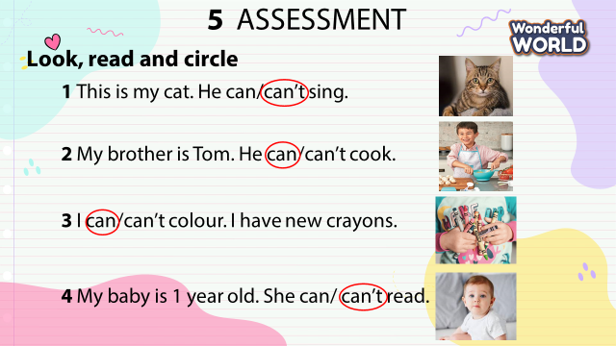  - Check-in pair then whole class.  - Say goodbye | - Do the assessment.  - Check with friends and then with the teacher and the whole class.  - Say goodbye.

UNIT 6. MY HOBBY
Lesson 3. Task 1, 2, 3
Period 76
I. OBJECTIVES:
1. Knowledge:
Students will learn the phrases related to the topic Hobby: play the drums, play the guitar, play the piano
2. Competences:
- English competences: Students will be able to talk about the musical instruments people can play.
- Common competences: Students will have the opportunity to develop communication among friends.
3. Qualities:
- Students are given opportunities to think about good hobbies to develop their ability to play musical instruments.
II. EQUIPMENT AND MATERIALS:
- Basic things: Student’s book, flashcards, crayons.
- Advanced things: PPT, projector/interactive whiteboard/laptop/TV.
III. LESSON PROCEDURE:

Activity 1: Warm-up (5 minutes)
Teacher’s activities | Student’s activities
- Greet students  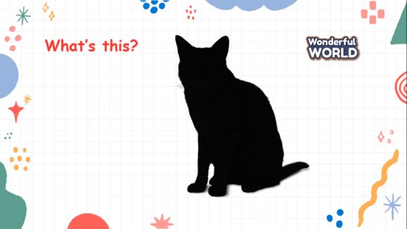  Game: Listen and guess  (Play sounds and show the shadows of objects or actions (cat, car, clock, cook, drums). Students listen and guess. The student who raises his/her hand first will get a chance to answer.)  - Divide the class into 6 groups  - Set the game rules  - Ask students to listen and guess.  - Award the best groups  Lead-in: Use the picture of the drums to lead in the new lesson. | - Greet teacher  - Sit in 6 circles  - Listen to the game rules carefully  - Play game
Activity 2: Presentation (8 minutes)
Teacher’s activities | Student’s activities
Task 1: Listen and point. Repeat. (Track 6.8)  - Use the flashcards and do the actions to introduce the vocabulary: Play the drums, play the guitar, play the piano  - Play the words one by one  - Play the track 6.8, ask students to listen and repeat in chorus, groups.  - Say a word for students to repeat then point.  - Vocabulary checking: Teacher reads a phrase (ex: play the guitar). Students listen, repeat and act out the phrase. | - Learn new words through flashcards and actions  - Listen  - Repeat the words  - Repeat then point.  - Listen, say and act out the phrases.
Activity 3: Practice (12 minutes)
Teacher’s activities | Student’s activities
Task 2:  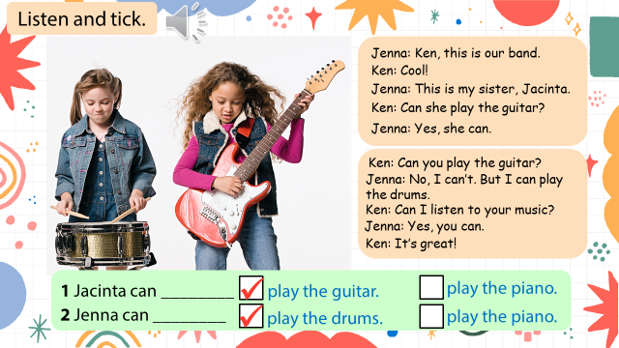  Listen and tick (Track 6.9)  Lead-in: Introduce the listening task  - Show the picture in task 2  - Ask students to look at the picture and answer:  Who are these?  What can they do?  Who is Jacita?  Who is Jenna?  - Ask students to read 2 sentences and guess the answer before listening:  1 Jacinta can play the guitar/play the piano  2 Jenna can play the drums/play the piano  - Play track 6.9 and ask students to listen.  - Play track 6.9 again for students to give the answer  - Play the audio again and ask students to do cross-check  - Show the bubbles  - Show the content one by one and ask students to repeat  - Play role  - Some pairs perform in front of the class  - Comment on each performance. | - Listen to the instruction carefully  - Look at the picture  - Give the answers:  2 girls, a band  Play the drums and play the guitar  - Read and guess  - Listen to the audio  - Listen to the audio and tick the answer  - Do cross-check  - Read aloud the sentences  - Listen and repeat  - Play role  - Perform the dialogue with a peer
Activity 4: Production (7 minutes)
Teacher’s activities | Student’s activities
Task 3: Say. Use the words in 1.  Game: Penguin sleeping  Make groups of 4  Number the students in each group 1, 2, 3, 4  Ask all students to close their eyes (go to sleep)  Say: Number 1, number 1 students wake up, check the word on the screen and then go back to sleep.  Repeat with students number 2, 3, and 4.  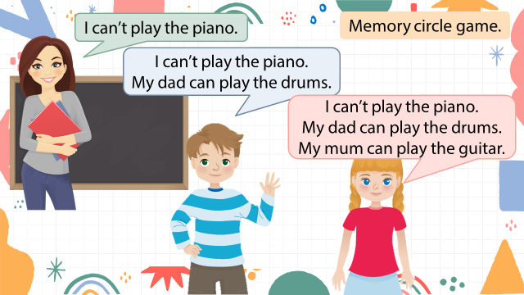  Then, the teacher says: wake up and all students  wake up and tell their words to their group members.  Each group has to say the sentence accurately.  Which group says the sentence first will be the winner.  Game: Memory circle game  (Teacher starts the game by saying a sentence, using can or can’t. Then, the next student says that sentence and then adds their own. If someone misses and gets it incorrect, they have to sit down, and the game is over..)  - Introduce and set game rules  - Do a demo  - Play several rounds. | - Listen carefully  - Look  - Play game
Activity 5: Assessment (3 minutes)
Teacher’s activities | Student’s activities
- Ask students to do the assessment.  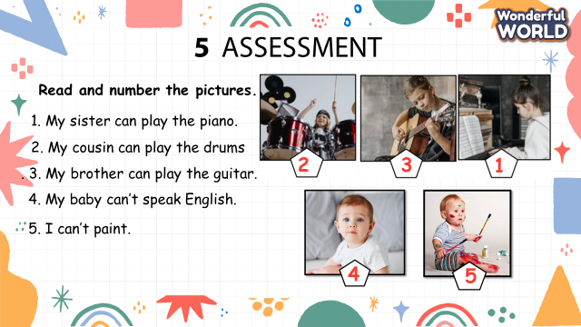  - Check-in pair then whole class.  - Say goodbye | - Do the assessment.  - Check with friends and then with the teacher and the whole class.  - Say goodbye.

GRADE 5
Week 19 (From 20/01 to 24/01)
UNIT 7: Sports
Lesson 2 - Part 1,2,3
Period 73
I. OBJECTIVES:
1. Knowledge:
Vocabulary:
- New words related to sport: control, fight, kick, mind, movement
- Listening and reading a dialogue about taekwondo.
2. Competences:
By the end of the lesson, students will be able to recognize new vocab and use vocab to talk about taekwondo.
3. Qualities:
- Students have a deeper insight into a particular sport.
- Students will be confident and active in communicating with friends and teachers.
II. EQUIPMENT AND MATERIALS:
- Basic things: Student’s book, flashcards.
- Advanced things: PPT, laptop, TV.
III. LESSON PROCEDURE:
Activity 1: Warm-up (5 minutes)
Teacher’s Activities | Students’ Activities
Aims:- Welcome students, and engage the class with a game “Order the words to make a sentence”.
- Warm-up activity to review the present continuous tense.
b, Procedure  - Greet students.  - Divide the class into many teams. Each team chooses their team names.  - Ask students to look at the words to rearrange the right sentence.  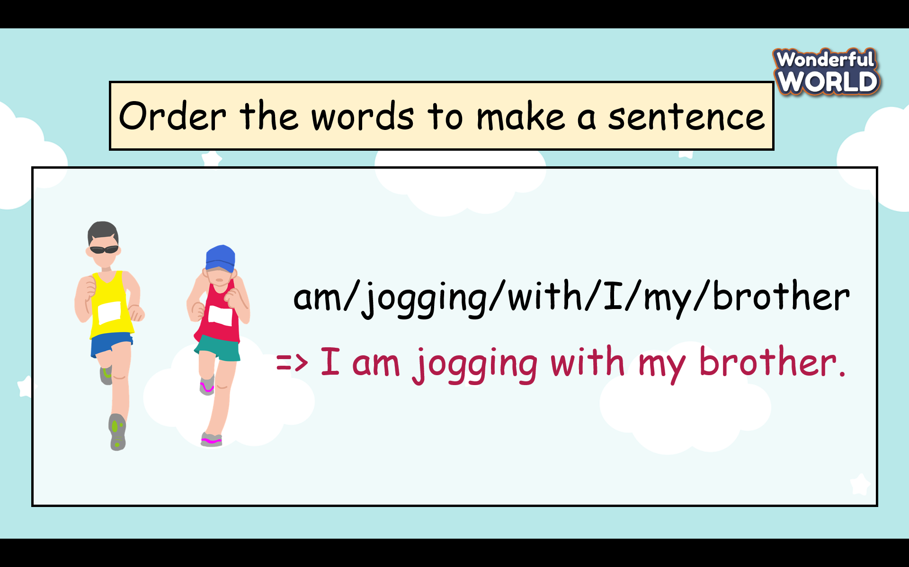  - T gives stars for the correct answer. | - Greet Teacher  - Choose the team name  - Join the activity.  - Look carefully and write the answers.  - Read the answers in front of the class.
Activity 2: Presentation (7 minutes)
Teacher’s Activities |  | Students’ Activities
Aim: Learn vocabulary about taekwondo and practice the listening skill.
Task 1 Listen and read. Then circle the correct words. TR: 7.4  -Before listening the teacher asks students to look at the picture and describe what they see in the picture.   + Where is it?  + What are they doing?  Are they young people or old people?  + Do you know the name of this sport?  - Ask students to watch a video about taekwondo.  - Ask students to look at a short dialogue and play the recording twice.  - Have students listen and read it as a group and in pairs.  - Call two pairs to read it out loud and check pronunciation if necessary.  - Ask students to read the dialogue again and circle the correct words.  - Have students work in pairs to compare answers.  - Check answers as a class by asking individual students to read the answers out loud.  Task 2 Listen, point, and repeat. TR: 7.5  - Show the five pictures, explain what they see, and guess the meaning of each word.  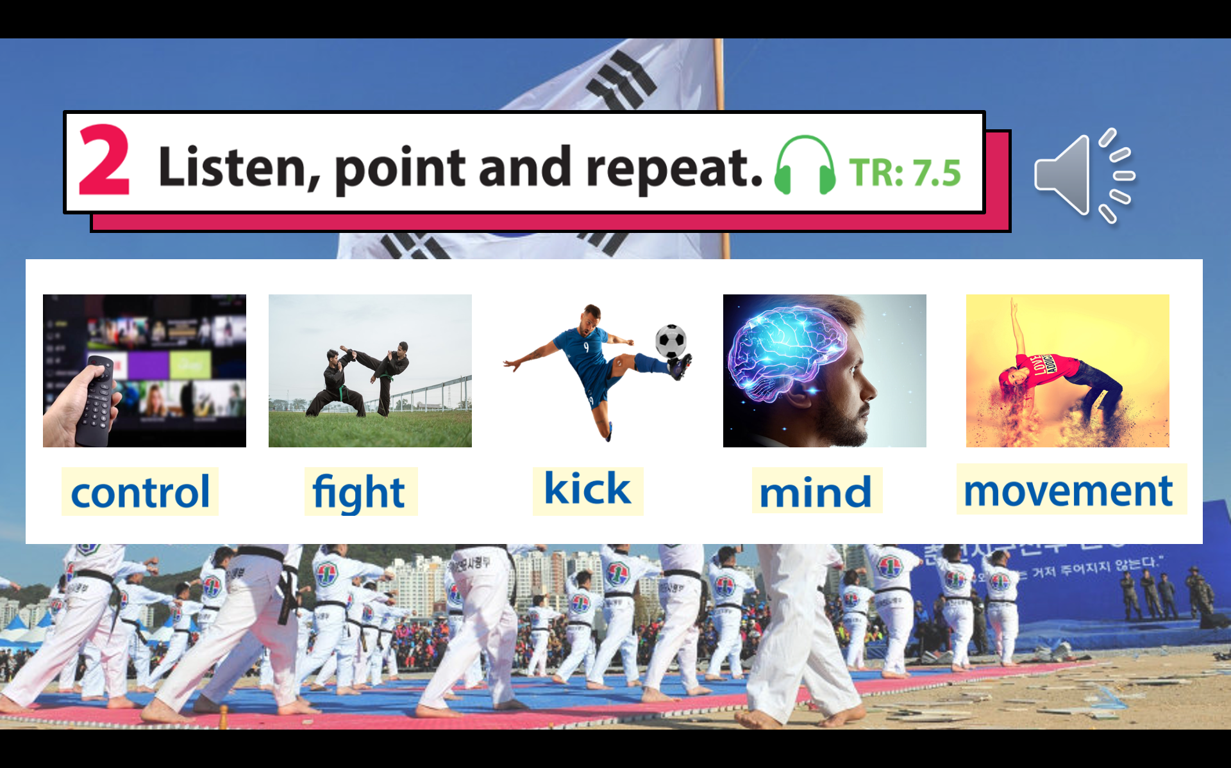  - Play the recording for students to listen, point to, and repeat the words as they hear them.  - Read out the new picture words in random order. Ask students to point to the correct pictures.  - Read each word again one by one and have students repeat. - Check pronunciation if necessary  * Mini game” look and say”  - Each picture runs across the screen and the teacher asks students to look as fast as possible and guess the picture  - T gives stars for the correct answer. |  | - Look at the picture carefully and answer the teacher’s questions.  (students can ask the teacher about words and structures if they are not sure).  - Write down ideas in the notebook( students can share ideas with their friends).  - Read each sentence in the dialogue and circle the right keywords.  2 In taekwondo, you use your mind to control your body’s movement / get ready for your body’s movement.  3 The word taekwondo means kicking / the way of the foot and the hand in Korean.  - Underline the words in the dialogue and guess the meaning of the word.  - Listen and repeat each word.( read in whole class, team and individual)  - Look quick and say fast
Activity 3: Practice (11 minutes)
Teacher’s Activities |  | Students’ Activities
Aims: Help students have a chance to find out more information about this interesting sport( taekwondo).
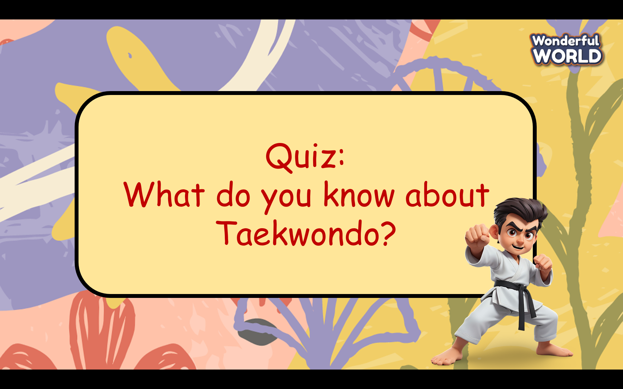  - Prepare some questions about taekwondo and ask students can read again the dialogue in task 1 (Some questions are beyond the scope of the dialogue.)  - Ask students can work in groups to choose the best answer.  - Give stars for the correct answers and the teacher can give further information on each answer. |  | - Read again the dialogue.  - Look at 4 options for each question carefully and choose the best answer.
Activity 4: Production (7 minutes)
Teacher’s Activities |  | Students’ Activities
Aims: control the class and help students sum up the content of the lesson.
“Let’s make a mind map about Taekwondo!”  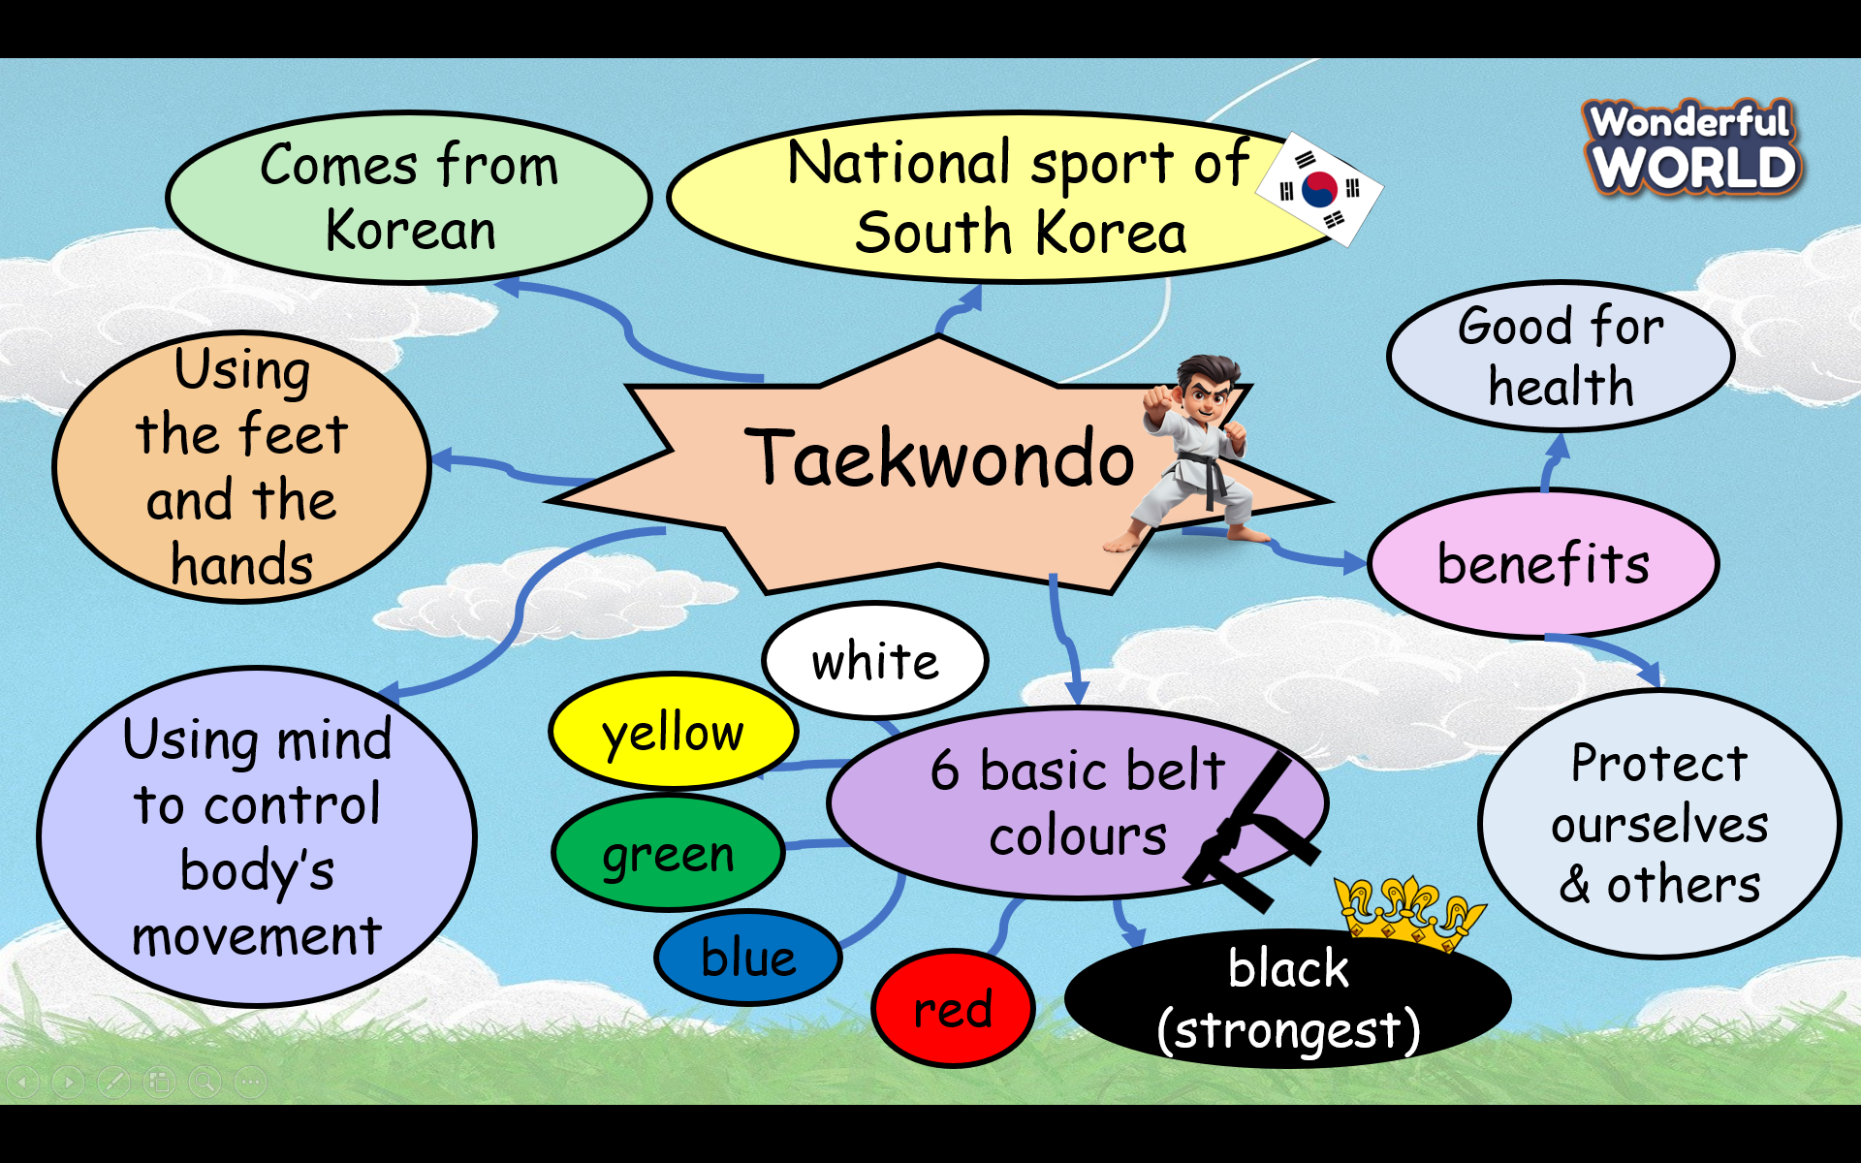  - Ask students to prepare A4 papers, pencils, crayons and work in a team of 2 or 4 students  - Ask students to make a mind map about taekwondo.  - Allow students enough time to complete the task.  - Circulate the class, providing support and guidance as needed.  - Ask each group to go to the board and present the mindmap.  - Give feedback to each team and choose the best mindmap to stick to the class’s wall. |  | - Listen to the teacher’s guide and prepare A4 papers, pencils, and crayons for the project.  -Work in a team of 2 or 4 students  - Go to the board and present the mind map in front of the class.  - Be confident and speak fluently.  - Clap their hands after each team finishes the task.
Teacher’s Activities |  | Students’ Activities
Aim:
- Check students’s understanding of what they have learnt.
- Students rehearse what they have learnt in the lesson.
- T asks sts to do the assessment (Look and circle the words)  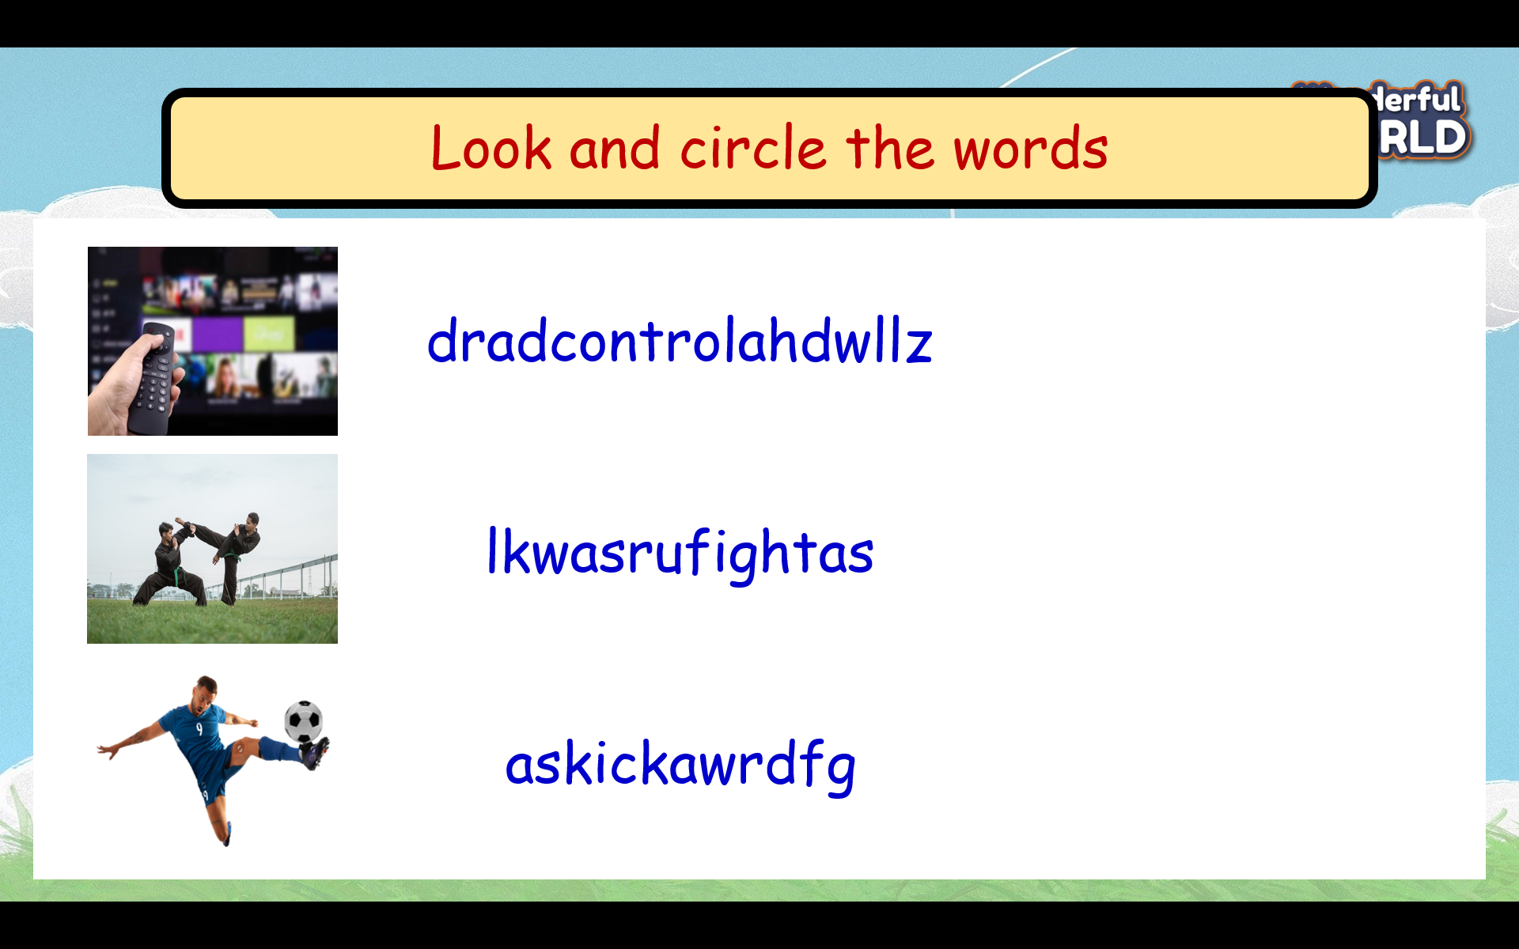  - Check with the class.  - Wrap-up  * Remember:  - Vocabulary: control, fight, kick, mind, movement |  | - Do the assessment.  - Check with the teacher  - Sts read the wrap-up  - Stand up and say goodbye to the teacher.

UNIT 7: Sports
Lesson 2 - Part 4,5,6
Period 74

I. OBJECTIVES:
1. Knowledge:
-Review Vocabulary:
control, fight, kick, mind, movement
-Review Grammar: Should / Shouldn’t
Ex: Children should learn to play a sport.
Ex: Children shouldn’t watch TV many hours a day.
2. Competences:
- English competences :- To review words relating to sports adjectives
- To talk about what a person should and shouldn’t do
- Common competences: to give some advice to help people and accomplish yourself.

3. Qualities:
- Students will be confident and active in communicating with friends and teachers.
- Students know how to care about other people around them.
II. EQUIPMENT AND MATERIALS:
- Basic things: Student’s book, flashcards.
- Advanced things: PPT, laptop, TV.
III. LESSON PROCEDURE:
Activity 1: Warm-up (5 minutes)
Teacher’s Activities | Students’ Activities
Aims:- Welcome students, and engage the class with a game “Crossword Puzzle!”.
-Warm-up activity to review the present continuous tense.
- Greet students.  -Divide the class into many teams. Each team chooses their team names.  - Ask students to choose numbers and answer the question to fill letters in the columns.  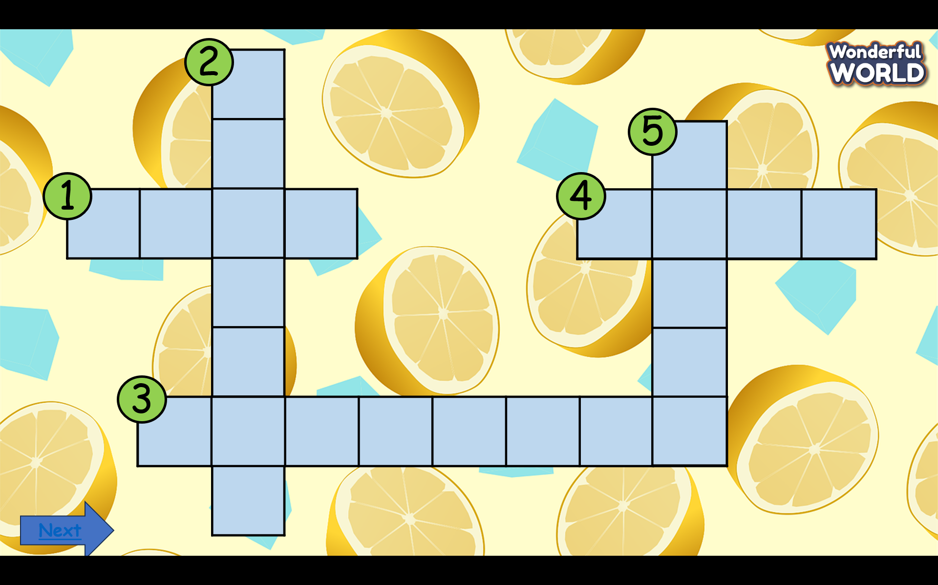  -T gives stars for the correct answer. | - Greet Teacher  -choose a team name  - Join the activity.  - After finishing the game, students read words in teams and individually.
Activity 2: Presentation (7 minutes)
Teacher’s Activities |  | Students’ Activities
Aims: - Ss are able to review the use of the modal verbs “should” and “shouldn’t”
Review Grammar: Should / Shouldn’t  *We use should or shouldn’t to give somebody advice and to say what is or isn’t the right thing to do.  Ex: You look tired. You should have some rest.  Ex: He shouldn’t drive so fast. He’ll have an accident one day.  *Should is a modal verb, and all modal verbs are followed by an infinitive (without to).  Ex: You should to listen to me.  Ex: You should listen to me.  *Should not= shouldn’t  -Ask students to look at the picture and the sentence then fill should or shouldn’t in the blank.  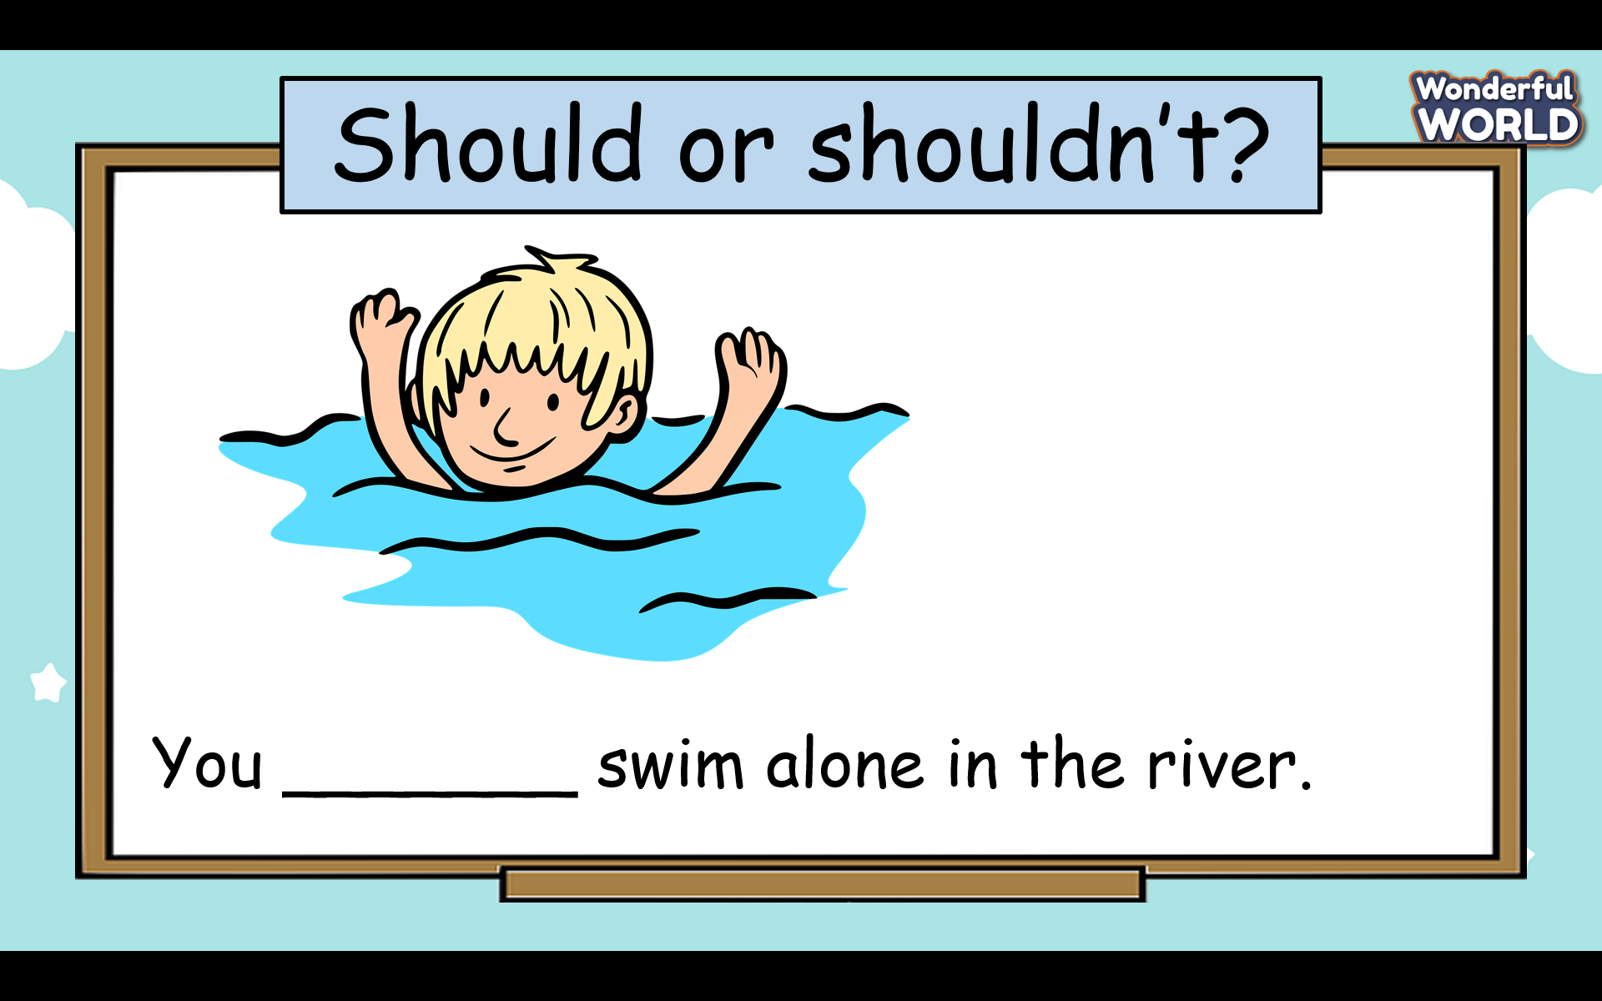  - T gives stars for the correct answer. |  | -Listen to the teacher carefully and write down in students’ notebooks.  -Read some examples from the whole class, team, and individual.)  Understand the tasks: Fill  “ should” for the picture with the tick, and “shouldn’t “ for the picture with the cross.  - Share their answers with the class.  - Check the answers.
Activity 3: Practice (11 minutes)
Teacher’s Activities |  | Students’ Activities
Aims: - Ss can complete the given sentences with “ should” and “shouldn’t” -Finish tasks 4, and 5.
Task 4 Look and match.  -Tell students that the sentences in the activity are related to should / shouldn’t.  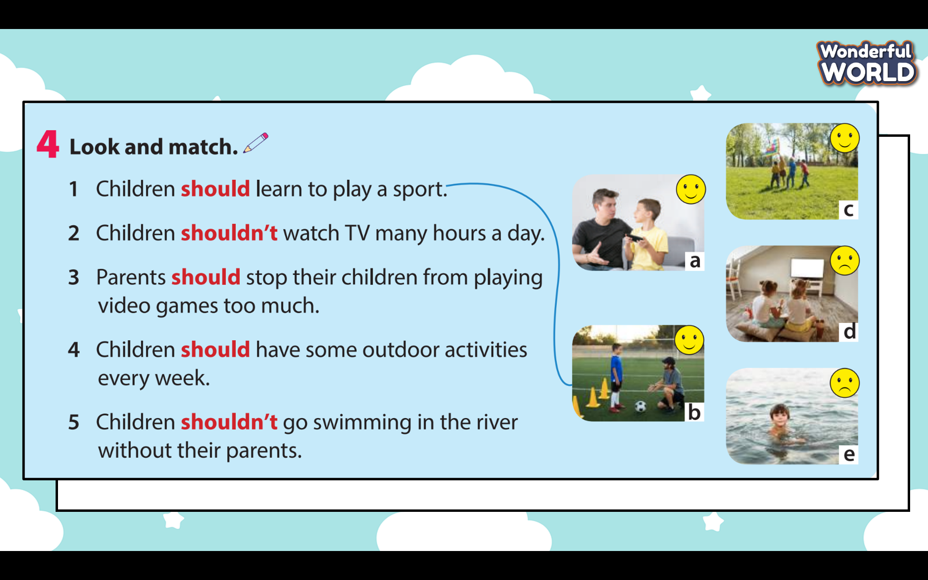  -Have students look and match each sentence with its correct picture.  -Do the first one as an example before asking students to match the rest in pairs.  - Check answers as a class.  Task 5 Make sentences using should or shouldn’t.  - Ask students to look at the sentences and the pictures in Activity 5.  e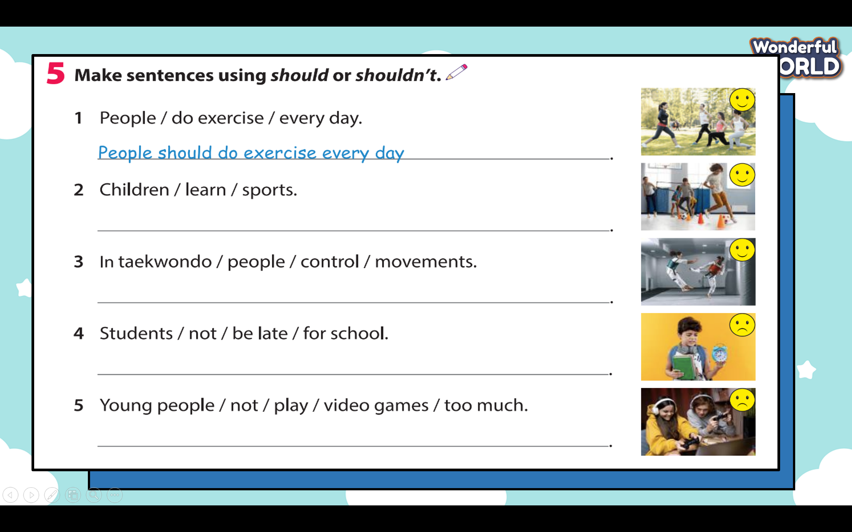  - Tell students to use should / shouldn’t to make sentences. If the picture has a happy face, they use should. And the picture has a sad face, they use shouldn’t.  - Do the first one as an example.  - Check answers as a class.  - Ask student to read each sentence to check pronunciation. |  | -Read five sentences and check the meaning of each word.  -Share the sentences with the class. Try to explain why people should or shouldn’t do those things.  -Add Should” for the picture with happy face, and “shouldn’t “ for the picture with sad face.  -Reading again each sentence many times.
Activity 4: Production (7 minutes)
Teacher’s Activities |  | Students’ Activities
Aims: -Help Ss to remember the use of “should” and “shouldn’t”
- Encourage Ss to think quickly by giving the correct answer in a short time.

Task 6 Let’s talk.  - Point to the question and answer in the bubbles. Read out the sentences and ask students to repeat them.  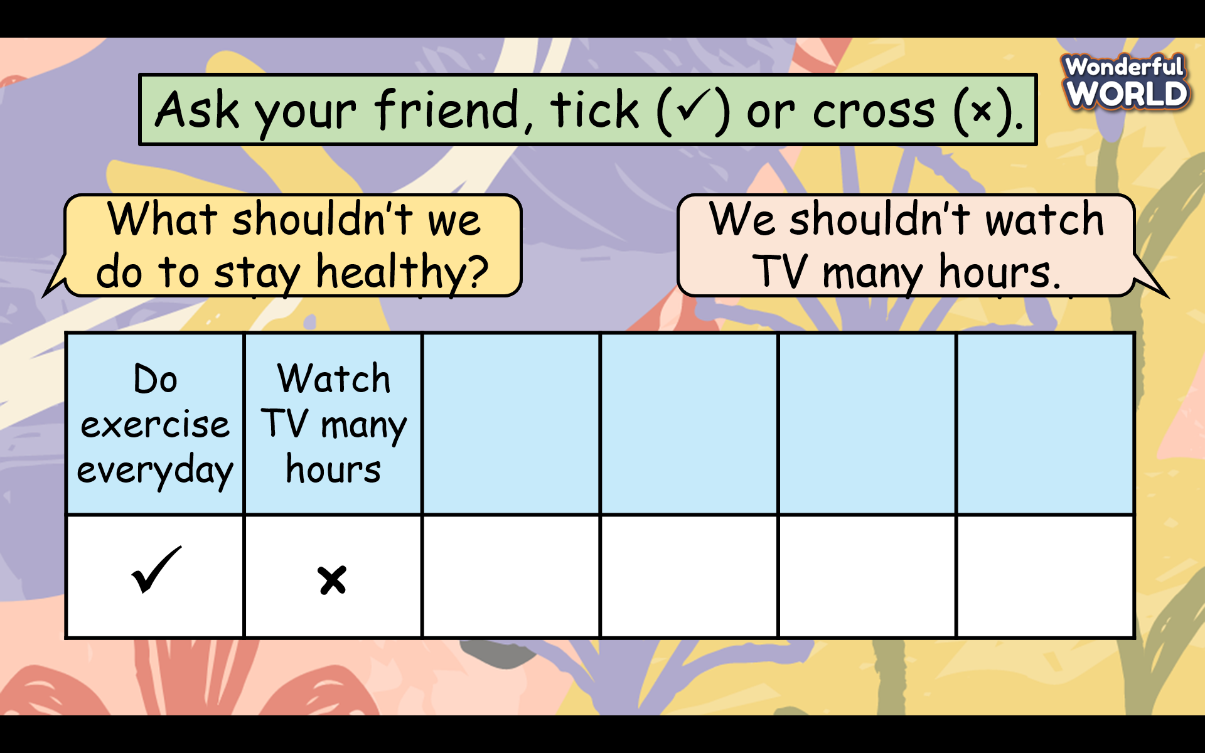  - Ask students to work in pairs. One of them is going to ask questions about their friend’s tips to stay healthy. The other answers the questions.  - Ask students to take turns by swapping roles.  - Go around the class helping where necessary. Encourage students to use as many words from Activity 1 as possible.  - Ask some volunteers to act out their dialogue in front of the class.  Example: - What should we do to stay healthy?  We should drink enough water.  - What should we do to stay healthy?  We should have a healthy diet.  - What should we do to stay healthy?  We should go to bed early |  | - Listen to the teacher’s guidance and prepare A4 papers.  -Work in a team of 2 students and take turns to swap roles.  What shouldn’t/should we do to stay healthy?  -Write the ideas into A4 paper.  - Go to the board and present the dialogue in front of the class.  - Be confident and speak fluently.  - Clap the hands after each pair finishes the task.
Teacher’s Activities |  | Students’ Activities
a, Aim:
- Check students’s understanding of what they have learned.
- Students rehearse what they have learned in the lesson.
-T asks sts to do the assessment (Look and circle the words)  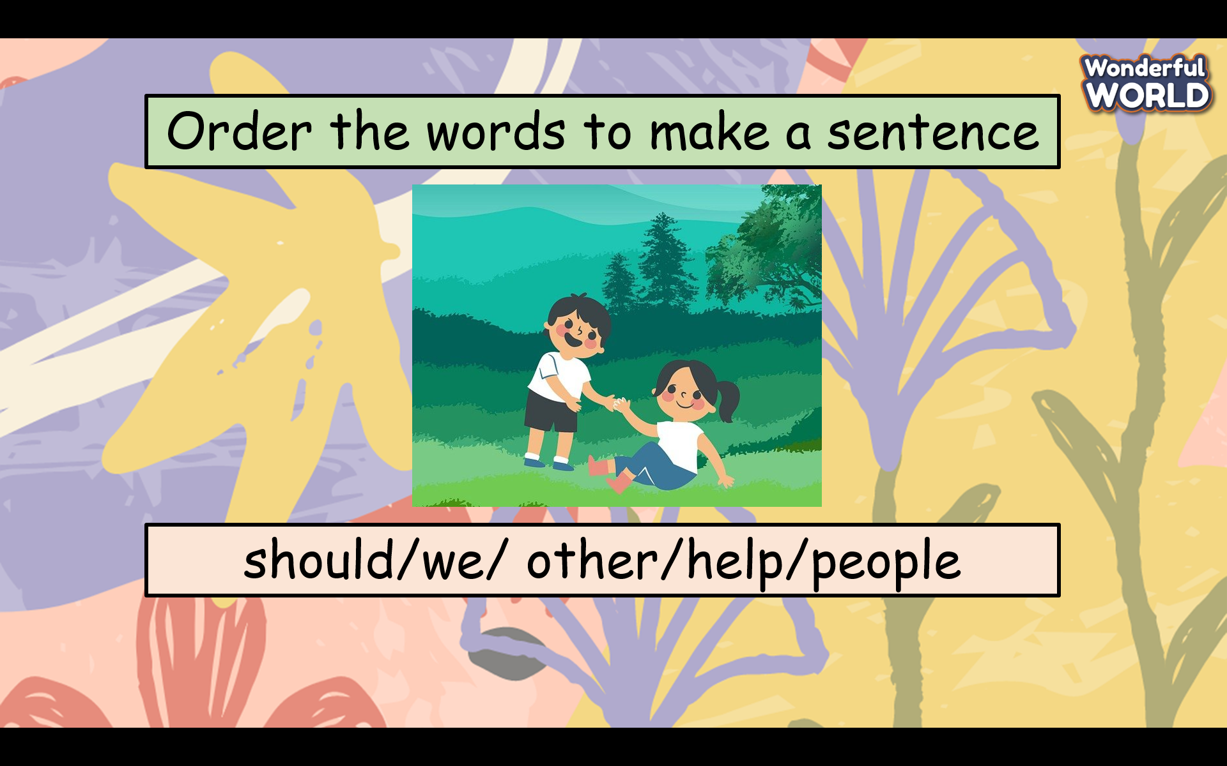  - Check with the class.  - Wrap-up  * Remember:  -Review Vocabulary:  control, fight, kick, mind, movement  -Review Grammar: Should / Shouldn’t  Ex: Children should learn to play a sport.  Ex: Children shouldn’t watch TV many hours a day. |  | -Do the assessment.  -Check with the teacher  - Sts read the wrap-up  - Stand up and say goodbye to the teacher.

UNIT 7: Sports
Lesson 3: Part 1,2,3
Period 75
I. OBJECTIVES:
1. Knowledge:
-Listening skills: Next week’s sports events
-Speaking skills: Guess the sports
2. Competences:
English competences : -To review some adjectives describing sports.
-To practise listening and speaking skills on sports topics.
Common competences: remember the names of the sports and use body language to describe a sport.
3. Qualities:
- Students will be confident and active in communicating with friends and teachers.
II. EQUIPMENT AND MATERIALS:
- Basic things: Student’s book, flashcards.
- Advanced things: PPT, laptop, TV.
III. LESSON PROCEDURE
Activity 1: Warm-up (5 minutes)
Teacher’s Activities | Students’ Activities
Aims:- Welcome students, and engage the class with a funny song.
- Greet students.  -Divide the class into many teams. Each team chooses their team names.  - Ask students to stand up and follow the actions in the video  - Give stars to the team that dances the most beautifully.   | - Greet Teacher  -choose a team name  - Join the activity.  - be active and happy
Activity 2: Review (7 minutes)
Teacher’s Activities |  | Students’ Activities
Aims: - Practice saying the full sentence with should and shouldn’t.
-List some habits and ask students to put them into the right column ( should or shouldn’t)  - Ask students on the board to write the full sentence :  We should do exercise every day  We shouldn’t play games 10 hours a day.  We shouldn’t eat fast food 5 days a week.  We should learn to swim.  We should listen to teachers.  -Give stars for each correct sentence.  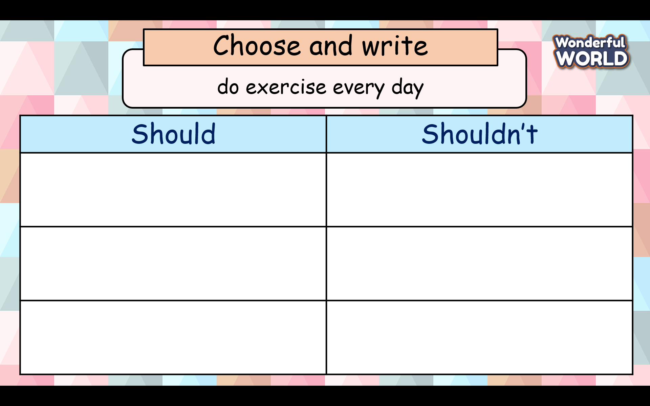  - Ask students to read each sentence many times to check pronunciation. |  | -Read habits quickly and put them into the right column.  -Read the sentence in the whole class, team and individual).
Activity 3: Practice (11 minutes)
Teacher’s Activities |  | Students’ Activities
Aims: - Listen to audio about Next week’s sports events to practice listening skills.
b, Procedure  Task 1 Look at the picture.  -Show the picture to the students.    - Ask questions such as:  1. What sport is it?  2. Is it popular in Vietnam?  3. What do we need to ice skate?  4. Do you like ice-skating? Why?  - Encourage students to think and answer. Elicit answers from the students and write them on the board.  - Give feedback.  Task 2 Read and complete. Then listen and check. TR: 7.6  - Ask students to look at three sentences and fill in the blanks with the given words to complete the sentence.  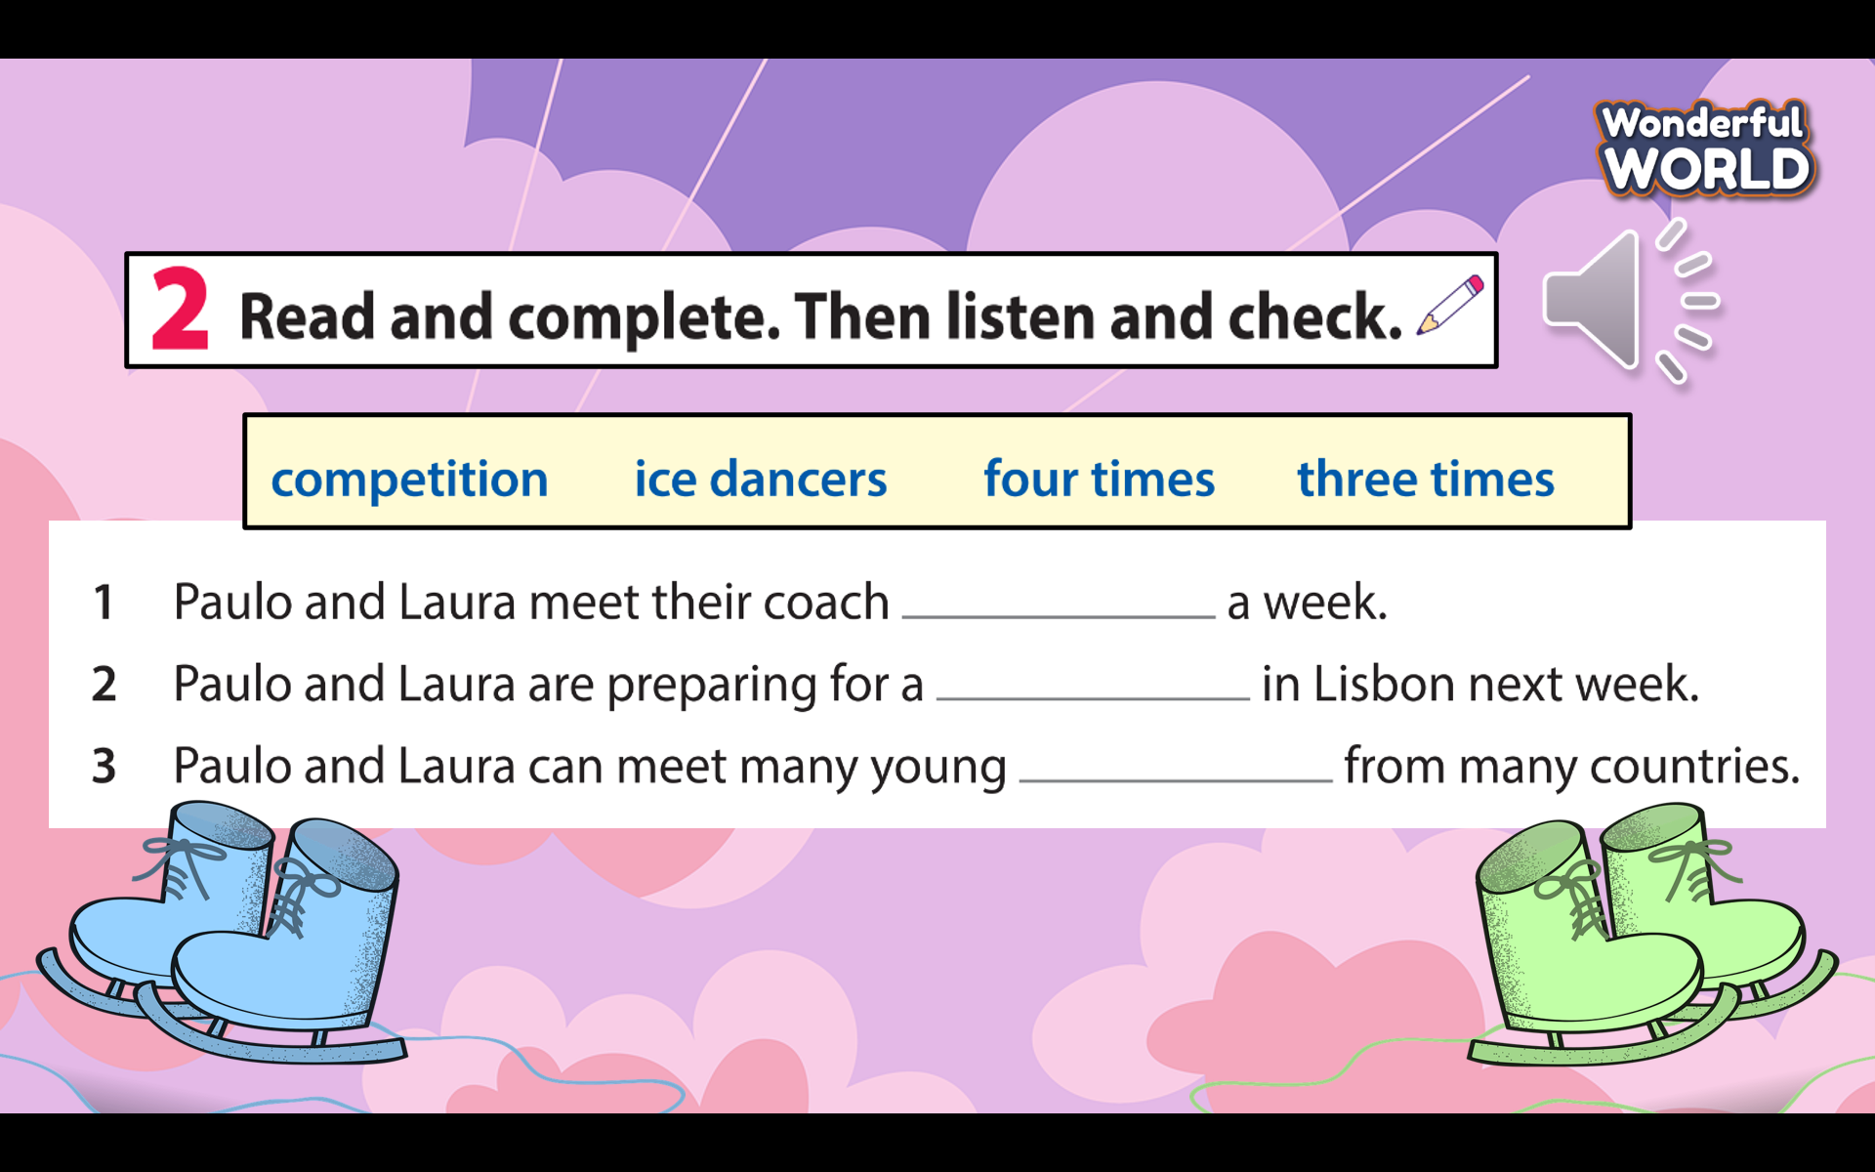  - Have students do the task in pairs.  - Have students exchange their textbooks and give feedback to each other.  - Play the recording twice and ask students to check the answers.  - Give feedback as a class discussion.  - Ask students to read each sentence individually to check pronunciation. |  | Look at the picture carefully and answer the question.  1. It’s ice-skating.  2. We need skates  3 No, it isn’t.  4. Answers may vary.  -Reading each sentence many times.  -Look through the given words and guess their meanings.  - Read each sentence and fill in the blank.  -Exchange the answers with friends  - Listen carefully to check the final result.  - Read each sentence one or two times.
Activity 4: Production (7 minutes)
Teacher’s Activities |  | Students’ Activities
Aims:- Review and help students remember the names of the sports.
-Use body language to describe a sport.
- Before doing task 3, the teacher plays a funny game “What sport is it”  - Tell students to look at this activity and explain the rules of the game. (The teacher shows some pictures about a sport, you have to guess what sport it is)  - Give stars for the correct answers  -Check student’s pronunciation.  Task 3 Let’s play. ( work in pairs)  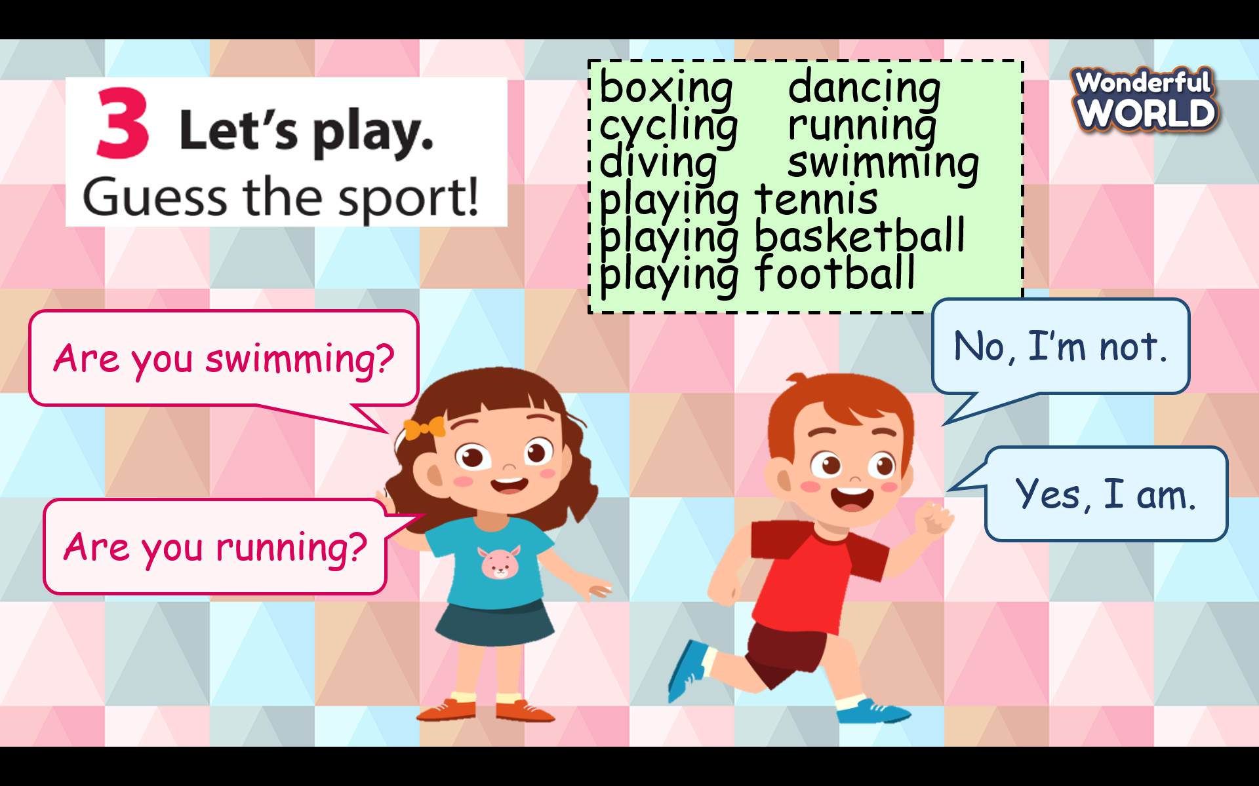  - Have students work in pairs. One does the actions and asks, while the other answers and then guesses the name of the sport.  - T recommends a list of sports for students to practice.  boxing dancing  cycling running  diving swimming  playing tennis  playing basketball  playing football  - Model and check whether students understand the instruction.  - Go around the classroom and offer help if necessary |  | - Listen to the teacher’s guidance.  - look at the pictures that relate to the sport quickly.  -Guess the name of that sport to receive stars for his/her team.  -  -Work in a team of 2 students and take turns to swap roles. ( one student does the actions, and another guesses the sport).
Teacher’s Activities |  | Students’ Activities
Aim:
- Check students’s understanding of what they have learned.
- Students rehearse what they have learned in the lesson.
-T asks sts to do the assessment (Find the wrong letter)  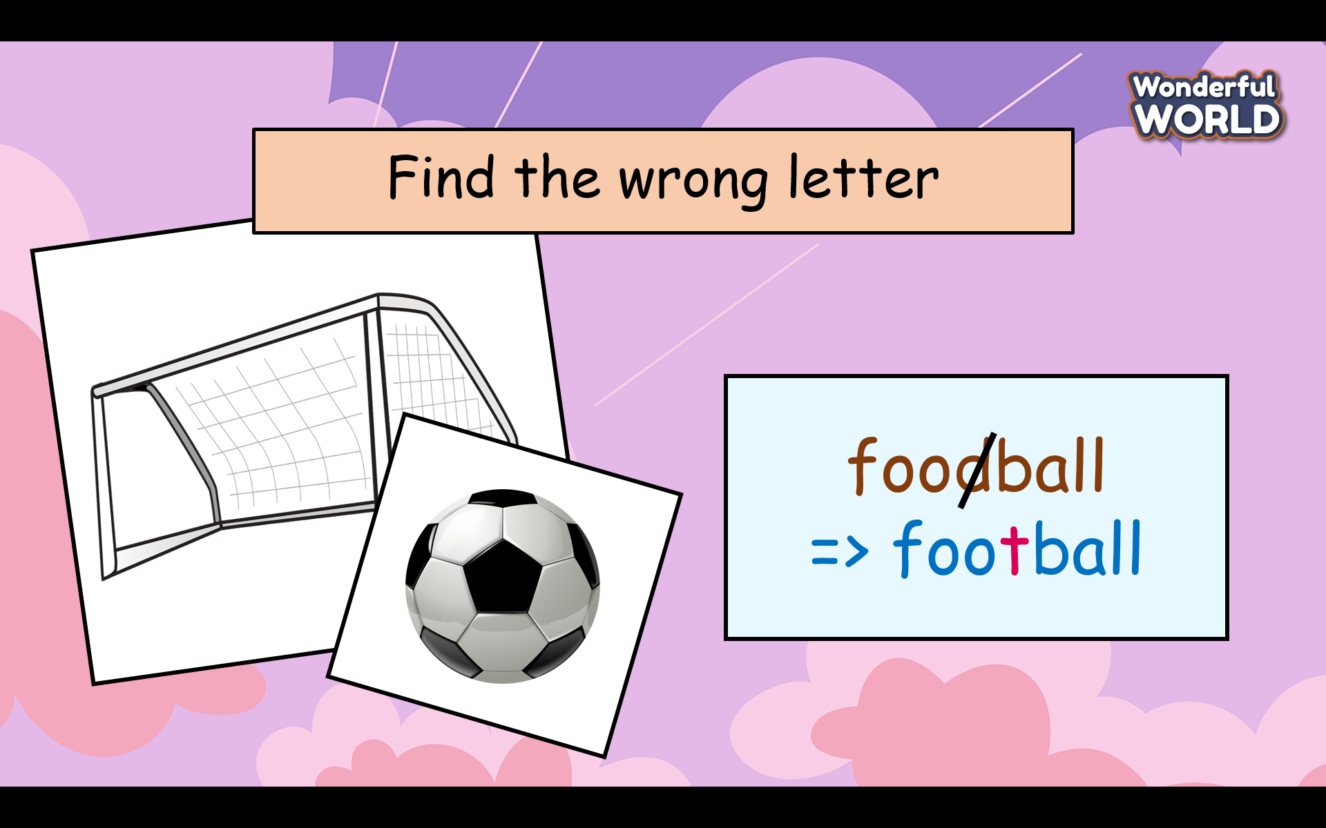  - Check with the class.  - Wrap-up  * Remember:-The names of the sports  -Practice listening and speaking about sports |  | -Do the assessment.  -Check with the teacher  - Sts read the wrap-up  - Stand up and say goodbye to the teacher.

UNIT 7: Sports
Lesson 3: Part 4-5-6
Period 76
1. Knowledge:
Grammar: Adverbs of frequency: once a week, twice a week, three times a week, four times a week.
Ex: I ride my bike twice a week.
2. Competences:
English competences:- To learn new adverbs of frequency
- Common competences: Students know how to describe how often an action happens.

3. Qualities:
- Students will be confident and active in communicating with friends and teachers
- student know how to manage their time in a week effectively.
II. EQUIPMENT AND MATERIALS:
- Basic things: Student’s book, flashcards.
- Advanced things: PPT, laptop, TV.
III. LESSON PROCEDURE:

Activity 1: Warm-up (5 minutes)
Teacher’s Activities | Students’ Activities
Aims:- Welcome students, and engage the class with a funny song. To warm up the class’s atmosphere.

- Greet students.  -Divide the class into many teams. Each team chooses their team names.  - Ask students to stand up and follow the actions in the video  - Give stars to the team that dances the most beautifully.  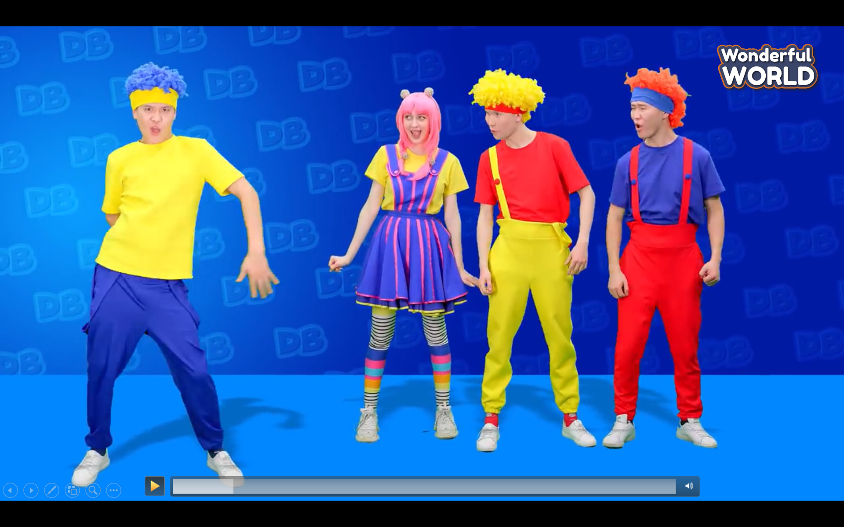 | - Greet Teacher  -choose a team name  - Join the activity.  - be active and happy
Activity 2: Presentation (7 minutes)
Teacher’s Activities |  | Students’ Activities
Aim: - Ss are able to learn new adverbs of frequency ( once a week, twice a week, three times a week, four times a week)
-Show the timetable and tick icons to express how often something occurs every week.  - Press the words for students to repeat.  -Ask students to look at the adverbs of frequency and pictures to match them together.  Answer key:1-c 2-b 3-a 4d  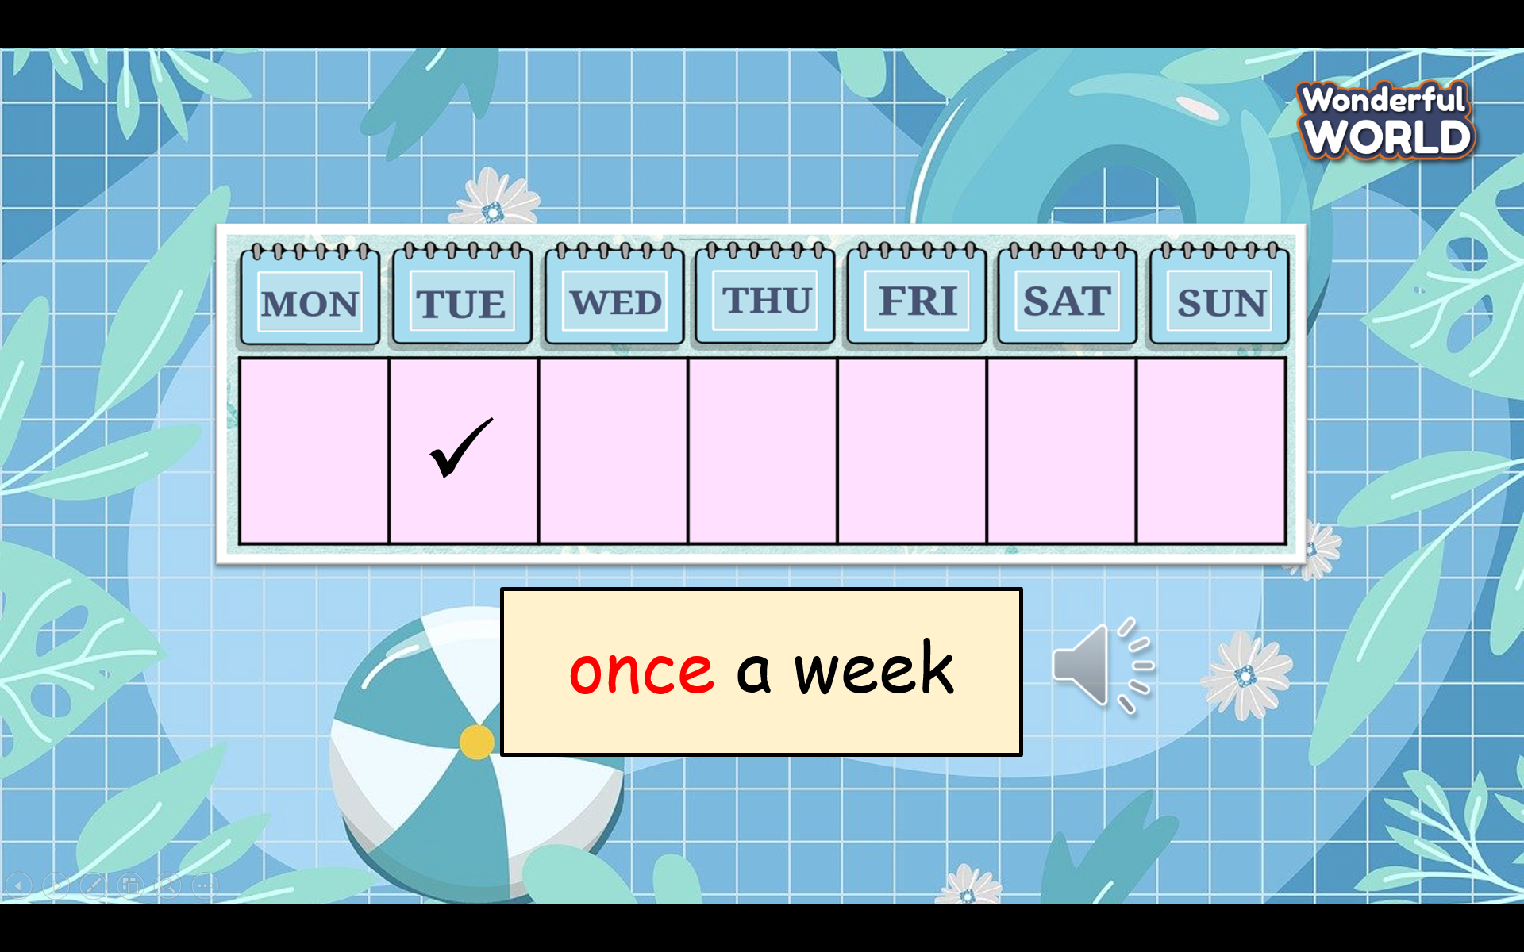  - T gives stars for the correct answer. |  | -Look at the screen and write it down in students’ notebooks.  -Read the adverbs of frequency in the whole class, team, and individual).  -Look at the picture and match.
Activity 3: Practice (11 minutes)
Teacher’s Activities |  | Students’ Activities
Aims: - Practice using the adverb of frequency in each sentence.
- Look at the picture to choose the right adverb of frequency.
Task 4 Read and circle True or False.  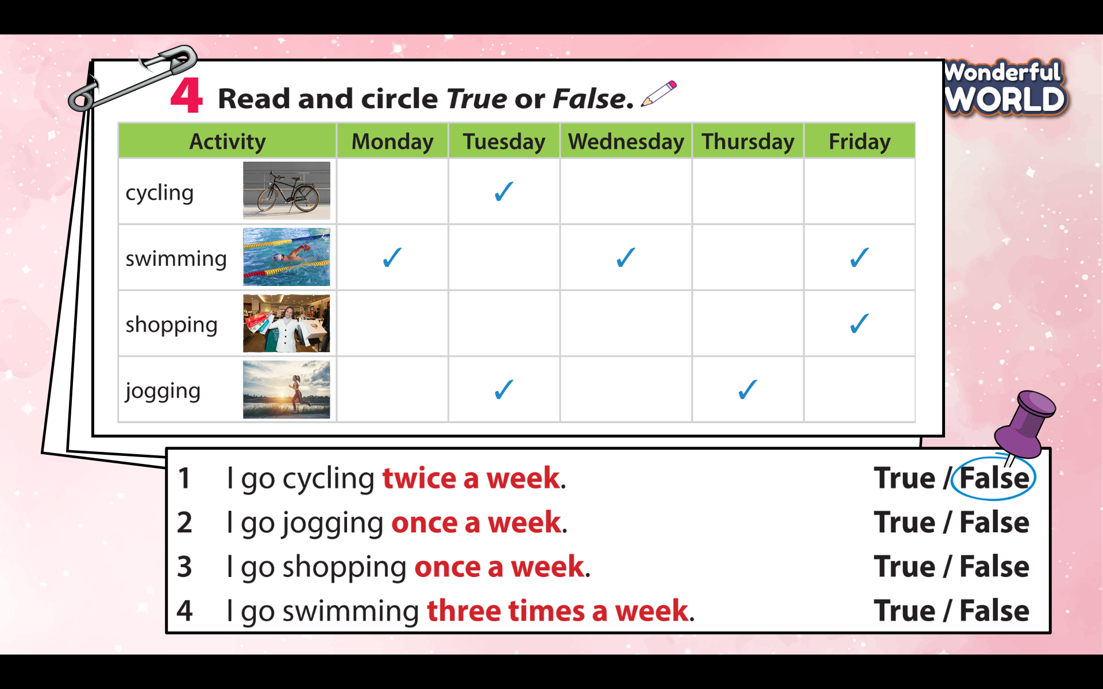  - Tell students that they are going to read and circle True or False.  - Give a few minutes for students to read four sentences and tell them to pay attention to the phrases highlighted in red.  - Ask students to look at the box and do the task.  - Do the first one as an example.  - Set a time limit go around the class and offer help if necessary.  - Have students exchange the answers with their partners.  - Call on three students to write their answers on the board and give feedback.  Task 5 Read, circle and write.  - Tell students to look at Tommy’s weekly timetable, circle, and write the correct phrases.  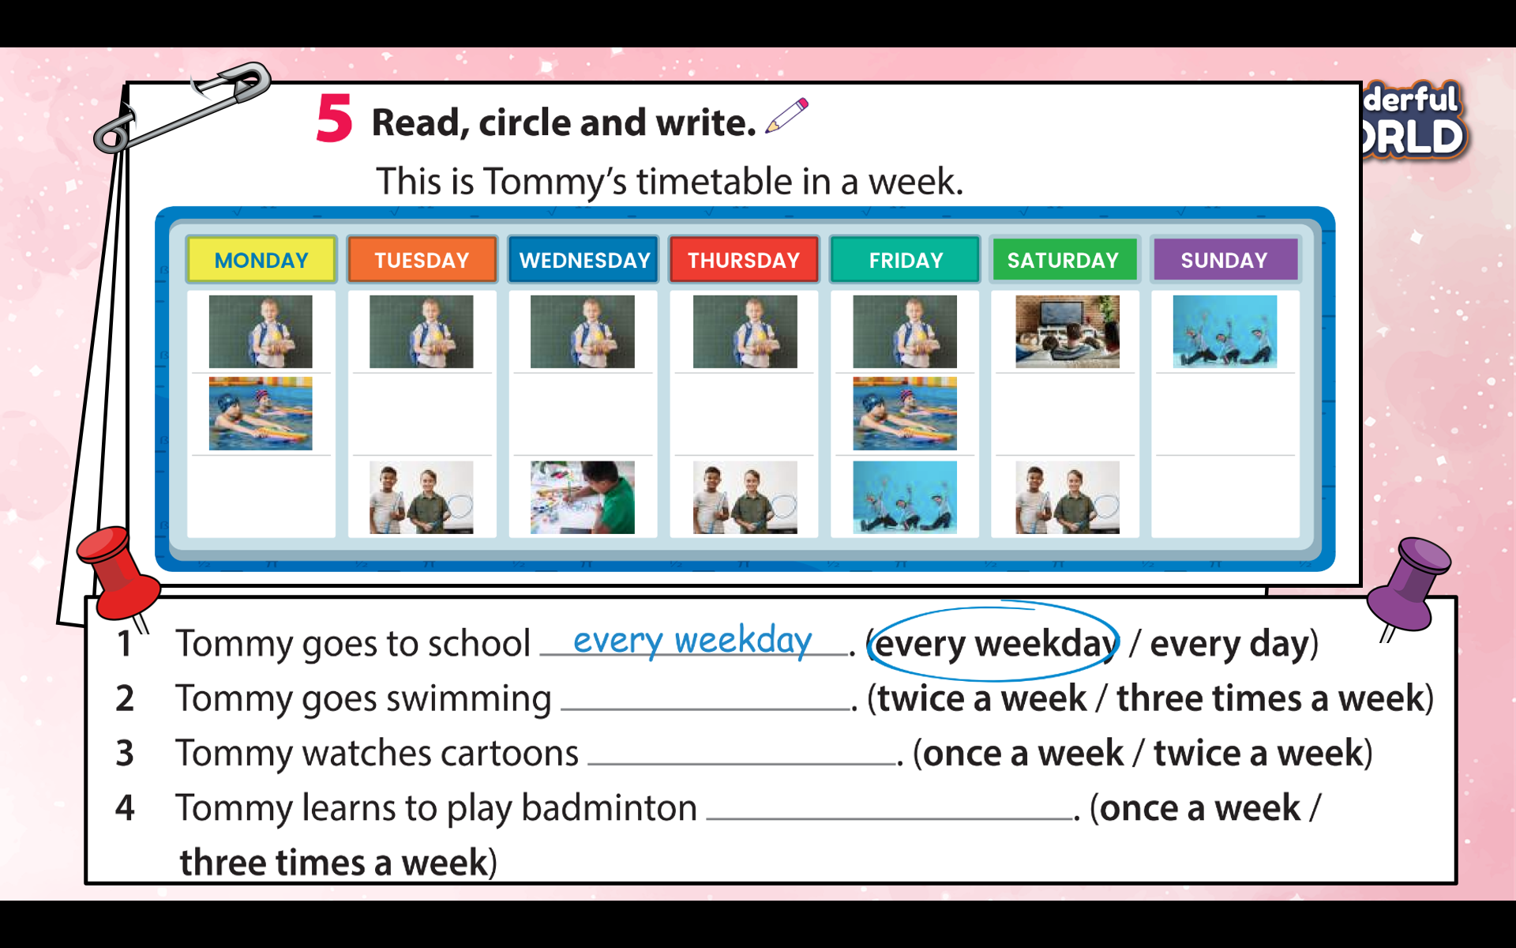  -Do the first one as an example and check whether students understand the task.  - Have students work in pairs to complete this task.  - Check answers as a class. |  | - Read four sentences and tell them to pay attention to the phrases highlighted in red.  -Look at the schedule and identify the information they read F/T.  - Correct the False sentences.  -Look at the number of the repeated pictures to circle the correct answer.  -Work in pairs to complete this task.  -Reading again each sentence many times.
Activity 4: Production (7 minutes)
Teacher’s Activities |  | Students’ Activities
Aim: -Make the timetable and write about it using different time expression.
Task 6 Make your timetable and write about it using different time expressions.  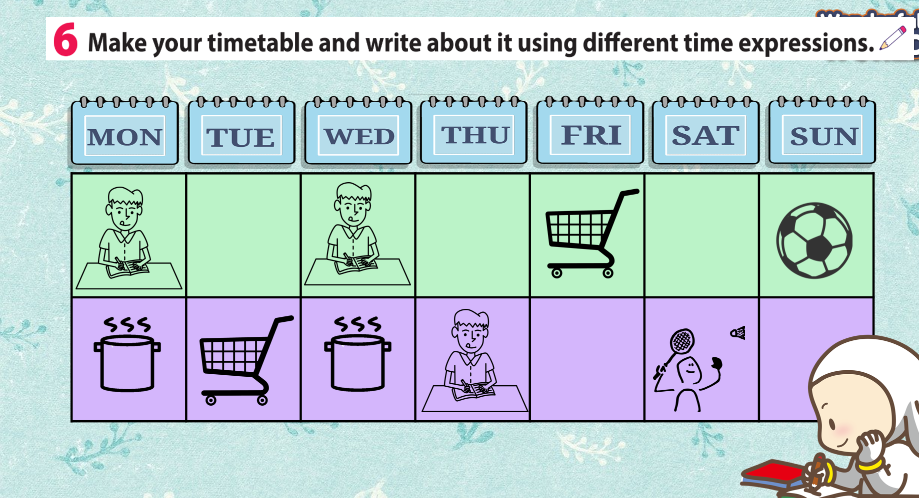  - Tell students that they are going to make their timetable.  - Show a sample timetable and give some examples of different time expressions.  - Allow students five minutes to fill in the timetable in Activity 6.  - Then tell students to write four sentences about their activities using time expressions such as every day, every weekend, in the morning, etc.  - Show students the first sentence as an example.  - Allow students five to eight minutes to write their sentences.  - Call some students to stand up and read their sentences in front of the class.  - Correct them if they make any mistakes.  -Give stars or candies to students. |  | -Look at the teacher’s timetable and his/her expression at different times in a week.  “This is my timetable.  “I learn English three times a week. I go shopping and cook twice a week. I play badminton and play football once a week”  -Make your timetable and go to the board to present it in front of the class.  - Be confident and speak fluently.  - Clap the hands after each student finishes his/her task.
Activity 5:Wrap-up & Assessment ( 5minutes)
Teacher’s Activities |  | Students’ Activities
Aim:
- Check students’s understanding of what they have learned.
- Students rehearse what they have learned in the lesson.
-T asks sts to do the assessment (Look and write)  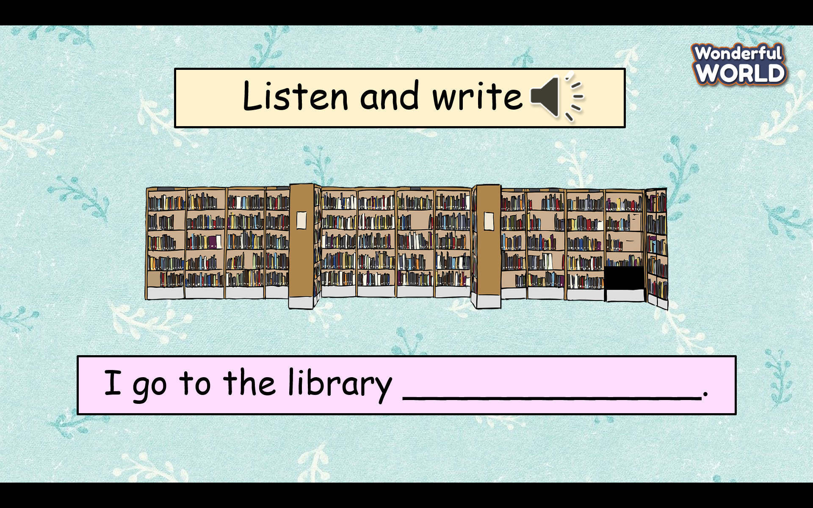  - Check with the class.  - Wrap-up  * Remember: Adverbs of frequency: once a week, twice a week, three times a week, four times a week. |  |  | Do the assessment.  -Check with the teacher  - Sts read the wrap-up  - Stand up and say goodbye to the teacher.

