UBND HUYỆN VĨNH BẢO  TRƯỜNG TH VĨNH AN | ĐỀ KHẢO SÁT CHẤT LƯỢNG CUỐI HỌC KỲ I  MÔN TIẾNG ANH LỚP 2  NĂM HỌC 2024 – 2025  (Thời gian làm bài: 40 phút)
Name: ………………………….. Class: ………………………..
I. LISTENING
Question 1. Listen and tick () (1.5 pt)
1 | 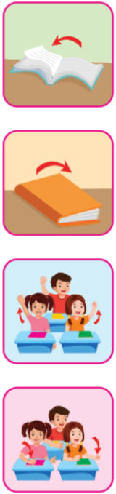 | 2 |  | 3 | 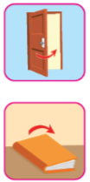
Question 2. Listen and circle the correct word (1 pt)
1 | A. fine | B. great
2 | A. thirsty | B. hungry
3 | A. scared | B. bored
4 | A. great | B. happy
Question 3. Listen and number (1pt)
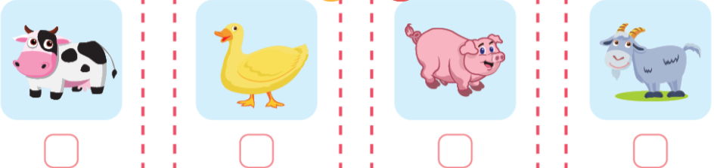
II. READING
Question 4. Circle the odd one out (1pt)
1 | A. shapes | B. triangles | C. squares
2 | A. circle | B. is | C. rectangle
3 | A. play | B. tag | C. hopscotch
4 | A. ride my bike | B. snacks | C. read books
Question 5. Read and tick the box (1.5pt)
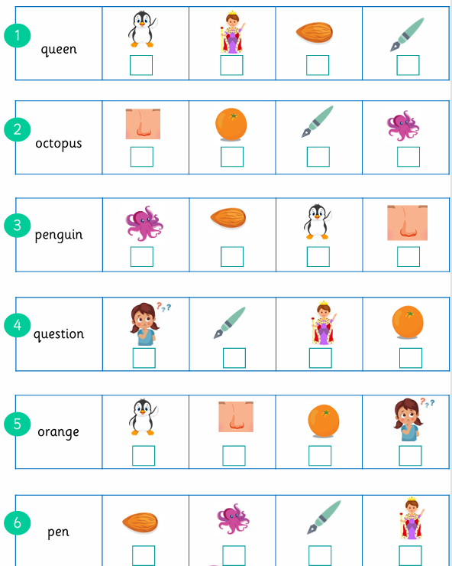
Question 6. Read and match (1pt)
1.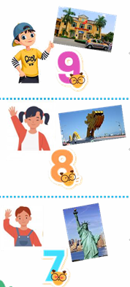 | a. I’m Bobby. I’m seven years old. I’m from New York.
2. | b. I’m Quan. I’m nine. I’m from Hai Phong.
3. | c. I’m Bill. I’m hungry.
4. 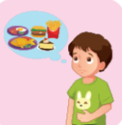 | d. I’m Linh. I’m eight. I’m from Da Nang.
Question 7. Look and write (1.5pt)
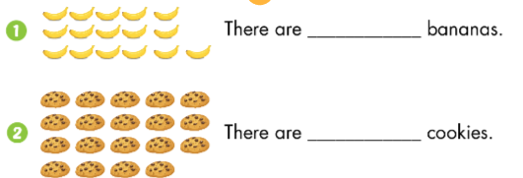
There are ____________ bananas. There are _______________ cookies.
3. 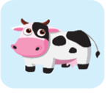 What’s this? – It’s a ______________.
Question 8. Reorder the words to make the correct sentence. (1.5pt)
1. listen / I / to / music / .
________________________________________________________
2. hide / play / seek / Let’s / and / .
________________________________________________________
3. triangles / How / are / many / there / ?
________________________________________________________
ANSWER KEYS
I. LISTENING
Question 1. Listen and tick () (1.5 pt)
1. Open your books
2. Hand ups
3. Close your books.
Question 2. Listen and circle the correct word (1 pt)
1. A 2. B 3. B 4. B
Question 3. Listen and number (1pt)
1. pig 2. goat 3. duck 4. cow
II. READING
Question 4. Circle the odd one out (1pt)
1. A 2. B 3. A 4. B
Question 5. Read and tick the box (1.5pt)
Question 6. Read and match (1pt)
1. b 2. d 3. a 4. c
Question 7. Look and write (1.5pt)
1. sixteen 2. nineteen 3. goat
Question 8. Reorder the words to make the correct sentence. (1.5pt)
1. I listen to music.
2. Let’s play hide and seek.
3. How many triangles are there?

