UBND HUYỆN VĨNH BẢO  TRƯỜNG TH VĨNH AN | ĐỀ KHẢO SÁT CHẤT LƯỢNG CUỐI HỌC KỲ I  MÔN TIẾNG ANH LỚP 3  NĂM HỌC 2024 – 2025  (Thời gian làm bài: 40 phút)
Name: ………………………….. Class: ………………………..
Question 1 : Listen and number (1pt)
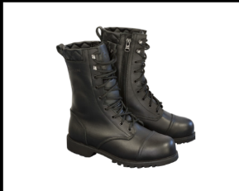
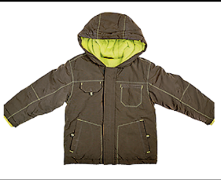
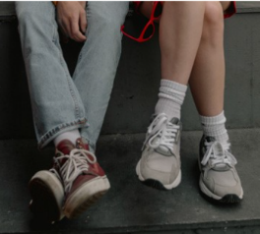
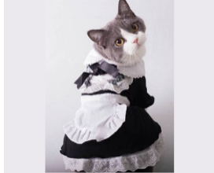

a. | b. | c. | d.
Question 2: Listen and circle the correct picture. (1pt)

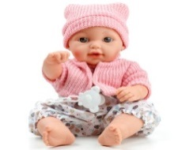

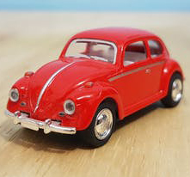


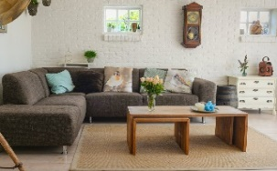
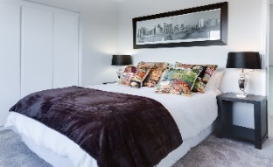
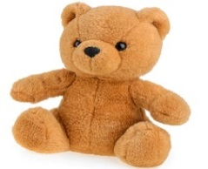
1. 2.
A
B
A
B
A
B
A
B

3. 4.

Question 3.Listen and tick the word. (1pt)
1. This is ……………………………  giraffe monkey | 2. That is ……………………………  dog lion
3. These are ………………………  monkeys elephants | 4. Those are ……………………………  giraffes rabbits
Question 4. Listen to the question and choose the correct answer. (0.5pt)
1. A. No, I don’t B. Yes, I have. C. Yes, it is
2. A. No, there isn’t B. Yes, it is. It’s a coat. C. Yes, it isn’t
Question 5: Odd one out (1.5 pts)
1. a. skirt | b. dress | c. hat | d. trousers
2. a. turtle | b. whale | c. monkey | d. shark
3. a. green | b. blue | c. orange | d. come
4. a. homework | b. board | c. desk | d. chair
5. a. funny | b. cousin | c. short | d. young
6. a. lamp | b. TV | c. computer | d. kitchen

Question 6. Choose the best answer. (1.5pts)
1..............they pencils ?
a. Is b. Am c . Are d. Do
2.They're ............. They're green
a.door b. chair c. table d. desks
3. There..........two bedrooms in my house.
a. is b. are c . this d. these
4. Is Hoa a teacher ? – No, she ……………………….
a is. b. does c. do d. isn’t
5. My sister ...........got a red skirt .
a. is b. has c. have d. are
6. Laura has got a brother……………..name is Brandon.
a. her b. my c. his d. he
Question 7. Choose the words from the box (1.5pts)
parrot - family - orange - old - mum - is
Hello, My name (1) ………………….Tung. I’m eight years (2)…………... This is a picture of my (3)………………….This is my dad. His name is Hai. This is my (4)……………….. Her name is Mai. We live in a big house. I have a (5)……………………………….in my house. Its colour is blue and (6) …. …….. I love my pet very much.
Question 8. Arrange the words to make sentences (1 pt)
1. Are / elephants / those / ?
____________________________________________________________________
2.she / got / Has / blue / a / dress/ ?
____________________________________________________________________
3. shoes / white / Their / and / black / are / .
____________________________________________________________________
4. aren’t / The / garden / in / giraffes / the /
____________________________________________________________________

Question 9. Look and write (1 pt)
1.  | 2.  | 3.  | 4.  

