UBND HUYỆN VĨNH BẢO  TRƯỜNG TH VĨNH AN | ĐỀ KHẢO SÁT CHẤT LƯỢNG CUỐI HỌC KỲ I  MÔN TIẾNG ANH LỚP 4  NĂM HỌC 2024 – 2025  (Thời gian làm bài: 40 phút)
Name: ………………………….. Class: ………………………..
I. LISTENING
Question 1. Listen and number (1pt)
a.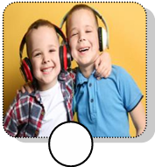 b.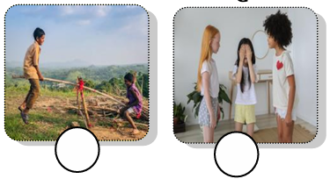 c. 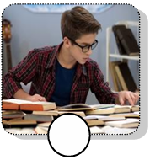 d.
Question 2. Listen and circle the correct picture (1pt)
1. Where is the table? 2. Whose bowls are they?
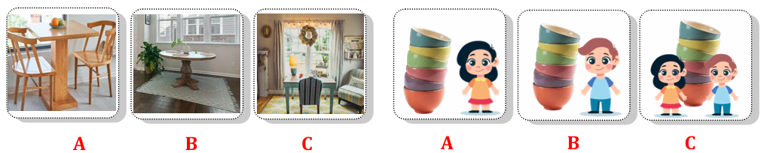
3. How many cupcakes are there? 4. What is your favourite drink?
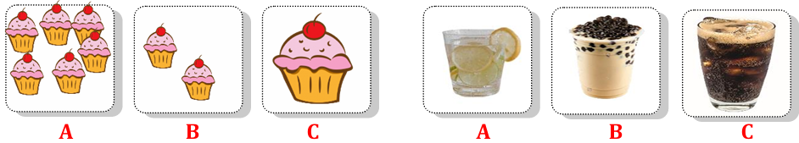
Question 3. Listen and tick (1pt)
1. They can go __________today. ice – skating ice hockey fishing
2. They can go swimming in the _____. sea river pool
3. We have got ________ on the farm. animals plants goats
4. The goat have got ___________. white tails white fur white hands
Question 4. Listen to the questions and circle the correct answers. (0,5pt)
1. A. He’s jumping rope. 2. A. They’re playing basketball.
B. She’s jumping rope. B. We’re playing on the seesaw.
II. READING
Question 5. Odd the one out (1.5pt)
1. A. daughter B. son C. father D. polite
2. A. messy B. plate C. table D. sofa
3. A. hands B. fur C. legs D. tails
4. A. vegetables B. yogurt C. twenty D. pizza
5. A. tidy B. cloudy C. snowy D. rainy
6. A. making B. dining C. pitching D. going
Question 6. Read and choose the correct answer (1.5pt)
1. The cows haven’t got _____________________.
A. tails B. fur C. head D. hands
2. Have ____________________ got wings? – Yes, they have.
A. fish B. birds C. horses D. goats
3. We’ve got some chickens ________ the farm.
A. in B. on C. at D. of
4. We can’t make a campfire today __________________ it’s rainy.
A. but B. can C. because D. Let’s
5. ______________________ can we do on the mountain?
A. Where B. Why C. What D. How many
6. It’s snowy and cold. I can _______________.
A. have a picnic B. go fishing C. pitch a tent D. go skiing
Question 7. Fill in the blank with the given words (1,5pt)
egg and food cupcakes pieces sandwich
Today, Tim has lunch at school. His mom made a lot of (1) _______________ for him. Tim has got two(2) _______________ of pizza, some spaghetti (3) _______________ yoghurt for his lunch. His friends are having lunch with him. Jake has got a (4) _______________, some nuts and an orange for his lunch. Jane has got an (5) ______________ and some vegetables. Surprisingly, today is Tammy’s birthday! She brought twenty-four (6) ______________ and some bubble tea for her classmates. They eat together and have lots of fun!
Question 8. Reorder the words to make the correct sentence. (1pt)
1. is / weather/ today / The / sunny / .
_______________________________________________________
2. Are / tree / they / the / climbing / ?
_______________________________________________________
3. the / in / What / like / weather / is / winter / ?
_______________________________________________________
4. board / home / I’m / playing / at / games / .
_______________________________________________________

Question 9. Look and write (1pt)
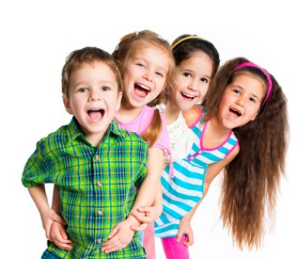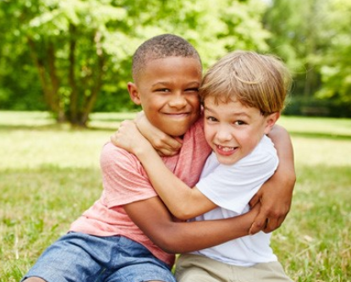
1. ________________ 2. ____________ 3. ______________ 4. ________________

