TUẦN 20 Khối 3, 5 (Từ ngày 03/02/2025 đến ngày 07/02/2025)
THỨ | TIẾT | MÔN | TIẾT THỨ | NỘI DUNG BÀI DẠY |  | UDCNTT | ĐỒ DÙNG DẠY HỌC
Hai  03/02 | 1 | 5A | 77 | Unit 7. Sports | Lesson 3 (7, 8, 9, 10) | Wonderfulworld | Flashcards, TV, books
Hai  03/02 | 2
Hai  03/02 | 3 | 3A | 77 | Unit 6. My body | Lesson 3 (4, 5, 6) | Wonderfulworld | Flashcards, TV, books
Hai  03/02 | 4 | 3A | 78 | Unit 6. My body | Lesson 3 (7, 8, 9) | Wonderfulworld | Flashcards, TV, books
Hai  03/02 | 5 | 5D | 77 | Unit 7. Sports | Lesson 3 (7, 8, 9, 10) | Wonderfulworld | Flashcards, TV, books
Hai  03/02 | 6 | 3B | 77 | Unit 6. My body | Lesson 3 (4, 5, 6) | Wonderfulworld | Flashcards, TV, books
Hai  03/02 | 7
Ba  04/02 | 1 | 5C | 77 | Unit 7. Sports | Lesson 3 (7, 8, 9, 10) | Wonderfulworld | Flashcards, TV, books
Ba  04/02 | 2 | 5B | 77 | Unit 7. Sports | Lesson 3 (7, 8, 9, 10) | Wonderfulworld | Flashcards, TV, books
Ba  04/02 | 3 | 5A | 78 | Unit 7. Sports | Fun time and project (1, 2, 3) | Wonderfulworld | Flashcards, TV, books
Ba  04/02 | 4
Ba  04/02 | 5 | 3A | 79 | Unit 6. My body | Fun time and project (1, 2) | Wonderfulworld | Flashcards, TV, books
Ba  04/02 | 6 | 5D | 78 | Unit 7. Sports | Fun time and project (1, 2, 3) | Wonderfulworld | Flashcards, TV, books
Ba  04/02 | 7 | 3B | 78 | Unit 6. My body | Lesson 3 (7, 8, 9) | Wonderfulworld | Flashcards, TV, books
Tư  05/02 | 1 | 5A | 79 | Unit 7. Sports | Fun time and project (4, 5) | Wonderfulworld | Flashcards, TV, books
Tư  05/02 | 2
Tư  05/02 | 3
Tư  05/02 | 4
Tư  05/02 | 5 | 5B | 78 | Unit 7. Sports | Fun time and project (1, 2, 3) | Wonderfulworld | Flashcards, TV, books
Tư  05/02 | 6 | 5C | 78 | Unit 7. Sports | Fun time and project (1, 2, 3) | Wonderfulworld | Flashcards, TV, books
Tư  05/02 | 7
Năm  06/02 | 1 | 5C | 79 | Unit 7. Sports | Fun time and project (4, 5) | Wonderfulworld | Flashcards, TV, books
Năm  06/02 | 2 | 5B | 79 | Unit 7. Sports | Fun time and project (4, 5) | Wonderfulworld | Flashcards, TV, books
Năm  06/02 | 3 | 5A | 80 | Unit 8. People and places | Lesson 1 (1, 2, 3) | Wonderfulworld | Flashcards, TV, books
Năm  06/02 | 4
Năm  06/02 | 5 | 5D | 79 | Unit 7. Sports | Fun time and project (4, 5) | Wonderfulworld | Flashcards, TV, books
Năm  06/02 | 6 | 5C | 80 | Unit 8. People and places | Lesson 1 (1, 2, 3) | Wonderfulworld | Flashcards, TV, books
Năm  06/02 | 7
Sáu  07/02 | 1 | 3B | 79 | Unit 6. My body | Fun time and project (1, 2) | Wonderfulworld | Flashcards, TV, books
Sáu  07/02 | 2 | 5D | 80 | Unit 8. People and places | Lesson 1 (1, 2, 3) | Wonderfulworld | Flashcards, TV, books
Sáu  07/02 | 3 | 5B | 80 | Unit 8. People and places | Lesson 1 (1, 2, 3) | Wonderfulworld | Flashcards, TV, books
Sáu  07/02 | 4
Sáu  07/02 | 5
Sáu  07/02 | 6 | 3B | 80 | Unit 7. My favourite sport | Lesson 1 (1, 2, 3) | Wonderfulworld | Flashcards, TV, books
Sáu  07/02 | 7 | 3A | 80 | Unit 7. My favourite sport | Lesson 1 (1, 2, 3) | Wonderfulworld | Flashcards, TV, books

GRADE 3

WEEK 20 (FROM 03/02 TO 07/02)
UNIT 6. MY HOBBY
Lesson 3 -Task 4,5,6
Period 77
I. OBJECTIVES:
1. Knowledge:
Students will learn the structure - Can ………? - Yes, …. can./No, … can’t and revise the words related to the topic Hobby.
2. Competences:
- English competences: Students will be able to ask and answer about ability.
- Common competences: Students will have the opportunity to develop the solving problem in doing tasks and creativeness in composing music.
3. Qualities:
- Students are given opportunities to think about good activities to develop their working responsibility.
II. EQUIPMENT AND MATERIALS:
- Basic things: Student’s book, flashcards, crayons.
- Advanced things: PPT, projector/interactive whiteboard/laptop/TV.
III. LESSON PROCEDURE:
Activity 1: Warm-up (5 minutes)
Teacher’s activities | Student’s activities
- Greet students  Game: Move and Freeze game.  (Divide the class into 4 groups. Choose a student from each group. Shows the picture and asks students to say a full sentence, using can/ can’t. If students say correctly, they can continue the game. Then, the teacher closes his/ her eyes and counts 1, 2, 3. While the teacher closes her/his eyes, the students step forward quickly. When the teacher opens her/his eyes, students must freeze immediately. If a student does not freeze immediately, he/ she must back their seat. The students who can go and touch the teacher will be the winner.)  - Set the game rules  - Play as a model  - Have students play in turns.  - Award the best groups  Suggested answers:  1 She can play the guitar  2 He can’t cook  3 He can read  4 He can’t colour.  5 I can write  6 She can swim  7 We can dance  8 They can’t play the drums.  9 He can’t sing  10 I can paint | - Greet teacher  - Listen to the game rules carefully  - Look  - Join the game
Activity 2: Presentation (8 minutes)
Teacher’s activities | Student’s activities
Lead-in: Use a picture in the game to lead in the new structure.  Task 4: Listen and repeat. (Track 6.10)  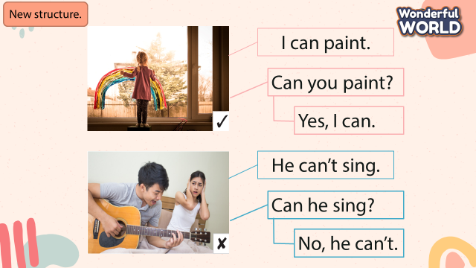  - Present the structure:  + Can … ?  + Yes, … can/ No, …. can’t  - Ask students to point and say the actions in each picture.  - Ask students to identify Yes or No  - Play track 6.10 and ask students to listen.  - Play the track 6.10 again, ask students to listen and repeat in chorus, groups.  - Structure checking: Teacher says the questions: Can … ? and asks students to run, point to the picture related to the question and answer Yes .. can/ No, … can’t  + Divide the class into 4 groups  + Set the game rules  + Play as a model  + Have students play in turns.  + Award the best groups  - Point to the pictures and ask students to read again. | - Learn a new structure  - Point and say: 1 can paint, 2 can sing, 3 can’t sing, 4 can’t play the drums  - 1 Yes, 2 Yes, 3 No, 4 No  - Listen  - Listen and repeat  -Sit in 4 groups  - Listen carefully  - Look  - Join the activity  - Read
Activity 3: Practice (12 minutes)
Teacher’s activities | Student’s activities
Task 5: Look and say.  Fast speed game:  - Divide the class into 2 groups, choose a student from each group  - Give instruction: Look at the pictures and keywords, ask a student to make the question: Can … ? and another to answer the question.  - Show the pictures in task 5 one by one  - Ask students to ask and answer the question about actions people can do or can’t do in pairs  - The pairs that give the correct answer first will get the stars  - Have students look at the pictures, point and say in chorus, group, pairs  Suggested answers:  1 Can a shark swim? Yes it can  2 Can he sing? No, he can’t  3 Can she play the drums? Yes, she can  4 Can we speak English? Yes, we can  5 Can a cat read? No, it can. | - Sit in 2 groups, volunteer to play  - Listen  - Look at the picture  - Join the activity  - Look at the pictures, point and say in chorus, group, pairs, using …
Activity 4: Production (7 minutes)
Teacher’s activities | Student’s activities
Task 6: Listen and sing ( Track 6.11)  - Show the picture in task 6 and ask students to answer the questions: Who are they? What are they doing?  - Play the audio once for students to check the melody  - Show the lyrics one by one  - Ask students to listen and repeat  - Demonstrate the actions and ask students to follow them.  - Play the audio again for students to sing along  Song performance  - Have students look at the lyric again  - Ask students to form groups  - Ask a group to sing and a group to dance  - Let students perform their songs  - Vote for the best team | -Answer the questions  - Listen  - Look  - Listen and repeat  - Act out  - Sing along  - Perform the song  - Look at the lyric  - Make groups  - Listen carefully  - Perform the song
Activity 5: Assessment (3 minutes)
Teacher’s activities | Student’s activities
- Ask students to do the assessment.  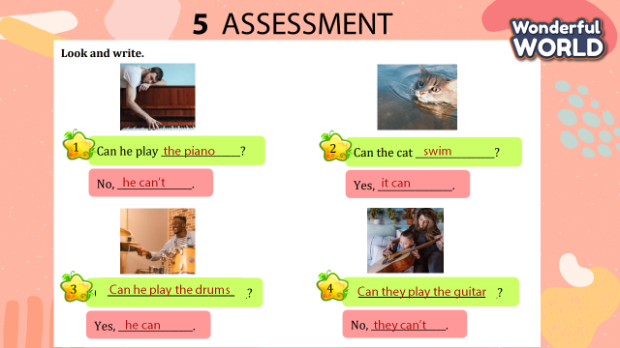 - Check-in pair then whole class.  - Say goodbye | - Do the assessment.  - Check with friends and then with the teacher and the whole class.  - Say goodbye.
____________________________________
UNIT 6. MY HOBBY
Lesson 3 - Task 7,8,9
Period 78
I. OBJECTIVES:
1. Knowledge:
Students will learn the phonic /t/ in the word write and /ɔɪ/ in the word toy and revise the words related to the topic Hobby.
2. Competences:
- English competences: Students will be able to listen and pronounce the sound seperately and in words correctly.
- Common competences: Students will have an opportunity to develop the solving problem skill in doing the tasks and creativeness in chant.
3. Qualities:
- Students are given opportunities to think about good activities to develop their working responsibility.
II. EQUIPMENT AND MATERIALS:
- Basic things: Student’s books, flashcards, crayons.
- Advanced things: PPT, projector/interactive whiteboard/laptop/TV.
III. LESSON PROCEDURE:
Activity 1: Warm-up (5 minutes)
Teacher’s activities | Student’s activities
- Greet students  Game: Candy catch.  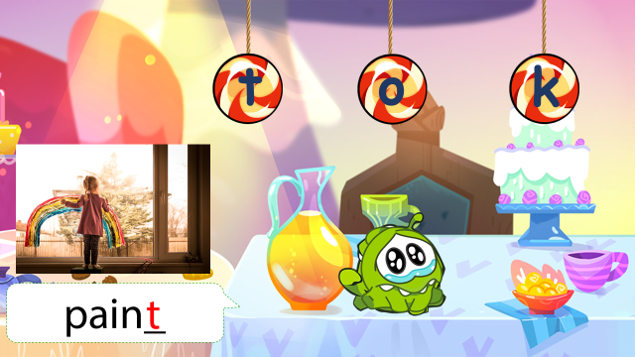  - Tell students how to play the game  - Do as a model  - Ask students to choose the missing letters.  Câu A. pain_  1.t 2. o 3. k  Câu B. coa_  1. n 2. d 3. t  Câu C. b_ _  1. ee 2. oy 3. ou  Câu D. ha_  1. b 2. t 3. d | - Greet teacher  - Listen  - Look and play with the teacher  - Look and choose the missing letter  1. a. t  2. c. t  3. b. oy  4. b. t  5. c. oy
Activity 2: Presentation (8 minutes)
Teacher’s activities | Student’s activities
Lead-in: Use 3 letters t, oy in the previous game to lead in the sound /t/, /ɔɪ/  Task 7: Listen and repeat. (Track 6.12)  - Play the recording and tell students how to pronounce the sound /t/, / ɔɪ /, pronounce the sound /t/ in the word write, / ɔɪ / in the word toy and in the sentence I can write with my pen. I can buy a toy  - Play the recording again. Tell students to repeat the words and sounds (whole class, in groups and individually).  - Ask some volunteers to perform in front of the whole class.  - Checking: “Sit and stand” game  + Teacher say /t/, write and students must repeat and stand up  + Teacher says /ɔɪ/, toy and students must repeat and sit down  + If students do a wrong action, they will be out of the game  -Play some rounds (increase the speed to make the game more interesting.) | - Learn to pronounce the sound /t/, /ɔɪ /  - Listen and repeat  - Perform in front of the whole class.  - Listen, repeat and stand up  - Listen, repeat and sit down  - Join in the game
Activity 3: Practice (12 minutes)
Teacher’s activities | Student’s activities
Task 8: Listen and chant. (Track 6.13)  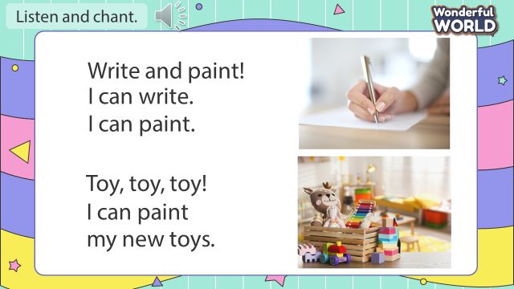  - Play the recording and tell students to listen and follow the words with their fingers.  - Read out the chant one line at a time and ask students to repeat it after the teacher.  - Play the recording again. Encourage students to chant along. Practice several times until students are familiar with the words and sounds.  - Ask one team to make the beat by clapping hands, the team has to follow the beat to chant.  - Ask some volunteers to chant in front of the class.  Task 9: Say it!  - Show three pictures and ask some questions:  1 What can you do?  2 What can she do?  3 What can they do?  - Ask students to look at the sentences. Tell them to pay attention to the sounds /t/ and /ɔɪ/ in each word.  - Read out the words with /t/ and /ɔɪ/ and ask students to repeat them.  - Ask students to work in pairs and say the sentences, paying attention to the correct pronunciation of /t/ and /ɔɪ/  - Ask volunteers to say the sentences in front of the class. | - Listen and follow the words with their fingers.  - Listen and repeat after the teacher  - Listen and practice the chants  - One team makes the beat by clap hands and another team have to follow the beat to chant.  - Look and answer:  1 I can write  2 She can paint  3 They can play with toys  - Look  - Listen and repeat  - Say the sentences in pairs  - Perform in front of the class.
Activity 4: Production (7 minutes)
Teacher’s activities | Student’s activities
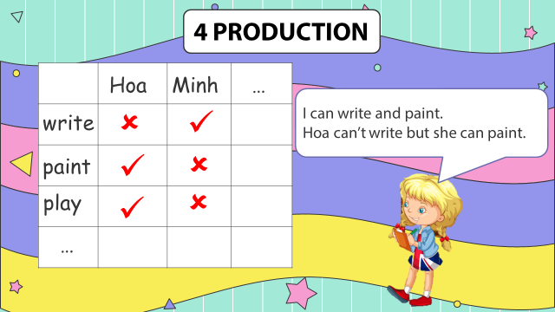  - Divide the class into 8 groups.  - Ask students to make a survey with their friends in groups using the question Can you….?.  - Ask students to show their survey and perform in front of the class, using can/ can’t. | - Sit in 8 groups.  - Make a survey.  - Perform in front of the class.
Activity 5: Assessment (3 minutes)
Teacher’s activities | Student’s activities
- Ask students to do the assessment.  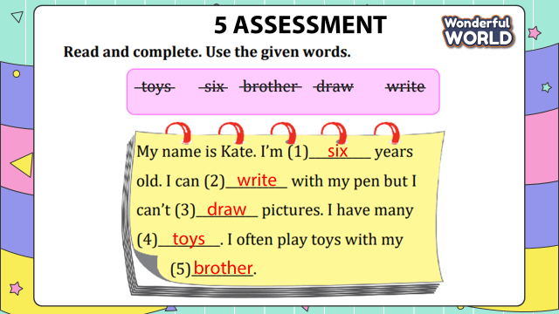  - Check in pair then whole class.  - Say goodbye | - Do the assessment.  - Check with friends and then with the teacher and the whole class.  - Say goodbye.

UNIT 6. MY HOBBY
Fun time and project -Task 1, 2
Period 79
I. OBJECTIVES:
1. Knowledge:
Students will review words related to the topic My hobby and the unit grammar.
2. Competences:
- English competences: Students will be able to talk and write about their abilities.
- Common competences: Students will develop creativeness skills in drawing pictures of their family member’s tree.
3. Qualities:
- Students are given opportunities to think about the good activities of their family members.
II. EQUIPMENT AND MATERIALS:
- Basic things: Student’s book, flashcards, crayons, green and red papers.
- Advanced things: PPT, projector/interactive whiteboard/laptop/TV.
III. LESSON PROCEDURE:

Activity 1: Warm-up (5 minutes)
Teacher’s activities | Student’s activities
- Greet students  Game: Finding diamond.  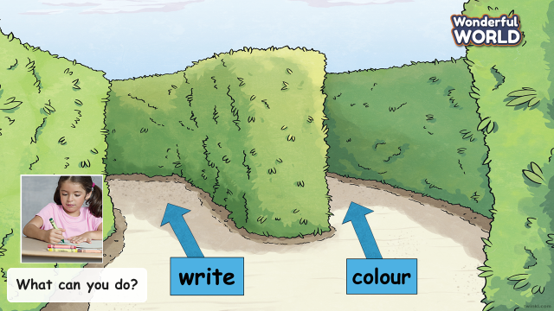  (Set the context: Students looking for diamonds in the maze. There are 8 questions. Each question is a way. Students answer the questions to find the right way to a big diamond in a maze.)  - Tell students how to play the game  - Do as a model  - Ask students to choose the correct words.  1 What can you do? – colour  2 What can you do? - sing  3 What can you do? - cook  4 What can you do? - dance  5 What can you do? - paint  6 What can you do? - write  7 What can you do? - swim  8 What can you do? - speak English | - Greet teacher  - Listen  - Look and play with the teacher  - Look and choose the correct words
Activity 2: Practice (10 minutes)
Teacher’s activities | Student’s activities
Lead-in: Use the game to lead in task 1.  Task 1: Find and circle.  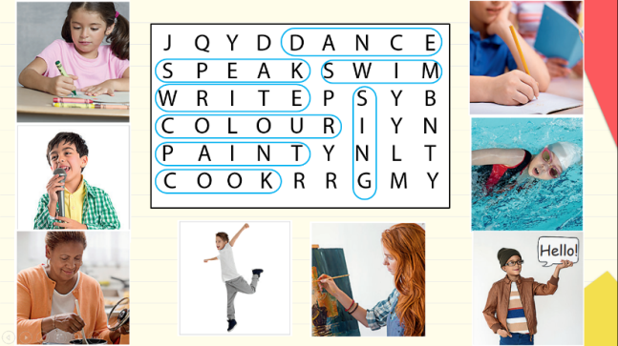  - Show the platform of the task  - Set context: You have to find 8 codes to open the treasure chest and get the big diamond. (Show the diamond when students have circled all 8 words)  - Ask students to work in groups  - Give game instruction: look at the picture, circle the equivalent words  - Give students time to play the game  - Have students do cross-check  - Check with the whole class by saying words aloud  - Award the fastest team with the most correct answer | - Look at the platform of the task  - Listen to the context  - Work in groups  - Find and circle  - Do cross-check  - Say words aloud
Activity 3: Project (15 minutes)
Teacher’s activities | Student’s activities
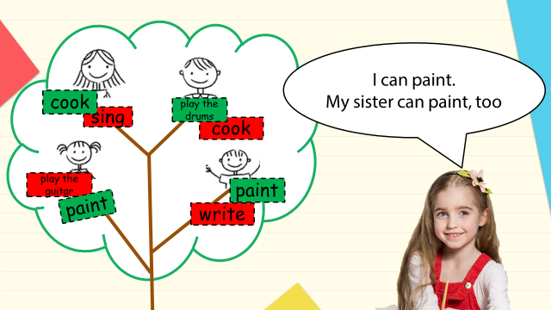  Planning stage  - Give students some green and a red piece of paper.  - Ask students to write the actions they and their family members can do on a green piece of paper, the actions they and their family members can’t do on a red piece of paper  - Ask students to draw a family member’s tree and stick the action words each member can do and can’t do.  Implementing stage  - Ask students to share some ideas with friends next to them, using: I can/ can’t…, my … can/ can’t…., he/she can/ can’t….  - Ask students to write about what their family members can do and can’t do.  Displaying and Reflecting stage  - Ask students to display their works in front of the class  - Ask others to give feedback  - Give feedback at the end | - Receive the piece of paper.  - Write the actions they and their family members can do on a green piece of paper, the actions they and their family members can’t do on a red piece of paper  - Draw a family member’s tree and stick the action words each member can do and can’t do.  - Share some ideas with friends next to them, using: I can/ can’t…, my … can/ can’t…., he/she can/ can’t….  - Write about what your family member can do and can’t do.  -Perform their work in front of the class.  - Listen to their friends.
Activity 5: Assessment (5 minutes)
Teacher’s activities | Student’s activities
- Ask students to do the assessment.  Reorder the words to make correct sentences  1. a/ I/ draw/ picture/ can/.  2. speak English/ A/ can’t/ monkey/.  3. brother/ can swim/ My/ he/ can’t draw/ but/.  4. My/ can/ friend/ and dance/ sing/.  5. she/ play/ can/ the piano/?  - Check-in pair then whole class.  - Say goodbye | - Do the assessment.  1. I can draw a picture.  2. A monkey can’t speak English  3. My brother can swim but he can’t draw  4. My friend can sing and dance  5. Can she play the piano?  - Check with friends and then with the teacher and the whole class.  - Say goodbye.
____________________________________

UNIT 7. MY FAVOURITE SPORT
Lesson 1 - Task 1,2,3
Period 80
I. OBJECTIVES:
1. Knowledge:
Students will learn the words related to the topic Sport : baseball, basketball, football, hockey, tennis
2. Competences:
- English competences: Students will be able to talk about what sports they can play.
- Common competences: Students will have opportunity to develop the autonomy in doing tasks and communication among friends.
3. Qualities:
- Students will have opportunity to think about sports that make people live healthily.
- Students will be friendly and confident in communicating with friends.
II. EQUIPMENT AND MATERIALS:
- For Teacher: PP, TV, flashcards, music, audio track 7.1, track 7.2
- For students: pictures, handout
III. LESSON PROCEDURE:
Activity 1: Warm up (5 minutes)
Teacher’s activities | Student’s activities
Game: GUESSING TOPIC GAME  Prepares 4 different pairs of pictures of the topics school, animals, house , sport.  Have Sts look and guess the topics.  Introduce the topic: Sport | Sts look at the pictures and say the name of the topics: school, animals, house , sport.
Activity 2: Presentation (8 minutes)
Teacher’s activities | Student’s activities
Lead-in: Use the opener picture to lead in:  - Ask students where the people are. Ask them if they think it’s hot or cold at the beach.  - Ask students to tick the clothing items they can see in the picture.  - Ask Sts about the activity what they are playing and explains for Sts about the sport (baseball) | - Sts answer .  - Tick .  - Sts answer
Task 1: Listen and point. Repeat. (Track 7.1)  - Show the flashcards of baseball, basketball, football, hockey, tennis and read out .  - Play the words one by one  - Play the track 7.1 and ask students to listen and repeat in chorus, groups.  - Say a word/sentence for sts to repeat then point  - Then read out the new picture words in the vocabulary box in random order and ask students to point to the correct pictures.  Vocabulary checking GAME  - Ask 5 students to hold the flashcards. Each Sts stand behind and point to one student.  - Ask class to say the word aloud, the st holding the picture with that word will raise the picture. | - Repeat the words  - Repeat then point.  - Hold the pictures and stand face to the class  - Say aloud the word  - Raise the picture high
Activity 3: Practice (12 minutes)
Teacher’s activities | Student’s activities
Task 2 : Listen and tick.(7.2)  - Have sts look at the photo and ask sts if they know the name of the game.  - Introduce Phan and 2 boys talking to each other.  - Play the recording. Tell students to  look at the picture and follow the  text with their fingers.  - Play the recording again. Ask  students to repeat.  - Ask students to look at the  question below the picture,  read out the sentence and elicit  answers. Check with sts.  - Have sts act out the dialogue | - Sts answer.  - Sts repeat.  - Act out the dialogue in pairs
Task 3 : Ask and answer. Use the words in 1
- Ask students to read out the word  in 1 again. Read out the sample  dialogue and ask students to  repeat.  - Have sts ask and answer in pairs and then have some pairs present. | - Sts repeat.  - Work in pairs.
Activity 4: Production (7 minutes )
Teacher’s activities | Student’s activities
SURVEY  - Let Sts do the survey with their friends using Can you play…? Yes, I can./No, I can’t.  MY SURVEY  - Have some sts present later | - Sts do the survey
  Friends’ name | baseball | football | tennis | hockey | baseball
  ……..
  ……...
  …….
  …….
  …….
Activity 5 : Assessemnet (3 minutes )
Teacher’s activities | Student’s activities
Ask sts to do the assessment in workbook (p57) (Hạn chế dùng bài tập trong WB)  . 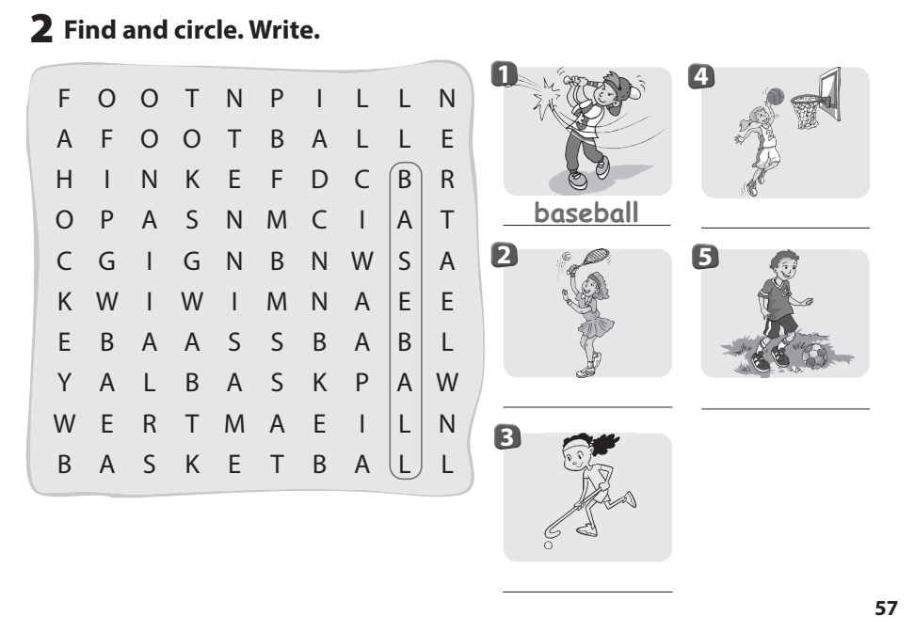 | Do the assessment.  (Đưa trang đáp án lên)  - Check with friends and then with teacher and whole class.

GRADE 5
Week 20 (From 03/2 to 07/2)
UNIT 7: Sports
Lesson 3 - Part 7,8,9
Period 77

I. OBJECTIVES:
1. Knowledge: Word stress( the stressed syllable in two- and three-syllable words)
2. Competences:
English competences:- To learn new adverbs of frequency.
-To recognize the stressed syllable in two- and three-syllable words.
- To practice pronouncing stressed syllables.
Common competences: Students can speak English with intonation
3. Qualities:
- Students will be confident and active in communicating with friends and teachers.
-Students know the beauty of English while speaking with intonation.
II. EQUIPMENT AND MATERIALS:
- Basic things: Student’s book, flashcards.
- Advanced things: PPT, laptop, TV.
III. LESSON PROCEDURE:
Activity 1: Review (5 minutes)
Teacher’s Activities | Students’ Activities
Aims:- Welcome students, and engage the class with a funny game” Order the words to make a sentence” to review the adverbs of frequency.

- Greet students.  -Divide the class into many teams. Each team chooses their team names.  -Ask students to look at the given words and picture to write the correct sentence.  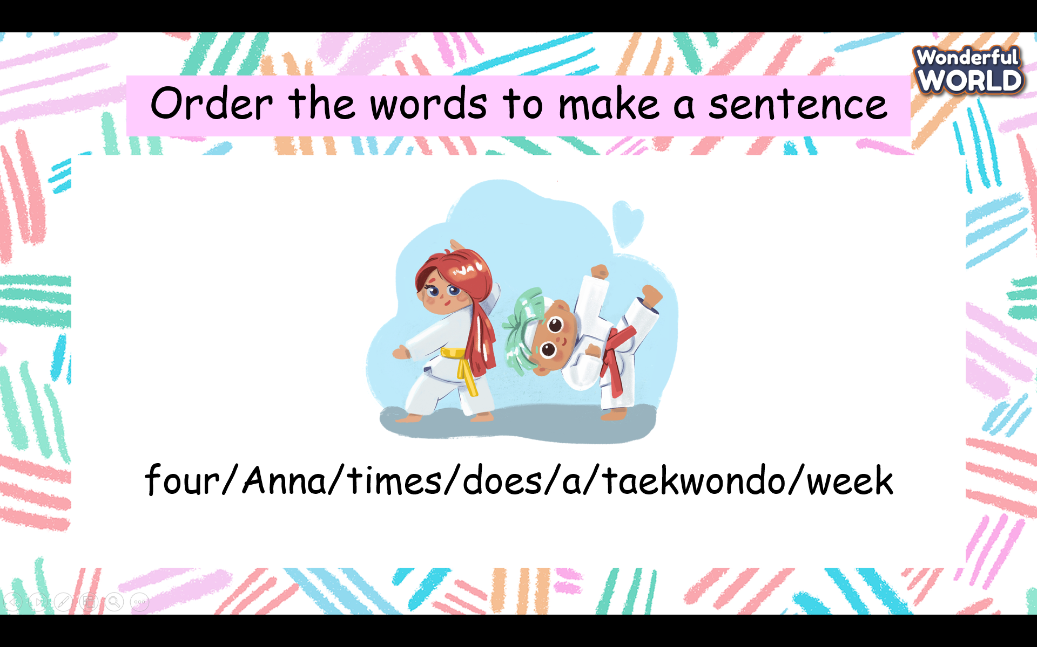  -Check the answer:  1. Anna does taekwondo four times a week.  2. Our brothers play volleyball once a week.  3. Jack practices the violin three times a week  4. My family goes to the beach once a year.  5. My friend and I ride our bikes five times a week. | - Greet Teacher  -choose a team name  - Join the activity.  - be active and happy
Activity 2: Presentation (7 minutes)
Teacher’s Activities | Students’ Activities
Aim: Review stress in words and how to put the stress in words while speaking.
- Watch a video about one, two, three and four-syllable words  -Review the stress: The way that a word or syllable is pronounced with greater force than other words in the same sentence or other syllables in the same word.  -Show the words on the screen and the stress in words  -Ask Ss to repeat after the audio.  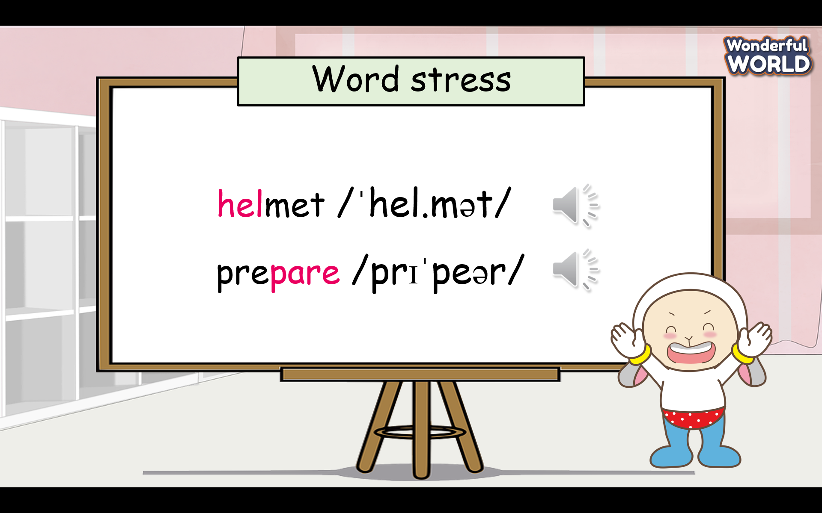  - T gives stars for the correct pronunciation. | - Look at the screen and repeat the words with correct intonation.  -Read in the whole class, team, and individual.
Activity 3: Practice (11 minutes)
Teacher’s Activities | Students’ Activities
Aims: Practice speaking the words with stress by saying words individually.
-Watch a video about one, two, three, and four-syllable words.  Task 7 Listen and repeat. TR: 7.7  - Tell students that they are going to listen to six words.  - Ask students to look at the six words and try to read them.  - Play the recording and ask students to look at their books and listen.  - Play the recording again and ask students to repeat each word a few times.  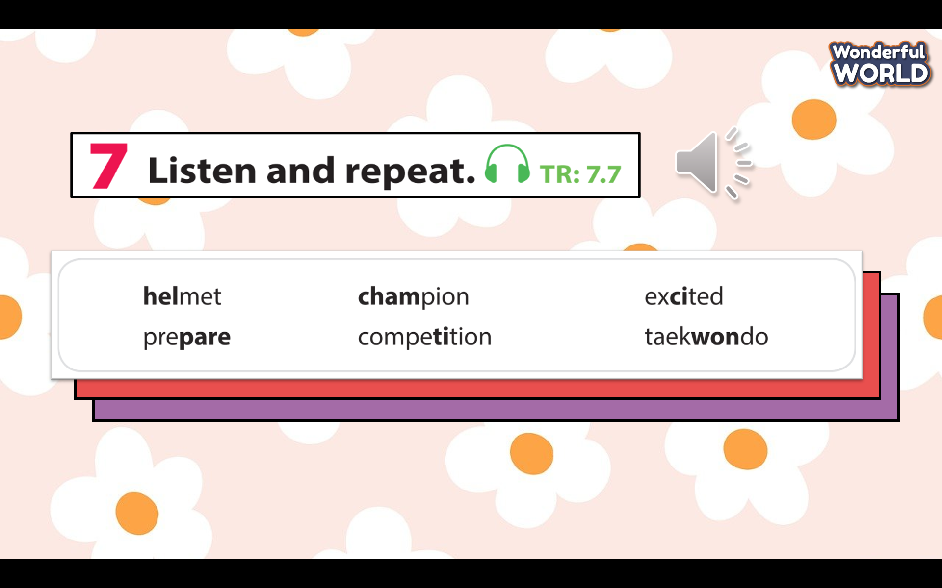  - Have students say the six words aloud as a whole class.  - Check pronunciation if necessary.  - T gives stars for the correct answer.  Task 8 Listen and circle the word with different stress. TR: 7.8  -Tell students to listen and circle the one with different stress.  - Check students’ understanding of the task. Elicit number 1 if necessary.  - Play the recording twice for students to do this task.  - Check answers as a class.  -Ask them to read each word aloud.  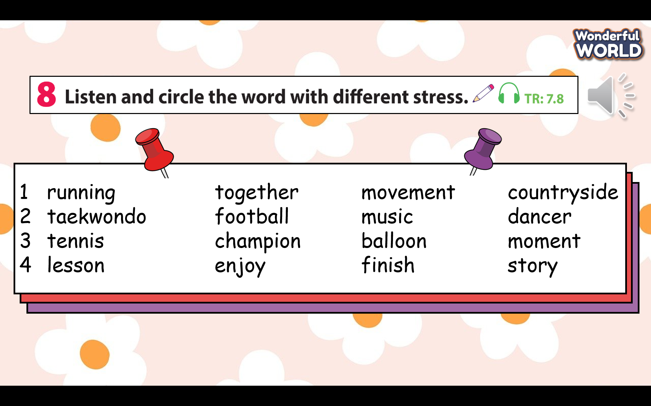 | - Look at the six words and try to read them.  - repeat each word a few times.  .  - Look at the screen and listen to the words individually.  - Work in groups to choose the word with different stress.  - Write the answers on the board and explain why they choose that word.  - Check the result.  - Listen and repeat the  words.
Activity 4: Production (7 minutes)
Teacher’s Activities | Students’ Activities
Aim: Practice speaking with stress and intonation while chanting
Task 9 Listen and chant. TR: 7.9  -Tell students they are going to learn a chant. Explain to students that the chant uses the sounds they have just learned  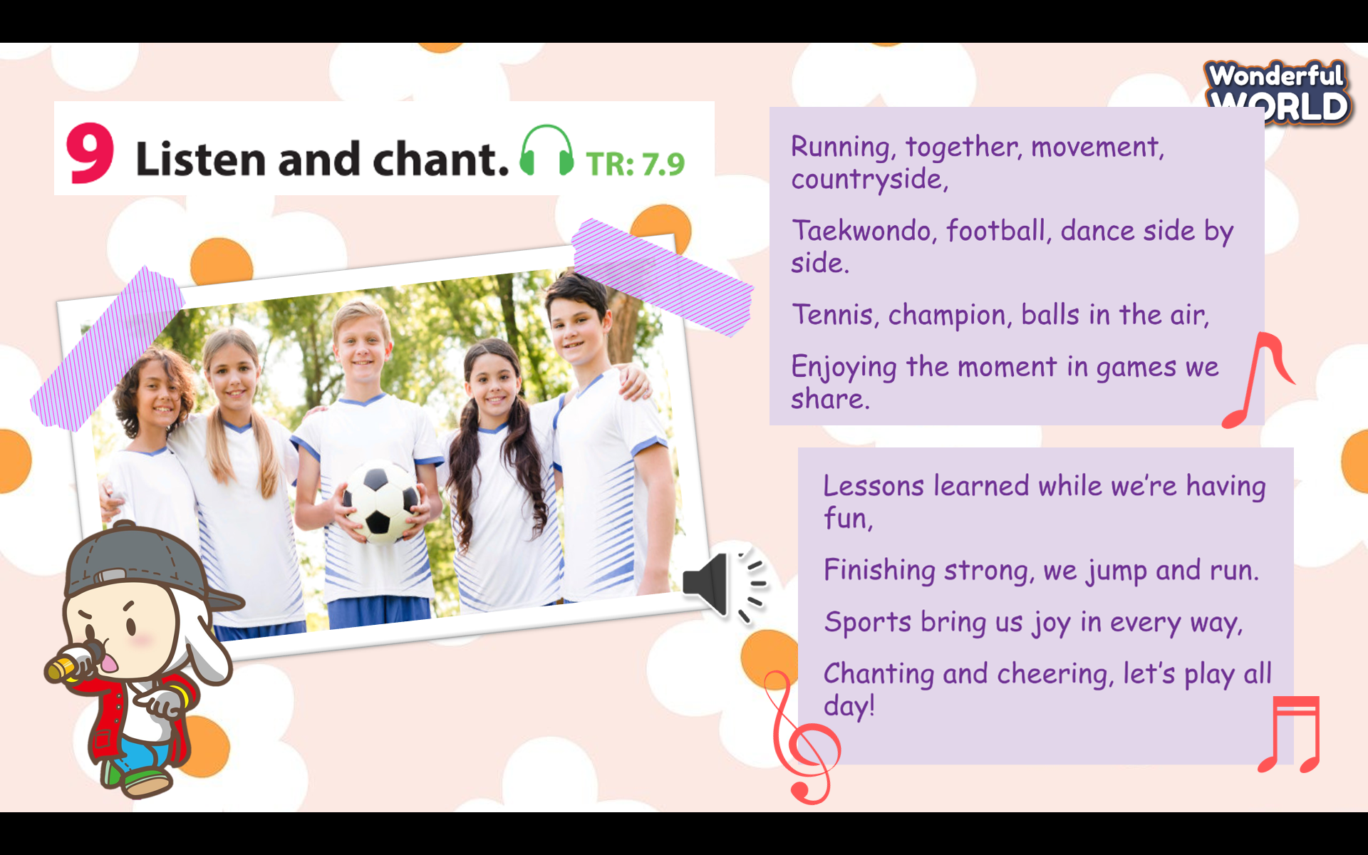.  - Play the recording and tell students to listen and follow the words with their fingers.  -Read out the chant one line at a time and ask students to repeat after you.  -Play the recording again. Encourage students to chant along. Practise several times until students are familiar with the words and sounds.  -Ask students to practise the chant individually, and then in pairs or in groups.  For example, one group chants the first verse, and the other group chants the second verse.  Optional activity:  - Ask some volunteers to say the whole chant  - Correct them if they make any mistakes.  -Give stars or candies to students. | - Listen and follow the words with their fingers.  -Chant several times to be familiar with the words and sounds.  - Chant individually, and then in pairs or groups  - Clap the hands after each team finishes their task.
Activity 5:Wrap-up & Assessment ( 5minutes)
Teacher’s Activities | Students’ Activities
Aim:
- Check students’s understanding of what they have learned.
- Students rehearse what they have learned in the lesson.
-T asks sts to do the assessment (Listen and write)  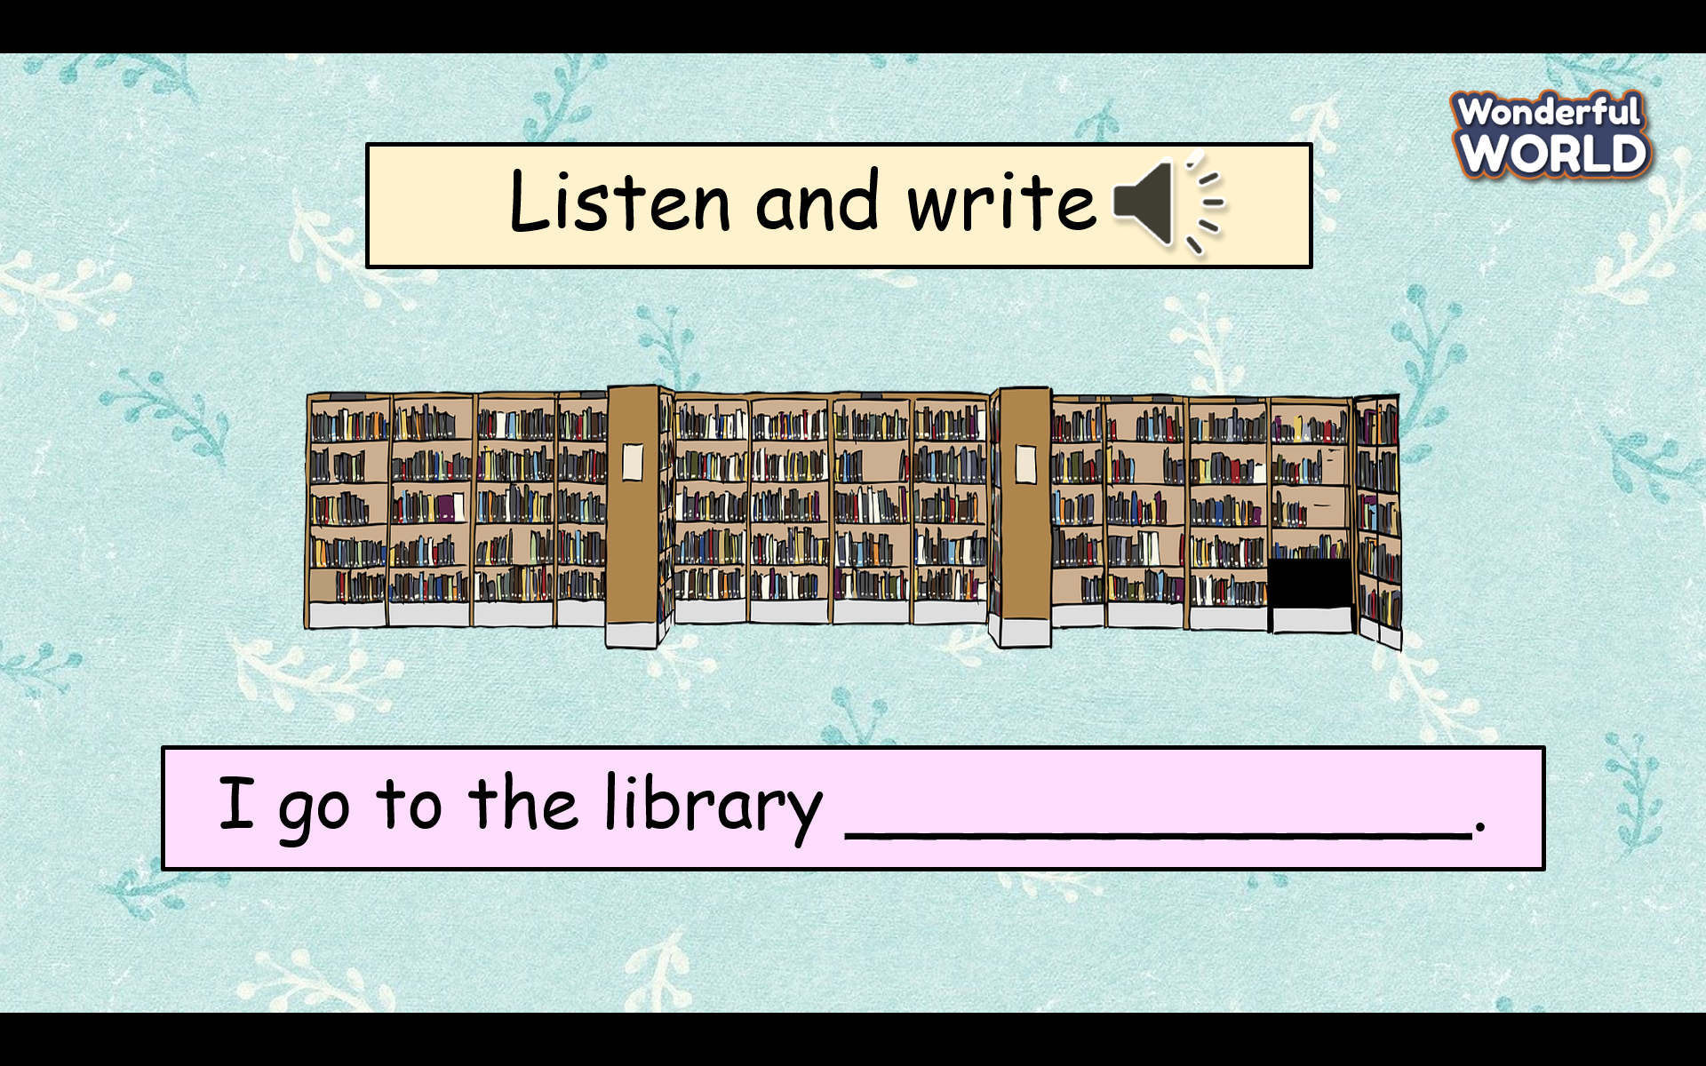  - Check with the class.  - Wrap-up  * Remember: Adverbs of frequency: once a week, twice a week, three times a week, four times a week. | -Do the assessment.  -Check with the teacher  - Sts read the wrap-up  - Stand up and say goodbye to the teacher.

UNIT 7: Sports
FUN TIME & PROJECT PART 1
Period 78
I. OBJECTIVES:
1. Knowledge: To review all target vocabulary of Unit 7 and some fun activities.
2. Competences:
- English competences:- Review some words related to sports.
- Common competences: - students will be able to develop collaborative skills through teamwork and logical thinking.
3. Qualities:
- Be confident and active in communication with friends and teachers.
- Show their love and passion for sports.
II. EQUIPMENT AND MATERIALS:
- Basic things: Student’s book, flashcards.
- Advanced things: PPT, laptop, TV.
III. LESSON PROCEDURE:
Activity 1:Warm-up & Review (9 minutes)
Teacher’s Activities | Students’ Activities
Aims:- Welcome students and engage the class with a funny song to warm up the class’s atmosphere. Guess the names of sports through pictures.
- Greet students.  -Divide the class into many teams. Each team chooses their team names.  -Ask students to stand up and follow the actions in the video.  - Give stars to the team that dances the most beautifully.  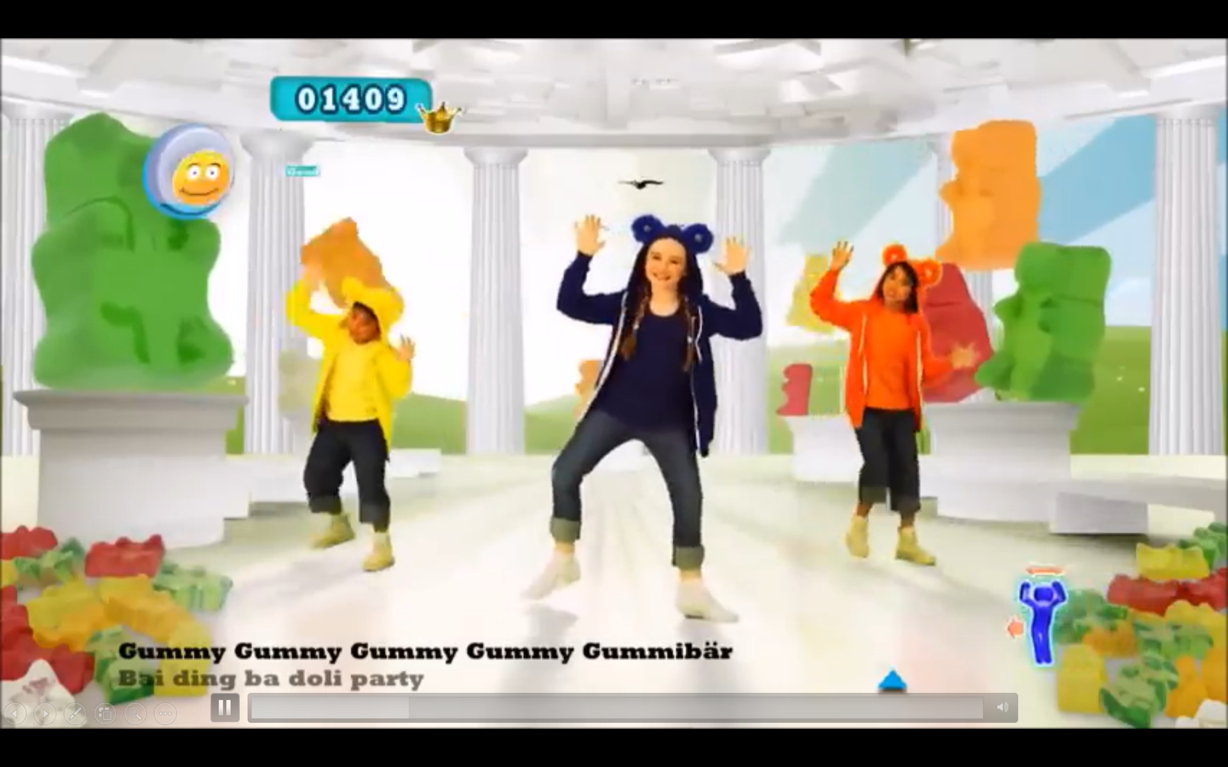  - Each picture is hidden by bricks. Each brick has 1 point. (It deletes 1 point of this question when each brick disappears.)  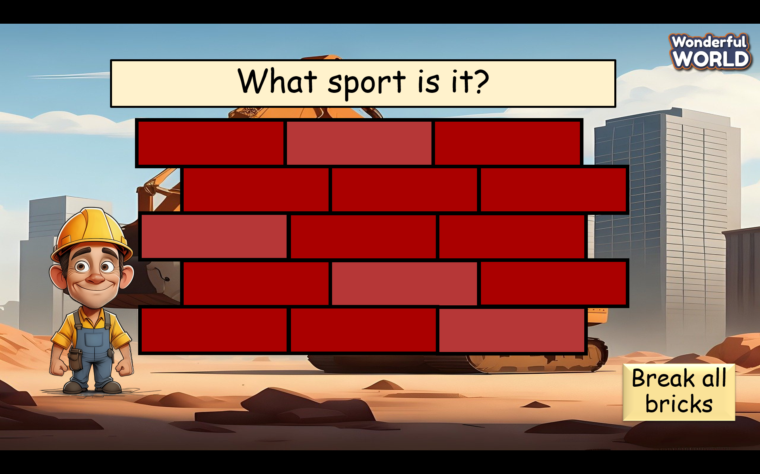  - Clicks “Break all bricks” to show the whole picture at once. | - Greet Teacher  -choose a team name  - Join the activity.  - be active and happy  - Guess the name of the picture through pieces of bricks.  - Check the answers( running, horse riding, baseball, golf).  - Read in the whole class, team, and individual.
Activity 2: Practice (10 minutes)
Teacher’s Activities | Students’ Activities
Aim: Control the whole class and help students have a chance to play the game.
-Before playing a bingo game, the teacher asks students to match the letters with the right pictures.  -Gives stars for the correct answer.  -answer key: (1-f, 2-I, 3-e, 4-a, 5-g, 6-c,7-d,8-h,9-b)  - Ask students to read in the whole class, team, and individual.  -Check pronunciation.  Task 1 Bingo game  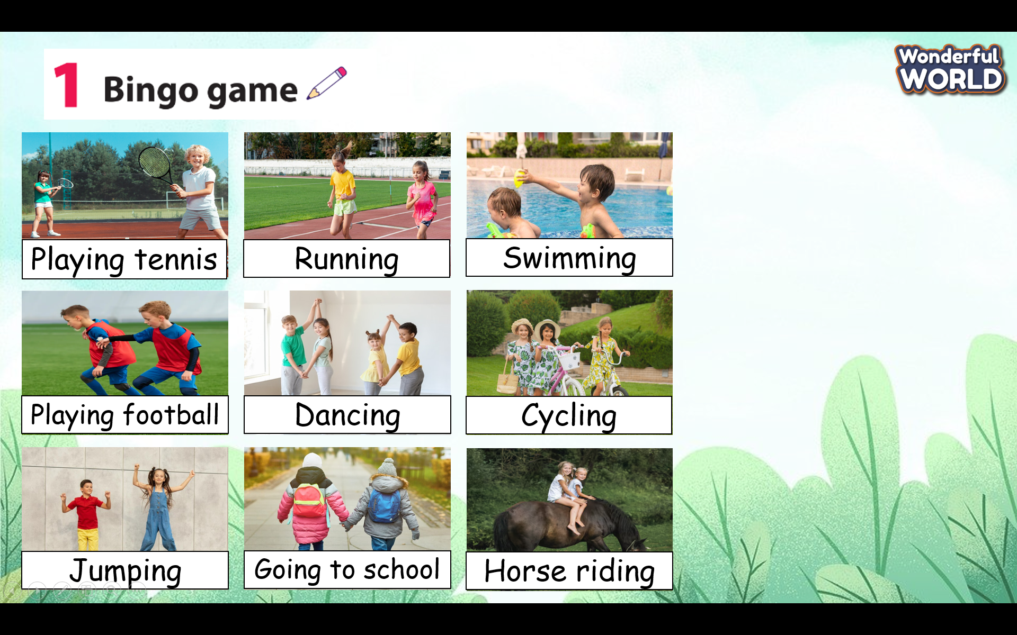  - Explain the rule: when students hear the teacher read a word, they will cross out the appropriate picture. Students will shout out “Bingo!” once they’ve made a complete diagonal, vertical, or horizontal line.  - Model and check students’ understanding.  - Read the words twice and have students play. | - Look at the screen and repeat the words with the correct intonation. (read in the whole class, team, and individual.)  - Prepare A4 paper and arrange the words in diagonal, vertical, or horizontal lines.  - Listen to the teacher say the words.  - shout out “Bingo!” if they win.
Activity 3: Production (11 minutes)
Teacher’s Activities | Students’ Activities
Aims: Increase the speed of reading questions with eyes and develop student’s logical thinking.
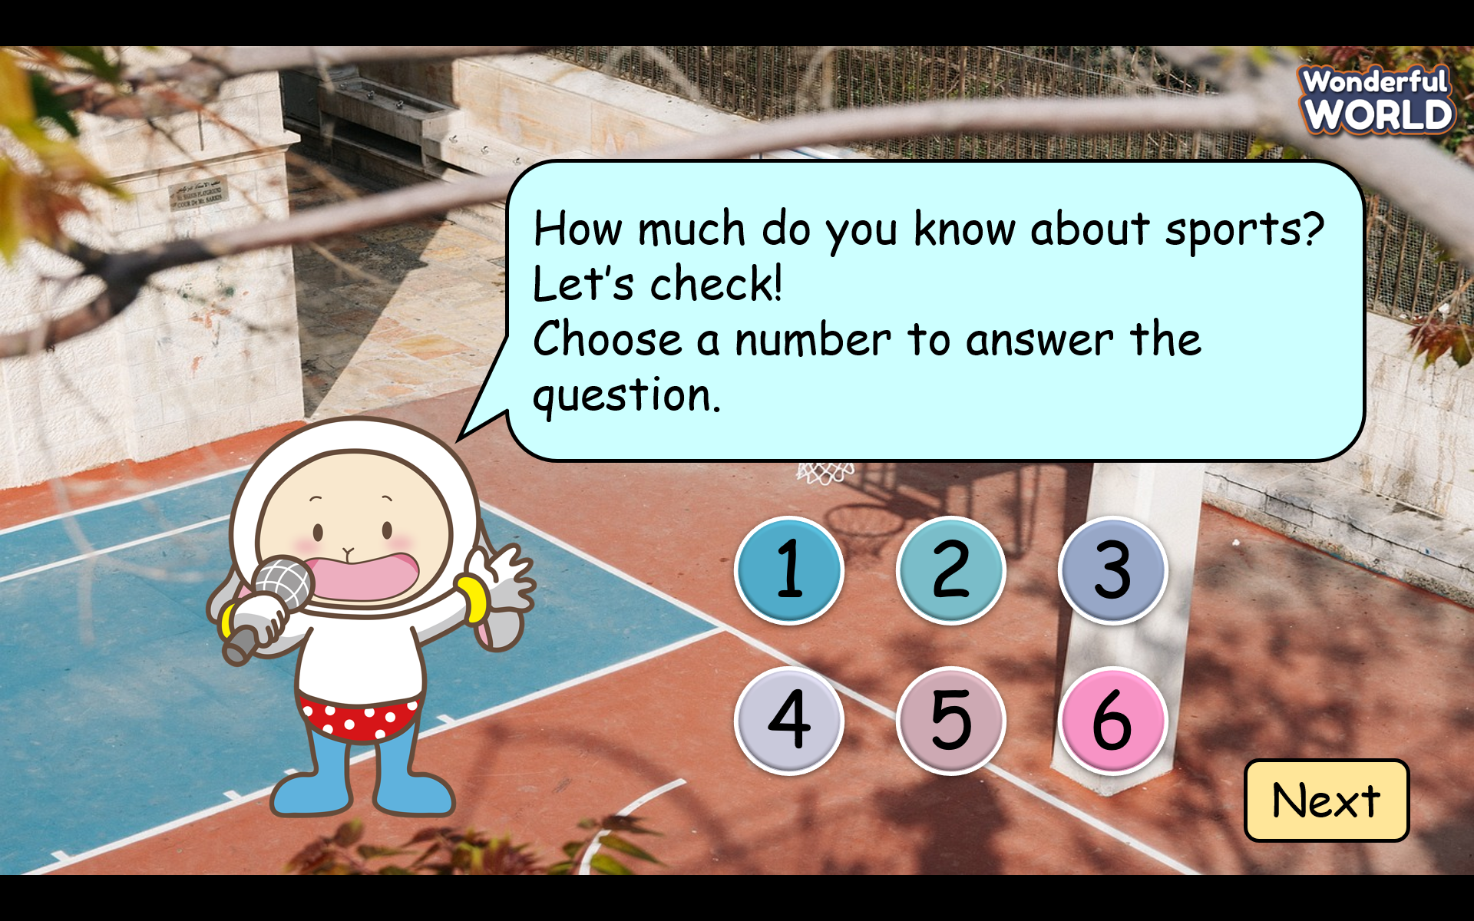  -Give six questions that describe sports:  What is the largest football competition in the world?  It’s World Cup  In this sport, two teams use their hands to hit a large ball over a high net. What sport is it?  It’s volleyball  Which country is the founder of Taekwondo?  - It’s South Korea.  - In this sport, two teams get points by throwing a large ball through a hoop.  What sport is it?  It’s basketball.  - In this sport, people move through water by moving their bodies. What sport is it?  It’s swimming.  Which sport is the king of sports in Vietnam?  It’s football. | - Look at the screen and read the questions as quickly as possible.  - Work in pairs to guess the names of the sports  - Check the result.  - Repeat the answer several times.
Activity 4: Wrap-up & Assessment ( 5minutes)
Teacher’s Activities | Students’ Activities
Aim:
- Check students’s understanding of what they have learned.
- Students rehearse what they have learned in the lesson.
-T asks sts to do the assessment (Odd one out)  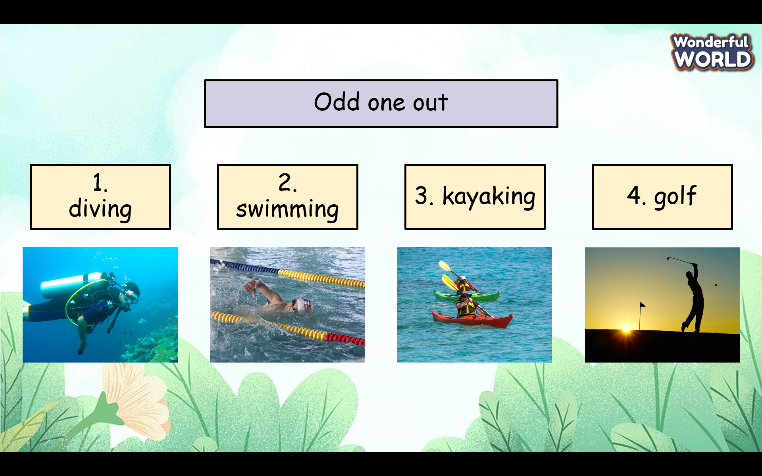  - Check with the class.  - Wrap-up  * Remember: | -Do the assessment.  -Check with the teacher  - Sts read the wrap-up  - Stand up and say goodbye to the teacher.

UNIT 7: Sports
FUN TIME & PROJECT PART 2
Period 79
I. OBJECTIVES:
1. Knowledge:- To review all target vocabularies and structures of Unit 7 and some fun activities.
- Making instructions on how to keep safe when playing sports.
2. Competences:
English competences:- Students will be able to think and talk about topics.
related to sports.
Common competences: - students will be able to develop collaborative skills through teamwork and logical thinking.

3. Qualities:
- Be confident and active in communication with friends and teachers.
- Show their love and passion for sports.
II. EQUIPMENT AND MATERIALS:
- Basic things: Student’s book, flashcards.
- Advanced things: PPT, laptop, TV.
III. LESSON PROCEDURE:
 | Activity 1:Warm-up & Review (7minutes)
 | Teacher’s Activities | Students’ Activities
 | Aims:- Welcome students and engage the class with a funny song to warm up the class’s atmosphere.
 | - Greet students.  -Divide the class into many teams. Each team chooses their team names.  -Ask students to stand up and follow the actions in the video.  - Give stars to the team that dances the most beautifully.    -Review some sports for students and then play the game “What sports are missing”.  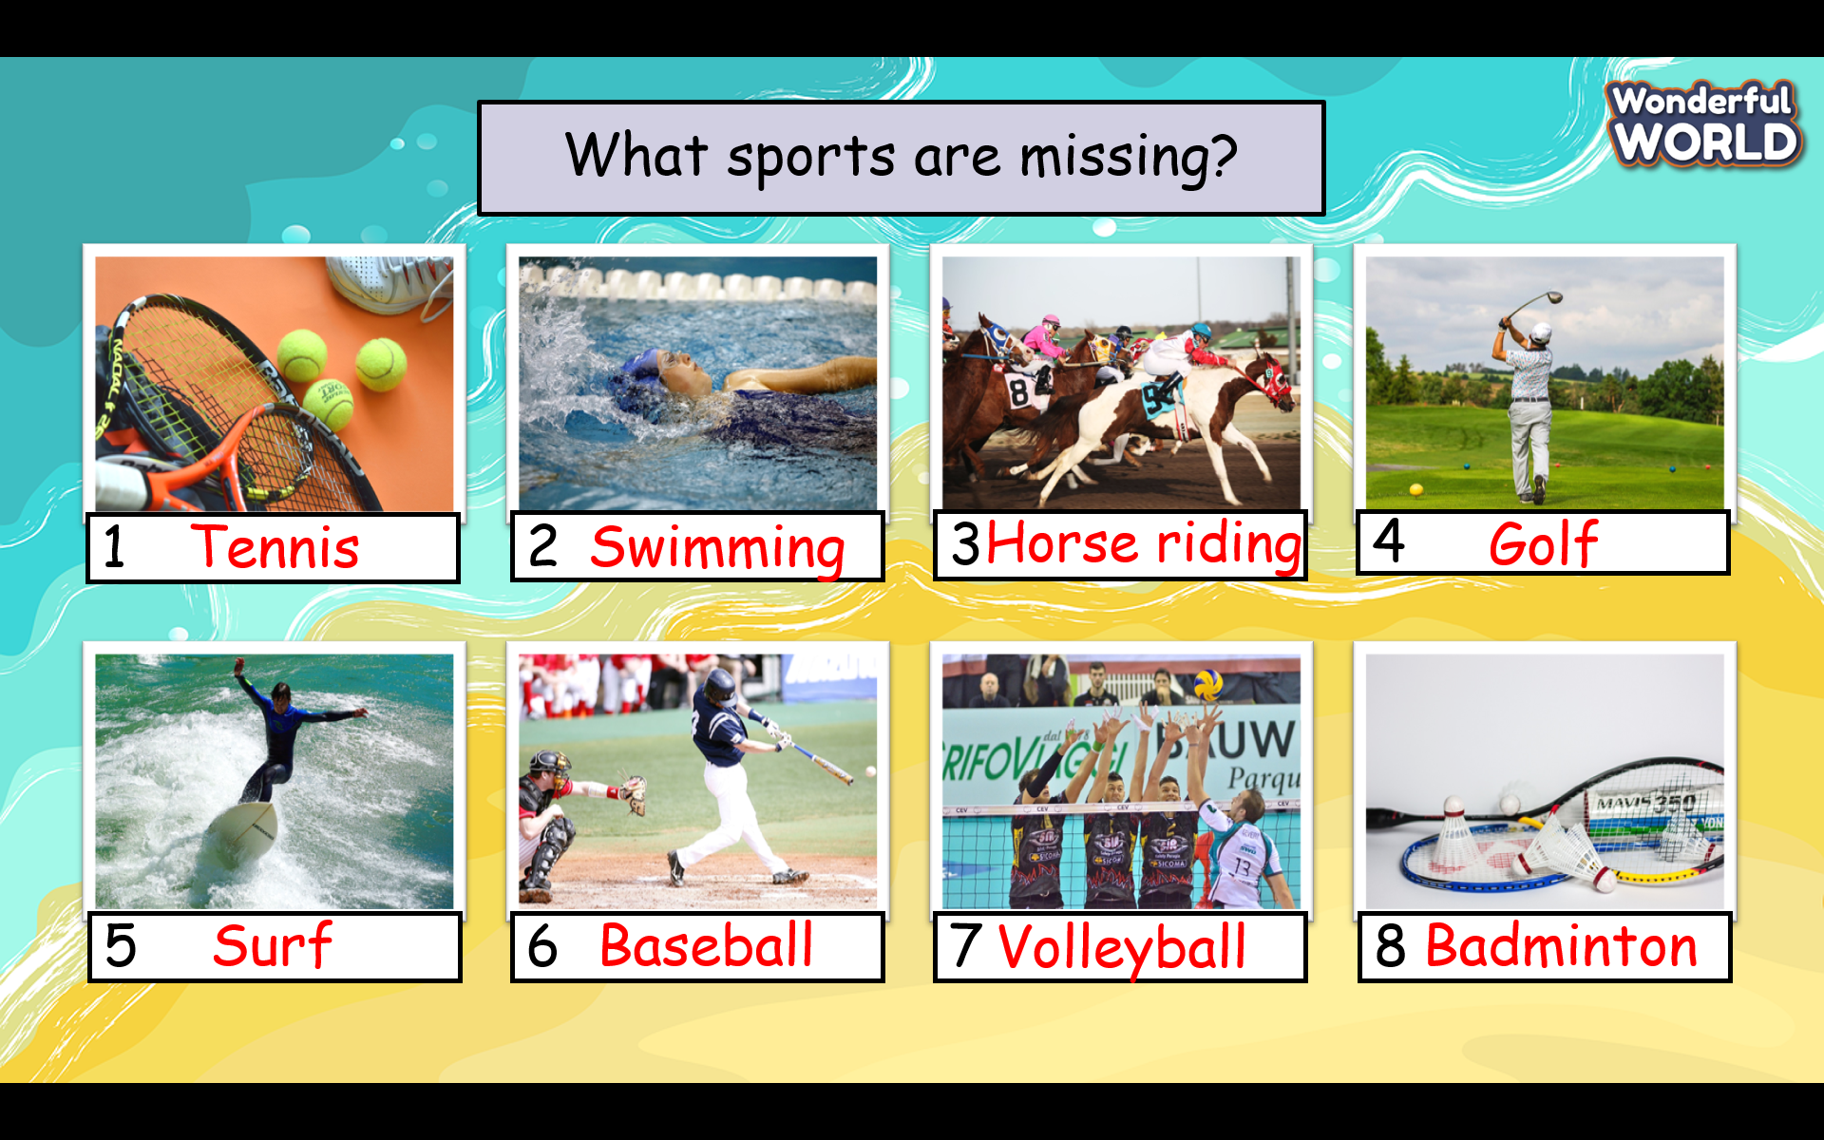  -Give students 30 seconds to remember the position of each picture.  -Click to hide pictures at once and ask students to recognize which pictures have disappeared.  -Give stars for the correct answer  -Check students’ pronunciation. | - Greet Teacher  -choose a team name  - Join the activity.  - be active and happy  - remember the position of each picture.  -raise the hand to recognize which pictures are disappeared.  - Read in the whole class, team, and individual.
Activity 2: Practice (8 minutes)
Teacher’s Activities |  | Students’ Activities
Aim: Control the whole class and help students have a chance to play games to review vocabulary structures and phonetics.
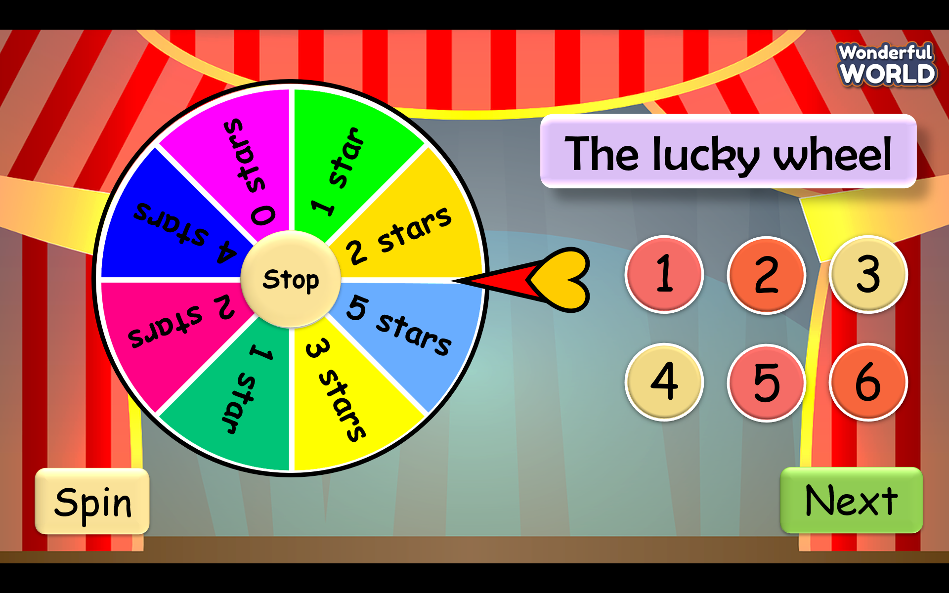  - Create 6 questions about structures and phonetics that students learn in Unit 7  +Question1: their/much/shouldn’t/use/People/smartphones/too  People shouldn’t use their smartphones too much.  +Question 2:  You/helmet/when/a/motorbikes/wear/should/riding/your  You should wear a helmet when riding your motorbike.  +Question 3: She ____________ at the moment. (run)  is running  Question 4: They ___________________ at present. (ride the horses) are riding horses  Question 5: Champion  Question 6:  My family has outdoor activities__ __.  twice a week  -Click the spin button to spin and click the stop button if the student wants to stop. |  | - Choose the question and read it carefully.  - Have a chance to spin the wheel if they answer correctly.
Activity 3: Production (115 minutes)
Teacher’s Activities |  | Students’ Activities
Aims: Develop speaking skills and teamwork skills.
Task 3 Project: How to stay safe when playing a sport  - Explain to students that they will work in groups of four. Each group will write four instructions on how to stay safe when playing sports.  - Ask students to read the example sentences.  - Allow students time to work in their groups.  - Have each group write their sentences on a poster.  - Ask students to choose the sport they like.  ( use should and shouldn’t in each sentence)  - Have each group put up their poster on the classroom wall for a walking exhibition.  Task4 Show and tell.  - Show your poster. Tell your class about it.  -T will read the sample first and ask some students to read it several times.  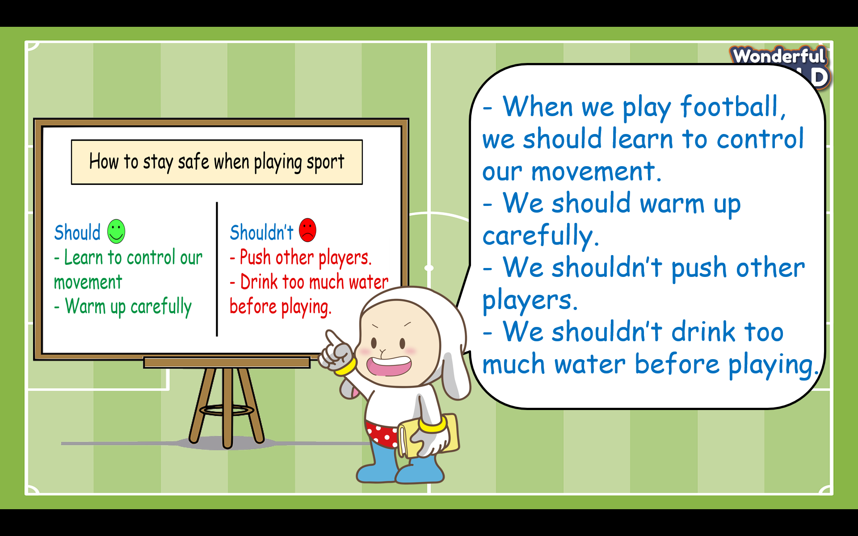  -Give some comments for each team after the leader of each team has finished his/her task. |  | -Read the example sentences.  - Choose a sport to write four instructions on how to stay safe when playing it.  -work in groups.  - The leader of each group will go to to board to present his/her group’s production.  - Give comments for each team.
Activity 4:Wrap-up & Assessment ( 5minutes)
Teacher’s Activities |  | Students’ Activities
Aim:
- Check students’s understanding of what they have learned.
- Students rehearse what they have learned in the lesson.
-T asks sts to do the assessment (Read and write)  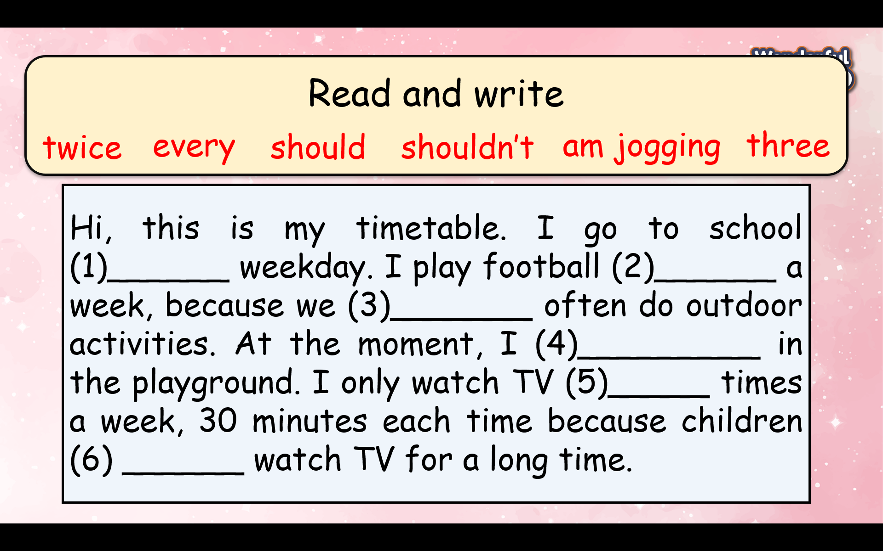  - Check with the class.  Answer key: 1-every, 2- twice, 3- should, 4-am jogging, 5-three, 6- shouldn’t  - Wrap-up  * Remember: To review all target vocabularies and structures of Unit 7. |  | -Do the assessment.  -Check with the teacher  - Sts read the wrap-up  - Stand up and say goodbye to the teacher.

Unit 8. People and places
Lesson 1- Part 1,2,3
Period 80
I. OBJECTIVES:
1. Knowledge:
To introduce and engage students to the topic of the unit
To identify words relating to accommodation
To listen to and read a passage about a type of house in Japan
2. Competences:
- English competences: Students are able to use English to effectively use new vocabulary and structures to describe and discuss various types of accommodation, express preferences, and share information with others.
- Common competences: Students can draw their house and introduce them to their friends.
3. Qualities:
- Students will
+ Discuss accommodation types from different cultures, which enhances cross-cultural awareness and appreciation.
+ Develop a curiosity about different living environments and cultural practices related to housing.
II. EQUIPMENT AND MATERIALS:
- Basic things: Student’s book, flashcards, photos, papers
- Advanced things: PPT, laptop, TV.
III. LESSON PROCEDURE:
Activity 1: Warm-up (5 minutes)
Game: EXPLORE OUR WORLD.
Quiz game about famous landmarks
Aims: Welcome students. Warm the class up with a game to check their knowledge and widen their understanding of the famous landmarks in the world.
Teacher’s Activities | Students’ Activities
Do you want to travel and explore the world with me? I will take you to discover the landmarks in the world!  Let’s play the game.  Quiz Instruction :  - Write your 5 answers on your paper.  - You must solve each question individually.  - You get one point for each right answer.  Question 1 . What is the name of the iconic tower in Paris, France, that is one of the most famous landmarks in the world?  Question 2. How many years did it take to complete the construction of the Big Ben clock tower, which stands over 96 meters tall?  Question 3: In which city can you find the iconic Opera House, which is shaped like sails and is one of the most famous buildings in Australia?  Question 4: What is the name of the rock that was used to build the Great Pyramid of Giza, one of Egypt's largest and most famous pyramids?  Question 5: In which city can you find the Colosseum, an ancient amphitheater that was once used for gladiator fights and other public spectacles?  T asks Sts to write the answers on the paper and tick the answers if they’re correct. | - Greet Teacher  - Join the activity.  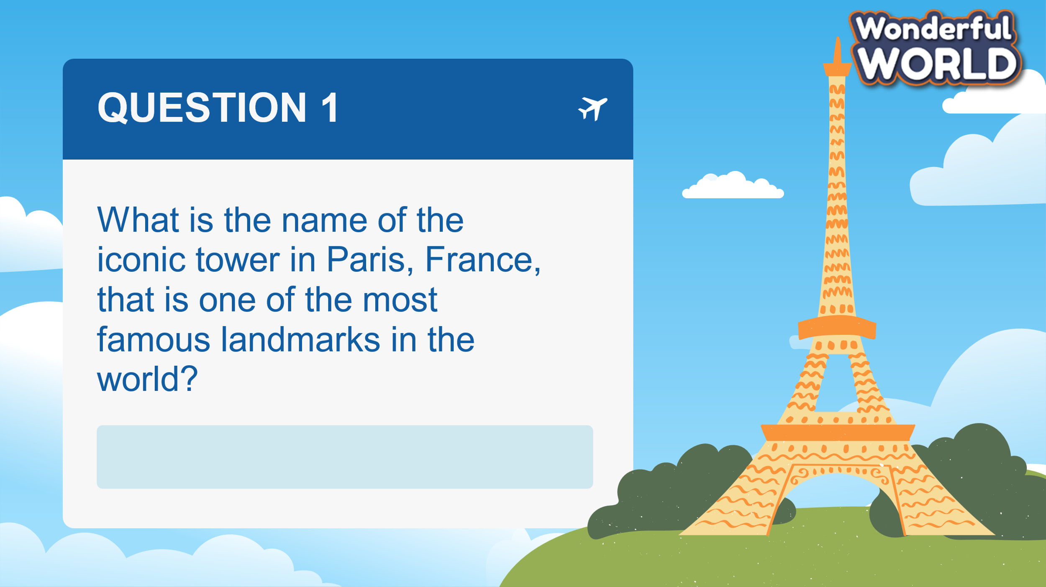  -
Activity 2: Presentation – Controlled practice (8 minutes)
Aims: Ss can practice listening and writing skills about the topic: the house
Teacher’s Activities | Students’ Activities
To engage students with the topic and activate knowledge and vocabulary with a picture,  Tell students to look at the photo on page 15 and say what they can see. Ask: “ Have you seen the house before? Is it unique? Is it beautiful ?”  Elicit ideas (house, rock, coastline, beach, mountains) and write them on the board.  Listen and read. Would you like to live in a football-shaped house? Why or why not?  - Tell students to look at the text. Ask them to read quickly and find out what the photo is showing (a football-shaped house).  Tell students to look at the text about a football-shaped house in Japan. Tell them to read the pre-reading questions.  Play the recording. Pause after each sentence for students to repeat.  Play the recording again. Ask students to each read out a sentence from the text.  Check answers to the pre-reading questions.  Read again and write the words.  To elicit the new words, ask S to read again and fill in the blanks.  Keywords  Ladder/ basements/ balconies/ views.  Present new words :  Balcony/ basement/ floor/ garden/ ladder/ view/ | - Answer the questions.  - Read  - Write
Activity 3: Practice – Controlled practice (8 minutes)
Aims: Ss can remember the new words.
Teacher’s Activities | Students’ Activities
Complete the sentences with these words.  Tell students to complete the sentences with the words in the box.  Remind them to re-read the text for help if necessary.  Check answers. Write the answers on the board if necessary.  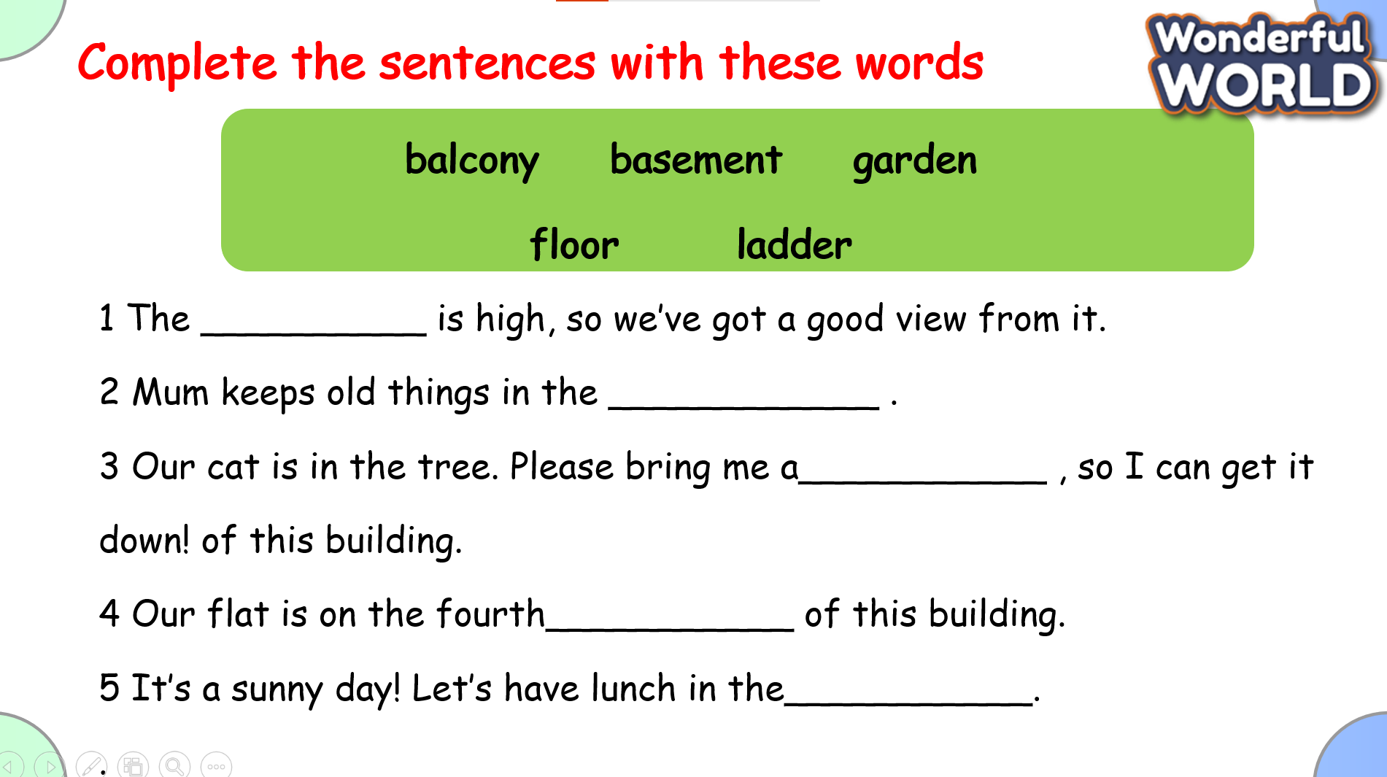  Game: TREASURE HUNT  By answering the questions,  1. How do you access the bedrooms in the house?  I climb a ladder to get into the house.  2. These houses do not have________ or balconies.  Basements  3. Our flat is on the fourth___________ of this building.  Floor  4. Do football-shaped houses in Japan provide strong protection during earthquakes and floods?  Yes  5 She climbed the _______ to fix the roof.  balcony | 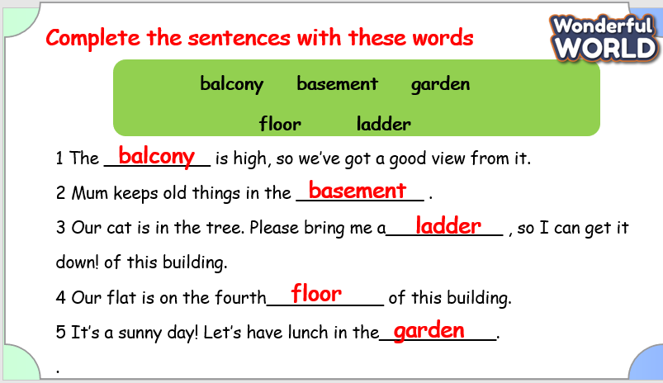  Answer the questions.
Activity 4: Production – Free practice (6 minutes)
Aims:
Apply their understanding in drawing the picture about the house and talk with their friends
Teacher’s Activities | Students’ Activities
Preparation:  Prepare Materials: Ensure each student has access to drawing paper and coloring materials.  Begin with a brief discussion about houses. Ask questions like, “What do you see in a house?” or “What are some parts of a house?”  Show Examples: Display images of different types of houses. Discuss various features (roof, windows, doors, etc.) and their functions.  Drawing Activity  Instructions: Explain that each student will draw a picture of a house. Encourage them to include various parts such as the roof, windows, door, and any additional details they like (garden, trees, etc.).  Drawing Time:  Worksheet: If using a worksheet, have students write a few sentences describing their house. Prompts might include, “My house has…” or “I drew a big…”  Assist: Provide help with spelling and sentence structure if needed.  Discussion  Pair Up: Have students pair up with a classmate.  Share and Describe: Each student will take turns showing their drawing and describing it to their partner. Encourage them to use descriptive language to explain the different features and why they chose them.  Discuss: After each student has shared, ask pairs to discuss what they liked about each other’s houses. | - Draw and say in front of the class.
Activity 5: Wrap up & Assessment (4 minutes)
Teacher’s Activities | Students’ Activities
Aims:
- Check students’s understanding of what they have learned about the house.
Asks sts to do the assessment.  T assesses class and some Ss.  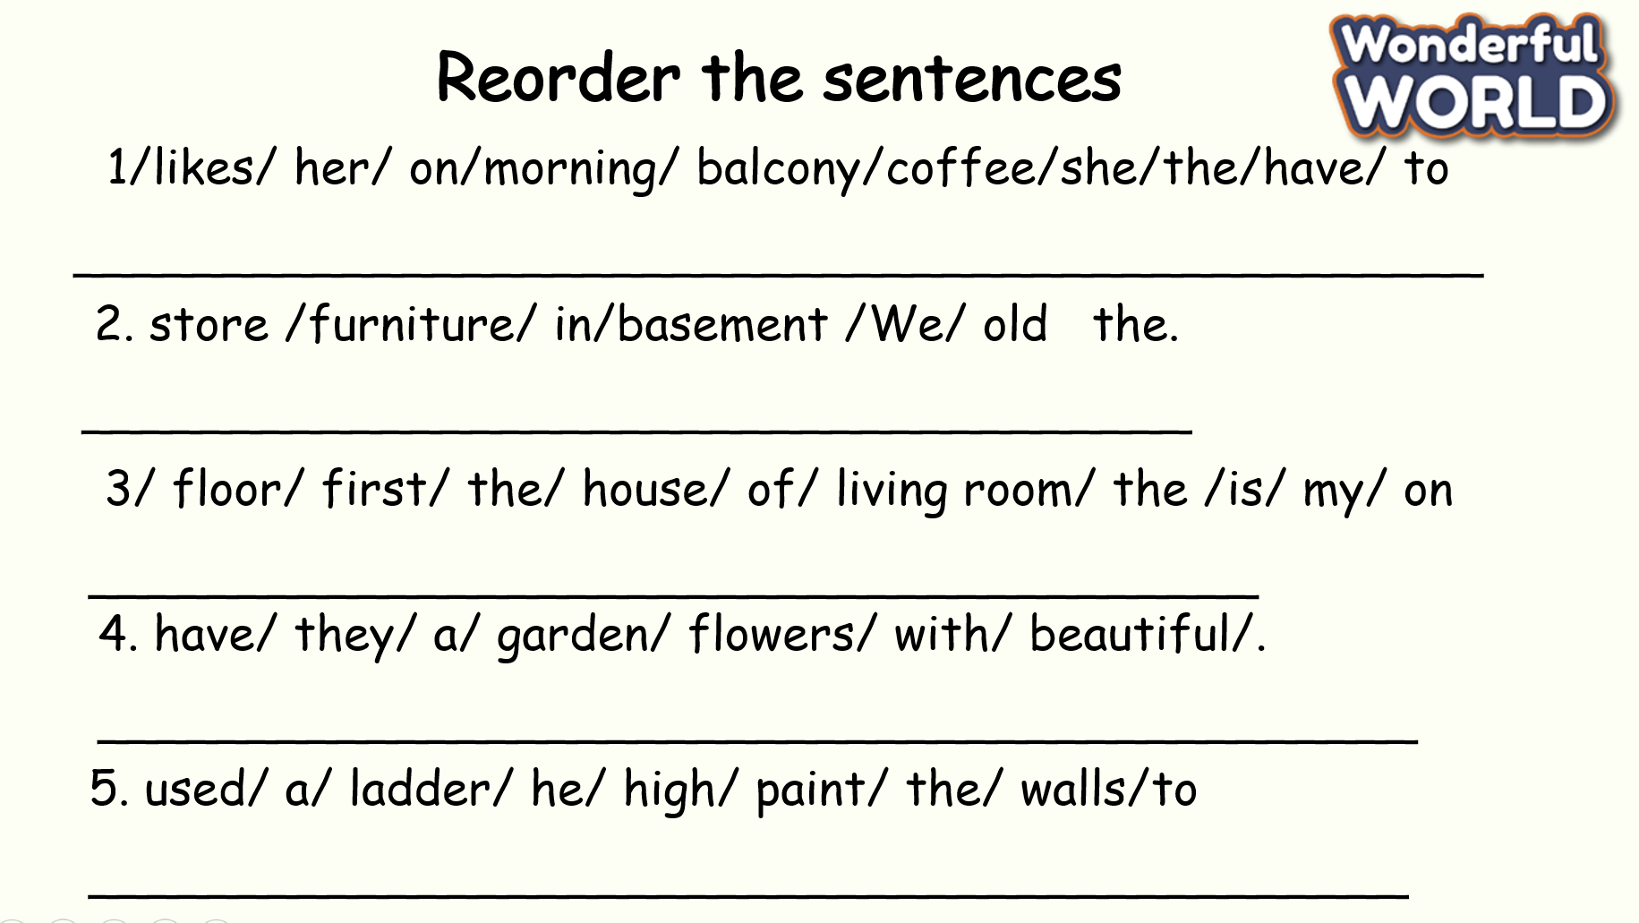  - Check with the class.  - Wrap-up  * Remember  Vocabulary:  balcony, basement, floor, garden, ladder, view | -Do the assessment.  -Check with the teacher  - Sts read the wrap-up  - Stand up and say goodbye to the teacher.  