TUẦN 14 Khối 2, 3, 5 (Từ ngày 09/12/2024 đến ngày 13/12/2024)
THỨ | TIẾT | MÔN | TIẾT THỨ | NỘI DUNG BÀI DẠY |  | UDCNTT | ĐỒ DÙNG DẠY HỌC
Hai  09/12 | 1 | 5A | 53 | Unit 5. Celebrations | Fun time and project (4, 5) | Wonderfulworld | Flashcards, TV, books
Hai  09/12 | 2
Hai  09/12 | 3 | 3A | 53 | Unit 4. My house | Fun time and project (1, 2) | Wonderfulworld | Flashcards, TV, books
Hai  09/12 | 4 | 3A | 54 | Unit 5. My clothes | Lesson 1 (1, 2, 3) | Wonderfulworld | Flashcards, TV, books
Hai  09/12 | 5 | 5D | 53 | Unit 5. Celebrations | Fun time and project (4, 5) | Wonderfulworld | Flashcards, TV, books
Hai  09/12 | 6 | 3B | 53 | Unit 4. My house | Fun time and project (1, 2) | Wonderfulworld | Flashcards, TV, books
Hai  09/12 | 7
Ba  10/12 | 1 | 5C | 53 | Unit 5. Celebrations | Fun time and project (4, 5) | Wonderfulworld | Flashcards, TV, books
Ba  10/12 | 2 | 5B | 53 | Unit 5. Celebrations | Fun time and project (4, 5) | Wonderfulworld | Flashcards, TV, books
Ba  10/12 | 3 | 5A | 54 | Unit 6. Food | Lesson 1 (1, 2, 3) | Wonderfulworld | Flashcards, TV, books
Ba  10/12 | 4
Ba  10/12 | 5 | 3A | 55 | Unit 5. My clothes | Lesson 1 (4, 5, 6) | Wonderfulworld | Flashcards, TV, books
Ba  10/12 | 6 | 5D | 54 | Unit 6. Food | Lesson 1 (1, 2, 3) | Wonderfulworld | Flashcards, TV, books
Ba  10/12 | 7 | 3B | 54 | Unit 5. My clothes | Lesson 1 (1, 2, 3) | Wonderfulworld | Flashcards, TV, books
Tư  11/12 | 1 | 5A | 55 | Unit 6. Food | Lesson 1 (4, 5, 6) | Wonderfulworld | Flashcards, TV, books
Tư  11/12 | 2
Tư  11/12 | 3
Tư  11/12 | 4
Tư  11/12 | 5 | 5B | 54 | Unit 6. Food | Lesson 1 (1, 2, 3) | Wonderfulworld | Flashcards, TV, books
Tư  11/12 | 6 | 5C | 54 | Unit 6. Food | Lesson 1 (1, 2, 3) | Wonderfulworld | Flashcards, TV, books
Tư  11/12 | 7
Năm  12/12 | 1 | 5C | 55 | Unit 6. Food | Lesson 1 (4, 5, 6) | Wonderfulworld | Flashcards, TV, books
Năm  12/12 | 2 | 5B | 55 | Unit 6. Food | Lesson 1 (4, 5, 6) | Wonderfulworld | Flashcards, TV, books
Năm  12/12 | 3 | 5A | 56 | Unit 6. Food | Lesson 2 (1, 2, 3) | Wonderfulworld | Flashcards, TV, books
Năm  12/12 | 4
Năm  12/12 | 5 | 5D | 55 | Unit 6. Food | Lesson 1 (4, 5, 6) | Wonderfulworld | Flashcards, TV, books
Năm  12/12 | 6 | 5C | 56 | Unit 6. Food | Lesson 2 (1, 2, 3) | Wonderfulworld | Flashcards, TV, books
Năm  12/12 | 7
Sáu  13/12 | 1 | 3B | 55 | Unit 5. My clothes | Lesson 1 (4, 5, 6) | Wonderfulworld | Flashcards, TV, books
Sáu  13/12 | 2 | 5D | 56 | Unit 6. Food | Lesson 2 (1, 2, 3) | Wonderfulworld | Flashcards, TV, books
Sáu  13/12 | 3 | 5B | 56 | Unit 6. Food | Lesson 2 (1, 2, 3) | Wonderfulworld | Flashcards, TV, books
Sáu  13/12 | 4
Sáu  13/12 | 5
Sáu  13/12 | 6 | 3B | 56 | Unit 5. My clothes | Lesson 2 (1, 2, 3) | Wonderfulworld | Flashcards, TV, books
Sáu  13/12 | 7 | 3A | 56 | Unit 5. My clothes | Lesson 2 (1, 2, 3) | Wonderfulworld | Flashcards, TV, books

GRADE 3
WEEK 14
UNIT 4. MY HOUSE
Fun time and project: Task 1, 2
Period 53
I. OBJECTIVES:
1. Knowledge:
Students will review My house vocabulary and unit grammar
2. Competence:
- English competences: Students will be able to talk about their friends about the rooms of their houses
- Common competences: Students will develop their creativeness in drawing pictures
3. Qualities:
- Students will be proud of where they live
II. EQUIPMENT AND MATERIALS:
- Basic things: Student’s book, flashcards; audio track 4.13
- Advanced things: PPT, projector/interactive whiteboard/laptop/TV.
III. LESSON PROCEDURE
Activity 1: Fun Time (10 minutes)
Teacher’s activities | Student’s activities
- Greet students.  - Chants play track 4.13 and have ss chant and do activities.  - Game. Memory chain  - Redistribute the bags from the previous activity among groups of sts.  - Ss in each group take objects out of their bags and describe them in order  S1: There is (a car)  S2: There is (a car) and There is (a teddy bear)  S3: There is (a car) and there is (a teddy bear) and there is a ball  …etc … | - Greet teacher.  - Chant and do.  - Play game in groups.
* Vocabulary: 10 words  (rooms and room objects)  - Shuffle 10 flashcards and place them around the classroom.  - Quickly show the cards and have ss identify the items.  - Show three cards in sequence and have sts recall the words in proper sequence.  * Game: Find your partner  - Use word cards and put in multiple sets so that all sts have word cards or pictures (half of flashcards are word cards the others are pictures)  - Have ss walk around to look for another ss who have the same flashcards (Words or pictures)  * Structure:  - Game: Walk and talk  + Place a couple of flashcards around the room (eg: T. V- living room  a lamp - bedroom, game – T.V, a clock – living room,  a computer – classroom, a toy – bathroom)  - Have ss go around in pairs. At signal “stop”  S1: face up the cards and ask “What’s this?”  S2: There is a T.V in the living room. | - Look and say are by one.  - Look and say in sequence  - Go around and find one of their partners.  - Play game
Task 1: Unscramble the letters  - Show 4 photos in part 1 and have ss focus on photo 1 and the words below.  - Have ss answer What they have to do in the exercise.  - Have ss do the task (spoken).  - Have ss write down in their book  - Have 2 volunteers write their answers on the board.  - Give the right answers and have sts check | - Look  - Answer the teacher  - Write the correct words  - Check in pairs
Activity 2: Project (25 minutes)
Teacher’s activities | Student’s activities
Task 2. Project: A nice house  - Show the words in the part (living room…)  - Ask sts to form group of four and to make a house together  -They may devide the paper into some parts with each part representing one room in the house.  - Each member draws things for one of the rooms, and copies the drawings of the other three parts. Otherwise, sts can devide up the rooms among themselves, and use the entire space given to draw one room each.  - When sts have completed their drawing, they should share them with their group  -Ask some groups to come to the front of the class to show their drawings and about the completed house  - Ask sts to make an exhibition | - Look  - Answer  - draw the room.  - works in groups  - Some sts say about their rooms  Sts can ask their friends questions about household objects in the pictures

____________________________________
UNIT 5. CLOTHES
Lesson 1. Task 1, 2, 3
Period 54
I. OBJECTIVES:
1. Knowledge:
- Students will be able to use the words and phrases related to the topic My Clothes: shoes; skirt; socks; trousers; T-shirt
2. Competence:
- English competences: Students will be able to describe kind of clothes.
- Common competences: Students will have the opportunity to develop communication among friends.
3. Qualities:
- Students will be friendly and confident in communicating with their friends.
II. EQUIPMENT AND MATERIALS:
- Basic things: Student’s book, flashcards; audio track …
-Advanced things: PPT, projector/interactive whiteboard/laptop/TV.
III. LESSON PROCEDURE
Activity 1: Warm up (5 minutes)
Teacher’s activities | Student’s activities
- Greet students.  + Play the Hello song. Students sing along and do.  Guessing game:  + Review name of the colors.  + Set the rules: There are 6 numbers, each number contains 1 colour question What colour is it?, whoever wins in the game will be opened in order from 1 to 6. If the opener answers the question correctly, they will get 3 stars, if not, the answer will be given to the remaining team. When answering all 6 questions, sts will see the opener picture of the lesson.  + Divide the class into groups; ask four students come into the front, they rock paper, and scissors. The winner opens the cross and answers the question.  + Each time they get stars for their groups  + Students have six times to open the key picture.  Lead in: Use the Opener picture to lead in the topic: My Clothes  - Show slide of Doremon to sts  - Ask sts to say the nationality of him  - Tell the special thing he has got  - Write on the board The date and introduce the lesson. | - Great teacher.  - Listen and sing. Then do the action with teacher.  - Read follow teacher if possible.  Groups  Look and answer  Listen and repeat clothes’ words  Copy down
Activity 2: Presentation (8 minutes)
Teacher’s activities | Student’s activities
Task 1: Listen and point. Repeat. (Track 5.1)  - Use flashcards to introduce the vocabulary.  - Say the words/sentences for sts to repeat in chorus.  - Put the flashcards in different places around the room.  - Say a word/sentence for sts to repeat then point.  - Play the track 5.1, ask students to listen and repeat in chorus, group. | - Learn new words and structures through flashcard.  - Repeat the words/sentences  - Repeat then point.  - Repeat.
Activity 3: Practice (10 minutes)
Task 2: Listen and match (track 5.2)  - Ask sts how many friends can they see and where they are.  - Have sts look at the dialogue  - Students listen and repeat  - Role play with sts’groups!  - Have sts look at the exercise and ask them to complete match.  - Have sts practice the dialogues in chorus, group, pairs. | - Look at the pictures and answer: There are five (girls). They are in Japan  - Listen and repeat  - Practice the dialogues.
Task 3: Say  Game: Broken sentences  - Make a copy of the Broken sentences worksheet for each student/group (Make the activity shorter by leaving out some sentences)  - Explain the objective of the activity. This can be done by example on the board  Eg: “There are” on one side of the board and a number of possible combinations on the other “uniforms”; “their”; “in”; “skirts” / …..  - Give student/group a copy worksheet. Let them look at it for a few minutes to familiarise themselves with its contents. They cut the worksheet and place them face up on the desk.  - Divide the class into pairs. Pairs work together to match up each of their sets of cards as in the demonstration  - Monitor to check that they are making correct combinations. Show sts how to look for a logical connection between paths of sentences  - Correct collectively, with sts reading out sentences for the others to check their combination  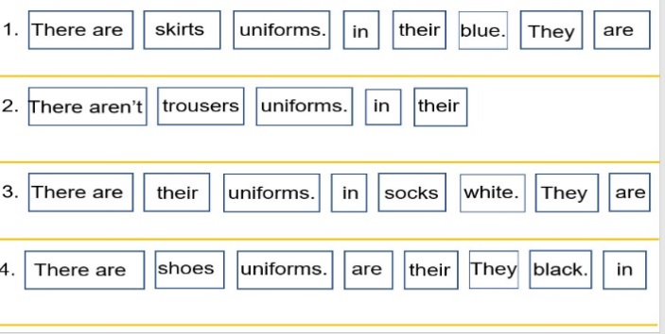 | - Listen to the rules. Then do.  -Work in pair  Some groups present  1. There are skirts in their uniforms. They are blue.  2. There aren’t trousers in their uniforms.  3. There are socks in their uniforms. They are white.  4. There are shoes in their uniforms. They are black.
Activity 4: Production (9 minutes)
Teacher’s activities | Student’s activities
- Ask Sts to draw on their notebook/paper their uniforms and color it. Then use pattern and say.  Ex:  + There are (skirts) in my uniform. They are (red).  + There aren’t (black shoes) in my uniform. | - Think about their uniforms, draw and colour  - Work individual/groups then say  (Eg: There are trousers, They are blue.....)
Activity 5: Assessment (3 minutes)
Teacher’s activities | Student’s activities
- Ask sts to answer the quick question (Vietnamese is acceptable):  1. Which topic do they learn today?  2. How many words have they learned?  3. What’s activity do they like the most and why?  - Encourage the whole class  - Check sts’answers  - Have sts count stars and claim the winner group  - Say goodbye | - Answer the question  1. Clothes  2. There are five: shoes, skirt, trousers, T-shirt  3. I like....because it’s..  - Say goodbye: sing the Goodbye song.
____________________________________
UNIT 5. CLOTHES
Lesson 1. Task 4, 5, 6
Period 55
I. OBJECTIVES:
1. Knowledge:
- Students will learn the structure I/ You/ They have got…..
2. Competences
- English competences: Students will be able to introduce their possesses clothes.
- Common competences: Students will have the opportunity to develop communication among friends.
3. Qualities:
- Students will be friendly and confident in communicating with their friends.
II. EQUIPMENT AND MATERIALS:
- Basic things: Student’s book, flashcards; audio track 5.3
- Advanced things: PPT, projector/interactive whiteboard/laptop/TV.
III. LESSON PROCEDURE
Activity 1: Warm up (5 minutes)
Teacher’s activities | Student’s activities
- Greet students.  + Play the Hello song. Students sing along and do.  Game: The secret window  + Review name of the clothes  + Set the rules: The teacher divides the class into four teams; Each secret window given is accompanied by some suggestions. The groups will discuss and give the correct answer to the name of the costume. The team that guesses correctly will get five stars for the first answer and will be deducted when opening the next suggestions  1.  -You wear me in summer.  - My name starts with ‘T’.  - My name has 6 letters.  2.  - I’m always in plural form.  - I am often blue.  - I am your uniform.  3.  - I keep you warm.  - My name starts with ‘s’.  - I always come in pair.  4.  - I love your feet.  - I come in pair.  - I am a footwear.  5.  - I can be long or short.  - My name ends with ‘t’.  - Only girls wear me.  + Count the number of stars and celebrate the winner groups | - Greet teacher.  - Listen and sing. Then do the action with teacher.  - Read follow teacher if possible.  Groups  1. T-shirt  2. trousers  3. socks  4.shoes  5. skirt  Count the number of stars
Activity 2: Presentation (8 minutes)
Teacher’s activities | Student’s activities
Lead in: Use the game and the picture to lead in the new lesson  - Write on the board The date and introduce the lesson.  Task 4: Listen and repeat. (Track 5.3)  1. Ask sts to look at the pictures and answer the questions: What is it? What colour is it?  2. Use the picture and/or explanation to teach the structure I/you/they have got…  3.Have sts listen and repeat the sentences  4. Correct pronunciation when needed.  Blended Teaching Tip: TPR practice: Point to the teacher and some sts talk about possession clothes  - I have got …..  - You’ve got…..  *GAME: Who’s faster?  - Show the 4 cards in front of the Ss  - Divide class into 2 teams  - Give instruction of game: T has six pictures when teacher says “One, two, three” the faster student will choose one picture. Then hang up and say louder “They have got skirts. Their skirts are brown and blue …”  Take turn to the monitor to guide the teams  - T makes models | Copy down  Listen and answer  Listen and repeat in chorus, group.  Listen and answer  Look, listen and do  Listen and answer  1.They have got skirts. Their skirts are brown and blue./..  2. They have got T-shirts. Their T-shirts are white./…  3. They have got books. Their books are blue./….  4.They have got toys. Their toys are yellow, blue,….
Activity 3: Practice (10 minutes)
Task 5: Look and say  Game: Sentence jumble  - Make an enlaeged copy the the worksheet and cut out the card, select the oppropriate number of cards , ensuring that they make up complete sentences  - Explain that the activity involves forming sentences, and each sentence consists the cards. They should use the puntuation to help them (full stop and captital letter)  - Elicit the model sentence  “They’ve got T-shirt.  Their T-shirt are white.”  Give the sts the worksheet. Sts must put the words into the correct order. They can do this by:  + cutting out  + stick on the group boards  - Correct collectively on the board  - Have sts practice the sentence in chorus, group, pairs, individual | - Look and work in group  - Practice  Practice the sentence in chorus, group, pairs, individual
Task 6: Write and say.  -The teacher uses any school things in the classroom. Use the “I've got...” sentence pattern to say what you have. Change roles 3 to 5 students speak according to the teacher's model.  - Use a broken given sentence, ask students to arrange it into a complete sentence  - examine and correct  - ask the students to work in pairs  - ask the students to cross-check each other  - call to correct the lesson | -Work in group  Some groups present  Correct their first sentence.  work in pairs  Students read, write the completed sentence in full
Activity 4: Production (9 minutes)
Teacher’s activities | Student’s activities
- Show a table and a model sentence  - Ask Sts to make the own sentences then say.  Eg:  +S1: I’ve got a skirt.  +S2: I’ve got a skirt and trousers.  +S3: I’ve got a skirt, trousers and a cat.  ……..  - The student has the longest sentence is the winner. | Individual
Activity 5: Assessment (3 minutes)
Teacher’s activities | Student’s activities
- Ask sts to do the assessment  - Check in pair then whole class.  1. I’ve got new shoes. … shoes are cool.  A. They B. My  2. Lan and Lisa ’ve got lots of toys. They love… toys.  A. their B. you  3. Your T-shirt is black and… shoes are black, too.  A. your B. you  - Say goodbye | - Do the assessment.  - Check with friends and then with teacher and whole class.  1.B 2.A 3.A  - Say goodbye. sing the Goodbye song.
____________________________________
UNIT 5. CLOTHES
Lesson 2. Task 1, 2, 3
Period 56
I. OBJECTIVES:
1. Knowledge:
- Students will learn the words related to the topic clothes: boots, coat, dress, hat, warm and revise the structure I’ve got …
2. Competences:
- English competences: Students will be able to introduce their possesses clothes…
- Common competences: Students will have opportunity to develop the solving problem in doing tasks and cooperation among teammates
3. Qualities:
- Students will be friendly and confident in communicating with their friends.
II. EQUIPMENT AND MATERIALS:
- Basic things: Student’s book, flashcards; audio track 5.4; track 5.5
- Advanced things: PPT, projector/interactive whiteboard/laptop/TV.
III. LESSON PROCEDURE
Activity 1: Warm up (5 minutes)
Teacher’s activities | Student’s activities
- Greet students.  - Play the Hello song. Students sing along and do.  Game: Crossword - In my closet  - Introduce the topic of the game.  - Elicit sentences for each word. Ex: Its name starts with ‘T’. You wear it in summer. It has six letters.  - Play all 5 words then have sts check and read out the words  shoes; socks; skirt; trousers  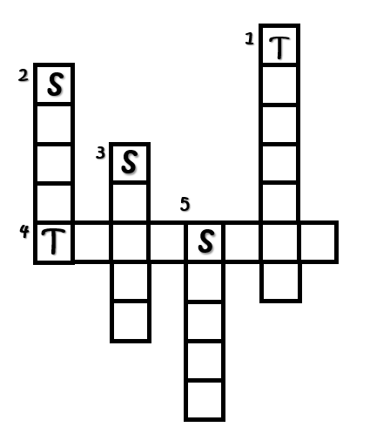 | - Greet teacher.  - Listen and sing. Then do the action with teacher.  - Read follow teacher if possible.  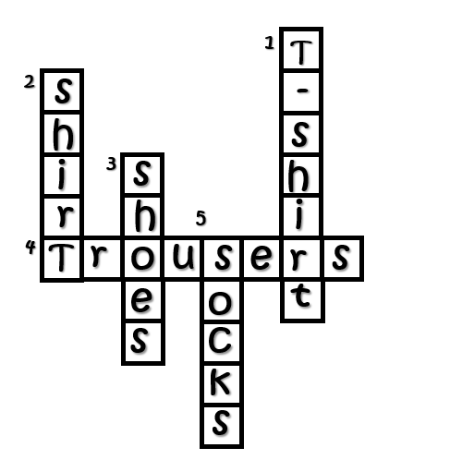
Activity 2: Presentation (8 minutes)
Teacher’s activities | Student’s activities
Lead in: Use the game and the picture to lead in the new lesson  - Write on the board The date and introduce the lesson.  Task 1: Listen and repeat (Track 5.4)  - Use flashcards to introduce the vocabulary: boots, coat, dress, hat, warm.  - Say the words for sts to repeat in chorus.  - Use one more picture of Doremon and his friends to explain the meaning of the word “warm” – “ We wear warm clothes, when it’s cold.”  - Put the flashcards in different places around the room.  - Say a word for sts to repeat then point.  - Play the track 5.4, ask students to listen and repeat in chorus, group. | Copy down  - Learn new words and structures through flashcard.  - Repeat the words/sentences  - Repeat then point.  - Repeat.
Activity 3: Practice (10 minutes)
Task 2: Listen and match (Track 5.5)  Pre-listening:  - Show picture of the task  - Ask sts to talk about the picture  + How’s the weather?  + How many girls are there?  + Have they got warm clothes?  + What clothes are these?  + What colors are her boots?  - Ask sts to read and guess the answer  - Collect the suitable answer on the board  While listening:  - Ask sts to listen and match  - Play the audio 5.5 twice  - Have sts do cross-check  - Play audio again and check with whole class  Post listening:  - Show the text and the picture  - Ask sts to listen and repeat sentence by sentence  - Ask sts to pretend acting as a reporter | Look and answer  + Cold. / It’s cold.  + Two. / There are two girls.  + Yes. / Yes, they have.  + Coats. Boots / These are coats /boots.  + Black. / They’re black. / Her boots are black.  - Read the text  - Guess the answers  - Listen and match  - Do cross-check  - Check with teacher  - Listen and repeat  - Act and say
Task 3: Look and say.  Game: Who is faster?  - Show some pictures and the words randomly  - Make a copy of the worksheet for each student/group  - Explain the objective of the activity. This can be done by example on the board  Eg: “I’ve got” on one side of the board and a number of possible combinations on the other “”; “My....”; “are”; “They are warm.” / …..  - Give student/group a copy worksheet. Let them look at it for a few minutes to familiarise themselves with its contents. They cut the worksheet and place them face up on the desk.  - Divide the class into pairs. Pairs work together to match up each of their sets of cards as in the demonstration.  - Monitor to check that they are making correct combinations. Show sts how to look for a logical connection between paths of sentences  - Correct collectively, with sts reading out sentences for the others to check their combination  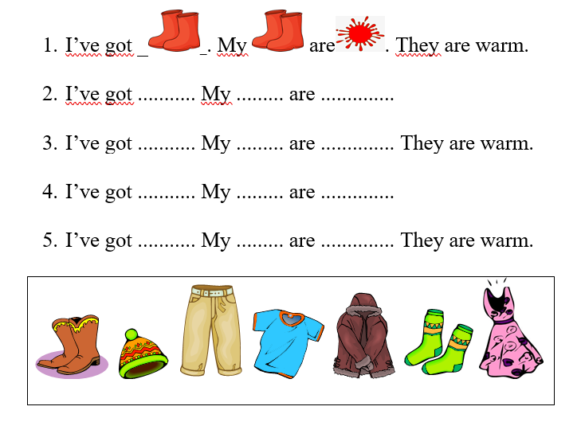 | - Listen to the rules. Then do.  -Work in group  Some groups present
Activity 4: Production (9 minutes)
Teacher’s activities | Student’s activities
- Ask Sts to draw on their notebook/paper their warm clothes and color it. Then use pattern and say  I’ve got ______. My ____ is/ are ______. They are warm. | Individual
Activity 5: Assessment (3 minutes)
Teacher’s activities | Student’s activities
- Ask sts to do the assessment  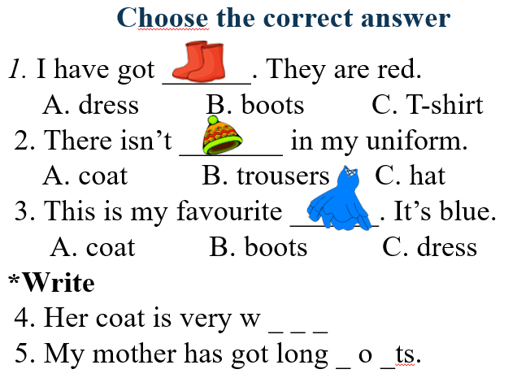  - Check in pair then whole class.  - Say goodbye | - Do the assessment.  - Check with friends and then with teacher and whole class.  1. A  2. C  3. C  4.warm 5. boots  - Say goodbye. Sing the Goodbye song.
__________________________________________
GRADE 5
WEEK 14
UNIT 5: CELEBRATIONS
Fun time and project: Task 4-5
Period 53
I. OBJECTIVES:
1. Knowledge:
- Students review words of celebrations: lantern, lion dance, lunar month, mooncake, Mid-Autumn festival, parade
- Students review the simple past tense: did, went, had, was/were
2. Competences:
- English competences: Students can use English to introduce the celebrations and the activities they do.
- Common competences: Students can use simple past tense to talk about something in the past.
3. Qualities:
- Students will
+ have a strong knowledge and comparison between celebrations around the world.
+ recall and reflect on personal experiences with the celebrations they have joined and the activities they did.
+ be enthusiastic about sharing their memories with their friends.
II. EQUIPMENT AND MATERIALS:
- Basic things: Student’s book, flashcards, photos, papers
- Advanced things: PPT, laptop, TV.
III. LESSON PROCEDURE:
Activity 1: Warm-up (10 minutes)
Show time “We’re all in this together!”
Aims: Welcome students. Engage the class (or warm the class up) with a song to help Ss relax and warm-up the lesson.
- Lead in the new one.
Teacher’s Activities | Students’ Activities
Procedure
1. Greet students. Chatting…  - Do you remember the song we listened to last week?  - Have you prepared for your show?  - May I have some groups performing in the show today?  2. Introduce the show: We’re all in this together  - Give Ss some minutes to revive the dance  - Invite some groups to perform in front of the class. Encourage the volunteers.  - Click on the play button to play the background video  - Click on the stop button to stop and move to the next slide  - Make compliment on the performance and encourage Ss to perform in the next lesson    Lead in:  - T raises some pictures and asks Ss to guess the topic of the lesson  - T reviews the topic “Celebration”  - Write on the board “Fun time and Project” and review the words and structures of the learned lesson | - Greet T and answer the questions  - Take the time to revive the song and the dance  - Perform in front of the class  - Look at the pictures and guess the topic
Activity 2: Review (5 minutes)
Aims:
- Review the words: lantern, lion dance, lunar month, mooncake, Mid-Autumn festival, parade
- Review the past tense verbs: did, went, made, had, was/were, etc.
+ Ss can use the past tense verbs in normal conversation
Teacher’s Activities | Students’ Activities
REVIEW  - Show the words on the screen  - Ask students to look at the screen and say the word  - Show the text and audio  - Ask Ss to listen again and repeat after the audio  - Can play twice or three times so that Ss can practice the words  - Asks some students to read the words or phrases individually  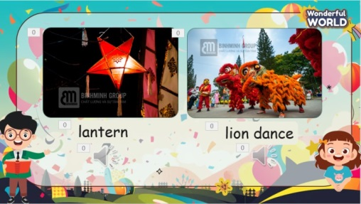  - Show the past tense verbs on the screen and review when to use them  - Show the example sentence and invite some Ss to make their sentences  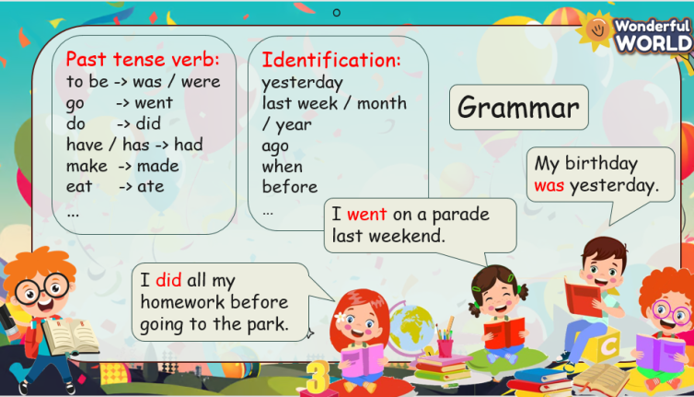 | - Look at the screen and say the words  - Check the words and listen to the audio  - Listen and repeat  - Listen to the explanation  - Create the sentences and speak in front of the class
Activity 3: Practice – Controlled practice (5 minutes)
Aims:
- Ss join the game to review the past tense verb
- Encourage Ss to read and think fast under the pressure of timeProcedure
Teacher’s Activities | Students’ Activities
Game: “Can you guess what they did”  T divides the class into 4 groups and chooses 4 inspectors. Each group will prepare a blackboard and a chalk.  T will show the quizzes on the screen. In 5 seconds, each group will read and write A, B, and C.  When the alert rings, all groups must stop and raise their board.  4 inspectors will stand in front of the class and check, then write the answer of each group on the board.  After that, T shows the answer and checks the result.  When the game finishes, the 3 groups with lower scores will do an exercise (hop, dance, etc.)   | - 4 volunteers standing on the board  - The others sit in groups of 4 and everyone listens to the rules  - Each group will have a blackboard and a chalk  - Write the answer on the board and raise it when the time ends (A, B, C)  - Check the answers  - Check the final results  - Do the exercise
Activity 4: Project – Free practice (9 minutes)
Aims:
- Apply the words and knowledge they have learned in talking about the activities of different celebrations and their hobbies.
- Encourage Ss to make conversation and speak freely in front of the crowd.
Teacher’s Activities | Students’ Activities
- Show some pictures of the different festivals in Vietnam and ask questions to get information about these celebrations, such as:  1. When is it celebrated?  2. What is the purpose of the festival?  3. What are the special properties of the festival?  4. What do people eat or drink at that festival?  5. What do they do in the festival?  6. How is the festival?  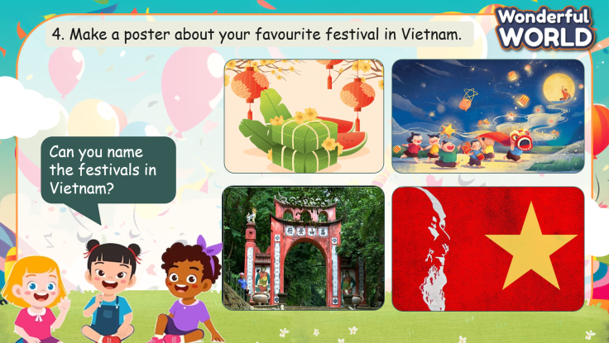  - Put Ss in groups of 6 and ask them to discuss and make a poster about their favourite holiday in Vietnam  - Give them 5 minutes to finish the task  - Invite some groups to talk about their favourite holiday. Encourage Ss take turns to speak  - Give them compliments  - Ask Ss to finish the poster at home  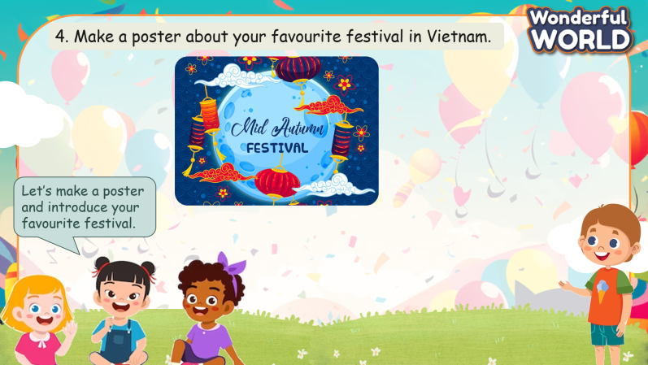 | - Look at the screen and read the names of the festivals in Vietnam  - Think of each festival and answer the questions  - Sit in groups of 6 and make a poster of their favourite festival  - Introduce their festival to the class, take turns to speak  - Complete the poster at home
Activity 5: Wrap up & Assessment (4 minutes)
Teacher’s Activities | Students’ Activities
Aims:
- Check Ss’s understanding of what they have learned.
- Students rehearse what they have learned in the lesson.
- Ask Ss to do the assessment.  - Give the assessment to the class and some Ss  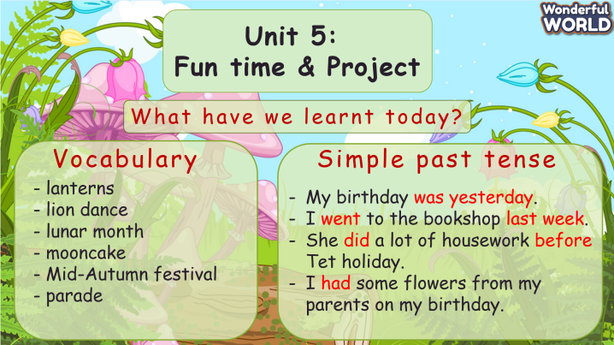  - Check with the class.  - Wrap-up  * Remember  VOCABULARY  Lantern, lion dance, Mid-Autumn Festival, mooncake, parade, lunar month  Past tense verbs  Did, went, had, made, ate, etc | - Do the assessment.  - Check with the teacher  - Ss read the wrap-up  - Stand up and say goodbye to the teacher.

UNIT 6: FOOD
Lesson 1: Task 1-2-3
Period 54
I. OBJECTIVES:
1. Knowledge:
- Students will be able to:
+ list words about some food that they have learnt.
+ remember the pronunciation and meaning of new words about food drawn out from the dialogue about food shopping: bread, butter, chocolate, cupcake, salad, spaghetti.
2. Competences:
- English competences: Students will be able to use English to introduce the food they need or don’t need.
- Common competences: Students will be able to work in pairs to create a short dialogue about the food that they need for a picnic.
3. Qualities:
- Students will
+ have a strong sense of respect in pair work.
+ show their interest in food through words and behaviors.
II. EQUIPMENT AND MATERIALS:
- Basic things: Student’s Book, Class Audio CD, Posters, IWB, DVD.
- Advanced things: PPT, laptop, TV.
III. LESSON PROCEDURE:
Activity 1: Warm-up (5 minutes)
A guessing game “Jigsaw”.
Teacher’s Activities | Students’ Activities
Aims: Welcome students. Engage the class with a guessing picture game to open the topic and lead in the new lesson.
1. Greeting Ss and chatting: Before starting the new lesson, let’s do a jigsaw puzzle to see what we will learn today.  2. Introducing and playing the game:  - Show a jigsaw puzzle and ask Ss to choose every random piece until Ss can answer what is underneath.  + There is a picture under the puzzle. You will choose every piece of the puzzle and guess what it is. (If correct, your team will get stars/ gifts/ points.)  + Correct answer: “food”  - Lead in the topic and write it down on the board.  + Today, we will learn about food. Now, turn to page 63.  3. Leading in the new lesson: Unit 6 – Lesson 1 task 1, 2, 3.  Lead in: Photo time!  - Keep showing the jigsaw puzzle photo on the screen and ask Ss to look and name the food they can see.  - Present the question “What kinds of food are they? Look and say.”  + Direct students to read the question and observe the photo to identify the type of food.  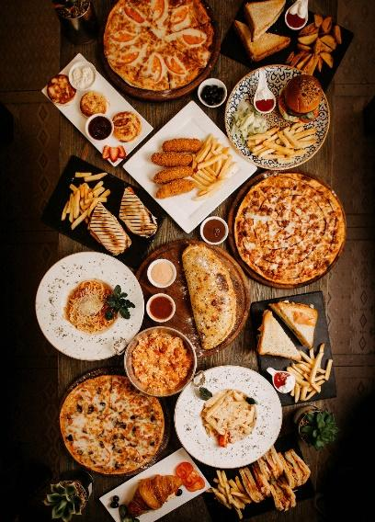  + Ask students to read the question and tick the correct answer (fast food).  + Check the answer as a class. | - Greet Teacher  - Join the activity.  - Look and listen.  - Look at the picture and listen to the teacher.  - Name the food: pizza, fries, hamburger, bread, toast, etc.  - Say the type of food that they think is correct.  - Tick and say the things in the photo.
Activity 2: Presentation (12 minutes)
Teacher’s Activities | Students’ Activities
Aims:
- Present new words: bread, butter, chocolate, cupcake, salad, spaghetti and guide Ss to know how correctly these words are pronounced.
- Encourage Ss. to answer the question: What do we need for dinner? based on the dialogue.
- Instruct Ss to finish task 2.
Task 1. Listen and read. What do they need to buy for dinner?  1. Show the picture on the screen. Point to the child and her mother and ask:  - Who are they?  - Where are they?  - What are they doing?  - Why are they buying food at the supermarket?  *Note: Let Ss answer the questions and move into the part of listening to the dialogue  - Now, we are listening to a dialogue between the mom and her daughter about what they are going to buy for dinner.    2. Ask Ss to look at the dialogue and listen. The audio is played twice.  3. During listening, ask Ss to listen and underline the words answering the question “What do they need for dinner?”  - Show the question & the dialogue on the slide  - Correct the whole class by showing answers on the slide.  4. Divide Ss into two groups and let them role-play as the child and her mom read aloud the dialogue  - Correct Ss’ pronunciation if necessary.  Task 2. Listen, point and repeat (Track 6.2).  - Show all the pictures of task 2 on the screen or use the flashcards and show them on the board.  - Play track 6.2 for Ss to listen without repeating.  - Play the track again. Ask Ss to point to the word and repeat in chorus and group after each pause. Correct Ss’ pronunciation if necessary.  - Check Ss’ understanding of each word by asking the Vietnamese meanings.  - Show pictures in random order and ask students to read out the correct words. | - Look, listen and answer the questions:  + They are mother and daughter.  + They are at the supermarket.  + They are buying food.  + They are buying food to cook dinner.  - Listen and underline.  - Listen and read aloud as a group.  - Look at the pictures/ flashcards.  - Listen to the 6 words.  - Listen, point and repeat the words in chorus, and group.  - Say the Vietnamese meanings.  - Look and read out the correct words
Activity 3: Practice – Controlled practice (8 minutes)
Teacher’s Activities | Students’ Activities
Aim: Ss will be able to practice the words in task 2 by doing the guessing activity “What food am I?”.
1. Introducing the activity “What food am I?” to Ss.  - Show three sentences of each new word on the screen and let Ss guess what food they have just learnt.  - Ask the rest to attentively listen and give a guess.  *Note:  - To make it exciting, T can get Ss who can answer right after the first sentence stars/ points or gifts.  + Bread:    - I am brown.  - I am eaten at breakfast.  - I can make sandwiches.  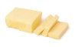  + Butter  - I am yellow.  - I can be eaten with bread.  - I am made from milk.  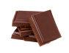  + Chocolate  - I am brown or black.  - I am made from a kind of fruit.    - I begin with the letter “C”.  + Cupcake  - I am colorful.  - I have cream on the top.  - I am sweet.  + Salad  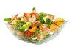  - I have many colors.  - I am healthy.  - I have vegetables or fruits.    + Spaghetti  - I am long.  - I am eaten with tomato sauce.  - I am from Italy. | - Join in the activity.  - Guess what food is described by the chosen students.
Activity 4: Production (5 minutes)
Teacher’s Activities | Students’ Activities
Aims:
- Ss apply the new words to work in pairs and then present in front of the class what they need and don’t need for a picnic.
- Ss will be able to give reasons for something unnecessary to buy.
- Start by explaining the activity to the students. Mention that they will be imagining and planning a picnic.  - Emphasize that they need to complete a shopping list for the picnic.  - Provide a guided example to help students understand the task.  - Model completing the shopping list by saying, “For the picnic, I need sandwiches, fruits and drinks. I don’t need chips or chocolate because I don’t like them.”  - Ask students to complete the shopping list individually, imagining the items they would like for a picnic.  - Have students pair up and discuss their picnic shopping lists with a partner.  - Encourage them to share why they chose certain items and why they didn’t choose anything else.  - Invite two or more pairs if there is enough time to share their picnic plans with the whole class.  - Encourage creativity and variation in responses. | - Think and finish the shopping list.  - Work in pairs and discuss what is needed and what isn’t needed.
Activity 5: Wrap up & Assessment (5 minutes)
Teacher’s Activities | Students’ Activities
Aims:
- Check students’ understanding of what they have learned.
- Students rehearse what they have learned in the lesson.
- Check with the class.  - Activity “Fill the missing letters”:  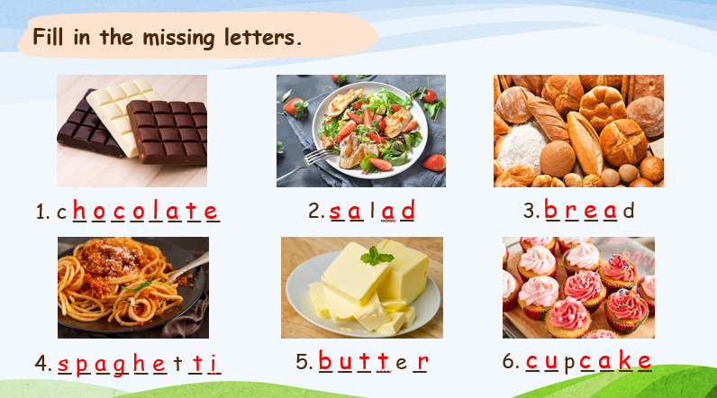  + Ss are asked to say the missing letters of each word.  - Assessment: Give compliments to the group/ team that has completed the activities the best and encourage the other groups/teams to keep doing them during the next lessons.  - Wrap-up.  * Remember  VOCABULARY  bread, butter, chocolate, cupcake, salad, spaghetti | - Check with the teacher.  - Read the new words again.  - Stand up and say goodbye to the teacher.
__________________________________________

UNIT 6: FOOD
Lesson 1: Task 4-5-6
Period 55
I. OBJECTIVES:
1. Knowledge:
- Students will be able to:
+ recall words about food that they have learnt in the previous lesson: bread, butter, chocolate, cupcake, salad, spaghetti.
+ get to know and use the new grammar about quantifiers: a lot of, many, much.
+ practice the new grammar by making affirmative and negative sentences using quantifiers.
2. Competences:
- English competences: Students will be able to use English to create sentences using food themes and quantifiers.
- Common competences: Students will be able to develop collaborative skills through pair work.
3. Qualities:
- Students will
+ have a strong sense of respect in pair work.
+ raise their confidence by presenting in front of the class.
II. EQUIPMENT AND MATERIALS:
- Basic things: Student’s Book, Class Audio, IWB.
- Advanced things: PPT, laptop, TV.
III. LESSON PROCEDURE:
Activity 1: Warm-up (5 minutes)
A card game “Memory”
Teacher’s Activities | Students’ Activities
Aims: Welcome students. Engage the class with a card game to review words that Ss have learnt: bread, butter, chocolate, cupcake, salad, spaghetti, etc.
1. Greeting Ss and chatting: Before starting the new lesson, do you want to play a game?  2. Introducing and playing the game:  - Show a set of cards on the screen and explain how the game works.  - Ask Ss to look at the cards carefully and remember as fast as they can. Ss need to choose two cards which have the word and the corresponding picture. Each team will only answer once each turn.  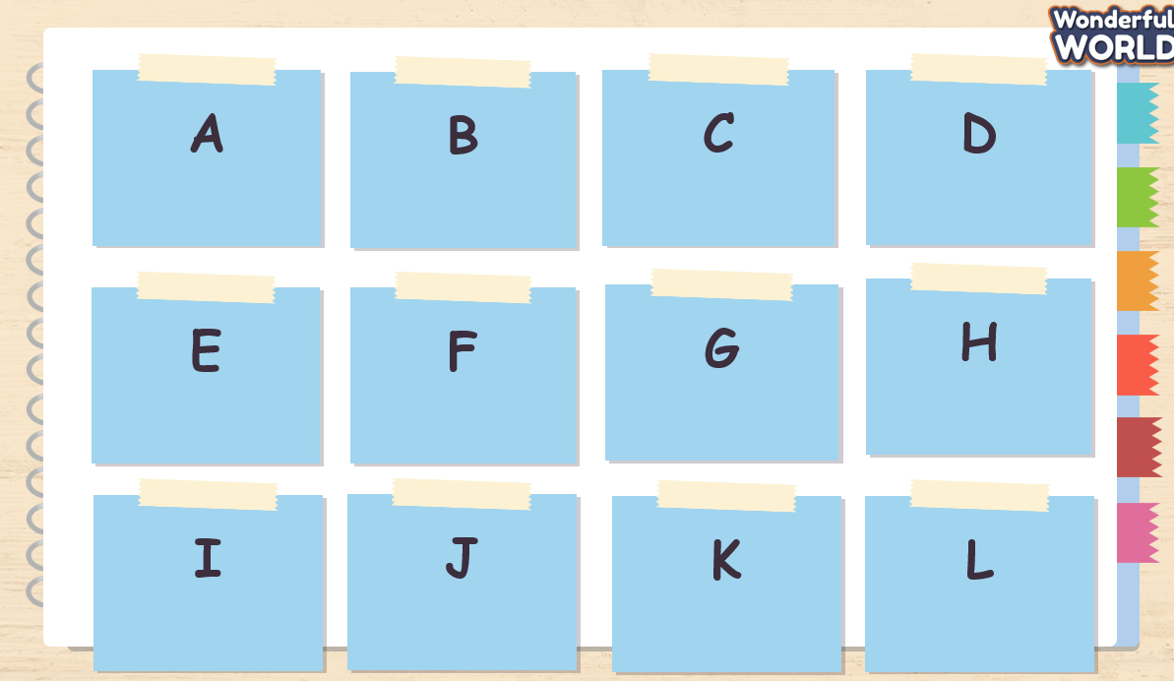 | - Greet Teacher  - Join the activity.  - Look and listen.
Activity 2: Presentation (10 minutes)
Teacher’s Activities | Students’ Activities
Aims:
- Present the new grammar: a lot of, many, much and guide Ss how to use these quantifiers correctly in sentences.
- Instruct Ss to finish task 4 by individual and pair.
1. Eliciting Quantifiers “many”, “much”, “a lot of”  - T shows pictures and examples of quantifiers which are used in the first two sentences from Exercise 4.  - Ask Ss to listen (Track 6.3) and wholly read aloud along with the audio.  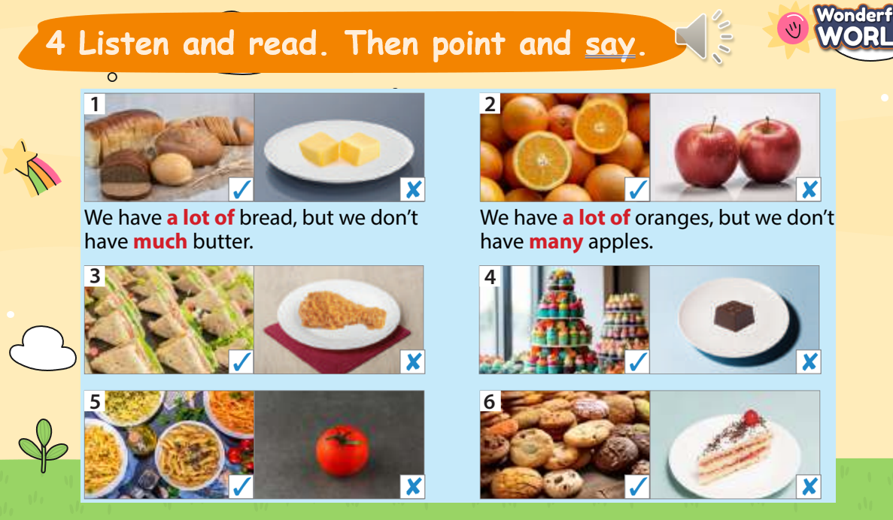  - T asks Ss what types of nouns are used with “many”, “much”, “a lot of” when Ss see the pictures and examples.  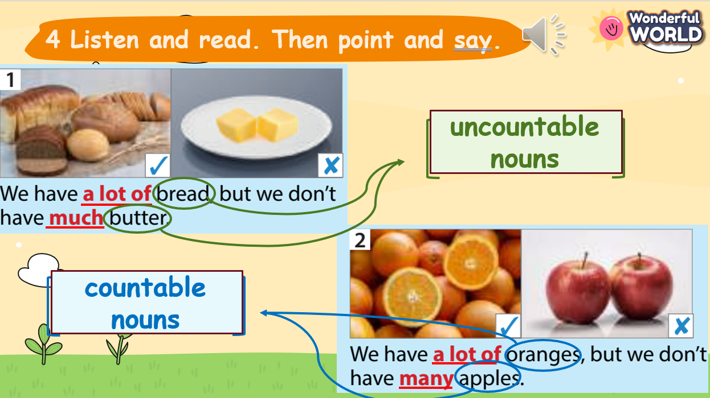  - T repeats the combination of the quantifiers and nouns in the following table.  - Tell students that we use much, many and a lot of to describe quantities.  - We use much with uncountable nouns.  - We use many with plural countable nouns.  - We can use a lot of with both types of nouns.  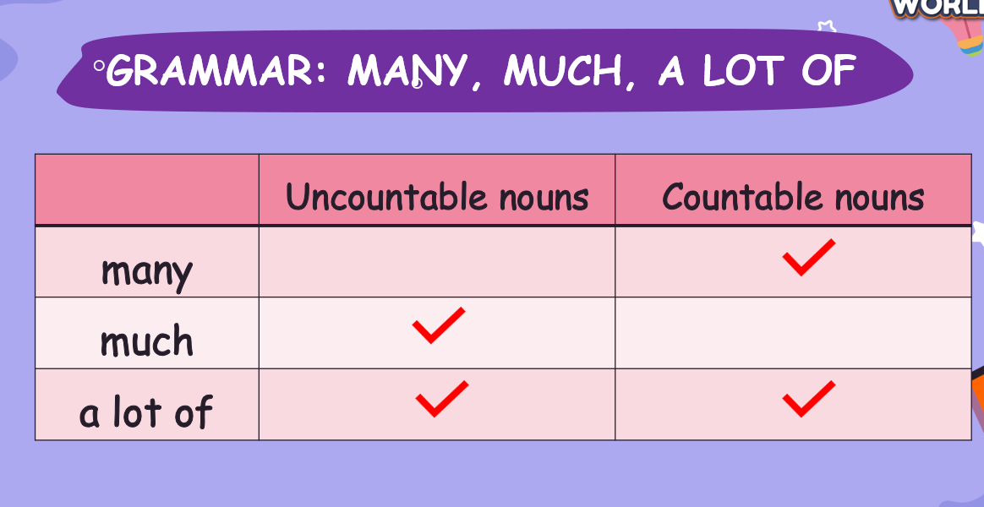  2. Elicit what type of sentences Quantifiers “many”, “much” and “a lot of” are used.  - From the first two sentences from Exercise 4, T asks Ss what type of sentences Quantifiers “many”, “much” and “a lot of” are used for.  - T summarizes into a table:  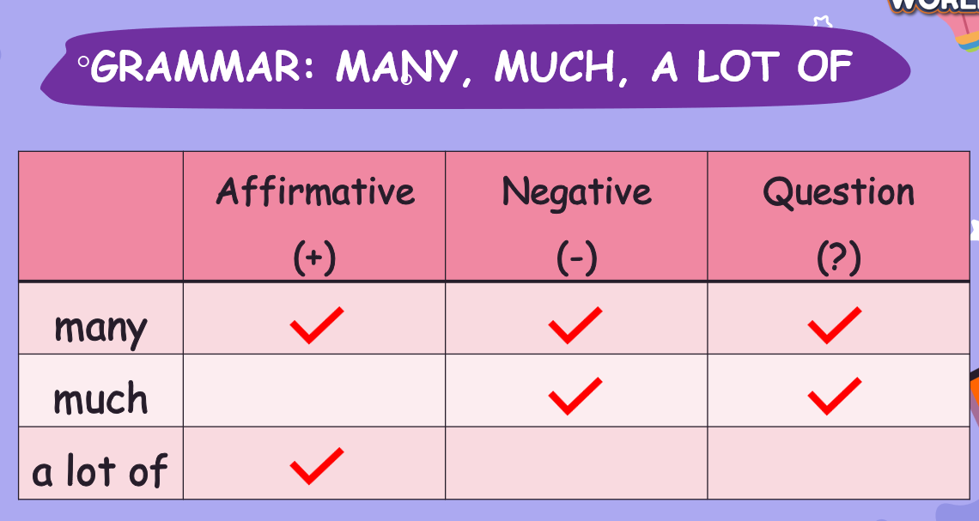  - Tell students that we use much, many and a lot of to describe quantities.  - We use much in negative sentences and questions with uncountable nouns.  - We use many in affirmative and negative sentences and questions with plural countable nouns.  - We can use a lot of instead of many or much in affirmative sentences.  3. Finishing task 4: Point and say  - Tell students to look at the photos in Activity 4, page 65.  - Ask students to describe the photos from number 3 to 6. Remind them to use the structures like the first two sentences.  - Then, ask Ss to practice saying the sentences individually for 1 to 2 minutes and then in pairs for 1 minute. Go round the class helping students where necessary.  - Ask volunteers to say their answers. Correct any mistakes. | - Look, listen and read.  - Answer T’s questions.  - Complete the exercise 4: Point and say with the partners.
Activity 3: Practice – Controlled practice (8 minutes)
Teacher’s Activities | Students’ Activities
Aims:
- Practicing sorting food quantifiers through “Food sorting” activity.
- Practice using quantifiers in sentences through exercise 5.
- “Food sorting” activity  + T shows a list of food words and ask Ss to sort them into the correct quantifiers.  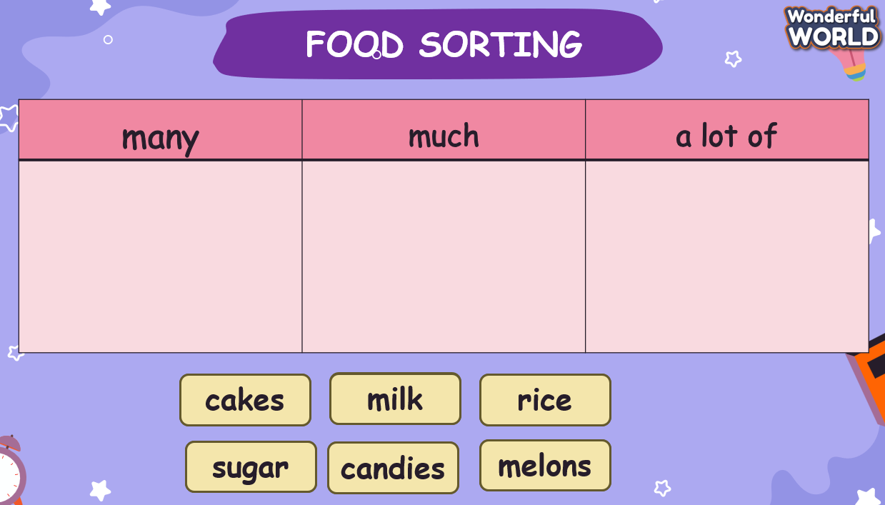  - Complete exercise 5  + Ask students to read and circle the correct words for each sentence  individually.  + Give the final answers.  + Allow them enough time to practice saying the sentences  in pairs. Go around the class helping where necessary.  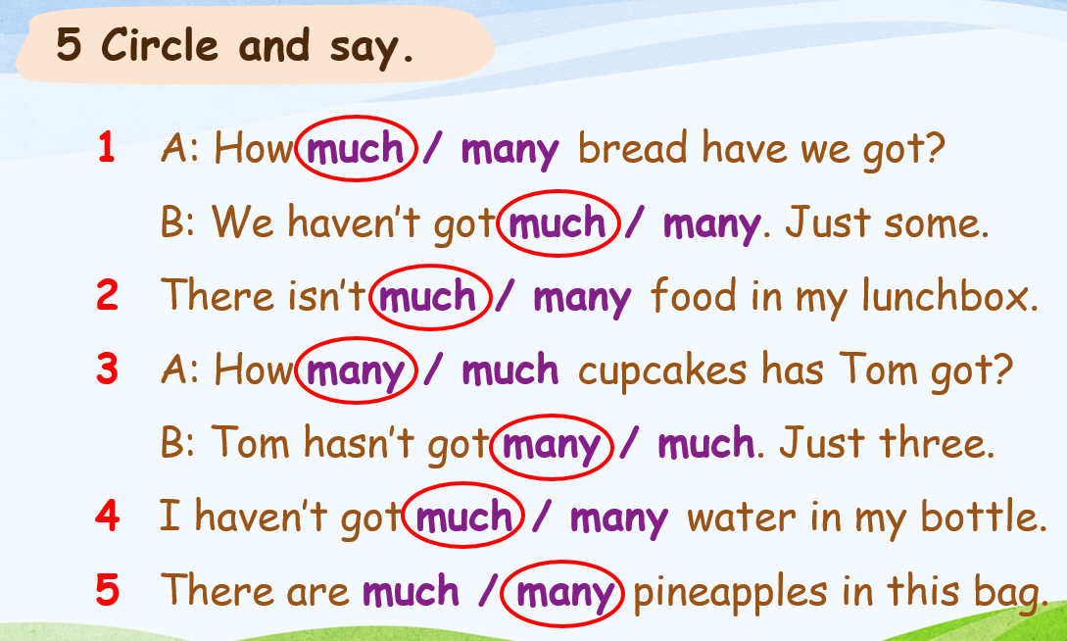 | - Join the activity.  - Complete the exercise individually.  - Correct the exercise with the teacher.  - Work in pairs to practice saying the sentences.
Activity 4: Production (7 minutes)
Teacher’s Activities | Students’ Activities
Aims:
- Ss apply the words and grammar to play the board game of Exercise 6.
- Tell students to look at the board game on page 65.  - Ss are asked to work in pairs.  - Explain the rules of the game:  + Each pair plays “rocks, papers and scissors” to decide who will have to make a sentence first.  + Players will create sentences or questions using “a lot of”, “much”, or “many” based on the items, signs and numbers on the board game. + Who can move to the “Finish” first is the winner of the board game.  + Players make affirmative sentences with the sign “+”, make negative sentences with the sign “-“ and make questions with the sign “?”.  + Players need to add numbers before countable nouns when making sentences.  - Play a round as a demonstration. For example:  + If the item is “Milk” with a “-” sign and a correct sentence could be: “There isn’t much milk left.”  - Encourage them to use the correct quantity terms.  - Bring the class together and review a few sentences or questions created by students.  - Provide positive feedback on correct usage and address any common mistakes.  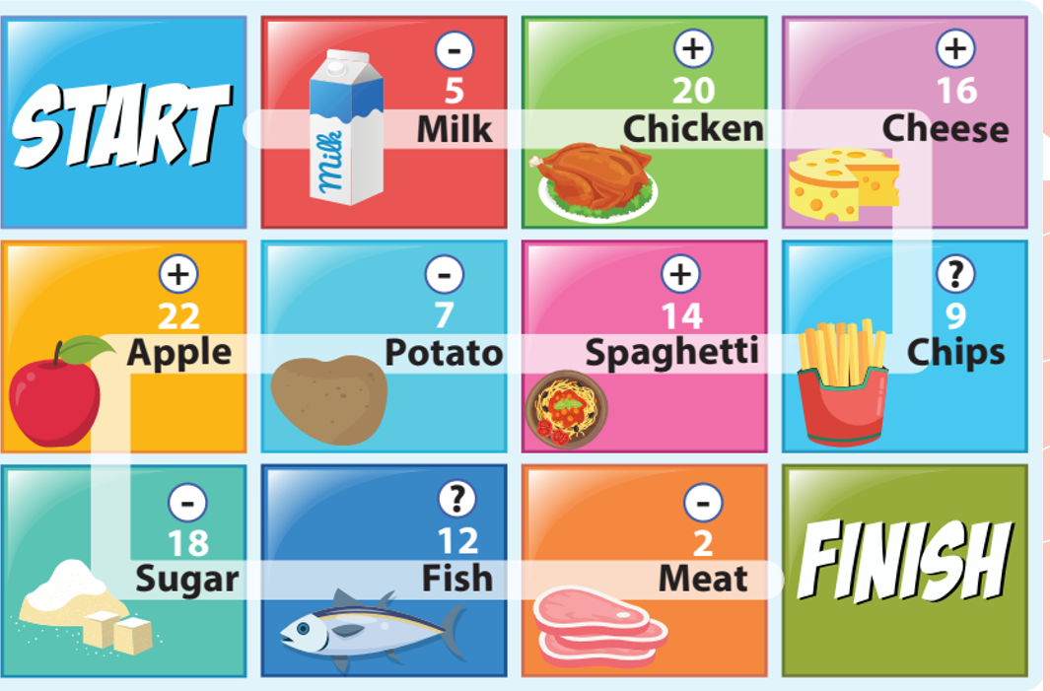 | - Work in pairs.  - Listen to the rule from the Teacher.  - Play “rocks, papers & scissors” and make sentences.
Activity 5: Wrap up & Assessment (5 minutes)
Teacher’s Activities | Students’ Activities
Aims:
- Check students’ understanding of what they have learned.
- Students rehearse what they have learned in the lesson.
- Assessment: Give compliments to the group/ team which has completed the activities the best and encourage the other groups/teams to keep doing them during the next lessons.  - Wrap-up: Do the activity “rearrange the sentences”.  1. isn’t/ left/ chocolate/ There/ much/.  There isn’t much chocolate left.  2. a lot of/ I’ve/ in/ candies/ my/ got/ bag.  I’ve got a lot of candies in my bag.  3. many/ have/ does/ mangoes/ How/ she/?  How many mangoes does she have?  4. coffee/ is/ in/ a lot of/ There/ his/ sugar.  There is a lot of sugar in his coffee.  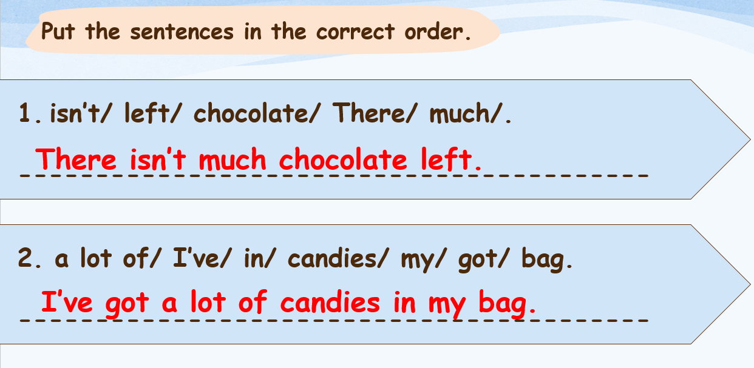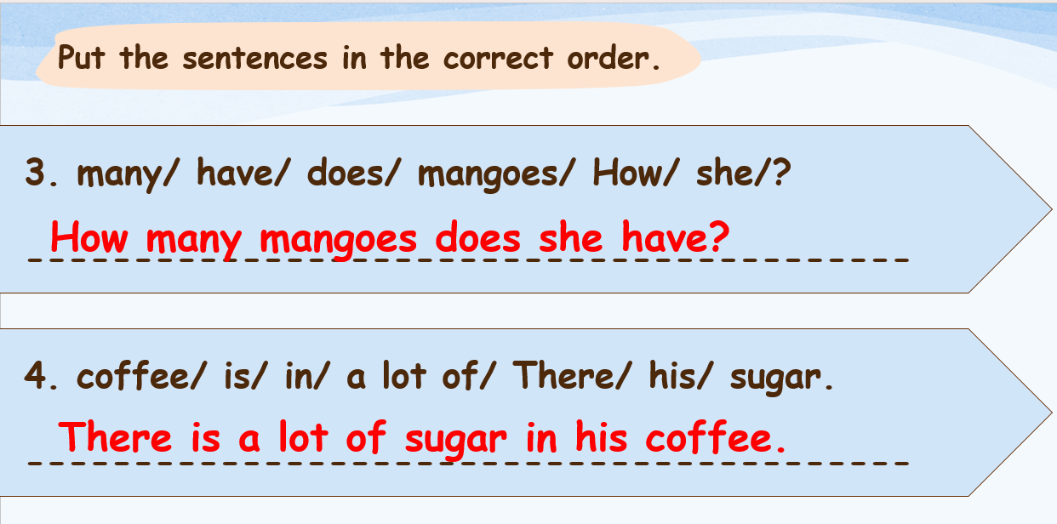  * Remember  - Review vocabulary: bread, butter, chocolate, cupcake, salad, spaghetti.  - Grammar: a lot of, much, many  + We have a lot of bread, but we don’t have much butter.  + We don’t have many apples here. | - Check with the teacher.  - Do the activity “rearrange the sentences”.  - Stand up and say goodbye to the teacher.
_________________________________________
UNIT 6: FOOD
Lesson 2: Task 1-2-3
Period 56
I. OBJECTIVES:
1. Knowledge:
- Students get to know:
+ some adjectives to describe food: crispy, delicious, salty, sour, spicy, sweet, tasty.
+ students can draw out new words through listening and reading the text.
+ student can use the structures:
What is your favourite food? - My favourite food is ................
- It has.........................................
- It tastes .....................................
2. Competences:
- English competences: Students can use English to describe their favourite food.
- Common competences: Students can write and talk about their favourite food.
3. Qualities:
- Students will
+ have a strong sense of respect in pair work.
+ raise their confidence by presenting in front of the class.
II. EQUIPMENT AND MATERIALS:
- Basic things: Student’s book, flashcards, photos.
- Advanced things: PPT, laptop, TV.
III. LESSON PROCEDURE:
Activity 1: Warm-up (4 minutes)
A song called “Yum yum World Foods”
Teacher’s Activities | Students’ Activities
a. Aims: Welcome students. Warm the class up with a song to lead in the new lesson with some words related to the topic: Food
1. Greeting Ss and chatting (1 minute):  Let's start our new lesson with a song about the world's food. Please remember the names of the food and the country these foods came from in this song!  2. Sing the song “Yum yum World Foods” (2 minutes)  - Play the song and ask students to listen and sing along.  https://www.youtube.com/watch?v=TP8zck-c8Ig  - Ask Ss to tell the names of foods and the countries where these foods came from in this song.  Vietnamese Rice Noodles, Mexican Taco, Thai Pad Thai, Italian Pizza, Korean Bibimbap, Japanese Sushi, American Burger, Spanish Churros, Turkish Baklava, Chinese Tang Hu Lu, French Macaron  3. Leading in the lesson:  Unit 6 – Lesson 2 task 1, 2, 3 (1 minute)  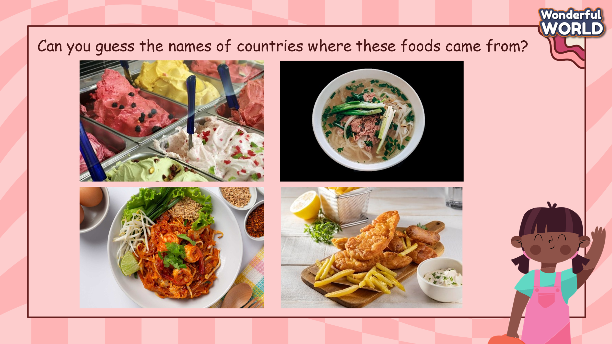  - Show 4 photos (gelato, pho, pad Thai, fish and chips) in the reading on the screen. Ask students to look at the picture and answer the questions: “What dishes are these? Where are they come from?, How do they taste? Elicit ideas from the class and write them on the board.  - Use these pictures to lead in the lesson.  Lead in: Today, we are going to learn some adjectives to describe food from different countries around the world! | - Greet Teacher  - Join the activity.  - Look at the picture and answer the question.
Activity 2: Presentation (14 minutes)
Teacher’s Activities | Students’ Activities
a. Aims:
- Present some new words crispy, sour, sweet, salty, delicious, tasty, spicy
- Encourage sts with the topic and vocabulary related to the topic.
- Develop sts’ reading abilities
b. Procedure  1. Task 1. Listen and read. Then fill in the table (5 minutes)  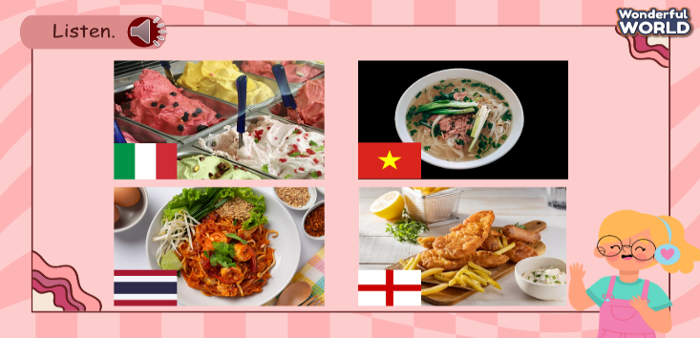  - Ask students to look at the photos again and guess the contents of the reading passages (food around the world).  - Play track 6.4 for students to listen.  - Play the video and ask them to listen again.  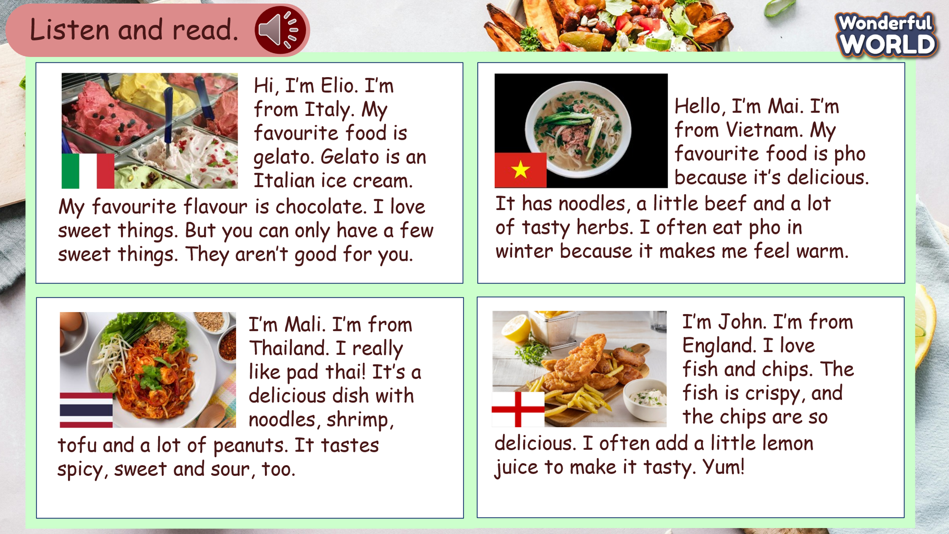  - Show the text, play the audio again, and ask students to listen and follow the text with their fingers.  - Ask ss to find out and underline new words.  - Point to the new words in the text. Read them out and ask students to repeat  - Play the recording again, pause after each sentence and ask students to repeat.  - Ask students to practise reading out the text individually. Ask some volunteers to read it out in front of the whole class.  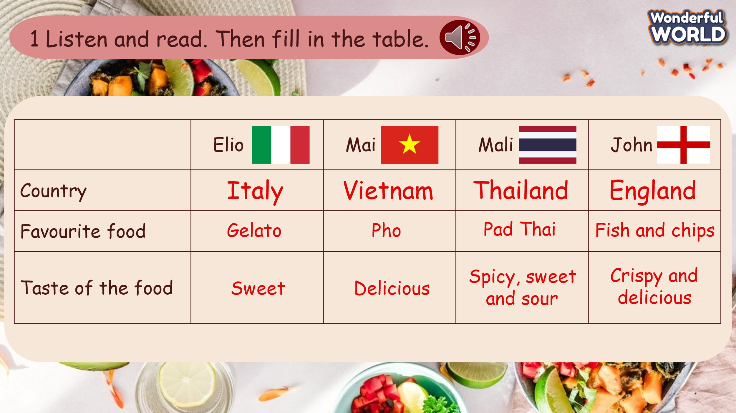  - Tell students to look at the table and ask them what should be filled in the gap. Modeling if necessary. Elicit Italy for gap 1, gelato in gap 2, and sweet for gap 3.  - Check answers. Write the answers on the board if necessary  2. New words (4 minutes)  - Use flashcards and PowerPoint to introduce the lesson's vocabulary (crispy, sour, sweet, salty, delicious, tasty, spicy).  + Show the pictures-> show the words -> play audio twice for Ss to listen then ask them to repeat in chorus, groups, and individually.  - Correct student’s pronunciation if necessary.  3. Task 2: Listen and point. Repeat. (Track 6.5) (5 minutes)  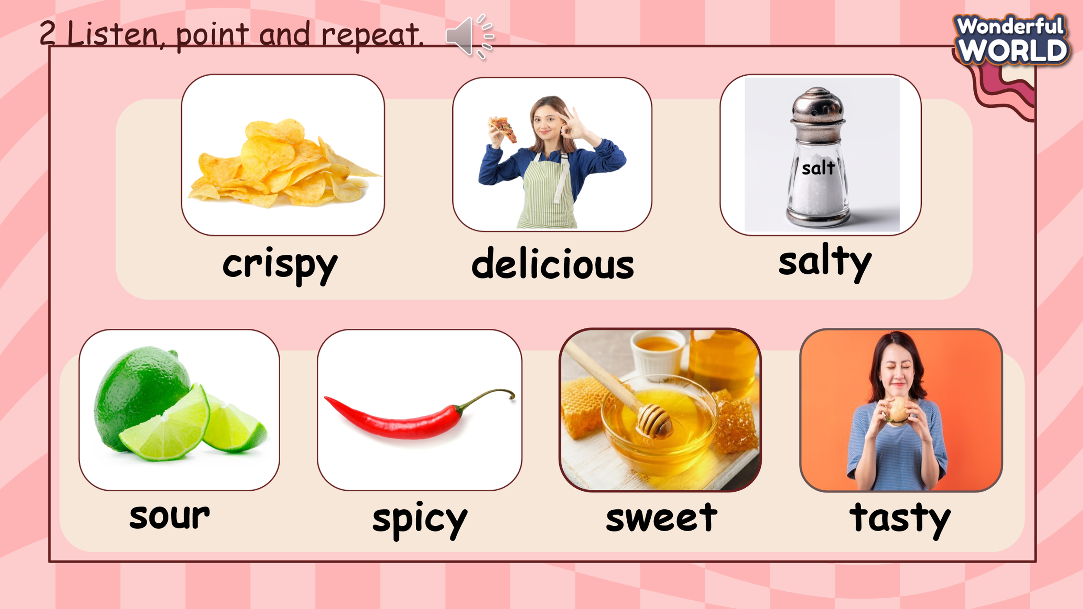  - Show all the pictures of task 2 on the screen or use the flashcards and show them on the board.  - Play track 6.5 for the students to listen to, point to, and repeat the words in chorus and group.  - Show pictures or point to the pictures randomly and ask students to read the correct words. | - Look and guess  - Listen.  - Watch and listen.  - Listen and read.  - Find out the new words  - Repeat  - Listen and repeat  - Read in front of the class.  - Fill in the table  - Check answers with T  - Learn the vocabulary.  - Repeat after the teacher.  - Look at the pictures/ flashcards.  - Listen to, point to, and repeat the words in chorus and group.  - Look and read out the correct words.
Activity 3: Practice (8 minutes)
Teacher’s Activities |  | Students’ Activities
a. Aims: Controlled practice:
- practice some adjectives and structures to describe food.
- students can write about their favorite food, the ingredients, and the taste of this food.
b. Procedure  1. Play Treasure hunt Game (3 minutes)  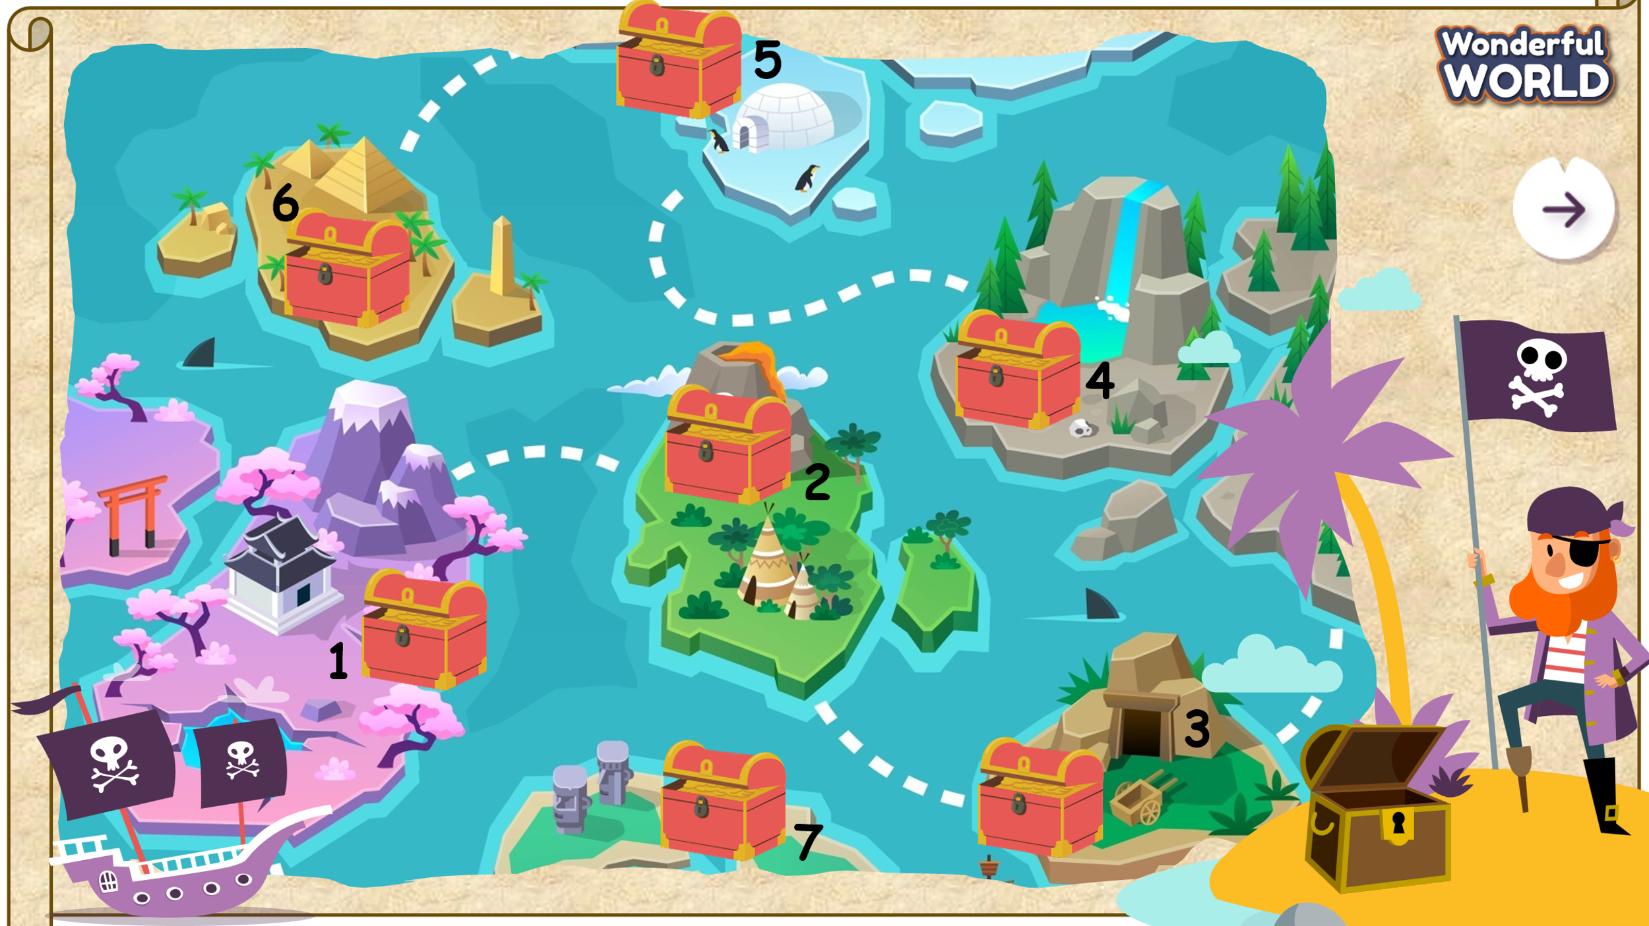  -Ask students to play the “Treasure hunt” game.  “Let’s go out to sea, hunt for treasure and explore the world's cuisines”  (There are 7 questions. Students choose a number and answer the question. Students get treasure with each correct answer.)  Questions  1. What is your favourite food?  + My favourite food is (fish and chips)  + It has........................................  D. It has fish and chips.  2. What is your favourite food?  + My favourite food is (gelato)  + It tastes ........................................  C. It tastes sweet.  3. What is your favourite food?  + My favourite food is (pad Thai)  + It has........................................  B. It has noodles, shrimp, tofu and peanuts.  4. What is your favourite food?  + My favourite food is (spaghetti)  + It has........................................  B. It has beef, noodles and tomato.  5. What is your favourite food?  + My favourite food is (pho)  + It tastes ........................................  D. It tastes delicious.  6. It tastes delicious. (Choose the correct picture)  Picture A  7. It tastes sour. (Choose the correct picture)  Picture B  2. Complete Task 3: Write and say. (5 minutes)  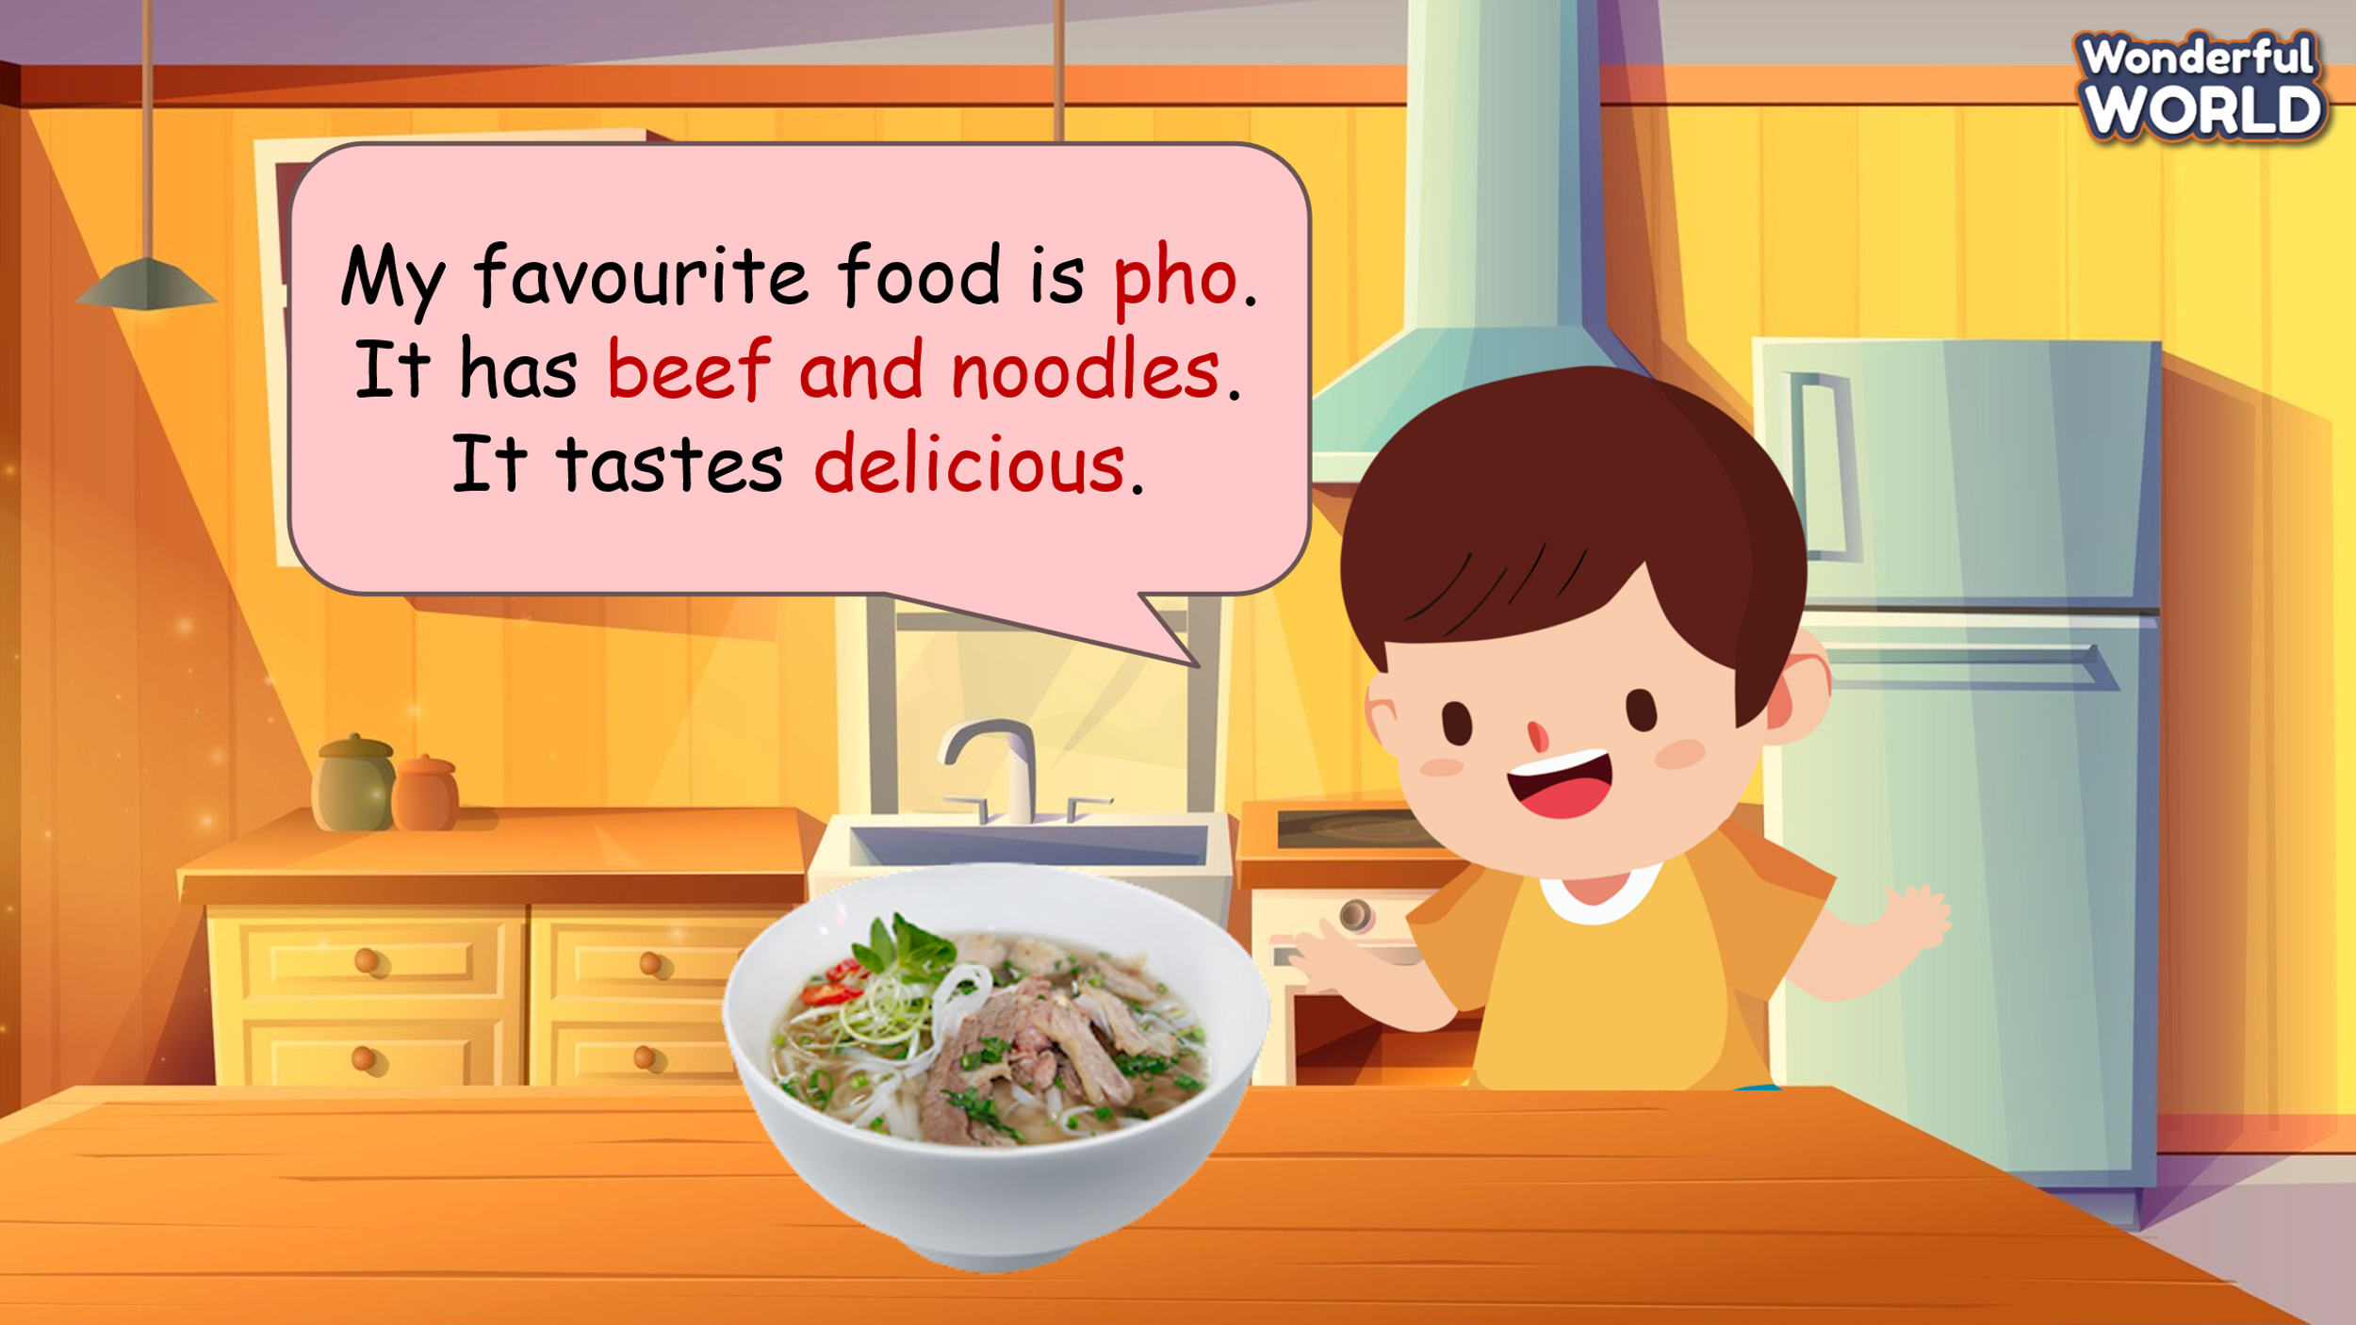  - Read out the speech bubble to students and ask them to repeat.  - Tell students to think about their favourite food and complete the sentences. Ask them to write down sentences in their notebook or on another piece of paper.  - Give students some time to share the notes in pairs.  - Ask some volunteers to read out their notes. Correct any mistakes. |  | - Join the activity.  - Listen and repeat  - Write  - Share the notes in pairs.  - Read out the notes.
Activity 4: Production (7 minutes)
Teacher’s Activities |  | Students’ Activities
Aim: Apply new words and structures to present in front of the class about students’ favourite food using writing in task 3.
- Show a video of tourists interviewing their favorite food and ask Ss to watch.  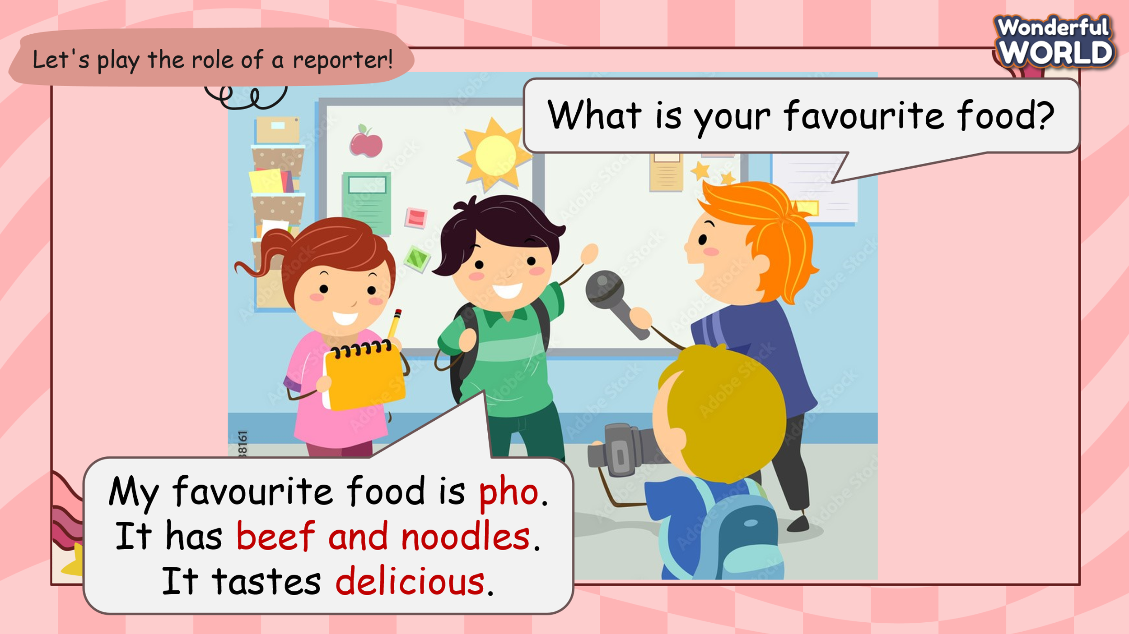  - Ask students to play the role of a reporter and the tourists, ask and answer the question: What is your favourite food?  + My favourite food is ................  + It has.........................................  + It tastes .....................................  - Call some groups to perform in front of the class. |  | - Watch the video  - Role play and practice the structures.  - Perform in front of the class in groups.
Activity 5: Wrap up & Assessment (3 minutes)
Teacher’s Activities |  | Students’ Activities
Aims:
- Check student's understanding of what they have learned.
- Students rehearse what they have learned in the lesson.
1. Assessment: Do the activity to match the pictures with the correct words.  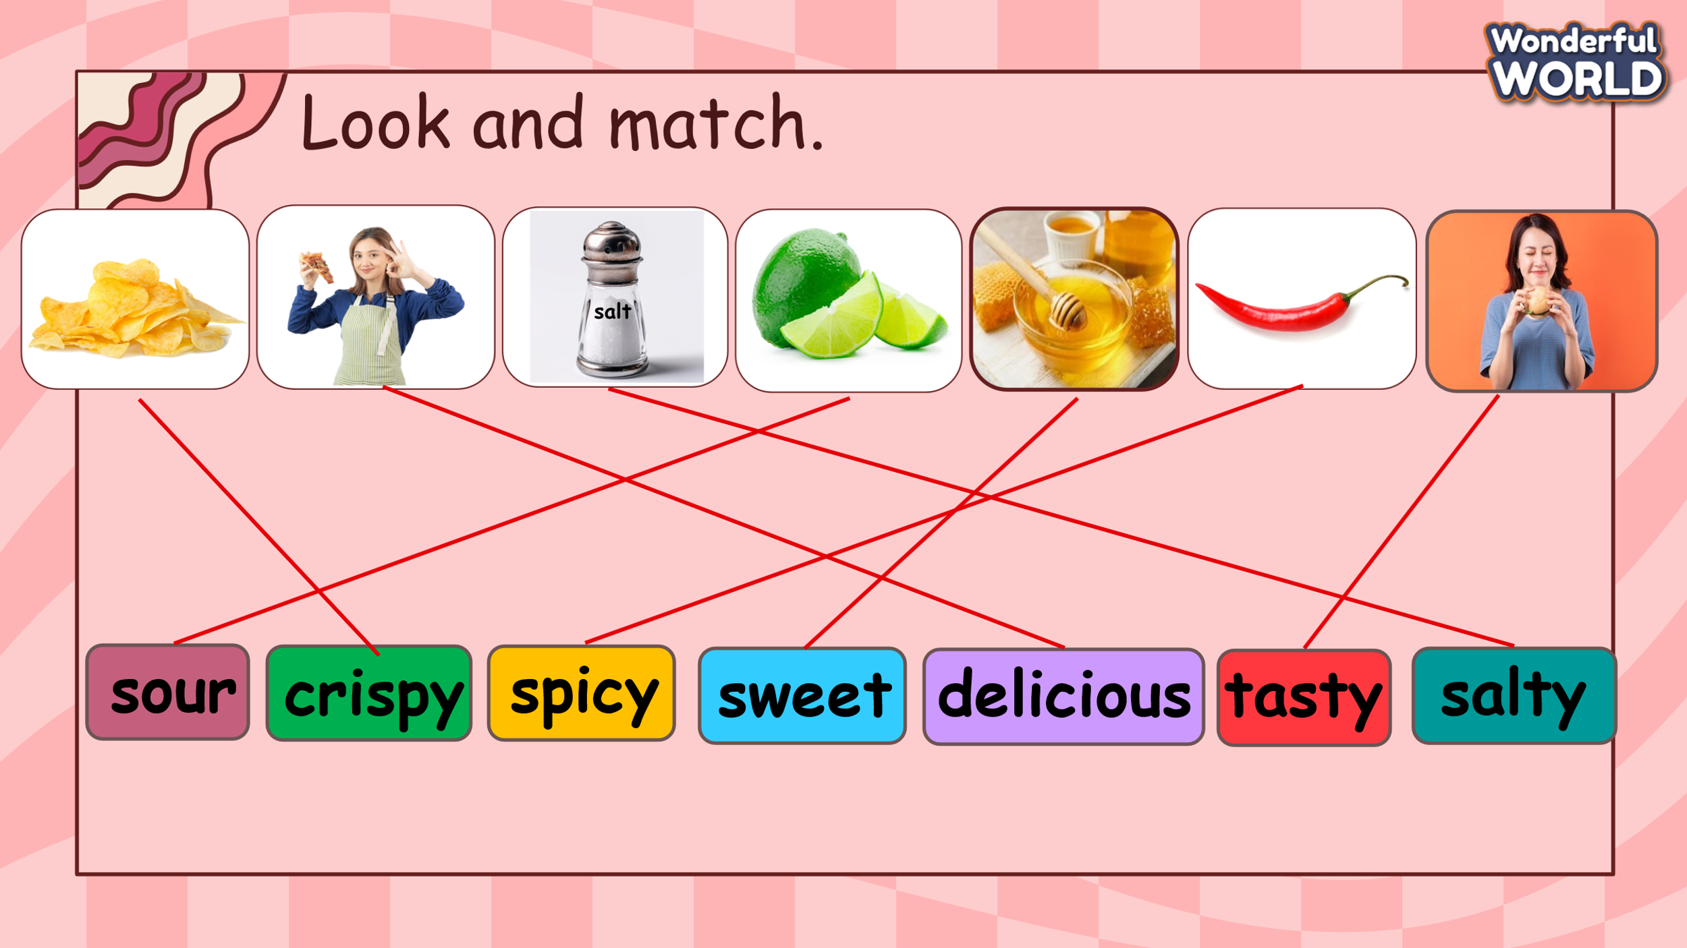  2. Wrap-up:  * Remember  - Vocabulary: crispy, delicious, salty, sour, spicy, sweet, tasty.  - Structures:  What is your favourite food?  + My favourite food is ................  + It has.........................................  + It tastes .....................................  3. Sing a goodbye song  - Ask Ss to sing a goodbye song. |  | - Do the assessment.  - Check with the teacher.  - Ss read the wrap-up.  - Stand up and say goodbye to the teacher.

