TUẦN 15 Khối 3, 5 (Từ ngày 16/12/2024 đến ngày 20/12/2024)
THỨ | TIẾT | MÔN | TIẾT THỨ | NỘI DUNG BÀI DẠY |  | UDCNTT | ĐỒ DÙNG DẠY HỌC
Hai  16/12 | 1 | 5A | 57 | Unit 6. Food | Lesson 2 (4, 5, 6) | Wonderfulworld | Flashcards, TV, books
Hai  16/12 | 2
Hai  16/12 | 3 | 3A | 57 | Unit 5. My clothes | Lesson 2 (4, 5, 6) | Wonderfulworld | Flashcards, TV, books
Hai  16/12 | 4 | 3A | 58 | Unit 5. My clothes | Lesson 2 (7, 8, 9) | Wonderfulworld | Flashcards, TV, books
Hai  16/12 | 5 | 5D | 57 | Unit 6. Food | Lesson 2 (4, 5, 6) | Wonderfulworld | Flashcards, TV, books
Hai  16/12 | 6 | 3B | 57 | Unit 5. My clothes | Lesson 2 (4, 5, 6) | Wonderfulworld | Flashcards, TV, books
Hai  16/12 | 7
Ba  17/12 | 1 | 5C | 57 | Unit 6. Food | Lesson 2 (4, 5, 6) | Wonderfulworld | Flashcards, TV, books
Ba  17/12 | 2 | 5B | 57 | Unit 6. Food | Lesson 2 (4, 5, 6) | Wonderfulworld | Flashcards, TV, books
Ba  17/12 | 3 | 5A | 58 | Unit 6. Food | Lesson 3 (1, 2, 3) | Wonderfulworld | Flashcards, TV, books
Ba  17/12 | 4
Ba  17/12 | 5 | 3A | 59 | Unit 5. My clothes | Lesson 3 (1, 2, 3) | Wonderfulworld | Flashcards, TV, books
Ba  17/12 | 6 | 5D | 58 | Unit 6. Food | Lesson 3 (1, 2, 3) | Wonderfulworld | Flashcards, TV, books
Ba  17/12 | 7 | 3B | 58 | Unit 5. My clothes | Lesson 2 (7, 8, 9) | Wonderfulworld | Flashcards, TV, books
Tư  18/12 | 1 | 5A | 59 | Unit 6. Food | Lesson 3 (4, 5, 6) | Wonderfulworld | Flashcards, TV, books
Tư  18/12 | 2
Tư  18/12 | 3
Tư  18/12 | 4
Tư  18/12 | 5 | 5B | 58 | Unit 6. Food | Lesson 3 (1, 2, 3) | Wonderfulworld | Flashcards, TV, books
Tư  18/12 | 6 | 5C | 58 | Unit 6. Food | Lesson 3 (1, 2, 3) | Wonderfulworld | Flashcards, TV, books
Tư  18/12 | 7
Năm  19/12 | 1 | 5C | 59 | Unit 6. Food | Lesson 3 (4, 5, 6) | Wonderfulworld | Flashcards, TV, books
Năm  19/12 | 2 | 5B | 59 | Unit 6. Food | Lesson 3 (4, 5, 6) | Wonderfulworld | Flashcards, TV, books
Năm  19/12 | 3 | 5A | 60 | Unit 6. Food | Lesson 3 (7, 8, 9, 10) | Wonderfulworld | Flashcards, TV, books
Năm  19/12 | 4
Năm  19/12 | 5 | 5D | 59 | Unit 6. Food | Lesson 3 (4, 5, 6) | Wonderfulworld | Flashcards, TV, books
Năm  19/12 | 6 | 5C | 60 | Unit 6. Food | Lesson 3 (7, 8, 9, 10) | Wonderfulworld | Flashcards, TV, books
Năm  19/12 | 7
Sáu  13/12 | 1 | 3B | 59 | Unit 5. My clothes | Lesson 3 (1, 2, 3) | Wonderfulworld | Flashcards, TV, books
Sáu  13/12 | 2 | 5D | 60 | Unit 6. Food | Lesson 3 (7, 8, 9, 10) | Wonderfulworld | Flashcards, TV, books
Sáu  13/12 | 3 | 5B | 60 | Unit 6. Food | Lesson 3 (7, 8, 9, 10) | Wonderfulworld | Flashcards, TV, books
Sáu  13/12 | 4
Sáu  13/12 | 5
Sáu  13/12 | 6 | 3B | 60 | Unit 5. My clothes | Lesson 3 (4, 5, 6) | Wonderfulworld | Flashcards, TV, books
Sáu  13/12 | 7 | 3A | 60 | Unit 5. My clothes | Lesson 3 (4, 5, 6) | Wonderfulworld | Flashcards, TV, books

GRADE 3
WEEK 15
UNIT 5. CLOTHES
Lesson 2. Task 4, 5, 6
Period 57
I. OBJECTIVES:
1. Knowledge:
- Students will learn the structure He/ She/ It has got…..
2. Competences
- English competences: Students will be able to introduce their possessed clothes…
- Common competences: Students will have the opportunity to develop communication among friends.
3. Qualities:
- Students will develope the care toward family members.
II. EQUIPMENT AND MATERIALS:
- Teacher: TV, PPT, flashcards; audio track 5.6; handouts
- Students: Student’s book, students’ family photos, pens, A4 paper, pictures
III. LESSON PROCEDURE
Activity 1: Warm up (5 minutes)
Teacher’s activities | Student’s activities
- Greet students.  + Play the Brain gym. Students look and do.  Game: Mysterious letter  + Review name of the clothes  + Set the rules: The teacher divides the class into four teams; Each secret window given is accompanied by some suggestions. The groups will discuss and give the correct answer to the name of the costume. The team that guesses correctly will get five stars for the first answer and will be deducted when opening the next suggestions  1.  -It starts and ends with ‘T’.  -You wear me on your upper body.  - You wear me in summer.  2.  - It is a bit longer than your legs.  - It starts with ‘T’.  - It’s quite similar to shorts.  3.  - It starts with ‘B’.  - I keep you warm.  - I love your feet.  - I am a footwear.  4.  - There’re 2 of these.  - You need it to wear shoes.  - It can be long or short.  5.  -It is longer than your torso.  - It starts with letter ‘d’.  - Boys don’t wear it.  6.  - My name has 3 letters.  - You wear me on your head.  - You wear me in summer.  + Count the number of stars and celebrate the winner groups | - Greet teacher.  - Look then do the action with teacher.  - Read follow teacher if possible.  Groups  1. T-shirt  2. trousers  3. boots  4.socks  5. dress  6. hat  Count the number of stars
Activity 2: Presentation (8 minutes)
Teacher’s activities | Student’s activities
Lead in: You’re going to meet some friends. Let’s see who they are  Task 4: Listen and repeat. (Track 5.6)  - Show the picture of a girl with a coat  - Lead sts to look at the picture and elicit: she/coat  - Show the sentences She’s got a coat. Her coat is warm one by one  - Elicit the grammar point  She’s got …  Her … is …  - Ask sts to listen and repeat  - Do the same with the boy/boots and the cat/ dress  - Ask sts to listen and repeat  - Call some sts to read the sentences out loud  Blended Teaching Tip: TPR practice: Point to the teacher and some sts talk about possession clothes  - I have got …..  - You’ve got…..  - He’s got…/ She’s got  *GAME: Who’s faster?  - Show the 4 cards in front of the Ss  - Divide the class into groups of four  - Give instruction of game: T has four pictures when the teacher says “One, two, three” the faster student will choose one picture. Then match with the correct answer  Take turn to the monitor to guide the teams  - T makes models | Listen to teacher  Look at the picture  Elicit the picture with teacher  Listen and repeat  Pay attention to the grammar point  Look and read. Then match.  1. She’s got a pencil. Her pen is red.  2. They’ve got hats. Their hats are blue.  3. He’s got a ball. His ball is orange.  4. She’s got a teddy bear. It’s nice.
Activity 3: Practice (10 minutes)
Teacher’s activities | Student’s activities
Task 5: Point and say  Game: Sentence jumble  - Make an enlarged copy the worksheet and cut out the card, select the appropriate number of cards , ensuring that they make up complete sentences  - Explain that the activity involves forming sentences, and each sentence consists the cards.  They should use the punctuation to help them (full stop and captital letter)  - Elicit the model sentence  “I’ve got a hat.  My hat is white and red.”  Give the sts the worksheet. Sts must put the words into the correct order. They can do this by:  + cutting out  + stick on the group boards  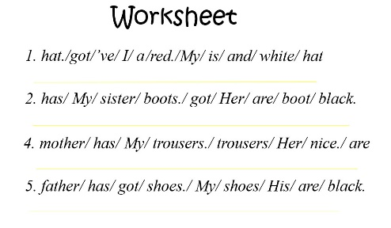  - Correct collectively on the board  - Have sts practice the sentence in chorus, group, pairs, individual | - Look and work in group  - Practice  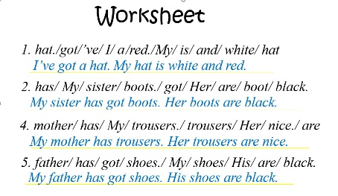  Practice the sentence in chorus, group, pairs, individual
Activity 4: Production (9 minutes)
Teacher’s activities | Student’s activities
Task 6: Let’s talk.  -Ask students to take pictures of their family/or quickly draw family members  - Divide students into groups of 4  -Students use pictures they’ve just drawn or their family ‘s photos to introduce what the person in the picture has.  -Ask sts to use the sentence pattern they have learned  in part 4 and 5 to speak  -After introducing them to the group, ask the students to present in groups as an exhibition  -Give commands | Take photo/ draw  -Work in group  -Some groups present
Activity 5: Assessment (3 minutes)
Teacher’s activities | Student’s activities
- Ask sts to do the assessment  Ask sts to look, write about Sophie’s clothes and their colours. “ She’s got….”  - Check in pair then whole class.  - Say goodbye | - Do the assessment.  Answer  - She’s got a hat. It’s black.  - She’s got a skirt. It’s red.  - She’s got trousers. They’re blue.  - She’s got shoes. They’re purple.  - Check with friends and then with teacher and whole class.  - Say goodbye. sing the Goodbye song.
  Ex. She’s got a T-shirt. It is green.  1. ……………………………………  2. ……………………………………  3. ……………………………………  4. ……………………………………  5. ………………………………………… |           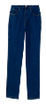  
____________________________________
UNIT 5. CLOTHES
Lesson 2. Task 7, 8, 9
Period 58
I. OBJECTIVES:
1. Knowledge:
- Students will review the structure He/ She/ It has got….. and vocabulary of clothes
2. Competences:
- English competences: Students will be able to introduce someone's possessed clothes…
- Common competences: Students will have opportunity to develop the solving problem in doing tasks and cooperation among teammates
3. Qualities:
- Students will be friendly and confident in communicating with their friends.
II. EQUIPMENT AND MATERIALS:
- Teacher: PPT, TV, flashcards; audio track 5.7
- Students: Student’s book, pens, crayons, A4 paper
III. LESSON PROCEDURE:
Activity 1: Warm up (7 minutes)
Teacher’s Activities | Students’ Activities
- Greet students.  + Play the Brain gym. Students look, listen, and do.  Guessing game:  + Review name of the clothes.  + Set the rules: There are 6 colors in each question What is behind the six colors, whoever wins in the game will open one of the colors. If the opener answers the question correctly, it will get 3 stars, if not, the answer will be given to the remaining team back and the score will be 1 star back for each team.  + Divide the class into groups; ask four students to  come into the front, they rock, paper, and scissors. The winner opens the cross and answers the question.  + Each time they get stars for their groups  + Students have a maximum of six times to open the key picture  1. Trousers 2. coat 3. dress  4.T-shirt 5. boots 6. hat  + Count the number of stars and celebrate the winner groups | - Greet teacher.  - Look, listen, and then do the action with teacher.  - Read follow teacher if possible.  Work in groups  Count the number of stars
Activity 2: Listening (8 minutes)
Teacher’s Activities | Students’ Activities
Lead in: Use the game and the picture to lead in the new lesson  - Write on the board The date and introduce the lesson.  Task 7: Listen and complete (Track 5.7)  Pre-listening:  - Show picture/slide of the task  - Ask sts to talk about the picture  + How many numbers are there?  + How many missing words are there?  - Ask sts to read and guess the answer  - Collect the suitable answer on the board  While listening:  - Ask sts to listen and complete  - Play the audio 5.7 twice  - Have sts do cross-check  - Play audio again and check with whole class  Post listening:  - Show the text and the picture  - Ask sts to listen and repeat sentence by sentence  - Ask sts to pretend acting as a reporter | Copy down  Look and answer  - Read the text  - Guess the answers  - Listen and complete  - Do cross-check  - Check with teacher  - Listen and repeat  - Act and say
Activity 3: Speaking (17 minutes)
Teacher’s Activities | Students’ Activities
Controlled speaking  Task 8: Look and say  Game: Sentence jumble  - Make an enlarged copy the the worksheet and cut out the card, select the appropriate number of cards , ensuring that they make up complete sentences  - Explain that the activity involves forming sentences, and each sentence consists the cards. They should use the punctuation to help them (full stop and captital letter)  - Elicit the model sentence  “He’s got a coat.  His coat is warm.”  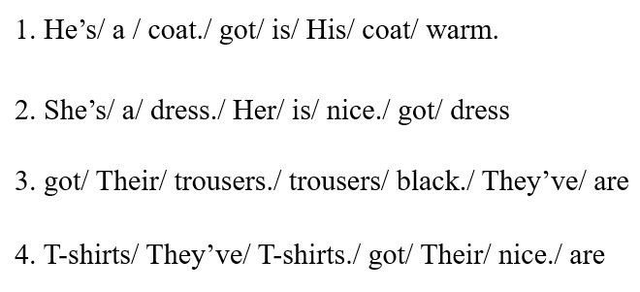  Give the sts the worksheet. Sts must put the words into the correct order.  Set sts to work in groups  Pick up the picture and say  Make sure every group member has chance to pick and say | - Look and work in group  Work in groups  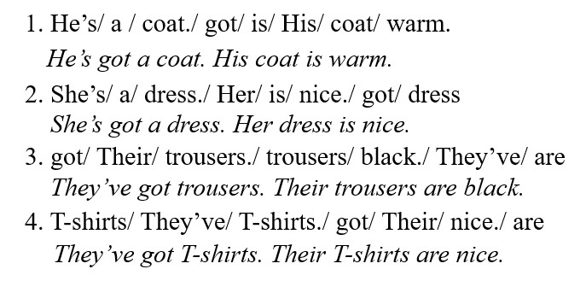  - Work in groups  - Pick up the picture and say
Free talk  Task 9: Draw. Write and say.  - Ask sts to look at the picture of Liam (the boy) then ask sts to describe the content of the picture  + Is this a boy or a girl?  + What does he have?  + What colour is his hat?  +What colour is his …?  + Is he cool/ funny?  - Show the model writing  - Ask sts to look at the picture and read  - Ask them to draw a family member, colour clothes  - Ask them to base on the picture and write  - Practise speaking with friends  - Perform their work in front of class | - Look and answer the questions  - Read the sample  - Draw a family member  - write his/her information as in the sample  - Share with friends
Activity 5: Assessment (3 minutes)
Teacher’s Activities | Students’ Activities
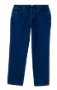  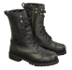  Ask sts to do the assessment  Listen and complete.  Ex: I have got a blue dress.    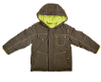  1. Peter has got_____________  2. Lily has got_______________      3. We have got ______________  4. My dad has got______________  5. Her brother has got______________  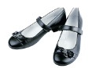    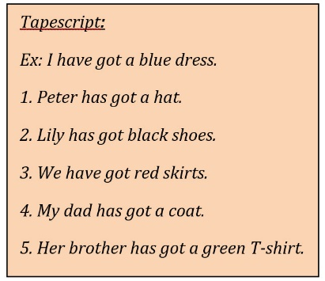  - Check in pair then whole class.  - Say goodbye | - Do the assessment.  Listen and complete.  Ex: I have got a blue dress.  1. Peter has got a hat.  2. Lily has got black shoes.  3. We have got red skirts  4. My dad has got a coat.  5. Her brother has got a green T-shirt.  Check with friends and then with teacher and whole class.  - Say goodbye. Sing the Goodbye song.
____________________________________
UNIT 5. CLOTHES
Lesson 3. Task 1, 2, 3
Period 5594
I. OBJECTIVES:
1. Knowledge:
- Students will be able to use the words and phrases related to the topic My Clothes: big; small; new; pretty; ugly
2. Competence:
- English competences: Students will be able to describe kind of clothes.
- Common competences: Students will have the opportunity to develop communication among friends.
3. Qualities:
- Students will be friendly and confident in communicating with their friends.
II. EQUIPMENT AND MATERIALS:
- Teacher: PPT, TV, flashcards; audio track 5.8; track 5.9
- Students: Student’s book, pens, crayons, A4 paper
III. LESSON PROCEDURE
Activity 1: Warm up (5 minutes)
Teacher’s activities | Student’s activities
- Greet students.  + Play Brain Gym video. Students watch and do.  Guessing game:  + Review name of the clothes.  + Set the rules:  Show the picture and ask sts  + Who’s he?  + Where does he come from?  And let’s sts to join the adventure to come to Mr. Bean’s house. In Mr. Bean’s bedroom, sts guess what kinds of clothes he has.  + Divide the class into groups; ask four students come to the front, they rock paper, and scissors. The winner chooses the answers and answers the question.  + Each time they get stars for their groups  + Students have six times to open the key picture.  Lead in: Use the game pictures to lead in the lesson: My Clothes – Lesson three (Period one) Are Mr Bean things new or ugly? Big or small?... | - Greet teacher.  - Look then do the action with teacher.  - Read follow teacher if possible.  Work in groups  Look and answer  Listen and repeat  Copy down
Activity 2: Presentation (8 minutes)
Teacher’s activities | Student’s activities
Task 1: Listen and point. Repeat. (Track 5.8)  - Use flashcards to introduce the vocabulary.  - Say the words for sts to repeat in chorus.  - Put the flashcards in different places around the room.  - Say a word for sts to repeat then point.  - Play the track 5.1, ask students to listen and repeat in chorus, group.  Checking:  Facing Board Game:  - Ask sts to stand in groups  - Vote for one player from each group  - The player face back to teacher  - T shows the picture  - Groups act, player says the words  - Change the role: players act, groups say  - The first correct one gets the star  - Award the winner | - Learn new words and structures through flashcard.  - Repeat the words  - Repeat then point.  - Repeat.  - Stand in groups  - Choose a player  - Look at the picture  - Act  - Say the word  - Change the role
Activity 3: Practice (10 minutes)
Task 2: Listen and tick (track 5.9)  Set the scene: It’s summer vacation. And we’re at the beach…  - Ask sts how many friends can they see and where they are.  - Have sts look at the dialogue  - Students listen and repeat  - Role play with sts’groups!  - Have sts look at the exercise and ask them to complete match (spoken).  - Have sts practice the dialogues in chorus, group, pairs. | - Look at the pictures and answer  - Listen and repeat  - Practice the dialogues in role  Perform the dialogue
Task 3: Let’s play!  Game: Leisure dominoes  - Make a copy of the Leisure dominoes worksheet and cut it into flashcards. Make a copy of the Leisure dominoes worksheet for each small group and stick it onto a card  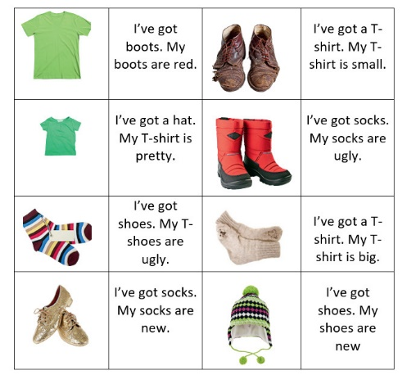  - Brainstorm sts by asking them what they have learned, and focus on the new words of this lesson. Use the flashcards to play a miming game. One student comes to the front of the class. Show them a card and they have to mime the activity for the rest of the class to guess  - Arrange the class in small groups working around table  - Explain the rules. This can be done by example. Shuffle the dominoes and divide them between a group of sts. Place the last dominoes face up in the middle of the table  - The player to the left of the dealer starts. He or she put a dominoes next to the one on the table (either before or after) It must match the word or the picture  - The player on his or her left continues and repeat process. If any player cannot put a domino down, it is the player’s turn  - The first person to play all their dominoes is the winner. The others continue playing. When all the dominoes have been played, they should form a closed circuit. If sts do not have a closed circuit at the end of the game, they should look for the mistake  - Circulate to monitor and check | - Listen to the rules. Then do.  -Work in group  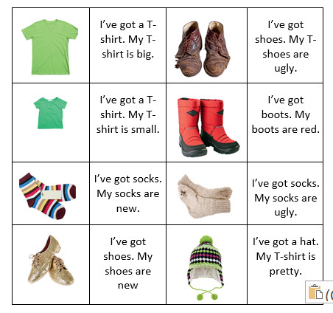  -Check the answers with their groups  - Check the answers with the teacher
Activity 4: Production (9 minutes)
Teacher’s activities | Student’s activities
- Ask Sts to quickly write on their papers someone’s clothes they are wearing. Then sts fold up like a paper airplane. Sts make a circle/ lines/ groups (with their backs to each other). Then throw it to their friends. Whoever receives it will guess the name of the writer who wants to mention | - Think about their clothes or someone clothes, write  - Work groups then say  (Eg:- I’ve got...../She/He’s got….)
Activity 5: Assessment (3 minutes)
Teacher’s activities | Student’s activities
- Ask ss to do the assesment.  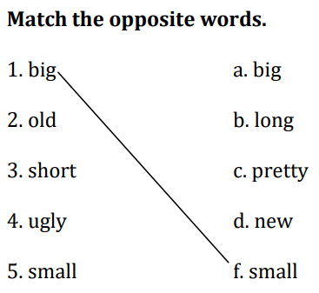  - Encourage the whole class  - Check sts’answers  - Say goodbye | - Do the assessment.  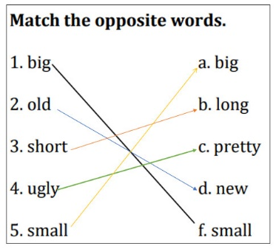  - Check with friends and then with teacher and whole class.  - Say goodbye: sing the Goodbye song.

____________________________________
UNIT 5. CLOTHES
Lesson 3. Task 4, 5, 6
Period 60
I. OBJECTIVES:
1. Knowledge:
Students will learn how to use adjective with nouns and vocabulary about clothes
2. Competence:
- English competences: Students will be able to introduce clothes with adjectives properly
- Common competences: Students will develop their self-study ability in joining difficult activities during the lesson
3. Qualities:
Students will form good habits to know how to protect and protect personal clothes.
II. EQUIPMENT AND MATERIALS:
- Teacher: TV, PPT, flashcards; audio track 5.10; track 5.11
- Students: Student’s book, markers, boards, pens, A4 paper
III. LESSON PROCEDURE
Activity 1: Warm up (5 minutes)
Teacher’s activities | Student’s activities
- Greet students.  + Play the Brain gym. Students look, listen, and do.  Guessing game:  + Review name of the clothes  + Set the rules: There are 6 numbers, each number contains one color question What is it?/ What are these? whoever wins in the game will be opened in order from 1 to 6. If the opener answers the question correctly, it will get 3 stars, if not, the answer will be given to the remaining team back and the score will be 1 star back for each team. When answering all 6 questions, sts will see 6 photos of the lesson (a new T-shirt, a pretty skirt, old shoes)  + Divide the class into groups; ask four students to come into the front, they rock paper and scissors. The winner opens the cross and answers the question.  + Each time they get stars for their groups  + Students have six times to open the key picture. | - Greet teacher.  - Look, listen, and then do the action with teacher.  - Read and follow teacher if possible.  Work in groups  Count the number of stars
Activity 2: Presentation (8 minutes)
Teacher’s activities | Student’s activities
Lead in: Use the game and the picture to lead in the new lesson  - Write on the board The date and introduce the lesson.  Task 4: Listen and repeat (Track 5.11)  - Show picture/slide of the task  - Ask sts to talk about the picture  - Collect the suitable answer on the board  - Use flashcards to introduce  - Say the words/sentences for sts to repeat in chorus.  - Play the audio 5.10  - Ask sts to listen and repeat sentence by sentence  Checking:  Chinese whisper game  - Ask sts to work in 3 teams  - Ask the teams to stand in lines  - Prepare three sentences at the end of the line  - T says the sentence to the first players  - Ask them to whisper the sentence to friends  - The last member listens and chooses the correct sentence. Then sticks it on the board  - The first correct sticking gets the point  - Continue the game until the end  - Award the winner | Copy down  Look and answer:  Listen and repeat  - Listen and repeat  - Work in teams  - Listen to the teacher  - Whisper to the next person  - Continue whispering  - Choose the correct sentence, stick on the board  - Continue playing
Activity 3: Practice (10 minutes)
Teacher’s activities | Student’s activities
Task 5: Look and say  Game: Broken Sentence  - Make an enlarged copy the the worksheet and cut out the card, select the appropriate number of cards , ensuring that they make up complete sentences  - Explain that the activity involves forming sentences, and each sentence consists the cards. They should use the punctuation to help them (full stop and captital letter)  - Elicit the model sentence  “I’ve got new shoes.”  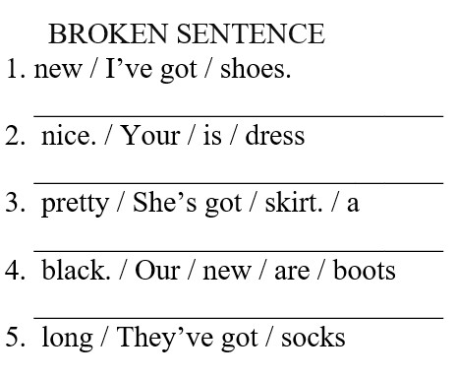  Give the sts the worksheet. Sts must put the words into the correct order. They can do this by:  + cutting out  + stick on the group boards  - Correct collectively on the board  * Ask sts to look at the picture of this activity then ask sts to describe the content of the picture  Revise the words of the lesson  * Circulate to monitor but try to encourage sts autonomy to write the correct words in the blank  - Sts correct their works in pairs first. Then correct it collectively  - Correct the activity collectively. Sts swap worksheets and dictate the answers  - Have sts present their works  - Have sts practice the sentence in chorus, group, pairs, individual | - Look and work in groups  Work in groups  1. I’ve got new shoes.  2. Your dress is nice.  3. She’s got a pretty skirt.  4. Our new boots are black.  5. They’ve got long socks.  - Practice the sentence  - Say the name of each picture  - Write the correct words  - Check answers  - Present  - Say
Activity 4: Production (9 minutes)
Teacher’s activities | Student’s activities
Task 6: Listen and sing  Set context by the given picture of the crazy hat  - Let sts guess the song melody that they’re going to sing  - Play the track 5.11 once for sts to check the melody  - Show the lyrics one by one  - Ask sts to read the lyrics fluently  - Ask sts listen and sing along  - Play the audio again for sts to sing along  - Have a singing contest | - Guess the song melody  - Listen to the song  - Look and read  - Listen and sing  - Join the singing contest
Activity 5: Assessment (3 minutes)
Teacher’s activities | Student’s activities
Ask sts to do the assessment  Circle the odd one out  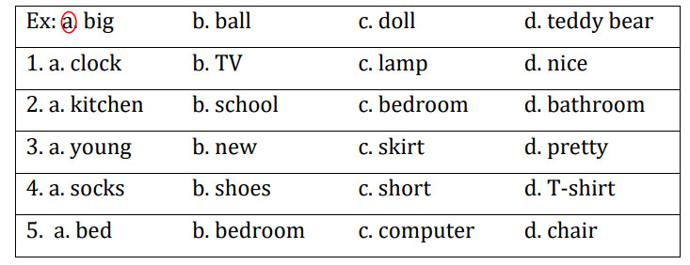  - Check in pair then whole class.  - Say goodbye | - Do the assessment.  1.d  2.b  3.c  4.c  5.b  - Check with friends and then with teacher and whole class.  - Say goodbye. Sing the Goodbye song.
__________________________________________
GRADE 5
WEEK 15
UNIT 6: FOOD
Lesson 2: Task 4-5-6
Period 57
I. OBJECTIVES:
1. Knowledge:
- Students will be able to:
+ Recall some adjectives to describe food that they have learnt in the previous lesson: crispy, delicious, salty, sour, spicy, sweet, tasty.
+ Get to know and use the new grammar about quantifiers: a few, a little.
2. Competences:
- English competences: Students will be able to use English to describe food’s amount and flavors.
- Common competences: Students will be able to develop collaborative skills through pair work.
3. Qualities:
- Students will
+ Have a strong sense of respect in pair work.
+ Raise their confidence by presenting in front of the class.
II. EQUIPMENT AND MATERIALS:
- Basic things: Student’s Book, Class Audio, dice, flashcards.
- Advanced things: PPT, laptop, TV.
Activity 1: Warm-up (4 minutes)
A game “Stop the bus”
Teacher’s Activities | Students’ Activities
Aims: Welcome students. Engage the class with a game to review words that Ss have learnt: crispy, delicious, salty, sour, spicy, sweet, tasty.
1. Greeting Ss and chatting: Before starting our new lesson, let’s play a game to review some adjectives to describe food!  2. Introducing and playing the game “Stop the bus”:  Game rules:  - The class will be divided into some teams (2 or 4 - depending on teacher’s plan).  - There is a bus with one picture shown on the screen. Ss have to look at the picture and guess what adjective it is.  - Ss from each team raise their hands to speak up for points or stars. If no team has the correct answer, the teacher will minus 1 point/star of all teams.  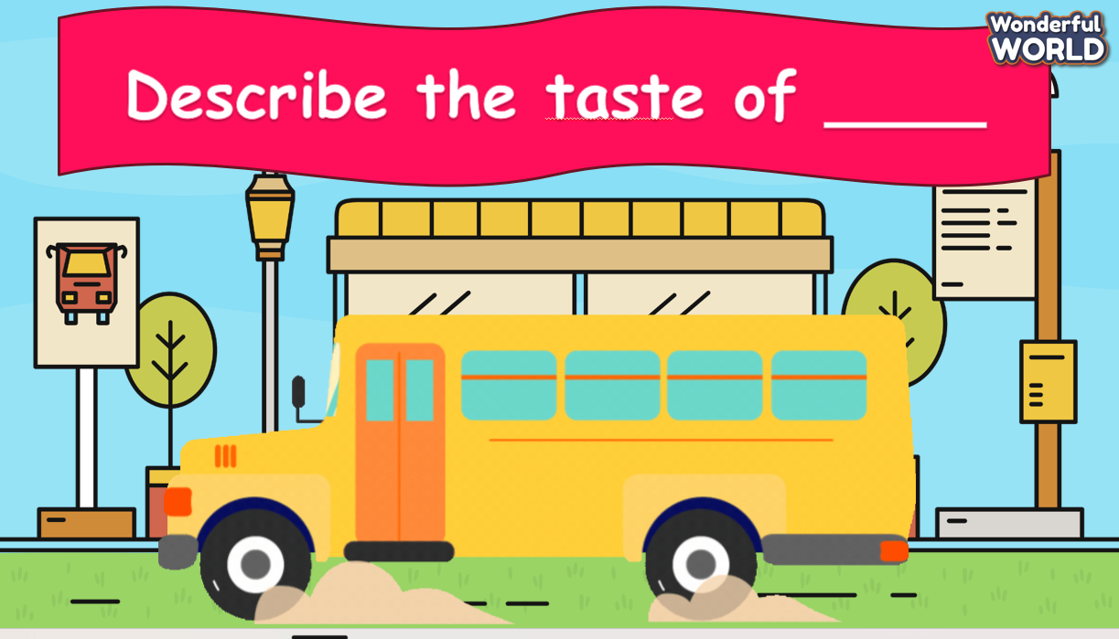  3. Leading in the lesson: Unit 6 – Lesson 2 task 4, 5, 6.  Lead in: Now, let’s move on to our new lesson. Today, we are going to learn some new quantifiers to describe food’s amount. | - Greet Teacher  - Listen to the teacher.  - Join the activity.  - Look and listen.
Activity 2: Presentation (11 minutes)
Teacher’s Activities | Students’ Activities
Aims:
- Present two new quantifiers: a few, a little and guide Ss how to use these quantifiers correctly in sentences.
- Instruct Ss to finish task 4.
Procedure:  1. (3 minutes) Eliciting quantifiers “a few”, “a little” (Track 6.3 – Task 4: Listen and read):  - Have Ss listen to Track 6.3 separately and show corresponding pictures at the same time.  - Encourage Ss to repeat what they have heard with each sentence then show the sentences on the screen.  - Ask Ss to listen again and repeat after the track by class and groups.  - Ask Ss to identify the quantifiers in 2 sentences (a few, a little).  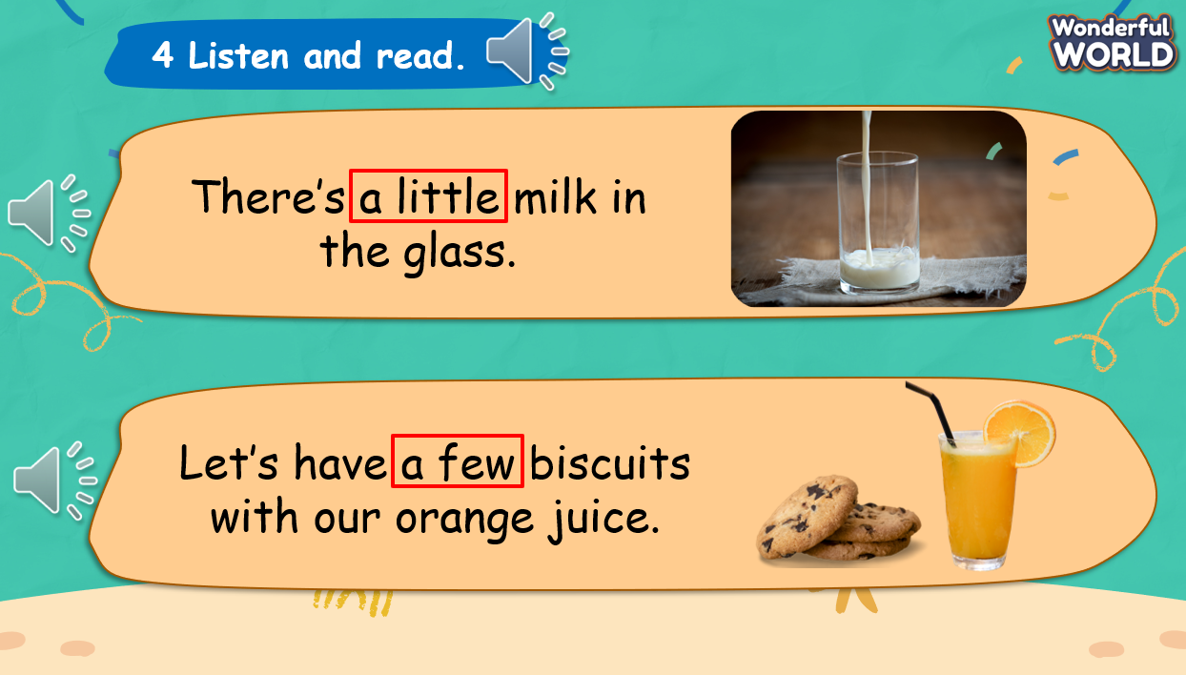  2. (5 minutes) Instructing how to use the quantifiers:  2.1. A little:  - Show a full glass of milk to lead in the quantifier “a lot of” and explain: “a lot of” means a large number or amount of something”.  - Show another glass of milk and ask Ss to give the correct answer then explain: “a little” means a small amount of something”.  - Ask Ss what type of nouns is used after “a little”.  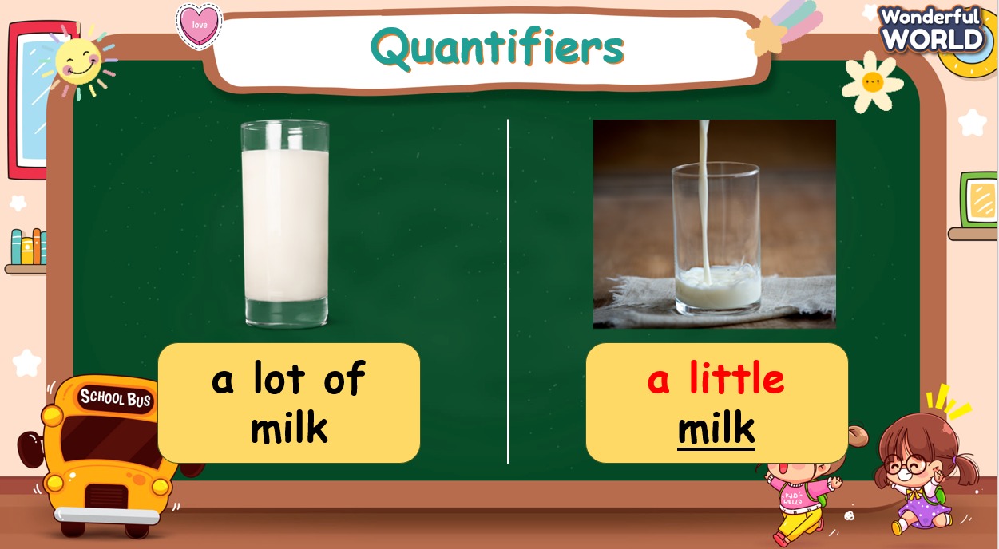  2.2. A few:  - Repeat the above steps with “a few”.  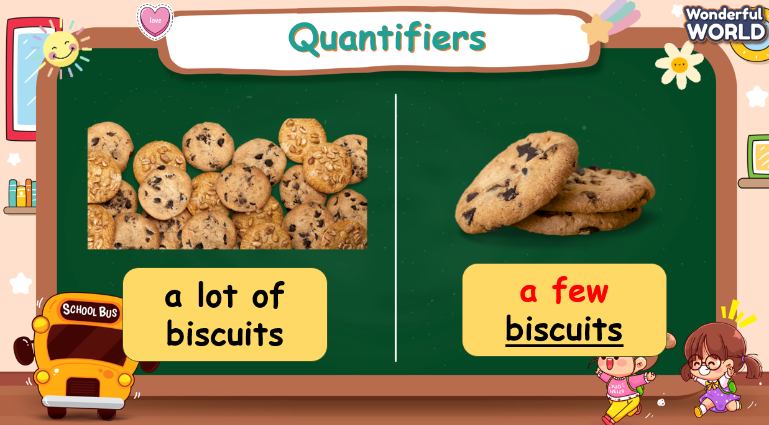  2.3. Quantifiers in sentences:  - Show a table to compare “a few” and “a little” and encourage Ss to make sentences with the given pictures.  - Explain how the verb “be” is used in each case:  + We use “There is” if the quantifier “a little” is in the sentences.  + We use “There are” if the quantifier “a few” is in the sentences.  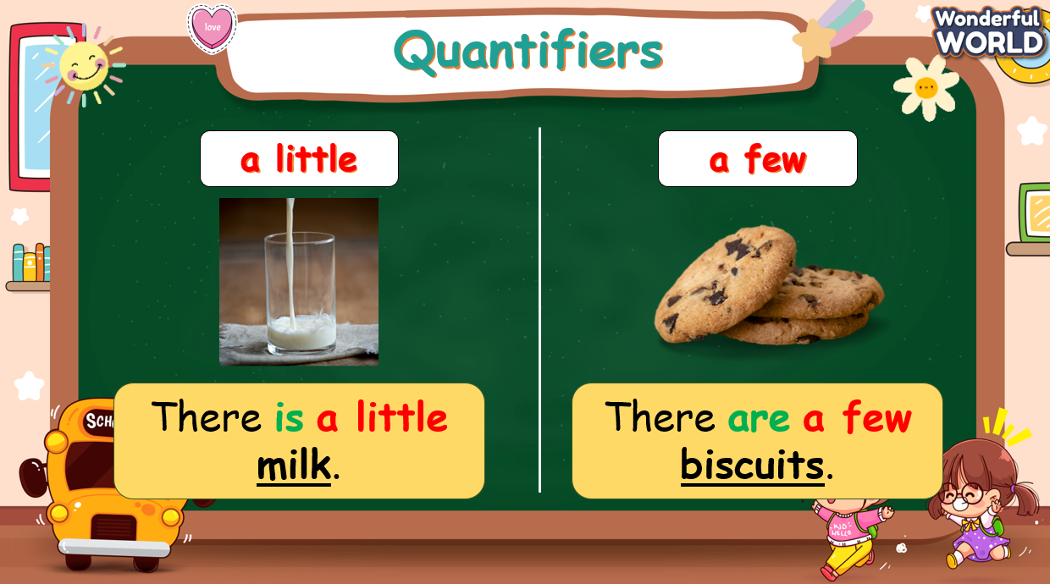  3. (3 minutes) Finishing Task 4 – Now, read, circle and say:  - Tell students to look at the pictures in the book and complete the sentences by circling “a few” or “a little”.  - Check students understand the task. Elicit the first answer if necessary.  - Allow them enough time to practice saying the sentences both individually and in pairs.  - Check answers as a class.  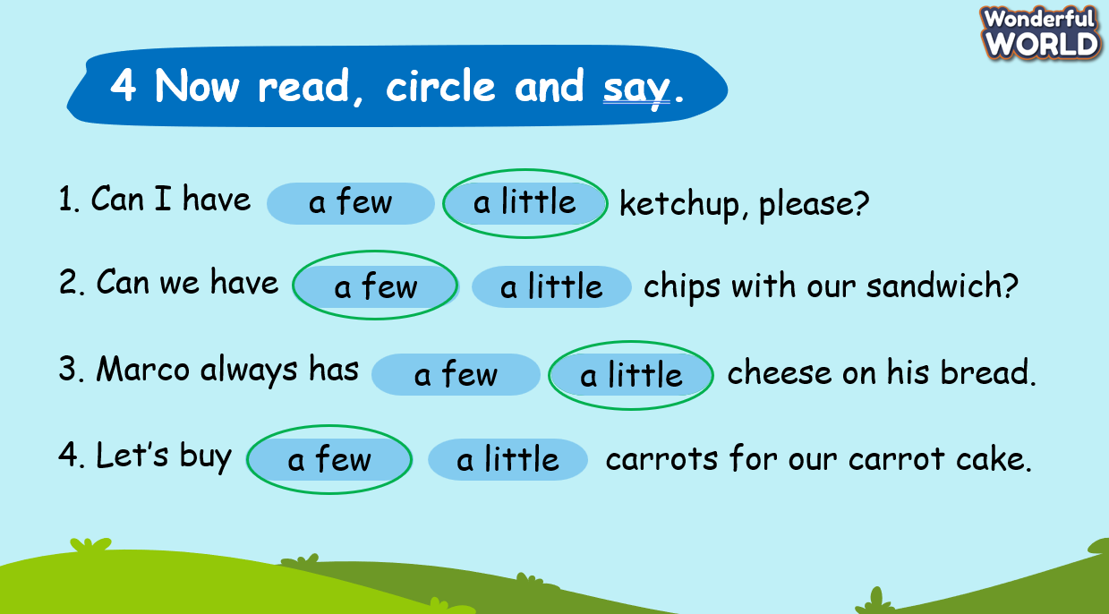 | - Listen to the audio.  - Volunteer to fulfill teacher’s requirements.  - Repeat after the audio.  - Answer teacher’s question.  - Listen to the teacher.  - Answer the question.  - Listen to the teacher.  - Answer the question.  - Volunteer to make sentences.  - Listen to the teacher.  - Work on task 4 individually.  - Check the answers.
Activity 3: Practice – Controlled practice (8 minutes)
Teacher’s Activities | Students’ Activities
Aims:
- Practice the quantifiers through Quiz activity.
- Practice using quantifiers in sentences through Task 5.
Procedure:  1. (4 minutes) Play Quiz game:  Instructions:  - The game includes three types of questions, Ss need to look and think carefully before answering.  - Three types of questions:  + Type 1: Look and choose the correct answer - Ss need to look at the pictures and choose the correct quantifiers.  + Type 2: Read and fill in the blank – Ss need to read and fill in the missing “be” in the blanks to have correct sentences.  + Type 3: Look, read, and choose True or False – Ss have to look at the pictures, read the sentences and identify if the sentences are true or false. If the sentences are false, Ss must correct the mistakes to have the correct sentences.  - Reward points/ stars with each correct answer. If the chosen team answers wrong, the teacher has to choose the other team.  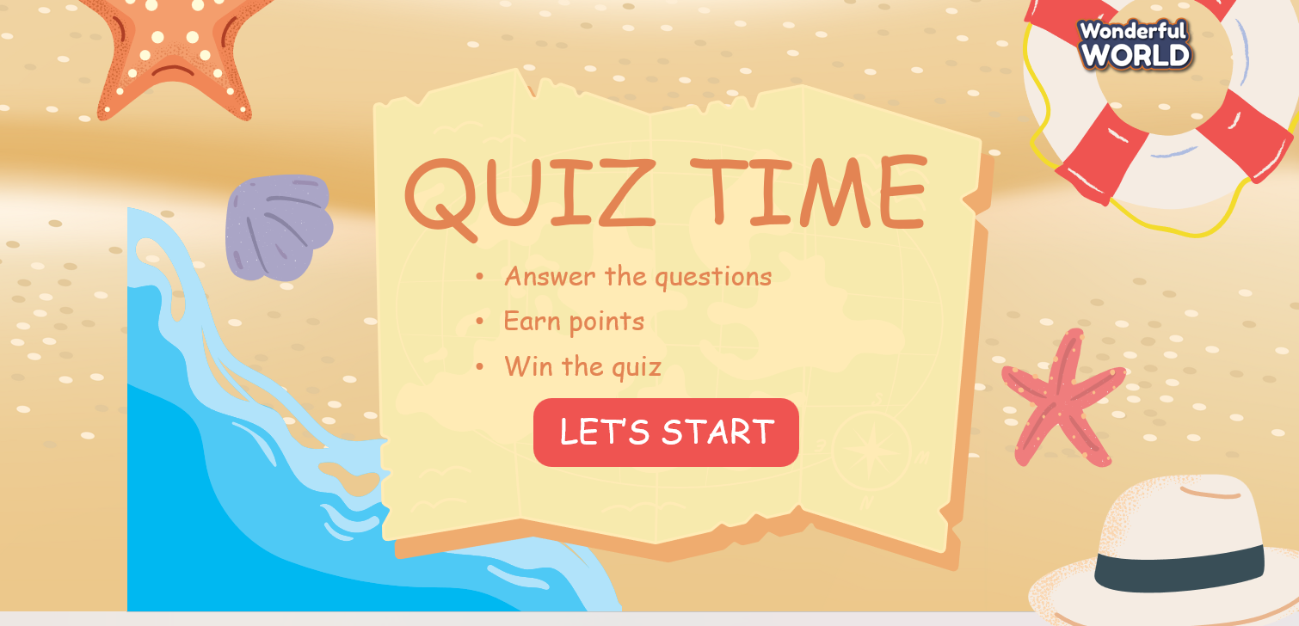  2. (4 minutes) Complete Task 5 - Put the words in the correct order to make sentences or questions:  - Tell students to write the words in the correct order.  - Go through the example sentence together to ensure students understand the task.  - Allow students to work individually to reorder the words in each sentence.  - After individual work, students can compare their answers with a partner or in small groups.  - Bring the class together and discuss the correct order of words for each sentence.  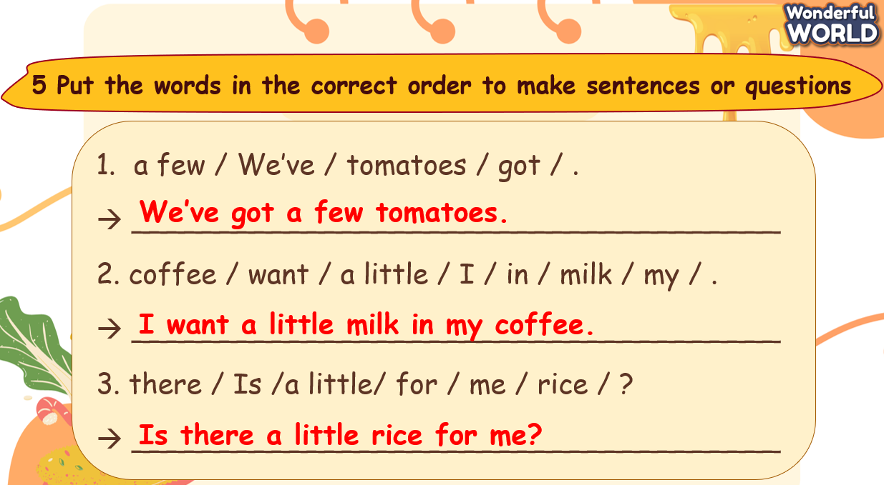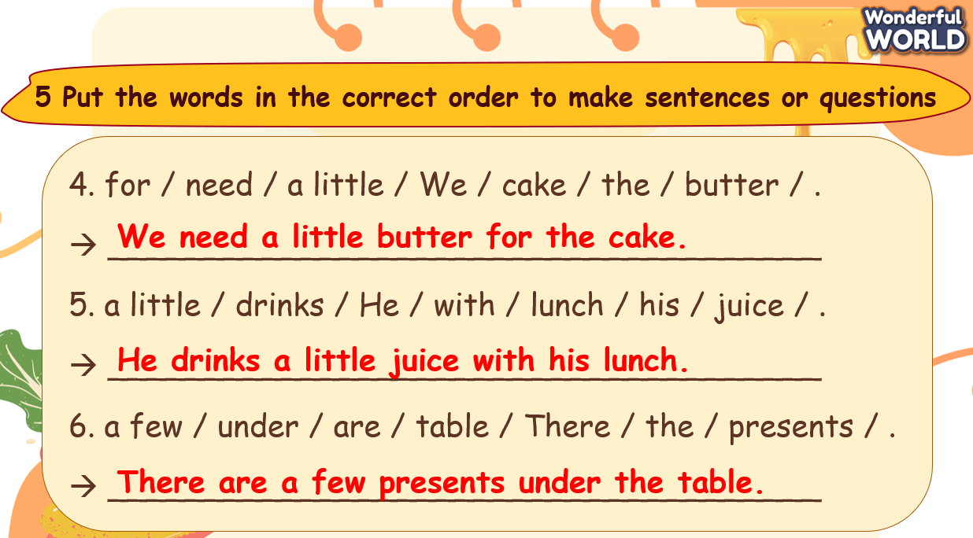 | - Join the activity.  - Complete the exercise individually.  - Work in pairs to practice saying the sentences  - Correct the exercise with the teacher.
Activity 4: Production (7 minutes)
Teacher’s Activities | Students’ Activities
Aim: Ss apply the words and grammar to finish Task 6.
- Tell Ss to look and read out the dialogue by class, groups and individuals  - Role play the example conversation with a student in front of the class.  - Pair up the Ss and give them some minutes to practice with each other.  - Go around the class and observe the conversations to ensure Ss are using the questions appropriately and responding effectively.  - Ask some volunteers to speak in front of the class when time’s up.  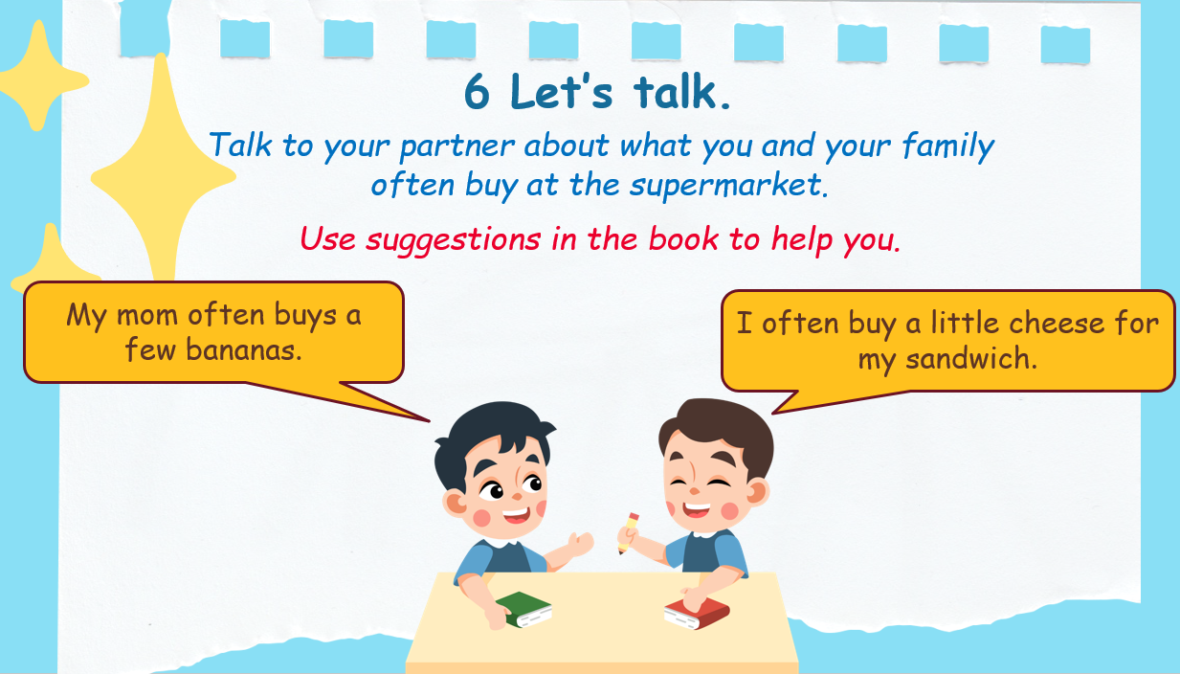 | - Read aloud the dialogue.  - Pay attention to the role play.  - Work in pairs.  - Present in front of the class.
Activity 5: Wrap up & Assessment (5 minutes)
Teacher’s Activities | Students’ Activities
Aims:
- Check students’ understanding of what they have learned.
- Students rehearse what they have learned in the lesson.
- Assessment: Do the activity to sort food into the correct quantifiers:  Answer:  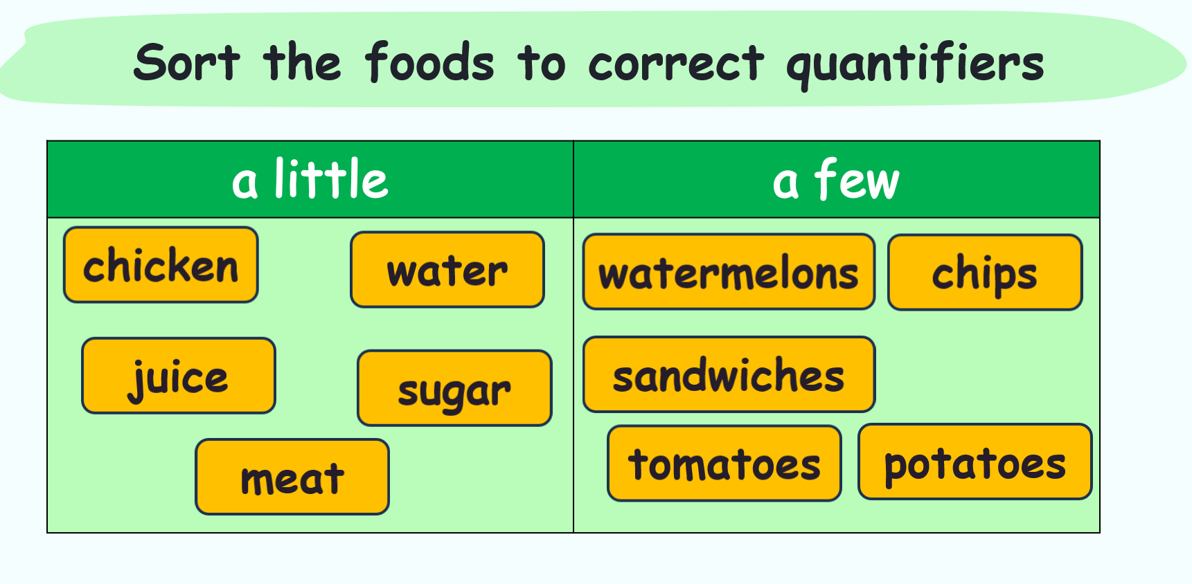  - Wrap up:  * Remember  - Review Vocabulary: crispy, delicious, salty, sour, spicy, sweet, tasty.  - Grammar: a few, a little  There are a few sandwiches.  There is a little water. | - Do the quick sorting activity.  - Stand up and say goodbye to the teacher.
__________________________________________

UNIT 6: FOOD
Lesson 3: Task 1-2-3
Period 58
I. OBJECTIVES:
1. Knowledge:
- Students will be able to:
+ Recall words about food and learn some new words: meatball, cereal, bowl, plate, piece.
+ Practice speaking and listening skills about food.
2. Competences:
- English competences: Students will be able to use English to talk about their favorite food in each meal.
- Common competences: Students will be able to develop their confidence in speaking about their meals.
3. Qualities:
- Students will
+ have a strong sense of familiar love.
+ show their interests in food through words and behaviors.
II. EQUIPMENT AND MATERIALS:
- Basic things: Student’s Book, Class Audio CD, Posters, IWB, DVD.
- Advanced things: PPT, laptop, TV.
III. LESSON PROCEDURE:
Activity 1: Warm-up (5 minutes)
Food flavor sorting
Teacher’s Activities | Students’ Activities
Aims: Welcome students. Engage the class with a sorting game to review vocabulary and lead in the new lesson.
1. Greeting Ss and chatting: Before starting the new lesson, let’s sort out the taste of the food to review what we have learnt.  2. Introducing and playing the game:  - Show or draw a table of 4 dishes: pizza, Pad Thai, fish and chips, nem chua and words of taste: crispy, delicious, salty, sour, spicy, sweet, tasty.  - Assign each team 1 food and ask Ss to sort out the taste of the corresponding food by writing on the board. Each student writes only one word.  + There are 4 dishes on the table. Each team will choose 1 dish and write the taste of the food. Each member can write only once. You have 30 seconds to write down at least 3 correct tastes to describe the food.  + Correct answer (reference):  Pizza: delicious, salty, tasty  Pad Thai: sweet, spicy, sour.  Fish and chips: crispy, salty, tasty.  Nem chua: sour, spicy, delicious.  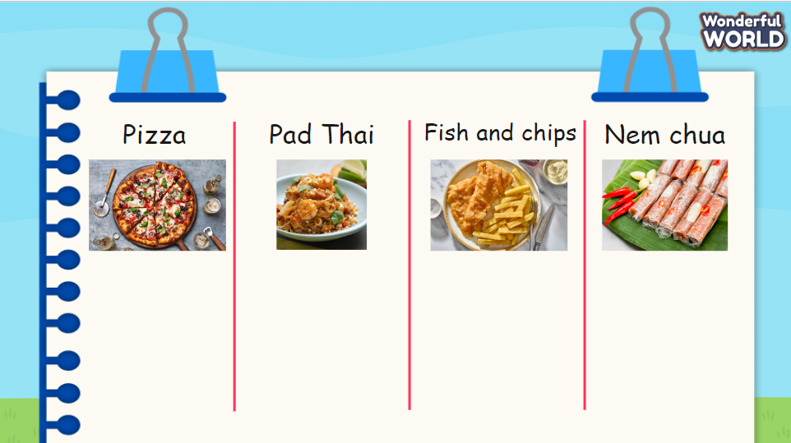  3. Leading in the new lesson: Unit 6 – Lesson 3 task 1, 2, 3. | - Greet Teacher  - Join the activity.  - Look and listen.
Activity 2: Presentation (12 minutes)
Teacher’s Activities | Students’ Activities
Aims:
- Present some words learnt in the lesson: meatball, cereal, bowl, plate, piece to prepare for the next listening part.
- Complete task 1 & 2.
- T presents some new words that appear in the lesson: meatball, cereal, bowl, plate, piece.  - Show the pictures and elicit these words to let them know the words and their meaning.  - Do the activity called “Zoom in, Zoom out” to practice the words.  + Ss will look at the pictures which are zoomed out and then they will have to guess what the food in the pictures is.  + T will zoom in on the pictures again to show the food and correct the answers.  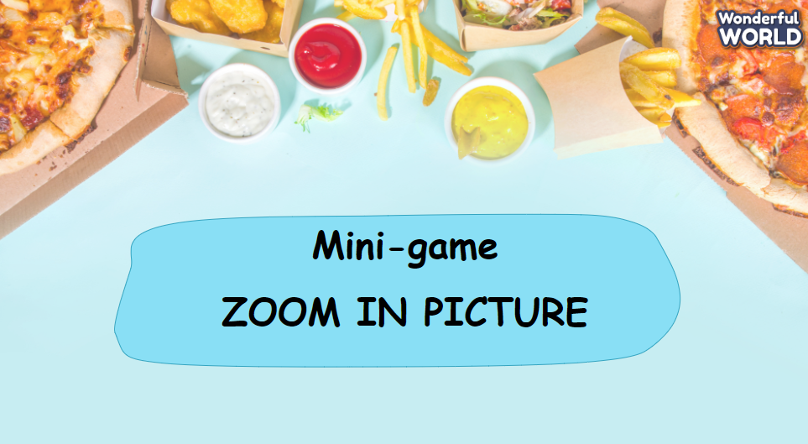  Task 1. Look and say. What food can you see?  - Show pictures in the textbook and ask Ss what food they can see from the picture.  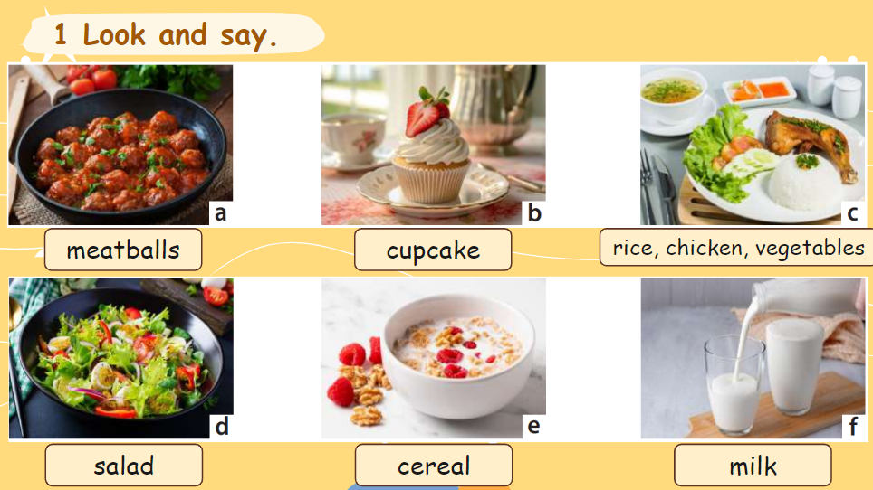  Task 2. Listen and match.  - Provide a brief introduction to the activity and tell students they will hear three different people: Minh, Nam and Lan talking about their favorite meals.  - Explain that for each talk, students have to listen and match the speaker  with the meals (a, b, c).  - Play the audio first and ask them to match.  - Before playing the second time, ask them what the speakers like eating in their favorite meals.  - Reason and review the correct answers as a class.  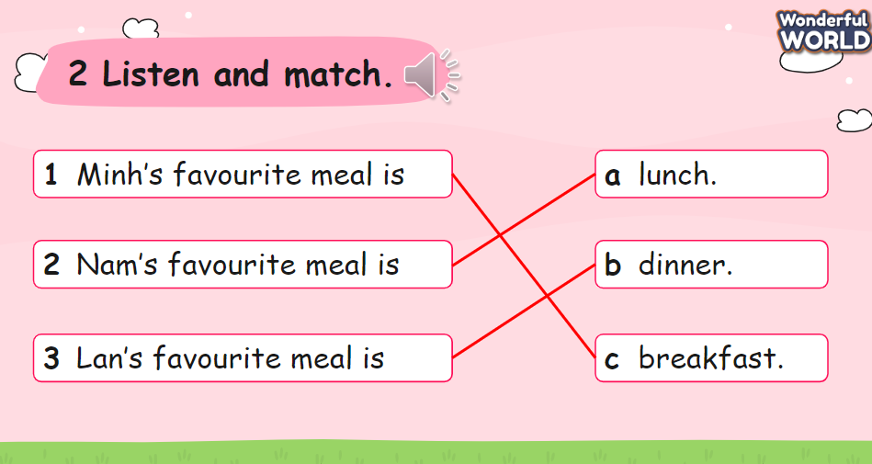 | - Learn the words.  - Join in the activity.  - Look and say.  - Listen and match.
Activity 3: Practice – Controlled practice (8 minutes)
Teacher’s Activities | Students’ Activities
Aim: Ss will be able to practice listening and fill in the gaps to complete task 3.
Task 3. Listen again and write.  - Tell the students to read the instructions and tell them they are going to listen to the talks again and choose the right word in the box to fill in the blank.  - Ask students to look at the gaps.  - Play the recording and tell students to listen and fill in the gaps. Play the recording more than once if students cannot catch the answers.  - Play the recording again and pause after each sentence to reason.  - Check answers.  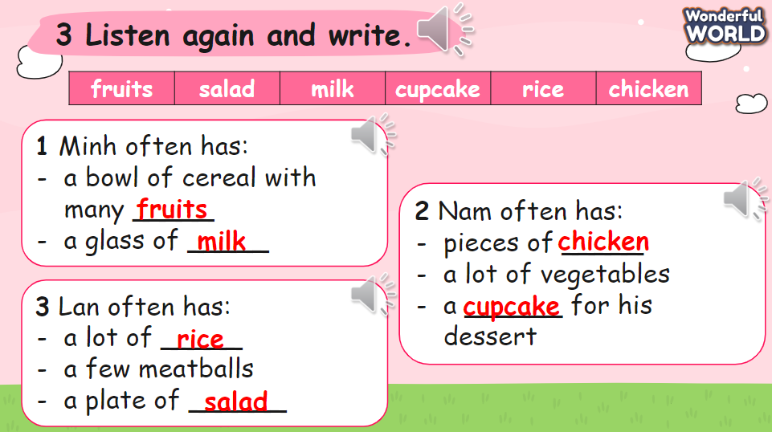 | - Listen and write.  - Correct with T.
Activity 4: Production (5 minutes)
Teacher’s Activities | Students’ Activities
Aim: Ss apply the new words to make a mind map of their favorite meals and work in pairs to share.
- Ask and elicit Ss to make a mind map of their favorite meals with different food. Give an example to Ss so that they can understand what they should do. This activity will be done individually in 2 minutes.  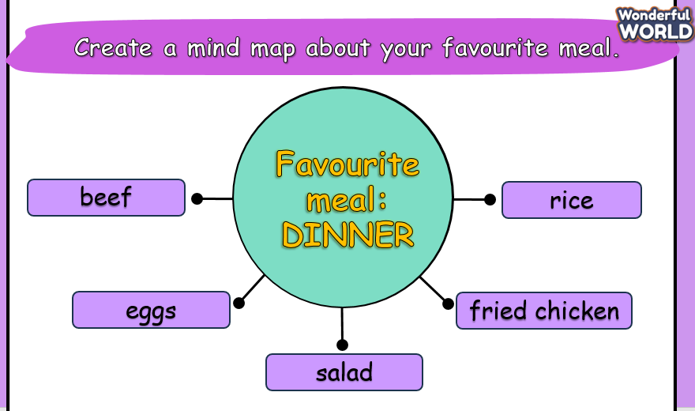  - Let Ss work in pairs for 3 minutes and share about their favourite meals and what they like to eat. | - Make a mind map.  - Work in pairs and talk.
Activity 5: Wrap up & Assessment (5 minutes)
Teacher’s Activities | Students’ Activities
Aims:
- Check students’ understanding of what they have learned.
- Students rehearse what they have learned in the lesson.
Assessment:  - Ask Ss to write sentences with some given words.  1. of / often / a / have / bowl / I / soup /.  I often have a bowl of soup.  2. often / He / a / of / plate / salad / has /.  He often has a plate of salad.  3. chicken / has / pieces / often / of / some / She /.  She often has some pieces of chicken.  4. for / They / often / lunch / have / rice.  They often have rice for lunch.  Wrap up:  ‘What have we learnt today? Can anyone tell me? - T asks the class and gives some Ss a chance to try answering this question.  + Speaking skills: What food can you see?  + Listening skills: What’s your favorite meal? | - Check with the teacher.  - Write sentences with given words.  - Answer T’s question about what they learnt in today’s lesson.  - Stand up and say goodbye to the teacher.
__________________________________________

UNIT 6: FOOD
Lesson 3: Task 4-5-6
Period 59
I. OBJECTIVES:
1. Knowledge:
- Students will be able to:
+ To review some adjectives describing food.
+ To learn the usage of food quantifiers.
2. Competences:
- English competences: Students will be able to use English to write about their favorite meal.
- Common competences: Students will be able to build more confidence in applying vocabulary and quantifiers to write sentences and speak in English what they like eating at a meal.
3. Qualities:
- Students will
+ Develop public speaking in front of the class.
+ Develop a sense of love towards food.
II. EQUIPMENT AND MATERIALS:
- Basic things: Student’s Book, Class Audio CD, IWB, DVD.
- Advanced things: PPT, laptop, TV.
III. LESSON PROCEDURE:
Activity 1: Warm-up (5 minutes)
“Speed up”
Teacher’s Activities | Students’ Activities
Aims: Welcome students. Engage and recall the class about adjectives describing food they have learned previously and then lead in the lesson.
1. Greet Ss and chat.  2. Introduce and conduct the activity “Speed up”:  ‘Before starting the new lesson, let’s do a “Speed up” activity to review some food vocabulary that we’ve learned before.’  - Divide the class into different teams. It depends on T’s plan.  + Rules: T will show different hints for each word on the screen. The team that finds the answer faster is the winner.  + 1st word: delicious + 2nd word: crispy  + 3rd word: salty + 4th word: tasty  + 5th word: sour + 6th word: sweet  + 7th word: spicy  3. Leading in the lesson: Unit 3 – Lesson 3 tasks 4, 5, 6.  Lead in: Food is usually uncountable nouns, so how to count uncountable nouns. Today, let’s find out what food quantifiers. | - Greet Teacher.  - Join the activity.
Activity 2: Presentation (7 minutes)
Teacher’s Activities |  | Students’ Activities
Aims:
- Check & learn the usage of food quantifiers.
- Complete task 4.
Task 4. Listen and read. Then look and match.  - Ask students to look at the phrases. Then play the recording and tell students to listen and read.  - Ask students to practice saying the phrases in pairs.  - Walk around and correct any mistakes.  - Quick check: Say Vietnamese and ask them to say it in English.  - Tell the students that they are going to match words and pictures.  - Show students how to do the task by matching the first word with the correct picture. Praise or award a prize to the quickest student with all correct answers.  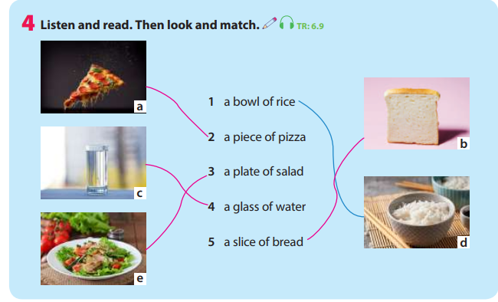  Presentation: the plural form of food quantifiers  - Let Ss guess the plural form of each phrase and then show the final answer on the screen.  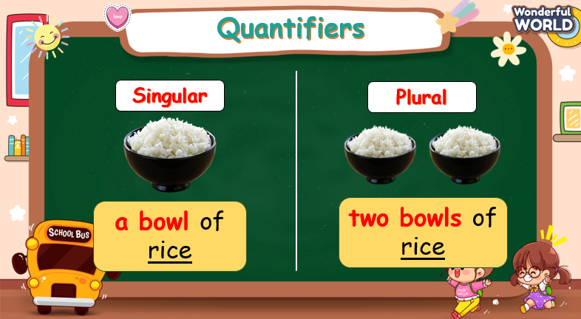  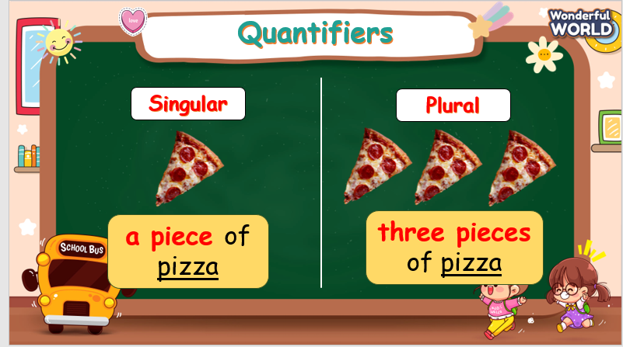  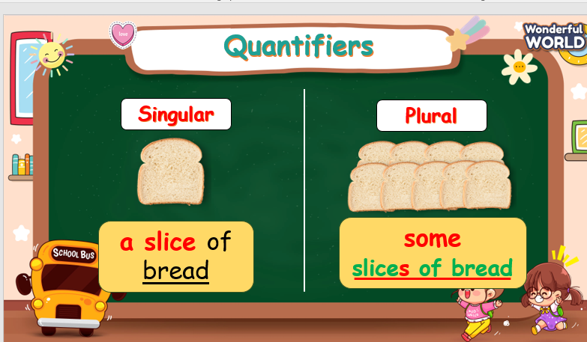 |  | - Look, listen, and read again.  - Look and match.  - Listen and answer.
Activity 3: Practice – Controlled practice (10 minutes)
Teacher’s Activities |  | Students’ Activities
Aims:
Ss will:
- practice using food quantifiers.
- complete task 5.
Activity “What do you love having?”  - There are five questions. Ss are asked to look at the pictures and answer questions by saying in a full sentence and using food quantifiers.  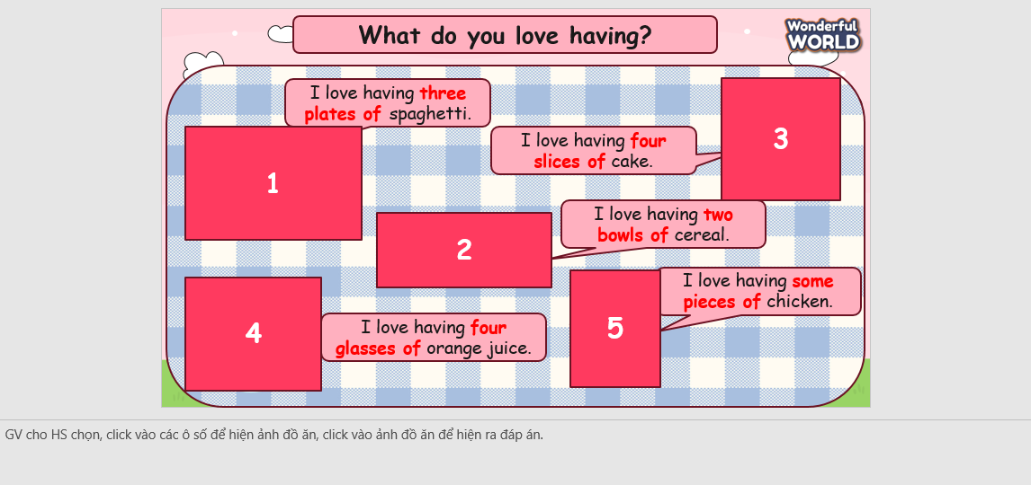  Task 5: Read and write.  + Tell students to read and write the correct form of food quantifiers.  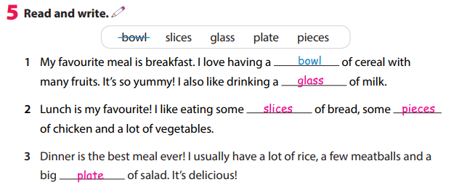  + Show answers and do the correction. |  | - Join in the activity.  - Look and answer.  - Read and write.
Activity 4: Production (8 minutes)
Teacher’s Activities |  | Students’ Activities
a. Aim: Ss will be able to apply food quantifiers to write about their favorite meal and work in pairs to share with their partners.
b. Procedure:  - Let Ss work individually for 5 minutes to draw and write a short paragraph about their favorite meal. Remember to use food quantifiers.  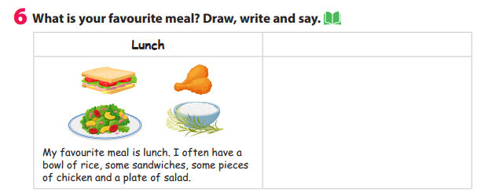  - Divide the class into different pairs.  - Let Ss work in pairs to share about their favorite meal. Choose Ss voluntarily to share in front of the class about their partners’ favorite meal. |  | - Write a short paragraph.  - Work in pairs.  - Take notes and talk in front of the class.
Activity 5: Wrap up & Assessment (5 minutes)
Teacher’s Activities |  | Students’ Activities
a, Aims:
- Assess individuals or groups who have done the best in the lesson.
- Wrap up the activities Ss have done during the lesson.
- Assessment: Do the activity “catch the word”.  + Ask Ss to look at two small pictures and guess what word or phrase is made from these two pictures.  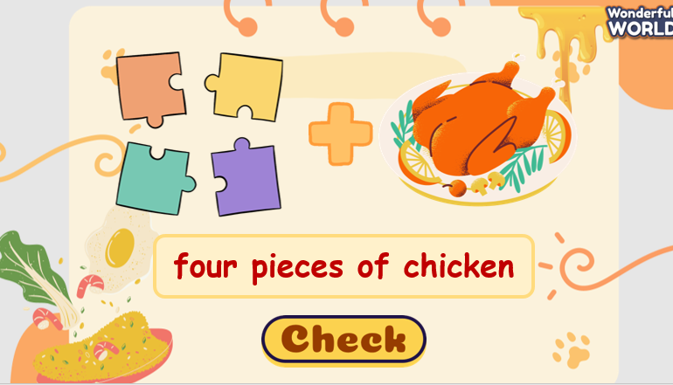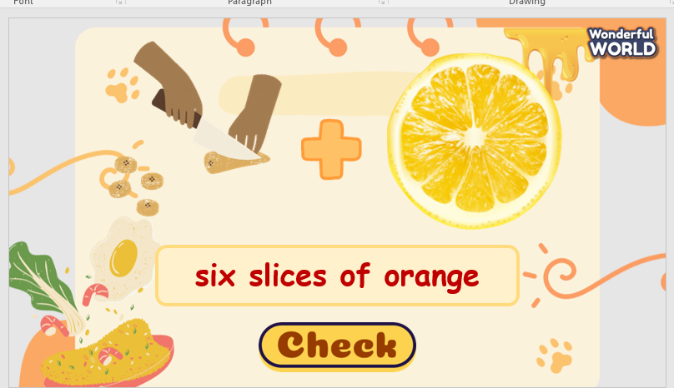  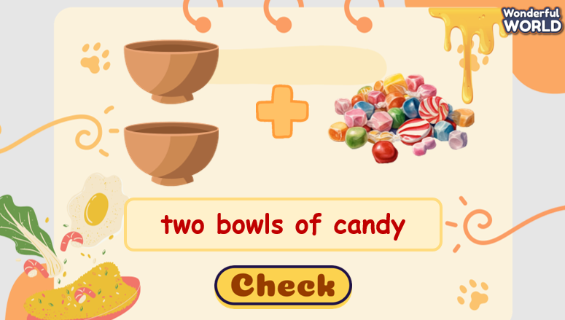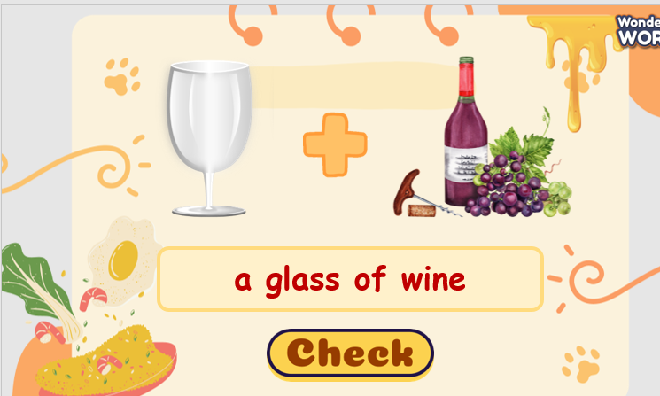  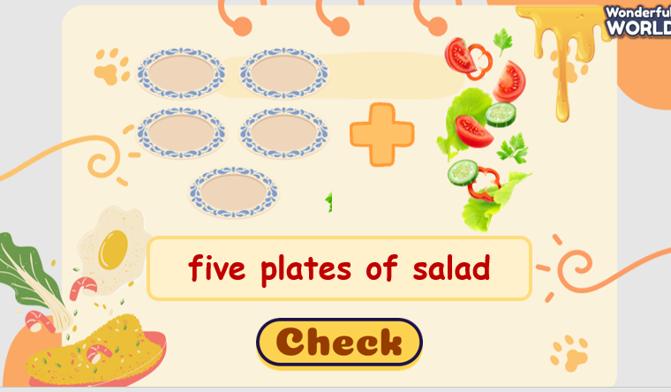  + Give compliments to the individuals/ groups who have completed the activities the best and encourage the other groups/teams to keep doing them during the next lessons.  - Wrap-up:  ‘What have we learnt today?’ - T might ask 1 S or a group of Ss to talk about what they learnt in today’s lesson.  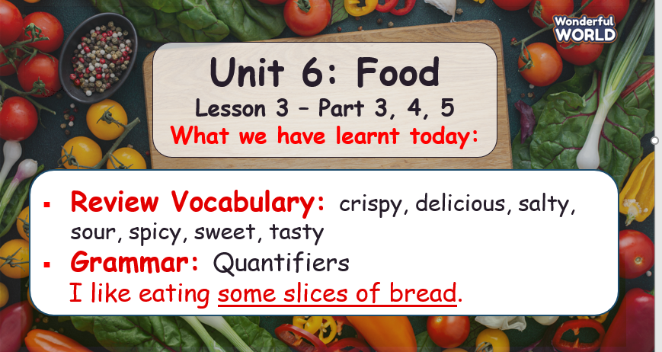 |  | - Ss answer.  - Ss answer T’s question about what they have learnt today.  - Stand up and say goodbye to the teacher.
__________________________________________
UNIT 6: FOOD
Lesson 3: Task 7-8-9-10
Period 60
I. OBJECTIVES:
1. Knowledge:
- Students will be able to recognize and know how to pronounce word stress correctly.
2. Competences:
- English competences: Students will be able to apply in pronouncing words with the stressed syllable.
- Common competences: Students will be able to build more confidence in speaking English with word stress.
3. Qualities:
- Students will develop a sense of confidence in speaking English with correct word stress.
II. EQUIPMENT AND MATERIALS:
- Basic things: Student’s Book, Class Audio, posters.
- Advanced things: PPT, laptop, TV.
III. LESSON PROCEDURE:
Activity 1: Warm-up (5 minutes)
“Watch a video”
Teacher’s Activities | Students’ Activities
Aims: Welcome students. Engage students by letting them watch a video. After that, lead in the lesson.
1. Greet Ss and chat.  2. Introduce and conduct the activity of watching a video:  “Before starting the new lesson, let’s watch a video and pay attention to how the speakers say the words and which syllable of each word is pronounced louder than the rest?”  - After each word appears, T can pause the video and ask Ss such questions above.  Lead in: “So today, we are going to discover word stress that the syllable of each word is pronounced louder and higher.” | - Greet Teacher.  - Listen to T’s instructions.  - Join the activity.
Activity 2: Presentation (7 minutes)
Teacher’s Activities | Students’ Activities
Aims:
- Ss know how to pronounce the word stress and recall it.
- Have Ss complete tasks 7 & 9.
Task 7. Listen and repeat. Then circle the stress.  - T explains what the word stress is.  “English words often have stressed syllables. In a word, we say one syllable very loudly and all the other syllables very quietly.”  - Let Ss listen to the words and guess what the word stress is and then correct if there is any mistake, and emphasize the correct ans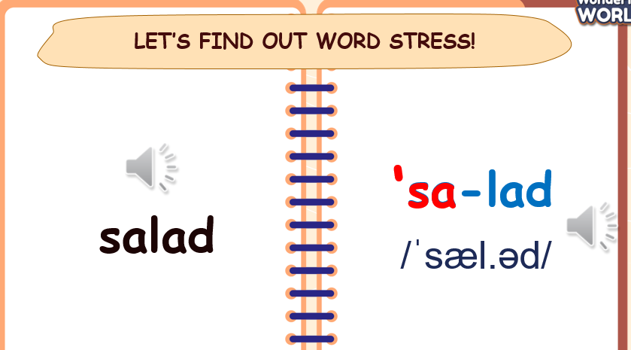wer.  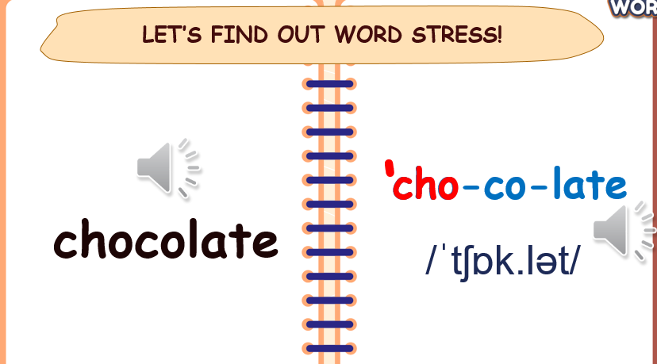  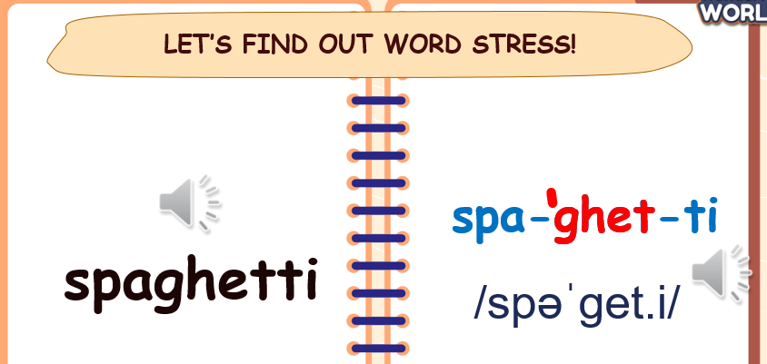  - Play the audio of task 7.  - Instruct Ss to listen carefully and repeat each word with the correct stressed syllable. Tell them to highly pay attention to the stress.  - Write each word on the board and ask students to practise the sounds with you.  - Play the recording again and tell students to repeat the words, paying particular attention to the correct stressed syllable of each word. Ask them to circle the stressed syllable in each word.  - Ask Ss to practise their pronunciation in pairs, and then ask some volunteers to read out the words and sentences. Correct them if there is any mistake.  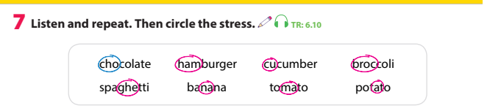  Task 9: Listen and chant  - Tell Ss they are going to learn a chant. Explain to Ss that the chant uses the sounds they have just learnt.  - Play the recording and tell students to listen and follow the words with their fingers.  - Read out the chant one line at a time and ask students to repeat  after you.  - Play the recording again.  - Encourage students to chant along. Practice several times until  students are familiar with the words and sounds.  - Ask students to practice the chant in pairs or groups. For example, one group chants the first verse, and the other group chants the second verse, following until it’s the end of the chant.  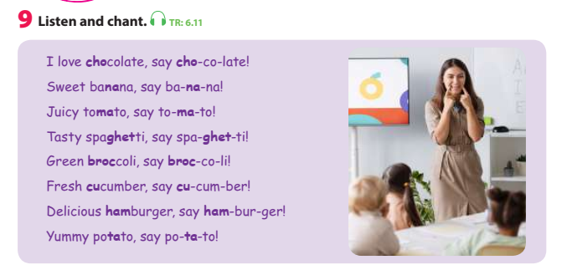 | - Look, listen and answer.  - Listen and repeat.  - Listen and chant.
Activity 3: Practice – Controlled practice (10 minutes)
Teacher’s Activities | Students’ Activities
Aims:
Ss will: - practise pronouncing word stress.
- complete task 8.
Activity 1: Play “World Race Game” to practice the pronunciation of word stress.  - Introduce the Word Race Game:  “Today, we’re going to play a fun game to reinforce our vocabulary and spelling skills and we’re going to use hand gestures for rock-paper-scissors to decide how many spaces to move!”  - Explain how they will use hand gestures for rock-paper-scissors: rock (a fist), paper (an open hand) and scissors (a fist with the index and middle fingers extended).  - Use the existing game board in the book, on page 70.  - Place the hand gesture cues on the Start space and explain the goal: to reach the End space.  - Ask 1 S to come to the board to make an example. Use hand gestures for rock-paper-scissors, determine the number of spaces to move, and say the word in space.  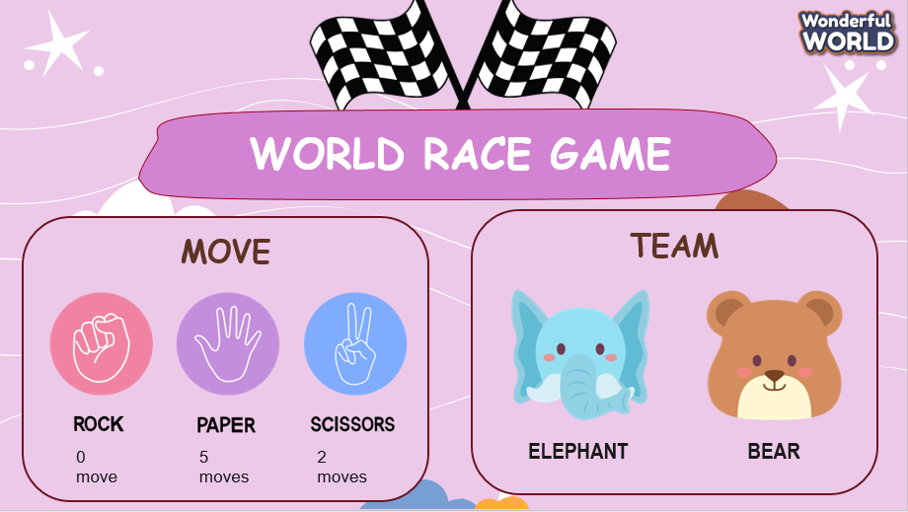  - Have students play the game in 2 teams (Elephant and Bear). They use hand gestures for rock-paper-scissors to decide the number of spaces to move, then move their game piece and say the word on the space.  - Congratulate the winning team who reaches the End space first.  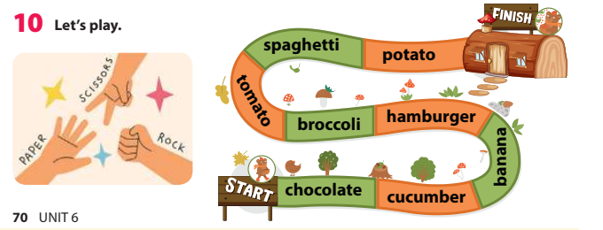  Activity 2: Complete task 8 - Circle the words that have different stressed syllables.  - Tell the students that they are going to find the words that have the stressed syllable different from the two others.  - Divide students into pairs to do the task.  - Show the students how to do the task if necessary checking together why in item #1, the word “spaghetti” is circled (stressed on the second syllable) while “chocolate” and “hamburger” are  stressed on the first syllables.  - Allow them enough time to finish the task in pairs. Go round the class helping students where necessary.  - Ask some volunteers to tell the class.  - Check the answers with the class  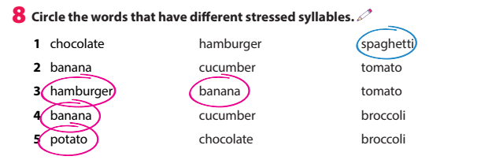 | - Join in the activity.  - Circle the words that have different stressed syllables.
Activity 4: Production (8 minutes)
Teacher’s Activities | Students’ Activities
Aim: Ss will be able to find different words with the same stress and say them correctly.
- Work in groups and find different words with the same stress as required.  - The stressed syllable is symbolized with the uppercase O. Ss are asked to find the words with the same word stress.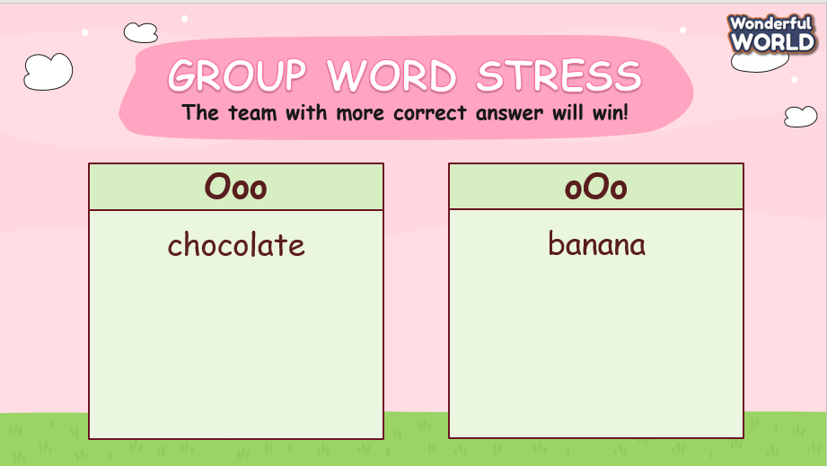 | - Find words with first-syllable and second-syllable stress.
Activity 5: Wrap up & Assessment (5 minutes)
Teacher’s Activities | Students’ Activities
Aims:
- Assess individuals or groups who have done the best in the lesson.
- Wrap up the activities Ss have done during the lesson.
- Assessment: Choose the correct word stress.  + Ask Ss to look at the picture and choose the word below with the correct stress.  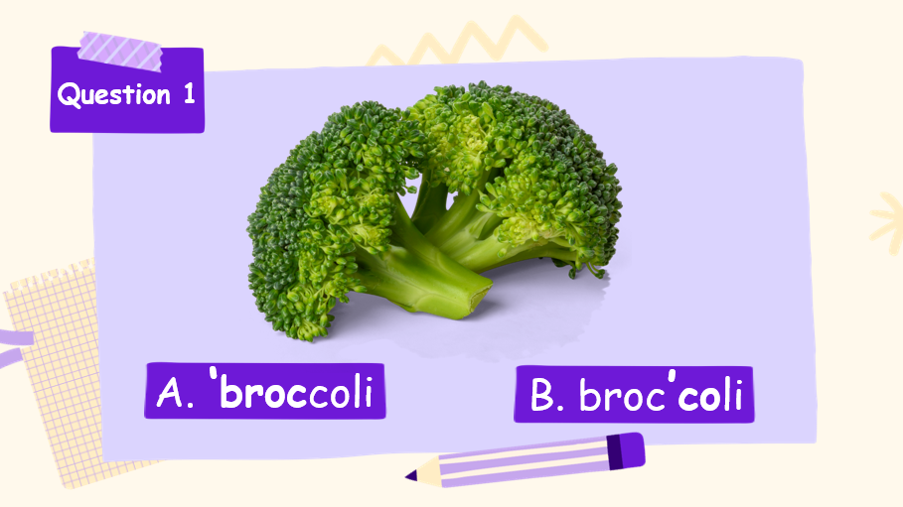  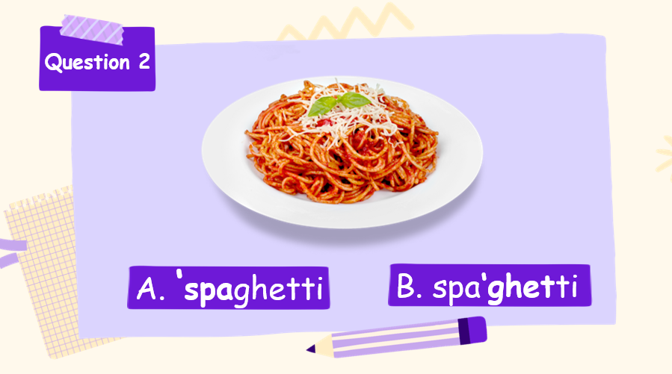  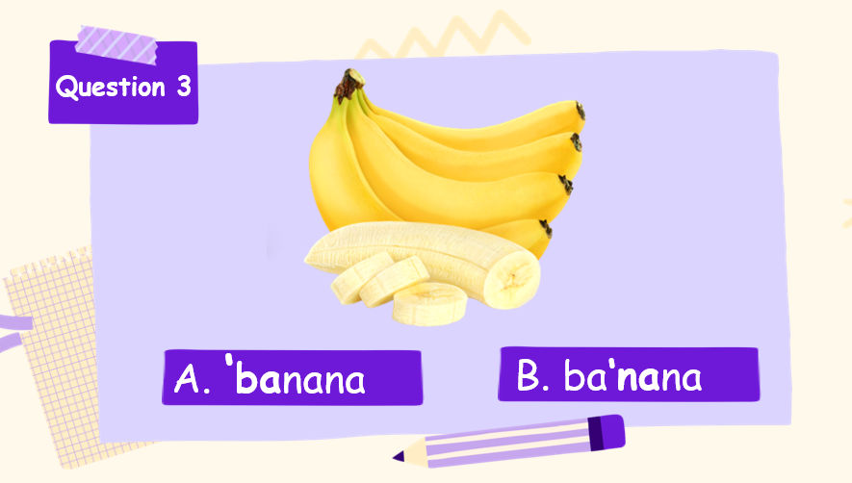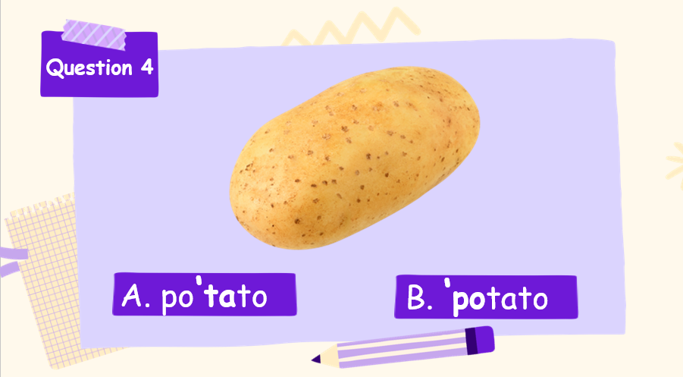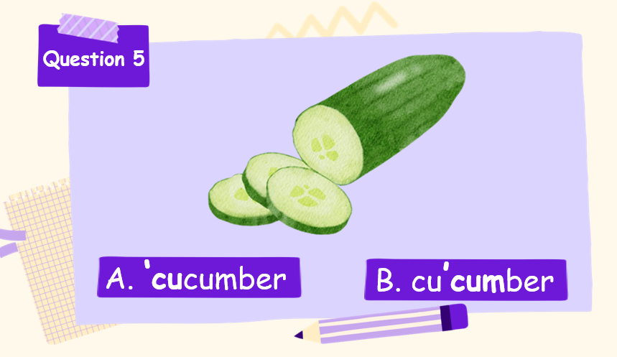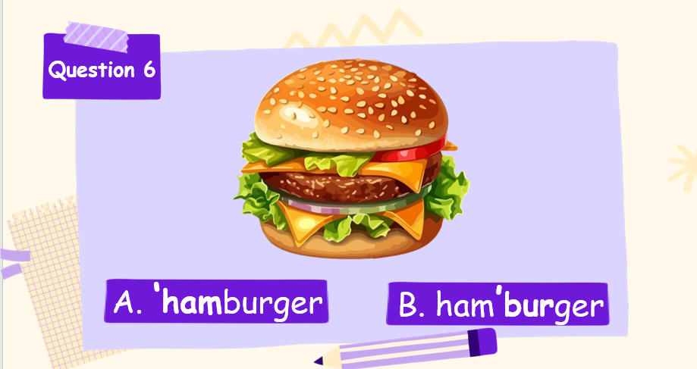  + Give compliments to the individuals/groups who have completed the activities the best and encourage the other groups/teams to keep doing them during the next lessons.  - Wrap-up:  T: ‘What have we learnt today?’  - T asks some Ss to answer about what they learnt today before showing the content on the slide.  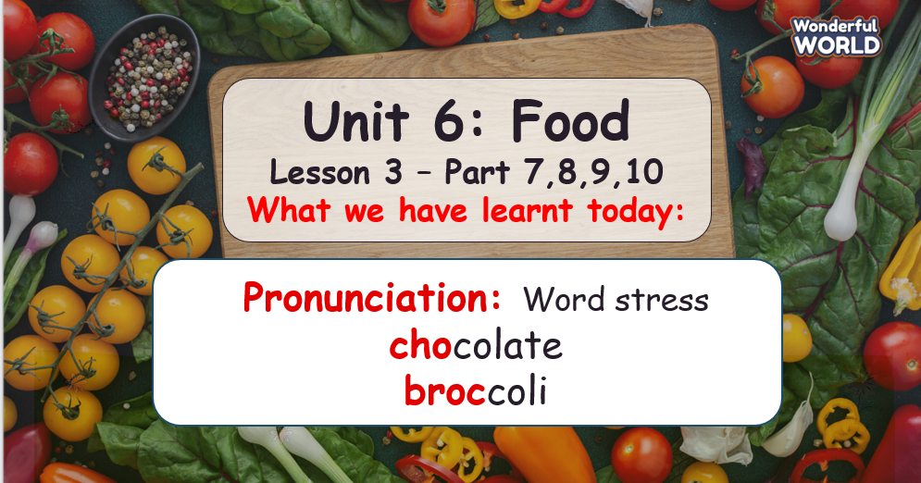 | - Look and choose.  - Ss answer T’s question of what they learnt today.  - Ss focus on the ‘wrap-up’ slide to see what they have learnt in today’s lesson.  - Stand up and say goodbye to the teacher.

