TUẦN 16 Khối 3, 5 (Từ ngày 23/12/2024 đến ngày 27/12/2024)
THỨ | TIẾT | MÔN | TIẾT THỨ | NỘI DUNG BÀI DẠY |  | UDCNTT | ĐỒ DÙNG DẠY HỌC
Hai  23/12 | 1 | 5A | 61 | Unit 6. Food | Fun time and project (1, 2, 3) | Wonderfulworld | Flashcards, TV, books
Hai  23/12 | 2
Hai  23/12 | 3 | 3A | 61 | Unit 5. My clothes | Lesson 3 (7, 8, 9) | Wonderfulworld | Flashcards, TV, books
Hai  23/12 | 4 | 3A | 62 | Unit 5. My clothes | Fun time and project (1, 2) | Wonderfulworld | Flashcards, TV, books
Hai  23/12 | 5 | 5D | 61 | Unit 6. Food | Fun time and project (1, 2, 3) | Wonderfulworld | Flashcards, TV, books
Hai  23/12 | 6 | 3B | 61 | Unit 5. My clothes | Lesson 3 (7, 8, 9) | Wonderfulworld | Flashcards, TV, books
Hai  23/12 | 7
Ba  24/12 | 1 | 5C | 61 | Unit 6. Food | Fun time and project (1, 2, 3) | Wonderfulworld | Flashcards, TV, books
Ba  24/12 | 2 | 5B | 61 | Unit 6. Food | Fun time and project (1, 2, 3) | Wonderfulworld | Flashcards, TV, books
Ba  24/12 | 3 | 5A | 62 | Unit 6. Food | Fun time and project (4, 5) | Wonderfulworld | Flashcards, TV, books
Ba  24/12 | 4
Ba  24/12 | 5 | 3A | 63 | Review 3 | Part 1 (1, 2, 3) | Wonderfulworld | Flashcards, TV, books
Ba  24/12 | 6 | 5D | 62 | Unit 6. Food | Fun time and project (4, 5) | Wonderfulworld | Flashcards, TV, books
Ba  24/12 | 7 | 3B | 62 | Unit 5. My clothes | Fun time and project (1, 2) | Wonderfulworld | Flashcards, TV, books
Tư  25/12 | 1 | 5A | 63 | Review 3 | Part 1 (1, 2, 3) | Wonderfulworld | Flashcards, TV, books
Tư  25/12 | 2
Tư  25/12 | 3
Tư  25/12 | 4
Tư  25/12 | 5 | 5B | 62 | Unit 6. Food | Fun time and project (4, 5) | Wonderfulworld | Flashcards, TV, books
Tư  25/12 | 6 | 5C | 62 | Unit 6. Food | Fun time and project (4, 5) | Wonderfulworld | Flashcards, TV, books
Tư  25/12 | 7
Năm  26/12 | 1 | 5C | 63 | Review 3 | Part 1 (1, 2, 3) | Wonderfulworld | Flashcards, TV, books
Năm  26/12 | 2 | 5B | 63 | Review 3 | Part 1 (1, 2, 3) | Wonderfulworld | Flashcards, TV, books
Năm  26/12 | 3 | 5A | 64 | Review 3 | Part 2 (1, 2, 3) | Wonderfulworld | Flashcards, TV, books
Năm  26/12 | 4
Năm  26/12 | 5 | 5D | 63 | Review 3 | Part 1 (1, 2, 3) | Wonderfulworld | Flashcards, TV, books
Năm  26/12 | 6 | 5C | 64 | Review 3 | Part 2 (1, 2, 3) | Wonderfulworld | Flashcards, TV, books
Năm  26/12 | 7
Sáu  27/12 | 1 | 3B | 63 | Review 3 | Part 1 (1, 2, 3) | Wonderfulworld | Flashcards, TV, books
Sáu  27/12 | 2 | 5D | 64 | Review 3 | Part 2 (1, 2, 3) | Wonderfulworld | Flashcards, TV, books
Sáu  27/12 | 3 | 5B | 64 | Review 3 | Part 2 (1, 2, 3) | Wonderfulworld | Flashcards, TV, books
Sáu  27/12 | 4
Sáu  27/12 | 5
Sáu  27/12 | 6 | 3B | 64 | Review 3 | Part 2 (1, 2, 3) | Wonderfulworld | Flashcards, TV, books
Sáu  27/12 | 7 | 3A | 64 | Review 3 | Part 2 (1, 2, 3) | Wonderfulworld | Flashcards, TV, books

GRADE 3
WEEK 16
UNIT 5. CLOTHES
Lesson 3. Task 7, 8, 9
Period 61
I. OBJECTIVES:
1. Knowledge:
- Students will learn how to pronounce properly the sound /aʊ/ and /b/ separately or in words.
2. Competences:
- English competences: Students will be able to recognize and pronounce /aʊ/ and /b/ correctly separately or in words.
- Common competences: Students will have the opportunity to develop language skills by working with friends
3. Qualities:
- Students become more friendly through group activities and have confidence in themselves
II. EQUIPMENT AND MATERIALS:
- Teacher: PPT, TV flashcards, audio track 5.12; 5.13
- Students: Student’s book, pens, markers, A4 paper
III. LESSON PROCEDURE:
Activity 1: Warm up (5 minutes)
Teacher’s Activities | Students’ Activities
- Greet students.  Sing and do: A ram sam sam song  Ask sts to look at the video and try to sing and do  Board race  - Put 2 flashcards on the board: clothes (T-shirt; coat;..)  - Put flashcards (new; old; pretty; … on chalk rail)  - Have sts in two groups  - Run as fast as possible to the board, choose the pictures to stick on the board and say the sentence “ I’ve got….” Or “ My ….is/are….”  - Praise the group with more points and encourage the team with fewer points | - Greet teacher  - Listen, sing and, do  Look  Work in groups  Stick and say  Count the points
Activity 2: Presentation (7 minutes)
Teacher’s Activities | Students’ Activities
Lead in: Use the game and the pictures to lead in the new lesson  - Write on the board The date and introduce the lesson.  Task 7: Listen and repeat (track 5.12)  *Set context: Pete and Lisa go to the Clothes shop with their parents. In the shop, they see many kinds of clothes. Of all outfits they like, they love (blue trousers) stick the picture of trousers on the board and (black boots) stick the picture of the boots. They are very happy because their mom buys both for them  - Ask sts to look at the flashcard of trousers and T says the sound /aʊ/ do the same with /b/  - Say the /aʊ/ and /b/ sound for sts to listen and repeat several times  - Ask sts to clap their hands when they hear then say the sound and say the words  - Ask sts to take turns imitating the /aʊ/ and /b/ sound correctly  - Show the two pictures of the task  - Give some suggested questions:  + What are these?  + What colors are these?  + Are these new/pretty/….?  - Play the track 5.12  - Ask sts to listen and look at the words and sentences  - Play the track again, and sts to repeat  - Show sts that the sound comes from different part of your mouth  - Let’s sts practice pronunciation in pairs and ask some volunteers to read out the words and sentence  - Checking: Slap the board  + Put the vocabulary items on the board in any order - jumbled and sometimes a little bit higher than the tallest child can reach, so that they'll have to jump  + Form groups. Say the sound and say the word. The students have to recognize the picture which has sound. They then run to the board and slap the correct picture. The first person in each group to slap the right word gets a point.  + The teacher can get other sts to call out so they're getting practice speaking too. | - Listen to teacher  - Copy down  -Listen, guess the words: trousers and boots  - Listen and repeat the 2 sounds  - Say the sound and say the words  - Listen and repeat  +These are boots and trousers  + These are black and blue.  + Yes,…  -Listen  -Listen and repeat  -Listen and repeat  -Pracice  - Form 2 or 4 groups  - Say the sound, say the words  Practice
Activity 3: Practice (12 minutes)
Teacher’s Activities | Students’ Activities
Task 8: Listen and chant ( track 5.13)  - Show the puppet of Pete and Lisa to set context: They have bought boots and trousers All off them are happy and they said:  - Show the first part of the chant one by one  B, b, b.  Big, big, big.  Boots, boots, boots.  I’ve got big boots!  - Ask sts to look at the chair and ask what he said ….  Ou, ou, ou.  Trousers, trousers, trousers.  House, house, house.  I’ve got trousers in my house!.  - As showing, ask sts to listen, read and repeat  - Play the chant one for sts to listen  - Play again, ask sts to listen and chant along  - Have chant contest in groups, in pairs  (Students can use specific music to beat the rhythm of the chant)  Task 9: Say it  Matching game  - Ask sts to work in 4 groups  - Give instruction: T shows the pictures on the screen, and you look at the pictures, pick up the right sentence and match with the suitable one as fast as possible. Read that sentence aloud and then get the point.  Teacher uses group boards with the broken sentences  1. We’re in the house. It’s my birthday.  2. There are trousers on the bed.  3. I’ve got big boots.  - Show pictures one by one.  - Ask sts to pick up the equivalent sentence and stick it on the board.  - Ask groups to read the sentence out loud  - Give groups points  - Award the team with most point at the end | - Look at the picture  - Listen to the teacher  - Guess what he says  - Listen and repeat  - Look and say how the boots and the trousers are  - Listen and repeat  - Listen to the chant  - Listen and chant  - Join chant contest  -Form groups  - Listen to teacher  - Look at the pictures  - Pick the equivalent sentence  - Run to the board, choose, and match  - Read the sentence out loud
Activity 4: Production (8 minutes)
Teacher’s Activities | Students’ Activities
Cookie jar  - Ask sts to prepare one cookie jar for each group; they can bring some cookies or candies and put them in the jar. For each phonics lesson, they can take it out and use  - Ask sts to work in groups  - Ask them to discuss and find their own word that has the sound they have learned and collect them in a jar. Each word is correct they can take out one cookie/candy for their own  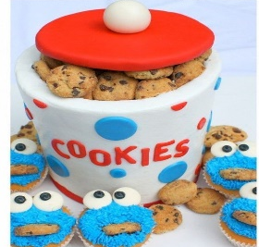  -Groups take turns to say out loud the word’s content sound. The group having the most words/ cookies wins the game. | - Sit in groups  - Discuss and write words  - Say words aloud
Activity 5: Assessment (3 minutes)
Teacher’s Activities | Students’ Activities
- Ask sts to do assessment  /aʊ/ or /b/ Listen and write the words in the correct column.  trousers / boots / house/ big/ down/ ball  - Check with whole class  - Say goodbye | - Do assessment  - Check with teacher  Answer  /aʊ/ /: trousers; house; down  /b/: boots; big; ball  - Goodbye
  /aʊ/ | /b/
  trousers
____________________________________
UNIT 5. CLOTHES
Fun time and project: Task 1, 2
Period 62
I. OBJECTIVES:
1. Knowledge:
- Students will review clothes vocabulary and unit grammar
2. Competences:
- English competences: Students will be able to talk about their friends and what clothes they have
- Common competences: Students will develop their creativeness in drawing pictures
3. Qualities:
- Students will be nice with friends
II. EQUIPMENT AND MATERIALS:
- For Teacher: PP, TV, boards, markers
- For students: A0 paper, books, pens, crayons
III. LESSON PROCEDURE:
Activity 1: Fun Time (10 minutes)
Teacher’s Activities | Students’ Activities
Clothes song  - Introduce the song  - Ask sts to review some vocabulary and do action  - Play the song  - Sts do and repeat clothes words  Task 1: Match  - Introduce the task  - Ask sts to work in two groups  - Hand each group a print of task 1  - Ask them to look Rock Scissors Paper to take turn  - Ask the winner to match  - Continue playing until the end  - The first finishing matching wins the game | -Listen to teacher  - Repeat and do action  - Listen, do and repeat  - Listen to teacher  - Work in 2 groups  - Play Rock Scissors Paper  - Match the words and pictures  - Check
Activity 2: Project (25 minutes)
Teacher’s Activities | Students’ Activities
Project: My friends  Planning stage (5 minutes)  Magic Wardrobe Game  Lucy is going to have a party. She has too many clothes in her wardrobe, but she cannot open it. Please help her to open by correctly writing the things she has  -Show the Magic wardrobe  - Arrange sts to work in 8 groups  - Set game rules  - Hand each group a board and marker  - Show the picture  - Ask group to write the sentence as fast as possible  - The first correct answer gets the points  - Continue playing until the end  Implementing stage (12 minutes)  - Ask sts to work individually  - Show the picture of Lan  - Show the sentences in task 2 one by one  - Ask sts to repeat  - Show the picture of Hoa  - Ask sts to make sentences about her  - Show the sentences one by one  - Ask sts to repeat  - Tell them to draw a picture of two friends  - Colour the picture  - Ask the to write their information as in sample  Displaying and Reflecting stage (8 minutes)  - Ask sts to walk around and talk about their friends to class  - Go around to offer help when necessary  - Check the number of peers they have talked to  - Award the best speaker | - Listen to teacher  - Form 8 groups  - Listen to the game rules  - Take boards and markers  - Look and write  - Show the answer  - Look at the picture  - Listen, read and repeat  - Look at the picture  - Listen, read and repeat  - Draw pictures  - Write  -Talk to friends about the picture
____________________________________

REVIEW 3
Part 1. Task 1, 2, 3
Period 63
I. OBJECTIVES:
1. Knowledge:
By the end of the lesson, students will review the vocabulary related to the topic about rooms: bedroom, bathroom, living room, kitchen and objects: doll, toy, camera, computer, the structure:
- There is…./ There are …
- Is there/Are there….?.
+ Yes, there is/ there are
+ No, there isn’t/ aren’t
2. Competences:
- English competences: Students will able to talk and answer about houses and objects.
- Common competences: Students will have opportunities to develop communication through presenting in front of the class.
3. Qualities:
+ Students are given chances to think about their home and traditional lifestyle.
II. EQUIPMENT AND MATERIALS:
- For the teacher:
+ Basic things: Student’s book, teacher’s book, Family flashcards.
+ Advanced things: PPT, projector/interactive whiteboard/laptop/TV
- For students: student’s book, workbook.
III. LESSON PROCEDURE:
Activity 1: Warm up (10 minutes)
Teacher’s activities | Student’s activities
- Greeting  Option 1:  - “Pass the ball ” Game:  + While the music is playing Ss will pass the ball around the class. When the music stops, the student with the ball must answer the question from the teacher about the house.  Option 2:  * Mini game: What’s hiding?  - Show all the puzzles on the screen. The picture is hidden under some cover puzzles. Ss need to answer the puzzle to find out what is hiding. They have 3 questions to answer.  - Tell the rule and let children do a trial.  - Check children’s understanding. (If children can’t understand well, T can explain the rule in Vietnamese).  - T lets Ss choose numbers and answer the questions.  - The winner is the one who can find out the picture first. | - Pass the ball and answer questions  - Look at the puzzles on the screen.  - Listen to the rule and do a trial.  - Listen  - Join the activity.
Activity 2: Review (15 minutes)
Teacher’s activities | Student’s activities
Task1: Look and match  - Show pictures of the boy, camera, dolls and balls.  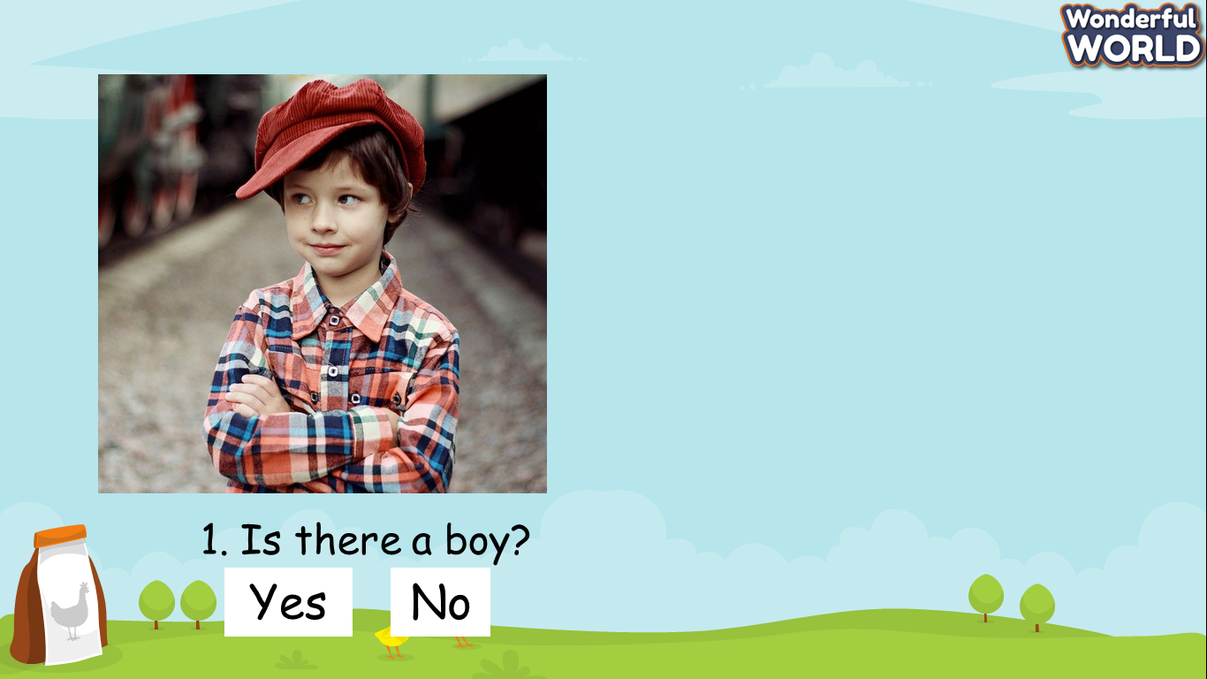 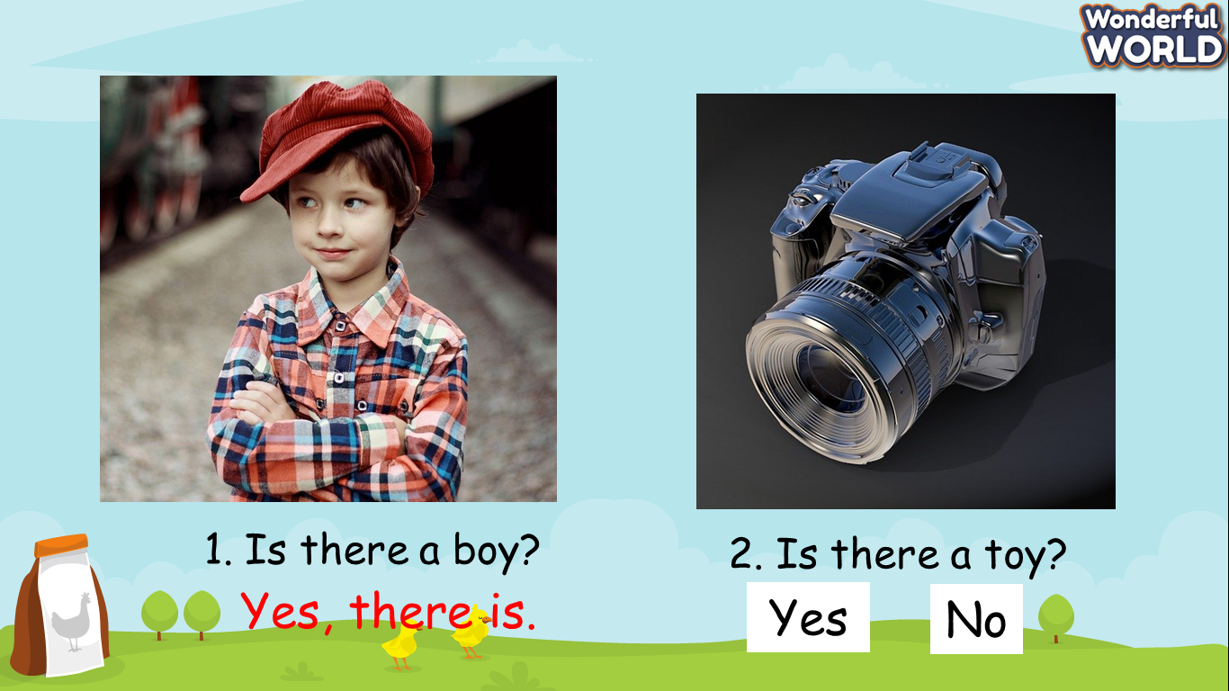  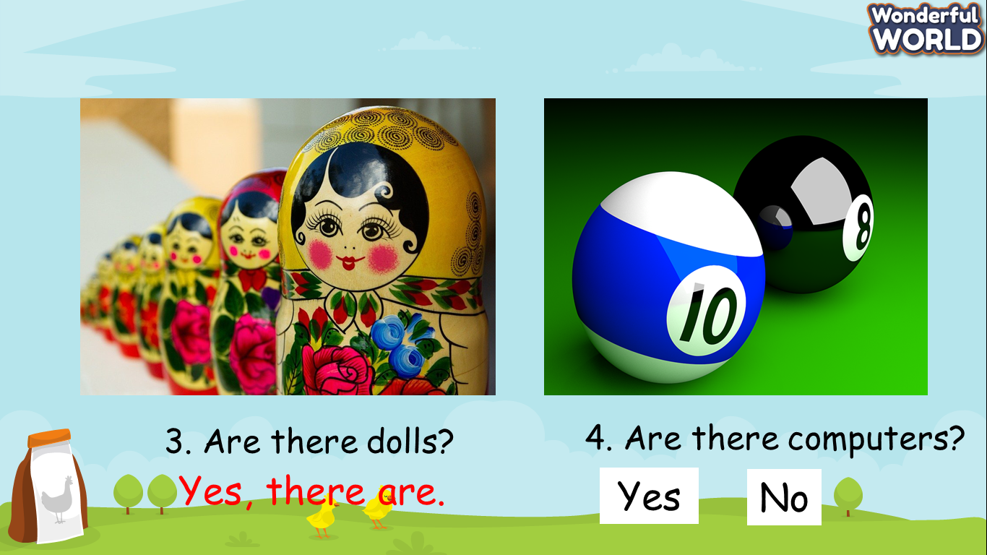  - Read the instruction to the class.  - Ask Ss to look at pictures and answer Yes/No questions.  - Look at the picture in the book and be given time to match the questions to the answers.  - Go round to help Ss.  - Check answers. | - Do the task and receive stars.
- Play game: “ Couple pictures”  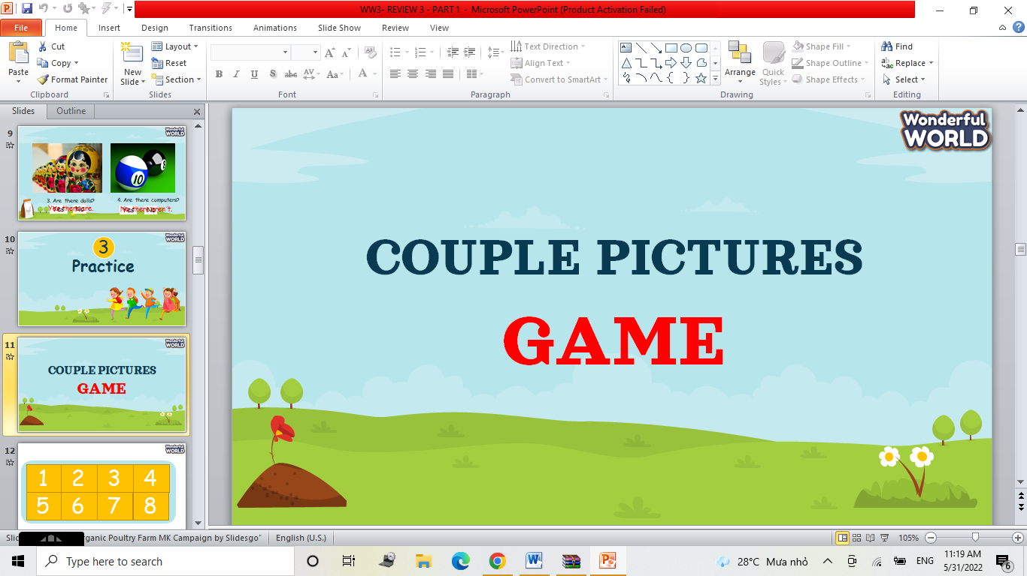 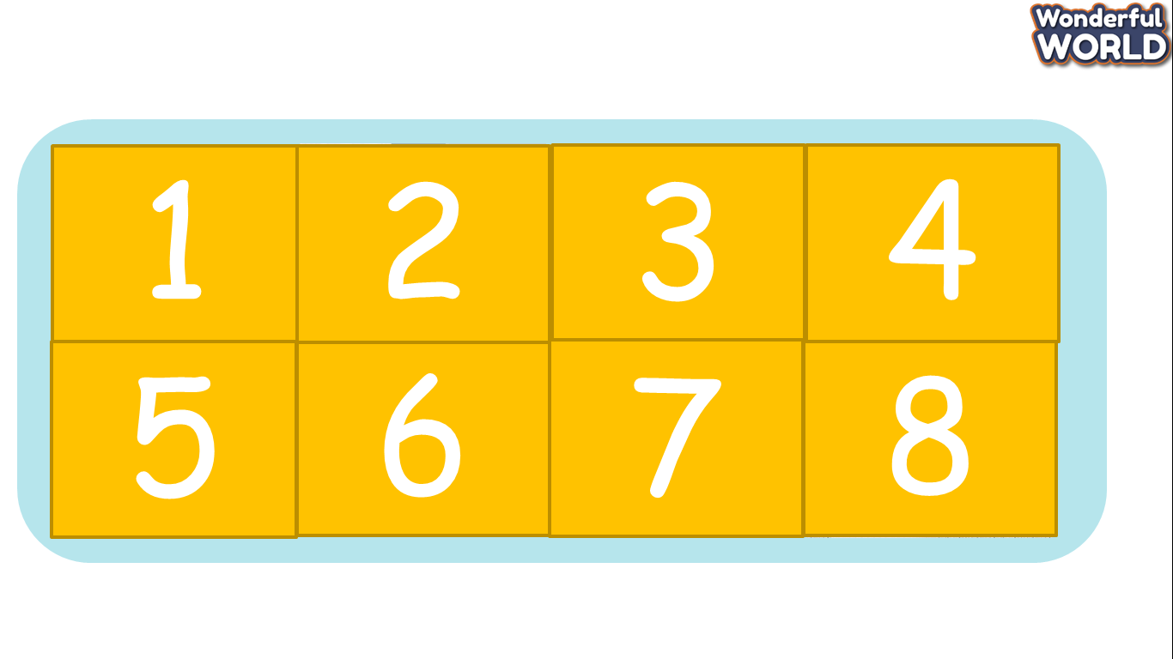  + T prepares 4 couples picture to relate to the knowledge from previous lessons and asks students to open the correct couples.  + If Ss answer correctly, they will open all the rooms. For each picture, Ss will have different questions to answer.  Task 2: Write  + Then, Ss will write the answer in the book.  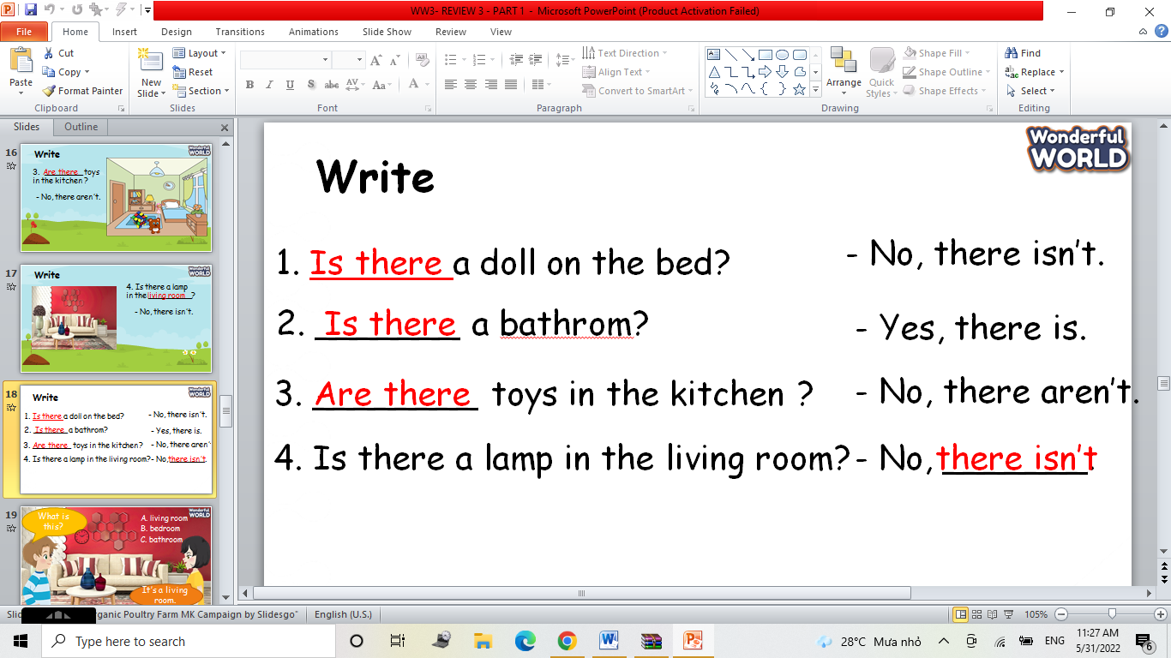 | - Join the game and get stars for the team.  - Ss do the task in their books.
Activity 3: Extra Activity (10 minutes )
Teacher’s activities | Student’s activities
- Task 3: Ask and answer  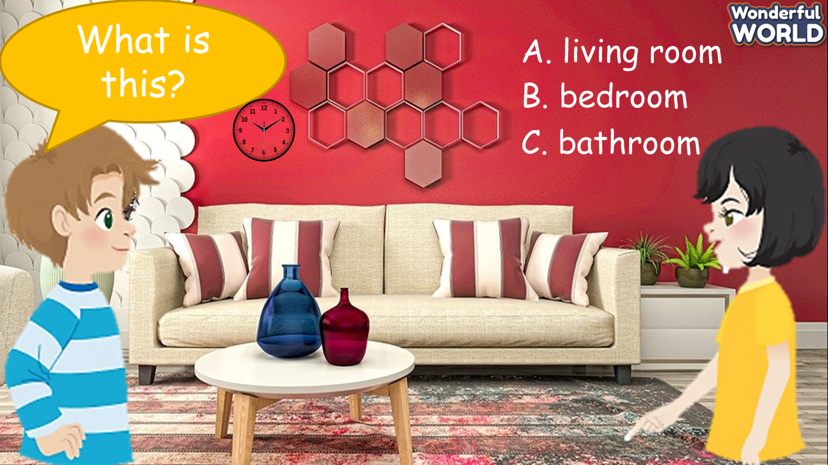  + Ask Ss to look at the picture on the screen and answers the questions.  + Let Ss work in pairs to practice asking and answering.  + Invite a few pairs to go to the board to present.  - Assess each presentation of Ss and give them stars. | - Be confident and present smoothly.
Activity 4: Wrap up (5 minutes )
Teacher’s activities | Student’s activities
-Ask Ss to do homework  - Say goodbye | - Say goodbye.
____________________________________
REVIEW 3
Part 2. Task 1, 2, 3
Period 64
I. OBJECTIVES:
1. Knowledge:
- By the end of the lesson, students will review the vocabulary about clothes: boots, dress, T-shirt, trousers, hat, shoes, socks, comparison of adjectives: big, small, long – short, old-new, pretty – ugly.
The grammar: Possessive adjective: my, his, her, its, your, their.
2. Competences:
- English competences: Students will be able to talk and answer about clothes.
- Common competences: Students will have opportunities to develop communication through presenting in front of the class.
3. Qualities:
+ Students are given chances to think about people’s clothes.
II. EQUIPMENT AND MATERIALS:
- For the teacher:
+ Basic things: Student’s book, teacher’s book, Clothes flashcards.
+ Advanced things: PPT, projector/interactive whiteboard/laptop/TV
- For students: student’s book, workbook.
III. LESSON PROCEDURE:
Activity 1: Warm up (10 minutes)
Teacher’s activities | Student’s activities
- Greeting  - Listen to the “Get dressed” song:  https://www.youtube.com/watch?v=KDE6i_ZZkFU  - After hearing the song, Ss will play mini-game “Look and choose”  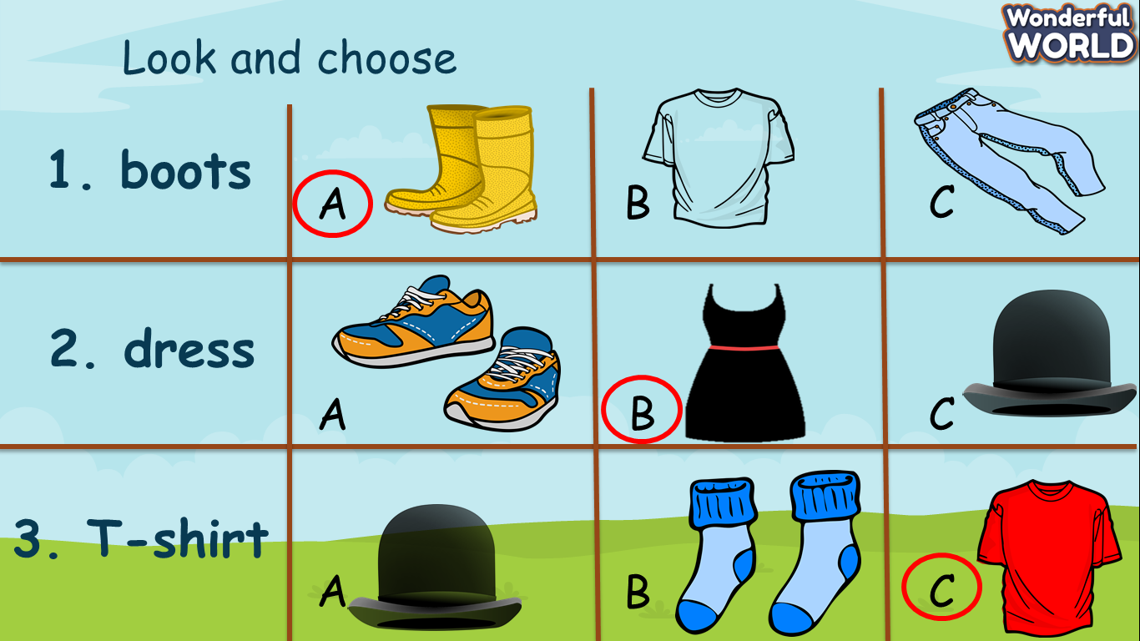  - Show all the pictures on the screen. Ask Ss to look at vocabulary and words; then, choose correct answers.  - Tell the rule and let children do a trial.  - Check children’s understanding. (If children can’t understand well, T can explain the rule in Vietnamese).  - T lets Ss answer the questions. | - Pass the ball and answer questions  - Listen to the song.  - Join the activity and get stars.  - Look at the pictures on the screen.  - Listen to the rule and do a trial.  - Listen
Activity 2: Review (15 minutes)
Teacher’s activities | Student’s activities
Task1: Look and match  -Show pictures and words  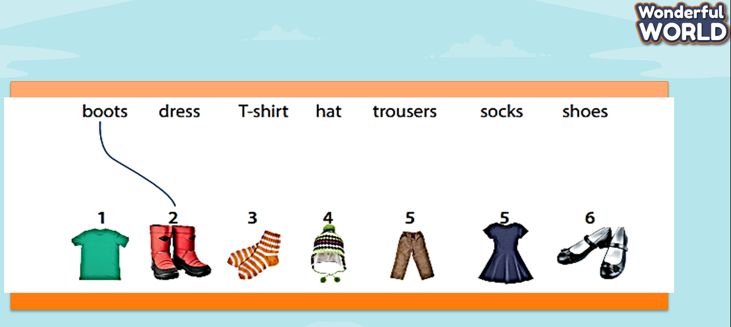  - Read the instruction to the class.  - Ask Ss to match words to the correct pictures.  - Go round to help Ss.  - Check answers.  Play game: Decrypt Password  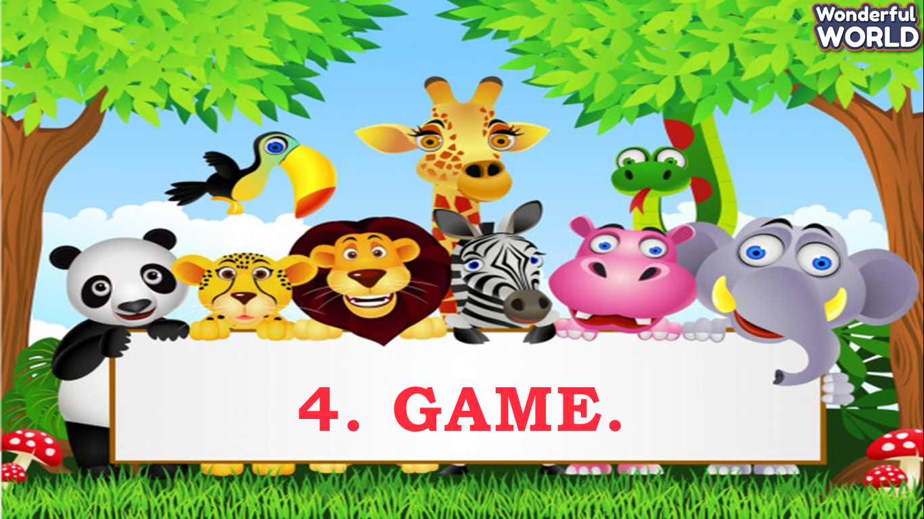  - T prepares 4 slides that relate to the knowledge from previous lessons, let Ss answer to open the secret boxes.  - Tell the rule and let children do a trial.  - Check children’s understanding. (If children can’t understand well, T can explain the rule in Vietnamese). | - Do the task.  - Join the activity.
Activity 3: Review
Teacher’s activities | Student’s activities
Play game: Match with the opposite  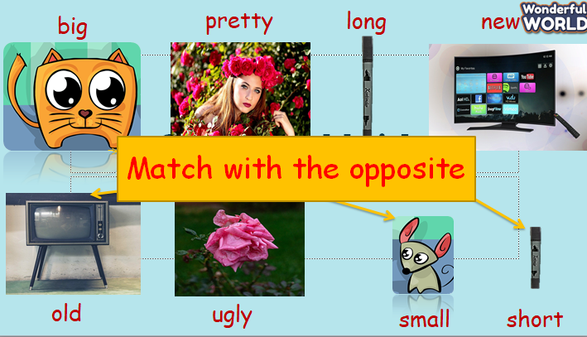  - Show all the pictures and words on the screen. Ask Ss to look at vocabulary and words; then, choose correct answers.  - Tell the rule and let children do a trial.  - Check children’s understanding. (If children can’t understand well, T can explain the rule in Vietnamese).  - T lets Ss answer the questions.  Task 2: Write the opposite  - After playing mini game, T asks Ss to write the antonym's words.  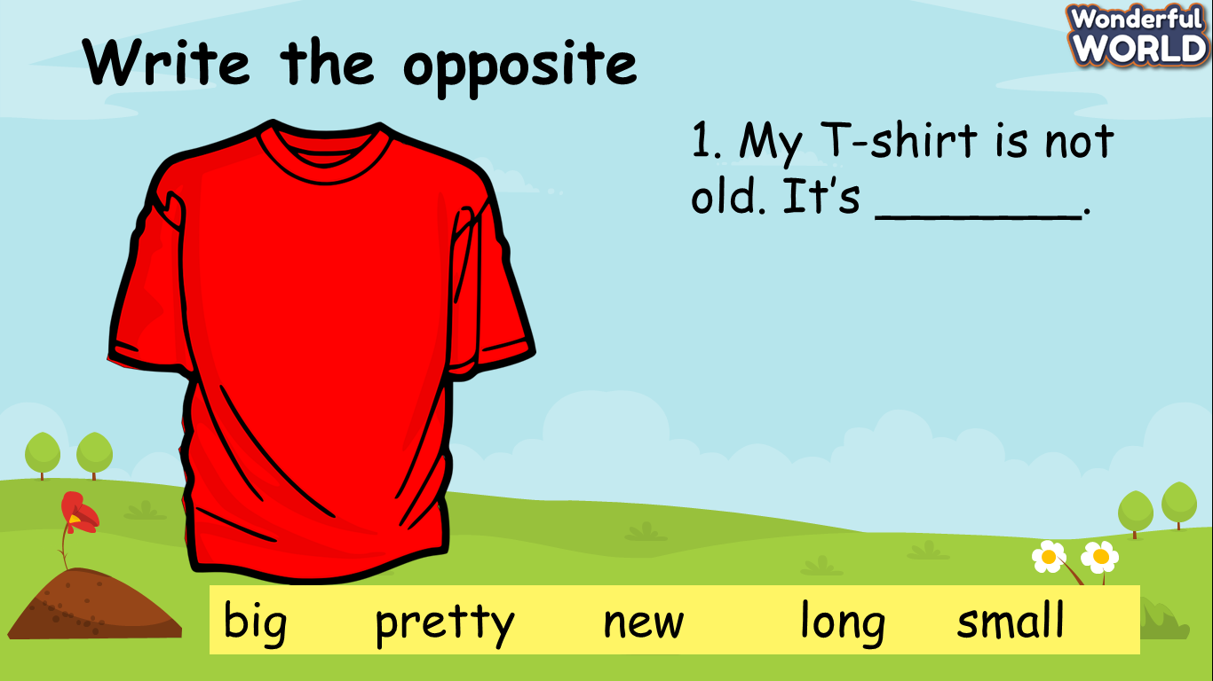  Yes/ No question  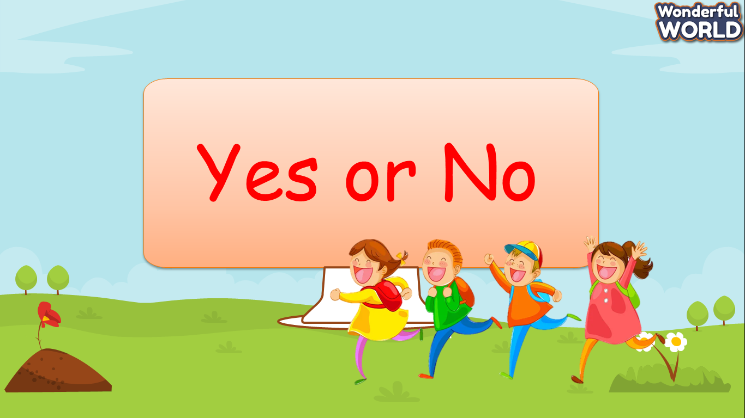  - T shows pictures and questions; asks Ss to find out the correct answers.  Task 3: Write  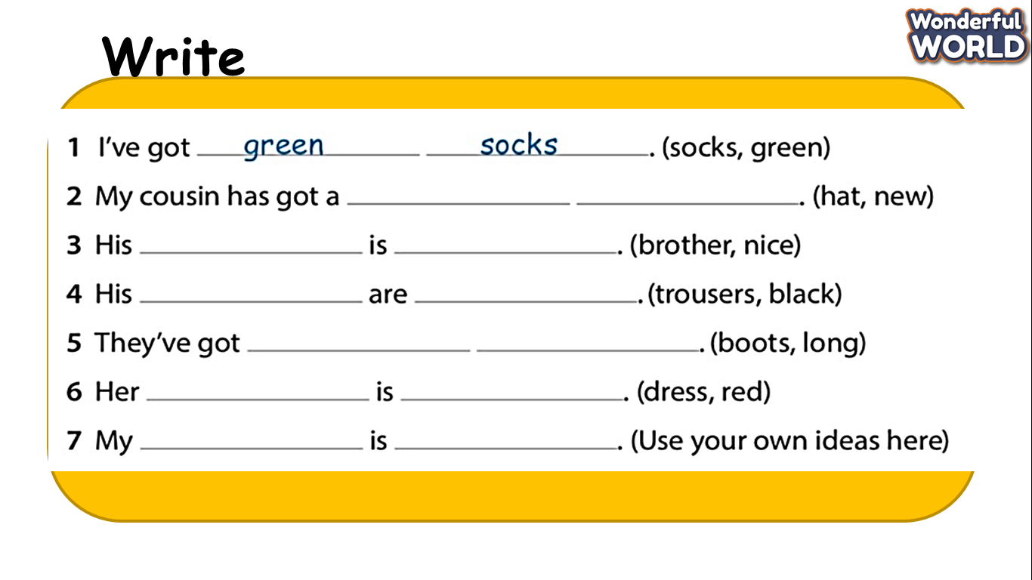  - Let ss write the words to complete sentences.  - Check children’s understanding. (If children can’t understand well, T can explain the rule in Vietnamese).  - T lets Ss answer the questions. | - Join the activity and get stars.  - Ss do the task in their books.  - Ss answer all questions.  Ss do the task.
Activity 4: Extra Activity (10 minutes )
Teacher’s activities | Student’s activities
- Let ss look at the DIY clothes. Ask them to prepare paper and do the DIY.  - Check children’s understanding. (If children can’t understand well, T can explain the rule in Vietnamese).  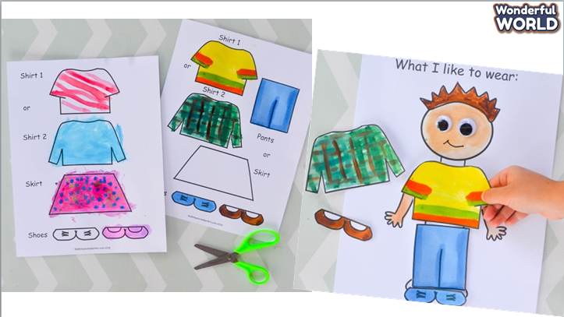 | - Do the DIY  - Be confident and present smoothly.
Activity 5: Wrap up (5 minutes )
Teacher’s activities | Student’s activities
-Ask Ss to do homework.  - Say goodbye | - Say goodbye.
____________________________________
GRADE 5
WEEK 16
UNIT 6: FOOD
Fun time and project: Task 1-2-3
Period 61
I. OBJECTIVES:
1. Knowledge:
Students will review and practice all target words and structures related to the topic Food.
2. Competences:
- English competences: Students will be able to think and talk about topics.
- Common competences: Students will have the opportunity to develop logical thinking and develop communication among friends.
3. Qualities:
- Students develop imagination and love for food.
- Be confident and active in communicating with friends and teachers.
II. EQUIPMENT AND MATERIALS:
- For Teacher: PPT, flashcards, printed papers, dice.
- For students: textbook
III. LESSON PROCEDURE:
Activity 1: Warm-up (5 minutes)
“Find the missing food”
Teacher’s Activities | Students’ Activities
Aims: Welcome students and engage the class with a game.
1. Greeting students. Chat….. ‘Do you like playing games?’  2. Introduce the game.  - There are 15 fruits and vegetables, Ss have 15 seconds to remember all the food on the slide.  - After 15 seconds, Ss close their eyes so that T can hide some food away. After that, T lets Ss open their eyes and start finding missing fruits and vegetables.  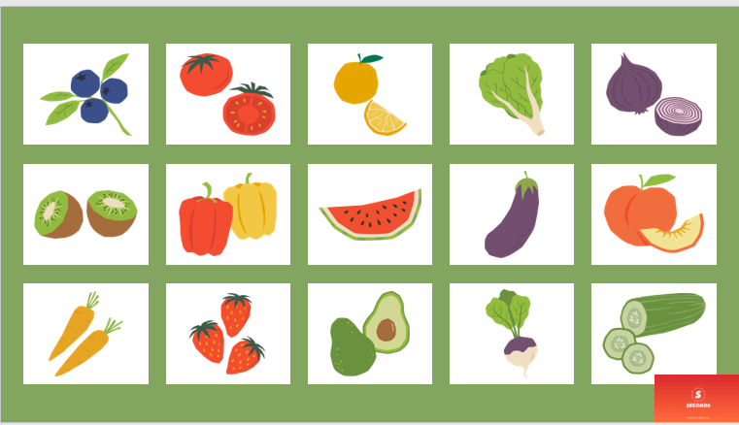 | - Greet Teacher  - Listen to the rules of the game.  - Join the activity.
Activity 2: Review & Practice (17 minutes)
Teacher’s Activities | Students’ Activities
Aims:
- Engage the class with a game named “Space Race” to review all target words and structures of Unit 6.
- Ss complete task 1 & task 2.
- Divide the class into 2 teams: One team is the ‘Rocket’ and the other team is the ‘Alien Ship’  - 2 teams take turns in choosing a letter and answering the question.  - After answering the question, click on the Rocket/Alien Ship and it will move nearer to Mars. The first team to arrive at Mars is the winner.  *Note: Each team has to answer 8 questions. There are 16 questions in total.  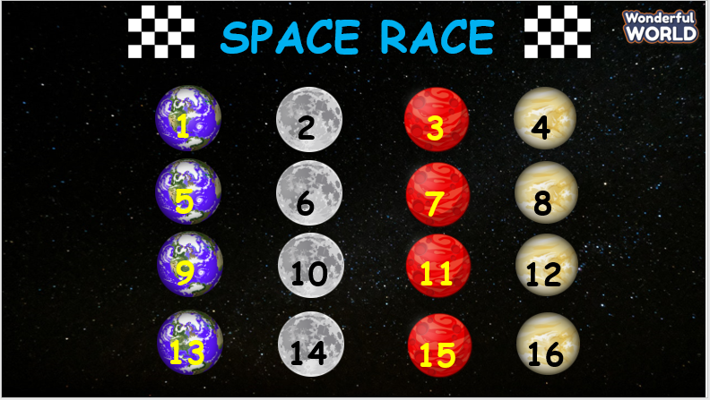  Task 1: Who am I? Read and write (this task is included in the Space Race game)  - Let Ss have a few minutes to finish the task in the Student book individually.  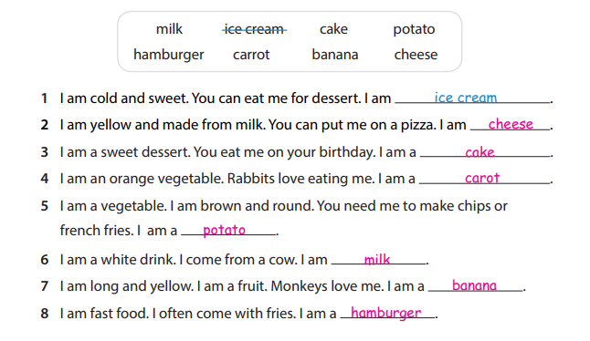  Task 2: Listen and sing.  - T has students close their books.  - T plays the recordings and says ‘Let’s listen to a song’.  - T has Ss pay attention to words you know in the song. After playing the song, T asks Ss to say some of the words they heard in the song. Then asks ‘What is the song about?’  - Have Ss open their books to p.71.  “Let’s listen to the song again.”  - Have Ss focus on the lyrics of the song and follow the lyrics with their fingers.  - Read out the song one line at a time and ask students to repeat after T.  - Play the recording again. Encourage students to sing along. Practise with Ss several times until they are familiar with the words.  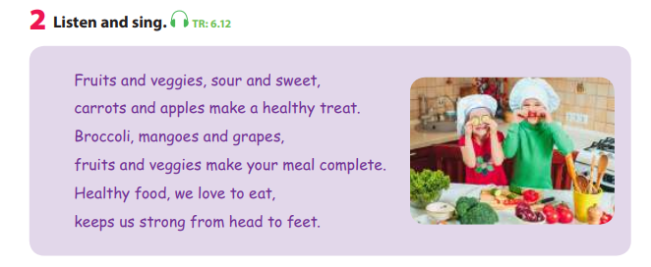 | - Look and choose the correct words.  - Join the activity.
Activity 3: Production (8 minutes)
Teacher’s Activities |  | Students’ Activities
Aims:
+ Help Ss develop writing and communicating skills.
+ Have Ss practice structures and answer the questions in full sentences.
Task 3: Answer the questions and make a list. Then say.  - Tell Ss that they are going to read and answer questions about how to keep healthy.  - Ask them to read the questions and then write their answers.  - Read out the questions and make sure that Ss understand the meanings of the questions.  - Allow Ss enough time to complete the task alone. T goes around the class to support Ss if they need help.  - Give Ss a few minutes to share the notes in pairs.  - Ask some volunteers to read out their notes. Correct if there is any mistake.  - Optional activity: Ask 1 S to share his or her notes out loud. Then ask other Ss questions referring to that S’s sharing to check their understanding.  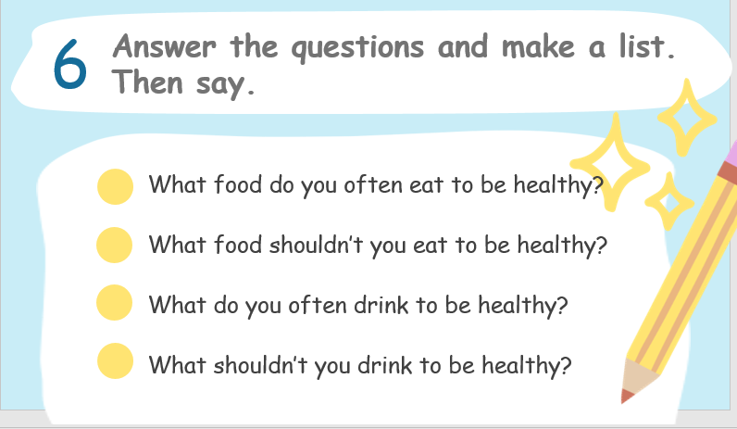 |  | - Write according to the time given.  - Work in pairs, ask and answer about the food we should/should not eat.
Activity 4: Wrap up & Assessment (2 minutes)
Teacher’s Activities |  | Students’ Activities
Aim: Do a quick exercise to review the target words and structure used in Unit 6 with activity “Matching”.
- Assessment: Matching  + Ask Ss to look at the screen and finish the quick exercise of matching.  + Call some Ss to do the task and check with the class.  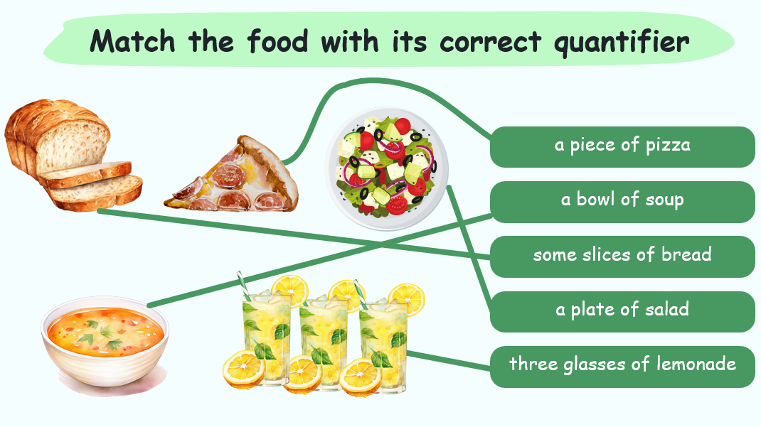  - Wrap-up:  + Review vocabulary: Food riddles and game  bread, butter, chocolate, cupcake, salad, spaghetti, crispy, delicious, salty, sour, spicy, sweet, tasty  + Song: Listen and sing about healthy foods |  | - Join in the activity.  - Check with the teacher.  - Look at the ‘wrap-up’ slide to see what they have learnt in today’s lesson.  - Stand up and say goodbye to the teacher.
_________________________________________

UNIT 6: FOOD
Fun time and project: Task 4-5
Period 62
I. OBJECTIVES:
1. Knowledge:
- Students will be able to review and practise all target words, structures and pronunciation related to Unit 6.
2. Competences:
- English competences: Students will be able to use English to discuss and present their favourite menu during the day.
- Common competences: Students will be able to draw and design their favourite food through the project.
3. Qualities:
- Students will
+ Develop their creativity through designing activities.
+ Show their interests in specific foods through discussing and presenting activities.
+ Be active and confident in communicating with friends and teachers.
II. EQUIPMENT AND MATERIALS:
- Basic things: Student’s Book, Audio, posters.
- Advanced things: PPT, laptop, TV.
III. LESSON PROCEDURE:
Activity 1: Warm-up (5 minutes)
The ABC game
Teacher’s Activities | Students’ Activities
Aims: Welcomes students, ‘break the ice’, and get Ss ready for the lesson.
1. Greet Ss and chat: “Before starting the new lesson, do you want to play a game?... We will play “The ABC game”, let’s get ready!”  2. Give Ss the instructions / Ask 1 Ss to give the instruction and let the rest of the class join the game:  Game rules:  a. The class will be divided into 2 teams.  b. For each question, T chooses 2 Ss from each team to play.  + The 1st student will read the question quickly and whisper the word to the 2nd student.  + The 2nd student will stand on the board and is not allowed to look at the screen. He/She will write the word as the 1st S told him/her.  + The whole class must keep quiet to focus on the game progress.  c. The teacher will show a letter and a category on the screen. Each group’s representative should take a turn to give a word that starts with the letter of the round.  d. The group that can't provide a word will lose their turn to answer that question.  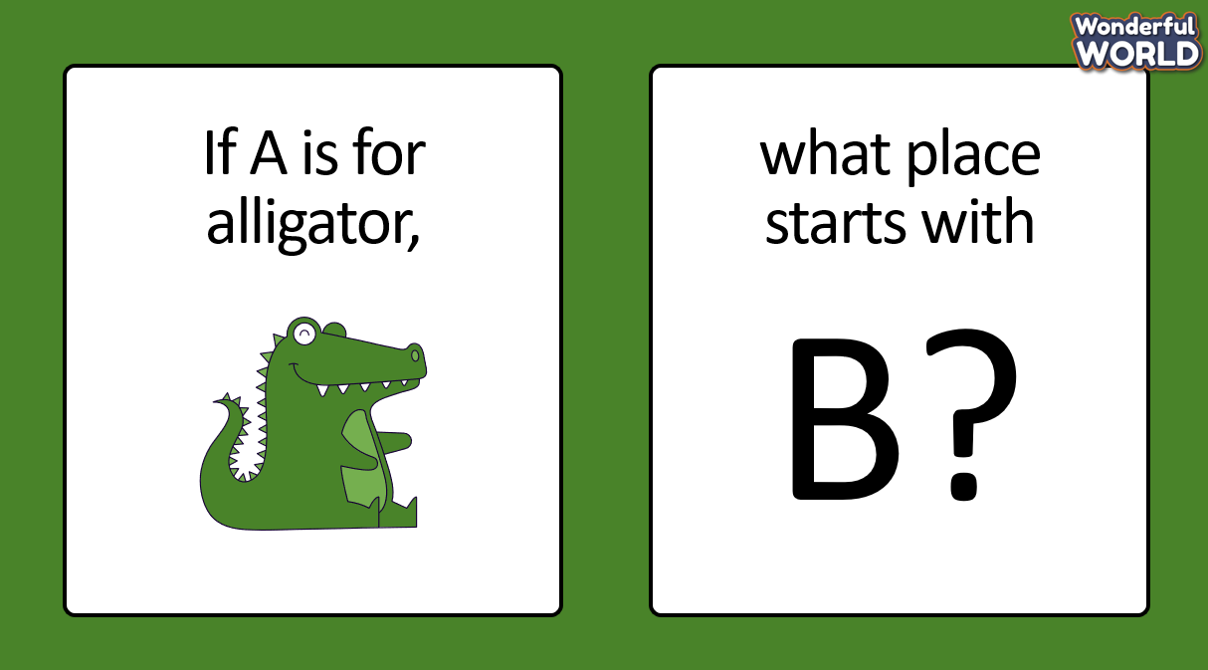 | - Greet Teacher  - Listen to the game rules.  - Join the warm-up game.
Activity 2: Review & Practice (10 minutes)
Teacher’s Activities | Students’ Activities
Aim: Have Ss engage with a game to review vocabulary and pronunciation related to the topic: ‘Food’.
Game instruction: The game includes 2 parts:    1. Part 1: Which one:  - Ss have to look at all the pictures and recall all of the words that they have learnt to identify the words and choose the correct answer.  - The teacher chooses 1 student from each team to come to the board and face the screen to play. Which student raises the hand faster will have the right to answer first.  T should choose Ss who haven’t joined the warm-up game.  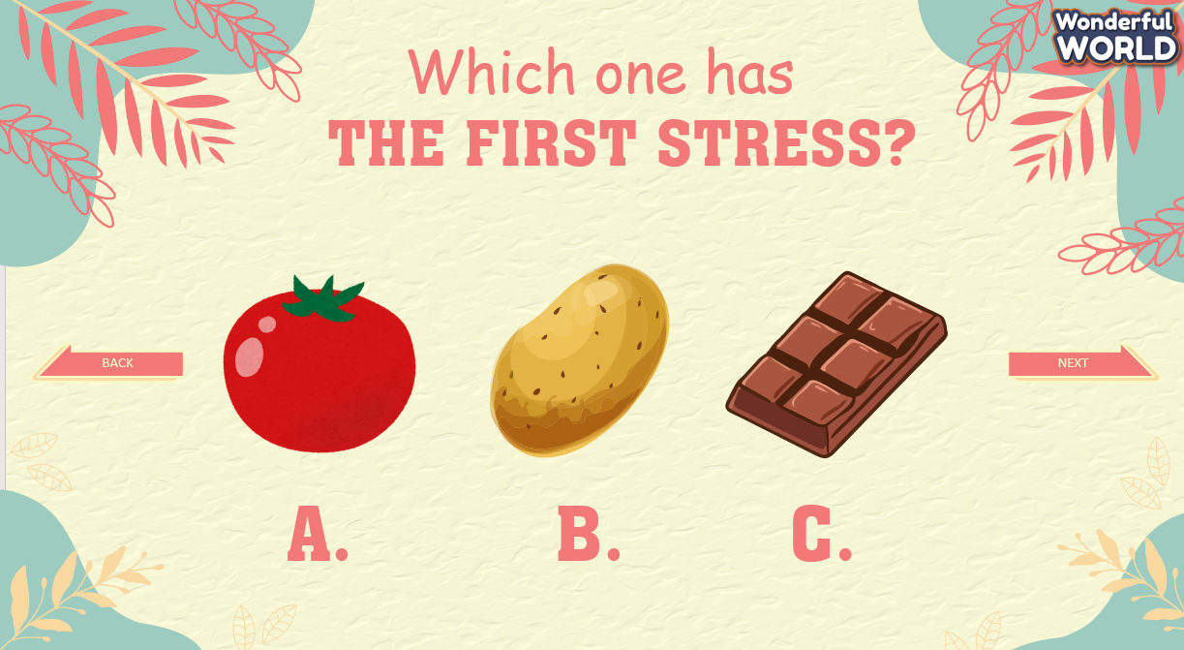  2. Part 2: Where is the stress?  - Ss will be provided with 1 word for each slide which has already been separated into syllables. They need to choose the correct syllable which the stress falls into.  - T has Ss play in teams by showing their fingers corresponding to the correct syllable that stress falls into.  - The team that has more correct fingers gets points.  T needs to emphasise that their choice will answer the question ‘Where is the stress?’  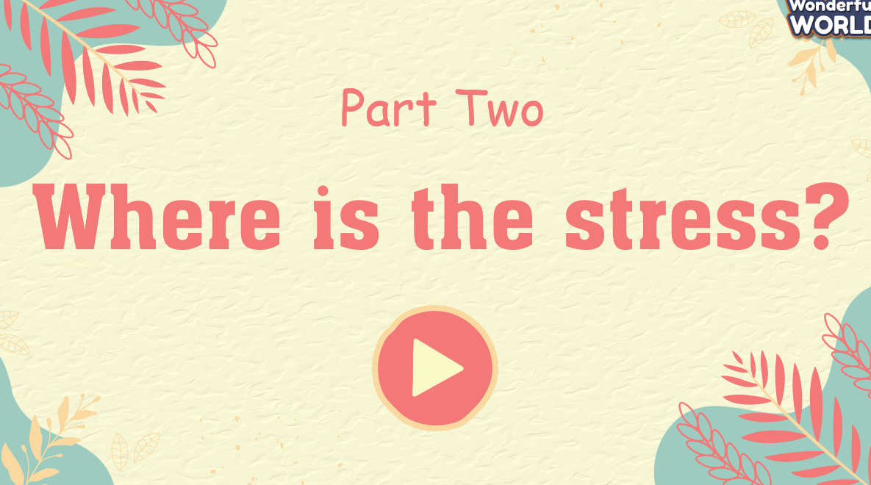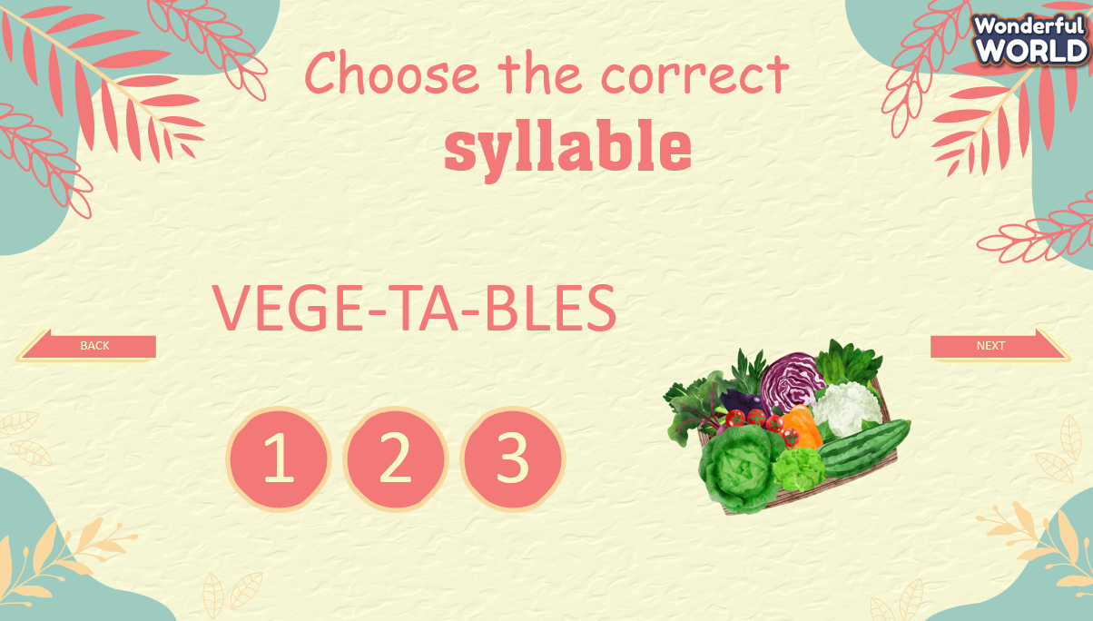 | - Listen to the teacher.  - Join the activity.  - Show the fingers in silence as T’s instructions.
Activity 3: Project (18 minutes)
Teacher’s Activities | Students’ Activities
Aims:
- Ss will develop their creativity and confidence.
- Ss will develop and improve their communication, writing, and speaking skills.
1. Preparation (2 minutes):  - Ask Ss about their favourite meals and foods before jumping into tasks 4 and 5.  - Encourages Ss to share the reasons why certain foods are their favourite.  “What is your favourite meal of the day?”, “What do you often eat/have for that meal?”, “Why is breakfast/lunch/dinner your favourite meal of the day?”  2. Task 4. Project: My favourite menu (9 minutes):  2.1. Drawing (4 minutes):  - Instruct Ss to think about and draw at least three different foods and drinks in the provided boxes for breakfast, lunch and dinner.  - Encourage creativity and variety in their drawings.  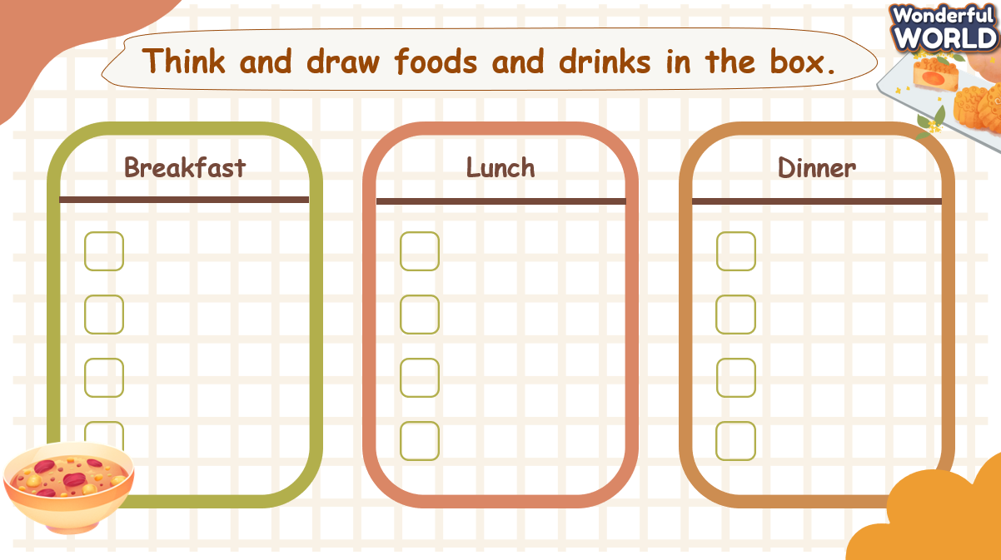  2.2. Writing (3 minutes):  - Guide students to write about their favourite menu for the day and have them finish the writing task.  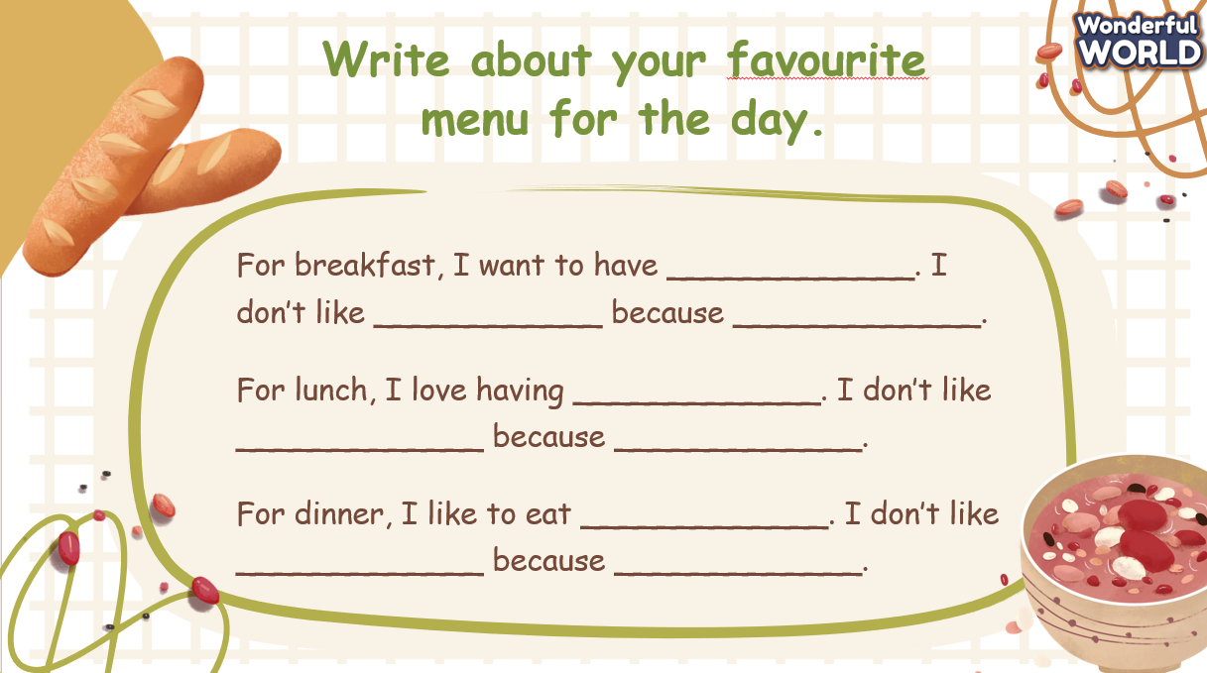  2.3. Work in pairs or groups of 4 (2 minutes):  - Have Ss work in pairs or groups of 4 and ask them to share their favourite menus with their partners.  - Encourage different discussions about why they like or dislike certain foods.  3. Task 5. Say it! (7 minutes):  - Invite several students to share their favourite menus with the class.  - Encourage Ss to ask questions to others or share similarities in their choices.  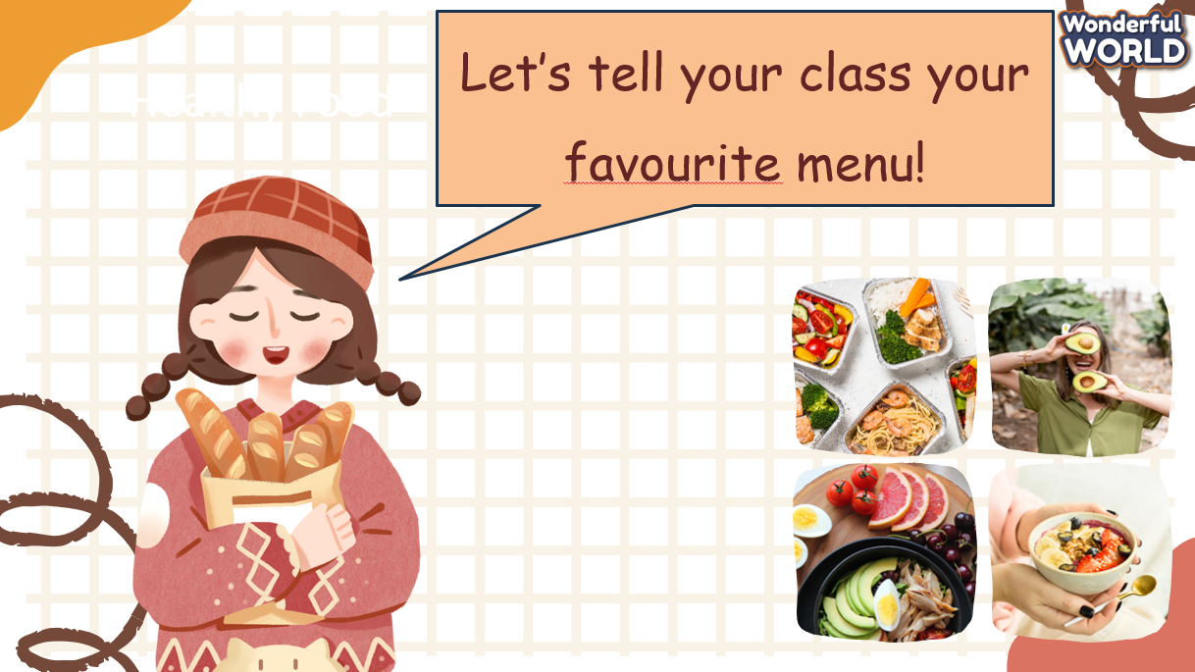 | - Share their ideas with the teacher.  - Listen to the T’s instructions.  - Draw their own menus.  - Listen to the teacher's guidance and finish writing task.  - Work in pairs or groups to share the menus.  - Present in front of the class.  - Ask classmates questions referring to their sharings.
Activity 4: Wrap up & Assessment (2 minutes)
Teacher’s Activities | Students’ Activities
Aims:
- The teacher assesses Ss by having a quick board race game.
- The teacher summarises quickly what Ss have learnt during the period.
- Assessment: T runs a quick board race game. The team that has more correct answers will win.  There are some categories for T to choose, including: food, flavour or quantifiers.  - Wrap up:  + Review word stress: 3-syllable words (vegetables; tomato)  + Project: My favourite menu | - Listen to the teacher’s assessment.  - Stand up and say goodbye to the teacher.

REVIEW 3
Part 1. Task 1-2-3
Period 63
I. OBJECTIVES:
1. Knowledge:
- Students review words of food: bread, butter, chocolate, cupcake, salad, and spaghetti.
- Students review the quantifiers: a few, a lot of, a little, many, much.
2. Competences:
- English competences: Students can use English to introduce their favourite food.
- Common competences: Students can describe the number of foods in the picture, using “a few, a little, a lot of, much, many”.
3. Qualities:
- Students will
+ Have a strong curiosity in exploring different types of food and the quantifiers used with nouns.
+ Recall and reflect on personal experiences with the Ss’s favourite food and make them more meaningful and memorable.
II. EQUIPMENT AND MATERIALS:
- Basic things: Student’s book, flashcards, photos, papers
- Advanced things: PPT, laptop, TV.
III. LESSON PROCEDURE:
Activity 1: Warm-up (5 minutes)
A guessing game “What’s in the box?”
Aims: Welcome students. Engage the class (or warm the class up) with a guessing word game to revive the vocabulary.
Teacher’s Activities | Students’ Activities
Procedure
1. Greet students. Chatting…Do you like playing games…  2. Introduce the game: Catch the word.  - Ask Ss to think of the food learnt in the previous lesson  - Put students in groups of four and ask them to stand in lines.  - Explain the rule: Each team will stand in lines and have an inspector. The first Ss will be given a word and must draw a picture according to that word in 10 seconds.  - After 10 seconds, the picture will be passed down to the next one to re-draw. The last Ss will write down the answer on the paper.  - After 4 groups give their answers, T shows the picture and checks the answers.  - When the game is finished, the group with the lowest point will get a punishment (hop, sing, dance, etc.).  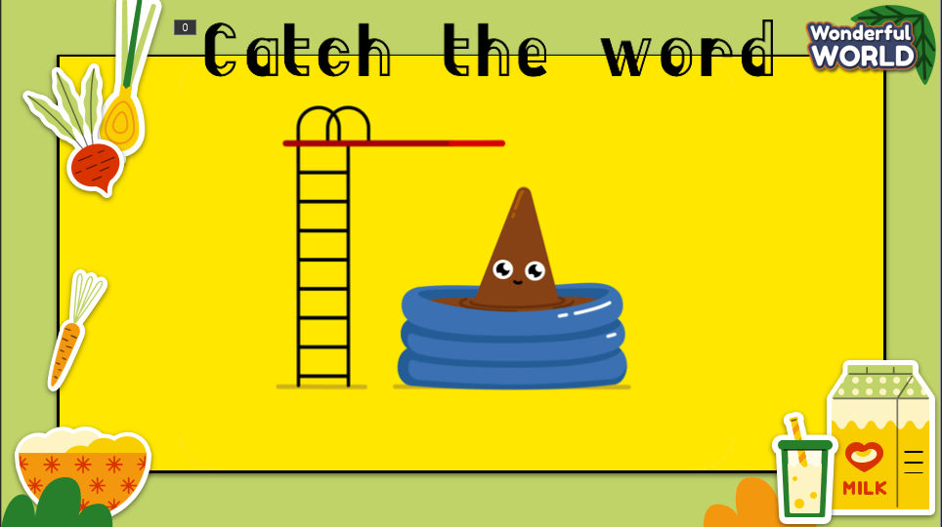  Lead in:  - T raises some pictures and asks Ss to guess the topic of the lesson.  - T reviews the topic “Food”.  - Write on the board “Review 1” and review the words and structures of the learned lesson. | - Greet Teacher.  - Listen to the clues.  - Stand in a group and pay attention to the game.  - Draw the pictures in 10 seconds then pass them down to the next one.  - The last student of the line will write the answer on the paper and raise it up.  - Check the result.  - Receive the punishment.  - Look at the pictures and guess the topic.
Activity 2: Review (12 minutes)
a. Aims:
- Review the words: bread, butter, chocolate, cupcake, salad, spaghetti.
- Quantifiers: a little, a lot of, a few, much, many.
+ Ss know how to use a little, a lot of, a few, much, many.
+ Finish Task 1.
Teacher’s Activities | Students’ Activities
REVIEW  - Show the words on the screen.  - Ask students to look at the screen and say the word.  - Show the text and audio.  - Ask Ss to listen again and repeat after the audio.  - Can play twice or three times so that Ss can practice the words.  - Ask some students to read the words or phrases individually.  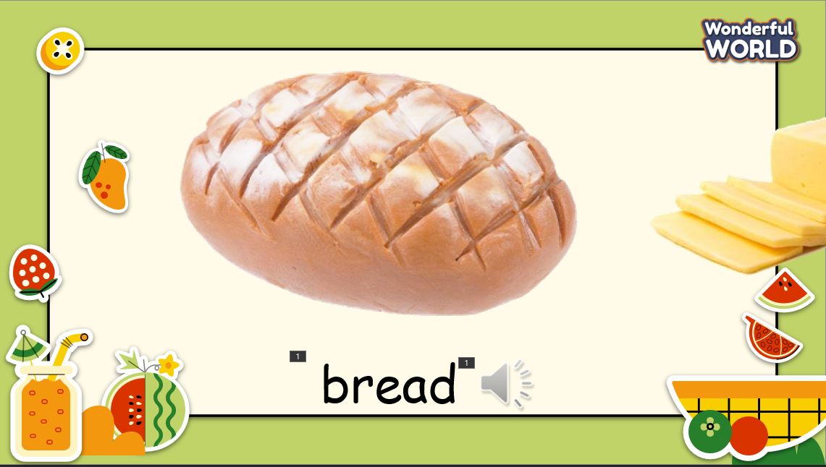  - Show the quantifiers on the screen and review how to use them.  - Show the example sentence and invite some Ss to make their sentences.  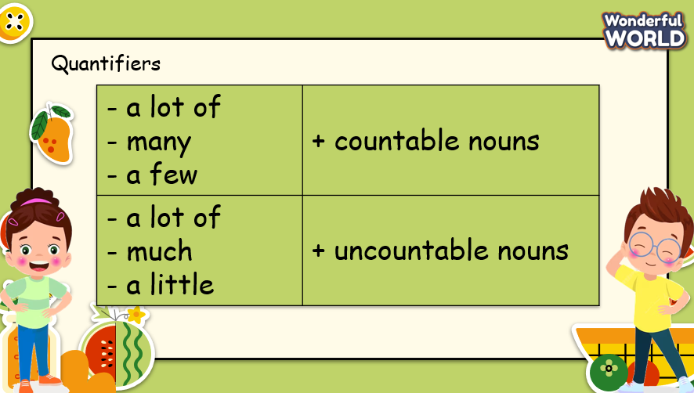  Task 1: Read and fill in the blanks.  - Show the paragraph on the screen and give Ss 2 minutes to finish the task.  - Invite 2 Ss to write their answers on the board.  - Check the answer.  - Invite some Ss to read the paragraph aloud.  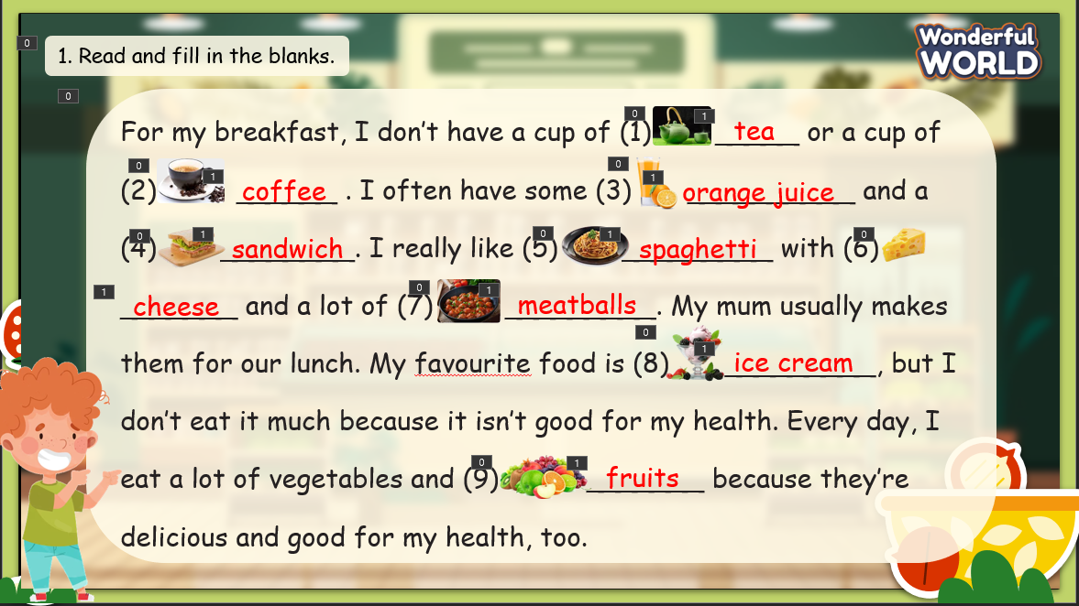 | - Look at the screen and say the words.  - Check the words and listen to the audio.  - Listen and repeat.  - Listen to the explanation.  - Create the sentences and speak in front of the class.  - Look at the task on the screen and do it in 2 minutes.  - Write the answers on the board.  - Check the answer.  - Read the paragraph aloud.
Activity 3: Practice – Controlled practice (8 minutes)
Aims:
- Ss join the game to review the words: bread, butter, chocolate, cupcake, salad, spaghetti.
and quantifiers: a lot of, a little, a few, many, much.
- Finish task 2
Teacher’s Activities | Students’ Activities
Task 2: Listen and tick the correct picture.  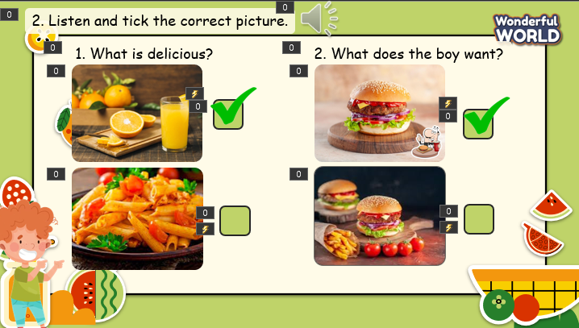  - Show the pictures on the screen.  - Ask Ss to look at the pictures and identify the food.  - Ask Ss to listen to the audio and choose the correct picture.  - Play the audio, can play twice if most of the Ss do not catch the answer.  - Invite some Ss to give their answers.  - Play the audio again and check the answers.  Game: “Candy Catcher”  - T divides the class into 2 groups. Each group will choose a name and play rock, scissors, and paper to decide which group goes first.  - The two groups will take turns answering the questions.  - T checks the answer. If it is correct, that team will get a point. If not, the next team will take turns and answer their question.  - When the game finishes, the team with the higher score will win the game.  - The team with the lower score will receive a punishment (hop, dance, sing, etc.).  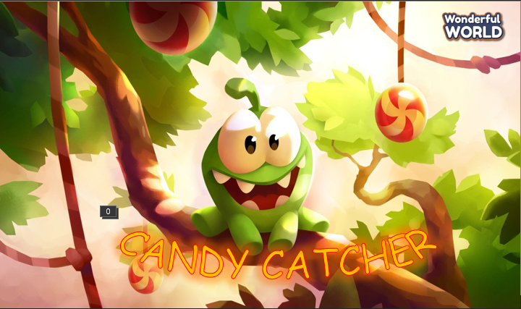 | - Look at the picture, and identify the food shown on the screen.  - Listen to the audio and choose the correct picture.  - Present the answer to the class.  - Listen again and check.  - Listen to the rules of the game.  - Appoint a representative to do rock, scissors, and paper to decide who goes first.  - Answer the question.  - If the answer is correct, check the point.  - If not, the next team will take the turn and answer the question.  - Check the results.
Activity 4: Production – Free practice (6 minutes)
Aims:
- Apply the words and quantifiers to describe the picture in front of the class.
- Encourage Ss to make conversation and speak freely in front of the crowd.
Teacher’s Activities | Students’ Activities
- Show the picture and quantifiers on the screen.  - Ask Ss about the food on the screen, and their number/amount.  - Ask Ss to work in pairs and make a description. Encourage Ss to describe as much detail as possible.  - Invite some pairs to present in front of the class.  - Encourage the rest part of the class to ask some questions for the presenting pair (such as: What food do you like? What do you often have for breakfast/lunch/dinner? etc.).  - Give them feedback if needed.  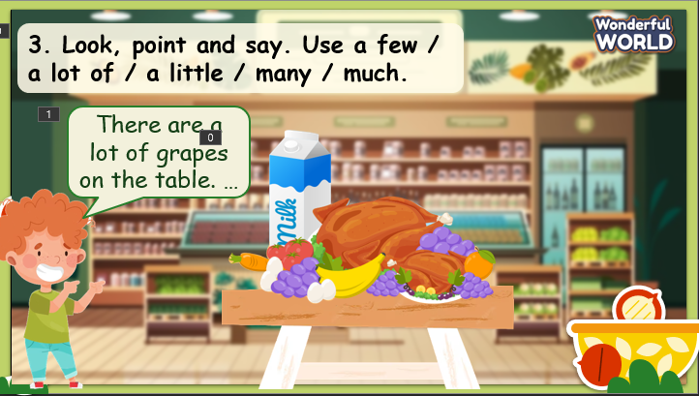 | - Look at the screen and work in pairs to talk about the food, using a few, a lot of, a little, many, much.  - Present in front of the class.  - Try to answer the question.
Activity 5: Wrap-up & Assessment (4 minutes)
Teacher’s Activities | Students’ Activities
a, Aims:
- Check Ss’s understanding of what they have learnt.
- Students rehearse what they have learnt in the lesson.
- Ask Ss to do the assessment.  - Give the assessment to the class and some Ss  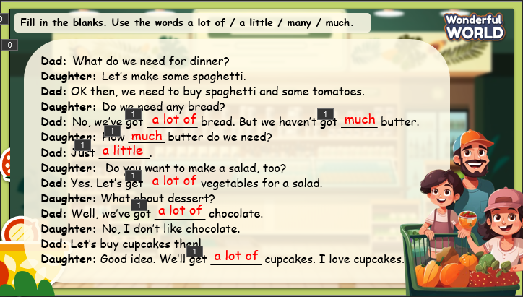  - Check with the class.  - Wrap-up  * Remember  VOCABULARY  bread, butter, chocolate, cupcake, salad, spaghetti  STRUCTURES  - We have a lot of bread, but we do not have much butter.  - We have a lot of oranges, but we don’t have many apples. | - Do the assessment.  - Check with the teacher.  - Ss read the wrap-up.  - Stand up and say goodbye to the teacher.
____________________________________________

REVIEW 3
Part 2. Task 1-2-3
Period 64
I. OBJECTIVES:
1. Knowledge:
- Students review words of food: meatballs, bowl, cereal, plate, piece, glass, slice
- Students review the quantifiers: a bowl of cereal, a piece of pizza, two bowls of cereal, some pieces of pizza
2. Competences:
- English competences: Students can use English to introduce their favourite food.
- Common competences: Students can describe the number of foods in the picture, using quantifiers, such as a bowl of cereal, a piece of pizza, two bowls of cereal, some pieces of pizza
3. Qualities:
- Students will
+ Have a strong curiosity in exploring different types of food and the quantifiers used with nouns.
+ Recall and reflect on personal experiences with the Ss’s favourite food and make them more meaningful and memorable.
II. EQUIPMENT AND MATERIALS:
- Basic things: Student’s book, flashcards, photos, papers.
- Advanced things: PPT, laptop, TV.
III. LESSON PROCEDURE:
Activity 1: Warm-up (5 minutes)
A guessing game “Cowboy game?”
Aims: Welcome students. Engage the class (or warm the class up) with a guessing word game to revive the vocabulary and lead in the new lesson.
Teacher’s Activities | Students’ Activities
Procedure
1. Greet students. Chatting…Do you like playing games…  2. Introduce the game: Cowboy game  - Ask Ss to think of the food learnt in the previous lesson.  - Put students in two groups and each group will nominate a representative to play the game.  - Each turn will have two Ss from each team. 2 Ss stand on the board, facing their backs to each other. Each S will be given a picture. When T counts 1,2,3, the two will turn back and look at the other’s picture and read that word aloud. Whoever reads it correctly and faster will be the winner.  - The game will last for 7 rounds.  - T asks Ss to repeat the words after checking.    Lead in:  - T raises some pictures and asks Ss to guess the topic of the lesson.  - T reviews the topic “Food”.  - Write on the board “Review 2” and review the words and structures of the learnt lesson. | - Greet the T.  - Listen to the rules of the game.  - Listen and play a game.  - Stand at the point and hold the pictures.  - Turn back when hearing the signal.  - Check the result.  - Repeat.  - Look at the pictures and guess the topic.
Activity 2: Review (12 minutes)
Aims:
- Review the words: meatballs, bowl, cereal, plate, piece, glass, slice.
- Quantifiers: a little, a lot of, a few, much, many.
+ Ss know how to use singular and plural nouns: a bowl of cereal, a piece of pizza, two bowls of cereal, some pieces of pizza.
+ Finish Task 1
Teacher’s Activities |  | Students’ Activities
REVIEW  - Show the words on the screen.  - Ask students to look at the screen and say the word.  - Show the text and audio.  - Ask Ss to listen again and repeat after the audio.  - Can play twice or three times so that Ss can practice the words.  - Ask some students to read the words or phrases individually.  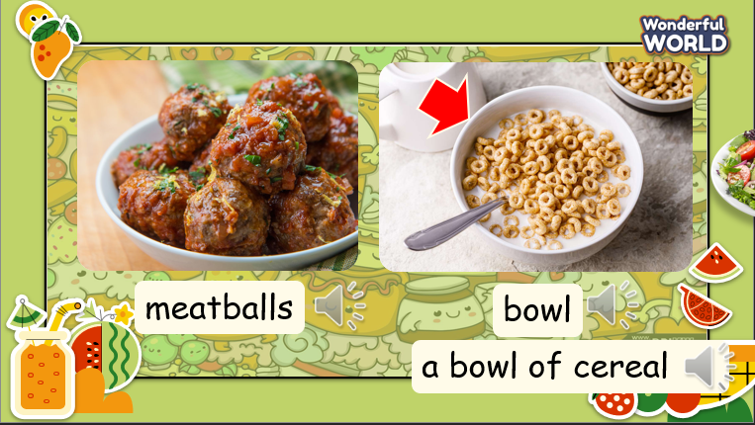  - Show the quantifiers on the screen and review how to use them.  - Show the example sentence and invite some Ss to make their sentences.  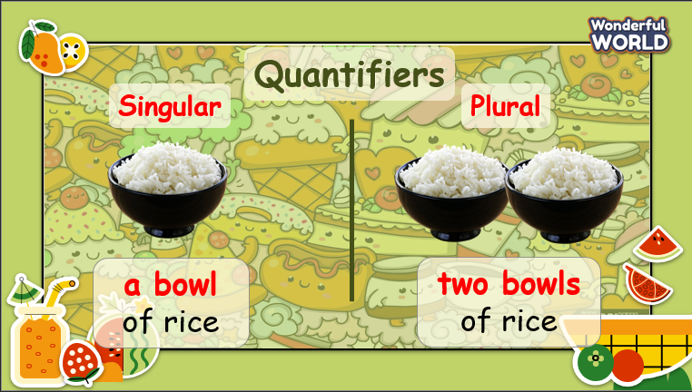  Task 1: Read the sentences. Choose the correct word (a, b or c) and write it on the line.  - Show the paragraph on the screen and give Ss 2 minutes to finish the task.  - Invite 2 Ss to write their answers on the board.  - Check the answer.  - Invite some Ss to read the paragraph aloud.  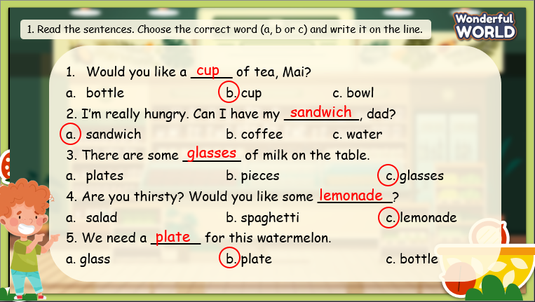 |  | - Look at the screen and say the words.  - Check the words and listen to the audio.  - Listen and repeat.  - Listen to the explanation.  - Create the sentences and speak in front of the class.  - Look at the task on the screen and do it in 2 minutes.  - Write the answers on the board.  - Check the answer.  - Read the paragraph aloud.
Activity 3: Practice – Controlled practice (8 minutes)
a. Aims:
- Ss join the game to review the words: meatballs, bowl, cereal, plate, piece, glass, slice
and quantifiers: a bowl of cereal, a piece of pizza, two bowls of cereal, some pieces of pizza
- Finish task 2
b. Procedure
Teacher’s Activities |  | Students’ Activities
Task 2: Listen and write A, B, C, D or E in the answer box.  There is one example.  - Show the pictures on the screen.  - Ask Ss to look at the pictures and identify the food.  - Ask Ss to listen to the audio and choose the correct picture.  - Play the audio, can play twice if most of the Ss do not catch the answer.  - Invite some Ss to give their answers.  - Play the audio again and check the answers.  Game: “Picking apples”  - T divides the class into 2 groups. Each group will choose a name and play rock, scissors, and paper to decide which group goes first.  - The two groups will take turns to answer the questions.  -T checks the answer. If it is correct, that team will get a point. If not, the next team will take turns and answer their question.  -When the game finishes, the team with the higher score will win the game.  -The team with lower score must do an exercise (hop, dance, sing, etc.).  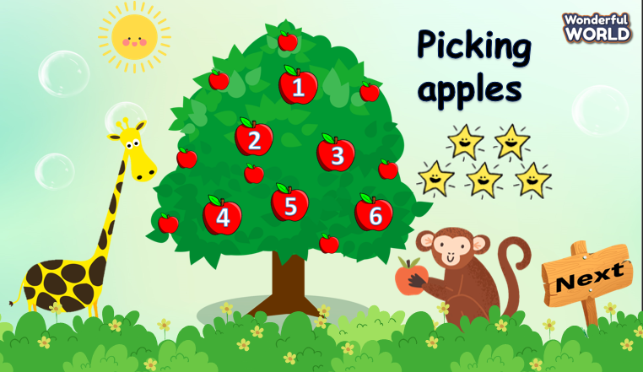 |  | - Look at the picture, and identify the food on the screen.  - Listen to the audio and choose the correct picture.  - Present the answer to the class.  - Listen again and check.  - Listen to the rules of the game.  - Appoint a representative to do rock, scissors, and paper to decide who goes first.  - Answer the question  - If the answer is correct, check the point.  - If not, the next team will take turns and answer.  - Check the results.
Activity 4: Production – Speaking (6 minutes)
Aims:
- Apply the words and quantifiers to describe the picture in front of the class.
- Encourage Ss to make the conversation and speak freely in front of the crowd.
Teacher’s Activities |  | Students’ Activities
- Show the statements on the screen.  - Ask Ss to decide if the statement is positive or negative, then put Ss in groups of two and say if it should be done or not. Encourage Ss to ask more questions, such as “Why should I do that?” to make it a full conversation.  - Give Ss some minutes to practice, then invite some groups to stand up to make conversation.  - Ask other groups for comments, encourage them to make detailed comments and give out further questions if they have.  - Give them feedback. |  | - Look at the screen and work in pairs to talk about what we should / should not do.  - Make the conversation about the given statement.  - Make comments about conversations, and ask if you have questions.  - Receive feedback.
Activity 5: Wrap up & Assessment (4 minutes)
Teacher’s Activities |  | Students’ Activities
Aims:
- Check Ss’s understanding of what they have learnt.
- Students rehearse what they have learnt in the lesson.
- Ask Ss to do the assessment.  - Give the assessment to the class and some Ss.  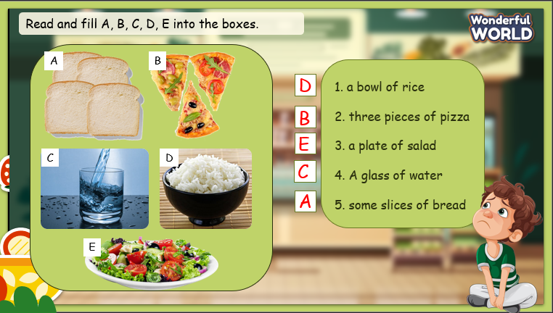  - Check with the class.  - T asks Ss about what they have learnt in today’s lesson.  - T shows the wrap-up slide and concludes the lesson.  * Remember  VOCABULARY  bread, butter, chocolate, cupcake, salad, spaghetti  STRUCTURE  - We have a lot of bread, but we do not have much butter.  - We have a lot of oranges, but we don’t have many apples. |  | - Do the assessment.  - Check with the teacher.  - Answer T’s question about what they have learnt in today’s lesson.  - Ss read the wrap-up.  - Stand up and say goodbye to the teacher.

