TUẦN 17 Khối 3, 5 (Từ ngày 30/12/2024 đến ngày 03/01/2025)
THỨ | TIẾT | MÔN | TIẾT THỨ | NỘI DUNG BÀI DẠY |  | UDCNTT | ĐỒ DÙNG DẠY HỌC
Hai  30/12 | 1 | 5A | 65 | Review 3 | Part 3 - Video (1, 2, 3, 4) | Wonderfulworld | Flashcards, TV, books
Hai  30/12 | 2
Hai  30/12 | 3 | 3A | 65 | Review 3 | Part 3 - Video (1, 2, 3, 4) | Wonderfulworld | Flashcards, TV, books
Hai  30/12 | 4 | 3A | 66 | Review 3 | Part 4 (1, 2, 3) | Wonderfulworld | Flashcards, TV, books
Hai  30/12 | 5 | 5D | 65 | Review 3 | Part 3 - Video (1, 2, 3, 4) | Wonderfulworld | Flashcards, TV, books
Hai  30/12 | 6 | 3B | 65 | Review 3 | Part 3 - Video (1, 2, 3, 4) | Wonderfulworld | Flashcards, TV, books
Hai  30/12 | 7 | 5C | 65 | Review 3 | Part 3 - Video (1, 2, 3, 4) | Wonderfulworld | Flashcards, TV, books
Ba  31/12 | 1 | 5C | 66 | Review 3 | Part 4 (1, 2, 3) | Wonderfulworld | Flashcards, TV, books
Ba  31/12 | 2 | 5B | 65 | Review 3 | Part 3 - Video (1, 2, 3, 4) | Wonderfulworld | Flashcards, TV, books
Ba  31/12 | 3 | 5A | 66 | Review 3 | Part 4 (1, 2, 3) | Wonderfulworld | Flashcards, TV, books
Ba  31/12 | 4 | 5B | 66 | Review 3 | Part 4 (1, 2, 3) | Wonderfulworld | Flashcards, TV, books
Ba  31/12 | 5 | 3A | 67 | End of semester review |  |  | Flashcards, TV, books
Ba  31/12 | 6 | 5D | 66 | Review 3 | Part 4 (1, 2, 3) | Wonderfulworld | Flashcards, TV, books
Ba  31/12 | 7 | 3B | 66 | Review 3 | Part 4 (1, 2, 3) | Wonderfulworld | Flashcards, TV, books
Tư  01/01 | 1
Tư  01/01 | 2
Tư  01/01 | 3
Tư  01/01 | 4 |  |  | NGHỈ TẾT DƯƠNG LỊCH
Tư  01/01 | 5
Tư  01/01 | 6
Tư  01/01 | 7
Năm  02/01 | 1 | 5C | 67 | End of semester review |  |  | Flashcards, TV, books
Năm  02/01 | 2 | 5B | 67 | End of semester review |  |  | Flashcards, TV, books
Năm  02/01 | 3 | 5A | 67 | End of semester review |  |  | Flashcards, TV, books
Năm  02/01 | 4 | 5A | 68 | End of semester review |  |  | Flashcards, TV, books
Năm  02/01 | 5 | 5D | 67 | End of semester review |  |  | Flashcards, TV, books
Năm  02/01 | 6 | 5C | 68 | End of semester review |  |  | Flashcards, TV, books
Năm  02/01 | 7
Sáu  03/01 | 1 | 3B | 67 | End of semester review |  |  | Flashcards, TV, books
Sáu  03/01 | 2 | 5D | 68 | End of semester review |  |  | Flashcards, TV, books
Sáu  03/01 | 3 | 5B | 68 | End of semester review |  |  | Flashcards, TV, books
Sáu  03/01 | 4
Sáu  03/01 | 5
Sáu  03/01 | 6 | 3B | 68 | End of semester review |  |  | Flashcards, TV, books
Sáu  03/01 | 7 | 3A | 68 | End of semester review |  |  | Flashcards, TV, books

WEEK 17.
REVIEW 3
Part 3 – VIDEO. Task 1, 2, 3
Period 65
I. OBJECTIVES:
1. Knowledge:
- By the end of the lesson, students will be able to:
+ Watch a video about people describing clothes.
+Students will review the words related to the topic clothes: shoes, skirt, socks, trousers, T-shirt, boots, coat, dress, hat, warm, big, small, new, pretty, ugly
+Review grammar:
- I’ve got a T-shirt. My T-shirt is red.
- She’s got a coat. Her coat is warm.
- I’ve got a new T-shirt.
2. Competences:
English competence
- Watch and understand a video about different clothes children wear.
General competence
+ Raise motivation and interests in learning English through their favourite clothing.
+ Build up self-learning skill through learning activities.
+ Develop communication and collaboration skills through learning activities.
+ Combine clothing to match each other about colour, style,...
+ Develop listening comprehension.
3. Qualities:
+ Be responsible for keeping the clothes clean and tidy.
+ Show the love and the sympathy with children in mountainous area by donating the used clothes.
II. EQUIPMENT AND MATERIALS:
- For teacher:
+ Basic things: Student’s book , teacher’s book and flashcards,
+ Advanced things: PPT, projector/interactive whiteboard/laptop/TV.
- For students: student’s book, work book.
III. LESSON PROCEDURE:
Warm up (10 minutes)
Teacher’s activities | Student’s activities
- Greeting  Option 1:  - for basic facilities in class  Game “ Hang man”  - T will present with a number of blank spaces representing the missing letters that students need to find.  - After T has revealed several letters, Ss may be able to guess what the answer is and fill in the remaining letters. T will give students many stars.  - Be warned, every time Ss guess a letter wrong, T will lose a life and the hangman begins to disappear, piece by piece.  Option 2:  - for advanced facilities in class (internet, projector, TV, …)  - Play “ Tick-Tac-toe” game  + T calls two Ss of two teams go to the board to take turns marking the spaces in a three-by-three grid with X or O. Each square contains a question and Ss will mark X or O if he/she answers question correctly .The player who succeeds in placing three of their marks in a horizontal, vertical, or diagonal row is the winner.  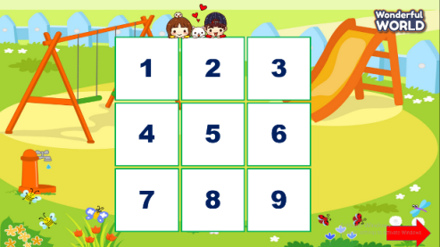 | - Use the keyboard to guess a letter.  - Listen the T’s guide.  - Ss will join the game.  - Receive stars for his/her team if he/she answers correctly.
Review (15 minutes)
Teacher’s activities | Student’s activities
Before watching:  Task 1: Tick. What do you wear to school.  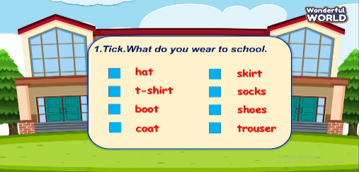  - Read the instruction to the class. Invite a student to read the list of items.  - Point to the first item, hat. Say Do you wear a hat to school? If students do wear a hat, show them how to tick the box. If they don’t wear one, tell them to leave the box gap.  - Repeat with the remaining items.  While watching:  Task 2: Look at the hats. What colours can you see? Tick.  - T asks Ss to look at the picture and asks a few questions before watching video:  + What subject are they studying?  + What do they wear?  + What colour are the ( trousers, t-shirt…)?  + How do they feel?  Task 3: Tick T for True or F for False  + T will turn on the video and ask students to tick T or F at task 3.  - Choose the best answer and receive stars.  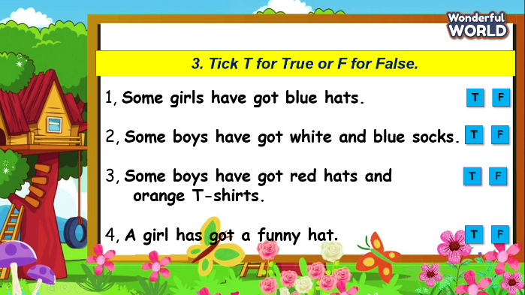  After watching:  - Play game: “Candy catcher”  T shows many questions and has many options and the task of student will have to choose the correct answer to get stars for each question.  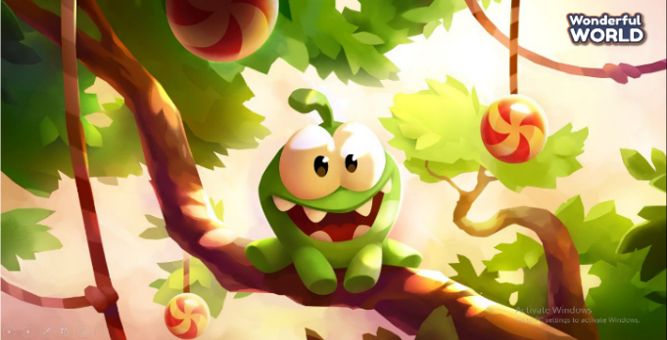 | - Read the product.  - Watch video and tick the boxes.  - Watch video again and and tick T or F.  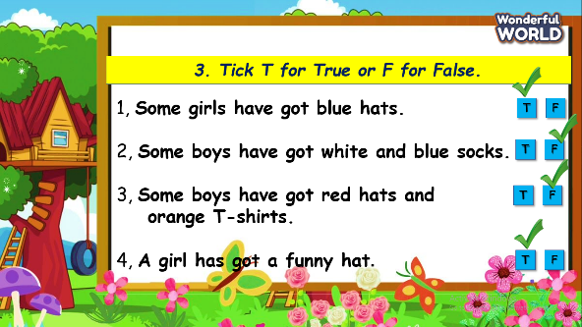  -Play game.
Extra activity(10 minutes )
Teacher’s activities | Student’s activities
-Task 1: Draw picture  - Ss will draw a picture that relate to vocabulary of unit 5.  - Ask Ss to present his/her picture with the class by using structures they have learned at unit 5  (if it’s enough time, T will assess each picture of Ss and choose the best one to give candies.)  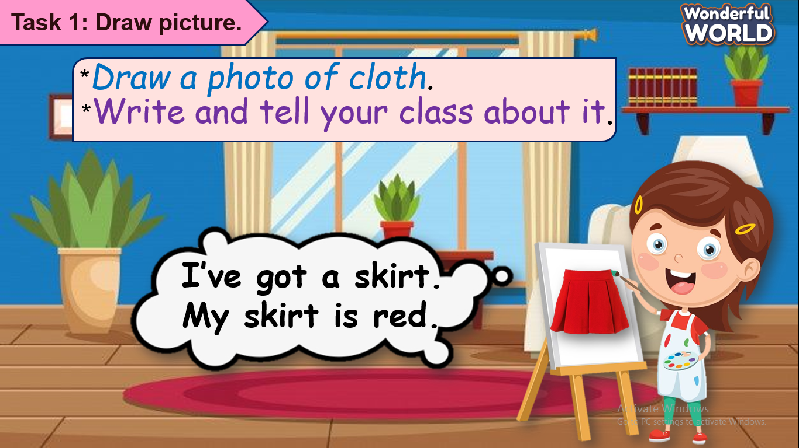 | - Draw the picture.  - Be confident to speak in front of the class.
- Assessment:  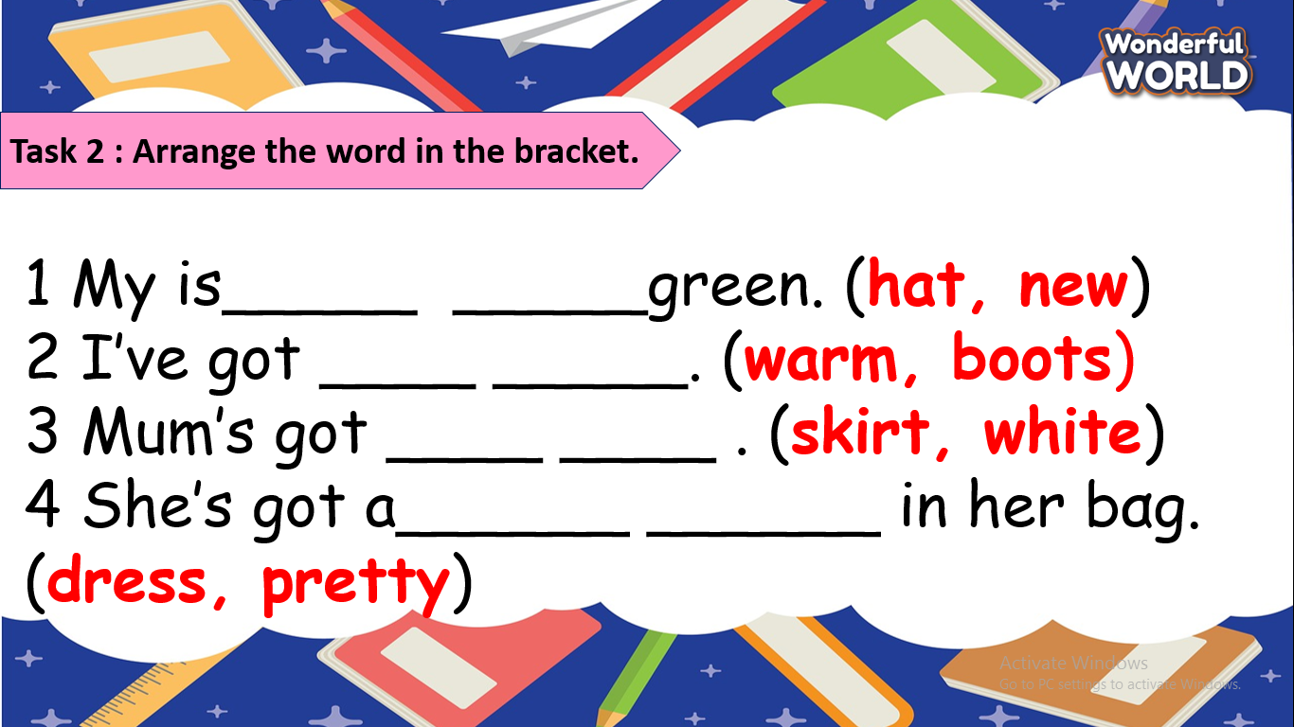  - Check answers.  - Say goodbye . | 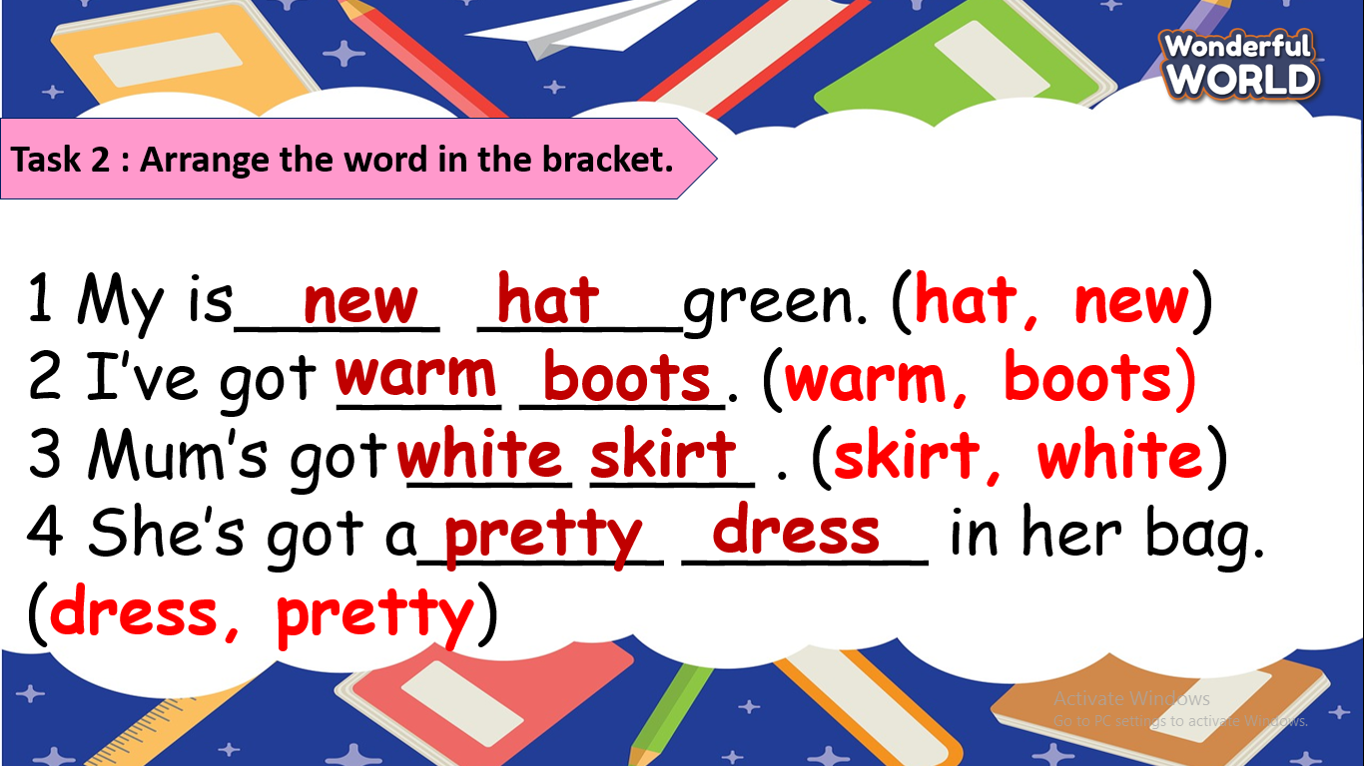  - Check with friends and then with teacher and whole class.  - Look and read aloud.  - Say goodbye.
____________________________________
REVIEW 3
Part 4. Task 1, 2, 3
Period 66
I. OBJECTIVES:
1. Knowledge:
- Practice describing clothes and toys
2. Competences:
English competence
-Students will describe their clothes and toys in english smoothly.
General competence
- Raise motivation and interests in learning English.
- Develop communication and collaboration skills through learning activities.
- Build up self-learning skill through learning activities.
3. Qualities:
- Be hard working in reviewing all vocabulary and structures to prepare the upcoming test.
- Be responible for keeping toys as well as clothes neat and tidy.
II. EQUIPMENT AND MATERIALS:
- For teacher:
+ Basic things: Student’s book, teacher’s book ,toys and clothes flashcards,
+ Advanced things: PPT, projector/interactive whiteboard/laptop/TV
- For students: student’s book, work book.
III. LESSON PROCEDURE:
Warm up (10 minutes)
Teacher’s activities | Student’s activities
- Greeting  - Option 1: Bingo game.  + Each Bingo card consists of 25 random words and are made up of 5 rows, and 5 columns. When the game starts,each random vocabulary are called, and players are required to cross their words. Once a card has been filled with a winning pattern (a line,row..). Teacher will continue read until the first students reach 5 words in arow, line....  - Option 2: Match the picture with its word  + Show toys and clothes that are appeared on slide.  - Ask Ss to match between picture and word.  - Open video again to check answer.  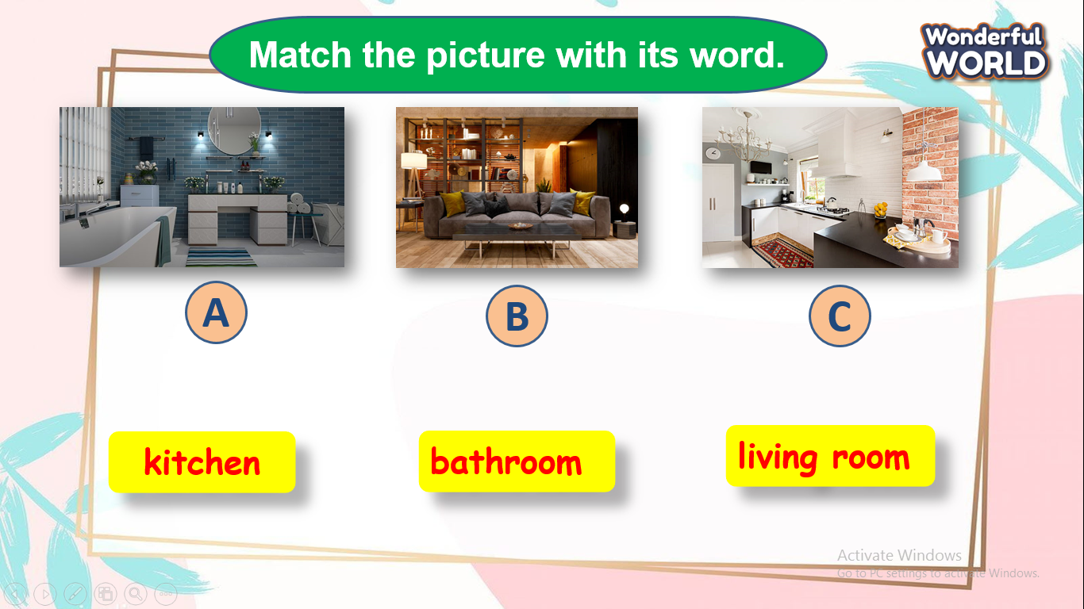 | - Play the game .  - Play game .  - The best students will gets stars or stickers for their teams
Review (15 minutes)
Teacher’s activities | Student’s activities
- There are two colums ( My toys and My clothes)  + T asks Ss to list all the toys and the toys into the book and then present with the class.  + Help students if they forget the word or have wrong pronunciation.  + Ask more information about those things.  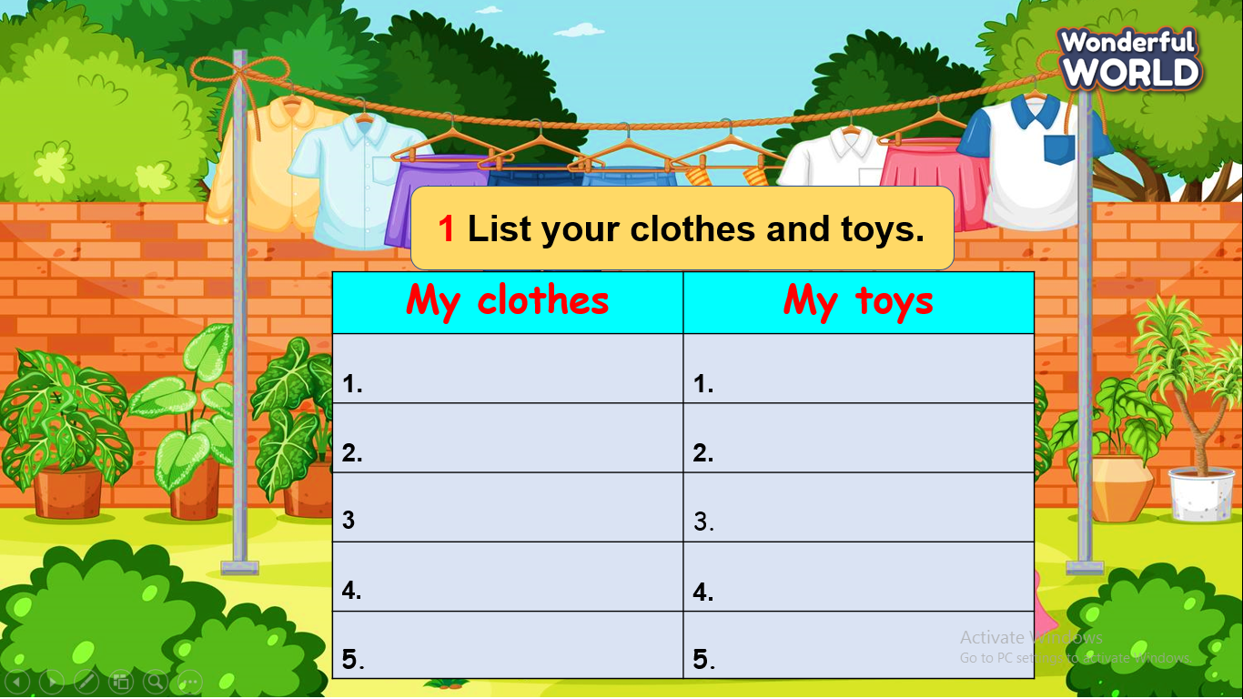  - Play game :The magic wheel  + T prepares 8 questions related to the previous lesson. If Ss answer correctly , they will spin the wheel to get stars .  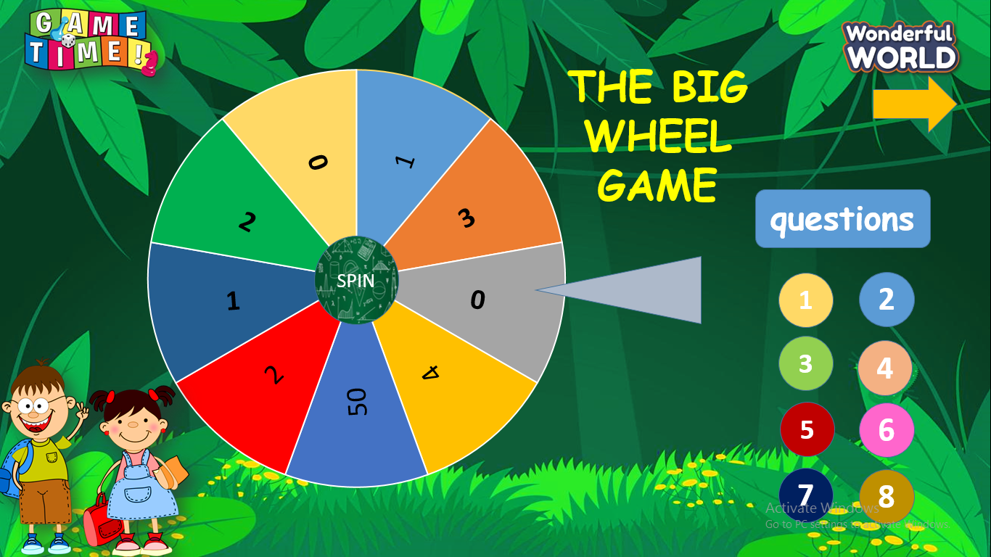 | - Raise the hand to read before the class.  - Play the game .  - Gets stars or stickers for their teams if they have the correct answers.
Extra activity (10 minutes )
Teacher’s activities | Student’s activities
Task 1: Draw and talk about the things you have got .  + T asks Ss to draw a thing( toy or cloth) that they are given on birthday party and use structure to describe about it.  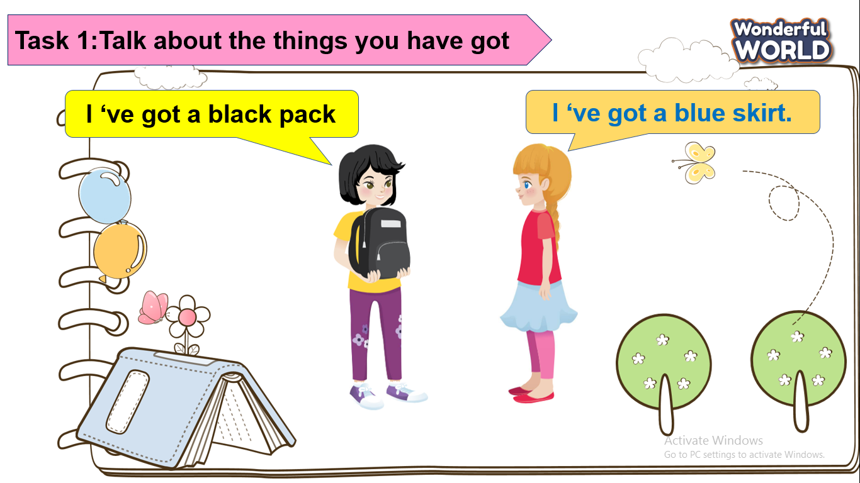  + Invite a few Ss go to to the board to talk about it  (if it’s enough time,teacher will assess each Ss carefully and choose the best one to give candies.) | - Draw the picture.  - Be confident to present in front of the class.
Task 2: Order and write.  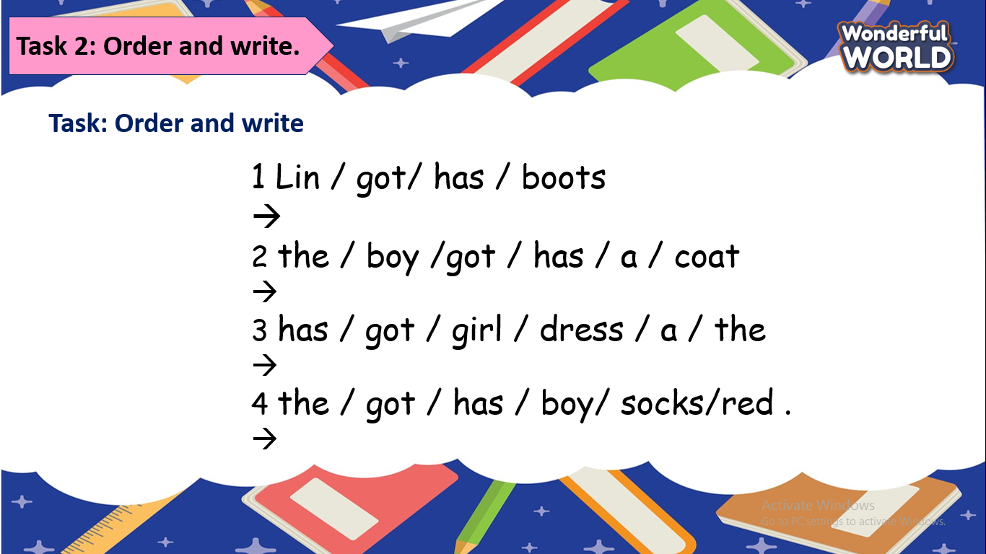  - Check answers.  - Say goodbye . | 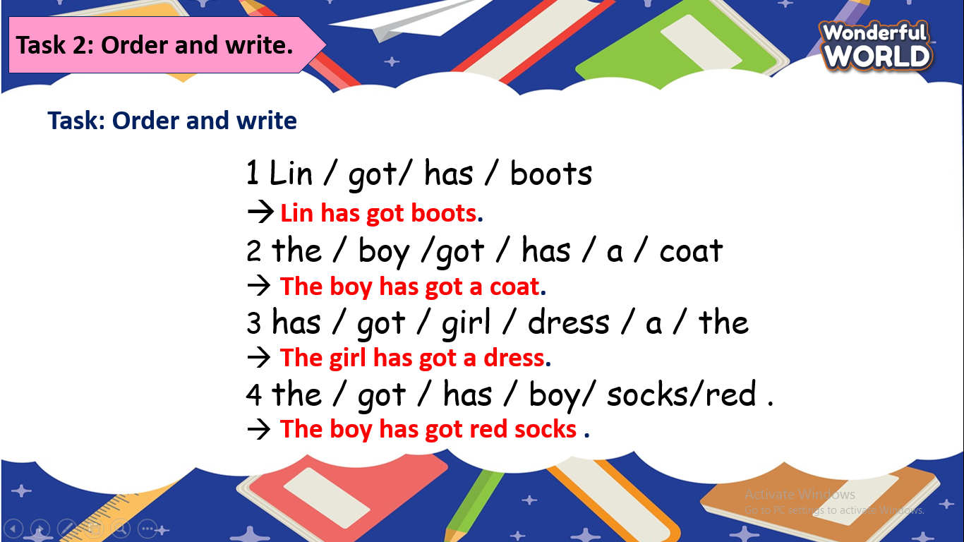  - Check with friends and then with teacher and whole class.  - Look and read aloud.  - Say goodbye.
____________________________________
END OF SEMESTER 1 REVIEW
Period 67
I. OBJECTIVES:
1. Knowledge:
Students will be able to review the words related to the topic My family, My school, animals, My house, My clothes and review the structure
2. Competences:
- English competences: Students will be able to introduce My family, My school, animals, My house, My clothes
- Common competences: Students will have the opportunity to develop autonomy in doing tasks and communicating among friends.
3. Qualities:
- Students will be friendly and confident in communicating with friends.
II. EQUIPMENT AND MATERIALS:
- For Teacher: PP, TV, music, related audio track.
- For students: paper, colour pencils or crayons, personal boards and markers.
III. LESSON PROCEDURE:
Activity 1: Warm-up (5 minutes)
Teacher’s activities |  | Student’s activities
Watch and sing: Tooty ta  - Ask students to watch the video and let them do action.  Watch the video and sing along to the song. |  | - Listen and do along  - Watch the video again and sing along to the song.
Activity 2: Review (10 minutes)
Teacher’s activities |  | Student’s activities
Lead-in: Use the song and the Opener picture to lead in the topics: My family, My school, animals, My house, My clothes  Vocabulary: Listen and Repeat.  - Play the words one by one  - Play the audio, ask students to listen, and repeat in chorus, groups.  - Vocabulary checking: Ask the students to recall all the words they have learnt.  Sentence structure:  - Present the structure and ask the students to repeat it.  - Sentence structure checking: Ask the students to use the sentence structure to describe their family and school |  | - Learn the words and structures through story and pictures.  - Repeat the words.  - Repeat then point.  - Say aloud the words  - Learn the structures and repeat the sentences  - Share their sports with the whole class.
Activity 3: Practice (15 minutes)
Teacher’s activities | Student’s activities
Task 1: Play pass the bag game (7 minutes)  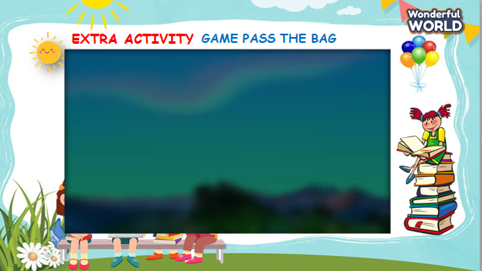  - Lead-in: Introduce the game rule:  - The teacher puts all flashcards of 6 units into 1 bag/pair/box and plays the music.  - While the music is playing, students should pass the bag around the class.  - When the music stops, the student with the bag must put out any flashcard and say aloud.  - If the student is good, he/ she can show the flashcard and ask her/his partner.  - Play the game.  - Show the questions and check if the answers are correct or not.  - Award the best student. | - Listen to the instruction carefully.  - Play the game.  - Read and give the answers.
Activity 4: Assessment (5 minutes)
Teacher’s activities | Student’s activities
- Ask students to do the task in WB.  - Check in pairs then the whole class.  - Wrap up the lesson by showing a summary.  - Say goodbye. | - Do the assessment.  - Check with friends and then with the teacher and the whole class.  - Listen carefully and repeat.  - Say goodbye.
____________________________________
END OF SEMESTER 1 REVIEW
Period 68
I. OBJECTIVES:
1. Knowledge:
- Students review the vocabularies and structures from Unit 1 to Unit 6 .
- Students are confident in practising about four skills.
2. Competences:
- English competences: Students can talk about the topics from unit 1 to unit 6.
- Common competences: Students can understand how people express their love towards favorite topics, and apply this in talking about theirs
3. Qualities:
- Students will
+ have strong confidence while talking about the topics in English.
II. EQUIPMENT AND MATERIALS:
- Basic things: handout.
- Advanced things: PPT, laptop, TV.
III. LESSON PROCEDURE:
1. Listen and number (1pt)
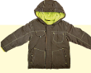 | 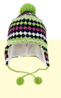 | 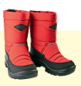 | 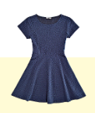
2. Listen and circle. (1pt)
1. A. It’s a classroom  B. It’s a computer room | 3. A. That’s a TV  B. That’s a book
2. A. He’s a student  B. She’s a student | 4. A. That’s a computer.  B. That’s a lamp.
3.Listen and tick the word. (1pt)
1. This is ……………………………  giraffe monkey | 2. That is ……………………………  dog lion
3. These are ………………………  monkeys elephants | 4. Those are ……………………………  giraffes rabbits
4. Listen to the question and choose the correct answer. (0.5pt)
1. A. No, I don’t B. Yes, I have. C. Yes, it is
2. A. No, there isn’t B. Yes, it is. It’s a coat. C. Yes, it isn’t
II.READING
5. Odd one out.(1.5pts)
1. A. coat | B. hat | C. socks | D. skirt
2. A. shoes | B. trousers | C. T-shirts | D. mum
3. A. lamp | B. TV | C. chair | D. living room
4. A. house | B. bedroom | C. bathroom | D. kitchen
5. A. brother | B. sisters | C. family | D. grandpa
6. A. giraffe | B. animals | C. elephant | D. rabbit
6.Choose the best answer. (1.5pts)
1.There ……………..a bed in my bedroom.
A. are B. is C. have D. has
2. There are two…………….in my house.
A. trees B. flower C. garden D. kitchen
3. Who is he? – He’s my……………………
A. sister B. aunt C. brother D. grandma
4. How ………..are you?
A. is B. old C. new D. great
5. Are they students? – ……………………
A. Yes, they aren’t B. No, they aren’t C. No, it isn’t D. Yes, it is
6. My coat is …………….
A. hat B. one C. new D. shoes
7. Choose the words from the box (1.5pts)
parrot - family - orange - old - mum - is
Hello, My name (1) ………………….Tung. I’m eight years (2)…………... This is a picture of my (3)………………………….This is my dad. His name is Hai. This is my (4)……………...Her name is Mai. We live in a big house.I have a (5)……………………………….in my house. Its colour is blue and (6) …. …….. I love my pet very much.
8. Arrange the words to make sentences (1pt)
1. are/these/What/?/
………………………………………………………………
2. an / garden / There / elephant / is / in / the /
……………………………………………………………
3. is/ That / a / rabbit / that / . / What / is /? /
……………………………………………………………………
4. big/ and / The / giraffe / is / tall. ……………………………………………………………………
9. Look at the picture and write one word in the blank (1pt)
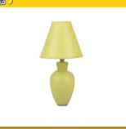 | 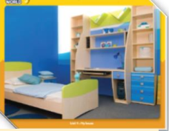 |  | 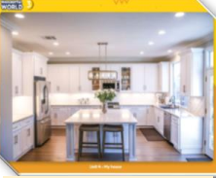
1………… | 2…………… | 3…………… | 4……………
____________________________________
GRADE 5
WEEK 17
REVIEW 3
Part 3: VIDEO - Task 1,2,3,4
Period 65
I. OBJECTIVES:
1. Knowledge:
- Students learn about the largest hot-air balloon festival in the world and the related vocabulary: pilot, cloth, hot-air balloon, size
- Students know how to describe a festival
2. Competences:
- English competences: Students can talk about a festival in the world.
- Common competences: Students can describe the purposes, events, activities, and visitors in an event.
3. Qualities:
- Students will
+ have a strong curiosity in exploring a specific festival in the world.
II. EQUIPMENT AND MATERIALS:
- Basic things: Student’s book, flashcards, photos, papers.
- Advanced things: PPT, laptop, TV.
III. LESSON PROCEDURE:
Activity 1: Warm-up (5 minutes)
A guessing game “Memory game?”
Aims: Welcome students. Engage the class (or warm the class up) with a guessing word game to revive the vocabulary (write the words here….) and lead in the new lesson.
Teacher’s Activities | Students’ Activities
Procedure
1. Greet students. Chatting…Do you like playing games…  2. Introduce the game: Memory game  - Ask Ss to think of the food learnt in the previous lesson.  - Put students in two groups and each group will take turns play.  - Each turn, a group will open two numbers. If the picture and the text match, click on the picture to clear and that team will get a point.  - If not, click on the red circle button to hide the picture and move to the next turn.  - When all pictures are clear, the team with higher scores will win the game.  - T can open the slide again and show all pictures and words to review  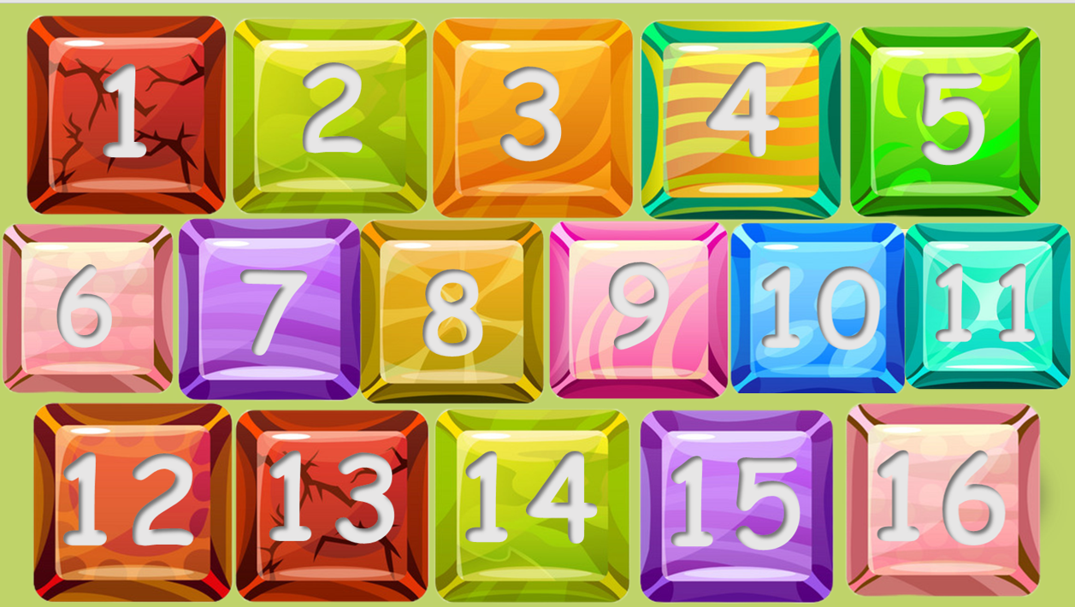  Lead in:  - T raises some pictures and ask Ss to guess the topic of the lesson.  - T introduces the topic “hot-air balloon festival”.  - T writes on the board “Review 3” and leads in the lesson. | - Greet the T.  - Listen to the rules of the game.  - Listen and play a game.  - Sit in groups and take turns to open the pictures.  - Check the result.  - Repeat after T.  - Look at the pictures and guess the topic.
Activity 2: Presentation (20 minutes)
Aims:
- Introduce the vocabulary about the hot-air balloon festival: pilot, cloth, hot-air balloon, size.
+ Ss know how to describe a festival
+ Finish Task 1, 2, 3, 4
Teacher’s Activities |  | Students’ Activities
- Show the words on the screen.  - Ask students to look at the screen and guess the word.  - Show the text and audio for each word.  - Ask Ss to listen and repeat after the audio.  - Play twice or three times so that Ss can practice the words.  - Asks some students to read the words or phrases individually.  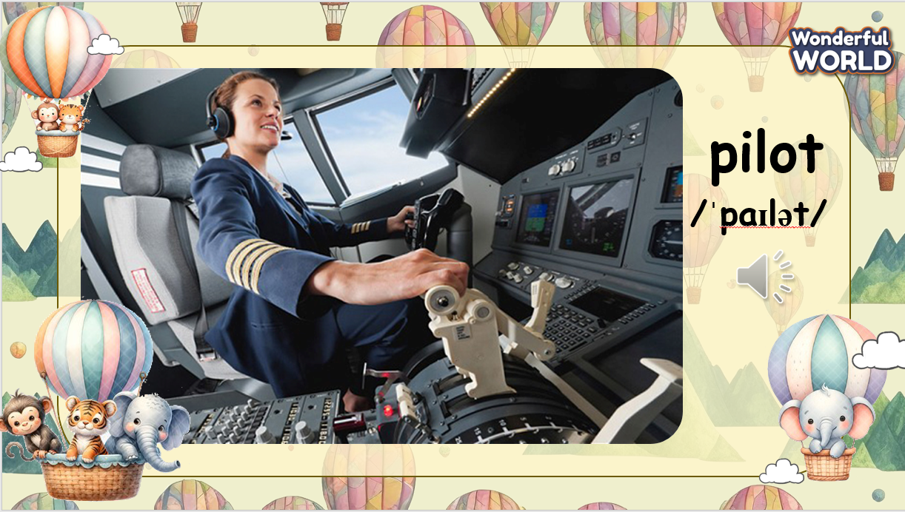  Task 1: Before you watch.  - Show the items on the screen.  - Tell students to look at the screen and tell you what they can see. If necessary, teach hot-air balloons.  - Ask students to tell you what colours they can see.  - Ask students if they have ever been in a hot-air balloon. If not, would they like to go in one? Why / Why not?  - Briefly explain how the hot-air balloon works: people stand in a basket beneath the balloon. The air inside the balloon is heated by a burner. This causes the balloon to rise. When the air inside  the balloon cools down, the hot-air balloon floats back down to  Earth.  - Ask if they are on a hot-air balloon ride, what they would take with them.  - Click on the box to show the checkmark, click on the checkmark to clear.  - Make a discussion to see what we should take with when we’re on a hot-air balloon ride and check the final answer.  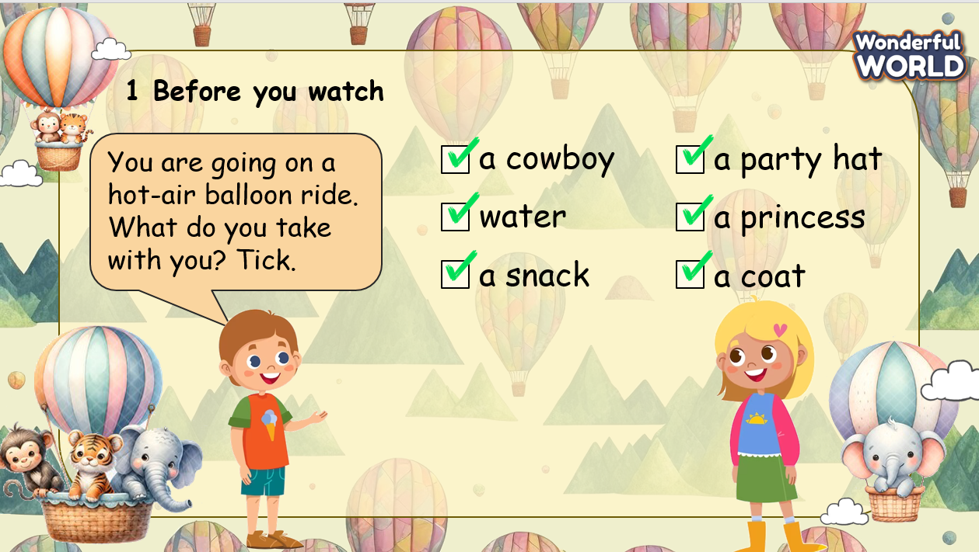  While you watch  Remind Ss of the question before watching.  After watching  - Ask and answer the question: Say the colours and shapes of the balloon you can see in the video.  - Play the video again and pause to check the answer.  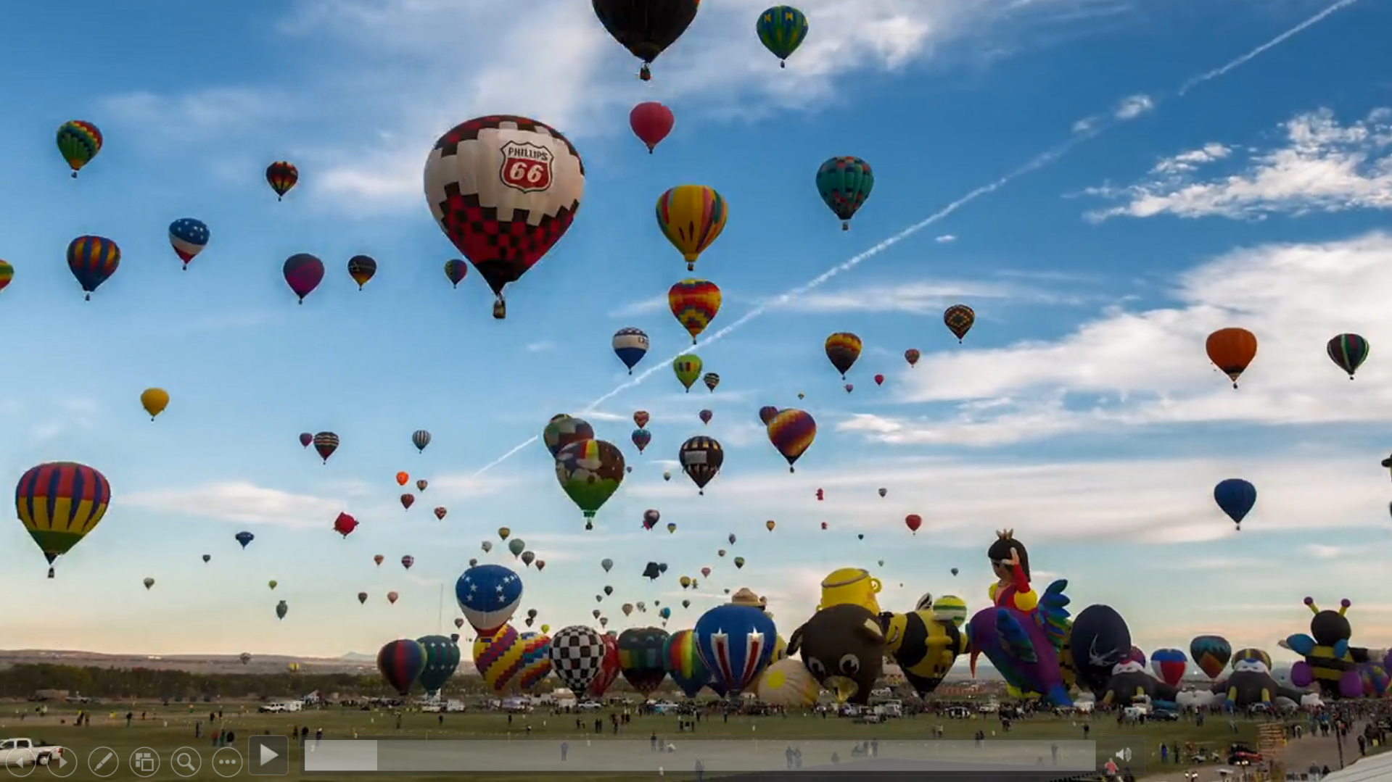  Task 4. After watching.  - Show the statements on the screen. Ask if Ss remember the content of the video.  - Ask Ss if it is necessary to play the video again.  - If yes, play the video and give Ss some minutes to finish the task.  - Invite some Ss to write their answers on the board.  - Play the video and check each Ss.  - Show the answers on the screen and check.  Let’s check.  T divides the class into 2 groups. Each group will choose a name and play rock, scissors, and paper to decide which group goes first.  Two groups will take turns to choose a number and answer the corresponding questions to review what they have seen in the video.  T checks the answer. If it is correct, T clicks the “spin” button to rotate the wheel, and then clicks on the wheel to stop and check the points.  If the answer is incorrect, T asks the next team to choose the number.  When all the questions are answered, the team with the higher score will win the game.  When the game is finished, click on the next button on the right bottom edge to move to the next slide. |  | - Look at the screen and say the words.  - Check the words and listen to the audio.  - Listen and repeat.  - Look at the screen and listen to the explanation.  - Look at the task on the screen and discuss with T  - Discuss with the class, explain why we should take the items  - Check the answer.  - Remember / take a note of the question  - Watch the video  - Answer the question  - Watch the video again and check the answer  - Check the statements on the screen  - Ask T to play the video again before starting task 4  - Fill T / F in the box  - Write the answer on the board  - Watch the video again and check the answers  - Listen to the rules of game  - Appoint a representative to do rock, scissors, and paper to decide who goes first  - Choose the number and pay attention to the questions, and then answer  - If the answer is correct, spin the wheel to get the points  - If not, the next team will choose another number to continue the game  - Check the results
Activity 3: Production – Crafting (6 minutes)
a. Aims:
- Guide Ss to make a paper hot-air balloon to decorate the class room
- Encourage Ss’ creativity and develop teamwork skills
Teacher’s Activities |  | Students’ Activities
- Show the instruction on the screen  - Ask Ss about the items needed  - Divide Ss into groups of 6, guide Ss to make a hot-air balloon step-by-step  - Give them some minutes to finish their products  - Invite some Ss to make quick introductions about their product (what is this? What colour is this? How many ___ are there? Etc.)  - Ask for comment from classmate  - Give them feedback  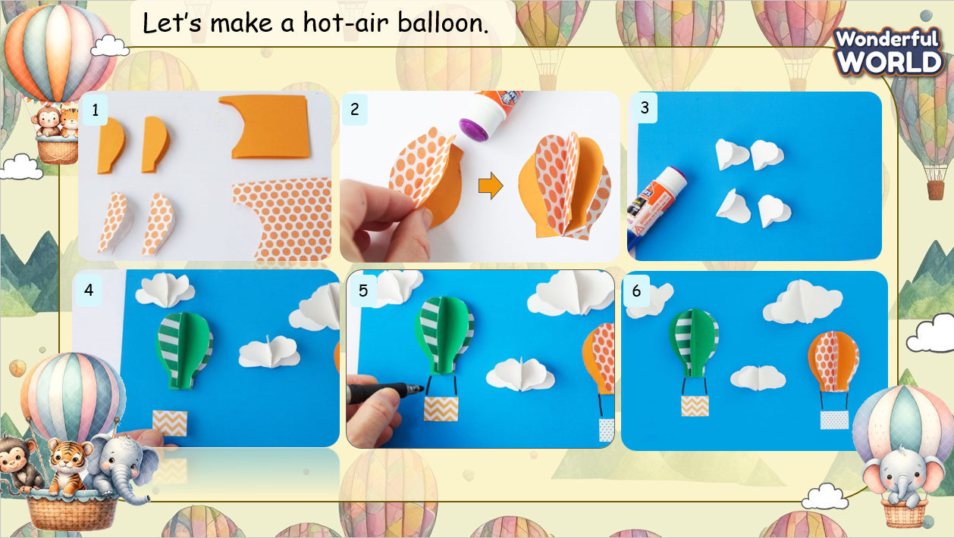 |  | - Look at the screen and identify the items needed  - Sit in groups and listen to the instruction  - Create their products  - Make a short introduction about their product  - Receive feedback.
Activity 4: Wrap up & Assessment (4 minutes)
Teacher’s Activities |  | Students’ Activities
Aims:
- Check Ss’s understanding of what they have learned.
- Students rehearse what they have learned in the lesson.
- Ask Ss to do the assessment.  - Give the assessment to class and some Ss.  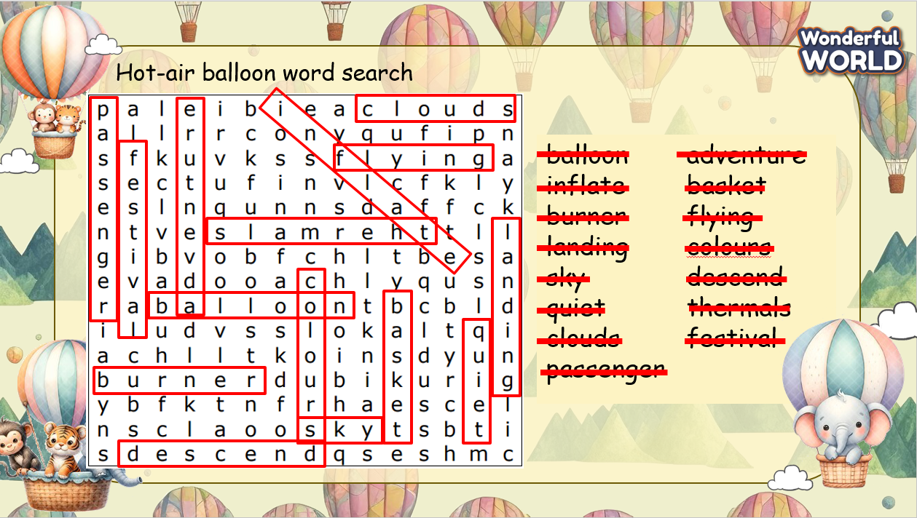  - Check with the class.  - T asks Ss about what they have learnt in today’s lesson.  - T show the wrap-up slide and conclude the lesson.  * Remember  VOCABULARY  Pilot, cloth, hot-air balloon, size |  | - Do the assessment.  - Check with the teacher.  - Answer T’s question of what they have learnt in today’s lesson.  - Ss read the wrap-up.  - Stand up and say goodbye to the teacher.
____________________________________________

REVIEW 3
Part 4 - Task 1,2,3
Period 66
I. OBJECTIVES:
1. Knowledge:
- Students learn and review how to talk about their favourite food.
- Students are confident in talking about food.
2. Competences:
- English competences: Students can talk about food in general, and their favourite food in specific.
- Common competences: Students can understand how people express their love towards favourite foods, and apply this in talking about theirs
3. Qualities:
- Students will
+ have strong confidence while talking about their favourite food in English.
II. EQUIPMENT AND MATERIALS:
- Basic things: Student’s book, flashcards, photos, papers.
- Advanced things: PPT, laptop, TV.
III. LESSON PROCEDURE:
Activity 1: Warm-up (5 minutes)
A guessing game “Cowboy game?”
Aims: Welcome students. Engage the class (or warm the class up) with a guessing word game to revive the vocabulary and lead in the new lesson.
Teacher’s Activities | Students’ Activities
Procedure
1. Greet students. Chatting…Do you like listening to music…  2. Introduce the video “Are you hungry”  - Show the question on the screen and remind Ss to pay attention and take notes if needed while watching the video  - Play the video  - Ask Ss about the topic of the video  - Ask Ss about the question, invite some Ss to show their answer  - Check the answer and ask Ss to repeat    Lead in:  - T raises some pictures and asks Ss to guess the topic of the lesson.  - T reviews the topic “Food”.  - Write on the board “Review 4” and review the words and structures of the learned lesson. | - Greet the T.  - Pay attention to the screen and remember the question  - Watch the video and take note of what they have seen  - Answer the questions  - Check the results  - Repeat after T.  - Look at the pictures and guess the topic.
Activity 2: Presentation (12 minutes)
Aims:
- Ss can read, understand, and answer the questions based on given information
- Ss can correct the information
- Ss review how to talk about favourite foods
+ Finish Task 1, 2
Teacher’s Activities |  | Students’ Activities
PRESENTATION  - Show the paragraphs on the screen, give them 3 minutes to read and understand the text  - Invite 3 Ss to read the text aloud  - Show task 2, ask Ss to think of the information they have read and finish the task  - Invite some Ss to write their answer on the board  - Check the answer. Can turn back to the paragraph to identify the position of the information  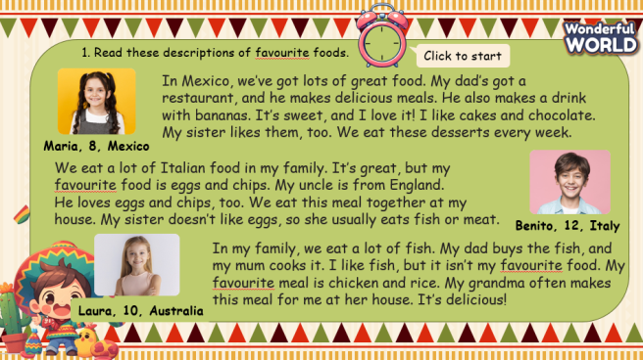  Review  - Show the extracts of the sentences that are used to describe favourite foods  - Invite some Ss to make their sentences, using the bold text on the screen  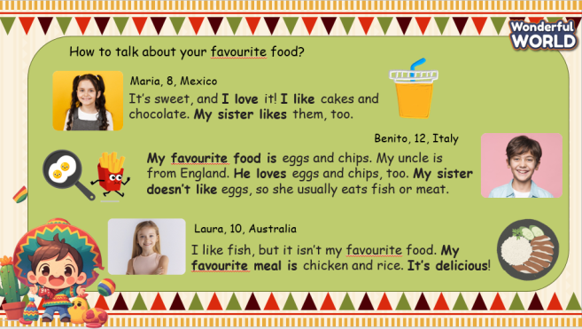 |  | - Look at the screen  - Read through all three paragraphs  - Read the text aloud  - Look at task 2 and do the task  - Write their answer on the board  - Figure out the information in the paragraph and check the answer  - Pay attention to the screen and review how the writer describes their favourite food  - Make sentences and say it aloud
Activity 3: Practice – Controlled practice (8 minutes)
Aims:
- Help Ss to remember the information they have read
- Encourage Ss to speak by asking and answering about topic's favourite food
- Encourage Ss to create a full conversation
- Join a small game to review the text
Teacher’s Activities |  | Students’ Activities
- Show each paragraph talking about your favourite food  - Encourage Ss to create questions based on the given information  - Ask Ss to work in pairs, take notes of their questions and answer  - Invite some pairs to speak in front of the class  - Ask for comments from other groups, and encourage them to ask further questions  - Give them feedback  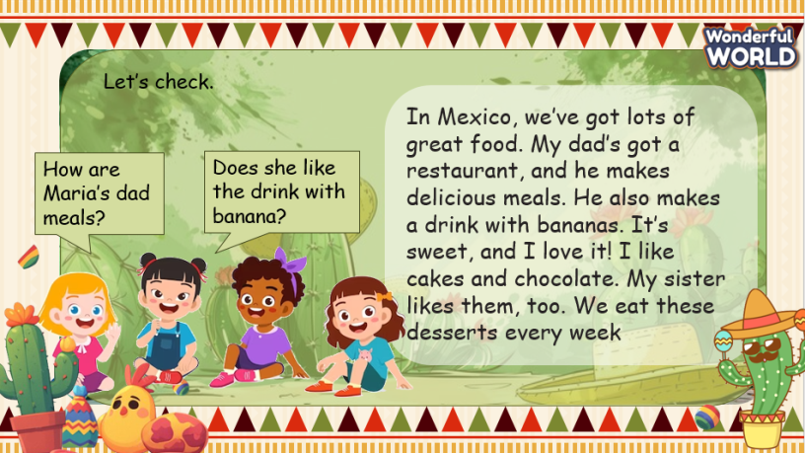  Food riddles  - T divides the class into 2 groups. Each group will choose a name and play rock, scissors, and paper to decide which group goes first.  - The two groups will take turns to answer the questions.  - Explain the rules of the game: Ss will start from 15 stars. T clicks on the rectangle to show the clue and starts the countdown.  - T reads the clue. If Ss can answer, ring the bell and give out the final one. T clicks on the magnifying glass to show the answer and clicks on the next button to move to the next one.  - If they do not have an answer, click on the 10 stars rectangle to show the second clue.  - The points that Ss get for the correct answer are based on the number of clues Ss have opened.  - The more clues, the less points.  - If the answer is incorrect, Ss get no points.  - If all three clues are opened and that team cannot answer, move to the next one.  - When the game finishes, the team with higher score will win the game.  - The team with lower score must do an exercise (hop, dance, sing, etc.).  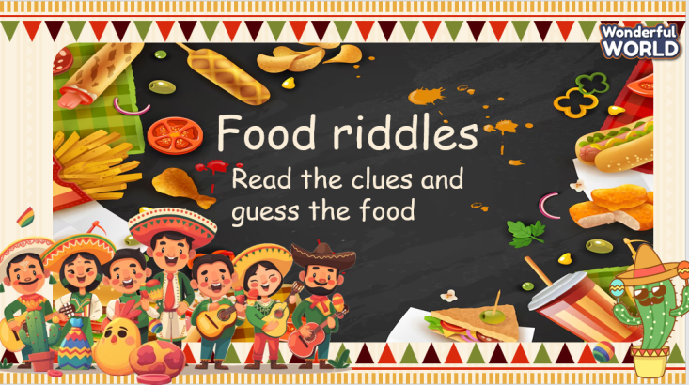 |  | - Read the text again  - Create questions based on each paragraph  - Work in pairs, create a full conversation, using the given text  - Receive feedbacks, answer further questions  - Listen to the rules of the game  - Appoint a representative to do rock, scissors, and paper to decide who goes first  - Read the clue  - If Ss can answer, ring the bell and say the answer  - If not, ask T to open the next clue  - If all three clues are opened and Ss cannot answer, move to the next team  - Check the results
Activity 4: Production – Writing & Speaking (6 minutes)
Aims:
- Apply the structures used in the paragraph to write a note about Ss’ favourite food
- Encourage Ss to introduce their favourite food to the class
- Encourage Ss to be willing to answer the extra questions
Teacher’s Activities |  | Students’ Activities
- Show the questions on the screen to help Ss create a note of their favourite food  - Instruct Ss to create a paragraph that includes the opening, body, and the closing  - Put Ss in pairs and complete the task  - Give them some minutes to do  - Invite some pairs to talk about their favourite food  - Ask for comments from the other pairs  - Give them feedback  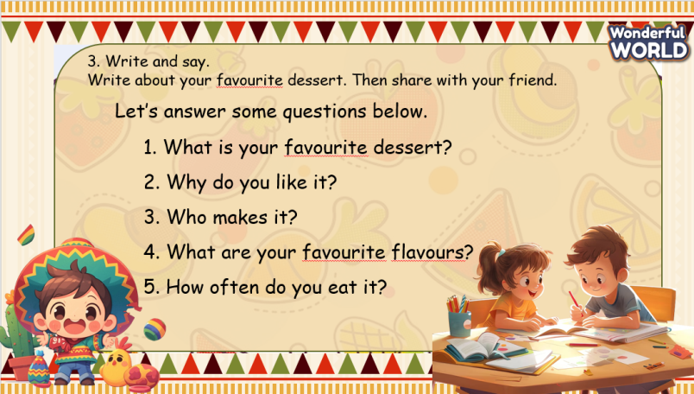 |  | - Look at the screen and work in pairs to make an introduction about their favourite food  - Complete the introduction, using the suggestion on the screen  - Speak in front of the class  - Make comments for the speaker  - Speaker: answer the extra questions  - Receive feedback.
Activity 5: Wrap up & Assessment (4 minutes)
Teacher’s Activities |  | Students’ Activities
Aims:
- Check Ss’s understanding of what they have learned.
- Students rehearse what they have learned in the lesson.
- Ask Ss to do the assessment.  - Give the assessment to the class and some Ss.  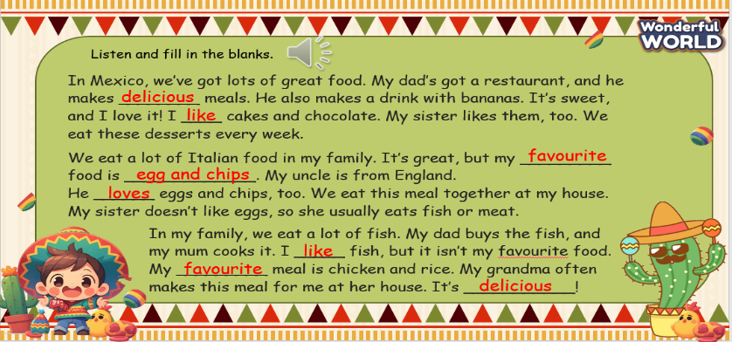  - Check with the class.  - T asks Ss about what they have learnt in today’s lesson.  - T shows the wrap-up slide and concludes the lesson.  * Remember  STRUCTURE  - My favourite food is ___.  - It’s delicious! / It’s great!  - I often eat it with ___.  - I often eat it in ___. |  | - Do the assessment.  - Check with the teacher.  - Answer T’s question about what they have learnt in today’s lesson.  - Ss read the wrap-up.  - Stand up and say goodbye to the teacher.

End of semester review
Period 67

I. OBJECTIVES:
1. Knowledge:
- Students review the vocabularies and structures from Unit 1 to Unit 6 .
- Students are confident in practising about four skills.
2. Competences:
- English competences: Students can talk about the topics from unit 1 to unit 6.
- Common competences: Students can understand how people express their love towards favorite topics, and apply this in talking about theirs
3. Qualities:
- Students will
+ have strong confidence while talking about the topics in English.
II. EQUIPMENT AND MATERIALS:
- Basic things: handout.
- Advanced things: PPT, laptop, TV.
III. LESSON PROCEDURE:
PART I:Listening
Question 1 : Listen and circle the sentences you hear (1pt)
1. |  | A. Lan’s hair is green.
1. |  | B. Lan’s hair is brown.
2. |  | A. I went to a festival last weekend.
 |  | B. I went to a birthday party last weekend.
3. |  | A. My mother did a lot of cooking before Tet holiday.
3. |  | B. My mother did a lot of housework before tet holiday.
4. |  | A. They play happily together.
 |  | B. They play happy together.
Question 2: Listen and fill the blank (1pt)
1. Two blue balls are ....................the chair.
under inside below
2. There is a ...........................red ball in the middle of the room.
big small large
3. I like ..........................things. I’m good at making a paper birD.
doing making collecting
4. She is good at playing football.She .............................playing outside every day.
likes loves enjoys
Question 3: Listen to the question and circle the correct answer (1pt)
1. A. She has maths on Mondays. 2. A. She starts her lesson with her friends.
B. She has English on Wednesdays. B. She starts her lesson at 8 o’clock.
C. She has geography on Tuesdays. C. She does her homework at weekends.
3. A. We need some butter 4. A. Yes, I do.
B. No, I don’t. B. No, I want to make a salaD.
C. Ok then. C. I love salaD.
Question 4. Listen and Match (1pt)
1. My father often .......................................... | A. 
2. I’ve got a box of ................................... | B. 
3. There are ................................. on the wall of my living room. | C. 
4. I need to buy a lot of .................... for the family party on Christmas Eve. | D. 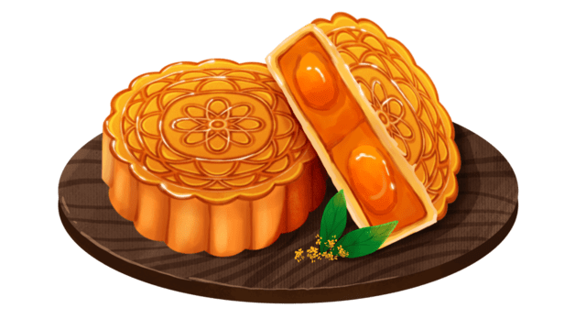

PART II . Reading and writing
Question 5: Odd one out (1.5 pts)
1 | A. bread | B. cupcakes | C. butter | D. chocolate
2 | A. sour | B. spicy | C.salty | D. food
3 | A. how | B. many | C. much | D. a lot of
4 | A. map | B. above | C. globe | D. ball
5 | A. computer | B. like | C. puzzle | D. typewriter
6 | A. was | B. were | C. are | D. but

Question 6 . Chosse the best answer (1.5 pts)
1. ………….. does she start her lesson at school? - At 8 o’clock.
A. What B. When C. Who D. How often
2. Let’s ___________________ for the bright future.
A. hopes B. hoping C. hoped D. hope
3. She ___________________ art class on Thursdays.
A. had B. have C. has D. is having
4. How often do you go to science clubs? –………………...
A. Every Saturday B. At 7 A.m. C. On Monday D. At home
5. Last Mid-Autumn Festival, we……………………on a parade.
A. make lanterns B. have C. went D. make Banh Chung
6. He ___________________ lunch at school.
A. have usually B. usually have C. usually has D. has usually
Question 7: Find and circle the mistakes. (1pt)
1. My sister runs very slowly. She is a slowly runner.
A B C D
2. Her mother hair is black, and her eyes are brown
A B C D
3. Mike help his uncle at the restaurant at the weekends.
A B C D
4. I love reading comic books, and I don’t like making things
A B C D
Question 8. Read the passage and circle the correct answer (1pt)
Do you go to school (1)……….. Saturday or Sundays? In Vietnam, children don’t go to school at the weekenD. What do they often do on those days? A lot of children stay at home and (2)……………their homework. They work very harD. Some children like football or going (3)………….. When they stay at home they love listening to music, watching films or reading……………..There are a lot of things for them to do when they don’t go to school.
1. A. at B. on C. in D. from
2 A. work B. make C. do D. read
2. A. swim B. to swim C. swims D. swimming
4. A. cartoons B.films C. dolls D. comic books
Question 9. Arrange the words to make sentences (1pt)
1. and / Computers / fun / exciting / are /./
_____________________________________________________________
2. often / he / How / fishing / go / does /?/
_____________________________________________________________
3. Clara / music / Does / usually / have / Tuesdays / on /?/
____________________________________________________________
4. Many students / their / Japan / 3.50 p.m. / in / finish / class / at/./
____________________________________________________________

End of semester review
Period 68
I. OBJECTIVES:
1. Knowledge:
- Students review the vocabularies and structures from Unit 1 to Unit 6 .
- Students are confident in practising about four skills.
2. Competences:
- English competences: Students can talk about the topics from unit 1 to unit 6.
- Common competences: Students can understand how people express their love towards favorite topics, and apply this in talking about theirs
3. Qualities:
- Students will
+ have strong confidence while talking about the topics in English.
II. EQUIPMENT AND MATERIALS:
- Basic things: handout.
- Advanced things: PPT, laptop, TV.
III. LESSON PROCEDURE:
PART I. LISTENING
Question 1. Listen and circle the sentences you hear (1pt)
1. A. The Mid-Autumn Festival is on the 15th day of the eighth lunar month.
B. Christmas Day is on the 25th of December every year.
C. People eat mooncakes during the Mid-Autumn Festival.
2. A. We went to birthday party last weekend.
B. We had a lot of work during Christmas.
C. I had some flowers from my parents on my birthday.
3. A. Everyone did housework and cleaned their rooms to prepare for Tet holiday.
B. Everyone decorated the house and bought new clothes for Tet holiday.
C. Everyone had a nice time with their family on Tet holiday holiday.
4. A. She wants to make a cake for her birthday.
B. There are four mooncakes in the photo.
C. My mother did a lot of housework before Tet holiday.
Question 2. Listen and fill in the blank with the correct answer. (1pt)
1. I like ________________________and watching movies in my free time.
a. reading comic books b. reading story c. playing the guitar d. swimming
2. I _______________play the piano in the living room.
a. sometimes b. usually c. often d. always
3. She is good at going_____________________.
a. swimming b. skiing c. fishing d. ice- skating
4. She _____________playing the guitar.
a. likes b. enjoys c. loves d. love
Question 3. Listen to the questions and circle the correct answers (1pt)
1. a. He goes to science clubs by bus.  b. He goes to science clubs every Fridays.  c. He goes to science clubs with his friend. | 2. a. I go to bed early.  b. I go to bed in my bedroom.  c. I go to bed at 10 o’clock.
3. a. He practises sport at 3 p.m.  b. He goes to science clubs at 8 a.m.  c. He does his homework at 9 p.m. | 4. a. I start English lessons early.  b. I start English lessons at my class.  c. I start English lessons at 10 o’clock.
Question 4. Listen and match. (1pt)
1. They eat mooncakes | a. into the streets with powder and paint.
2. In the Holi festival last year, they went | b. the celebration on the first evening.
3. I usually make colourful | c. on Mid-Autumn Festival.
4. There are bonfires to start | d. lanterns during the Mid-Autumn Festival.

PART II. READING AND WRITING
Question 5. Odd one out (1.5pt)
1. a. puzzle | b. puppet | c. kite | d. country
2. a. above | b. violin | c. below | d. inside
3. a. bowl | b. bread | c. cupcake | d. spaghetti
4. a. plate | b. bowl | c. meatball | d. glass
5. a. cucumber | b. sweet | c. salty | d. spicy
6. a. crispy | b. broccoli | c. delicious | d. tasty
Question 6. Read and choose the best answer (1.5pts)
1. How ______ do you do your homework? -I do my homework every evening.
a. time b. often c. much d. many
2. I go to science clubs ______ 7 a.m. ______ Sundays.
a. at - on b. on- at c. in - on d. on - in
3. My sister ____________ her lessons at 8 a.m.
a. start b. starts c. staring d. is
4. People often eat ___________ during the Mid – Autumn Festival.
a. mooncakes b. Chung cake c. birthday cake d. cupcakes
5. The Holi is a big ____________ at the end of winter.
a. meal b. festival c. season d. time
6. My mother ____________ a lot of housework before Tet holiday.
a. went b. played c. did d. watched

Question 7: Find and circle the mistakes. (1pt)
1. Do we go on a ride, Mum? – Yes, you can but you should ride it slowly and carefully.
A B C D
2. My brother’s hair is black and his eyes is brown.
A B C D
3. On Sundays, Mary go to the amusement park with her friends..
A B C D
4. She loves collecting stamps and I like make paper birds.
A B C D
Question 8. Read the passage and circle the best answer(1pt)
I love reading. When I have free time, I always read my favouirte books. I love to read comic books at the (21) _______. That is a great way to pass the time. I also love (22) _________ to music and dancing. I’m good (23) _______going ice-skating. I practise it in my free time. I also enjoy going fishing with my dad when we visit our grandparents. Of course, I also (24) ________ the piano.
1.a. cinema b. zoo c. restaurant d. bookshop
2. a. read b. collecting c. listening d. watch
3. a. at b. for c. with d. from
4. a. do b. play c. make d. sing
Question 9. Arrange the words to make sentences (1pt)
1. on/ practice/ Sundays/ I/ usually /sports/.
____________________________________________________________
2. often / he / How / piano / play / does / the ?
____________________________________________________________
3. brother / maths / My / the/ studies / afternoon / in / always.
___________________________________________________________
4. she / English / Does / usually / have / Thursdays/ Monday / on / and ?
__________________________________________________________

