TUẦN 18 Khối 3, 5 (Từ ngày 06/01/2025 đến ngày 10/01/2025)
THỨ | TIẾT | MÔN | TIẾT THỨ | NỘI DUNG BÀI DẠY |  | UDCNTT | ĐỒ DÙNG DẠY HỌC
Hai  06/01 | 1 | 5A | 69 | End of semester Test | Do the test
Hai  06/01 | 2
Hai  06/01 | 3 | 3A | 69 | End of semester Test | Do the test
Hai  06/01 | 4 | 3A | 70 | End of semester Test | Correct the test
Hai  06/01 | 5 | 5D | 69 | End of semester Test | Do the test
Hai  06/01 | 6 | 3B | 69 | End of semester Test | Do the test
Hai  06/01 | 7
Ba  07/01 | 1 | 5C | 69 | End of semester Test | Do the test
Ba  07/01 | 2 | 5B | 69 | End of semester Test | Do the test
Ba  07/01 | 3 | 5A | 70 | End of semester Test | Correct the test
Ba  07/01 | 4
Ba  07/01 | 5 | 3A | 71 | Unit 6. My body | Lesson 1 (1, 2, 3) | Wonderfulworld | Flashcards, TV, books
Ba  07/01 | 6 | 5D | 70 | End of semester Test | Correct the test
Ba  07/01 | 7 | 3B | 70 | End of semester Test | Correct the test
Tư  08/01 | 1 | 5A | 71 | Unit 7. Sports | Lesson 1 (1, 2, 3) | Wonderfulworld | Flashcards, TV, books
Tư  08/01 | 2
Tư  08/01 | 3
Tư  08/01 | 4
Tư  08/01 | 5 | 5B | 70 | End of semester Test | Correct the test
Tư  08/01 | 6 | 5C | 70 | End of semester Test | Correct the test
Tư  08/01 | 7
Năm  09/01 | 1 | 5C | 71 | Unit 7. Sports | Lesson 1 (1, 2, 3) | Wonderfulworld | Flashcards, TV, books
Năm  09/01 | 2 | 5B | 71 | Unit 7. Sports | Lesson 1 (1, 2, 3) | Wonderfulworld | Flashcards, TV, books
Năm  09/01 | 3 | 5A | 72 | Unit 7. Sports | Lesson 1 (4, 5, 6) | Wonderfulworld | Flashcards, TV, books
Năm  09/01 | 4
Năm  09/01 | 5 | 5D | 71 | Unit 7. Sports | Lesson 1 (1, 2, 3) | Wonderfulworld | Flashcards, TV, books
Năm  09/01 | 6 | 5C | 72 | Unit 7. Sports | Lesson 1 (4, 5, 6) | Wonderfulworld | Flashcards, TV, books
Năm  09/01 | 7
Sáu  10/01 | 1 | 3B | 71 | Unit 6. My body | Lesson 1 (1, 2, 3) | Wonderfulworld | Flashcards, TV, books
Sáu  10/01 | 2 | 5D | 72 | Unit 7. Sports | Lesson 1 (4, 5, 6) | Wonderfulworld | Flashcards, TV, books
Sáu  10/01 | 3 | 5B | 72 | Unit 7. Sports | Lesson 1 (4, 5, 6) | Wonderfulworld | Flashcards, TV, books
Sáu  10/01 | 4
Sáu  10/01 | 5
Sáu  10/01 | 6 | 3B | 72 | Unit 6. My body | Lesson 1 (4, 5, 6) | Wonderfulworld | Flashcards, TV, books
Sáu  10/01 | 7 | 3A | 72 | Unit 6. My body | Lesson 1 (4, 5, 6) | Wonderfulworld | Flashcards, TV, books

WEEK 18.
END OF SEMESTER 1 TEST
Period 69 + 70
I. OBJECTIVES:
Do and correct the test
II. EQUIPMENT AND MATERIALS:
- Basic things: handout.
- Advanced things: Laptop, TV.
III. LESSON PROCEDURE:

UBND HUYỆN VĨNH BẢO  TRƯỜNG TH VĨNH AN | ĐỀ KHẢO SÁT CHẤT LƯỢNG CUỐI HỌC KỲ I  MÔN TIẾNG ANH LỚP 3  NĂM HỌC 2024 – 2025  (Thời gian làm bài: 40 phút)
Name: …………………………. Class: ……………………….
Question 1 : Listen and number (1pt)
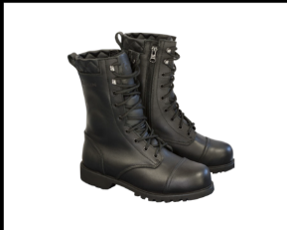
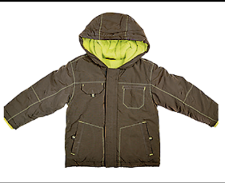

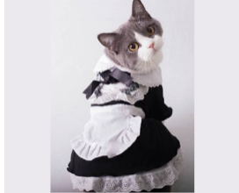

a. | b. | c. | d.
Question 2: Listen and circle the correct picture. (1pt)



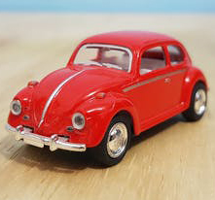




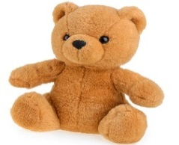
1. 2.
A
B
A
B
A
B
A
B

3. 4.

Question 3. Listen and tick the word. (1pt)
1. This is ……………………………  giraffe monkey | 2. That is ……………………………  dog lion
3. These are ………………………  monkeys elephants | 4. Those are ……………………………  giraffes rabbits
Question 4. Listen to the question and choose the correct answer. (0.5pt)
1. A. No, I don’t B. Yes, I have. C. Yes, it is
2. A. No, there isn’t B. Yes, it is. It’s a coat. C. Yes, it isn’t
Question 5: Odd one out (1.5 pts)
1. a. skirt | b. dress | c. hat | d. trousers
2. a. turtle | b. whale | c. monkey | d. shark
3. a. green | b. blue | c. orange | d. come
4. a. homework | b. board | c. desk | d. chair
5. a. funny | b. cousin | c. short | d. young
6. a. lamp | b. TV | c. computer | d. kitchen
Question 6. Choose the best answer. (1.5pts)
1..............they pencils ?
a. Is b. Am c . Are d. Do
2.They're ............. They're green
a.door b. chair c. table d. desks
3. There..........two bedrooms in my house.
a. is b. are c . this d. these
4. Is Hoa a teacher ? – No, she ……………………….
a is. b. does c. do d. isn’t
5. My sister ...........got a red skirt .
a. is b. has c. have d. are
6. Laura has got a brother……………..name is Brandon.
a. her b. my c. his d. he
Question 7. Choose the words from the box (1.5pts)
parrot - family - orange - old - mum - is
Hello, My name (1) …………………. Tung. I’m eight years (2) …………... This is a picture of my (3) …………………. This is my dad. His name is Hai. This is my (4) ………………. Her name is Mai. We live in a big house. I have a (5) ……………………………….in my house. Its colour is blue and (6) ……. I love my pet very much.
Question 8. Arrange the words to make sentences (1 pt)
1. are / those / cats.
___________________________________________________________
2.she / got / Has / blue / a / dress/ ?
___________________________________________________________
3. are / the / The / in / birds / garden / .
______________________________________________________________
4. aren’t / The / garden / in / giraffes / the /
____________________________________________________________

Question 9. Look and write (1 pt)
1.  | 2.  | 3.  | 4.  

ĐÁP ÁN
UBND HUYỆN VĨNH BẢO  TRƯỜNG TH VĨNH AN | ĐỀ KHẢO SÁT CHẤT LƯỢNG CUỐI HỌC KỲ I  MÔN TIẾNG ANH LỚP 3  NĂM HỌC 2024 – 2025  (Thời gian làm bài: 40 phút)
Question 1: Listen and number (1pt)
1 – c 2 – d 3 – a 4 - b
Question 2: Listen and circle the correct pictures (1pt)
1 – b 2 – b 3 – a 4 – a
Question 3: Listen and tick the word. (1pt)
1. giraffe 2. lion 3. monkeys 4. rabbits
Question 4: Listen to the question and choose the correct answer. (0.5pt)
1. b 2. b
Question 5: Odd one out (1.5 pts)
1. d 2. c 3. d 4. a 5. c 6. d
Question 6: Choose the best answer. (1.5pts)
1. c 2. d 3. b 4. d 5. a 6. c
Question 7: Choose the words from the box (1.5pts)
1. is 2. old 3. family 4. mum 5. parrot 6. orange
Question 8: Arrange the words to make sentences (1 pt)
1. Those are cats.
2. Has she got a blue dress?
3. The bird is in the garden.
4. The giraffes aren’t in the garden
Question 9: Look and write (1 pt)
1. living room 2. bathroom 3. computer 4. lamp
____________________________________

UNIT 6. MY HOBBY
Lesson 1. Task 1, 2, 3
Period 71
I. OBJECTIVES:
1. Knowledge:
Students will learn the words related to the topic Hobby: cook, read, speak English, swim, and write
2. Competences:
- English competences: Students will be able to talk about the actions; ask and answer about places they are in.
- Common competences: Students will have opportunity to develop the creativeness in drawing and the autonomy in doing tasks.
3. Qualities:
Sts are given opportunities to think about good activities to develop their working responsibility.
II. EQUIPMENT AND MATERIALS:
- Basic things: Student’s book, flashcards, crayons.
- Advanced things: PPT, projector/interactive whiteboard/laptop/TV.
III. LESSON PROCEDURE:

Activity 1: Warm up (5 minutes)
Teacher’s activities | Student’s activities
Game: Quick eyes and quick hands  (Print 6 Unit opener (UO) pictures and cut each picture into 4 pieces. Groups put the pieces together to make a picture and stick it on the board. The group that has a picture correctly and fast will be the winner)  - Divide the class into 6 groups  - Set the game rules  - Hand each group 4 pieces of UO picture  - Ask students to put the pieces together and stick the picture on the board.  - Show the UO picture and check in front of the class  - Award the best groups  Lead in: Use the Opener picture to lead in the topic: My hobby  - Ask students to look at the picture and answer some questions:  What are they doing?  What can you see?  - Ask students to read 4 words: hat, T-shirt, yellow, green and tick the box.  - Introduce the children with musical instruments in Rio de Janeiro, Brazil to students. | - Sit in 6 circles  - Listen to the game rules carefully  - Receive pieces of picture  - Play game  - Look and check  - Look at the picture and answer:  Playing musical instruments  Children, boy, girl, hat, T-shirt…  - Read and tick  - Listen to the teacher.
Activity 2: Presentation (8 minutes)
Teacher’s activities | Student’s activities
Task 1: Listen and point. Repeat. (Track 6.1)  - Use the flashcards and do the actions to introduce the vocabulary: cook, read, speak English, swim, write  - Play the words one by one  - Play the track 6.1, ask students to listen and repeat in chorus, groups.  - Put the 5 flashcards in 5 different corners around the room.  - Say a word for students to repeat then point.  - Vocabulary checking: read a word and show all flashcards one by one continuously. Students say: “Stop!” when they see the correct flashcard and read the word again. | - Learn new words through flashcards and actions  - Listen  - Repeat the words  - Repeat then point.  - Listen, look and say the word.
Activity 3: Practice (12 minutes)
Teacher’s activities | Student’s activities
Task 2: Listen and tick (Track 6.2)  Lead-in: Introduce the listening task  - Show 2 characters Alex and Sophie and ask students to identify their name.  - Show the picture of task 2  - Ask students to look at the picture and answer:  Who is this?  Where is he?  What is he doing?  - Ask students to read 2 questions and guess the answer before listening:  1. Is that her cousin?  2. Is he in the kitchen?  - Play track 6.2 and ask students to listen.  - Play track 6.2 again for students to give the answer  - Play the audio again and ask students to do cross-check  - Show the bubbles  - Show the content one by one and ask students to repeat  - Play role  - Some pairs perform in front of the class  Task 3: Let’s play! Use the words in 1.  Game: The hot chair game  (Put a chair in front of class. It’s called hot chair. A student chooses a flashcard, sits on the hot chair and say the word aloud. The rest of students ask some Yes–No questions to guess where he/she is. The student guesses the word correctly and fast will get points.)  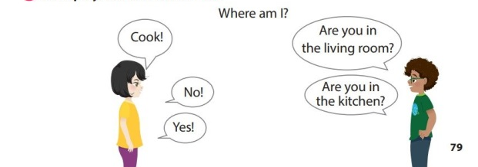  - Introduce and set game rules  - Do a demo  - Play several rounds. | - Listen to the listening instruction carefully  - Identify the name of 2 characters  - Look at the picture  - Look and give answers:  It’s a boy  In kitchen  Cook  - Read and guess Yes or No  - Listen to the audio  - Listen to the audio and tick the answer  - Do cross-check  - Read aloud the sentences  - Listen and repeat  - Play role  - Perform the dialogue with a peer  - Listen carefully  - Look  - Play game
Activity 4: Production (7 minutes)
Teacher’s activities | Student’s activities
Draw and say.  - Draw a picture of action quickly and ask students to say.  - Ask students to draw an action, show it to their friend and say the word. | - Look and guess  - Draw and say
Activity 5: Assessment (3 minutes)
Teacher’s activities | Student’s activities
- Ask students to do the assessment.  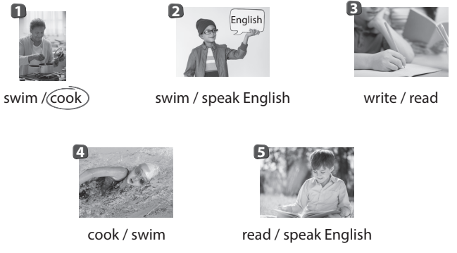  Look and circle  - Check in pair then whole class.  - Say goodbye | - Do the assessment.  - Check with friends and then with teacher and whole class.  - Say goodbye.
____________________________________
UNIT 6. MY HOBBY
Lesson 1. Task 4, 5, 6
Period 72
I. OBJECTIVES:
1. Knowledge:
Students will learn the structure I/ he/ she/ we/ they can……
2. Competences:
- English competences: Students will be able to talk about the actions that they can do.
- Common competences: Students will have opportunity to develop the creativeness in making big mind map and the autonomy in doing tasks.
3. Qualities:
- Students are confident when talk about what they can do in front of class.
- Students are given opportunities to think about good activities to develop their working responsibility.
II. EQUIPMENT AND MATERIALS:
- Basic things: Student’s book, flashcards, crayons, 4 papers (A1), glue
- Advanced things: PPT, projector/interactive whiteboard/laptop/TV.
III. LESSON PROCEDURE:
Activity 1: Warm up (5 minutes)
Teacher’s activities | Student’s activities
- Greet students  Game: Swimming race  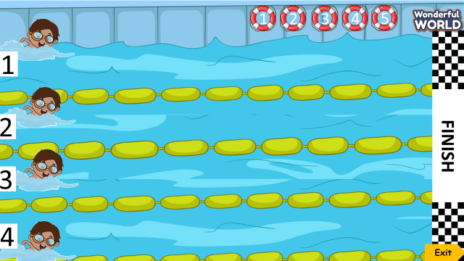  (There are 5 questions. Groups choose and answer questions. Each correct answer will help the swimmers swim forward. The swimmer of the group that reaches the finish line first will be the winner.  - Divide class into 4 groups  - Set the game rules  - Play as a model.  - Have students play in turns.  - Award the best groups  Lead in: Use the pictures of the game to lead in the new lesson. | - Greet teacher  - Sit in 4 groups  - Listen to the game rules  - Look  - Join to the game  - Listen
Activity 2: Presentation (8 minutes)
Teacher’s activities | Student’s activities
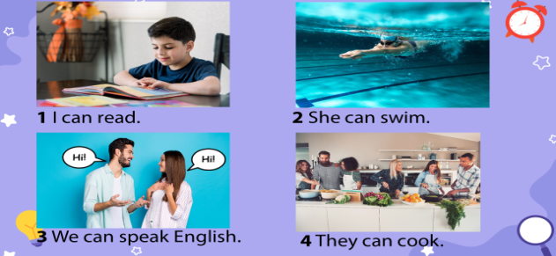  Task 4: Listen and repeat. (Track 6.3)  - Ask students to point and say the actions in each picture.  - Present the structure: I/she/we/they can….  - Play the track 6.3 and ask students to listen.  - Play the track 6.3 again, ask students to listen and repeat in chorus, groups.  - Structure checking:  + Prepare 4 sets of word cards:  I  can  she  we  they  read  swimm  speak English  cook  + Divide the class into 4 groups  + Set the game rules  + Hand each group a set of word cards.  + Play audio, ask students to listen and match the word cards to make the sentence. Then stick it on the board. The group that has a sentence correctly and fast will be the winner.  - Show the correct sentence and check in front of the class.  - Award the best groups | - Point and say: 1 read, 2 swim, 3 speak English, 4 cook  - Learn the structure.  - Listen  - Listen and repeat  - Listen the game rules  - Receive a set of word cards  - Listen, make the sentences and stick it on the board.  - Look and check
Activity 3: Practice (12 minutes)
Teacher’s activities | Student’s activities
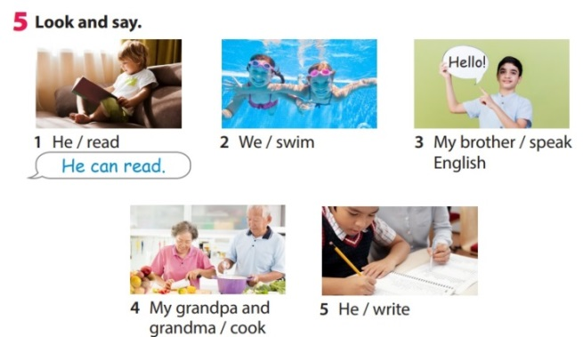  Task 5: Look and say.  - Show the pictures in task 5  - Ask students to look at the picture and identify people and actions in each picture.  - Ask students to read the words under each picture.  - Have students look at the pictures, point and say in chorus, group, pairs, using … can ….  Suggested answers:  1 He can read.  2 We can swim.  3 My brother can speak English.  4 My grandpa and grandma can cook.  5 He can write. | - Look at the picture  - Identify people and actions: 1 He/read, 2 two girls (we)/swim, 3 boy/ speak English, 4 grandpa and grandma/ cook, 5 boy/ write  - Read the words under each picture.  - Look at the pictures, point and say in chorus, group, pairs, using … can ….
Activity 4: Production (7 minutes)
Teacher’s activities | Student’s activities
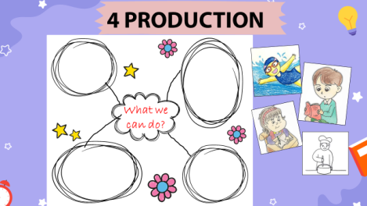  Task 6: Let’s talk  - Divive class in to 4 groups  - Hand each group a big paper (size A1) and ask students to decorate it to make a mind map with the topic What we can do.  - Ask students to stick the pictures that they drew in the task 3 of the previous lesson on the map.  - Ask students to show their mind map and talk about what they can do. | - Sit in 4 groups  - Receive the paper and decorate it to make a mind map  - Stick the pictures on their mind map  - Show their mind map and talk.
Activity 5: Assessment (3 minutes)
Teacher’s activities | Student’s activities
- Ask students to do the assessment.  Choose the correct answer:  - can/ write/ I/.  A. I write can. B. I can write.  - swim/ he/ can/.  A. He can swim. B. Swim can he.  - sister/ cook/ can/ My/.  A. Can my sister cook. B. My sister can cook  - Check in pair then whole class.  - Say goodbye | - Do the assessment.  Answers:  1-B, 2-A, 3-B  - Check with friends and then with teacher and whole class.  - Say goodbye.
____________________________________
GRADE 5
WEEK 18
End of semtester Test
Period 69 + 70

I. OBJECTIVES:
Do and correct the test
II. EQUIPMENT AND MATERIALS:
- Basic things: handout.
- Advanced things: Laptop, TV.
III. LESSON PROCEDURE:

UBND HUYỆN VĨNH BẢO  TRƯỜNG TH VĨNH AN | ĐỀ KHẢO SÁT CHẤT LƯỢNG HỌC KỲ I  TIẾNG ANH LỚP 5  NĂM HỌC 2024 - 2025  (Thời gian làm bài: 40 phút)
PART I. LISTENING
Question 1. Listen and circle the sentences you hear (1pt)
1. a. My brother is funny  b. My father is friendly  c. My mother is happy | 2. a. My sister is noisy  b. My sister is clever  c. My sister is friendly
3. a. My sister is a careful runner  b. My sister is a slow runner  c. My sister is a quick runner | 4. a. They play well together  b. They play happily together  c. They play happy together
Question 2. Listen and fill in the blanks (1pt)
1. Computers are ___________________ anfd fun.
expensive exciting interesting boring
2. My ___________________is green and black.
watch puzzle clock typewriter
3. The magazine is new, but It’s ___________________
exciting boring beautiful wonderful
4. This book is interesting, ___________________ It’s expensive.
so and because but
Question 3. Listen to the questions and circle the correct answers (1pt)
1. ___________________________?  a. Yes, she does. She has English on Mondays.  b. She has English on Mondays  c. No, she doesn’t. She has English on Mondays. | 2._________________________?  a. She has Geography at 3.50 on Tuesdays  b. Yes, she does  c. No, she doesn’t. She has Music at 3.50
3.___________________________?  a. She starts her lessons with her classmates.  b. She starts her lessons at school  c. She starts her lessons at 8 a.m | 4. ____________________________?  a. She has maths in the morning.  b. She has maths every Wednesday.  c. She has maths on Wednesdays.

Question 4. Listen and Match. (1pt)
1. My father often ______________ | a. 
2. I’ve got a box of _____________ | b. 
3. There are _________________ on the wall of my living room. | c. 
4. I need to buy a lot of _____________ for the family party on Christmas Eve. | d. 

PART II. READING AND WRITING
Question 5. Odd one out (1.5pt)
1. a. above | b. inside | c. near | d. scare
2. a.morning | b. exciting | c. boring | d. expensive
3. a. meal | b. breakfast | c. lunch | d. dinner
4. a. rice | b. milk | c. juice | d. lemonade
5. a. photo | b. puzzle | c. finish | d. computer
6. a. crispy | b. sour | c. spicy | d. spaghetti
Question 6. Read and choose the best answer (1.5pts)
1. Let’s ___________________ for the bright future.
a. hopes b. hoping c. hoped d. hope
2. He ___________________ a lot of work last Christmas.
a. had b. have c. has d. haves
3. People usually ___________________before Vietnamese Lunar New Year.
a. make lanterns b. wear new clothes c. throw powder d. make Banh Chung
4. Minh ___________________ breakfast with his parents
a. have usually b. usually have c. usually has d. has usually
5. ___________________ do you go swimming? – Every Thursday.
a. What b. When c. How often d. How
6. When does she start her lesson at school? - ___________________
a. always b. in the classroom c. by car d. at 7.30 a.m
Question 7: Find and circle the mistakes. (1pt)
1. Mary is a well swimmer. She can swim well
A B C D
2. My sisters eyes are black and her hair is brown
A B C D
3. On Sundays, Tom help his dad at the restaurant.
A B C D
4. I love reading comic books, but I don’t like make a paper bird
A B C D
Question 8. Read the passage and circle the best answer(1pt)
Hello, my name is Mai. I live in Hue city with my parents and my brother, Quang. He’s six years old. I’m good at (1)__________________, and it is my favourite activity. I often (2) __________________ swimming with my mum on Sunday afternoons. I like swimming because It’s fun. My brother is quite young. So he often stays at home. He can (3) __________________ or play football with my dad. My brother is really good at playing sports. He also enjoys (4) __________________ things.
1. a. swim b. swam c. swimming d. swiming
2. a. go b. goes c. going c. went
3. a. watching b. watch c. watched d. watches
4. a. makes b. making c. made d. to make
Question 9. Arrange the words to make sentences (1pt)
1. play / We / the / football / weekends / at.
______________________________________________________________
2. often / she / How / swimming / go / does?
____________________________________________________________
3. students / Japan / their / 7 a.m / Many / in / start / lessons / at.
______________________________________________________________
4. Linda / English / Does / usually / have / Tuesdays / on?
_____________________________________________________________

ĐÁP ÁN
UBND HUYỆN VĨNH BẢO  TRƯỜNG TIỂU HỌC VĨNH AN  (Đề đề xuất) | ĐỀ KHẢO SÁT CHẤT LƯỢNG HỌC KÌ I  MÔN TIẾNG ANH LỚP 5  NĂM HỌC 2024 - 2025  (Thời gian làm bài : 40 phút)
PART I : Listening
Question 1: (1pt)
4 câu x 0,25 = 1đ
1.a 2. ab 3. b 4. b
Question 2: (1pt)
4 câu x 0,25 = 1đ
1. exciting 2.watch 3. boring 4. but
Question 3: (1pt)
4 câu x 0,25 = 1đ
1. c 2. a 3. c 4. b
Question 4: (1pt)
4 câu x 0,25 = 1đ
1b 2.a 3.d 4. c
PART III : Reading and writing
Question 5: (1,5pt)
6 câu x 0,25 = 1,5đ
1.d 2.a 3. a 4. a 5. c 6. d
Question 6: (1,5pts)
- câu x 0,25 = 1,5đ
1. d 2. a 3. d 4. c 5. c 6. d
Question 7: (1pt)
4 câu x 0,25 = 1đ
1. b 2. a 3. c 4. c
Question 8: (1,25 pt)
4 câu x 0,25 = 1đ
1 c 2 a 3 b 4 b
Question 9: Arrange the words to make sentenmces (1,5pt)
4 câu x 0,25 = 1đ
- We play football at the weekend
- How often does she go swimming?
- Many students in Japan start their lessons at 7 a.m.
- Does Linda usually have English on Tuesdays?

UNIT 7: Sports
Lesson 2 - Part 1,2,3
Period 71

I. OBJECTIVES:
1. Knowledge:
Vocabulary:
- New words related to sport: control, fight, kick, mind, movement
- Listening and reading a dialogue about taekwondo.
2. Competences:
By the end of the lesson, students will be able to recognize new vocab and use vocab to talk about taekwondo.
3. Qualities:
- Students have a deeper insight into a particular sport.
- Students will be confident and active in communicating with friends and teachers.
II. EQUIPMENT AND MATERIALS:
- Basic things: Student’s book, flashcards.
- Advanced things: PPT, laptop, TV.
III. LESSON PROCEDURE:
 | Activity 1: Warm-up (5 minutes)
 | Teacher’s Activities | Students’ Activities
Aims:- Welcome students, and engage the class with a game “Order the words to make a sentence”.
Warm-up activity to review the present continuous tense.
 | b, Procedure  - Greet students.  - Divide the class into many teams. Each team chooses their team names.  - Ask students to look at the words to rearrange the right sentence.  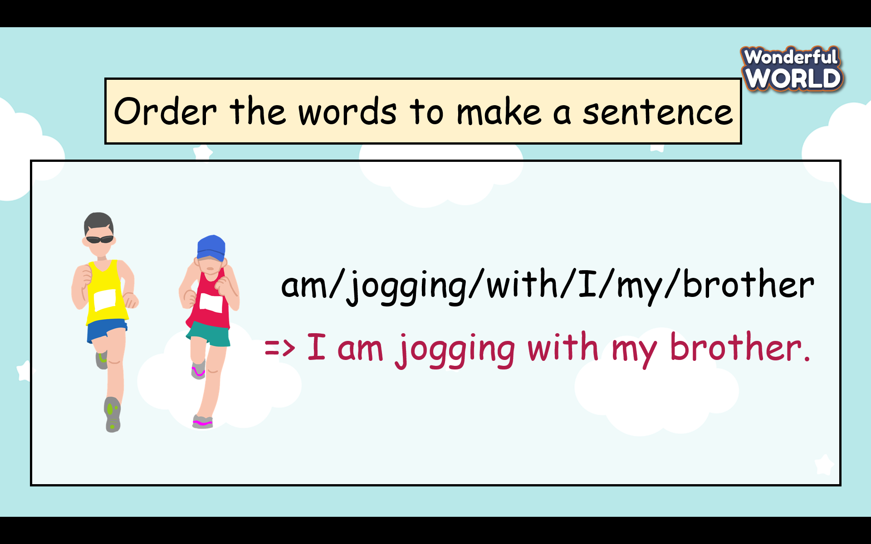  - T gives stars for the correct answer. | - Greet Teacher  - Choose the team name  - Join the activity.  - Look carefully and write the answers.  - Read the answers in front of the class.
Activity 2: Presentation (7 minutes)
Teacher’s Activities |  | Students’ Activities
- Aim: Learn vocabulary about taekwondo and practice the listening skill.
b, Procedure  Task 1 Listen and read. Then circle the correct words. TR: 7.4  -Before listening the teacher asks students to look at the picture and describe what they see in the picture.   + Where is it?  + What are they doing?  Are they young people or old people?  + Do you know the name of this sport?  - Ask students to watch a video about taekwondo.  - Ask students to look at a short dialogue and play the recording twice.  - Have students listen and read it as a group and in pairs.  - Call two pairs to read it out loud and check pronunciation if necessary.  - Ask students to read the dialogue again and circle the correct words.  - Have students work in pairs to compare answers.  - Check answers as a class by asking individual students to read the answers out loud.  Task 2 Listen, point, and repeat. TR: 7.5  - Show the five pictures, explain what they see, and guess the meaning of each word.  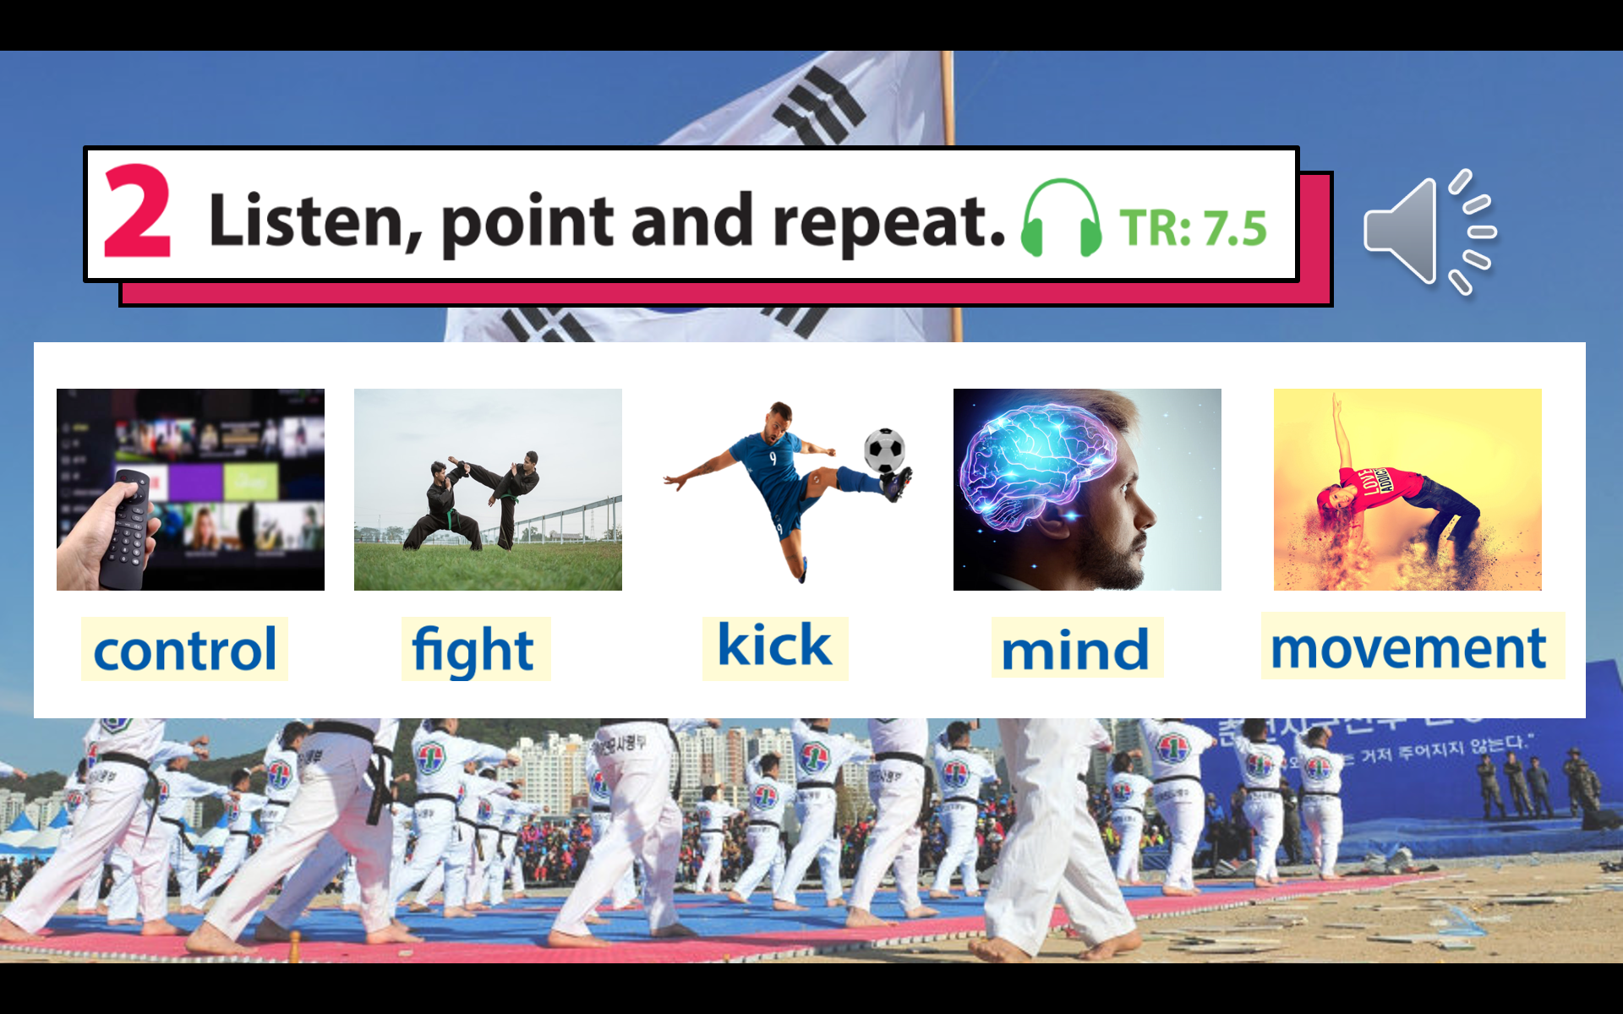  - Play the recording for students to listen, point to, and repeat the words as they hear them.  - Read out the new picture words in random order. Ask students to point to the correct pictures.  - Read each word again one by one and have students repeat. - Check pronunciation if necessary  * Mini game” look and say”  - Each picture runs across the screen and the teacher asks students to look as fast as possible and guess the picture  - T gives stars for the correct answer. |  | - Look at the picture carefully and answer the teacher’s questions.  (students can ask the teacher about words and structures if they are not sure).  - Write down ideas in the notebook( students can share ideas with their friends).  - Read each sentence in the dialogue and circle the right keywords.  2 In taekwondo, you use your mind to control your body’s movement / get ready for your body’s movement.  3 The word taekwondo means kicking / the way of the foot and the hand in Korean.  - Underline the words in the dialogue and guess the meaning of the word.  - Listen and repeat each word.( read in whole class, team and individual)  - Look quick and say fast
Activity 3: Practice (11 minutes)
Teacher’s Activities |  | Students’ Activities
Aims: Help students have a chance to find out more information about this interesting sport( taekwondo).
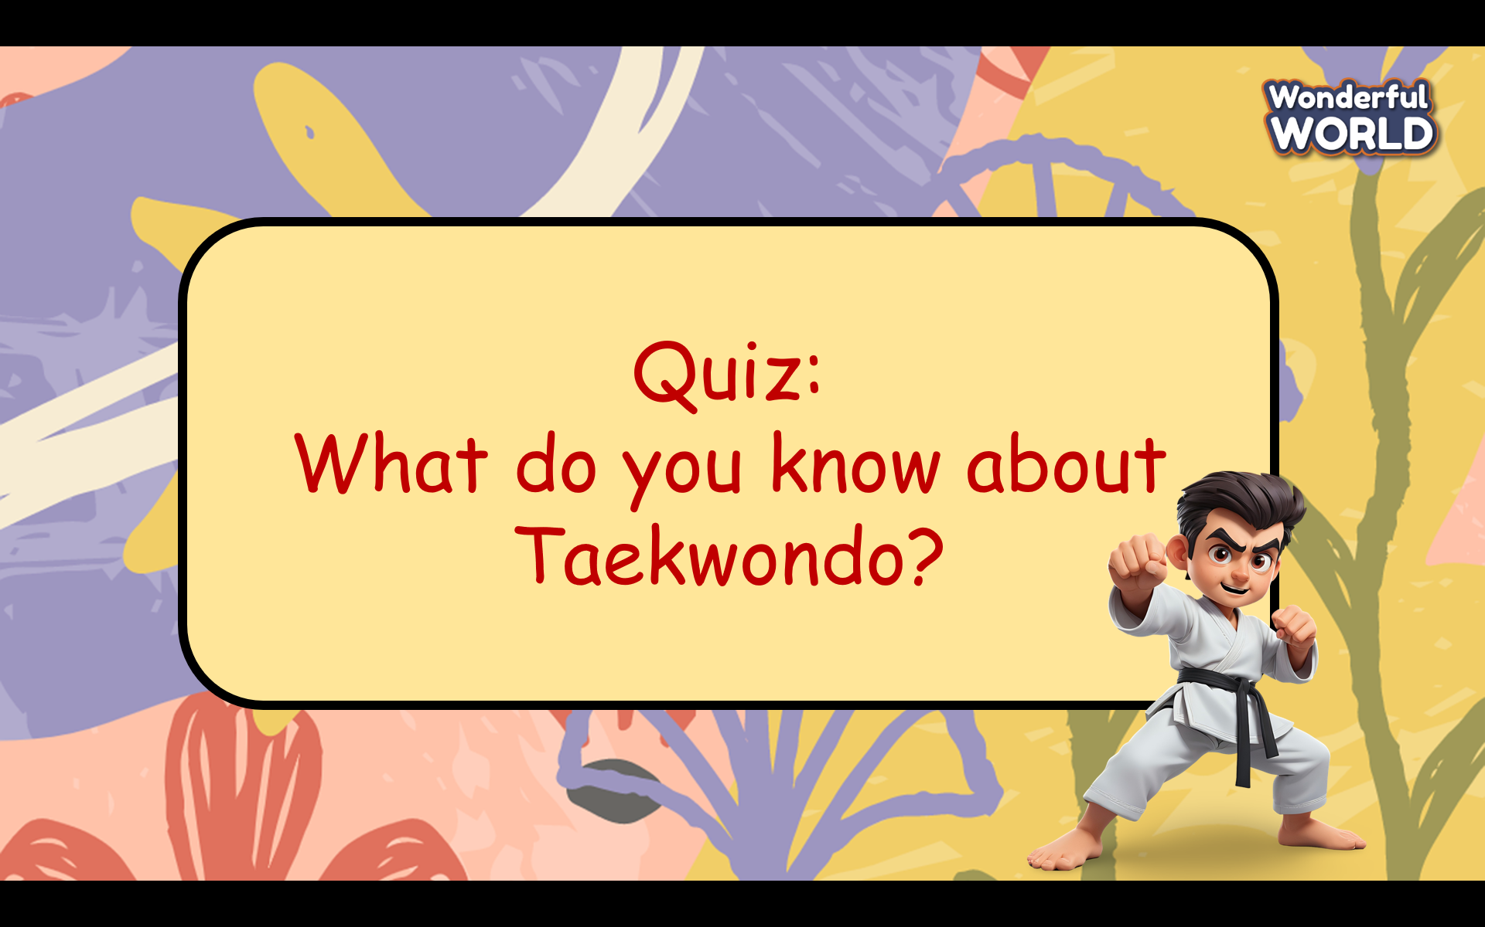  - Prepare some questions about taekwondo and ask students can read again the dialogue in task 1 (Some questions are beyond the scope of the dialogue.)  - Ask students can work in groups to choose the best answer.  - Give stars for the correct answers and the teacher can give further information on each answer. |  | - Read again the dialogue.  - Look at 4 options for each question carefully and choose the best answer.
Activity 4: Production (7 minutes)
Teacher’s Activities |  | Students’ Activities
Aims: control the class and help students sum up the content of the lesson.

“Let’s make a mind map about Taekwondo!”  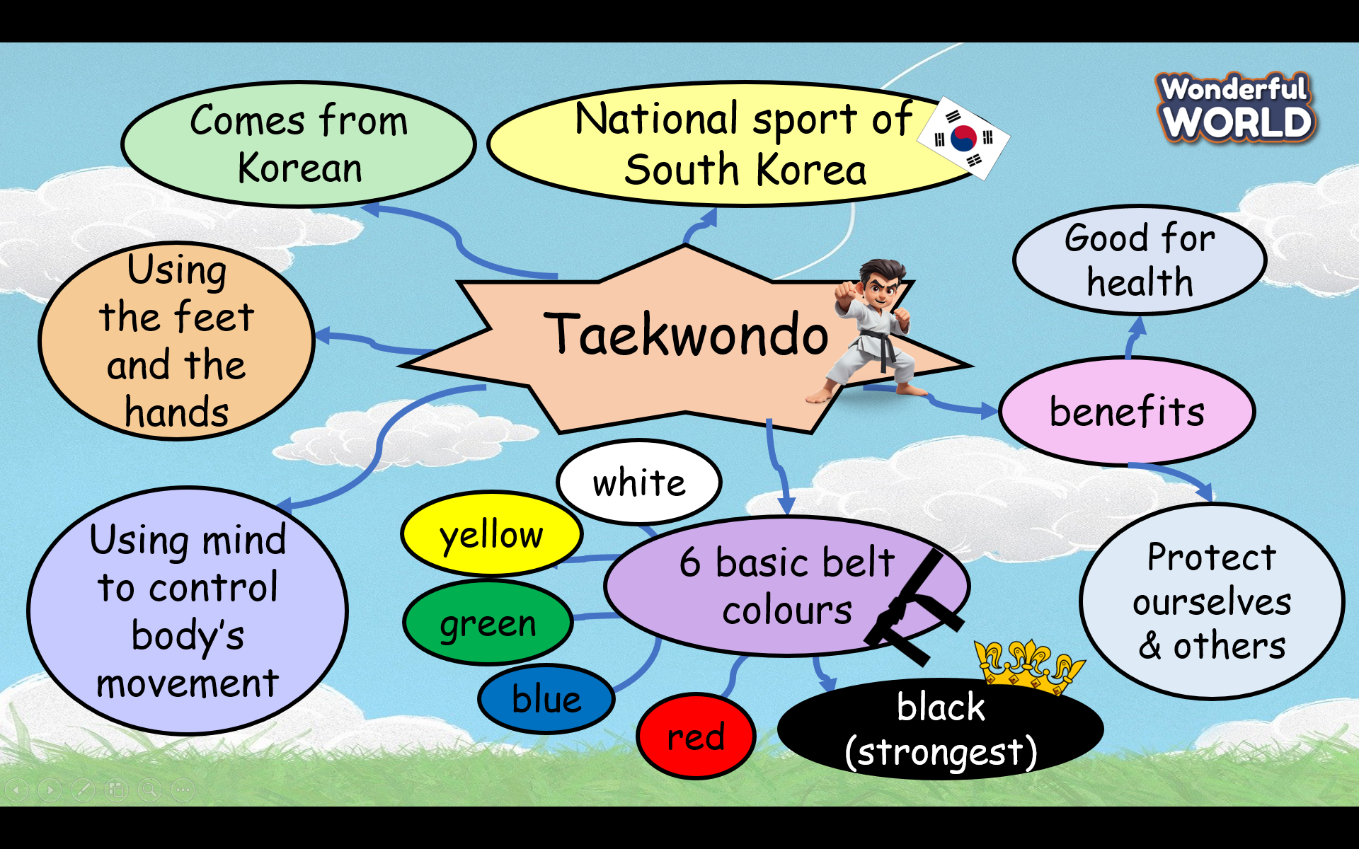  - Ask students to prepare A4 papers, pencils, crayons and work in a team of 2 or 4 students  - Ask students to make a mind map about taekwondo.  - Allow students enough time to complete the task.  - Circulate the class, providing support and guidance as needed.  - Ask each group to go to the board and present the mindmap.  - Give feedback to each team and choose the best mindmap to stick to the class’s wall. |  | - Listen to the teacher’s guide and prepare A4 papers, pencils, and crayons for the project.  -Work in a team of 2 or 4 students  - Go to the board and present the mind map in front of the class.  - Be confident and speak fluently.  - Clap their hands after each team finishes the task.
Teacher’s Activities |  | Students’ Activities
Aim:
- Check students’s understanding of what they have learnt.
- Students rehearse what they have learnt in the lesson.
- T asks sts to do the assessment (Look and circle the words)  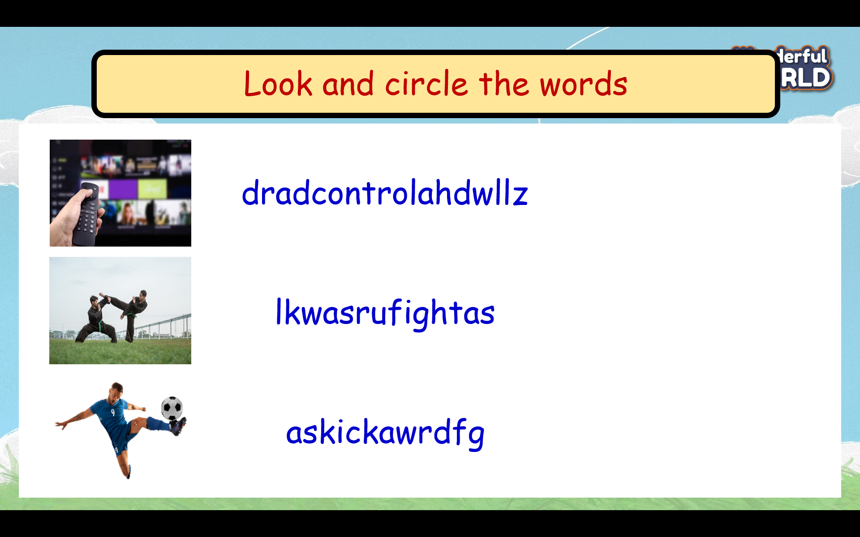  - Check with the class.  - Wrap-up  * Remember:  - Vocabulary: control, fight, kick, mind, movement |  | - Do the assessment.  - Check with the teacher  - Sts read the wrap-up  - Stand up and say goodbye to the teacher.

UNIT 7: Sports
Lesson 1- Part 4,5,6
Period 72

I. OBJECTIVES:
1. Knowledge:
-Review some words related to sports: fast, helmet, jump, race, win
-Review Grammar: Present continuous (affirmative and common time expressions: at present, now, at the moment.
- The spelling rules of changing the V-infinitive to V-ing
2. Competences:
By the end of the lesson, students will be able to:
- recognize some words relating to sports
- use Present Continuous tense and some common time expressions to talk about what people are doing.
3. Qualities:
- Students will be confident and active in communicating with friends and teachers.

II. EQUIPMENT AND MATERIALS:
- Basic things: Student’s book, flashcards.
- Advanced things: PPT, laptop, TV.
 | Activity 1: Warm-up (5 minutes)
 | Teacher’s Activities | Students’ Activities
Aim: Welcome students, and engage the class with a game “ arrange the word”.
Warm-up activity to review the names of sports.
 | - Greet students.  - Divide the class into 2 or 4 teams. Each team chooses their team names.  - Ask students to look at the picture and letters to rearrange the words.  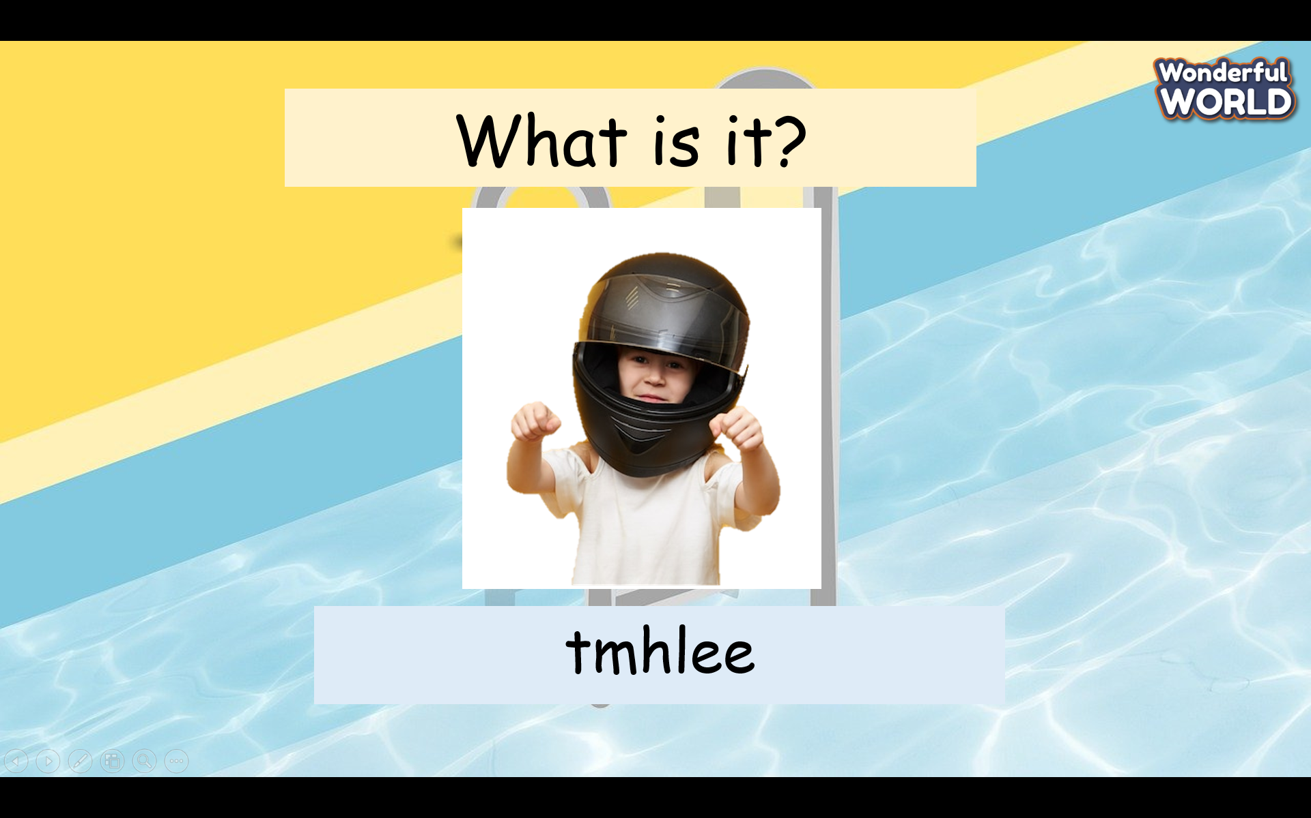  -T gives stars for the correct answer. | - Greet Teacher  - Choose a team name  - Join the activity.  - Listen carefully and write answers as fast as possible.  - Read the answers in front of the class.
Activity 2: Presentation (7 minutes)
Teacher’s Activities |  | Students’ Activities
Aim: Review grammar and present continuous tense.
Procedure  Review Grammar: Present continuous (affirmative)+ spelling rules and common time expressions: at present, now, at the moment  What is he doing now?  He is playing football.  => This tense is used for something that happens now, at present, or the moment, etc.  Subject + to be + verb + ing  I am reading  She/ He/ It is reading  You/We/They are reading  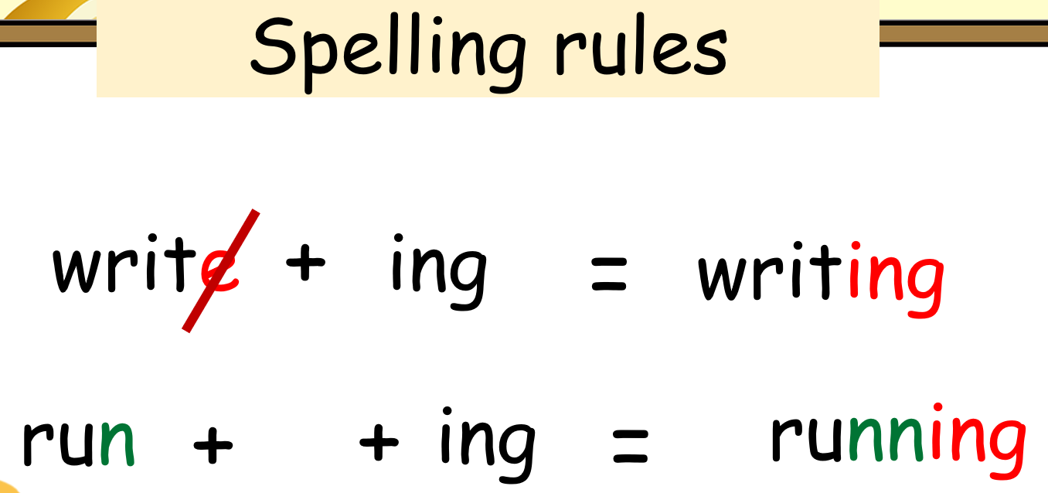 |  | - Look, listen, and answer the teacher’s questions.  -Write the present continuous tense in their notebook.  -Listen and repeat each word.( read in whole class, team and individual)
Activity 3: Practice (11 minutes)
Teacher’s Activities |  | Students’ Activities
Aims: Practice listening to keywords.
Task 4 Listen and write. TR: 7.3  Ask students to guess the activities in each photo.  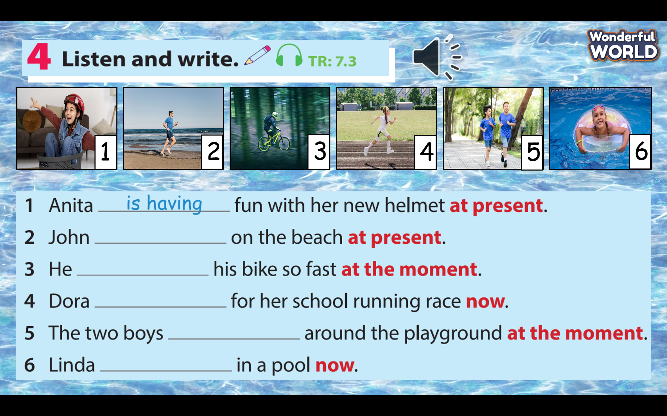  - Tell students to listen and write the correct verbs.  - Check whether students understand the task. Elicit the first answer.  - Check answers as a class. Write them on the board if necessary. ( 2. is running 3. is riding 4. is preparing 5. are jogging 6. is swimming)  - Ask students to read each sentence aloud.  Task 5 Look and write.  - Tell students to write the correct verbs (using present continuous).  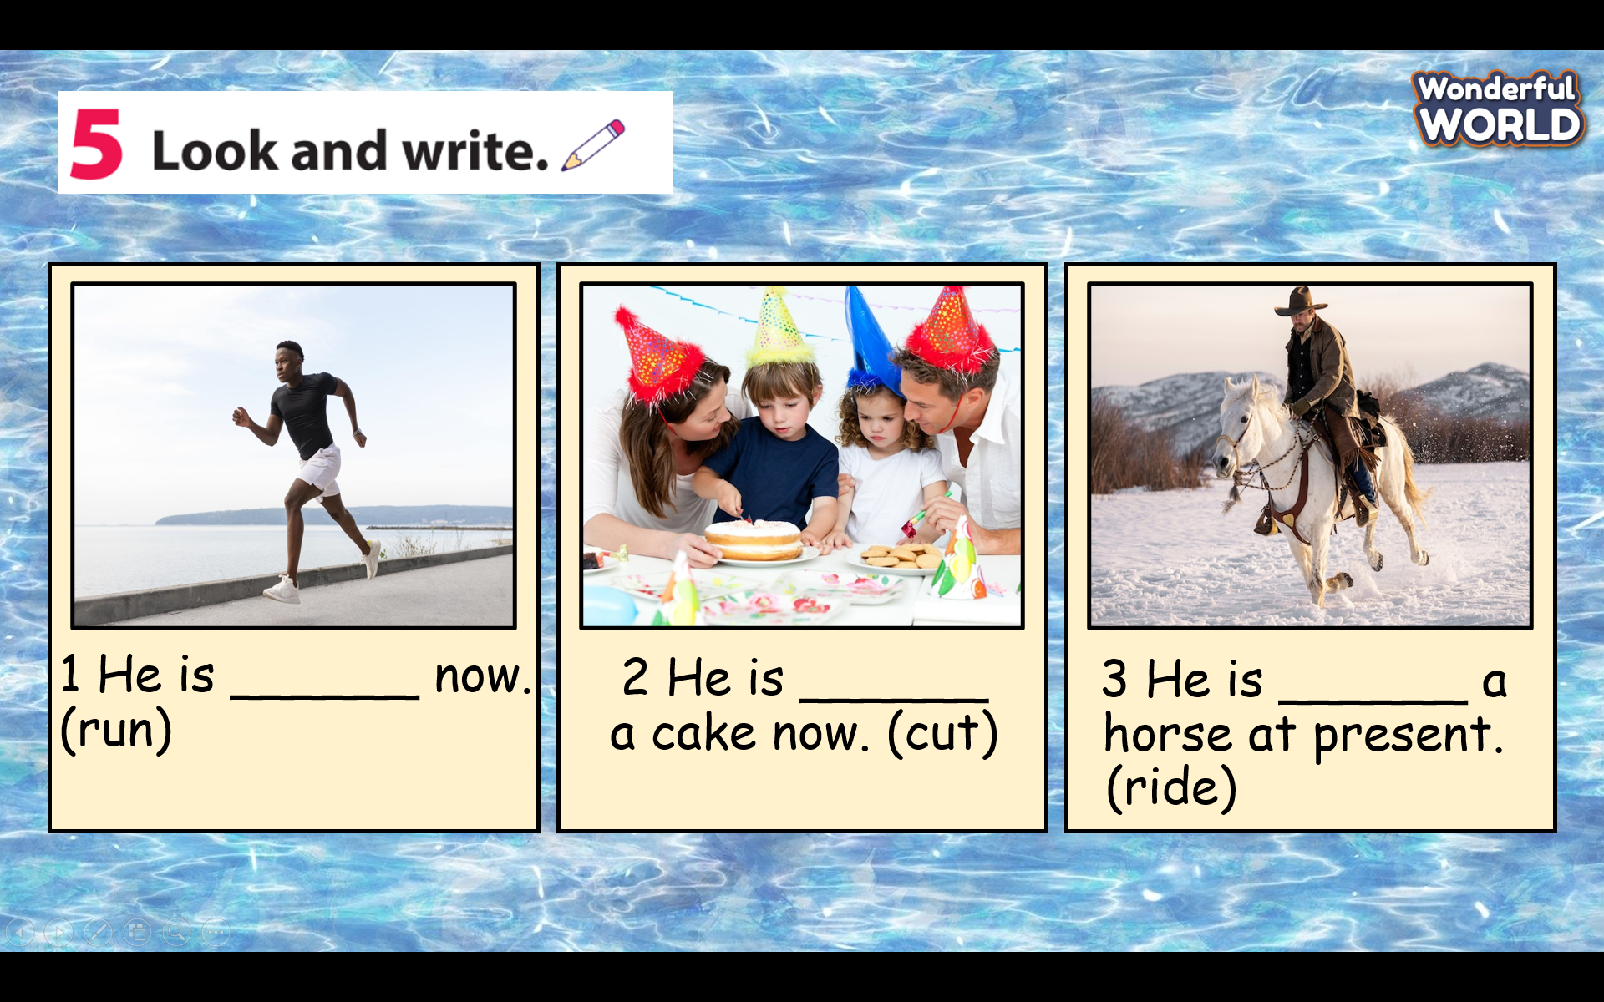  - Check whether students understand the task. Elicit the first answer.  - Check answers as a class. Write them on the board if necessary. ( 1. running 2. cutting 3. riding)  - Ask students to read each sentence alou |  | - Guess the activities in each photo.  - Listen and write the correct verbs  - Read again the adverbs of frequency  - Look back at the present continuous and write the correct verbs.  - Read these sentences in front of the class.
Activity 4: Production (7 minutes)
Teacher’s Activities |  | Students’ Activities
Aims: - Help students remember the spelling rules.
- Ask students to use their own words to write a full sentence.
Task 6 Point, ask, and answer.  -Tell students to look at the photo and say what they can see.  -Tell students that they are going to ask and answer using structures: “What are they doing? What is this girl doing? What is this boy doing?”  - Have students work in pairs, ask, and answer with their partners. - Demonstrate by using the example.  - Call three pairs to ask and answer, then check the students’ pronunciation.  Suggested answers:  2 Look at number 2. What are these boys doing? They are playing football.  3 Look at number 3. What are the cat and the dog doing? The cat is running after the dog.  4 Look at number 4. What are they doing? They are lying under the tree.  5 Look at number 5. What is this boy doing? He is falling off the bike.  6 Look at number 6. What is this man doing? He is running. |  | - Look at the photo carefully.  - Work in pairs, ask and answer with their partners.  - Volunteer to answer or go to the board to write them.
Activity 5: Wrap up & Assessment (5 minutes)
Teacher’s Activities |  | Students’ Activities
Aim:
- Check students’s understanding of what they have learnt.
- Students rehearse what they have learnt in the lesson.
-T asks sts to do the assessment (Find and correct the mistake)  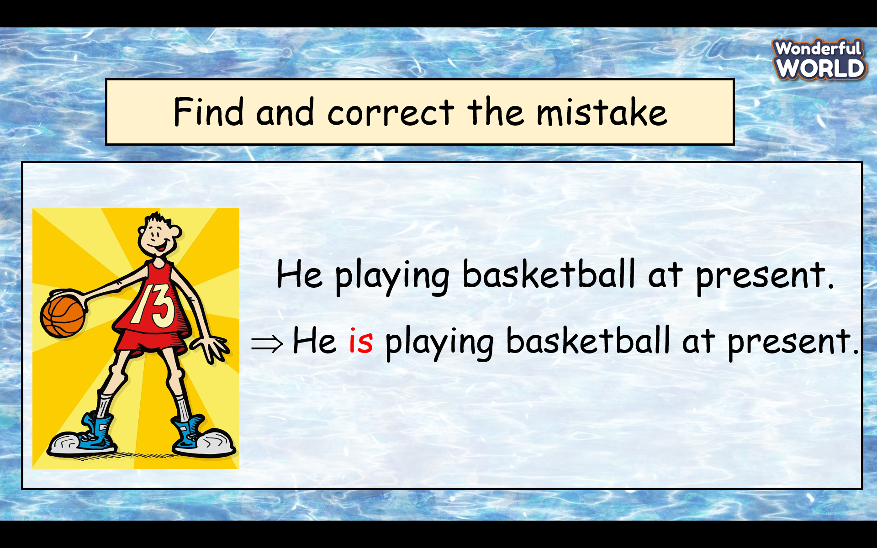  - Check with the class.  - Wrap-up  * Remember:  -Review Vocabulary: fast, helmet, jump, race, win  -Review Grammar: Present continuous (affirmative)+ spelling rules and common time expressions: at present, now, at the moment. |  | - Do the assessment.  - Check with the teacher  - Sts read the wrap-up  - Stand up and say goodbye to the teacher

