GRADE 4
Week 1 (08/9 – 13/9)
UNIT 1. FAMILY AND FRIENDS
Lesson 1. Task 1, 2, 3
Period 1
I. OBJECTIVES:
1. Knowledge:
Students will learn words and phrases related to the topic Family: father; mother; son; daughter; twins.
2. Competences:
- English competences: Students will be able to talk about different members of the family
- Common competences: Students will have the opportunity to develop the creativeness in drawing the family tree and develop communication among friends.
3. Qualities:
- Students develop a love for family.
II. EQUIPMENT AND MATERIALS:
- For Teacher: PP, flashcards, handout, track 1.1, track 1.2
- For students: pens, crayons, and A4 paper to make the production.
III. LESSON PROCEDURE:
Activity 1: Warm-up (5 minutes)
a. Aims: - To introduce students to the topic of the unit (families and friends)
- To engage students with the topic and activate knowledge and vocabulary by the game.
Teacher’s Activities | Students’ Activities
b. Procedure  - Greeting: Hello, students.  - Divide the class into 4 groups. All teams have to try their best to get stars for their teams by answering the questions and joining the games.  Warm Up: Photo time! “Hidden Faces” game  The teacher shows the picture with hidden faces and asks students some questions:  “Are they Vietnamese?  Are they at school/home?  Are they friends?”  Is (No 1) the boy or the girl?  Is she young or old?  Who is she?    Then, Sts can guess the members of India and recall the learnt vocabulary like“young, old, grandma, grandpa, sister, father….”  -Explain some information about the picture.  Lead in: Photo time!  -The teacher holds up a photo of his/her family.  - Point at you and ask "Who is this?". Elicit that it is you (teacher), then introduce the family members, and point to the members while talking.  - Write on the board: Family and introduce the lesson. | - Stand up to greet the teacher.  - Choose the team names  - Join the game  - Answer the questions.  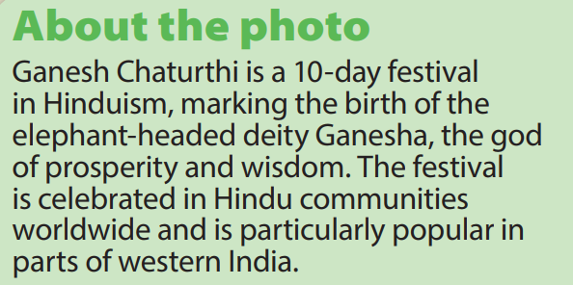  - Guess the members of the Indian family.  - Listen to the teacher.  - Look at the photo
Activity 2: Presentation (8 minutes)
a. Aim: Present the new words of family topic: father, mother, daughter, son, twins
Teacher’s Activities | Students’ Activities
b. Procedure  Task 1: Listen and point. Repeat. (Track 1.1)  - Use flashcards to introduce the vocabulary and structure of the lesson.  - Say the words/sentences for students to repeat in chorus.  - Say a word/sentence for students to repeat then point.  - Play the track 1.1 for the students to listen to, point to, and repeat the words in chorus, or in groups.  - Show pictures in random order and ask students to read out the correct words.  VOCABULARY CHECKING:  Let Sts listen to the dialogue, tick the correct answer, or write the word.  Pass the flashcard – team edition  How to play:  - 2 teams participate at once, the other 2 watch and make sure all Ss are joining in.  - Every student stands up with the flashcard and says the word then passes it to the S next to them  - Every S in the team has to stand up and say the word out loud until it gets to the last person who runs to the front and sticks the card on the board.  The first team to get to the front wins 10* and a bonus sticky ball throw. | - Look at the flashcards. Listen to the teacher  - Repeat after teacher.  - Listen and point  - Listen and repeat in chorus or groups.  - Look at the pictures and say the correct words.  - Listen, tick, and write the words  - Students stand up and join the activity.  - Pass the flashcards then say the word out loud.
Activity 3: Practice (10 minutes)
a. Aim: Practice listening, reading, writing, and saying using “He’s/ She’s ...”

Teacher’s Activities | Students’ Activities
b. Procedure  Task 2: Listen and read.  -Ask students to look at the photo and elicit who they can see.  -Point to the new words in the text. Read them out loud and ask students to repeat.  • Play the recording.  - Tell students to look at the picture and follow the dialogue with their fingers.  • Play the recording again, pause after each sentence and ask students to repeat.  • Ask students to read out the text in pairs and then ask volunteers to read aloud in front of the class  Let Sts read the dialogue by role-playing “Tom and Jack” to practice the words and the sentences.  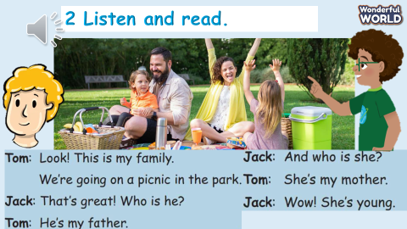  Task 3: Write, point, and say:  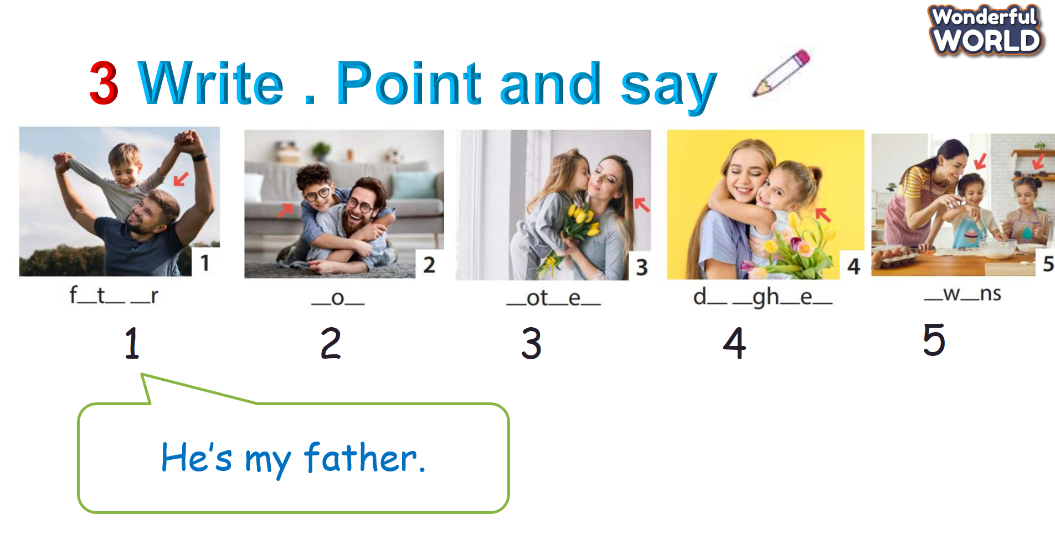  • Tell students to look at the picture for question 1 and ask who are in the picture.  -Elicit a son and a father. Read out the sample sentence and ask students to repeat.  • Explain the rest of the task to students.  -Allow them enough time to write the answers practise saying the sentences individually and in pairs.  -Go round the class helping students where necessary.  • Ask volunteers to read out their answers. Correct any mistakes. Look at the picture and let sts write the words and say the sentences like the example.  Board Dart Game:  *Set the context:  Let sts meet Peter’s family, look at his family tree, and then answer the questions to get the stars.  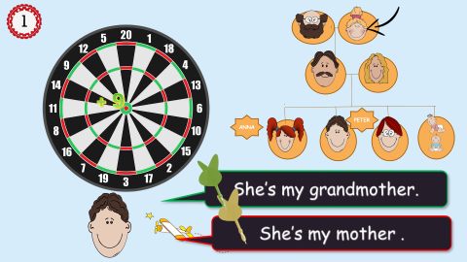 | - Look at the photo  -Point and read  - Listen and read.  - Work in pairs  - Role-play “Tom and Jack” to read the dialogue  - Look and answer the questions  -Work individually and in pairs  - Look and write the words and say the sentences.  - Join the game  - Look at Peter’s family tree and answer the questions
Activity 4: Production (9 minutes)
- Aim: To encourage students to make their family tree.
To apply the knowledge to make crafts. (a family tree and flashcards)
Teacher’s Activities |  | Students’ Activities
Family Tree:  Let Ss take the paper, pencil, and crayons to make the family tree, ask them to stick the family members’ pictures on the tree (if they can)  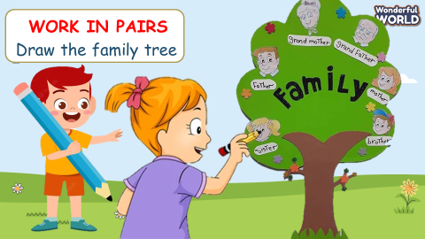  The other tip:  Suggest to students that they create their flashcards.  They draw a picture on one side of a note card and write the word or a clue on the other side. They then use the cards for ongoing practice. Once they have learnt the word, they remove the card from the pack. |  | - Draw the family tree.  - Point and say the names of the family members.
Activity 5: Assessment and Wrap-up (3 minutes)
a. Aim: Consolidate the content of the lesson.
Teacher’s Activities |  | Students’ Activities
- Let Ss do the assessment  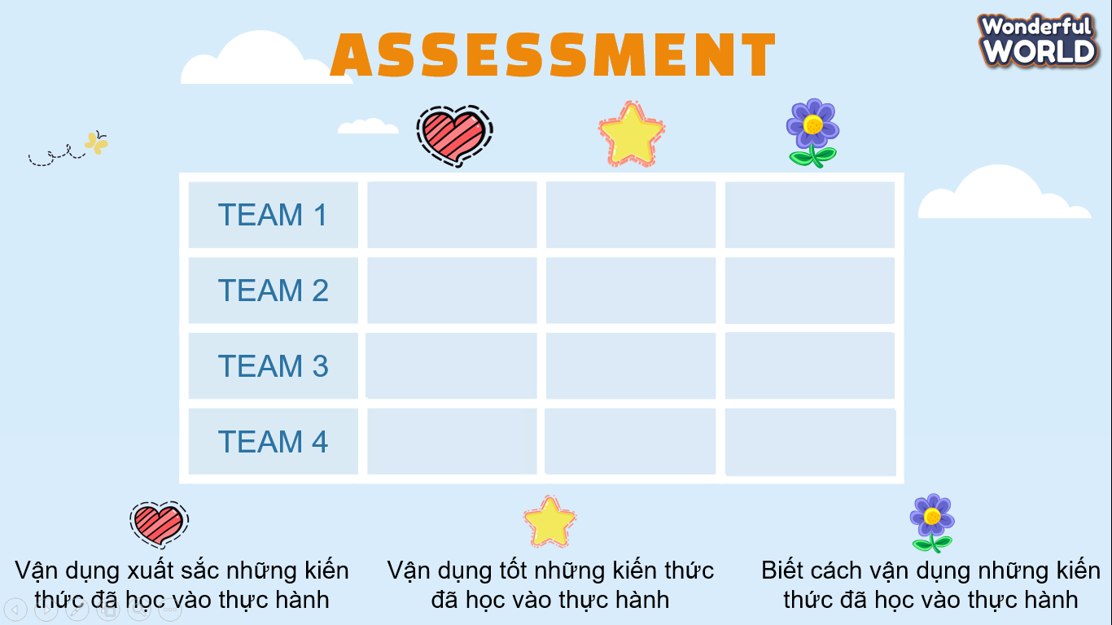  - Check with the whole class.  - Drill all words again and check for correct pronunciation.  - Count stars and award stamps to the winning team.  - Say goodbye to students. |  | - Do the assessment.  - Check with teacher  Answer:  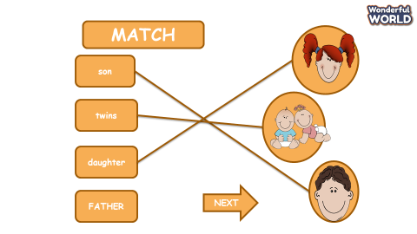  - Join in with drilling words for their team.  - Count stars with teacher.  - Say goodbye to the teacher.
________________________________
UNIT 1. FAMILY AND FRIENDS
Lesson 1. Task 4, 5, 6
Period 2
OBJECTIVES:
1. Knowledge:
Students will learn the structure “Who is he? He is my…”; “Who is she? She is my…” and review the words of the family topic
2. Competences:
- English competences: Students will be able to introduce their family members.
- Common competences: Students will have the opportunity to develop communication and collaboration.
3. Qualities:
- Students develop a love for their families.
II. EQUIPMENT AND MATERIALS:
- Basic things: Student’s book, flashcards, family photo, mini-board, worksheet.
- Advanced things: PPT, laptop/TV.
III. LESSON PROCEDURE:
Activity 1: Warm up (5 minutes)
Aims: To make Ss get ready for the topic Family and review some words they learnt in the previous lesson.
Teacher’s activities | Student’s activities
- Greet students.  -Warm up- Sing along the song: Baby Shark.  - Game: Jigsaw    - Tell the students they are going to guess who is this in 10 seconds by opening one by one puzzle.  - In 10 seconds if they have the right answer they will get a star.  - Continue with another family member to review all the words that they learnt in the previous lesson. | - Greet teacher.  - Sing and do action follow the song.  - Play the game
Activity 2: Presentation (8 minutes)
Aims: Present new sentences: Who is he?- He is my…… Who is she?-She is my….
Teacher’s activities | Student’s activities
Task 4: Listen and repeat. (Track 1.3)  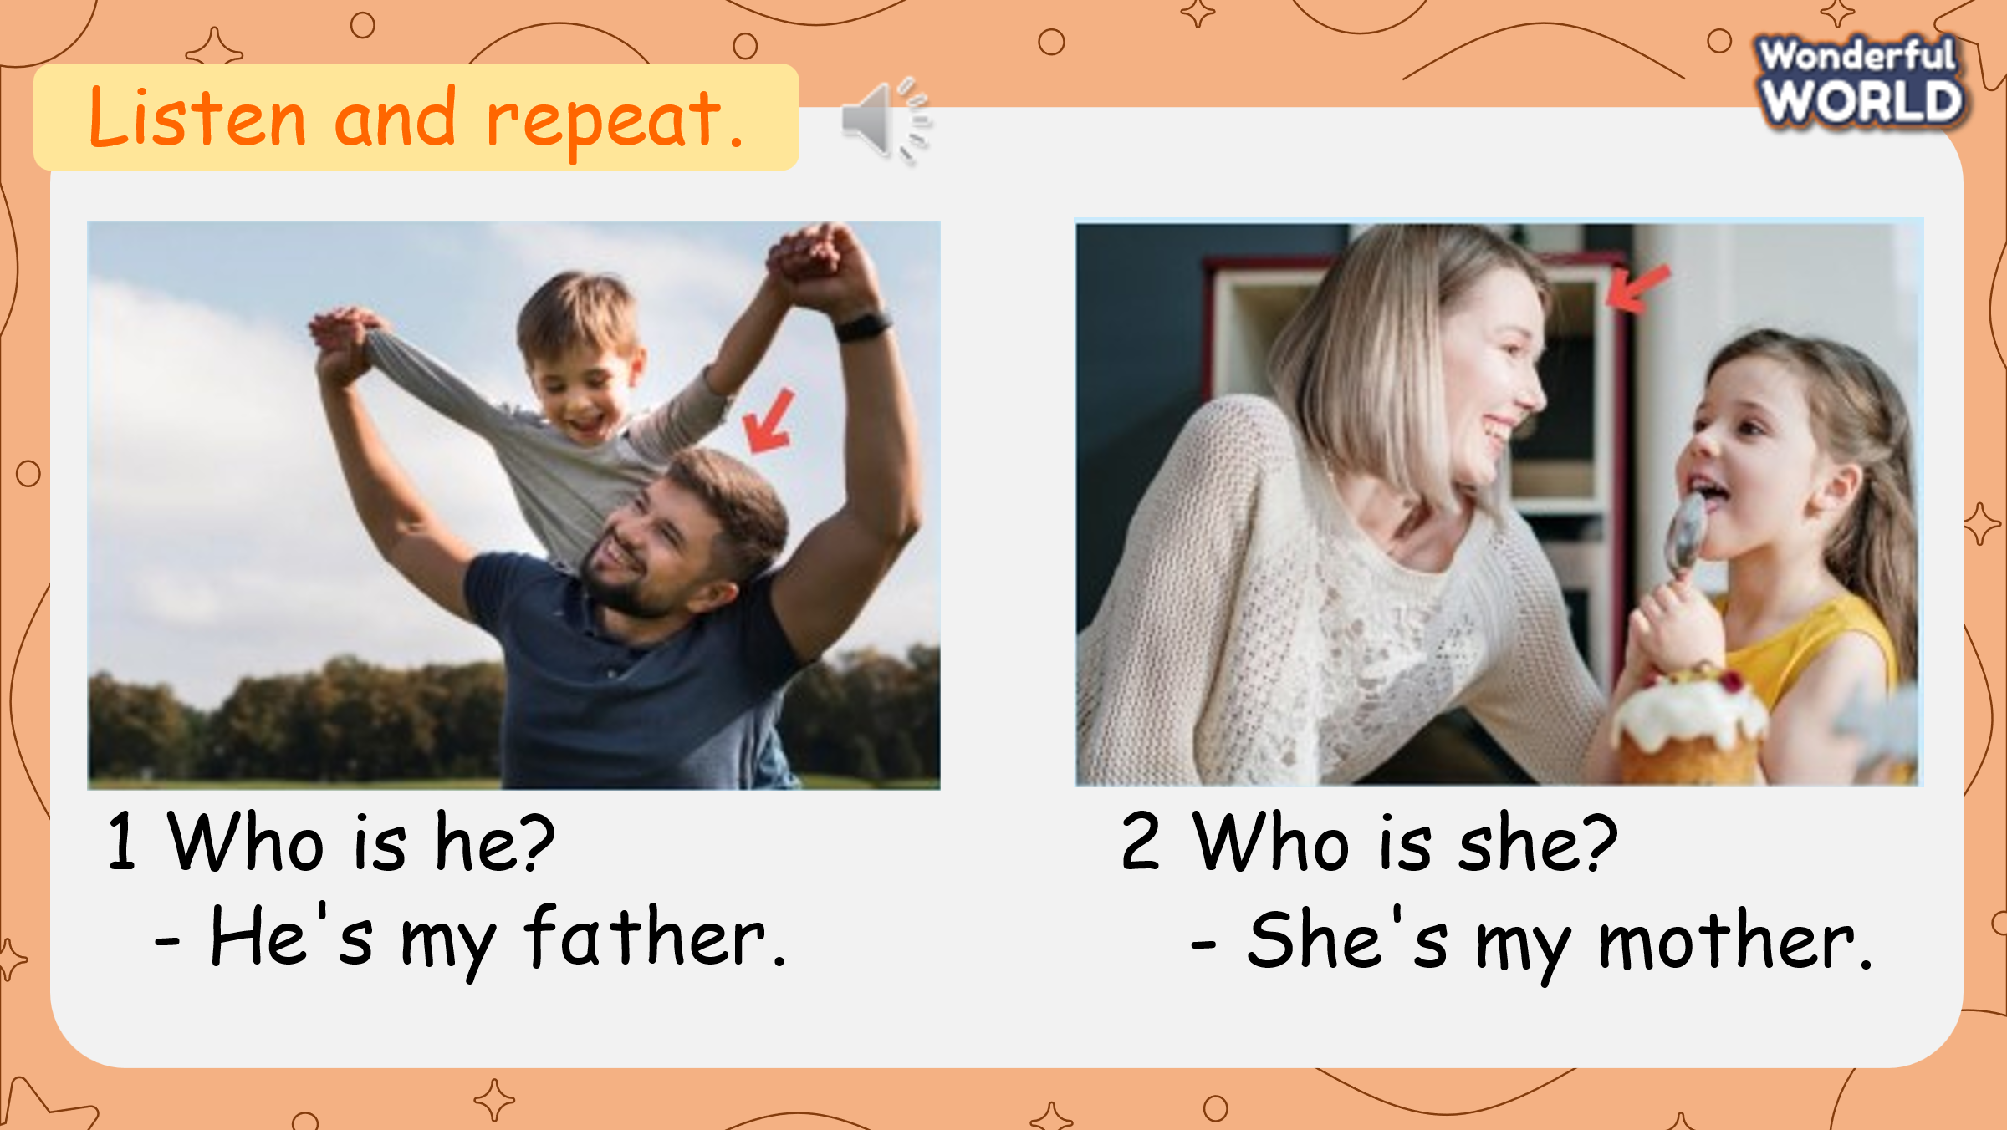  - Ask students to look and read the sentence in Activity 2 again.  - Play the recording (track 1.3). Students listen and repeat each line in chorus during the pauses.  - Point to the pictures. Ask students to notice that the  structure “Who is he? He is my…  -Who is she? – She is my…” is repeated.  - Show pictures randomly. Ask students to say a sentence.  Mini game: Listen and choose the correct picture.  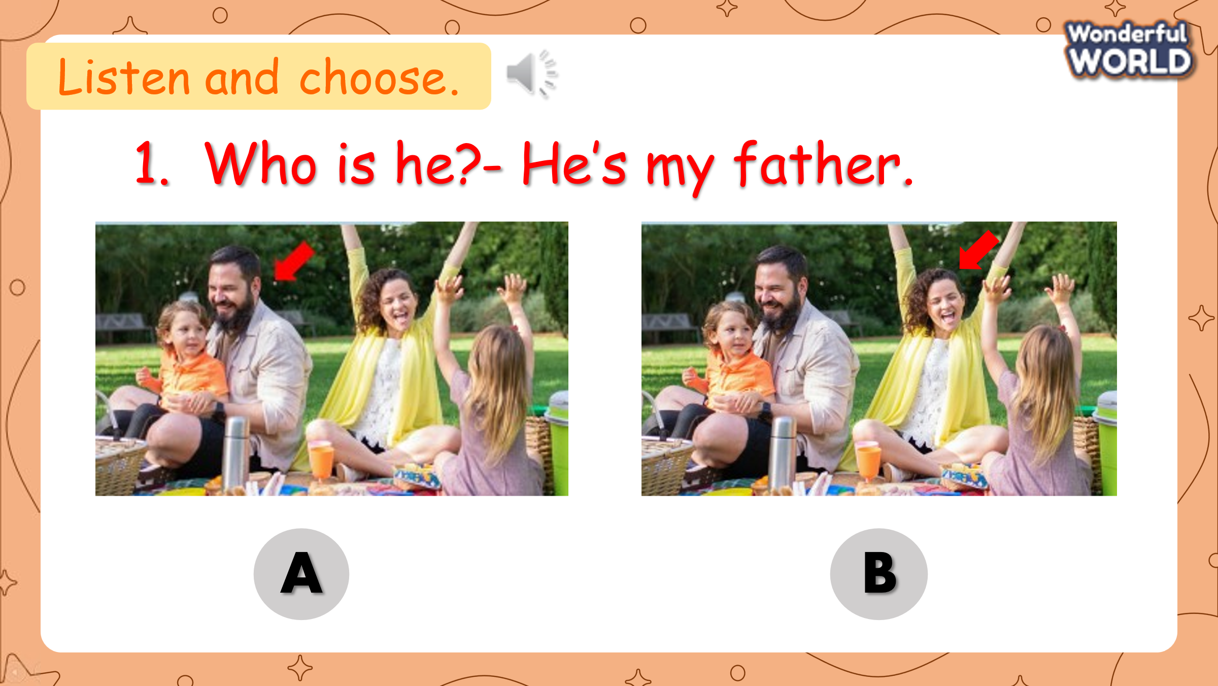  - Ask students to listen and choose the correct pictures (A or B).  Key:  1. Who is he? He is my father.  2. Who is she? She is my mother. | - Look and read.  - Listen and repeat  - Underline the structure.  - Say  - Listen and choose the correct answer.
Activity 3: Practice (10 minutes)
Aims: Controlled- practice to Free practice to make sentences using: Who is he? He is….Who is she?- She is …….
Teacher’s activities | Student’s activities
Task 5: Look and say.  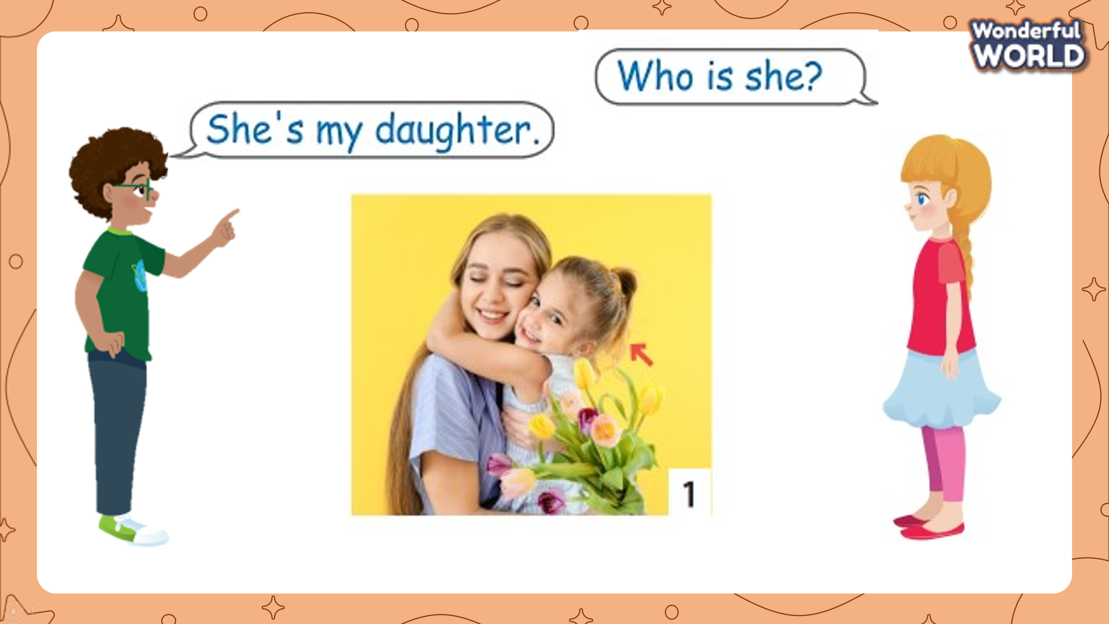  - Tell students to look at the picture for question 1 and ask them whom the arrow points to. Elicit “daughter”. Read out the example and ask students to repeat it.  - Explain the rest of the task to students. Ask sts to practise asking and answering in pairs. Go round the class helping students if necessary.  - Ask volunteers to read out their answers. Correct any mistakes.  Mini game: A lucky star  - Divide the class into 2 big groups. (Boys and Girls)  - There are 2 lucky numbers in this game. If students choose a lucky one, they will get 5 points without answering the question. If their number is not lucky one, they must answer the question and get points if it is right, otherwise, other groups will take their turn.  - The group which has more points will win the game.  Task 6: Let’s talk!  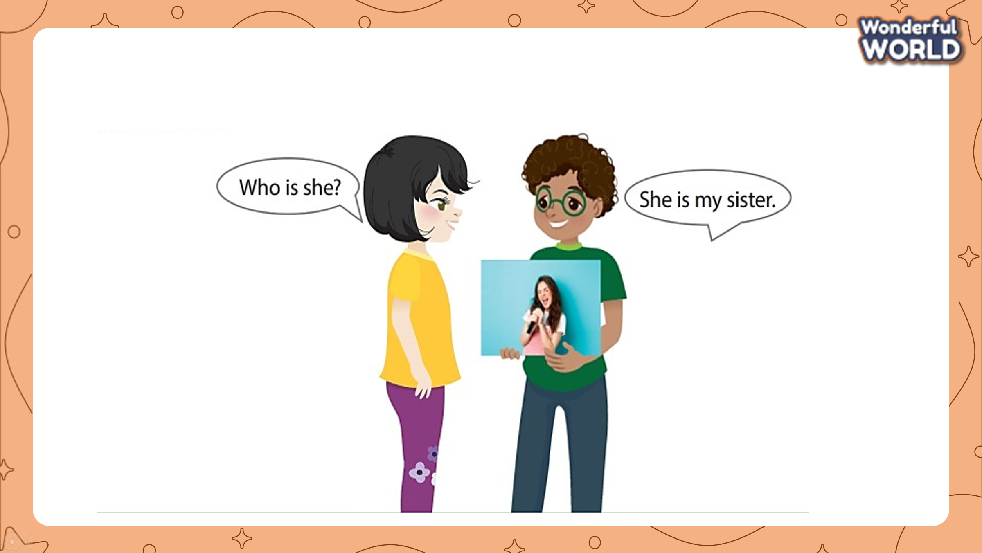  - Ask students to look at task 6. Read the example and ask students to repeat it.  - Ask students to prepare a picture of their family or draw a picture of a member of their family.  - Ask students to work in pairs to ask and answer about the people in the picture.  - Ask some volunteers to speak in front of the class.  Question tour  - Ask students to go around the class, show their family photo, then introduce family members to their friends.  Student 1: Who’s he/ she?  Student 2: He/she is my… | - Point and repeat  - Practice.  - Read  - Group work  - Choose the star and answer the question  - Draw a picture of your family or a member of your family.  - Work in pairs. Look at the picture, ask and answer about the people in the picture.
Activity 4: Production (9 minutes)
Aims: Apply structure to real world
Teacher’s activities | Student’s activities
Speaking activity. 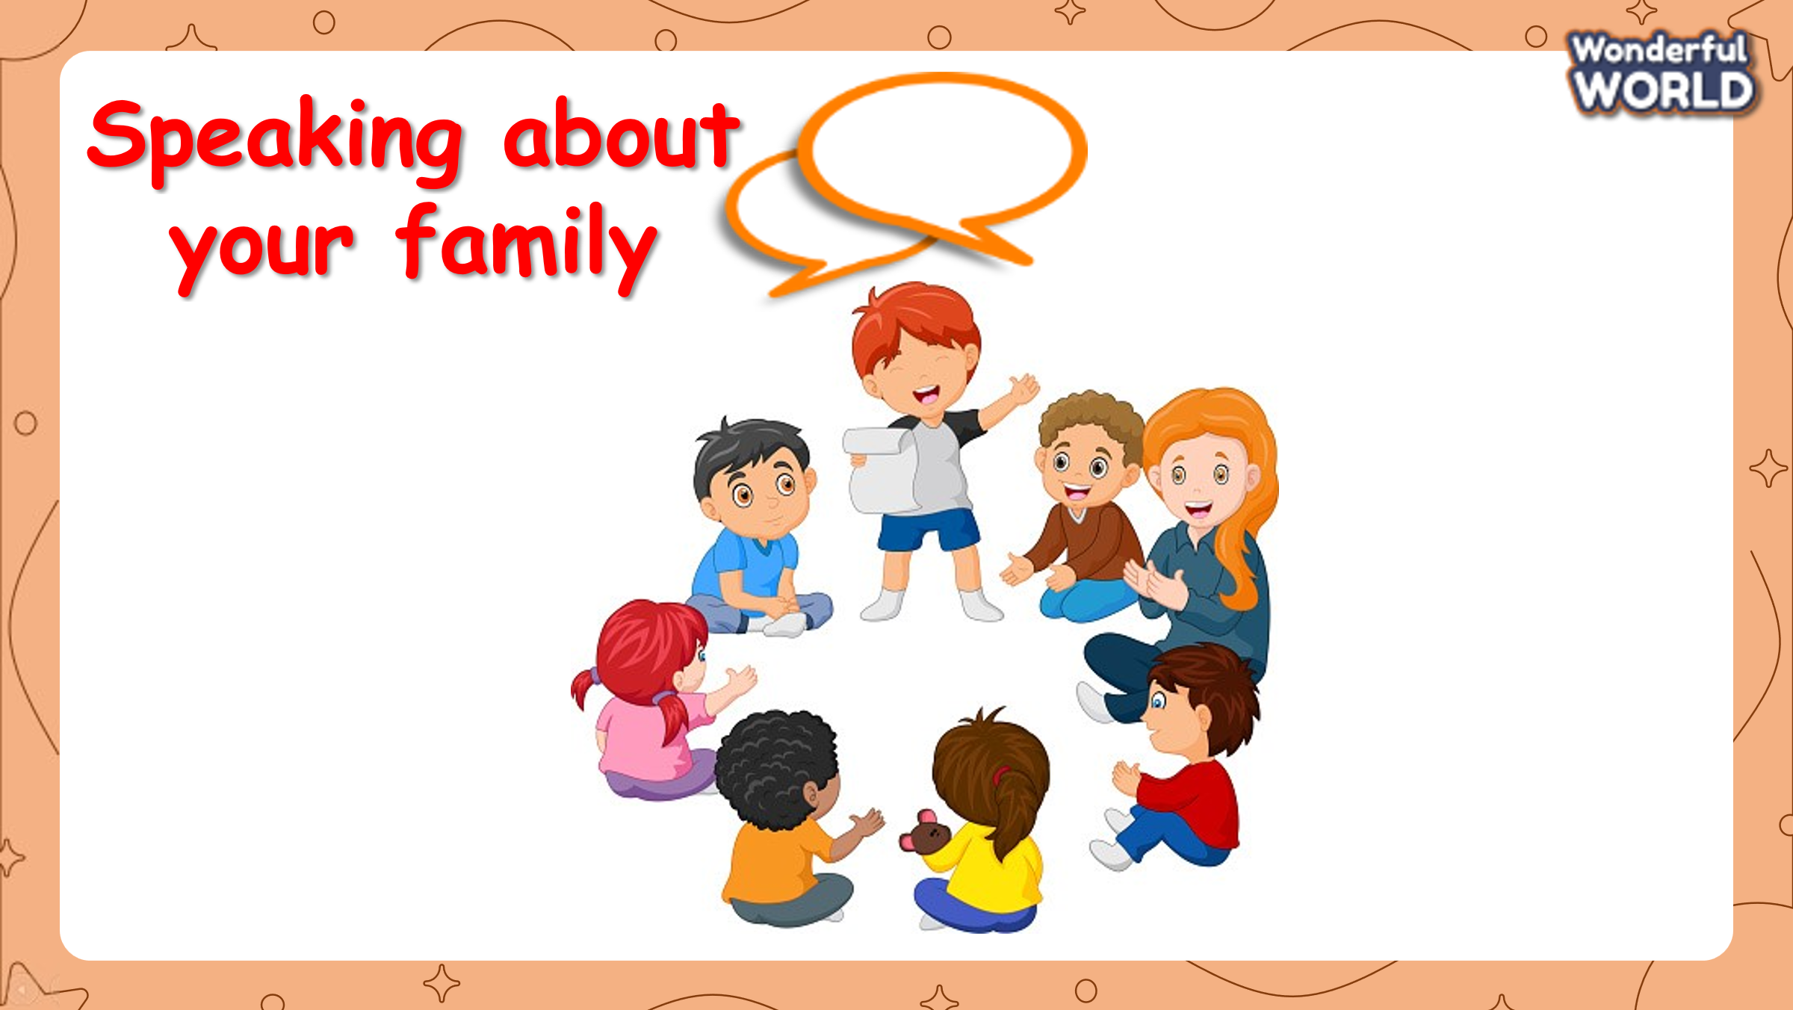  Short Talks  - Ask students to work in groups of 6.  - Ask students to write their own questions about the topic of family on a card.  - Each student is allowed to ask one question to their friend.  Suggested questions:  1. How many people are there in your family?  Student: numbers/ there are _(number)_  2. Who are they?  Student: My mum, my dad, my sister  3. How many brothers/sisters do you have?  Student: (Numbers) brothers/sisters  4. How old is your ...?  Student: He/She is ... | - Work in groups of 6.  - Write questions about the topic of family on a card.  - Ask and answer with your friends.
Activity 5: Assessment & Wrap up (3 minutes)
Aims: Consolidate the content of the lesson
Teacher’s activities | Student’s activities
*Assessment:  Word search: 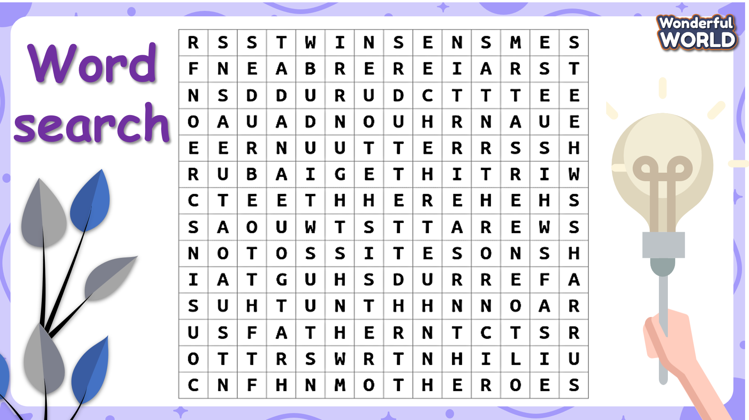  - Show the table and ask SS to find 10 family members.  - Who can find all as quickly as possible he/ she wins and gets stars.  * Wrap-up:  - Ask Ss to recall all the words which they have learnt in the lesson.  - Ask Ss to practise asking and answering about family members at home. | - Look at the table and find out all the family members.  - Listen and recall all the words in the lesson.
_____________________________________________
UNIT 1. FAMILY AND FRIENDS
Lesson 2. Task 1, 2, 3
Period 3
I. OBJECTIVES:
1. Knowledge:
- Students will learn the words of family topic: clever, kind, cute, polite.
- Students review the structure This is my….He/She is…
2. Competences:
- English competences: Students will be able to use some adjectives to talk about family members.
- Common competences: Students will have the opportunity to develop their presentation skills by drawing family members and introducing them. They also can develop communication skills among friends.
3. Qualities:
- Students develop a love for their families.
II. EQUIPMENT AND MATERIALS:
- Basic things: Student’s book, flashcards, papers, colour, pencil.
- Advanced things: PPT, laptop/TV.
III. LESSON PROCEDURE:
Activity 1: Warm up (5 minutes)
Aim: Warm-up activity to revise new words they have learnt from the previous lesson.
Teacher’s activities | Student’s activities
- Greet students.  - Revise the words from Lesson 1 with the flashcards.  Game: I’m a Fairy  - Divide the class into 2 groups: Boys and Girls.  - Ask each group to look and choose a letter. Behind each letter will be a question. They will have to answer the question to get stars.  - At the end of the game, which group has more stars will be the winner.  Lead in:  - The teacher shows a picture of family members (such as father, brother, daughter).  - Ask Ss to say a sentence to describe him/ her.  - Give the example: She is cute.  - Lead in the new lesson. Tell students they are going to learn more vocabulary to describe their family members. | - Greet teacher.  - Look and say the words.  - Play the game.  - Look at the picture and choose a letter.  - Work in groups to answer the question.  - Look at the picture and give a sentence to describe it.  - Listen to the example.
Activity 2: Presentation (8 minutes)
Aim: Present new vocabulary: clever, cute, kind, polite
Teacher’s activities | Student’s activities
Task 1: Listen and point. Repeat. (Track 1.4)  - Use flashcards to introduce the vocabulary and structure of the lesson.  - Say the words for students to repeat in chorus.  - Play the recording for the students to listen to, point to, and repeat the words.  - Read out the new words in random order and ask students to point to the correct pictures.  - Explain the meaning of each word.  - Read out the word clever. Then say a student’s name, e.g. Lan’s clever!, and ask students to repeat. Ask volunteers to stand at the front and do the same with any name they like.  Mini game: Touch the board  - Have 4 -5 students come to the board.  - The teacher takes turns to call out a word (clever, kind, cute, polite). Once the word has been called, have the students turn around and touch the correct picture.  - Who has the most correct answers will be the winner. | Learn new words and structures through flashcards.  - Repeat the words/sentences  - Listen, point and repeat the words.  - Listen and point to the correct pictures.  - Stand up and practise saying a sentence to describe your friends.  - Play the game  - Listen to the teacher then touch the right picture.
Activity 3: Practice (10 minutes)
Aims: Controlled- practice: to make sentences using: This is my …. She is ….
Teacher’s activities | Student’s activities
Task 2: Listen and tick. (Track 1.5)  - Ask students to look at the photo of 2 friends  - Point to the name in the text. Read them out and ask students to repeat them.  - Play the recording. Tell students to look at the picture and follow the text with their fingers.  - Play the recording again, pause after each sentence and ask students to repeat.  - Ask students to practice reading out the text individually or in pairs. Ask some volunteers to read it out in front of the whole class.  - Tell students to read again to tick the right answer in the box. Ask students to read the text again to find out information to make sure that they have the right answer.  Check answers as the whole class.  Task 3: Look and say.  - Ask students to work in pairs. Tell them they are going to say sentences based on the cue under each picture:  - Tell Ss the model sentences: This is my sister. She’s clever.  Game: Picking apple.  -Tell Ss that we will play a game called Apple Tree.  - There are 6 apples on the tree. Students need to choose an apple and then make a sentence based on the given words.  - If they have the correct sentence, they will get stars. | - Look at the photo  - Point to the name in the text and repeat.  - Follow the text with your finger.  - Listen and repeat  - Practice reading out the text  - Read again and tick the correct answer in the box.  - Pair work  - Practice speaking  - Play the game.  - Choose an apple and make a sentence based on the given words.
Activity 4: Production (9 minutes)
Aim: Apply grammar to real world
Teacher’s activities | Student’s activities
Make a picture of some new family members: ( father, mother, daughter, son) 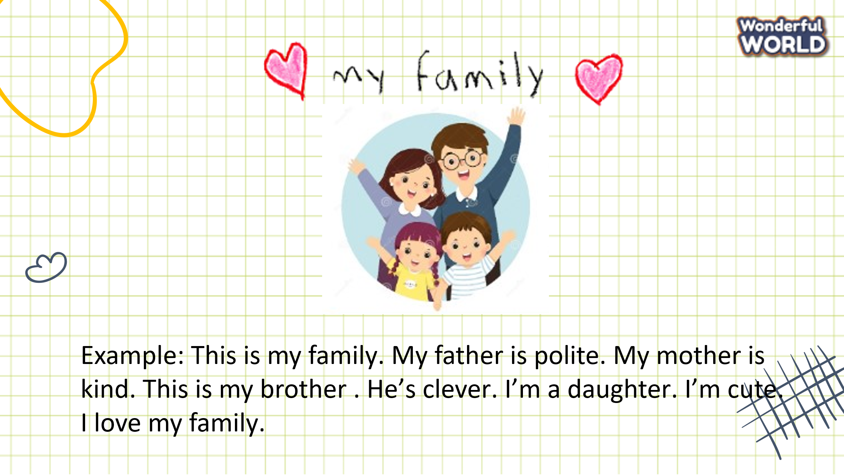  - Give a piece of paper to each student.  - Ask them to draw a picture of family members then write a text to describe them.  Ex: This is my family. My father is polite. My mother is kind. This is my brother. He’s clever. I’m a daughter. I’m cute.  I love my family.  - Call some sts to speak about their pictures. | - Draw a picture of your family and write some sentences to describe them.  - Go to the board and introduce your picture.
Activity 5: Assessment (3 minutes)
Aim: Consolidate the content of the lesson
Teacher’s activities | Student’s activities
- Write: 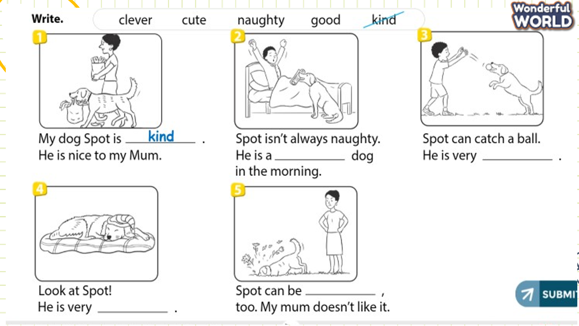  Give out the worksheet. Then ask students to look at the pictures and the sentences.  Try to fill in the right words to the blank.  - Teachers can give candies or stickers to the students who finish first.  - Say goodbye | Do the assessment.  - Check with friends and then with the teacher and the whole class.  - Say goodbye.
_____________________________________
UNIT 1. FAMILY AND FRIENDS
Lesson 2. Task 4, 5, 6
Period 4
I. OBJECTIVES:
1. Knowledge:
Students will be able to use the grammar structure to describe their family members and other people.
2. Competences:
- English competences: Students will be able to describe someone’s personality.
- Common competences: Students will have the opportunity to develop vocabulary by singing the song and developing their intonation
3. Qualities: Students develop a love for their families and friends.
II. EQUIPMENT AND MATERIALS:
- Basic things: Student’s book, flashcards, worksheet, construction paper, colour markers/crayons, glue, family or friends’ photos.
- Advanced things: PPT, laptop/TV.
III. LESSON PROCEDURE:
Activity 1: Warm up (5 minutes)
Aims: To make Ss get ready for the topic Family and review some words they learnt in the previous lesson. Lead into the new topic.
Teacher’s activities | Student’s activities
- Greet students.  - Sing “My family” song: https://www.youtube.com/watch?v=lGir6PUN-as  - Ask students to sing along.  Review:  - Revise and practice the functional language from lesson 2 with flashcards.  - Then ask volunteers to stand at the front of the class to ask and answer questions. (E.g.: How is she? - She is clever)  Game: What is behind the door?  - Divide the class into 4 groups.  - The teacher shows the cards of adjectives on the board/screen.  - The teacher uses a picture of a door to hide the flashcard  - Ask each member to stand and say what word is behind the door.  - Who says it fast will get points for the groups.  Lead in:  - Show a picture of a friend. Point then say  E.g.:My friend is cute and clever.  - Show another picture of two friends. Point then say  E.g.: My friends are kind and funny.  - Tell Ss to pay attention to using is or are  - Tell students to look at the pictures in task 4, and they call out who are they. What are they like?  - Tell students that they are going to learn how to use structure to describe someone’s personality. | - Greet teacher.  - Listen and do the action with the teacher.  - Read out loud  - Ask and answer  - Play the game  - Look at the picture  - Repeat then point.  - Repeat.
Activity 2: Presentation (8 minutes)
Aims: Present new structures that can be used to describe a person
Teacher’s activities | Student’s activities
Task 4: Listen and repeat. (Track 1.6)  - Point to the pictures. Ask students to notice the people. What are they doing? How are they doing? Tell students that this structure can be used to describe someone’s personality. Play the recording. Tell students to look at the pictures and follow the sentences with their fingers.  - Play the recording again. Ask students to repeat. | - Learn new words and structures through flashcards.  - Repeat the words/sentences
Activity 3: Practice (10 minutes):
- Aims: Controlled- practice to Free practice to make sentences using plural forms: are
Teacher’s activities | Student’s activities
Task 5: Look and say.  - Tell students to look at the picture for question 1 and ask them who the person in the picture is. Explain that they should focus on singular or plural subjects and use the adjective to describe someone’s personality.  - Read out the example and ask students to repeat.  - Explain the rest of the task to students. Ask students to practice saying the sentences individually and then in pairs.  - Ask volunteers to read out their answers. Correct any mistakes.  Suggested sentences:  - My twins are pretty and kind.  - My friends are cool and clever.  - Aunt Jane is young and polite.  Mini-game: Gold Miner  - Divide the class into 2 teams.  - Each team chooses one item to go to the question.  - Ask pupils to listen and choose the right pictures.  - Back to the menu for pupils to choose another question.  - Pupils continue their turns until there is no item left.  E.g.: His son is good and funny.  - The game will give students a random point if they answer correctly.  - Each time sts choose an answer, they get points that follow each photo.  - Who has the most points is the winner. | - Look  - Listen and repeat  - Individual work/ Pair work  - Practice  - Play the game
Activity 4: Production (9 minutes)
Aims: Apply structure to real world by singing activity
Teacher’s activities | Student’s activities
6 Let’s sing  - -Tell students they are going to learn a song.  - -Ask students to look at the picture and describe what they can see. Encourage them to use English for words they know. Hold up your book and point to “brother”. Ask a volunteer to say the word. Do the same for “sister”. Point to the brother and say: “He’s tall and nice! He isn’t funny.” Encourage students to repeat. Continue with the sister: “She is cute and clever. She isn’t funny”. Ask students to repeat.  - -Play the recording and tell students to listen and follow the words with their fingers.  - -Read out the song one line at a time and ask students to repeat after you.  - -Play the recording again. Encourage students to sing along. Practice several times until students are familiar with the words. | - Look and answer T’s question.  - Look and read  - Sing out loud in front of the class (individual work)
Activity 5: Assessment (3 minutes)
Aims: Consolidate the content of the lesson
Teacher’s activities | Student’s activities
Listen and write:  - Give out the worksheet. Then ask students to listen and write the sentence.  - Check in pairs, then the whole class.  - Say goodbye. | - Do the assessment.  - Check with friends and then with the teacher and the whole class.  - Say goodbye.

