UNIT 2. MY HOME
Lesson 3. Task 7, 8, 9
Period 17
I. OBJECTIVES:
1. Knowledge:
- Students will revise words and phrases related to the topic House: bookshelf, rug, dining room.
- Students will learn about how to pronounce /ʊ/, /n/,/r/
- Students will learn about the new structure: We have got a new bookshelf.
2. Competences:
- English competences: Students will be able to talk about the position of objects in the house.
- Common competences: Students will have the opportunity to develop the creativeness by participating in games and developing communication among friends.
3. Qualities:
- Students develop a love for their home.
II. EQUIPMENT AND MATERIALS:
- For Teacher: PP, flashcards, handout, track 2.12,2.13.
- For students: pens, books.
III. LESSON PROCEDURE:

Activity 1: Warm-up (5 minutes)
Teacher’s Activities | Students’ Activities
Aims: Warm-up activity to revise the vocabulary they have learned through a song.
b, Procedure  - Greet students and divide the class into 4 teams.  - Warm-up: Listen to a song: Objects in the room!    - The T shows the song and lets sts review some words and phrases relating to House.  - T asks sts: “How many objects in the house can you see?”  - T check all the comments. | - Sts greet the teacher and choose their team names.  -Listen to the song.  - Sts give comments about the objects.
Activity 2: Presentation (8 minutes)
Teacher’s Activities | Students’ Activities
Aims: Present new grammar: to pronounce /ʊ/, /n/,/r/
Encourage sts to pronounce words correctly through a game.
b, Procedure  Task 4: Listen and repeat.  - Let Sts look at the pictures.  - Write //ʊ/ on the board then write bookshelf.  - Ask sts to pronounce the word.  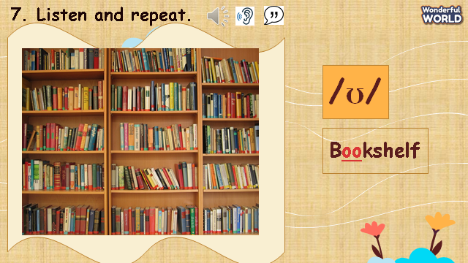  - Write //ʊ/ on the board then write “bookshelf”.  - Ask sts to pronounce the word.  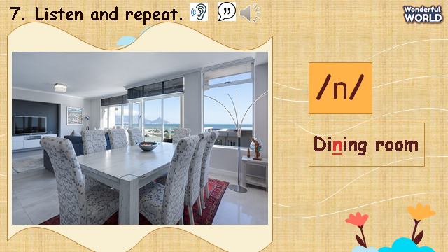  - Write //n/ on the board then write "dining room”.  - Ask sts to pronounce the word.  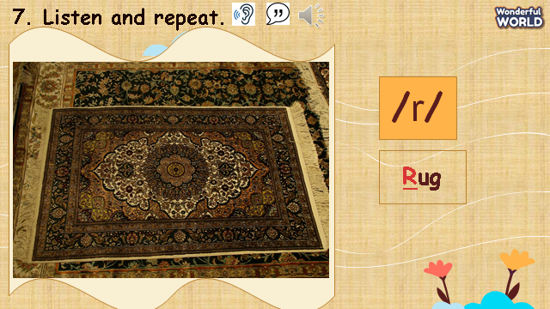  - Play the recording and tell students to point to the sounds they heard.  - Show sts how the sounds are different from each other.  - Ask sts to read the words.  - Play the recording again and tell sts to repeat the sentences and words, paying attention to pronunciation.  CHECKING VOCABULARY.  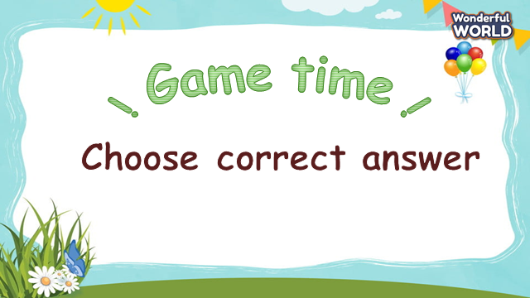  - Ask Sts to look at pictures and choose the correct answers.  - Sts having the correct answers will roll the dice to get stars. | -Look at the sounds and words.  -Sts listen to the recording and teacher.  -Repeat the words and sentences.  -Take part in the game.  -Sts look at pictures and words.  - Sts choose the correct words.
Activity 3: Practice (14 minutes)
Teacher’s Activities | Students’ Activities
Aims: Controlled practice: help sts to practice the vocab and grammar by doing a game.
Encourage sts to pay attention to the pronunciation.
b, Procedure  Task 9: Say it!  -Let Sts play “Wheel of Fortune” questions to practice Task 9.  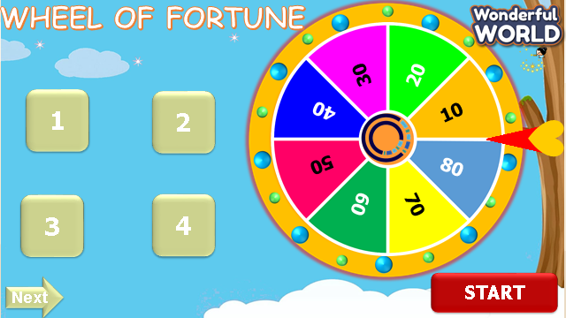  - Let sts choose the numbers and answer the questions.  - Then show sts the pictures and questions.  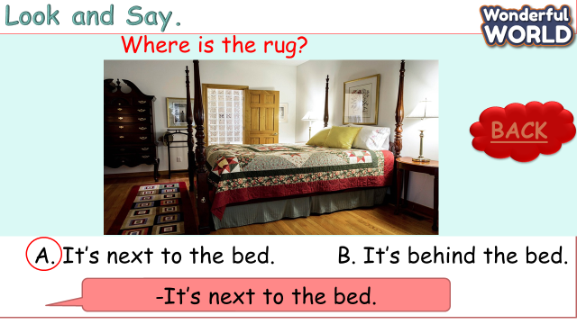  - Ask sts to choose and read out the correct answers.  - Tell sts to pay attention to the sounds that they have learnt in each word.  - Explain the rest of the task and ask sts to read sentences through the game.  - Ask sts to work in pairs and say the sentences, paying attention to the correct pronunciation.  - Ask some volunteers to speak in front of the class. | -Take part in the games.  -Sts choose the numbers, answer the questions, and get stars through the wheel.  -Sts join the game and answer the questions.  -Sts read aloud sentences in the class.  -Sts work in pairs and say it in front of the class.
Activity 4: Production (9 minutes)
Teacher’s Activities | Students’ Activities
Aims: Phonics is used via the chant of the song correctly according to the lyrics.
b, Procedure  Task 8: Listen and Chant.  -T shows the picture and asks sts what they can see. Let sts listen to a chant.  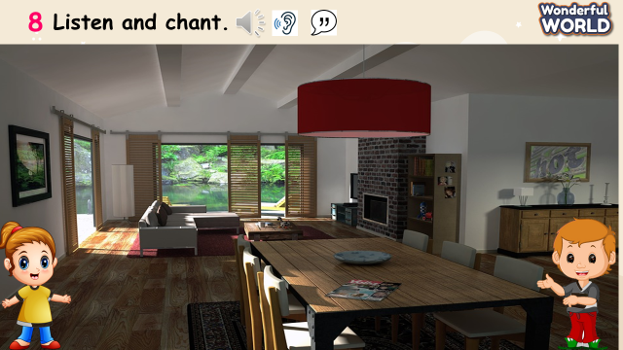  - Explain to sts that the chant uses the sounds they just have learnt.  - Play the record and ask sts to follow the chant with their fingers.  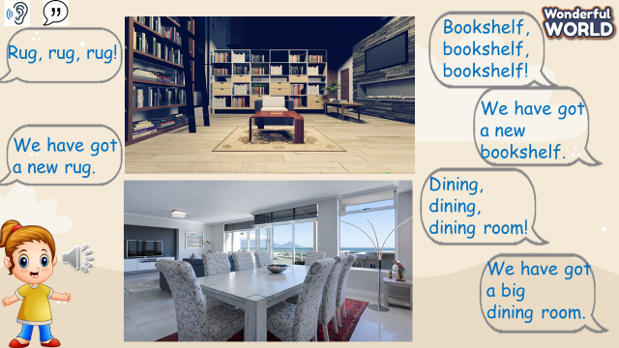  - Read out the chant one line at a time and ask sts to repeat.  - Play the recording again, and ask sts to chant along. Practice several times and let them do it individually and in groups.  - Ask some volunteers to chant. | - Sts answer the questions.  - Sts listen to a chant.  - Sts repeat after teacher.  - Sts chant several times individually and in groups.
Activity 5: Assessment (3 minutes)
Teacher’s Activities | Students’ Activities
Aims: Consolidate the content of the lesson.
-Ask sts to do the assessment.  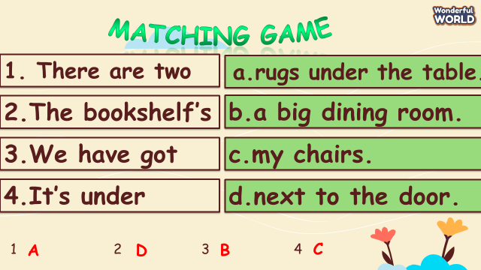  - Check with the class.  - Remember the vocabulary and structure.  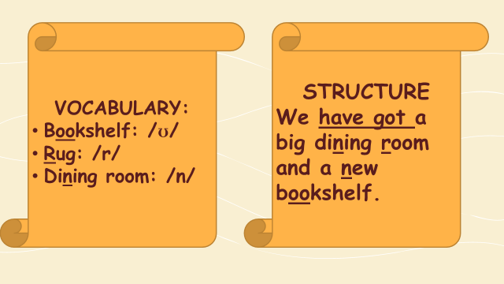  - Check with the class. | - Do the assessment.  - Check with the teacher  - Sts read the wrap-up  - Stand up and say goodbye to the teacher

__________________________________
UNIT 2. MY HOME
Fun time and project. Task 1, 2
Period 18
I. OBJECTIVES:
1. Knowledge:
- Students will review house vocabulary and unit grammar.
2. Competences:
- English competences: Students will be able to talk about their houses.
- Common competences: Students will develop their creativity in drawing pictures.
- Know how to use structures in the presentation:
- Whose table is it?
- It’s their table.
- Where is the rug?
- It’s in front of the sofa.
3. Qualities:
- Students will be confident and active in communicating with friends and teacher.
II. EQUIPMENT AND MATERIALS:
- For Teacher: PP, TV, boards, markers
- For students: A4 paper, books, pens, crayons
III. LESSON PROCEDURE:

Activity 1: Fun Time (10 minutes)
Teacher’s Activities | Students’ Activities
A, Aims: Review all the words of house and objects.
B, Procedure:  Warm up (3 minutes)  - Introduce the song  - Ask sts to review some vocabulary and do action  - Play the House song  https://www.youtube.com/watch?v=qZyJPZxsmZk  - Ask sts to sing and remember the rooms in video.  Task 1: Unscramble (7 MINUTES)  Do Task 1 via a game  Ask sts to look at the screen and choose the numbers they want. Then, answer all the questions and roll the dice to get stars.  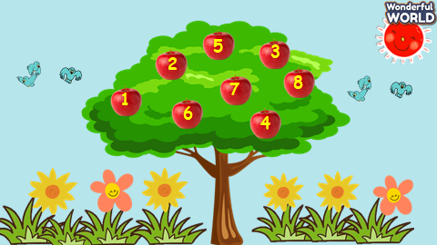  - Let sts choose the numbers.  - Sts can look at pictures and words.  - They can choose the correct words to get stars.  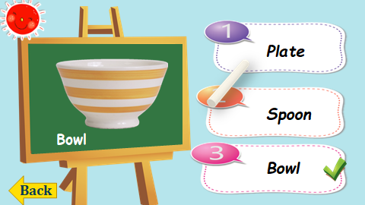  - Ask sts to work in pairs.  - Hand each pair a print of task 1.  - The sts will unscramble the words and get stars.  - The team, who gets the highest scores, will be the winner. | -Listen to the teacher  - Repeat and do the action  - Sing along and repeat the song.  - Answer the question.  - Look at the pictures and words.  - Sts can choose the correct answers.  - Read aloud the answers.  - Do the game and get stars.  - They can do task 1.
Activity 2: Project (20 minutes)
Teacher’s Activities | Students’ Activities
A, Aims: Review all words and structures of unit 2 – practice the presentation.
Project: My family  B, Procedure:  House quiz game  - Guides sts to play with the game and tick the correct pictures with the correct words.  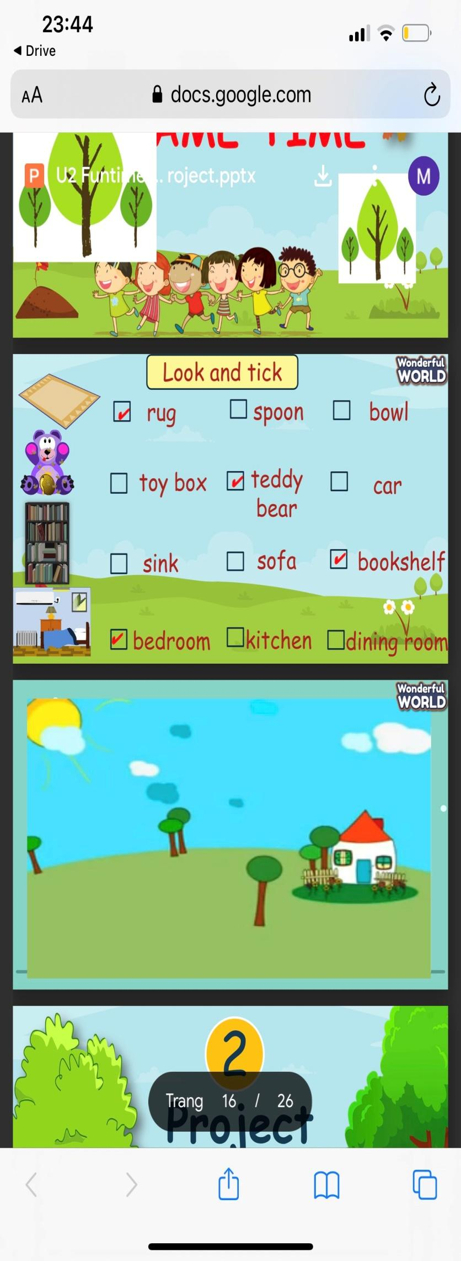  - Anyone who can answer correctly, will be given a star.  Video for the project  My House  This is my ….  There is a/ there are…  -T shows pictures of favourite bedroom.  - Writes down the structure and ask them to repeat the structure, using adjectives about objects and house.  Implementing stage  Before drawing  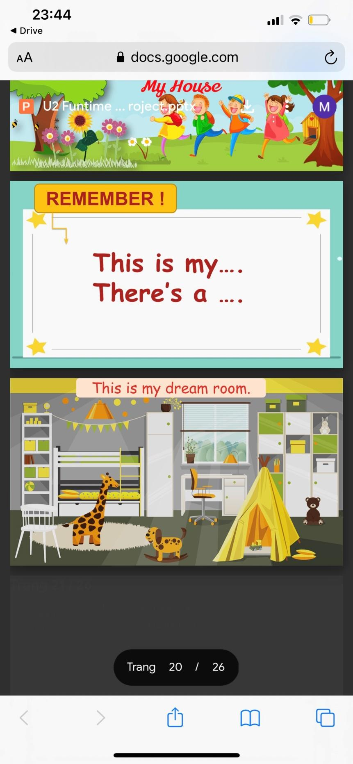  - Ask sts to work individually using the structures.  - Show the picture of rooms and ask sts to answer about rooms and objects.  - Ask sts to read aloud sentences.  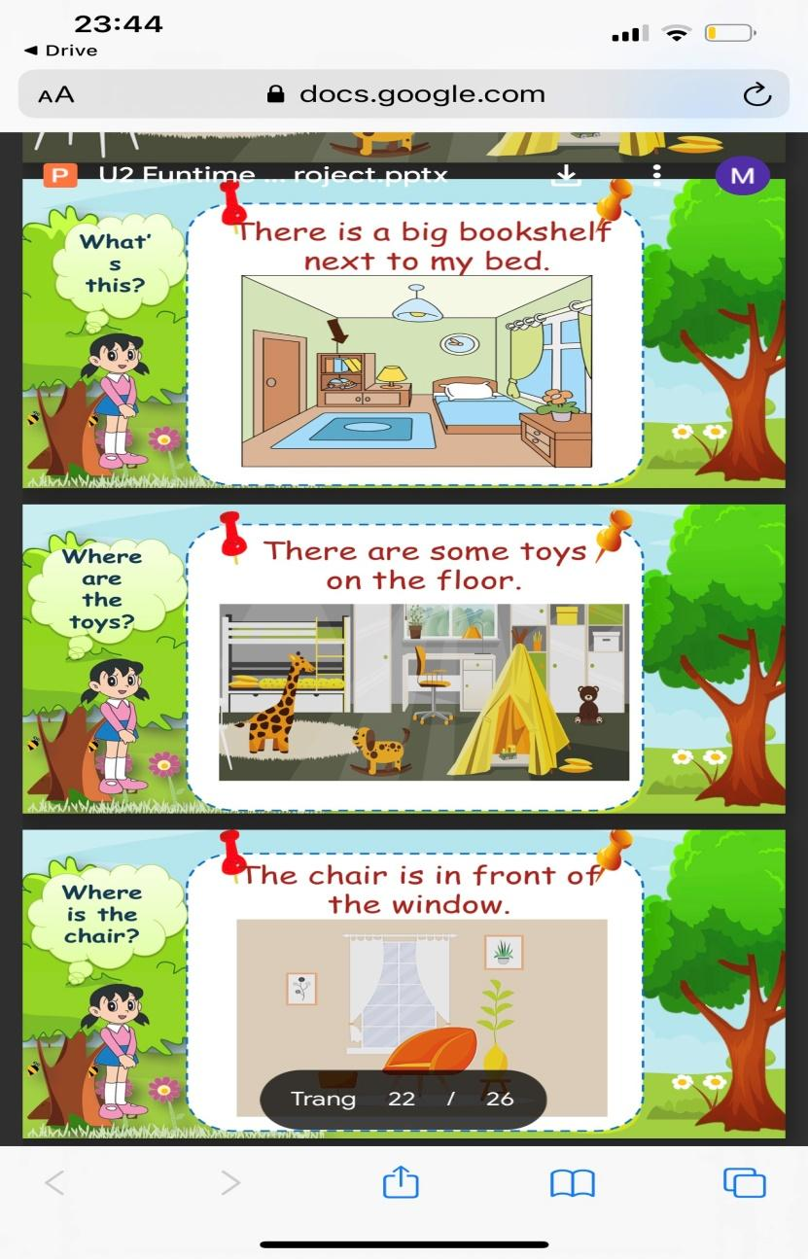  - Ask sts to make sentences about their rooms.  - Show the sentences one by one.  - Tell them to draw a picture of family  - Colour the picture  - Ask sts to go to the board – group by group and present.  Displaying and Reflecting on the board  - Ask sts to come to the board and present about their rooms in class.  - Go around to offer help when necessary.  - Check the number of members they have talked to  - Award the best speaker.  Evaluation (2 MINUTES)  Go to sleep  - T shows some flashcards of house and ask sts to guess what picture is missing. | - Listen to the teacher  - Listen to the game rules  - Look at the pictures  - Choose the correct answer  - Show the board of correct answers.  -Talk to friends about the picture.  - Read aloud the answers about rooms.  - Follow the instructions.  - Look at the pictures and complete some words.  - Speak out the sentences.  - Draw a picture of their favourite room.  - Present in group  - comment – cross-checking group by group.  - Do the task.
___________________________________________

REVIEW 1
Part 1. Task 1, 2, 3
Period 19
I. OBJECTIVES:
1. Knowledge: By the end of the lesson,
- Students will review the words and structures related to the topic: Family and friends:
+Family members: father, mother, daughter, son, twins
+Adjectives to describe someone’s personality: clever, cute, kind, polite, cheerful, friendly, hardworking, pleasant
+Questions about someone’s family members
Who is he/ she? - He’s my father. - She’s my mother.
+Questions about someone’s personalities
What is your sister like? - She’s hardworking and pleasant.
What is his twin brother like? - He’s naughty and cute.
2. Competences:
- English competences: Students will be able to talk about their family and friends, use some adjectives to describe someone’s personalities
- Common competences: Students will have the opportunity to develop communication among friends.
3. Qualities:
- Students will be responsible and well-behaved in communicating in the classroom with friends and others.

II. EQUIPMENT AND MATERIALS:
- Basic things: Student’s book, flashcards.
- Advanced things: PPT, projector/interactive whiteboard/laptop/TV.

III. LESSON PROCEDURE:
Teacher’s activities | Student’s activities
Activity 1: Warm-up (5 minutes)
a.Aims: warm-up activity to introduce the lesson, review the words of adjectives
b.Procedure:  - Greet the students  - Divide the class into 4 teams  - Play the video: Go banana!  https://www.youtube.com/watch?v=o6gHL1LJ-HQ  - Ask students to sing and dance the warm-up song.  - Play a game: Memory game  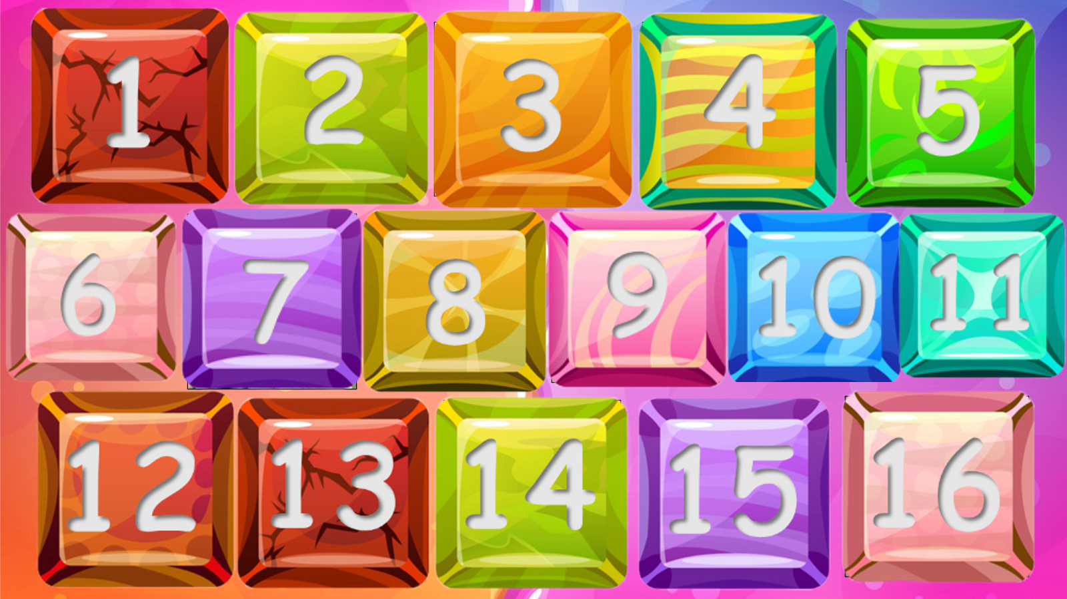  How to play: There are 8 pairs of words and pictures. Students choose 2 numbers each turn to find the matching word and picture pairs  - Set the game rules.  - Ask students to choose 2 numbers to find the correct pairs.  - Award the best groups  Lead-in: Use the pairs of pictures and words to review. | - Greet the teacher  - Choose the team name  - Look, listen, sing and dance  - Stand up, sing and dance  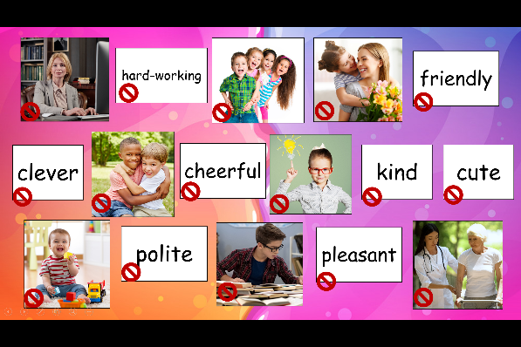  - Listen to the game rules carefully  - Play the game in groups  Suggested answers  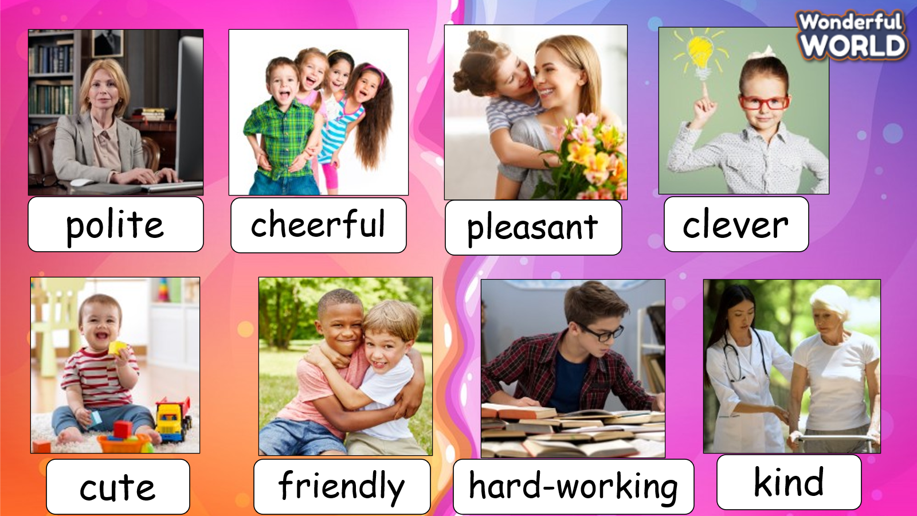
Activity 2: Review (20 minutes)
a.Aims: Review and practice the words and structures learned in Unit 1
b.Procedure:  Task 1: Do the crossword  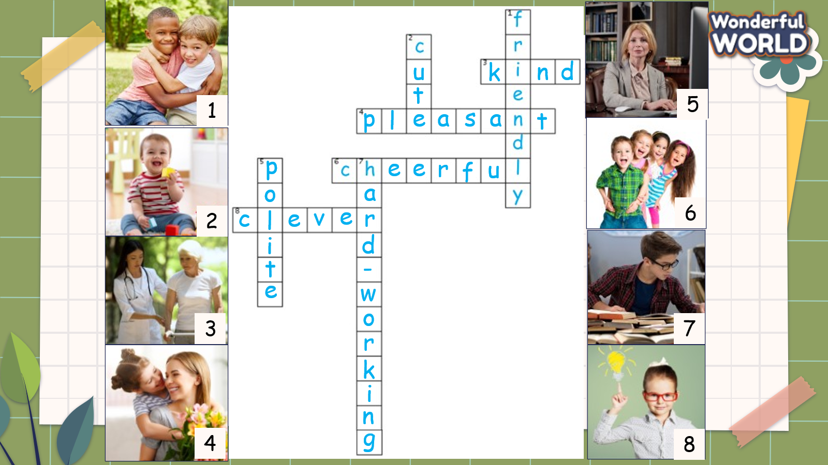  - Tell students to look at the photos 1–8.  - Ask them to tell you what they show. Elicit the words.  - Tell students that they have to complete the crosswords and they can use the photos to help them guess the words.  - Allow enough time to complete the task, individually or with a partner.  - Check answers as a class.  Task 2: Match  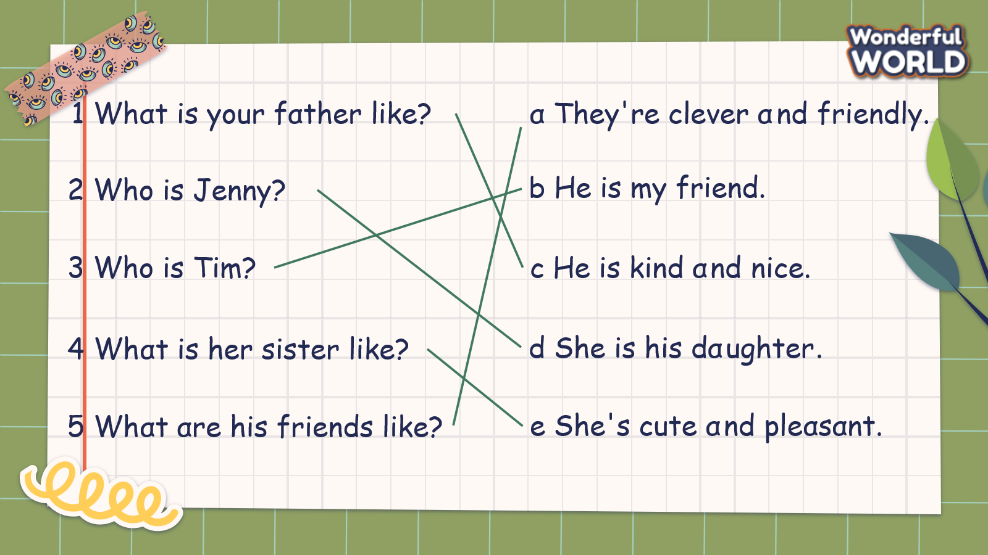  -Ask students to look at questions 1–5 and their answers a–e. Look at the example as a class.  -Read the sentences aloud and ask students to repeat. Match the first sentence as a class.  -Check students understand the task. Allow enough time to complete it, alone or with a partner.  -Check answers as a class.  -Play a game: “Dinosaur game”  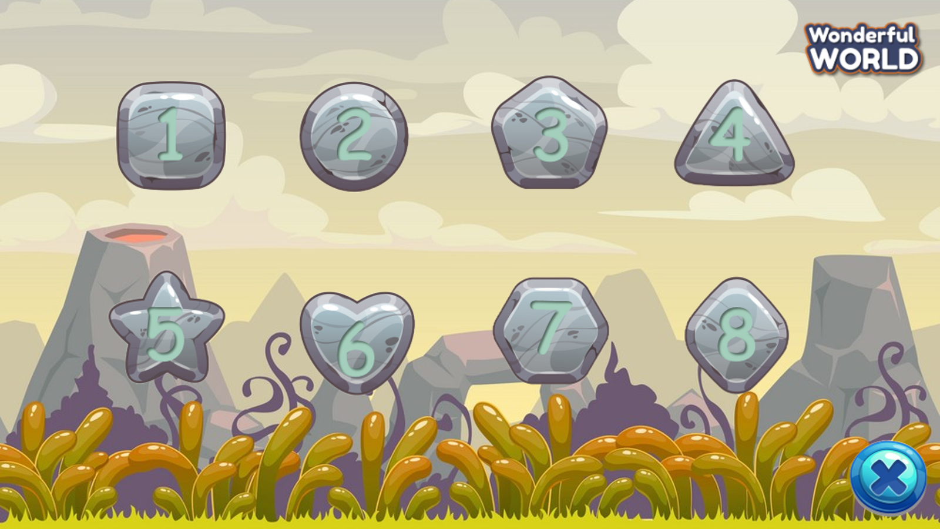  How to play: There are 8 questions. Students choose and answer questions. For each correct answer, students get a dinosaur with the corresponding score  - Introduce and set game rules.  - Call students to choose a number and answer the questions.  Questions  1. What are his friends like?  2. What is your mother like?  3. My sister/ugly/tall/cute  4. Her cousin/ hard-working/clever  5. cheerful/ mother/ and/ and/ My father/ are/ kind  6. Who are they?  7. Who is she?  8. His grandpa/ young/ old/ kind  - Check answers and give feedback.  Task 3: Ask and answer  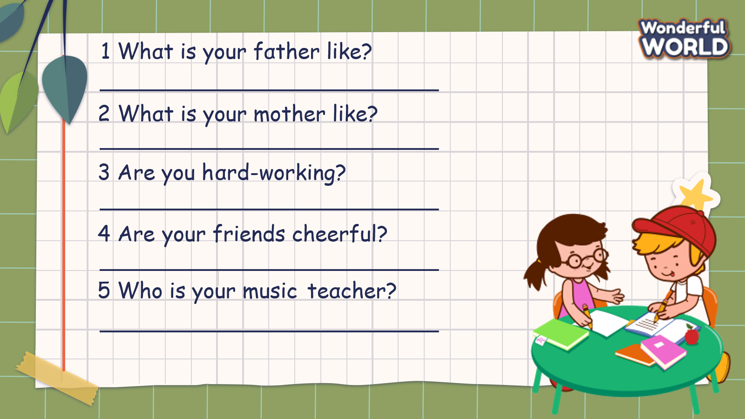  -Read out the question “What is your father like?” and the example answer “My father is very kind.”  -Ensure students understand how to complete the task. Allow them enough time to complete it, monitoring and helping as necessary  -Check answers. Ask volunteers to read out their answers. | -Look at the photos  -Answer the teacher’s questions.  -Listen to the teacher  -Do the crossword  -Check answers  -Look and read the example.  -Repeat after the teacher.  -Match questions with the answers.  -Check answers with friends  Suggested answers  1-c, 2-d, 3-b, 4-e, 5-a  -Listen to the game rule  -Join the game  Suggested answers  1. They are friendly  2. She is kind and pleasant.  3. My sister isn’t ugly. She is tall and cute.  4. Her cousin is hard-working and clever.  5. My father and mother are kind and cheerful.  6. They are twin brothers.  7. She is his grandma  8. His grandpa isn’t young. He is old and kind.  -Listen to the teacher  -Ask and answer the questions in pairs  -Check and practice in front of class  Suggested answers  1. My father is (adjective)  2. My mother is (adjective)  3. Yes, I am/ No, I am not  4. Yes, they are/ No they are not  5. My music teacher is (name)
Activity 3: Extra activity (10 minutes)
a. Aim: Apply grammar to real world
b.Procedure:  - Talk about your family and friends  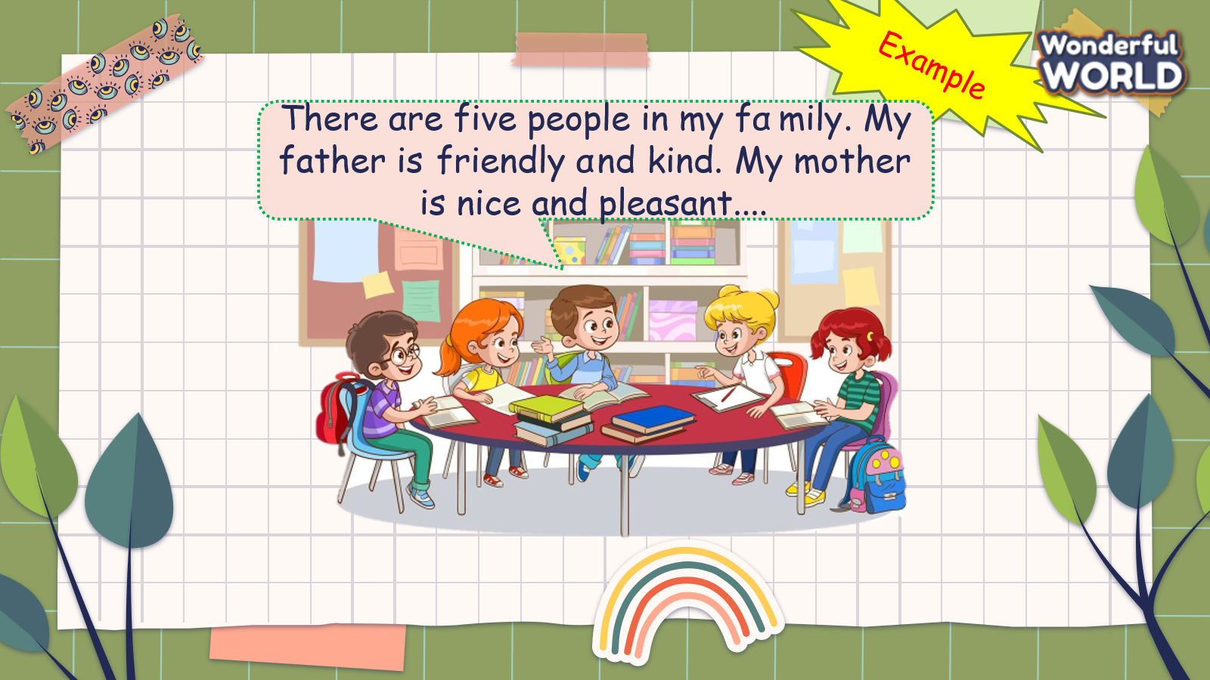  - Ask students to work in groups and talk about their family and friends  - Call some students to present in front of the class.  - Give feedback to them.  - Play the video, sing, do actions, and ask students to sing along then say goodbye. | - Work in groups. Talk about family and friends.  - Present in front of the class.  - Listen to the teacher.  - Stand up, sing, and dance. Then say goodbye to the teacher.
___________________________________

REVIEW 1
Part 2. Task 1, 2, 3
Period 20
I. OBJECTIVES:
1. Knowledge:
Students will learn words and phrases related to the topic my home
2. Competences:
- English competences: Students will be able to remember the words and structures they have learnt.
- Common competences: Students will have the opportunity to develop logical thinking and develop communication among friends.
3. Qualities:
- Students develop love toward different leisure activities and be friendly to their friends in the class.
II. EQUIPMENT AND MATERIALS:
- For Teacher: PPT, flashcards.
- For students: textbook
III. LESSON PROCEDURE:

Activity 1: Warm-up (10 minutes)
a. Aims: Review the vocab and grammar of the previous lesson- using the fun activities in the lesson.
Teacher’s Activities | Students’ Activities
b. Procedure  Warm-up:  Review: Play game Horse Race  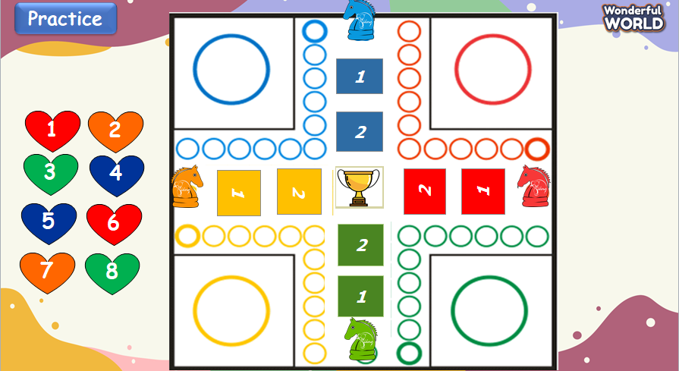  - Tell students how to play the game  + Divide class into teams  + Each team is asked a number question. If the answer correctly, click their teams colour butter to move.  + Which team has 2 correct answers, they win.  - Do as a model  - T asks Sts to repeat after checking. | - Listen to the instruction carefully  - Repeat.  - Listen to T.  - Play the game.
Activity 2: Practice (12 minutes)
a. Aims: Review words of My home learned in the unit via various activities from the book.
- Encourage sts to look around in class and ask friends about things in your home.

Teacher’s Activities |  | Students’ Activities
b. Procedure  Task 1: Write. Circle a or b  • Tell students to look at the pictures and match  • Ask students to look at the first picture, read out the first question and ask students to repeat.  • Check the answers in front of class.  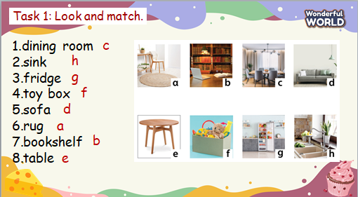 |  | - Look and answer.  - Work in pairs.  - Notice the cross at the corner of the picture
Teacher’s Activities |  | Students’ Activities
Task 2: Look and say  -Tell students to look at the picture for question 1 and the example.  -Read out the example and ask students to repeat.  -Explain the rest of the task to students. Allow them enough time to practise saying the sentences individually and in pairs. Go round the class helping students where necessary.  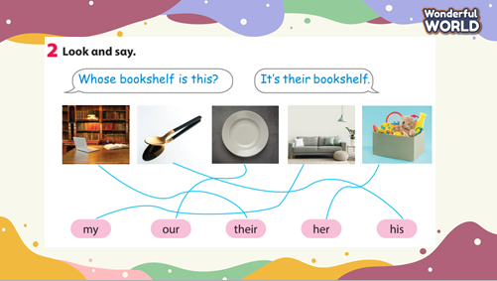 |  | - Listen and work in pairs.  - Present in front of the class  - Listen.
Task 3: Write  Read out the first question and ask students to look at the  words in the box to fill in the gap.  • Check that students understand the task. Allow enough  time to complete it.  • Check answers as a class  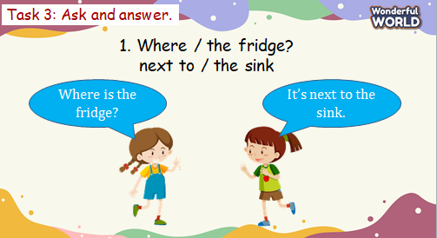 |  | - Look and answer.  - Work in pairs to practice asking and answering the questions.
Activity 3: Assessment (3 minutes)
a. Aims: Consolidate the content of the lesson
Teacher’s Activities |  | Students’ Activities
b. Procedure  -Ask sts to do the assessment.  - Check with the class.  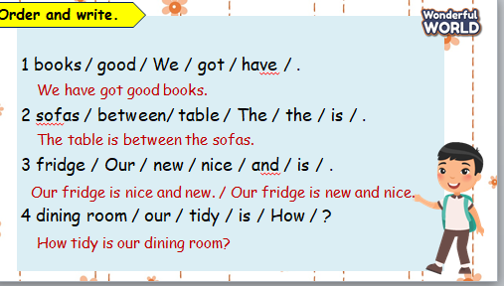 |  | -Do the assessment.  - Check with the teacher.

