REVIEW 1
Part 3 – VIDEO . Task 1, 2, 3
Period 21
I. OBJECTIVES:
1. Knowledge: By the end of the lesson students will be able to:
- Watch and understand a video about a house and family members
- Review vocabulary about family members, some furniture, and rooms in the house while watching the video.
2. Competences:
- English competences: Students will be able to talk and write a sentence about their house.
- Common competences: Students will develop their creativeness in drawing pictures.
3. Qualities:
- Being respectful and showing love to their house.
II. EQUIPMENT AND MATERIALS:
- For Teacher: PP, TV, boards, markers
- For students: A4 paper, books, pens, crayons
III. LESSON PROCEDURE:

Teacher’s activities | Student’s activities
Activity 1: Warm-up (5 minutes)
a.Aims: warm-up activity to introduce the lesson, review the words of rooms in the house.
b.Procedure:  - Greet the students  - Divide the class into 4 teams  - Play the video: My house  https://www.youtube.com/watch?v=qZyJPZxsmZk  - Ask students to sing, dance, and remember rooms in the video.  - Ask students to answer the question: How many rooms are in the video?  - Check students’ answers and give comments. | - Greet the teacher  - Choose the team’s name  - Look, listen, sing and dance  - Stand up, sing, dance, and remember rooms in the video.  - Answer the question of teacher: 4 rooms (living room, bedroom, bathroom, kitchen)  - Listen to the teacher.
Activity 2: Review (20 minutes)
a.Aims: Review the words and structures learned in unit 2 and watch the video
b.Procedure:  2.1. Vocabulary  Task 1: Circle the things in your house.  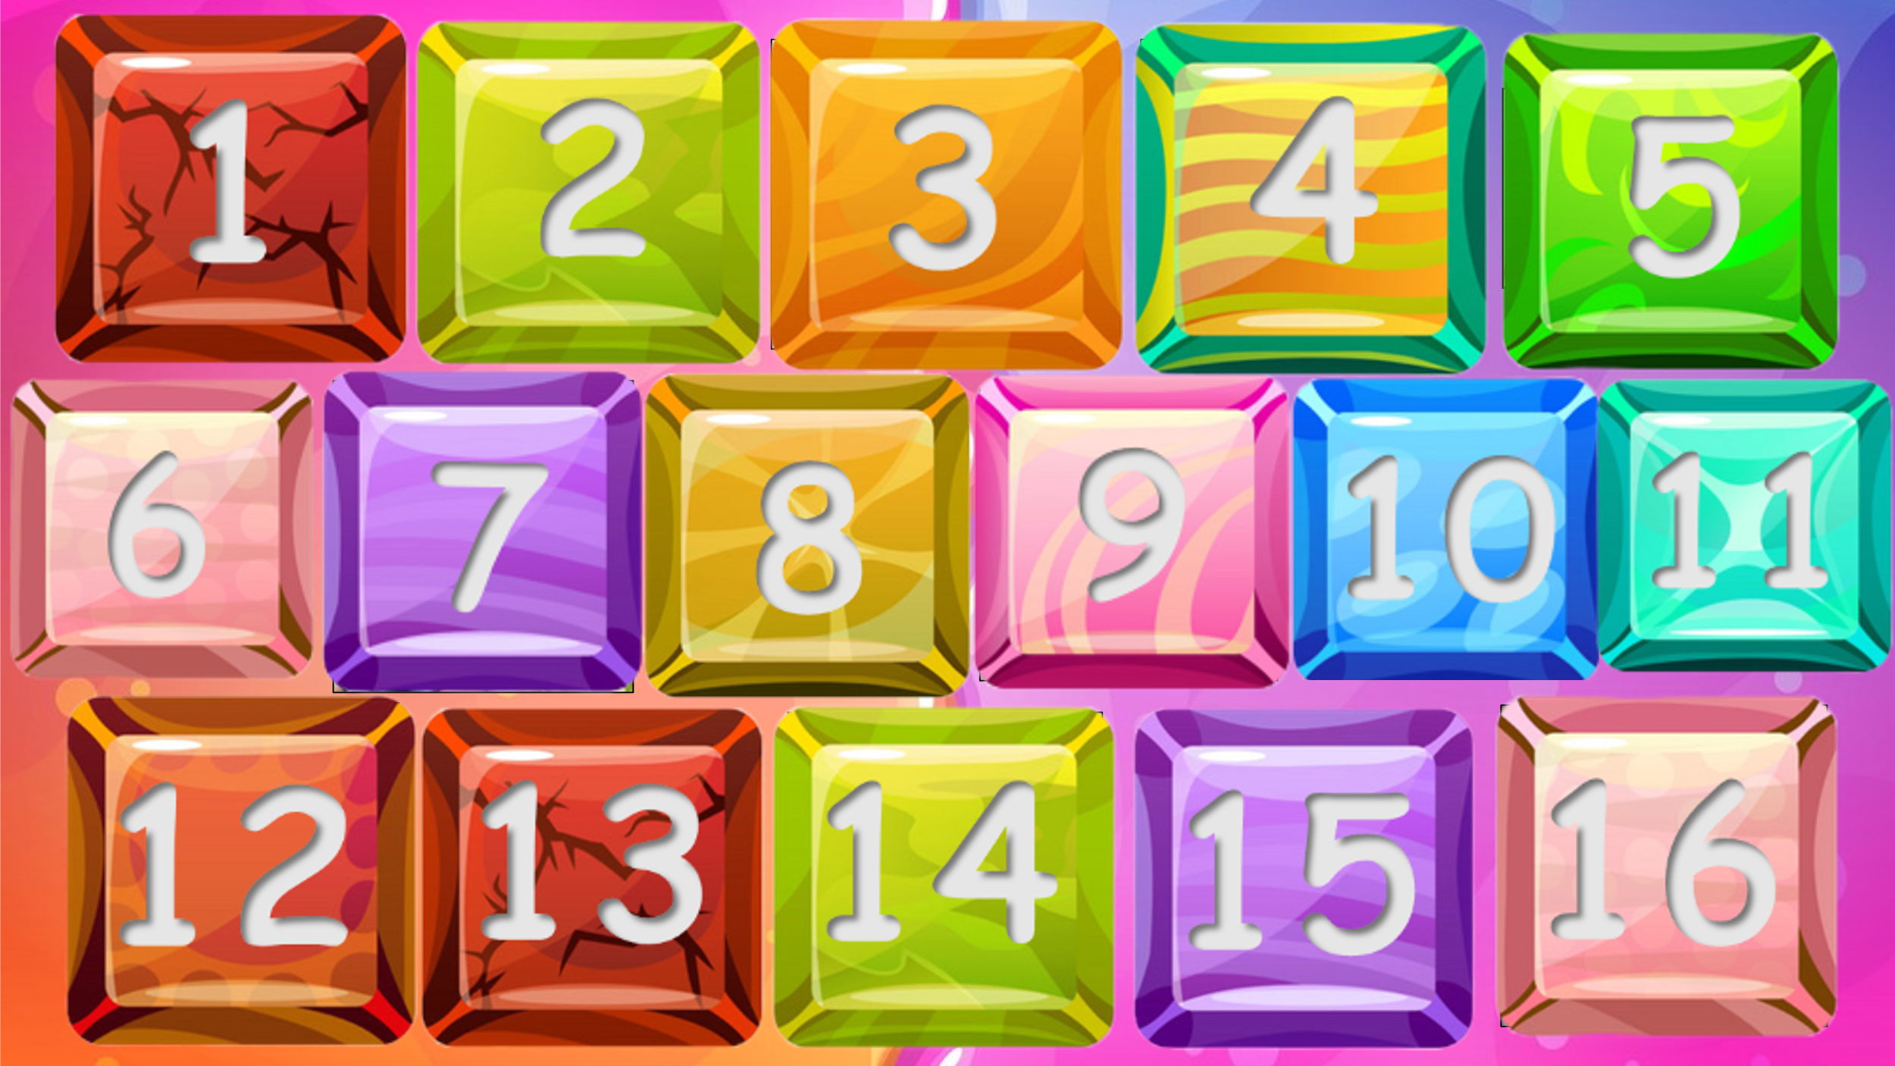  - Ask students to look at the picture and tell the teacher what they can see.  - Ask students to answer the questions:  Who are they?  Where are they?  -Ask them if they can remember any words to talk about family members and things in a house.  -Ask students to keep their books closed. Ask them what things they can have in a house. Write answers on the board.  - Show the list of things in task 1 on the screen and ask students to read.  - Look at the list of things on the board. How many things match the list in Activity 1?  - Tell students to complete the task 1. Ask them where they would find the other things on the list.  2.2. Video:  Task 2: Watch the video and circle.  The first time:  - Ask students to watch a video with no sound about a house then tell the teacher who they can see in the video.  - Praise the student who can name all the rooms and furniture in the video.  The second time:  - Ask students to answer the questions:  Is there any sound in this video?  - Ask students to watch the video again with sound and do exercise 2 in the student’s book – circle the correct answer they can see in the video.  - Ask students to exchange their books for pair checking.  - Ask students to raise their hands if they have all the correct answers.  -Play a game: Angry Birds mystery box.  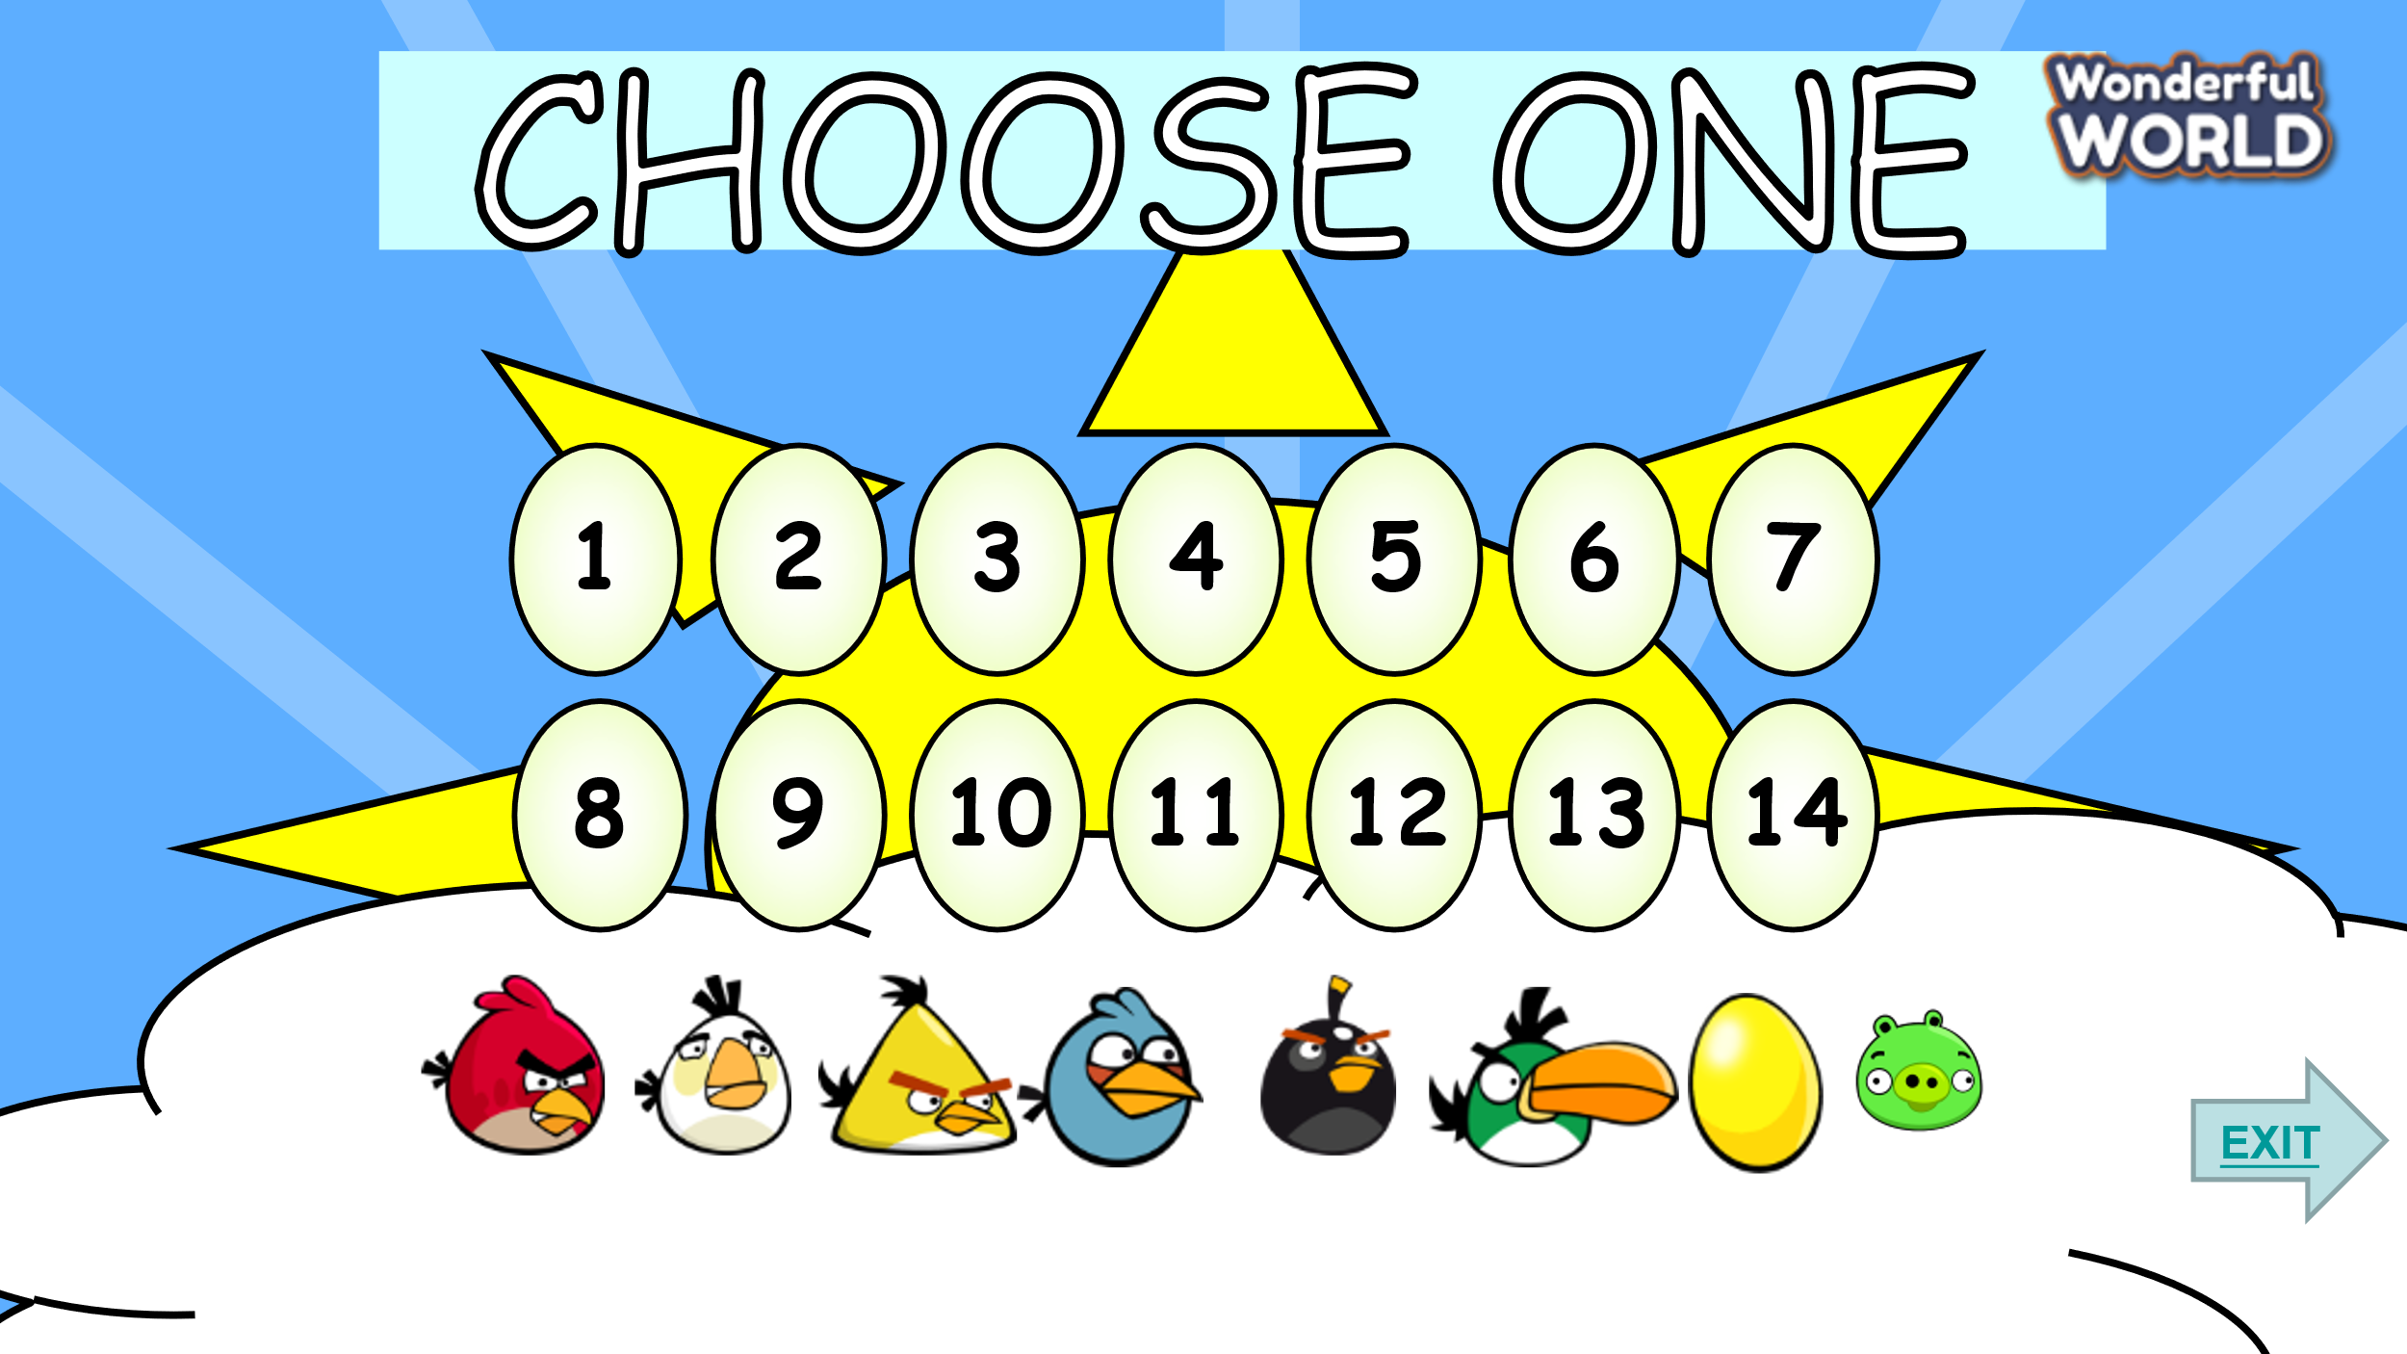  How to play: Students choose an egg and answer the question. Students have 5 seconds to answer. If students give an incorrect answer, another team can raise their hands to answer. If students get it right, they will get a MYSTERY BOX. The mystery box is good or bad. Students can keep it or give it to another team.  - Introduce and set game rules.  - Play as a model  - Call students to choose a number and answer the questions.  Questions:  +Where is the sofa?  +Where is the rug?  + How messy is his room?  +have got/ We/ kitchen/ big/ a.  +Where is the bookshelf?  +new/ They/dining room/ have got/ a.  +Where is the table?  +Where is the bowl?  Task 3: Talk about your room.  - Ask students to draw a picture of their bedroom.  - Ask students to talk about their room in group time: 3 minutes.  - Call some students to stand in front of class to introduce their family (A sentence by sentence)  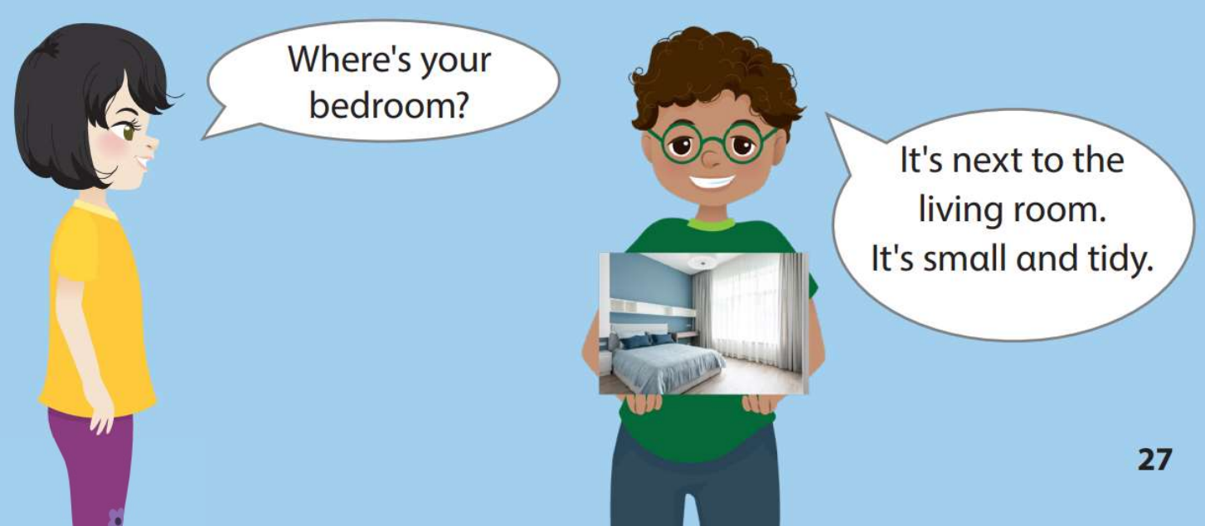 | - Look at the picture.  - Answer the questions  They are family (father, mother, son and daughter)  They are sitting on a sofa at home  - Tell the lists of things in a house  - Look and read the list of things in the task. Compare 2 lists and answer the question of the teacher.  - Complete the task 1.  -Watch a video with no sound about a house then tell the teacher who they can see in the video.  -Answer the question.  -Watch again and circle  -Pairs work  -Join the activity  Suggested answers  – It’s in the living room.  – It’s next to the sofa.  – It’s very messy.  –We have got a big kitchen.  – It’s next to the TV.  –They have got a new dining room.  – It’s between two chairs.  – It’s next to the spoon.  -Draw a picture of their room  -Talk about their room in group time: 3 minutes.  -Practice in front of class
Activity 3: Extra activity (12 minutes)
a.Aim: Do some exercises to revise the lesson in order to use words and structures effectively.
b.Procedure:  Task 1: Find and circle  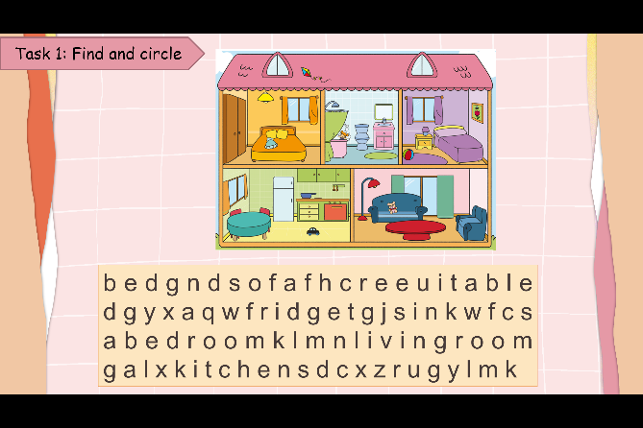  -Αsk students to look at the picture and elicit what rooms and things they can see.  -Tell students they are going to find and circle the correct words.  - Give an example.  -Αllow students enough time to complete the task individually. Go round the class helping students where necessary.  - Check students' answers and give comments  Task 2: Look and match  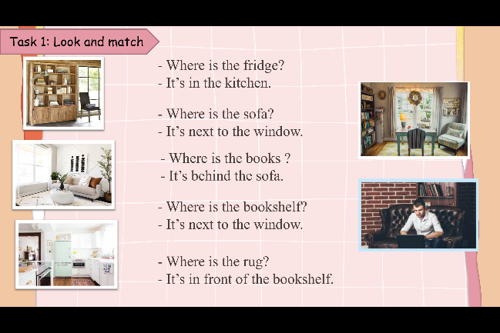  -Αsk students to look at the picture and elicit what rooms and things they can see.  -Tell students they are going to look and match the pictures with the conversations  - Give an example.  -Αllow students enough time to complete the task individually. Go round the class helping students where necessary.  - Check students' answers and give comments  - Play the video, sing, do actions, and ask students to sing along then say goodbye.  https://www.youtube.com/watch?v=2O975ewRT7Q |  | Suggested answers  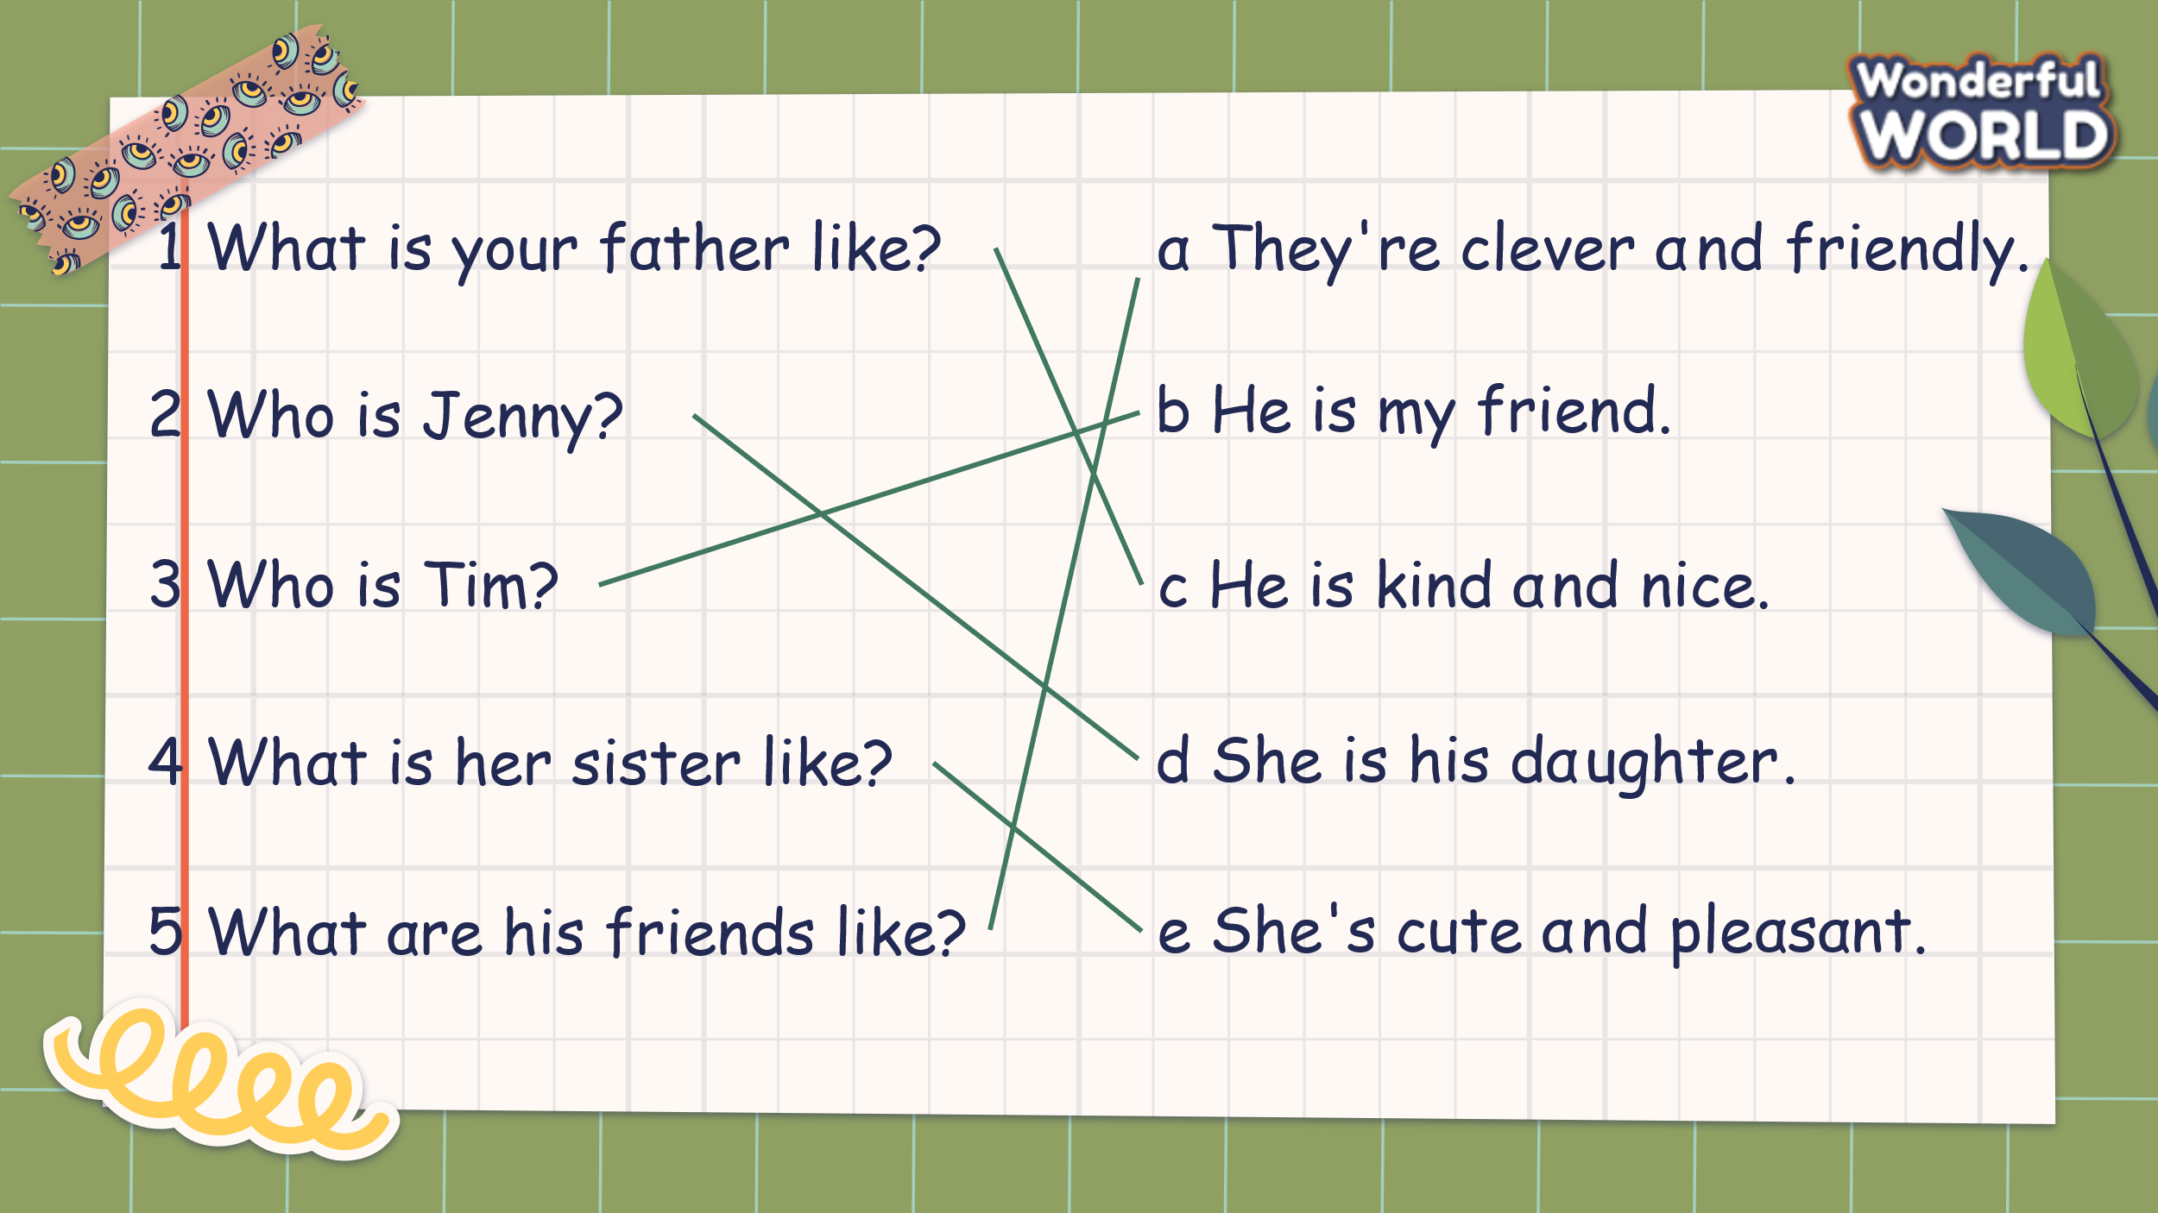  - Look at the picture and tell the rooms and things in the picture  - Listen to the teacher  - Complete the task  -Check the answers and listen to the teacher’s comments  Suggested answers  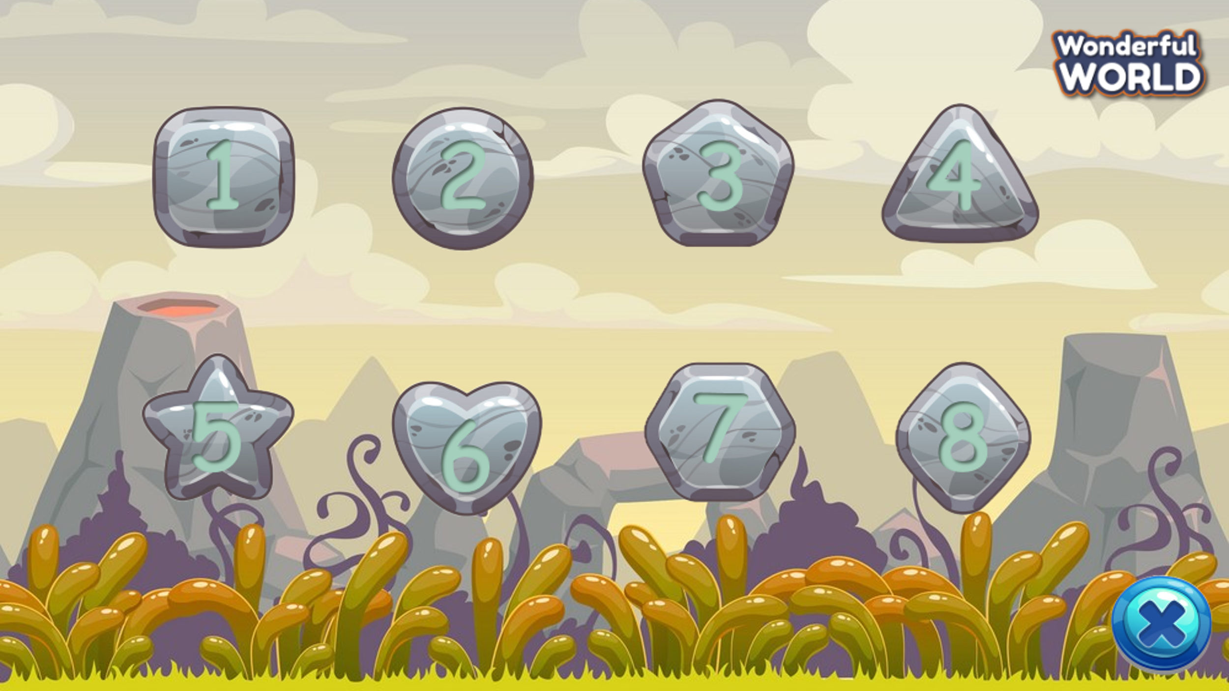  - Look at the picture and tell the rooms and things in the picture  - Listen to the teacher  - Complete the task  - Check the answers and listen to the teacher’s comments  - Stand up, sing, and dance the say goodbye to the teacher.

___________________________________
REVIEW 1
Part 4. Task 1, 2, 3
Period 22
I. OBJECTIVES:
1. Knowledge:
Students will learn words and phrases related to the topic My family and friends.
2. Competences:
- English competencces: Students will be able to remember the words and structures they have learnt.
- Common competences: Students will have the opportunity to develop logical thinking and develop communication among friends.
3. Qualities:
- Students develop love different leisure activities and be friendly to their friends in the class.
II. EQUIPMENT AND MATERIALS:
- For Teacher: PPT, flashcards.
- For students: textbook
III. LESSON PROCEDURE:

Activity 1: Warm-up (10 minutes)
Aim: warm-up activity to introduce the topic and review the previous lesson
Teacher’s Activities | Students’ Activities
b. Procedure  Warm-up:  Listen and dance : “Dance Family | D Billions Kids Songs” | - Listen and dance along
Activity 2: Review
a. Aim: Review the vocab and grammar of the previous lesson- using the fun activities in the lesson.
b. Procedure  Review: Play game “The Big Wheel”  - Tell students how to play the game:  Instructions:  1) Divide into Teams  2) Ask a Question to a Team ( click the question number button)  3) If correct, click the Spin Wheel Button to choose the number of  points that team will receive.  4) Continue until out of questions.  - Do as a model  - T asks Ss to repeat after checking. 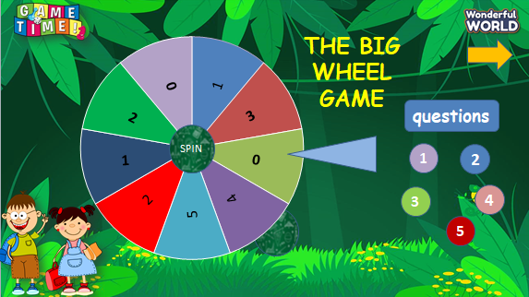 | - Listen to the rule carefully.  - Join the game.  -Look and read.  -Read  -Identify and read.  - Check with friends and then with the teacher and the whole class.  .
Activity 3: Practice (12 minutes)
a. Aims: - Do the exercise to review the words and structure to describe someone’s appearance and characteristics
- Encourage sts to make a presentation about a family member or a friend.
Teacher’s Activities | Students’ Activities
b. Procedure  Task 1: List the words to describe people.  • Ask students to work in pairs or groups to brainstorm for the words to describe people. Guide them to divide the words into those that describe appearance and characteristics. Read out the example words and explain the meaning of appearance and characteristics.  • Allow students enough time to finish their lists. Go round the class to help where necessary.  • Check the answers as a class.  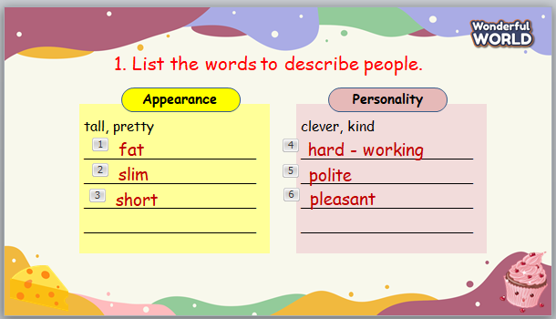 | - Look and answer.  - Work in pairs to exchange their lists.  - They can ask their friends  questions if there are words they  do not remember.
Teacher’s Activities | Students’ Activities
Task 2: Look and say  • Ask students to look at the example. Read it aloud and ask students to repeat after you.  • Tell students to think about a family member or a friend and note down some words to describe their appearance and characteristics. Then draw a picture of that person. Allow students enough time to finish drawing.  • Then ask students to write a few sentences to describe  the person they have just drawn. Remind them to use the  words from Activity 1. 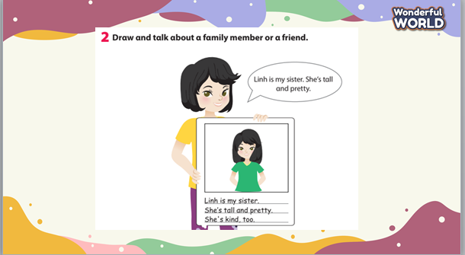 | - Listen and work in pairs.  - Present in front of the class  - Listen.  - Students draw.
Activity 4: Assessment (3 minutes)
a. Aim: Consolidate the content of the lesson
Teacher’s Activities | Students’ Activities
b. Procedure  -Ask sts to do the assessment.  - Check with the class.  - Encourage ST to read aloud the questions and answers  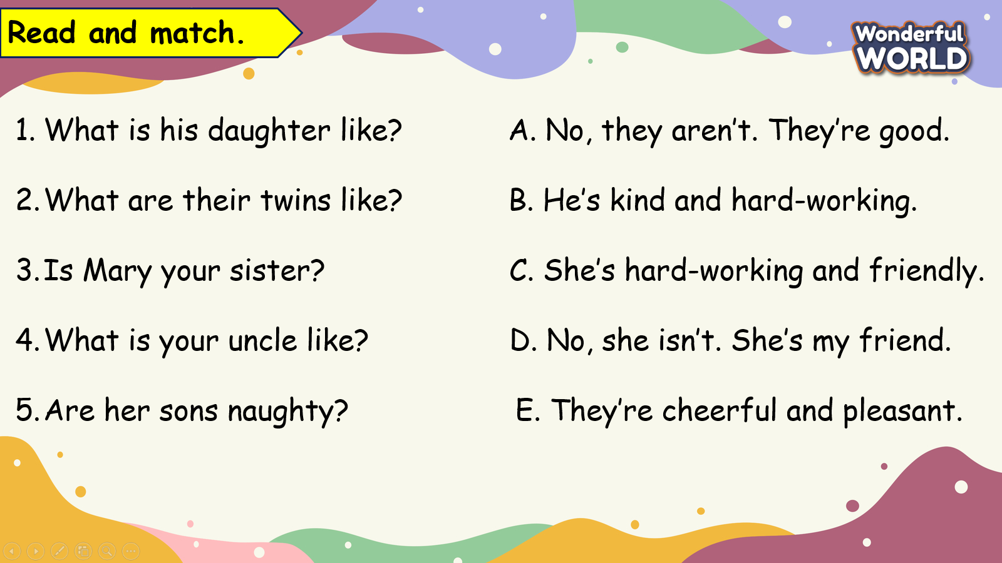 | -Do the assessment.  - Check with the teacher.
___________________________________________
UNIT 3. ON THE FARM
Lesson 1. Task 1, 2, 3
Period 23
I. OBJECTIVES:
1. Knowledge:
- Students will learn words and phrases related to the topic Farm Animals: Chicken, cow, goat, horse, sheep, and review structure: I’ve got…
2. Competences:
- English competences: Students will be able to introduce some farm animals properly
- Common competences: Students will have the opportunity to develop creativeness in drawing and colouring the craft.
3. Qualities:
- Students develop the love toward animals
II. EQUIPMENT AND MATERIALS:
- For Teacher: PP, flashcards, handout, track 3.1, track 3.2
- For students: pens, A4 paper, crayons,
III. LESSON PROCEDURE:

Activity 1: Warm up (5 minutes)
a. Aims : Warm up the class and make the students ready for the lesson by eliciting the topic of farm animals.
Teacher’s Activities | Students’ Activities
b. Procedure  - Greet the students.  - Divide class into 4 teams.  - Play the video : “Old Macdonald had a farm”  -Ask ss to watch and copy the animals’sounds and words for fun.  - Ask ss to answer “What is the song about?”  Show the “Unit Opener” picture and  Ask: What animal is it? Is it a giraffe?  Ask: “What animal? – It’s an alpaca.”  (show more pictures about them and tell students about their name: Lạc đà Nam Phi)  “Where do they live? Do they live in the forest or on the farm?”  “Yes, they live on the farm.”  Then, “talk about the farm animals do you know?” | - Greet the teacher.  - Choose the team name.  - Look, listen, sing and dance.  - Answer  - No, it isn’t.  - No, it isn’t.  - It’s an alpaca.  - Chicken, goat….
Activity 2: Presentation (8 minutes)
a. Aim : Present the new grammar : “ I’ve got….” Using the new words they have learned.
Teacher’s Activities | Students’ Activities
b. Procedure  Set context: There are a lot of animals on his farm. They are hiding behind the stable.  Have sts guess what they are in the stable by listening to the animal sounds.  Show each animal one by one  Ask sts to look, listen and repeat  Guide sts to listen, repeat and do action  Checking:  Miming Game  Set sts playing game in 4 groups  One actor comes into front  T shows picture of an animal  The actor acts, others say the animal.  The first mouth wins the point  Pass the actor role to another member  Change the role of actor and speaker for fun.  Award the groups with most points  Introduce all words : Listen and point. Repeat  Have Sts speak out all the new words, and then show the words. The class repeats after the audio.  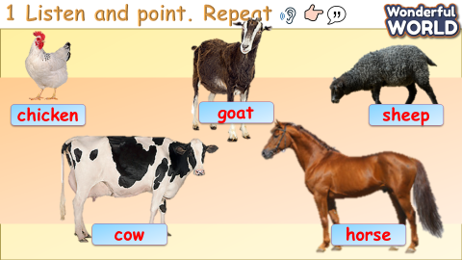 | Listen to teacher  Guess the animals  Listen to the sound  Guess the animals  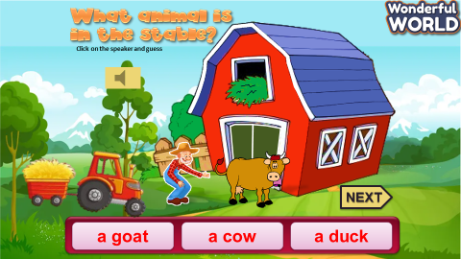  Listen, repeat and mime  Join miming game  Look at the picture  Do action  Say the animal  Change role  Listen and Repeat.
Activity 3: Practice (10 minutes)
a. Aim: Controlled- Practice to listen and match, discuss and practice in the modelled sentence.
Teacher’s Activities | Students’ Activities
b. Procedure:  Task 2: Listen and match.  Set context:  Ask sts: Do you want to visit the farm animals? Let’s go.  Which animal do you want to see ? Guess? What are they?  Listen and tick which animal and how it is.  Show the listening task:  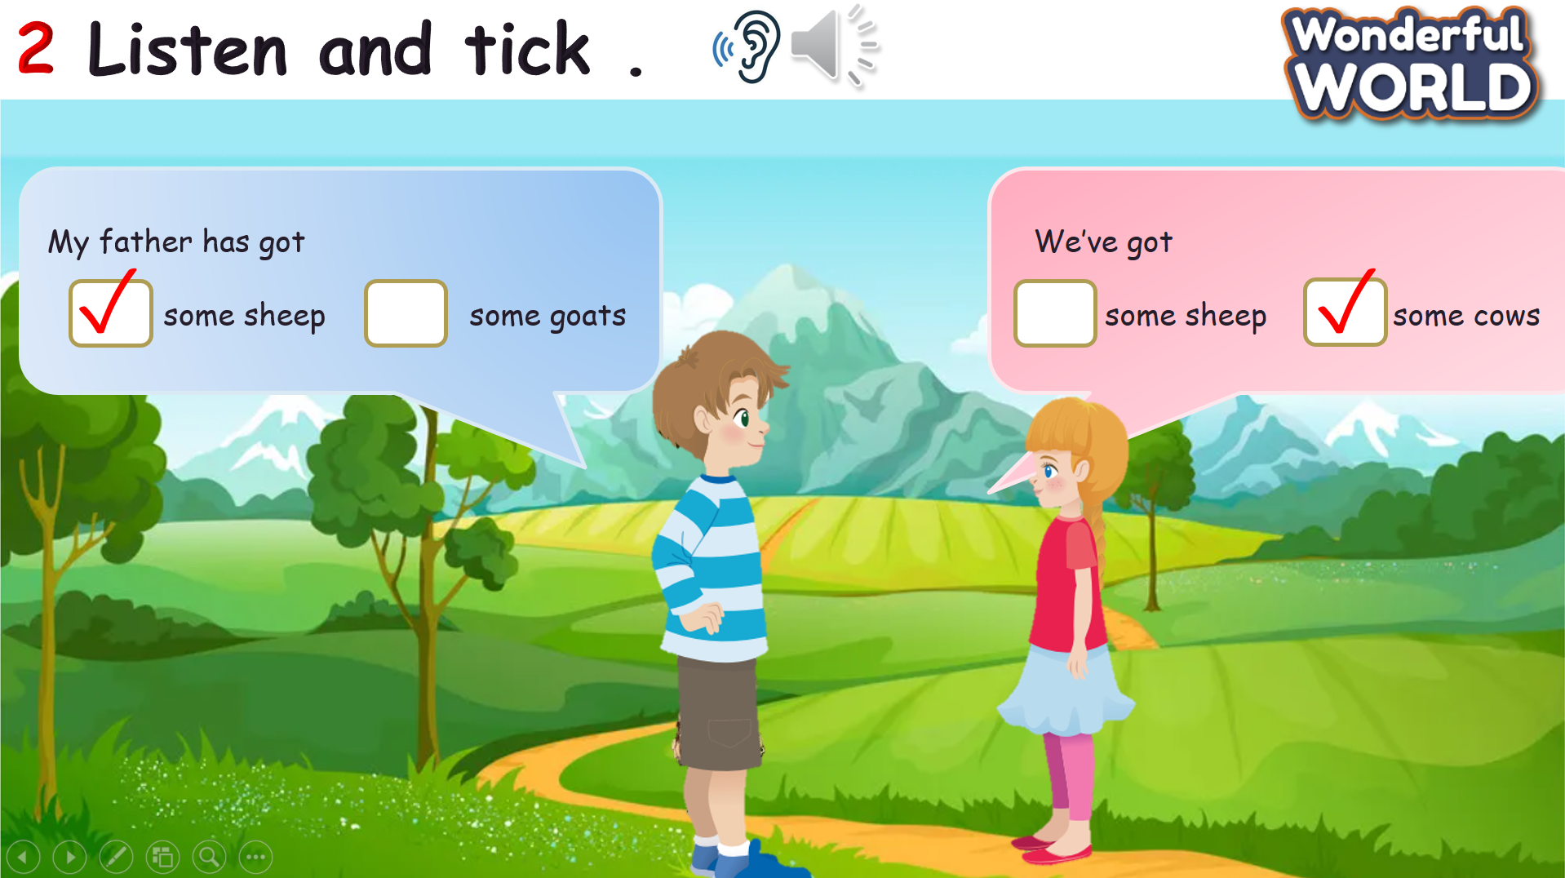  Play audio twice  Ask sts to listen and tick  Ask sts to do peer checking  Check with the whole class  Role play  Set context: you’re going to the farm and you can see the animals there. Guess how they are.  Show the picture of the animal  Check sts guessing  Play audio one by one with the dialogue  Ask sts to listen and repeat  Act out the dialogue as Sophie and Tomas  Vote for the best acting and speaking  Look and match  Ask sts to work in pairs  Ask sts to look at the pictures of animals and match with the words  Guide sts to do speaking task: one will be listener, one will be speaker  Ask the speaker to talk about the handout result to a listener  Change the role of speaker and listener  Go around and offer help when needed  Before they match, let Sts listen to the dialogue and read carefully.  Task 3: Look and say  Plants and Zombies Game:  Tell students to play the game by saying the picture with the structure “ I’ve got….”. Ss can listen to the sound of animal before seeing the picture of the animal . If they can say , give them the dice to roll to get stars.  Rule : With each correct answer, T clicks on the plant.  After finishing all the questions, click on the brown board to move to next slide. | - Answer the questions.  - Listen  - Do the tasks.  - Listen and tick.  - Guess.  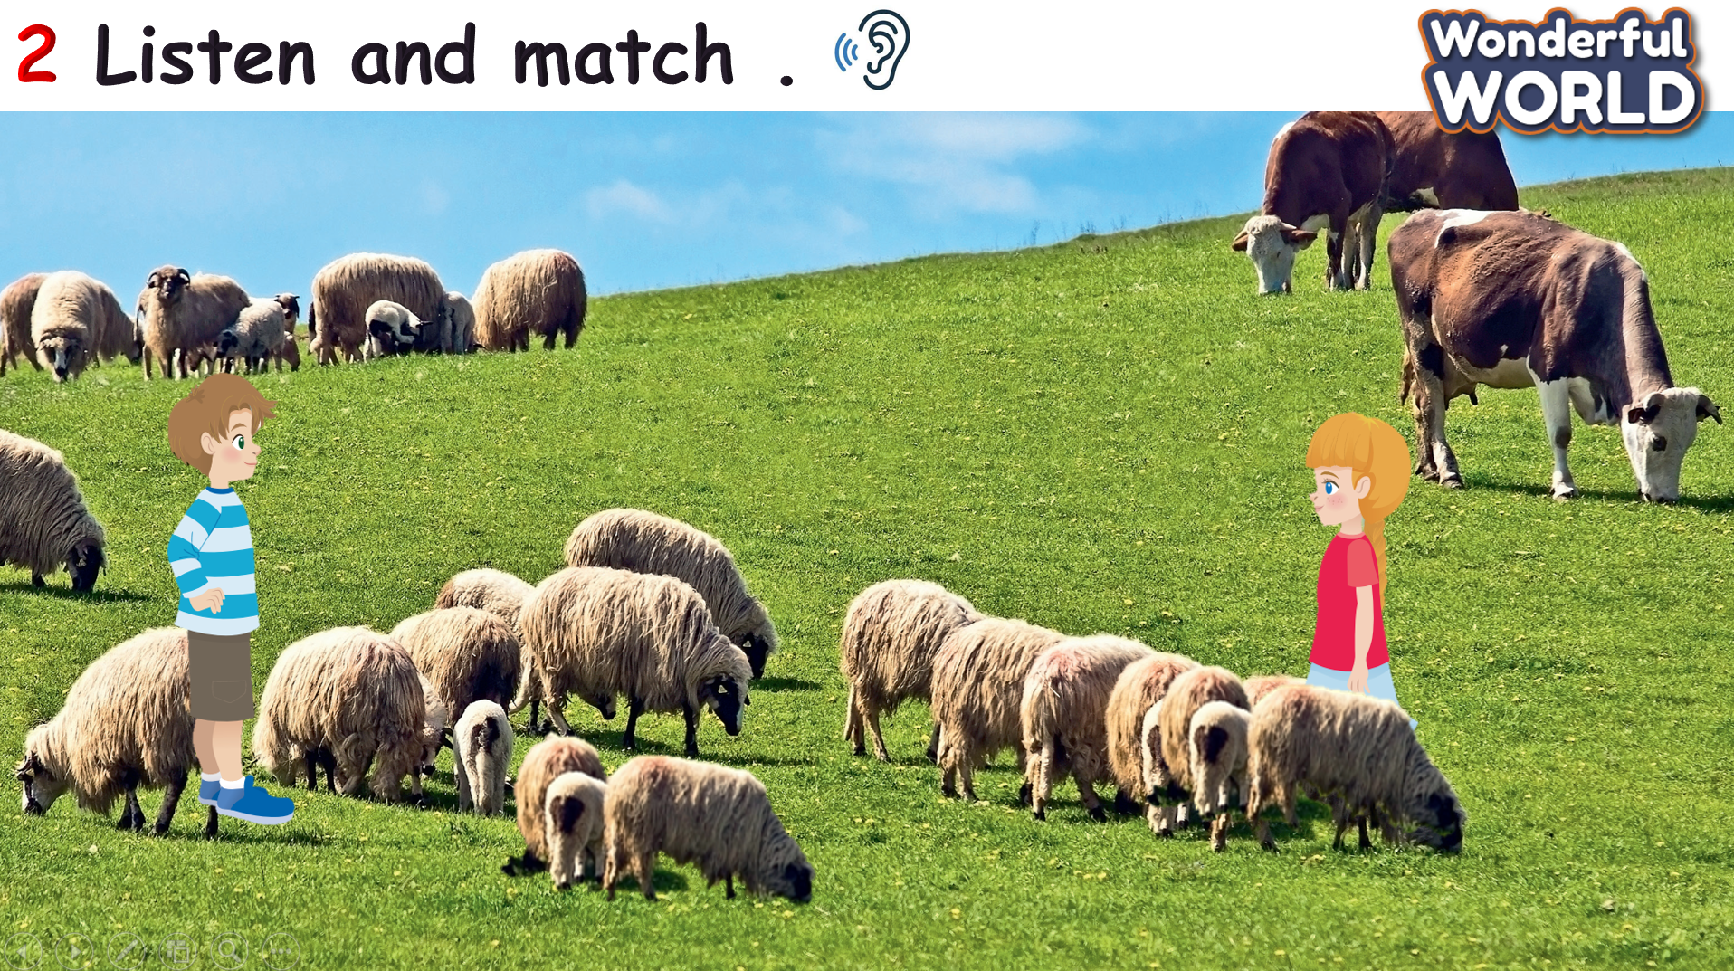  - Listen and repeat.  - Work in pairs.  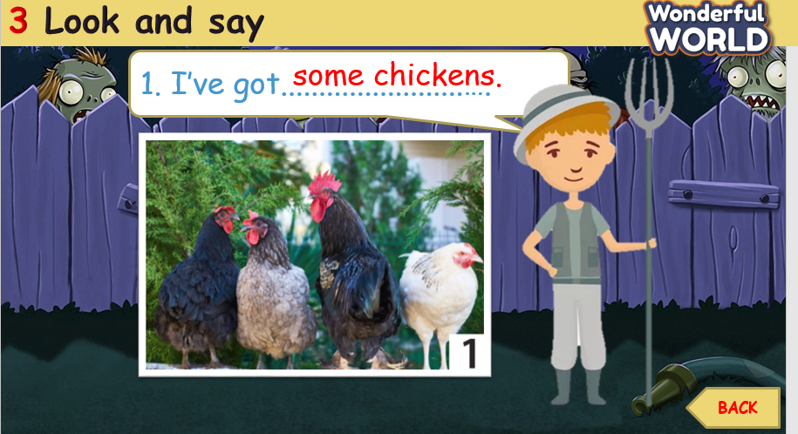  - Join the game  - Listen.  - Look and say
Activity 4: Production (9 minutes)
- Aim: - To engage students with the topic and activate knowledge and vocabulary:
- Making craft activity can encourage sts to get more motivation for this task of production.
Teacher’s Activities | Students’ Activities
b. Procedure : Old MacDonald Craft.  This craft is made from a paper, scissors, and colour pencils.  T can prepare the printed paper ( or if not ask them draw) and then show the sample craft, tell them cut the paper and color the stable and the animals.  Give them 5 minutes to make the craft.  Choose the best craft to show in front of the class , give S the award to encourage the other students or ask them show and say the names of the animals.  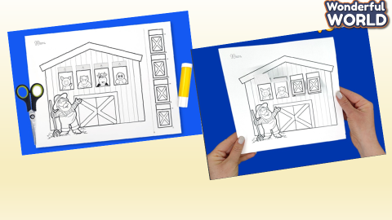 | - Prepare.  - Make the craft.  - Say the names of the animals.  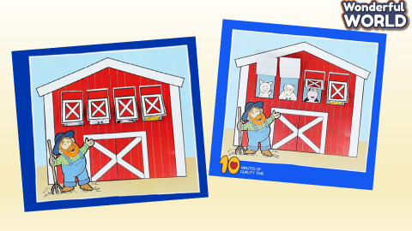
Activity 5: Assessment and Wrap up (3 minutes)
a. Aim : Consolidate the content of the lesson.
Teacher’s Activities | Students’ Activities
b. Procedure :  - Let ss do the assessment.  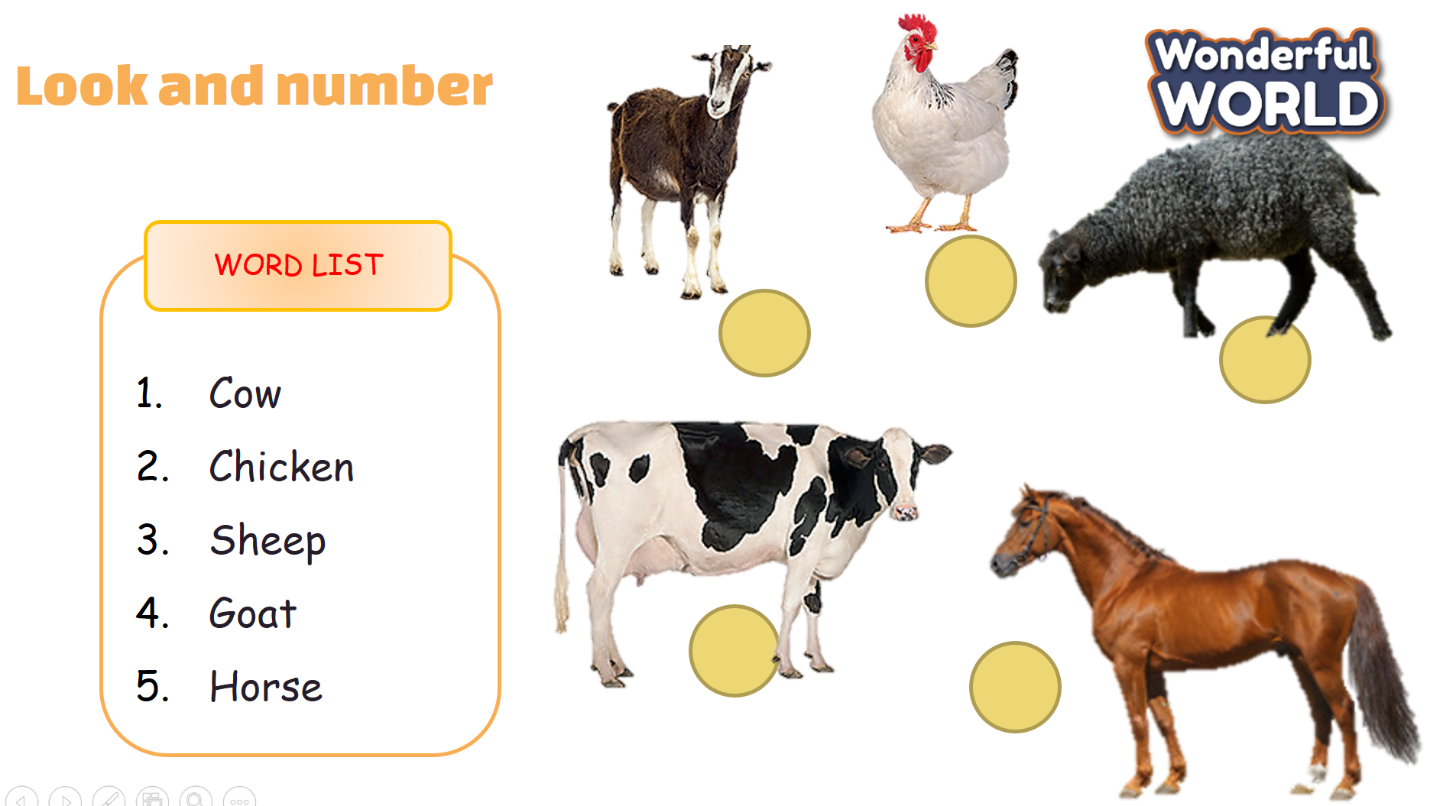  - Drill all words again and check for correct pronunciation  - Count stars and award stamps to winning team  Say goodbye students | -Do the assessment.  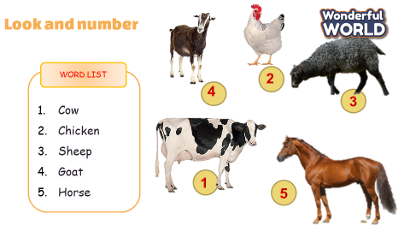  - Join in with drilling words for their team  Ss stand up to say  - Goodbye Teacher.
_____________________________

UNIT 3. ON THE FARM
Lesson 1. Task 4, 5, 6
Period 24
I. OBJECTIVES:
1. Knowledge:
Students will review some farm animals’ words: Chicken, cow, goat, horse, sheep
2. Competences:
- English competences:
- Students will be able to talk about some farm animals someone has got.
- The structure: have got = ‘ve got; We’ve got some chickens.
- Common competences: Students will have the opportunity to develop their creativeness by drawing animal farms.
3. Qualities:
- Students develop a love for animals more through learning activities.
II. EQUIPMENT AND MATERIALS:
- For Teacher: PP, flashcards, handout, track 3.3
- For students: pens, A4 paper, crayons,
III. LESSON PROCEDURE:
Activity 1: Warm-up (5 minutes)
a. Aims: Review the words of the previous lesson about farm animals and get students ready for the lesson.
Teacher’s Activities | Students’ Activities
b. Procedure  - Greet the students.  - Divide the class into 4 teams.  Warm Up: GUESSING GAME  Let Ss look at the part of the animals. Then guess the correct animals.  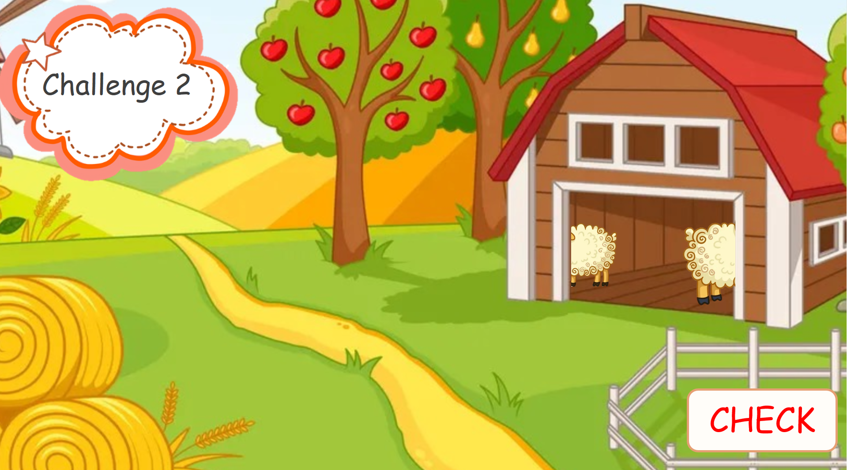  T asks Sts to say all the names of the animals that they studied. | - Greet the teacher.  - Choose the team’s name.  - Look and guess.  - Say the names.  .
Activity 2: Presentation (8 minutes)
Aim :
- Present the new structure “ We’ve got …………….” to make a complete sentence.
- Identify the Quantifiers: some, a, and its usage.
Teacher’s Activities | Students’ Activities
b. Procedure  Set a text:  T says that T will take the class to the farm of some children and ask them to guess what animals there are on the farm.  T shows the pictures of two children and listens to what they say.  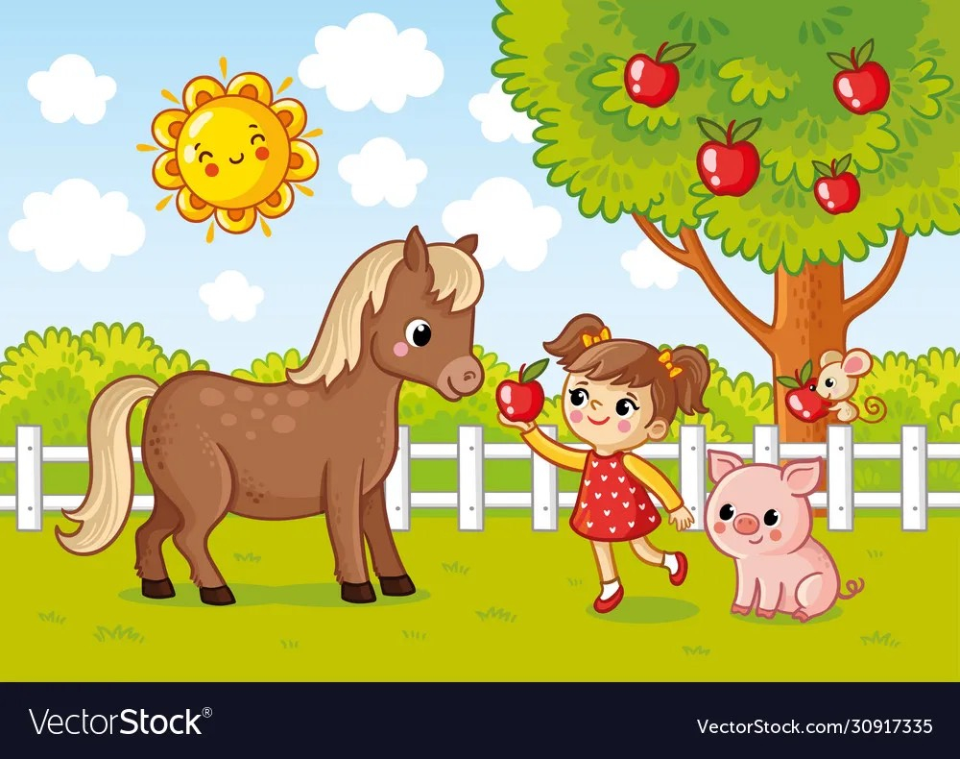  Focus on the structure: “ We’ve got…….” Or explain the structure in Vietnamese.  4 Listen and Repeat  Tell students to open their books on page 31 and look at the pictures. Point to the first picture word. Say the word and ask students to repeat it. Do the same with all the structures. Play the recording for the students to listen to, and repeat the sentences.  Read all the words again one by one and ask students to repeat them afterward.  Remind them about the abbreviation:    Checking  Let Sts listen and choose the picture to check their understanding. If Ss can answer, give them the dice to roll and get stars.  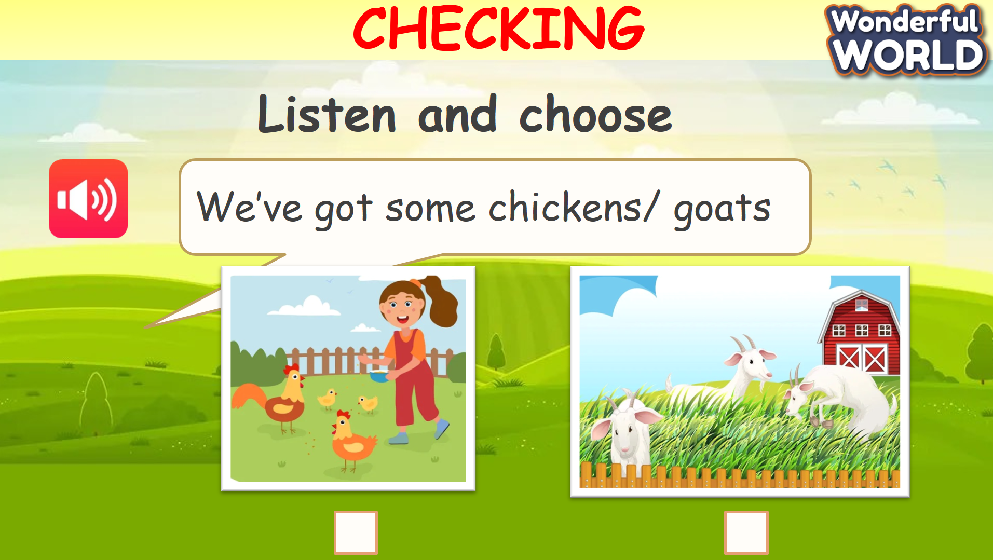 | - Guess  - Say and repeat.  - Repeat.  - Listen and choose. 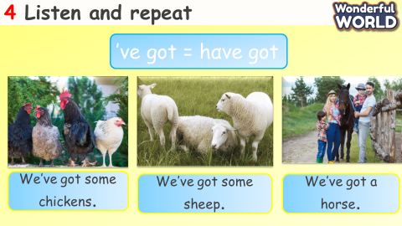  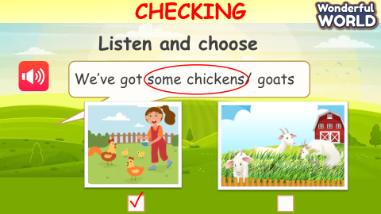
Activity 3: Practice (10 minutes)
a. Aim: Controlled- Practice to say following the model sentence with the structure: “ …..’ve got…”
Teacher’s Activities | Students’ Activities
b. Procedure:  PROTECT THE JUNGLE game:  Link the exercise 5 Point and Say with the game: Protect the jungle by saying the sentences with the prompts  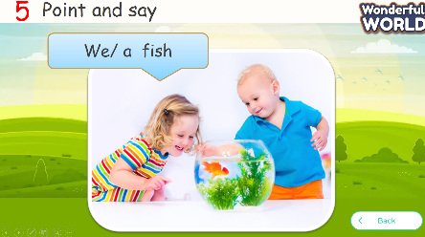  1. We /some goats.  2. We/ a cow.  3. We/ a dog.  4. We/ a fish.  5. We/ two rabbits.  Rule: With each correct answer, click the monkey to drop the fruits and protect the jungle. | Play the game by saying the sentences.  Keys:  1. We’ve got some goats.  2. We’ve got a cow.  3. We’ve got a dog.  4. We’ve got a fish.  5. We’ve got two rabbits.  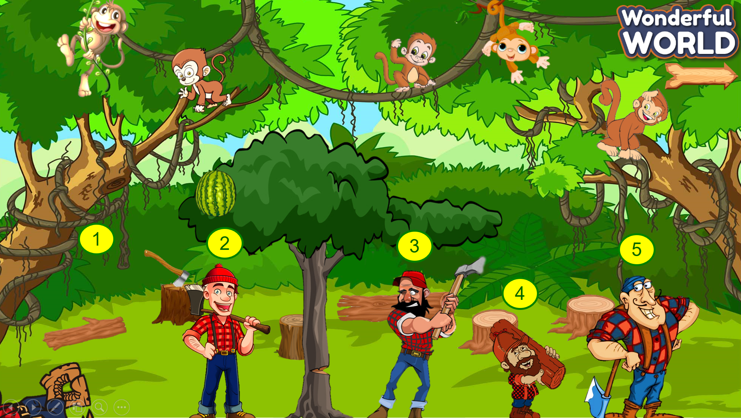
Activity 4: Production (9 minutes)
- Aim: Apply the learned knowledge to make a presentation
- Describe the pictures in colour and know how to use descriptive adjectives.
Teacher’s Activities | Students’ Activities
b. Procedure:  Do task 6 Let’s talk  Tell students to look at the picture and the example sentences. Ask them to read the sentences aloud a few times.  Ask students to look at other pictures and brainstorm for vocabulary to describe them. Suggested vocabulary to describe the pictures includes colours and descriptive adjectives such as tall, big, short, and small.  Students may want to quickly draw a photo of their favourite wild animals in their notebooks if no photo is available. Give students suggestions in case they have difficulties. Give students time to practise other sentences in pairs.  Ask some volunteers to read their sentences aloud in front of the whole class. | - Look and read.  - Draw.  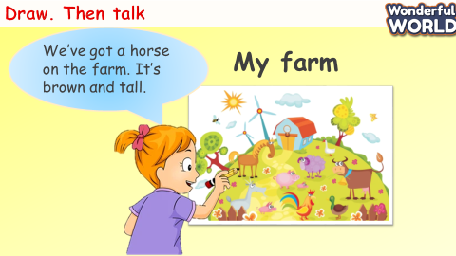
Activity 5: Assessment and Wrap-up (3 minutes)
a. Aim: Consolidate the content of the lesson.
Teacher’s Activities | Students’ Activities
b. Procedure:  Let ss do the assessment.  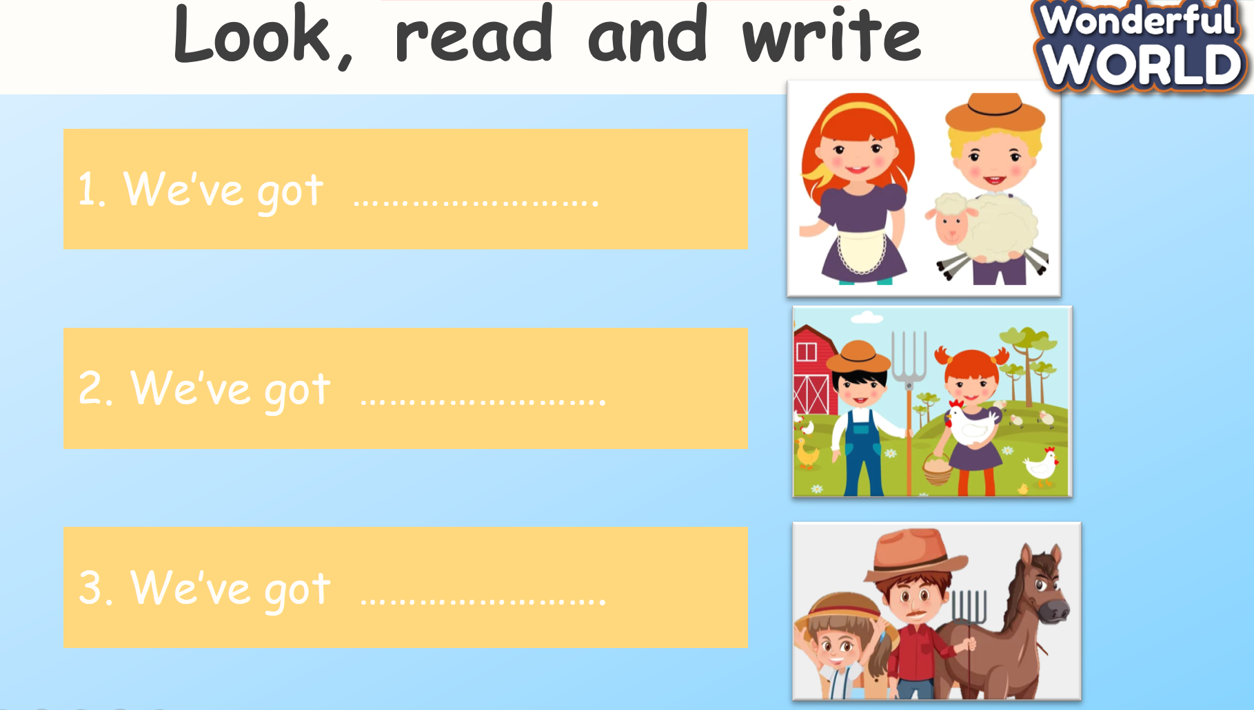  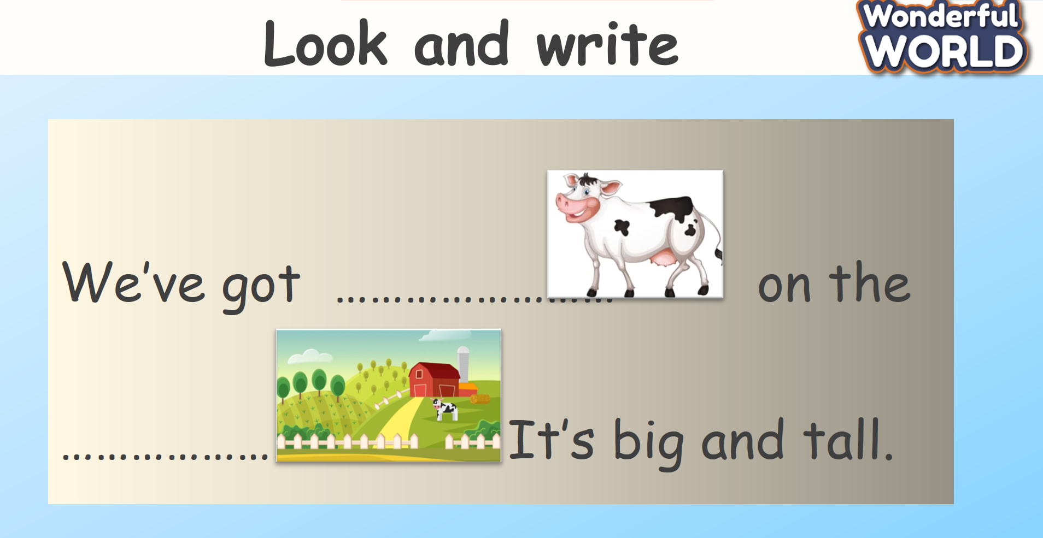  - Drill the structure again and check for correct understanding.  - Count stars and award stamps to the winning team  Say goodbye students | Do the assessment.  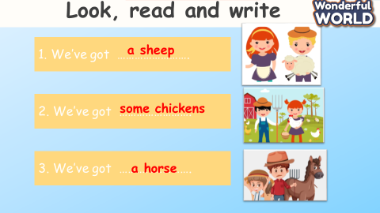  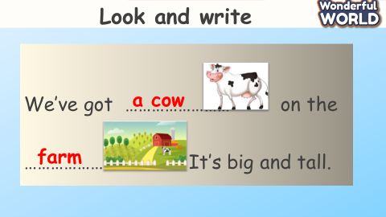  - Join in with the drilling structure for their team  - Ss stand up to say  - Goodbye Teacher.

