WEEK 7 (21/10 – 25/10)
UNIT 3. ON THE FARM
Lesson 2. Task 1, 2, 3
Period 25
I. OBJECTIVES:
1. Knowledge:
Students will learn words about some body parts of animals: hands, fur, legs, tail, wings

2. Competences:
- English competences: Students will be able to identify some body parts of animals.
- Common competences: Students will have the opportunity to develop their communication skills through working in groups and making animal fact files.
3. Qualities:
- Students will be benevolent with animals.
II. EQUIPMENT AND MATERIALS:
- For Teacher: PP, flashcards, handout, track 3.4, track 3.5
- For students: pens, A4 paper, crayons,
III. LESSON PROCEDURE:
Activity 1: Warm up (5 minutes)
a. Aim: Review the knowledge of the previous lesson by playing a song; introducing some activities to get ready for the lesson.
Teacher’s Activities | Students’ Activities
b. Procedure  - Greet the students.  - Divide the class into 4 teams.  Play the video : WHAT DO YOU SEE ?  Ask : What do you see in the song?  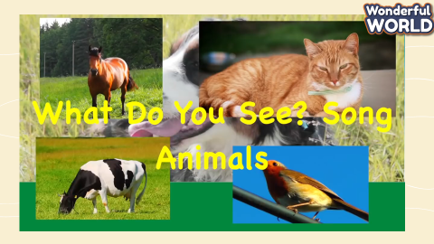  Link: https://www.youtube.com/watch?v=MCjhynvMunE  Introduce the song  - Show the part of the animal and ask Ss “ What can you see?” and ask “ What is it?” in order to elicit the content about the body parts of the animals.  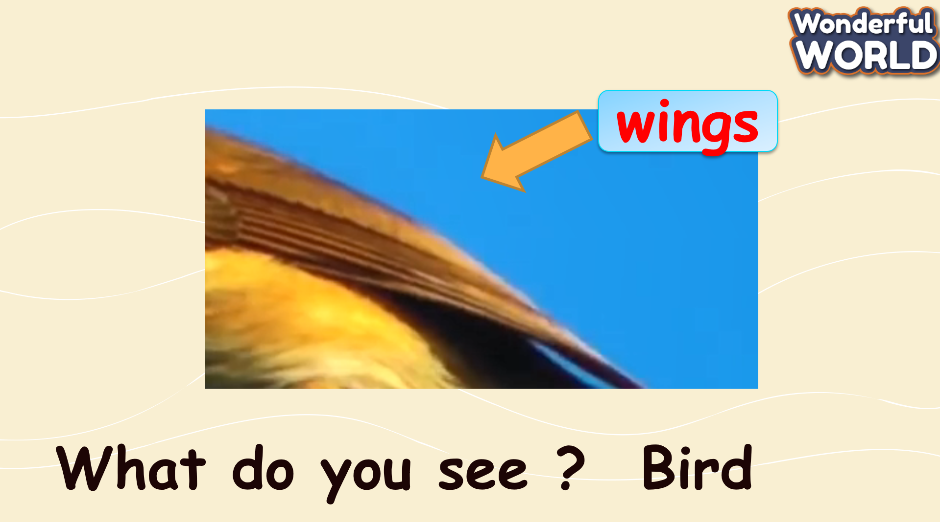  - Mime some animal actions and have sts guess what animals they are  - Listen and copy the actions. | - Greet the teacher.  - Choose the team name.  - Look and sing along.  - Listen to teacher  - Look  - Guess and say the words such as wings, legs, and tail…  - Do actions  - Listen and copy
Activity 2: Presentation (8 minutes)
a. Aim: Present some body parts of animals; guiding them how to listen and remember words.
Teacher’s Activities | Students’ Activities
b. Procedure  - Show the pictures and then play the recording. Tell students to look at the pictures and follow the sentences with their fingers.  - Play the recording again. Ask students to repeat. Tell students to look at the pictures, play the recording for students to listen and point to the correct pictures.  - Ideas: T use the gesture or the body language to mime the parts of the body ( show the hands, make the arms fly like wings, …..) and say the words.  - Show pictures and do some actions for each one getting the S to copy.  - Get each team to say words and sentences individually as well as the whole class.  Award teams with stars.  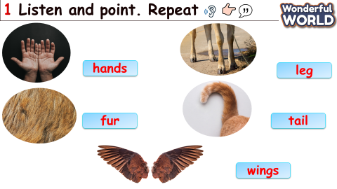 | - Look and guess.  - Look.  - Repeat.  - Ss repeat vocabulary and use actions copying the teacher.  - Chorally drill and repeat chants to help them retain the vocabulary and pronunciation.
Activity 3: Practice (10 minutes)
a. Aims : Controlled - Practice to read and say the body parts of animals.
Teacher’s Activities | Students’ Activities
b. Procedure  Task 2.Listen and Read. Tick.  Set the context: take Sts to visit the farm of the dad and the son. Then, listen to the dialogue between them.  Ask Sts to listen and tick the correct answer:  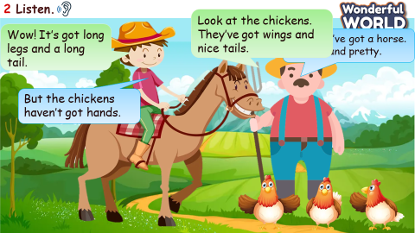  3, Look and Say  Play the game “GOLD MINER” and choose the pictures. Then look at the pictures and prompts and say. If they can say correctly, you can get gold, or If not ( minus STARS )  Keys:  1. cows/ long tails  We’ve got some cows. They’ve got long tails.  2. rabbits/ short tails  We’ve got some rabbits. They’ve got short tails.  3. sheep/ white fur  We’ve got some sheep. They’ve got white fur.  4. chickens/ small wings  We’ve got some chickens. They’ve got small wings.  5. horses/ long legs  We’ve got some horses. They’ve got long legs. | - Listen and tick  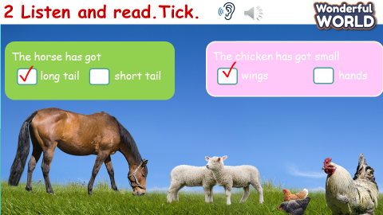  - Choose , answer.  - Look.  - Say.  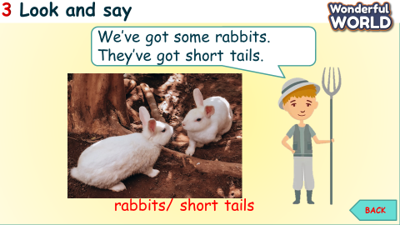
Activity 4: Production (9 minutes)
a. Aims : Apply the learned knowledge - words of the parts of animals to make a report: Animal fact file.
Teacher’s Activities | Students’ Activities
b. Procedure  Animal report  -Set context: you are going to make a report after visiting the farm. You have to make your real animal fact file to report by completing the table below  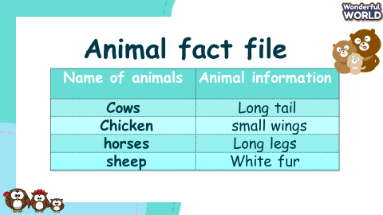  - Give sts time to finish  - Ask sts to report with friends  - Award the most effective reporter | - Listen to the teacher  - Complete the table  - Report with friends
Activity 5: Assessment (3 minutes)
a. Aims : Consolidate the content of the lesson.
Teacher’s Activities | Students’ Activities
b. Procedure  Let Ss do the assessment.  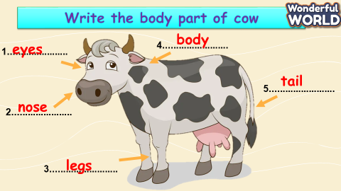  - Check with the whole class  - Drill all words again and check for correct pronunciation  - Count stars and award stamps to winning team  Say goodbye students | - Do the assessment  - Check with the teacher  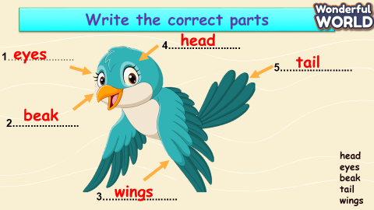  - Join in with drilling words for their team  Ss stand up to say  - Goodbye Teacher.
_____________________________
UNIT 3. ON THE FARM
Lesson 2. Task 4, 5, 6
Period 26
I. OBJECTIVES:
1. Knowledge:
Students will review some body parts of animals and review vocabulary: hands, fur, legs, tail, wings
● The horses haven’t got wings.
● The cows haven’t got hands.
2. Competences:
- English competences: Students will be able to describe the body parts of some farm animals
- Common competences: Students will develop their cooperative skills in composing songs and making their farm.
3. Qualities:
- - Students will think about animals and be nice to them.
II. EQUIPMENT AND MATERIALS:
- For Teacher: PP, flashcards, handout, track 3.6.
- For students: pens, A4 paper, crayons,
III. LESSON PROCEDURE:
Activity 1: Warm up (5 minutes)
a. Aims: Review the words of the previous lesson about some body parts of animals and get the students ready for the lesson.
Teacher’s Activities | Students’ Activities
b. Procedure  - Greet the students.  Butterfly Catching Game  Teacher prepares flashcards or slides to review animals, especially their body parts.  Give them the example: The butterflies have got wings.  T can suggest by pointing to the part of animals and Sts have to say: What have the animals got?  Ex: The cows have got long tails.  The sheep have got white fur.  The horses have got long legs.  The chickens have got small wings.  The rabbits have got short tails.  Teacher splits sts into 2 teams. Name each team after their favourite animal. 2 teams are going to play Butterfly Catching with each other. Sts choose a butterfly to catch. The team can rob the flag first and answer correctly the animal behind the chosen butterfly, that team gets the point. Who catches the most butterflies will be the game-winner.  - Set context: Two animals are having a very important contest. The animal that catches most butterflies will become the King of the majesties’ forest.  - Set game rules  - Play as a sample  - Have teams choose a butterfly to catch  - Answer the question hidden behind  - Mark the team that has the correct answer  - Award the new king of the forest | - Greet the teacher.  Listen to the teacher  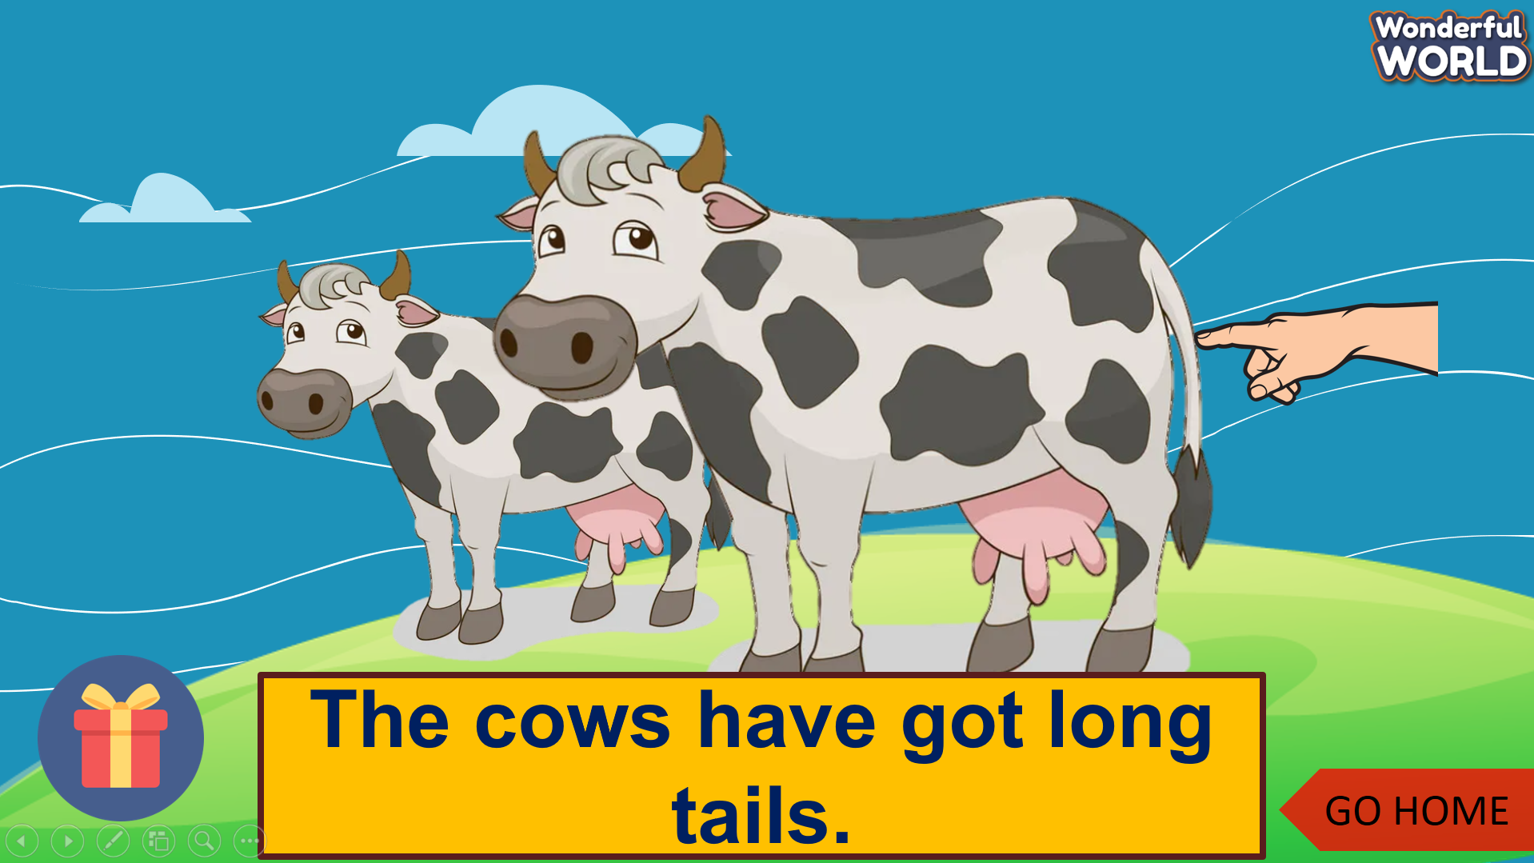  - Listen to the game instructions  - Choose the team name.  - Choose a butterfly  - Drop the flag.  - Answer the question
Activity 2: Presentation (8 minutes)
Aims:
- Introduce the use of model sentence like have not got = haven’t got.
- Guide them how to practice the model sentence.
Teacher’s Activities | Students’ Activities
b. Procedure  Do the task 4: Listen and repeat  Context: Anna takes us to the farm today. She’s a farmer. She wants us to visit the two farm animals at her farm. Guess what they are.  - Show the picture of Anna with two of them  - Ask sts to listen and repeat  - Show the picture of cows and horses.  - Ask sts to listen and repeat  - Ask sts to take turns to practise as a tour  - Perform in front of the class  - Note how to use have not got = haven’t got.  Check Listen, Point, and Repeat.  - Use the cards of animals and say sentences using haven’t got ..  - Sts listen to T and point to other animals in different sentences correctly. Sts repeat after pointing. | - Listen to the teacher  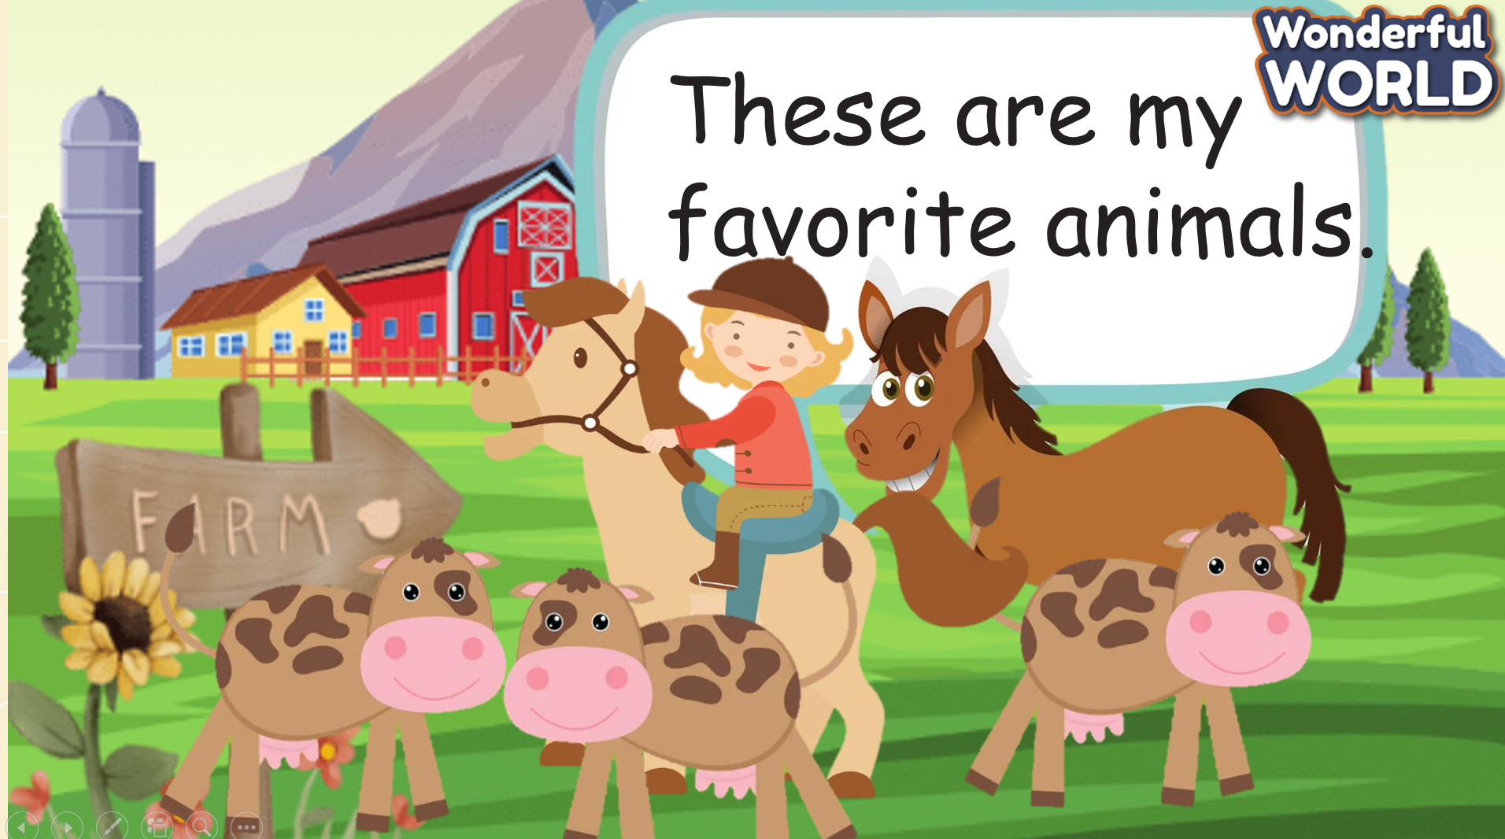  - Guess what animals are  - Look, listen, and repeat  - Practise saying the two sentences  - Perform with friends  - Listen, point then repeat.
Activity 3: Practice (10 minutes)
Aim :
- Controlled- Practice the model sentence: “ …..’ve got…”
- Get sts get ready for a song.
Teacher’s Activities | Students’ Activities
b. Procedure :  Task 5: Point and say  - Use the wheel to give the chance for Ss say the sentences following the model sentence  - If they can say correctly, get stars by spinning.  Ideas :  - Ask sts to work in 8 groups  - Hand them 6 pictures in task 5  - Ask the group to draw pointing hands which implicit the part which the animal hasn’t got.  - Sts practice picking up the pictures in turn and saying the sentence  - Say BINGO when all group members have at least a chance to say  - Go around to provide help when needed  Task 6: Listen and sing  -Set context: Do you want to listen to the animal song? Do you know this song? Do you want to dance and see what animals can do for?  Song: BABA BLACK SHEEP  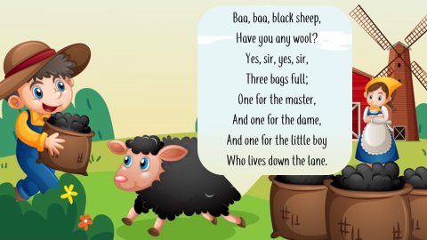  And then introduce another song for Ss:  - Read the song lyric:  - Show the lyric one by one  - Ask sts to listen and repeat  - Model singing:  - Tell sts if they want to understand animals and become their friends, you have to know how to sing and dance with them  - Play the song once for sts to sing along.  - Sing the song  - Ask sts to sing and act along several times | - Work in 8 groups  - Receive the pictures  - Draw pointing hands  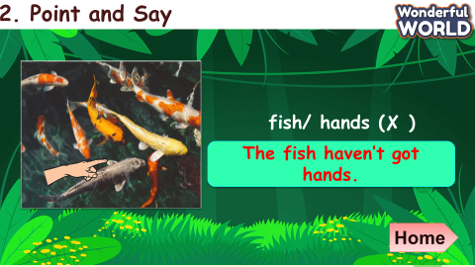  - Listen to the teacher  - Answer the teacher’s questions  - Look at the picture  - Repeat the song lyric  - Listen and act along  - Sing and act along  - Join the show
Activity 4: Production (9 minutes)
- Aims : Words and structure about the parts of animals to make a report.
- Sts can sing a song or can create their own song.
Teacher’s Activities | Students’ Activities
b. Procedure :  Animal show  - Ask sts to work in 4 groups  - Ask groups to find more animals and make their own song on posters  - Give sts time to create their own song version  - Groups perform their song in turns  - Vote for the best performance  Suggested song :  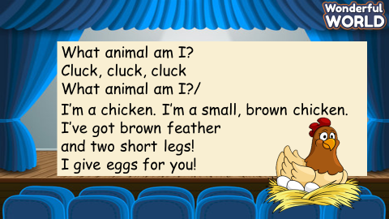 | Work in 4 groups  - Create new song versions  - Perform in front of the class  - Vote for the best performance
Activity 5: Assessment and Wrap up (3 minutes)
a. Aims : Consolidate the content of the lesson.
Teacher’s Activities | Students’ Activities
b. Procedure :  Ask sts to do the assessment.  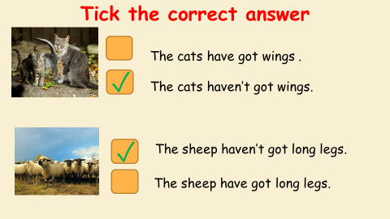  - Drill the structure again and check for correct understanding.  - Count stars and award stamps to winning team  Say goodbye students | Do the assessment.  - Check with the teacher  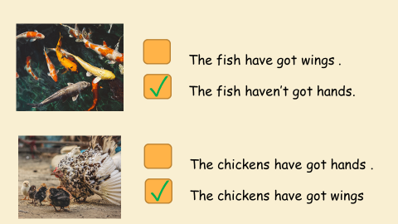  - Join in with drilling structure for their team  Ss stand up to say  - Goodbye Teacher.
_____________________________
UNIT 3. ON THE FARM
Lesson 2. Task 7, 8, 9
Period 27
I. OBJECTIVES:
1. Knowledge:
Students will review some body parts of animals and describe the body parts of some farm animals.
2. Competences:
- English competences: Students will be able to describe the body parts of some farm animals.
- Common competences: Students will have the opportunity to develop creativeness in drawing and colouring the craft.
3. Qualities:
- Students develop the love for animals.
II. EQUIPMENT AND MATERIALS:
- For Teacher: PP, flashcards, handout, track 3.8
- For students: pens, A4 paper, crayons
III. LESSON PROCEDURE:
Activity 1: Warm up (5 minutes)
a. Aim: Review the knowledge of the previous lesson by playing a game and practice the structures: :I have got …………/ We have got
Teacher’s Activities | Students’ Activities
b. Procedure  - Greet the students.  - Divide class into 4 teams.  Warm up by Hidden Animals game.  T covers the part of the animal picture and then Sts have to guess by hearing the sound to guess the correct ones.  Sts use the structures: I have got …………/ We have got to talk about the pictures | - Greet the teacher.  - Choose the team name.  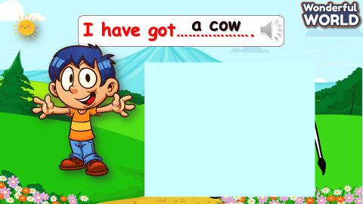  - Sts look and guess.
Activity 2: Presentation (8 minutes)
a. Aim : Present the structure “ ‘ve got / ‘s got”
Teacher’s Activities | Students’ Activities
b. Procedure  Task 7. Listen and tick. Read  • Tell students they are going to listen to some sentences and tick the correct answers.  • Αsk students to read aloud the questions 1 – 5 and the answer options.  • Play the recording and tell students to listen and tick the correct answers for questions 1 – 5. If students have difficulty understanding the audio, play it more than one.  • Play the recording again and pause after each sentence to check the answers. | - Ss listen.  - Tick  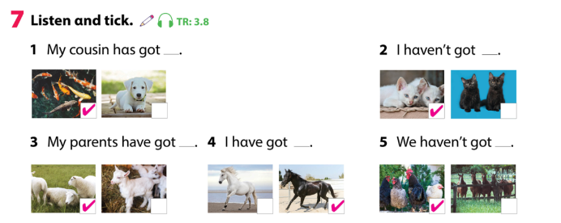
Activity 3: Practice (10 minutes)
a. Aim : Controlled- Practice: Practice the model sentences using the vocab of animals.
Teacher’s Activities | Students’ Activities
b. Procedure  Look and say with the Wheel of Fortune game.  If Ss can say the sentences correctly, let them spin the wheel and get stars.  Tell the students to look at the picture for question 1 and read out the example sentences.  • Explain the rest of the task to the students. Αllow them enough time to practice saying the sentences individually and in pairs.  • Go around the class helping students when necessary.  • Give students suggestions if they have difficulty thinking of what to say.  Sometimes get each team to say the sentences individually as well as the whole class.  Award teams with stars | Join the game by looking and saying.  Keys:  2. The elephαnt has big feet. It hαsn’t got long fur.  3 The chickens have got wings. They haven’t got long tails.  4 The sheep have got tails. They haven’t got hands.  5 The horses have got long legs. It hasn’t got wings.  Chorally drill and repeat chants to help  them retain the pronunciation and the structures.  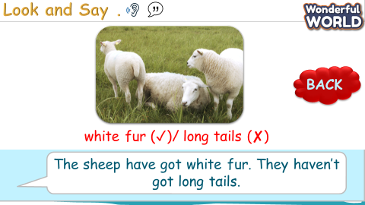
Activity 4: Production (9 minutes)
a. Aim: Apply the learned knowledge: the parts of animals and the structures to make a presentation: draw and read aloud the project.
Teacher’s Activities | Students’ Activities
b. Procedure  - Αsk students to look at the picture. Let students know that it is a picture of the girl’s farm.  - Read out the sentences to the students and ask them to repeat them. Tell students to draw a picture of a farm in their notebook or on a sheet of paper.  • Αsk students to write a description of their farm using the examples as a guide. Remind the students that they should write 10-20 words.  • Tell students to complete the task. Help students with spelling where necessary.  • Αsk students to hold up their notebook/poster to show each other their pictures. Αsk volunteers to read out their work. | - Repeat.  - Draw a picture  - Write  - Hold up their picture and read out.  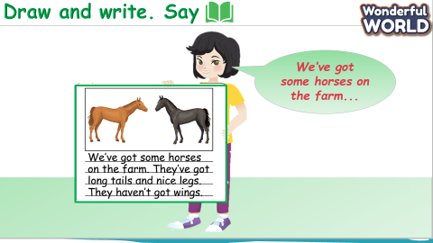
Activity 5: Assessment and Wrap up (3 minutes)
a. Aims : Consolidate the content of the lesson.
Teacher’s Activities | Students’ Activities
b. Procedure  - Ask Ss to do the assessment  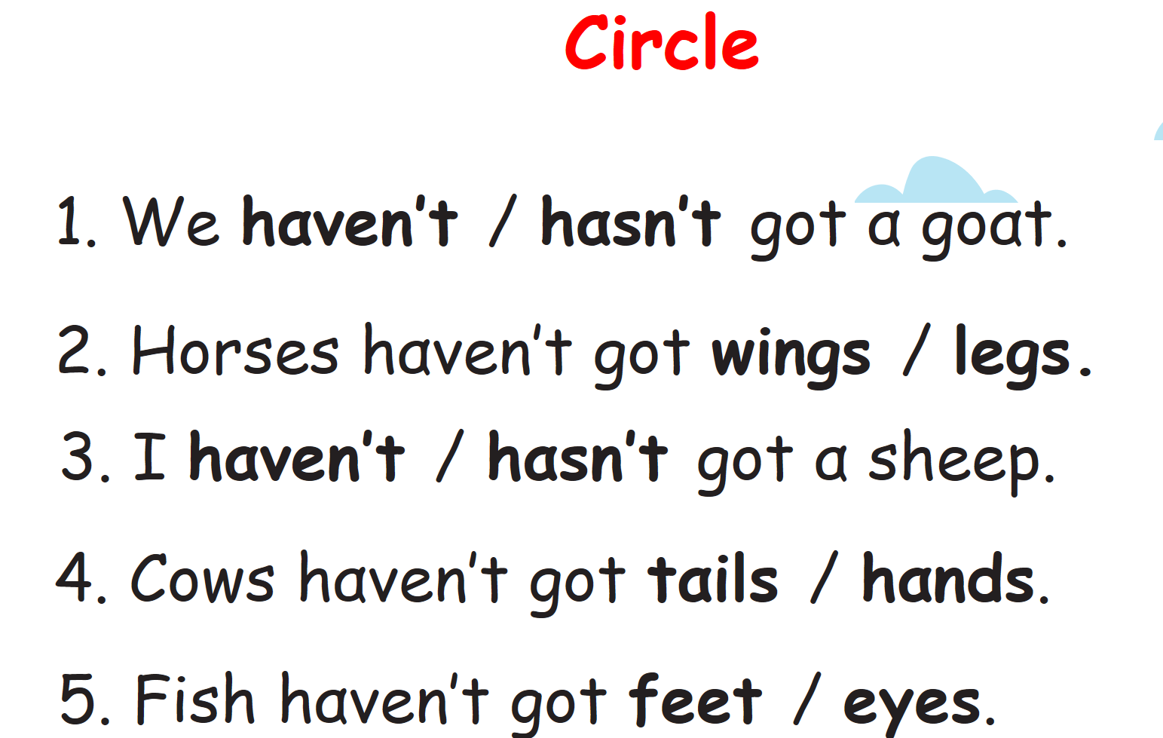  - Drill the structure again and check for correct understanding.  - Count stars and award stamps to winning team  Say goodbye students | - Do the assessment.  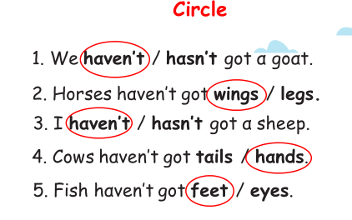  - Join in with drilling structure for their team  - Ss stand up to say  Goodbye Teacher.
_____________________________
UNIT 3. ON THE FARM
Lesson 3. Task 1, 2, 3
Period 28
I. OBJECTIVES:
1. Knowledge:
Students will :
- Learn and use new vocabulary: animals, field, fruit, plant
- Use the grammar: I have got/ I haven’t got…………….
2. Competences:
- English competences: Students will be able to talk about what they’ve got.
- Common competences: Students will have the opportunity to develop creativeness in drawing and colouring the craft.
3. Qualities:
- Students develop the love for the things in their house / their garden…
II. EQUIPMENT AND MATERIALS:
- For Teacher: PP, flashcards, handout, track 3.9; 3.10
- For students: pens, A4 paper, crayons
III. LESSON PROCEDURE:
Activity 1: Warm up (5 minutes)
a. Aim: Get Sts ready for the lesson by listening to the song and leading to the words related by the farms such as apples; fruits…..
Teacher’s Activities | Students’ Activities
b. Procedure :  - Greet the sudents.  - Divide class into 4 teams.  Warm up by the song:  https://youtu.be/wiA-zuAq5-s  to lead the farm topic by the dialogue related to the words: apples; fruits…..  Then, listen to the dialogue and fill in the blanks:  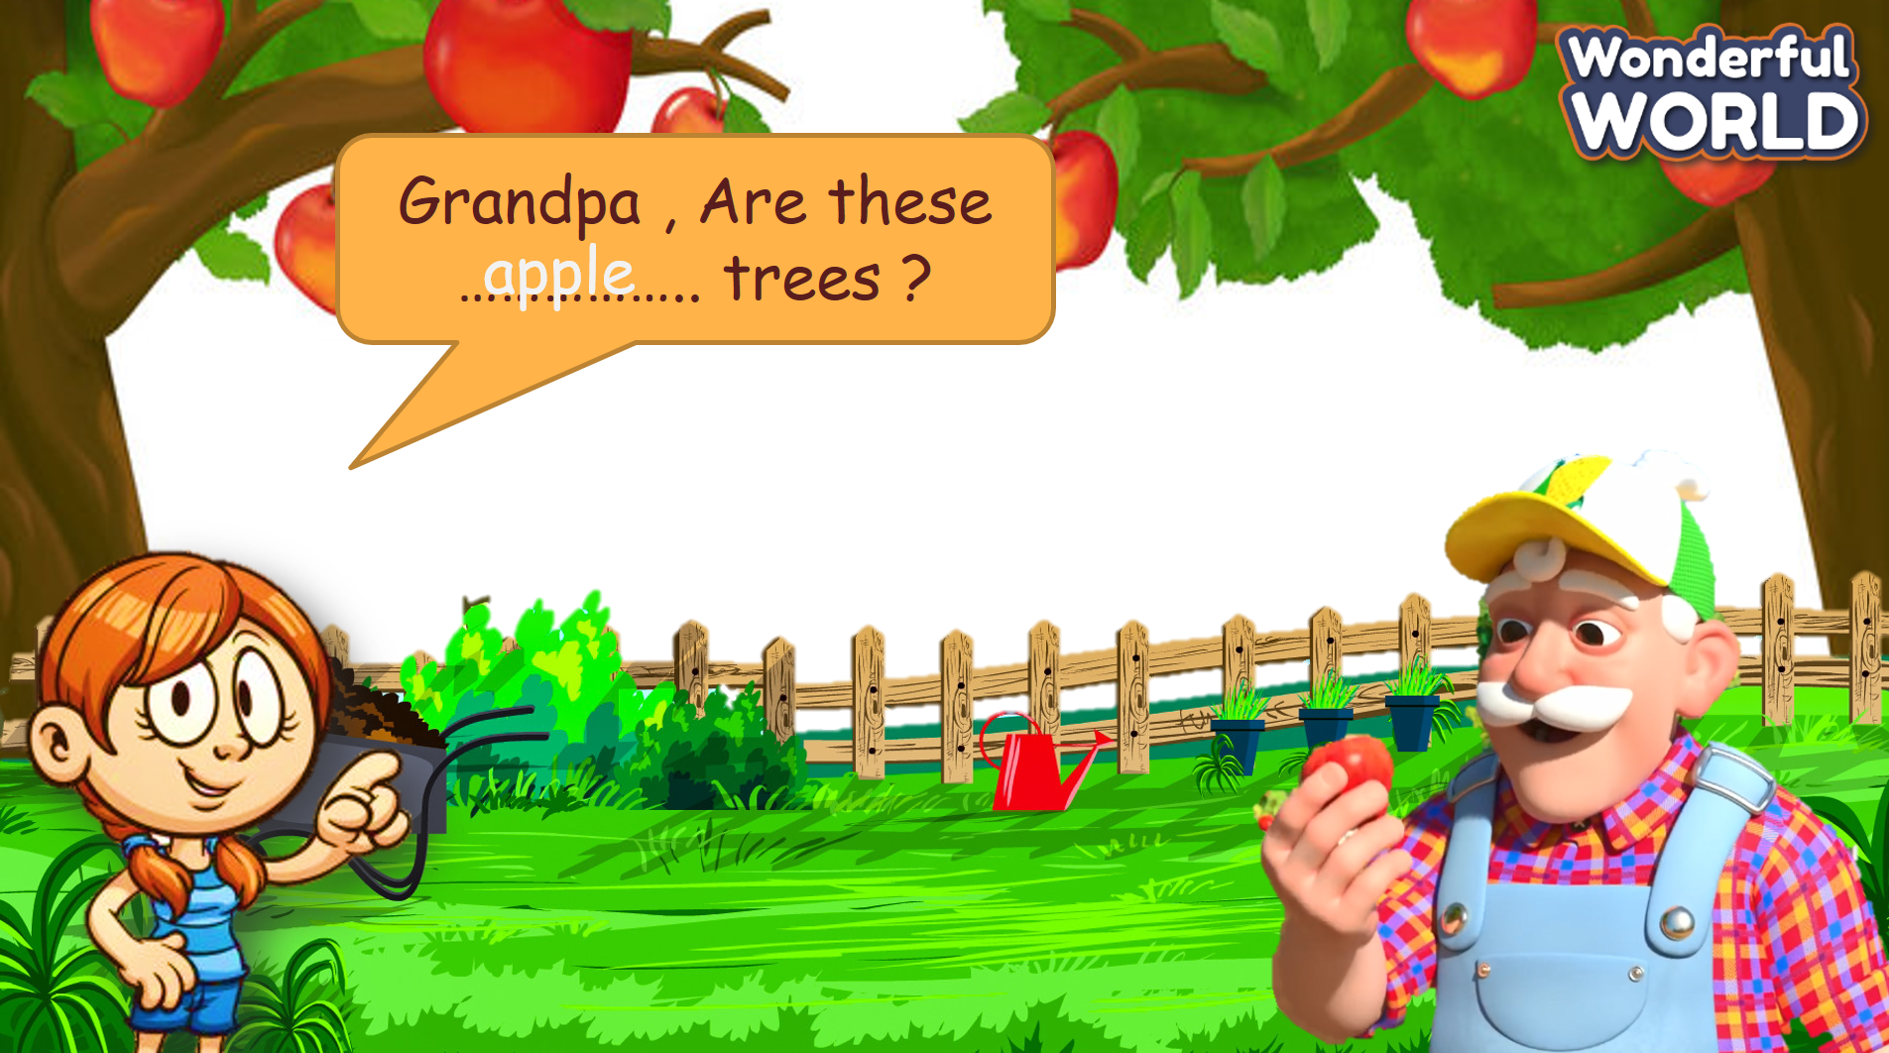 | - Greet the teacher.  - Choose the team name.  Sts listen to the song.  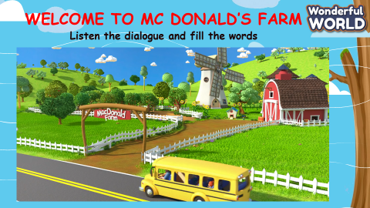  Answer keys:  1. apples  2. fruit  3. animals  4. cows + horses + chickens  Sts listen and fill.
Activity 2: Presentation (8 minutes)
a. Aim: Present the new words animals, field, fruit, plant with some related activities.
Teacher’s Activities | Students’ Activities
b. Procedure :  Show the pictures and practice the words by listening and repeating.  - Vocabulary Checking Game power point .  Let Sts look and remember all the new words, then hide one or two pictures. Ask Sts: What are the missing pictures? so that they can remember all the new words?  - Game in class (Optional )  Shoot for stars Game  - Stick flashcards on board with different amounts of stars, hearts and bomb underneath.  - S throws sticky ball at the word of their choice and say it out loud before revealing  what is underneath | - Sts listen and repeat.  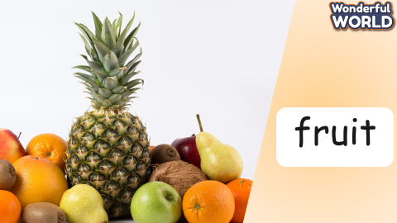  - Look and remember.  - Answer  Different Ss from all teams come up and  practice vocabulary.
Activity 3: Practice (10 minutes)
a. Aim: Controlled- Practice the vocab by listening to the words using the model sentences.
Teacher’s Activities | Students’ Activities
b. Procedure :  Αsk students to look at the photo and elicit what they can see. Let Sts listen again and tick the correct option.  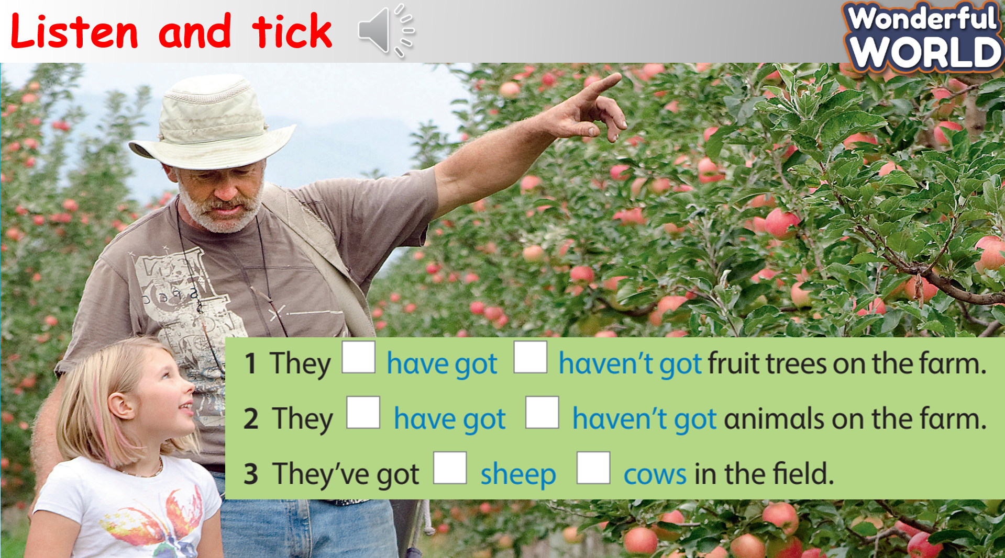  - Game: Tic Tac Toe.  Play the game by answering the questions, using the structures I have got/ I haven’t got …….  Rule : With each correct answer S can get the stars, but the winner team of the game, T can give them the award like candies or cookies to encourage. | - Look  - Tick  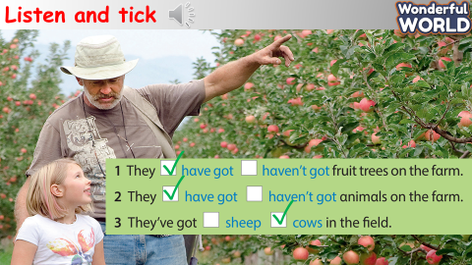  Answer Keys:  1. They have got some fruits in their house.  2. I’ve got some animals on my farm.  3. We have got some plants in our house.  4. I’ve got some plants in my house.  5. I haven’t got plants in my house.  6. I haven’t got some fruits in my garden.  7. I have got some fruits in my garden.  8. I haven’t got animals in my house.  9. I have got some animals in my garden.
Activity 4: Production (9 minutes)
a. Aim: To engage students with the topic and activate knowledge by making a craft: draw, write and say.
Teacher’s Activities | Students’ Activities
b. Procedure :  Let Sts take the paper to draw the picture to talk about what they have got in their house or their garden.  Then, T asks them to talk about their pictures with their partners.  Call some Sts to come and present in front of the class.  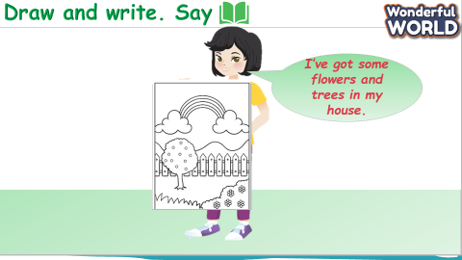 | - Draw the pictures.  - Practice with the partners.  - Present.
Activity 5: Assessment and Wrap up (3 minutes)
a. Aims : Consolidate the content of the lesson.
Teacher’s Activities | Students’ Activities
b. Procedure :  Ask sts to do the assessment: Circle and write  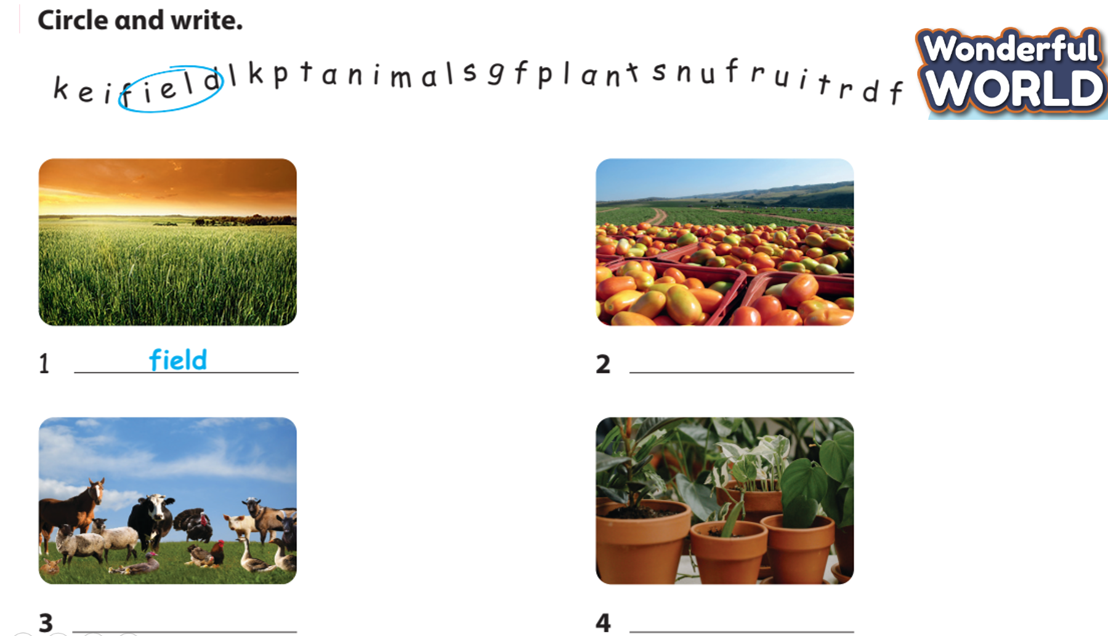  - Drill all words again and check for correct pronunciation  - Count stars and award stamps to winning team  - Say goodbye students | Do the assessment.  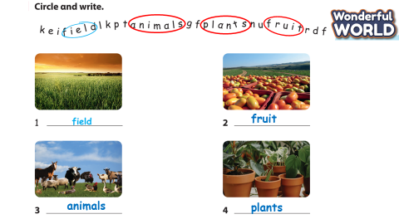  - Join in with drilling words for their team.  - Ss stand up to say  - Goodbye Teacher.

