ĐỀ KIỂM TRA THÁNG 10 LỚP 3A

Name: ……………………………..…………….. Class: ………………………..

Question 1. Odd the one out. (1,25pt)
1. a. giraffe b. animal c. elephant
2. a. living room b. kitchen c. classroom
3. a. bedroom b. lamp c. bed
4. a. board b. bird c. book
5. a. These b. Those c. They
Question 2. Read and choose the correct answer. (1,25pt)
1. What is this? – It’s_____________ .
A. dog B. a dog C. dogs
2. These are _______________.
A. monkeys. B. monkey. C. a monkey.
3. There is ___________ lamp.
A. some B. a C. an
4. Are there books? Yes, _______________
A. there are B. they are C. there is
5. There’s _____ ball. _____ ball is red
A. a/a B. a/the C. the / a

Q3: Read and match A – B.
A | B
1. What is this? | a. I’m Lien | 1 -
2. What are those? | b. It’s a TV | 2 -
3. Is there a ball? | c. No, there aren’t | 3 -
4. Are there lamps? | d. Yes, there is | 4 -
5. How old are you? | e. They’re beds | 5 -
6. What’s your name? | f. I’m eight. | 6 -

Question 4. Read and
( in , aren’t , is , a , blue , beds , four )
1. There __________ toys in the living room.
2. __________ a lamp on the table ?
3. The __________ are big.
4. There are __________ chair in the kitchen.
5. The __________ whales are great.
6. The teddy bear is __________ my bedroom.

Question 5. Look and write only one word in each blank (1,25pt)
This is my (1) __________________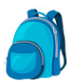. It’s small. I put my pencil case and my (2) 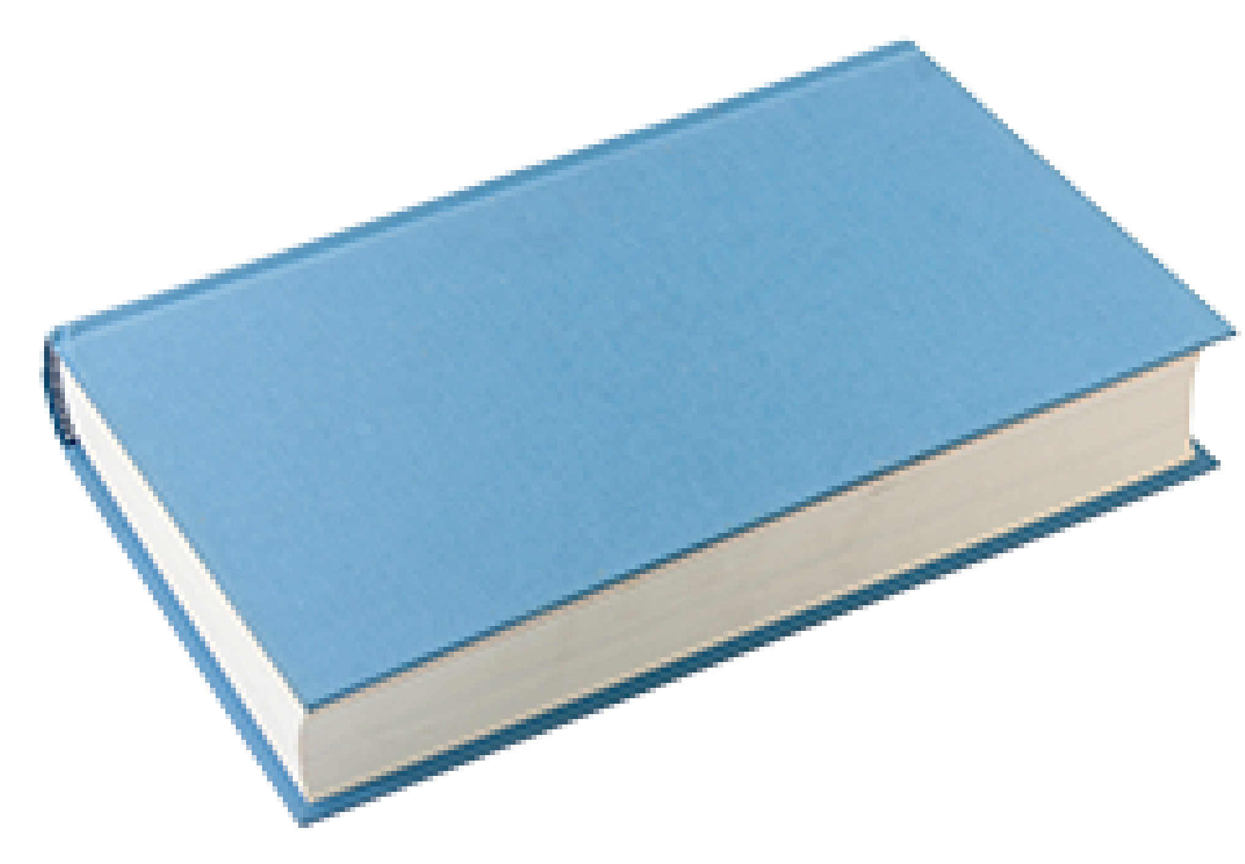____________ in it. In my pencil case, there are four (3) 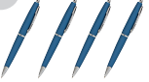______________, a pencil, a (4) 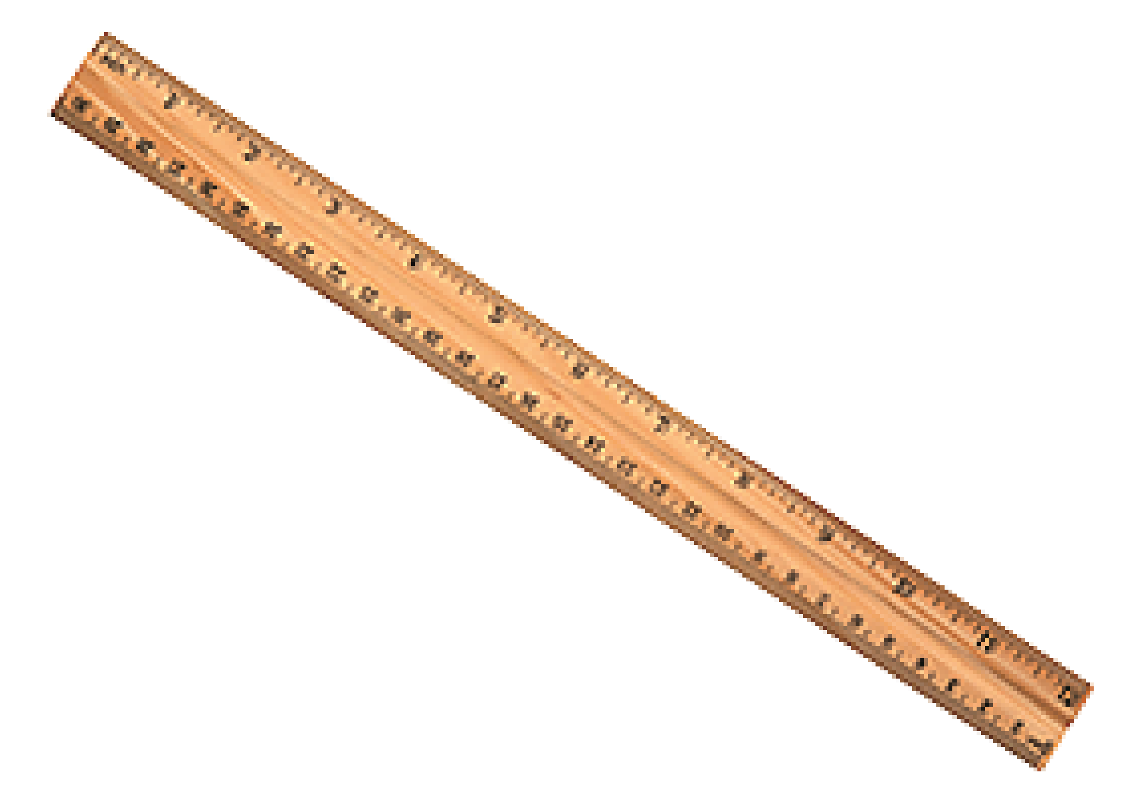__________________ and a (5) 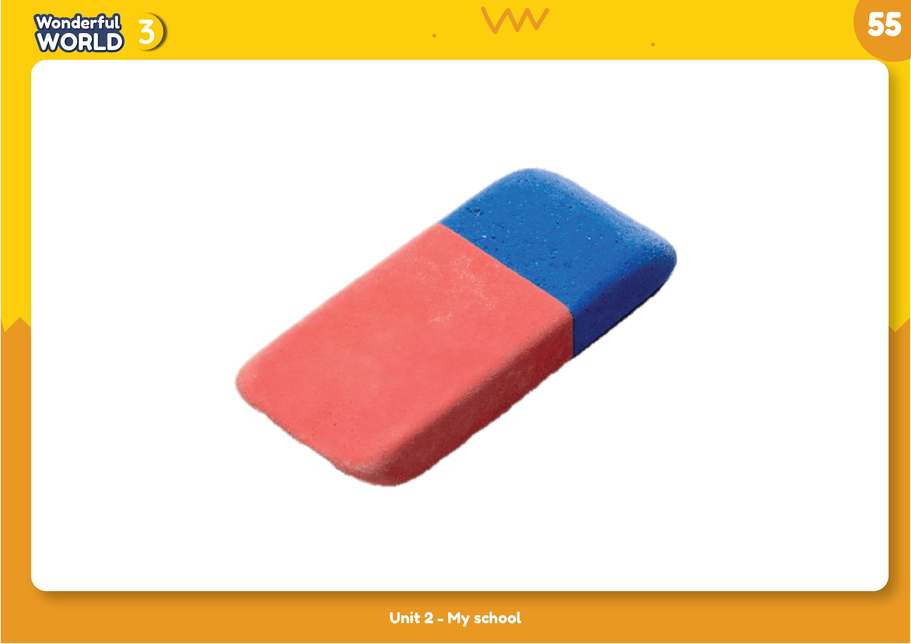

__________________. They’re nice. I bring them to school every day.

Question 6. Reorder the words to make the correct sentence. (1,25pt)
1. rabbit / This / a / is.
………………………………………………………………………………………….………….
2. monkeys / Those / are.
……………………………………………………………………………………………..…….
3. a / There / bedroom / is.
………………………………………………………………………………….……………….
4. there / living room / Are / books / the / in?
……………………………………………………………………………………..…………….
5. an / There’s / elephant. / elephant / young / The / is
…………………………………………………………………………………………….……….

Q7: Look and write.
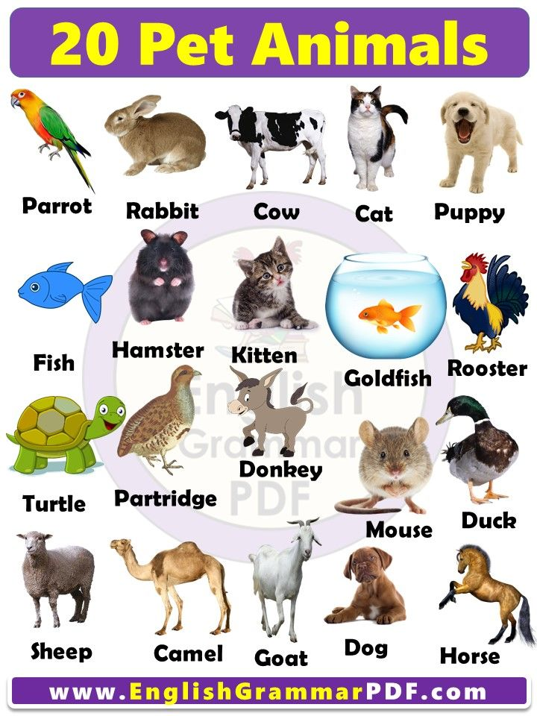 |  | 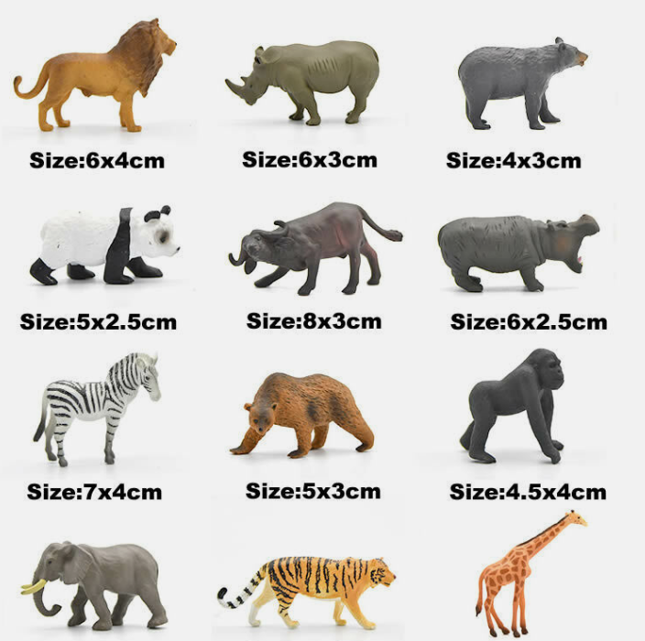 | 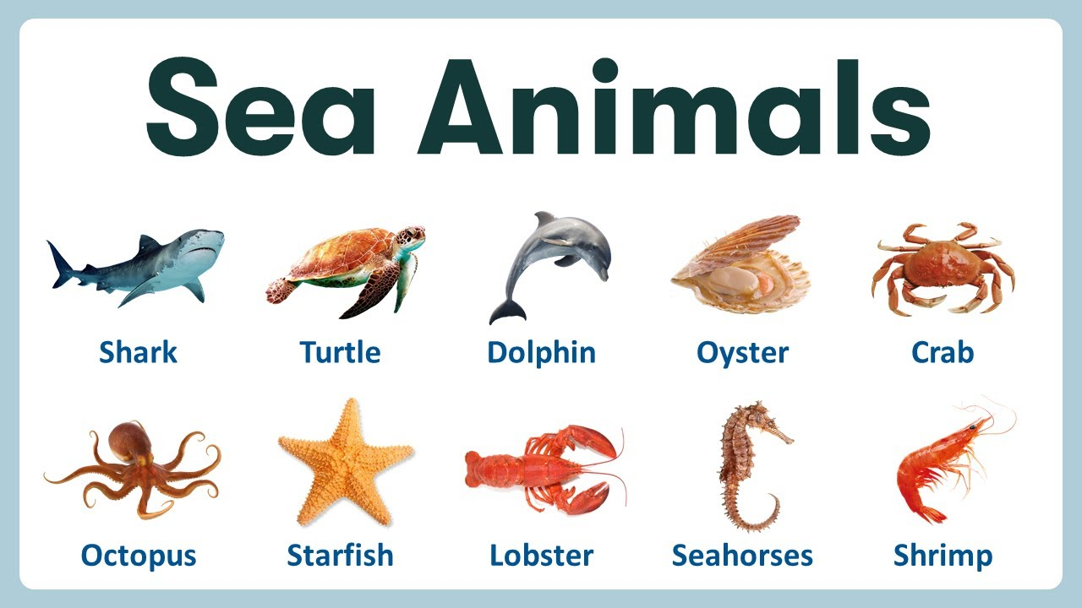
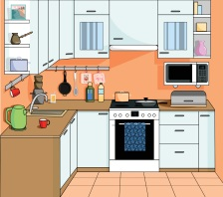 | 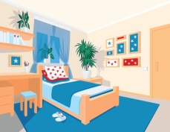 | 