WEEK 1
UNIT 0. GREETING
Lesson 1. Task 1, 2, 3
Period 1
I. OBJECTIVES:
1. Knowledge:
Students will be able to use the words and phrases related to the topic Greetings: Hello, Hi, I’m…, Nice to meet you.
2. Competences:
- English competences: Students will be able to greet and introduce themselves in English.
- Common competences: Students will have opportunity to develop the creativeness in making name tag and develop communication among friends.
3. Qualities:
- Students will be friendly and confident in communicating with friends.
II. EQUIPMENT AND MATERIALS:
- Basic things: Student’s book, flashcards, ball, small pieces of papers to make name tag.
- Advanced things: PPT, projector/interactive whiteboard/laptop/TV.
III. LESSON PROCEDURE:
Activity 1: Warm up (5 minutes)
Teacher’s activities | Student’s activities
- Greet students.  Movement Game: Hip hip hooray  - Read the instruction and do the action.  + Hands up: raise 2 hands up  + Hands down: Put 2 hands down  + Hip hip hooray (2 times): smack 2 hands on hips then put hands to mouth when saying hooray (2 times)  + Go to Wonderful World: join 2 hands and make waves then raise both hands up and wave.  Lead in: Memorization game  - Show flashcard of letters E L O L H to sts in 5 seconds.  - Ask sts to read the letters they have seen  - Ask if sts know what word in English built from 5 letter.  - Write on the board Hello and introduce the greeting lesson. | - Greet teacher.  - Listen and do the action with teacher.  - Follow teacher if possible.  - Look at the letters in 5 seconds  - Read the letters  - Find out key word HELLO
Activity 2: Presentation (5 minutes)
Teacher’s activities | Student’s activities
Task 1: Listen and repeat. (Track 0.2)  - Use flashcards to introduce the vocabulary and structure of lesson.  - Say the words/sentences for sts to repeat in chorus.  - Put the flashcards in different places around the room.  - Say a word/sentence for sts to repeat then point.  - Play the track 0.2, ask students to listen and repeat in chorus, group. | - Learn new words and structures through flashcard.  - Repeat the words/sentences  - Repeat then point.  - Repeat.
Activity 3: Practice (10 minutes)
Teacher’s activities | Student’s activities
Task 2: Say  - Ask sts how many friends can they see and their names.  - Have sts look at the bubbles and ask them to complete.  - Have sts practice the dialogues in chorus, group, pairs.  Task 3: Let’s talk  Game: Pass the ball  - Play some music.  - Ask sts to pass the ball to the next person.  - When the music stops the student with the ball stands up and say: “Hi/Hello, I’m…” | - Look at the pictures and answer: 4. Minh, Nga, Joe and Lan.  - Say the sentences:  Hi. I’m Minh.  Hello, Minh. I’m Nga  Hi, Joe. I’m Lan. Nice to meet you.  - Complete the bubbles.  - Practice the dialogues.  - Listen to the music and pass the ball.  - Stand up and say.
Activity 4: Production (9 minutes)
Teacher’s activities | Student’s activities
- Ask Sts to choose a name that they like then make a name tag and decorate it, stick on chest.  - Have Sts to stand in 2 lines facing together.  - Ask sts of 2 lines shake hand and introduce their name, using  Hello/Hi. I’m…  Hello/Hi. I’m… Nice to meet you.  - When hearing hand clapping, sts in line 1 make a step to the left. They meet a new friend and practice the conversation again. | - Think about a name (spiderman, ironman, Cinderella, Peter…), make a name tag.  - Stand in 2 line and practice.  - Step to the left when hearing hand clapping then practice again with new friend.
Activity 5: Assessment (3 minutes)
Teacher’s activities | Student’s activities
- Ask sts to do the assessment:  Choose the correct answer  - ……, I’m Nhung.  A. Hello B. I’m Tuan  2. Hi, ……….  A. Hello B. I’m Ana  3. I’m Thanh. …….  A. Hello, Thanh B. Nice to meet you  - Check in pair then whole class.  - Say goodbye | - Do the assessment.  - Check with friends and then with teacher and whole class.  - Say goodbye.
____________________________
UNIT 0. GREETING
Lesson 1. Task 4, 5, 6
Period 2
I. OBJECTIVES:
1. Knowledge:
Revise the functional language:
Hello. I’m …...; Hi, Ana. I’m …….; Nice to meet you.
Learn new functional language:
How are you? I’m fine. Thank you.; Bye./Goodbye.
2. Competences:
- English competences: Students will be able to greet and introduce themselves in English.
- Common competences: Students will have opportunity to develop the creativeness and think creatively and critically with the speaking task.
3. Qualities:
- Students will be a good listener and well-behaved in communicating with friends and others.
II. EQUIPMENT AND MATERIALS:
- Basic things: Student’s book, flashcards, ball, small pieces of papers to make puppets.
- Advanced things: PPT, projector/interactive whiteboard/laptop/TV.
III. LESSON PROCEDURE:
Activity 1: Warm up (5 minutes)
Teacher’s activities | Student’s activities
- Greet students.  Movement Game: Hip hip hooray  + Hands up: raise 2 hands up  + Hands down: Put 2 hands down  + Hip hip hooray (2 times): smack 2 hands on hips then put hands to mouth when saying hooray (2 times)  + Go to Wonderful World: join 2 hands and make waves then raise both hands up and wave.  Review: Let’s chant!  - Say the chant and do the action.  Hi, I’m Ana. (wave hand, put hand in front of chess)  Hello, I’m Tomas. (wave hand, put hand in front of chess)  Nice to meet you. (Shake hands)  Nice to meet you, too. (Shake hands back)  Lead in:  Ask 2 sts come to the board and say the chant. Then lead to the lesson with sentences:  Hi, ______ How are you?  I’m ______, thank you. | - Greet teacher.  - Listen and do the action with teacher.  - Follow teacher if possible.  - Do the actions with the whole class, then individual work.  - Pair work for the introducing chant.  Say the chant individually.  A pair come to the board and do the action.
Activity 2: Presentation (7 minutes)
Teacher’s activities | Student’s activities
Task 4: Listen and repeat. (Track 0.3)  - Use flashcards to introduce the new vocabularies and structures of lesson.  How are you? – I’m fine. Thank you.  Bye.  Goodbye.  - Say the words/sentences for sts to repeat in chorus.  - Put the flashcards in different places around the room.  - Say a word/sentence for sts to repeat then point.  Play the track 0.3, ask students to listen and repeat in chorus, group. | - Learn new words and structures through flashcard.  - Repeat the words/sentences  - Repeat then point.  - Listen and repeat (whole class, group, individual).
Activity 3: Practice (13 minutes)
Teacher’s activities | Student’s activities
Task 5: Say  - Ask sts how many friends can they see and their names.  - Have sts look at the bubbles and ask them to complete.  - Have sts practice the dialogues in chorus, group, pairs.  - Go over the activity. Ask children to say sentences about different pictures in their classroom, pointing to them.  Ask volunteers to say the complete dialogues in front of the class.  Game: whispering!  - Let sts stand in lines of 5-6. Say a sentence for them to whisper one by one, from the top the back. The last one will say out loud the sentence. | - Look at the pictures and answer: 4. Minh, Nga, Joe and Lan.  - Say the sentences:  Hi. I’m Minh.  Hello, Minh. I’m Nga  Hi, Joe. I’m Lan. Nice to meet you.  Bye, Lan.  Goodbye, Joe.  - Complete the bubbles.  - Practice the dialogues.  - volunteers come to the front and say the complete dialogues.  - Whole class/group work.
Activity 4: Production (7 minutes)
Teacher’s activities | Student’s activities
Game: Role play  Situation 1:  A new member of an English club come to the club. Practice the greeting and goodbye.  Situation 2:  2 new classmates meet at the school the first time. Practice the greeting and goodbye.  Ask some sts to come to the front to role play for the class. | - Group work.  - Sts role play. Practice the greeting and goodbye.  - Sts role play. Practice the greeting and goodbye.  - Some groups present in front of the class.
Activity 5: Assessment (3 minutes)
Teacher’s activities | Student’s activities
Ask sts to say and respond.  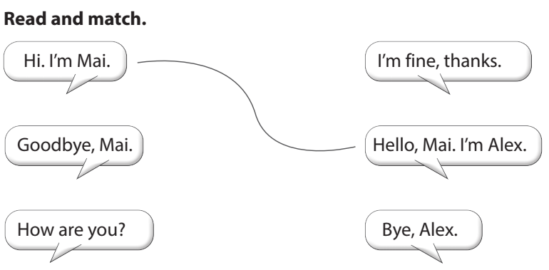  - Game: Spin, say and do action! | - Do the assessment.  - Check with friends and then with teacher and whole class.  - Spin the wheel and do action to review the lesson.
________________________________
UNIT 0. GREETING
Lesson 2. Task 1, 2, 3
Period 3
I. OBJECTIVES:
1. Knowledge:
Learn some classroom instructions: Stand up, Sit down, Look at the board, May I come in?, Don’t talk., May I go out?
2. Competences:
- English competences: Students will be able to listen and follow some classroom instructions.
- Common competences: Students will have opportunity to develop the Self-control & independent learning.
3. Qualities:
- Students will be responsible and well-behaved in communicating in the classroom with friends and others.
II. EQUIPMENT AND MATERIALS:
- Basic things: Student’s book, flashcards, a TV screen (can be made of paper) for the Game: Who says it fast?
- Advanced things: PPT, projector/interactive whiteboard/laptop/TV.
III. LESSON PROCEDURE:
Activity 1: Warm up and review (5 minutes)
Teacher’s activities | Student’s activities
- Greet students.  Movement Game: Dance and stop!  Play the music and let sts dance. When music stops, sts have to stand still. Who can make it (stand still) is the winner.  Who loses: Come to the board:  Say the names, greet the teacher and classmates (review), then do the stand up, sit down 5 times (lead in).  Review:  Say the names, greet the teacher and classmates.  Lead in:  The ones who loses the game must do the “stand up, sit down” 5 times, then teacher leads to the new lesson. | - Greet teacher.  - Listen and dance.  - Stop moving when the music stops.  - Some sts come to the board.  - Introduce names, greet the teacher and classmates.  - Do the actions with the whole class, then introduce the lesson.
Activity 2: Presentation (7 minutes)
Teacher’s activities | Student’s activities
Task 1: Listen and repeat. (Track 0.5)  Use flashcards to introduce the vocabulary and structure of lesson.  Stand up  Sit down  Look at the board  May I come in?  Don’t talk.  May I go out?  Tell the students to look at the pictures and pay attention to the actions that the pictures illustrate.  Play the recording and tell students to listen and point at the corresponding pictures. Play the recording again, pause after each instruction/ sentence and ask students to repeat it.  • Ask volunteers to say all the instructions/sentences with Game: Who says it fast?  Divide the class into 2 teams. One student from each team takes turn to play the game.  Pictures/flash cards are showed on the screen (put it in to a paper TV to make it more interesting). Who says it fast will get points. | - Learn new words and structures through flashcard.  - Repeat the words/sentences  - Repeat then point.  - Listen and repeat (whole class, group, individual).  - One student from each team comes to play the game.
Activity 3: Practice (8 minutes)
Teacher’s activities | Student’s activities
Task 2: Match and say  Ask students to look at the words in the two columns and tell them they have to match the words.  Ask students to look at the example 1 – b and read it aloud.  Ask students to work in pairs to match the words and take turns to say the words.  Check answers and ask volunteers to say the matched words.  Game: Let’s make it!  This game can be played in two teams (example: team A and B).  1 student from team A, say a word from the left. The student from team B must say the left of it. Who can say it fast gets a point for his/her team. | - Look at the the two columns, read and find pairs to match.  - Pair work  - Say the words.  - Team work
Activity 4: Production (10 minutes)
Teacher’s activities | Student’s activities
Task 3: Let’s play! - Game: Simon says  Tell students they are going to play a game called “Simon says”.  Ask students to look at the picture and the prompt. Read out the prompt and ask students to repeat.  Explain to students that in this game, one student will be Simon. When Simon calls out an action, all the other students have to do it. Any student who fails to do the correct action will lose the game.  Play one round with the whole class to make sure  students understand the rules.  Appoint one student to be Simon and ask the class to  play together.  Allow different students to be Simon and play the game again. | Listen to the rules of game.  Play the game.  Come to the boear and do with Simon
Activity 5: Assessment (5 minutes)
Teacher’s activities | Student’s activities
Game: Look and guess  Use 9 covering pictures (with numbers 1-9) to cover flashcards. Reveal the covering pictures one by one (sts choose the numbers) until sts can guess what the flashcard is.  This game can be played in teams.  Read and complete  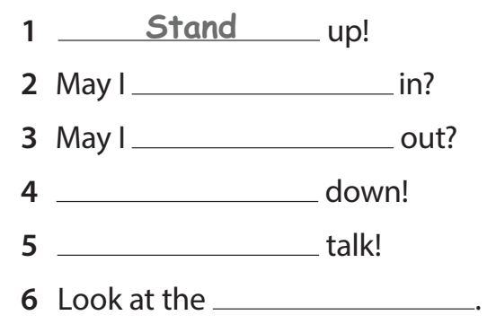  Good bye song. | - Do the assessment.  - Team work.  Individual work/pair work.  Sing a song and say goodbye.
________________________________
UNIT 0. GREETING
Lesson 3. Task 1, 2, 3
Period 4
I. OBJECTIVES:
1. Knowledge:
- Learn the colours: red, blue, black, green, white, orange
- Learn how to ask and answer about colours: What colour is it? It’s….
2. Competences:
- English competences: Students will be able to ask and answer about colours in English.
- Common competences: Students will have opportunity to develop the Communication skills & independent learning.
3. Qualities:
- Students will be responsible and confident in communicating in the classroom with friends and others.
II. EQUIPMENT AND MATERIALS:
- Basic things: Student’s book, flashcards, paper balloons to teach colours, objects (or crayons) to do the activity “Let’s play”, pictures for sts to colour in Let’s colour!
- Advanced things: PPT, projector/interactive whiteboard/laptop/TV.
III. LESSON PROCEDURE:
Activity 1: Warm up and review (5 minutes)
Teacher’s activities | Student’s activities
- Greet students.  https://www.youtube.com/watch?v=o6gHL1LJ-HQ  Chant Go, go, banana to warm up and energize the class.  Review:  Say the classroom instructions (practice in front of the class).  Stand up  Sit down  Look at the board  May I come in?  Don’t talk.  May I go out?  Lead in:  Show the picture of nature (without colour), for the students to see. Then show the real colour one by one to lead into the lesson: colours. Life is so beautiful with colours. | - Greet teacher.  - Listen, chant and dance.  - Do the action with the chant.  - Some sts come to the board to say the chant.  - Follow the teacher.  - Do the actions with the whole class.
Activity 2: Presentation (7 minutes)
Teacher’s activities | Student’s activities
Task 1: Listen and repeat. (Track 0.6)  - Introduce the colours one by one: red, blue, black, green, white, orange. Use balloons to teach colours. (ppt or paper balloons)  - Play the recording and ask students to point to the words in their books. Play the recording again and ask students to repeat what they hear. Do this as a class a few times. Then ask volunteers to repeat on their own.  -Ask volunteers to say in front of the class.  Game: What’s missing?  Divide the class into 4 teams. One student from each team takes turn to play the game.  Pictures/flash cards are showed on the screen, one picture is hidden. Those who can find it and say it fast will get points. | - Learn new words and structures through flashcard/ppt.  - Repeat the words/sentences  - Repeat then point.  - Listen and repeat (whole class, group, individual).  - Individual/team work  - One student from each team comes to play the game.  - Group work.
Activity 3: Practice (8 minutes)
Teacher’s activities | Students’ activities
Task 2: Listen and repeat. Then point  and say (Track 0.7)  - Tell students to look at the first picture and the prompts. Tell them they are going to learn how to ask and answer about colours.  What colour is it?  It’s….  - Play the recording and ask students to follow the question and answer as they listen.  - Play the recording again and ask students to repeat what they hear. Do this as a class a few times. Then ask volunteers to repeat on their own.  - Ask students to look at the other five pictures and elicit the colours (blue, black, green, white, orange).  - Ask students to work in pairs to practise asking and answering questions about those five pictures. Tell them to point at the pictures as they speak.  - Ask volunteers to ask and answer questions about colours in front of the class.  Game: Choose and say!  Divide class into 2 groups.  Do the rock, scissors, paper. Who wins will ask, who looses has to answer the question.  Sts choose an ice cream with a number below (from 1 to 6), it will show a picture. One student asks and the other answers. Give points for those who do it well. | - Look at the the pictures.  - Follow the question and answer.  - Listen and repeat.  - Pair work  -Ask and answer questions about colours in front of the class.  - Group work
Activity 4: Production (10 minutes)
Teacher’s activities | Student’s activities
Task 3: Let’s play  - Tell students they are going to play a game to ask and answer about colours.  - Tell students to look at the picture and the sample sentences. Read out the sample sentences and ask students to repeat.  - Explain to students that they’re going to play the game in pairs. One student holds up an object (or crayons) and asks What colour is it? The other student then answers the question.  - Give an example by asking a student to do the activit.  - Ask students to work in pairs to play the game.  - Ask volunteers to play it in front of the class. | -Listen to the rules of game.  -Pair work.  -Play the game.  -Come to the board and play it in front of the class.
Activity 5: Assessment (5 minutes)
Teacher’s activities | Student’s activities
Let’s colour!  Show a picture for sts to colour. Ask the sts to say the colours that they need to use to make the picture more beautiful.  Show the pictures to their classmates and practice the sentence: What colour is it? It’s …  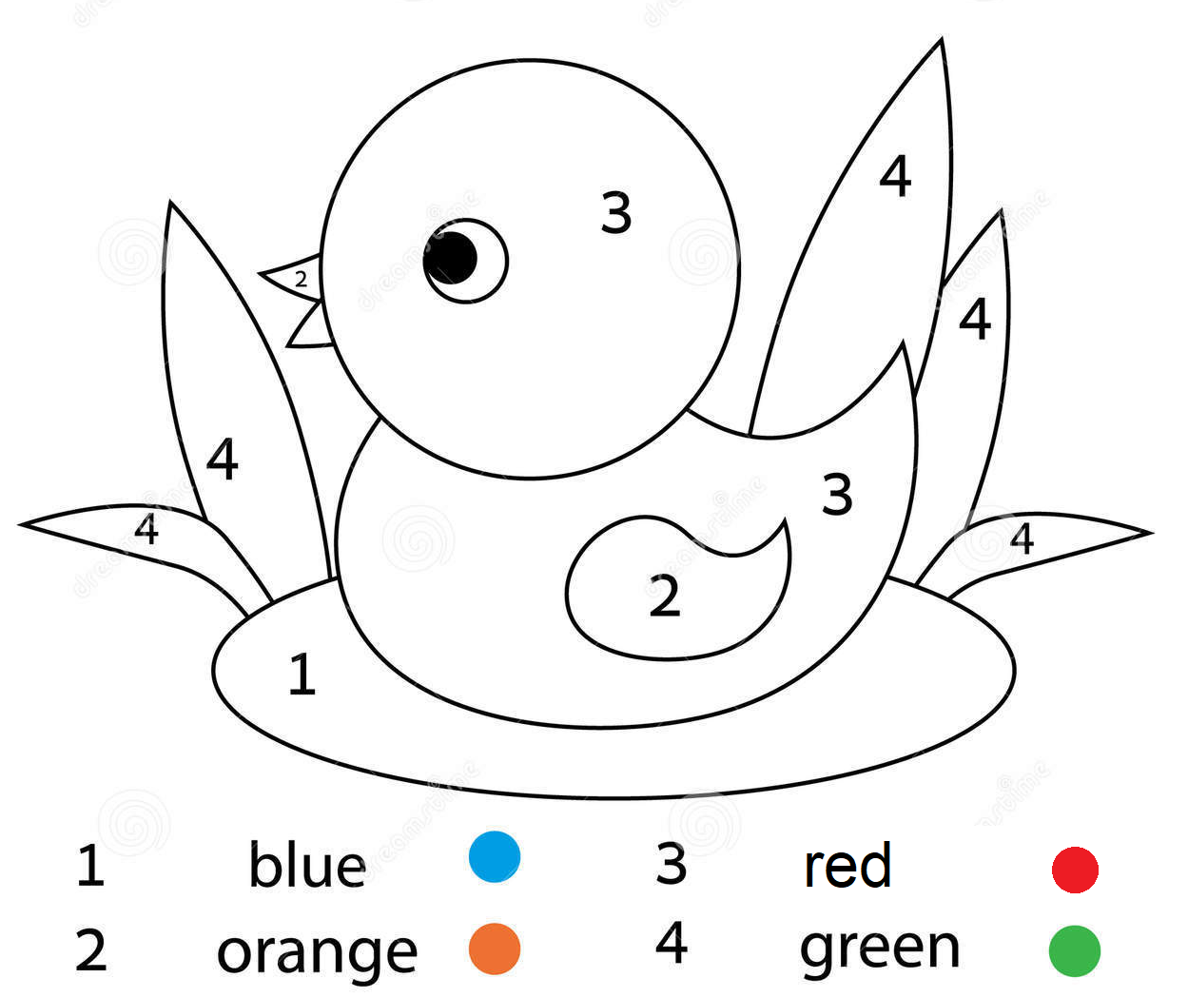  Good bye song. | - Do the assessment.  - Individual work  - Pair work.  Sing a song and say goodbye.

