WEEK 2
UNIT 0. GREETING
Lesson 4. Task 1, 2, 3
Period 5
I. OBJECTIVES:
1. Knowledge:
By the end of the lesson, Students will learn
- The numbers 1-10: one, two, three, four, five, six, seven, eight, nine, ten.
- The question and answer about one’s age:
How old are you?
I’m eight years old.
2. Competences:
English competences: Students have ability to ask and answer about one’s age: “How old are you? – I’m… years old”
Common competences: Students can improve their communication skill in simple conversation.
3. Qualities:
Students will be confident and active in communicating with friends.
II. EQUIPMENT AND MATERIALS:
- Student’s book, flashcard of numbers 1-10, a ball (or a stuffed animal – soft toy), pieces of paper.
- PowerPoint (PPT) presentation, projector/interactive whiteboard/laptop/TV.
III. LESSON PROCEDURE:
Activity 1: Warm up (3 minutes)
Teacher’s activities | Students’ activities
- Greet the students.  Do the action  + Have sts listen, sing along and do the actions with the song “ Hello”- Super Simple Songs – Kids Songs YouTube Chanel  Link on YouTube :  https://www.youtube.com/watch?v=tVlcKp3bWH8  Lead in:  - Introduce the topic “Numbers” by Magic Show Game.  - Teacher is a magician, introduce the topic by showing numbers on the screen (or board). | - Greet the teacher.  +Look, listen, sing along and do the actions.  - Look, listen and guess the topic.
Activity 2: Presentation (9 minutes)
Teacher’s activities | Students’ activities
Task 1: Listen and repeat. (Track 0.8)  - Use flashcards/ PPT slides to introduce the numbers 1-10.  - Have sts listen to the recording, point and repeat in whole class.  - Have sts read numbers 1-10 individually by the game: “Numbers in your finger”  + Say the rules:  1.Each student stands and uses his/her finger to draw the number which is shown.  2. Teacher asks one student to call out the number.  - Listen and correct the pronunciation in some difficult words, for example: one, three, four, five, six.  This game can be more interesting: Let sts draw numbers with head, or any body part. | - Look, listen and repeat.  - Listen, point and repeat.  - Draw a number by a finger.  - Say the correct number.  - Recognize and correct the pronunciation.  - Sts come to the board, use fingers to write numbers for their classmate to guess what numbers they are.
Activity 3: Practice (10 minutes)
Teacher’s activities | Students’ activities
Task 2. Listen and point. Repeat ( Track 0.9)  - Ask sts how many characters in the picture and call out their names.  - Tell sts they are going to ask and answer about age.  How old are you?  I’m eight years old.  - Have sts listen to the recording and point to the sentences.  - Play the recording again and repeat the sentences in whole class.  - Have sts practice in pairs, then work in group.  - Listen and correct the mistakes in pronunciation.  Task 3. Let’s talk.  - Ask students to work in pairs to fill in the missing words in the gaps.  - Play the game: Toss a stuffed animal  + Toss a ball (or a stuffed animal – soft toy) to a student (S1) and say “How old are you?” Have S1 answer: “I’m _____ years old.”  +S1 says “How old are you?” again, then toss the animal to another student (S2).Have S2 answer, then practice with other sts. | - Look at the picture and answer the questions.  - Listen and point.  - Listen and repeat.  - Practice in pairs and groups.  - Recognize and correct the pronunciation.  - Work in pairs and answer:  How old are you?  I’m eight years old.  - Toss, catch the stuffed animal and practice speaking.  - Practice individually.
Task 3. Let’s talk.
- Ask students to work in pairs to fill in the missing words in the gaps.
- Play the game: Toss a stuffed animal
+ Toss a ball (or a stuffed animal – soft toy) to a student (S1) and say “How old are you?” Have S1 answer: “I’m _____ years old.”
+S1 says “How old are you?” again, then toss the animal to another student (S2).Have S2 answer, then practice with other sts.
Activity 4: Production (10 minutes)
Teacher’s activities | Students’ activities
- Have Ss play the game: “Stand up and say!”  + Divide class into 2 groups.  + Each group have 5 minutes to stand up, go around and ask their friends about age as many as they can. Each one has a piece of paper to write his/her friends’ name. Who gets the most number of names is the winner.  Note: In this activities, teacher needs more pay attention to students to control their voice. | - Stand up, go around the class and ask friends:  “How old are you?  I’m eight years old.”
Activity 5: Assessment and Wrap up (3 minutes)
Teacher’s activities | Students’ activities
- Have sts play the game: “My Lucky Number”  + sts choose a number and answer the question behind it.  + Questions  (Note: It’s not necessary to open all the numbers)  Number 1. How…..are you?  - Hello b. old  Number 2. LUCKY NUMBER  Number 3. I’m eight….. old.  - years b. hi  Number 4. What number is it?   a. four b. five  Number 5. Answer the question  How old are you?  Number 6. Read the sentence: “I’m three years old.”  - Say goodbye to sts. | - Choose the number.  - Answer:  1. old  2. LUCKY NUMBER  3. years  4. five  5. I’m… years old  6. ( Read the sentence)  - Say goodbye to teacher.
__________________________________
UNIT 0. GREETING
Lesson 5. Task 1, 2, 3
Period 6
I. OBJECTIVES:
1. Knowledge:
Students (Sts) learn the alphabet – letter: Aa, Bb, Cc, Dd, Ee, Ff, Gg, Hh
2. Competences:
- English competences: Students have ability to recognize the beginning sounds of letters A-H with upper case and lower case letters.
- Common competences: Students can improve their good sense and observation skills through learning activities.
3. Qualities:
- Students will be responsible in doing their tasks, develop sefl-discipline when joining the activities.
II. EQUIPMENT AND MATERIALS:
- Student’s book, flashcards of alphabet (upper case and lower case of letters), pencil
- PowerPoint (PPT) presentation, projector/interactive whiteboard/laptop/TV.
III. LESSON PROCEDURE:
Activity 1: Warm up (3 minutes)
Teacher’s activities | Students’ activities
- Greet the students.  Do the action  + Have Sts listen, sing along and do the actions with the song “Finger plays”- Pinkfong Baby shark- Kids’ Songs and Stories.  Link on YouTube :  https://www.youtube.com/watch?v=G2-6HBoS9to  Lead in:  - Introduce the topic “Alphabet” by hearing the tune of the alphabet song on PPT slide. | - Greet the teacher.  +Look, listen, sing along and do the actions.  - Listen and guess the topic.
Activity 2: Presentation (9 minutes)
Teacher’s activities | Students’ activities
Task 1: Listen and repeat. (Track 0.10)  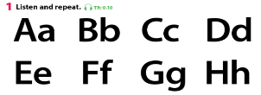  - Use flashcards/ PPT slides to introduce the letters A-H.  - Have Sts listen to the recording, point and repeat in whole class.  - Have Ss read letters A-H individually by “Memory Game”  + Say the rules:  - Choose the number and read aloud the letter behind it.  - Find the matching letters( upper case to lower case)  - Listen and correct the pronunciation mistakes, for example: B, F,G,H | - Look, listen and repeat.  - Listen, point and repeat  - Find the uper case and lower case letters that match to each other.  - Read aloud the pair letters.  - Recognize and correct the pronunciation
Activity 3: Practice (10 minutes)
Teacher’s activities | Students’ activities
Task 2. Listen and point. Repeat ( Track 0.11)  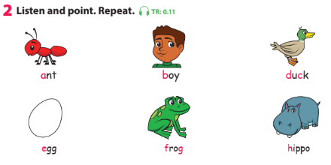  - Have Ss listen to the recording and point to the words.  - Have Ss listen to the recording again and repeat the world in whole class.  - Point to the letters in red in each word and ask students to say the name of the letters. (Do the same with all pictures and words)  - Listen and correct the mistakes in pronunciation. | - Listen and point.  - Listen and repeat.  - Say the correct letters  - Recognize and correct the pronunciation.
Task 3. Write and match.  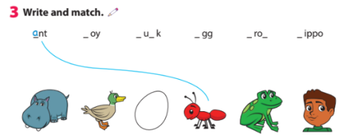  - Ask students to fill in the missing letter in the gaps.  - Play the game: Pass the ball  + Play some music.  + Ask Sts to pass the ball to the next person.  + When the music stops the student with the ball stands up and read aloud the words one by one.  - Listen and correct the mistakes in pronunciation. | - Listen to the music and pass the ball.  - Stand up and read aloud one by one: ant, boy, duck, egg, frog, hippo.  - Recognize and correct the pronunciation.
Activity 4: Production (10 minutes)
Teacher’s activities | Students’ activities
- Have Sts play the game: “Space race”  - Say the rules:  + divide the class into two teams : ‘Alien Ship” and ‘Rocket’.  +The teams should take turns in choosing a number and answering a question based on the image on the screen. The first team to arrive at Mars is the winner.  ( Questions are letters and words) | - Choose the number and anwer.  - Read aloud letters and words
Activity 5: Assessment and Wrap up (3 minutes)
Teacher’s activities | Students’ activities
Remove ONE unnecessary letter to make correct words:  Check answer:  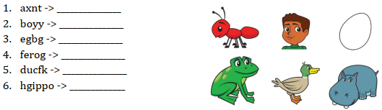  - Say goodbye | - Individual work/group work  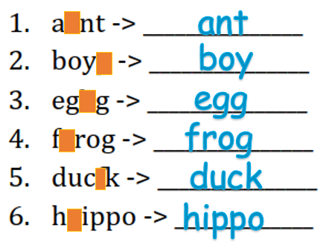  - Pair work/group work  - Say goodbye to teacher.
______________________________________
UNIT 0. GREETING
Lesson 6. Task 4, 5, 6
Period 7
I. OBJECTIVES:
1. Knowledge:
* Learn the letters: Ii, Jj, Kk, Ll, Mm, Nn, Oo, Pp, Qq.
* Learn some phonics words: insect, jug, king, lemon, octopus, queen.
2. Competences:
- English competences: Students will be able to listen and learn some letters of the alphabet and phonics words.
- Common competences: Students will have opportunity to develop the Communication skills & independent learning.
3. Qualities:
- Students will be responsible and confident in communicating in the classroom with friends and others.
II. EQUIPMENT AND MATERIALS:
- Basic things: Student’s book, flashcards, cards with letters and missing words to play game: What do you choose?
- Advanced things: PPT, projector/interactive whiteboard/laptop/TV.
III. LESSON PROCEDURE:
Activity 1: Warm up and review (5 minutes)
Teacher’s activities | Students’ activities
- Greet students.  Sing Alphabet song to warm up and energize the class.  Review:  Game: What do you choose?  Teacher shows cards of a picture of a phonics word (previous lesson) and some missing letters. Sts choose the correct one to make it become a right word.  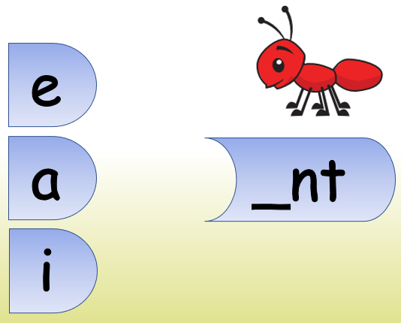  Example:  Lead in:  Say the alphabet in order (A-H), from the slowest to the fastest speed, then lead into the lesson: alphabet (I-Q) | - Great teacher.  - Listen, sing and dance.  - Some sts come to the board to say the chant.  - Play the game and review the alphabet.  - Follow the teacher.  - Do the actions with the whole class.
Activity 2: Presentation (7 minutes)
Teacher’s activities | Students’ activities
Task 4: Listen and repeat. (Track 0.12)  - Show flashcards of letters (I-Q), introduce the letters.  - Hold up your book and show students which task to look at.  - Play the recording. Ask students to repeat after it. Play the recording and ask students to repeat what they hear. Then ask volunteers to read out the letters on their own.  Game: Help the bee!  Divide the class into four teams.  Play the recording to let the bee here the letter then find it from the flowers.  One student from each team comes to the board, listens and chooses the correct ones.  Those who can find it and say it fast will get points. | - Learn new letters through flashcard/ppt.  - Repeat the words/sentences  - Follow the teacher.  - Listen and repeat (whole class, group, individual).  - Individual/team work  - One student from each team comes to play the game.  - Group work.
Activity 3: Practice (8 minutes)
Teacher’s activities | Students’ activities
Task 5: Listen and point. Repeat (Track 0.13)  -Tell students to look at the pictures and the words.  -Point to each picture and read the word aloud. Ask students to repeat after teacher.  -Point to the letter(s) in red in each word and ask students to say the name of the letter(s).  -Ask volunteers to say the words and the letters in red.  Game: What’s missing?  Show flashcards on the wall. Hide 1 flashcard (sts close their eyes). Then let the class guess which one is missing. | - Look at the the picturess.  - Follow the question and answer.  - Listen and repeat.  - Pair work/group work  - Individual work/group work
Activity 4: Production (10 minutes)
Teacher’s activities | Student’s activities
Task 6: Order the letters  • Tell the students to look at the pictures and the prompts. Tell them they are going to order the letters to make the correct word.  • Tell them to look at the first picture and the example. Hold up yourbook and point at the first picture. Read out the letters and the word. Then ask students to repeat.  • Ask students to order the letters to form the correct words for the other pictures. Tell them they can look back at Activity 5 to find out the right order of the letters.  Check students’ work. Ask volunteers to hold up their books and read out letters and words to the class. | -Listen to the teacher  - Follow the teacher  - Order the words  -Order the letter in their notebooks/writing boards.  - Individual work
Activity 5: Assessment (5 minutes)
Teacher’s activities | Student’s activities
Let’s write and match  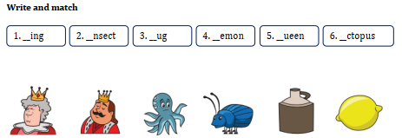  EXTRA ACTIVITY  Write students’ names on the front of a piece of paper folded in half. Prop the name cards up in front of the students facing you. Then read out the names one at a time and ask all students to repeat. Ask students to bring their name cards to the next lesson as this will help you remember their names.  - Say good bye. | - Do the assessment.  - Individual work  - Pair work (check answer).  - Say good bye.
____________________________________
UNIT 0. GREETING
Lesson 7. Task 7, 8, 9
Period 8
I. OBJECTIVES:
1. Knowledge:
* Learn the letters: R,S,T,U,V,W,X,Y,Z.
* Learn some phonics words: sun, tiger, van, box, yellow, zebra.
2. Competences:
- English competences: Students will be able to listen and learn some letters of the alphabet and phonics words.
- Common competences: Students will have opportunity to develop the Communication skills & independent learning.
3. Qualities:
- Students will be responsible and confident in communicating in the classroom with friends and others.
II. EQUIPMENT AND MATERIALS:
- Basic things: Student’s book, flashcards of phonics words, cards with letters A-Z to play game: What letter is missing?
- Advanced things: PPT, projector/interactive whiteboard/laptop/TV.
III. LESSON PROCEDURE:
Activity 1: Warm up and review (5 minutes)
Teacher’s activities | Students’ activities
- Greet students.  Sing Alphabet song to warm up and energize the class.  Review:  Game: What letter is missing?  Teacher shows some of letters in previous lessons. Ask sts to say the letters.  One letter is missing. Sts will look and say aloud that letter.  Lead in:  Say the alphabet in order (A-Q), from the biggest to the smallest voice, then lead into the lesson: alphabet (R-Z) | - Greet teacher.  - Listen, sing and dance.  - Some sts come to the board to say the chant.  - Play the game and review the alphabet..  - Follow the teacher.  - Do the actions with the whole class.
Activity 2: Presentation (7 minutes)
Teacher’s activities | Students’ activities
Task 7: Listen and repeat. (Track 0.14)  - Show flashcards of letters (R-Z), introduce the letters.  - Hold up the book and show students which task to look at.  - Play the recording and ask students to repeat. Then ask volunteers to read out the letters on their own.  - Point at random letters for the sts to say. | - Learn new letters through flashcard/ppt.  - Listen and repeat  - Follow the teacher.  - Say aloud the letters (whole class, group, individual).  - Individual/Group work.
Activity 3: Practice (8 minutes)
Teacher’s activities | Students’ activities
Task 8: Listen and point. Repeat (Track 0.15)  -Tell students to look at the pictures and the words.  -Point to each picture and read the word aloud. Ask students to repeat after teacher.  -Point to the letter(s) in red in each word and ask students to say the name of the letter(s).  -Ask volunteers to say the words and the letters in red.  Game: Slap the board!  Show flashcards of phonics words on the board. Play the recording (one phonics word) for the sts to choose (or slap the board). | - Look at the the pictures.  - Follow the question and answer.  - Listen and repeat.  - Individual work/group work  - Individual work/group work
Activity 4: Production (10 minutes)
Teacher’s activities | Student’s activities
Task 9: Listen and repeat. Then ask and answer  - Tell students to look at the pictures and the words.  - Point to the pictures and read the words aloud. Ask the students to repeat after you.  - Tell students they are going to ask and answer about spelling the words.  - Tell students to look at the first picture and word. Play the recording and ask students to repeat the word.  - Ask students to work in pairs (or group) and practise asking and answering for the other pictures.  - Ask volunteers to ask questions and spell the words in front of the class. | -Listen to the teacher  - Follow the teacher  - Listen and repeat  - Spell the words  -Order the letter in their notebooks/writing boards.  - Pair work/ group work  - Individual work
Activity 5: Assessment (5 minutes)
Teacher’s activities | Student’s activities
Find, circle and write.  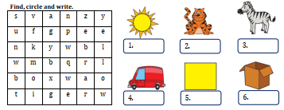  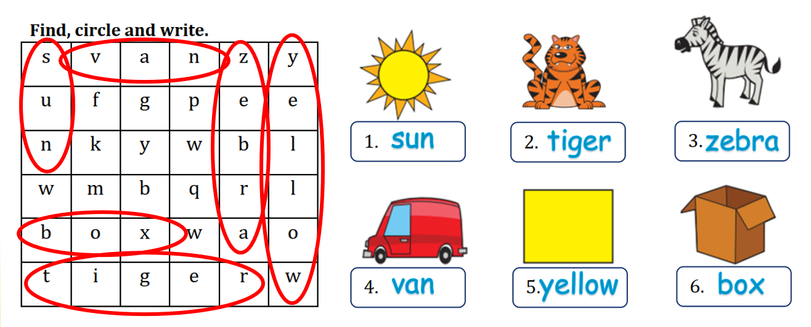  - Say good bye. | - Do the assessment.  - Individual work  - Pair work (check answer).  - Say good bye.
________________________________

