WEEK 4
UNIT 1. FAMILY
Lesson 2. Task 4, 5, 6
Period 13
I . OBJECTIVES:
1. Knowledge:
Students will learn the structure: My dad (mum/brother…) is... and review words related to family topic.
2. Competences:
- English competences: Students will be able to introduce the names of family members.
- Common competences: Students will have opportunity to develop the creativeness in making My family book and develop communication when introduce family members.
3. Qualities: Students develop the love toward family.
II. EQUIPMENT AND MATERIALS:
- Basic things: Student’s book, flashcards, worksheet, construction paper, colored markers/crayons, glue, family photos.
- Advanced things: PPT, laptop/TV.
III. LESSON PROCEDURE:
Activity 1: Warm up (5 minutes)
Teacher’s activities | Student’s activities
- Greet students.  - Sing “My family” song: https://www.youtube.com/watch?v=lGir6PUN-as  - Ask student to sing along.  Review:  - Revise and practice functional language from lesson 2 with the flashcards.  - Then ask volunteers to stand at the front of the class and  ask and answer questions. (E.g: Who is this? – This is my ...)  Game: Who’s missing?  Divide the class into 4 groups.  Teacher shows the cards of family members on the board/screen.  Teacher hides a flashcard of a family member.  Ask each member to stand and say which picture is missing.  Who says it fast will get points for the groups.  Lead in:  - Show a picture of your (teacher) family. Point to a member. Then say a name.  E.g: My brother is Khoa.  - Tell students to look at the pictures in task 4, and the names of the people. Elicit that they are a family.  - Tell students that they are going to learn how to use structure to introduce the names of the members in a family. | - Great teacher.  - Listen and do the action with teacher.  - Read out loud  - Ask and answer  - Play the game  - Look at the picture  - Repeat then point.  - Repeat.
Activity 2: Presentation (8 minutes)
Teacher’s activities | Student’s activities
Task 4: Listen and repeat. (Track 1.6)  - Point to the pictures. Ask students to notice the people and their names. Tell students that this structure can be used to introduce the names of the members in a family.  - Play the recording. Tell students to look at the pictures and follow the sentences with their fingers.  - Play the recording again. Ask students to repeat. | - Learn new words and structures through flashcard.  - Repeat the words/sentences
Activity 3: Practice (10 minutes):
Teacher’s activities | Student’s activities
Task 5: Look and say.  - Tell students to look at the picture for question 1 and ask them who the person in the picture is. Explain that Tom is his name.  - Read out the example and ask students to repeat.  - Explain the rest of the task to students. Ask students to practice saying the sentences individually and then in pairs.  - Ask volunteers to read out their answers. Correct any mistakes.  Suggested sentences:  2. My aunt is Susan.  3. My cousin is Peter  Mini game: Lucky member  - Divide class into 3 groups.  - Ask each group to choose one member they like, then say a structure to introduce the names of the members in their family.  E.g: My mum is Nga.  - The game will give students a random point if they answer correctly.  - Each time sts choose an answer, they get points which follow each photo.  - Who has the most points is the winner.  Task 6: Write about yourself!  - Tell them to look at the prompt. Elicit which information is missing in each sentence.  - Explain to students that they have to fill in the blanks with information about their family members.  - Allow students enough time to complete all the sentences. Ask them to write about 10 – 20 words.  - Ask volunteers to read out their sentences to the whole class. | - Look  - Listen and repeat  - Individual work/ Pair work  - Practice  - Play game  - Look and read  - Write missing information about sts’ family members  - Read out loud in front of class (individual work)
Activity 4: Production (9 minutes)
Teacher’s activities | Student’s activities
My Family book.  - Tell students they’re going to make a family story book together.  - Ask student to draw/ glue a picture of member in this book. Then write the information about him/her.  E.g.: This is my ______  He is__________  Age: __________ | - Draw pictures and write.  - Individual work/group work.
Activity 5: Assessment (5 minutes)
Teacher’s activities | Student’s activities
Word search  - Give out worksheet. Then ask students to find and circle all of the direction words that are hidden in the grid.  Hidden words:  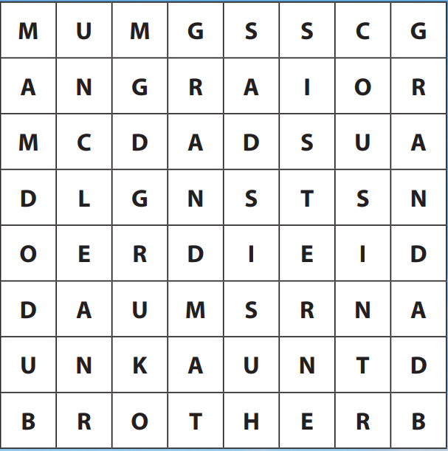  - Check in pairs, then whole class.  - Say goodbye. | - Do the assessment.  - Check with friends and then with teacher and whole class.  - Say goodbye.
_______________________________________________
UNIT 1. FAMILY
Lesson 2. Task 7, 8, 9
Period 14
I. OBJECTIVES:
1. Knowledge:
- Students will review the words and phrases related to the topic Family: family, grandpa, grandma, mum, dad, uncle, aunt, brother, sister, me.
- Students can review all structure: Simon is my uncle, This is my family, My grandma is Laura.
2. Competences:
- English competences: Students will listen and understand a short introduction about a family, fill in information in a family tree and about their family.
- Common competences: Students will have opportunity to develop the creativeness in drawing their own family tree, Solving problems and active role of learners.
3. Qualities:
- Students will be respectful in family, and develop the love toward family.
II. EQUIPMENT AND MATERIALS:
- Basic things: Student’s book, flashcards, pictures of family, pieces of papers, coloured pencils/crayons to draw family tree.
- Advanced things: PPT, projector/interactive whiteboard/laptop/TV.
III. LESSON PROCEDURE:
Activity 1: Warm up (5 minutes)
Teacher’s activities | Student’s activities
- Greet students.  Movement Game: Play “Move and Freeze”  -Let the sts stand up, listen to the music and dance.  -When the music stops and they hear the word “freeze”, they have to stop and stand still, the ones move have to come to the board.  -The team (1 of 4) has the most sts at their desks will get the points.  -Turn on the music and let the sts follow.  Needed: music  Review: Hidden pictures game  -Divide class into 2 teams-Boys and Girls  -Let the sts look at 1 of the pieces and guess the picture behind.  Lead in: Tell the sts that they are going to study more about the family. | - Greet teacher.  - Listen and do the action with teacher.  - Follow teacher if possible.  - Play the game.  - Look at the pieces of pictures and guess
Activity 2: Practice Listening (8 minutes)
Teacher’s activities | Student’s activities
Task 7: Listen and tick. (Track 1.7)  - Tell the students that they are going to listen to a short introduction about a family.  - Ask student to read through the questions and options.  - Ask students to look at question 1. Play the first part of the recording and tell students to read the sample answer. -Elicit why it is the correct answer for question 1.  - Play the recording and tell students to listen and tick the correct answers for questions 2 – 4.  - Play the recording more than once if students cannot catch the answers.  - Play the recording again and pause after each sentence to check answers.  - Option 1: Game: Listen and choose! (use flashcards)  - Sts listen and choose the correct answer.  - Show flashcards of family member.  - Play the the recording (or teacher calls a family member). Sts choose the correct one.  - Option 2: Game: Save the world! (ppt)  -T divides class into 2 teams: Boys and Girls.  1 boy and 1 girl take turn to answer 1 question by listening and choosing the correct pictures.  - After choosing the correct pictures, T asks 1 student to write the answers (words) on the board.  - Who can make it will save the world (the rocket flies to save the world) | - Read the questions and options.  -Look at the sample answer.  -Listen and tick the correct answers.  -Listen and check the answers  - Play the game  - Listen and choose the correct picture  - Group work  -Enjoy the game and write the words on the board.
Activity 3: Practice Writing (9 minutes)
Teacher’s activities | Student’s activities
Task 8: Write on the family tree  - Tell students they are going to fill in information in a family tree.  - Tell students to look at the picture and the family tree. Explain that a family tree shows people in a family and their relationship.  - Tell them to look at the picture again. Hold up your book, point at each member of the family and read out the prompts.  - Ask students to look at the family tree and the names of the people there. Elicit answers on the people who are missing.  - Allow students enough time to fill in the missing names in the family tree.  - Check answers as a whole class.  - Ask volunteers to show their work and read out the name of each member and their role in the family.  - Game: Who is who?  - Divide the class into 4 groups.  - Teacher calls a name of a member of the family member in the picture.  - Teacher hides a name of a family member.  - Sts have to say the name or who the person is.  Who says it fast will get points for the groups. | - Listen to the teacher  - Point at each member of the family and read out the prompts.  - Fill the names missing.  - Check the answers.  - Come to the front and read out loud.  - Play the game.
Activity 4: Practice Speaking (10 minutes)
Teacher’s activities | Student’s activities
Task 9: Let’s talk  Students bring the family pictures and present in group, using.  This is my family.  My grandma is...  My grandpa is...  Have some students present in front of the class  Extension:  Game: Memorization  -Let the sts show their picture of family they bring from home.  -Let the others listen and remember.  -Let other students talk about their friend’s family tree. | - Work in group  Present in front of the class  Play the game.
Activity 5: Assessment (3 minutes)
Teacher’s activities | Student’s activities
Look at the pictures and circle the correct answers.  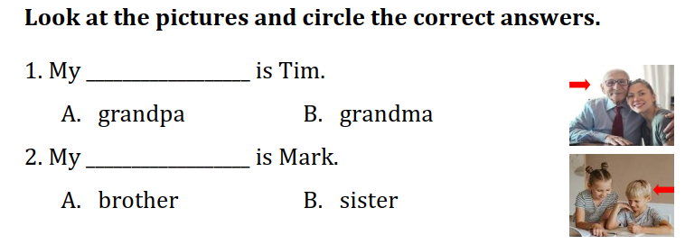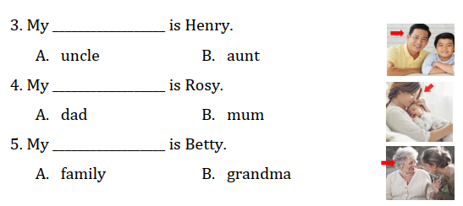  Answer: 1A, 2A, 3A, 4B, 5B  - Say goodbye | - Do the assessment.  - Check answer with friends and then with teacher and whole class.  - Say goodbye.
_______________________________________________
UNIT 1. FAMILY
Lesson 3. Task 1, 2, 3
Period 15
I. OBJECTIVES:
1. Knowledge:
- Review words of family members.
- Learn and use new vocabulary: short, tall, old, young, funny.
- Learn to talk about a family member My mom is cool.
2. Competences:
- English competences: Students will be able to describe the family members.
- Common competences: Students will have opportunity to develop the creativeness in drawing their own family.
3. Qualities:
- Students will be respectful with their family members.
- Students develop the love toward family.
II. EQUIPMENT AND MATERIALS:
- Basic things: Student’s book, ball, pieces of papers, crayons to draw family members.
- Advanced things: PPT, projector/interactive whiteboard/laptop/TV.
III. LESSON PROCEDURE:
Activity 1: Warm up (5 minutes)
Teacher’s activities | Student’s activities
- Greet students.  Warm up and review:  Movement Game: “Silent ball”  While the music plays, students pass the ball around the class. When the music stops, the student with the ball has to choose a pair of cards to play matching game (review family words).  -Let the sts in take turn to choose the numbers to find the 2 matched pictures and words.  Lead in:  - Ask a student to come to the board. Teacher stands next to that student. Use TPR to show short/tall.  - Introduce the lesson. | - Greet teacher.  - Enjoy the game.  - Individual work  - Follow the teacher
Activity 2: Presentation (8 minutes)
Teacher’s activities | Student’s activities
Task 1: Listen and point. (Track 1.8)  - Tell students to open their books to page 21 and to look at the vocabulary box. Point to the first two picture words.  - Say the words and use your arms to demonstrate short and tall and ask students to repeat. Do the same with all the other words.  - Read out the word funny. Explain the meaning. Show students pictures from Unit 0 and ask if they are funny. Tell them to answer Yes! or No! For example, turn to page 11, point to the ant and say Funny? At the end of the task praise students by saying Great!  - Play the recording for the students to listen and point, then repeat the words. Then read out the words in a random order and ask students to point to the correct pictures.  - Read out all the words again one by one and ask students to repeat after you.  - Game: Mime  Teacher says the words and sts act | - Follow the teacher’s instruction.  -Read out  - Listen, point, repeat the words.  - Individual, group, whole class.  Play the game
Activity 3: Practice (10 minutes)
Teacher’s activities | Student’s activities
Task 2: Listen and tick. (Track 1.9)  - Ask students to look at the photo and explain to them that the boy and the girl are siblings.  - Point to the new words in the text. Read them out loud and ask students to repeat.  - Play the recording. Tell students to look at the picture and follow the dialogue with their fingers.  - Play the recording again, pause after each sentence and ask students to repeat.  - Tell students to look at the sentence and the text. Guide them to find the information about Steve in the text and elicit that “Steve is short.” Ask them to look at the activity below and tick the correct answer.  - Ask students to act out the dialogue in pairs and then ask volunteers to act out the dialogue in front of the class.  - Extension:  Game: Listen and tick  Divide the class into groups of 4 (each group has 4 sts).  Give cards with letter A,B,C for the groups.  Sts listen and choose the correct answer (A,B,C). Who can make it will get points.  Task 3: Match and say  - Tell students to look at the photos and the prompts. Read out the prompts and ask students to repeat.  - Tell students to look at question 1 and the sample sentence. Read out the sample sentence and ask students to repeat several times. Elicit why the question matches picture a.  - Ask students to match questions 2 – 6 to photos b – f. Tell them they can look at the details of the photos for hints.  - Ask students to practise saying the sentences individually and in pairs.  - Check answers as a whole class. Then ask volunteers to say the sentences from questions 2 – 6.  - Suggested sentences:  - 2 My dad is tall. 3 My cousin is short. 4 My brother is funny. 5 My aunt is young. 6 My grandma is old.  - Game: Choose and say.  - This game can be played in groups/teams.  - Each member of a group chooses a letter talk about their family members.  - Give points for the groups. | - Listen.  - Point and repeat.  -Follow the dialogue.  - Listen and repeat.  -Listen and tick the correct answers.  -Work in pairs and practice speaking.  - Play the game.  - Group work.  - Follow the teacher.  - Repeat  - Match.  -Practice saying sentences in pairs.  -Check the answers.  - Play the game  - Group work
Activity 4: Production (9 minutes)
Teacher’s activities | Student’s activities
- Let the sts draw a picture of the family and write text about the using adjectives.  Ex: mum/ cool. Dad/tall….  - Have sts stay in a circle and take turn to raise the picture and say:  Ex: This is my family. My mum is cool. My dad is tall. My sister … | - Draw and decorate the family member.  - Present in front of class.
Activity 5: Assessment (3 minutes)
Teacher’s activities | Student’s activities
Look and write.  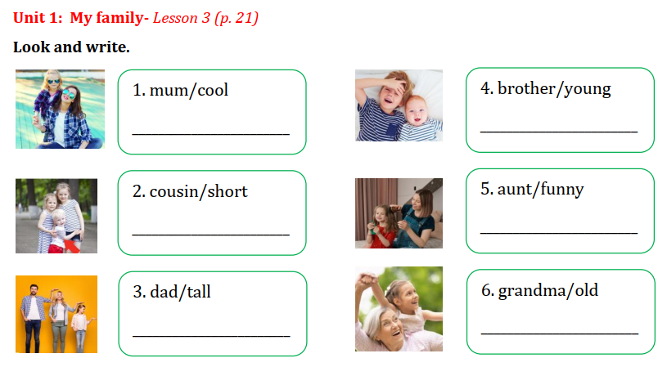  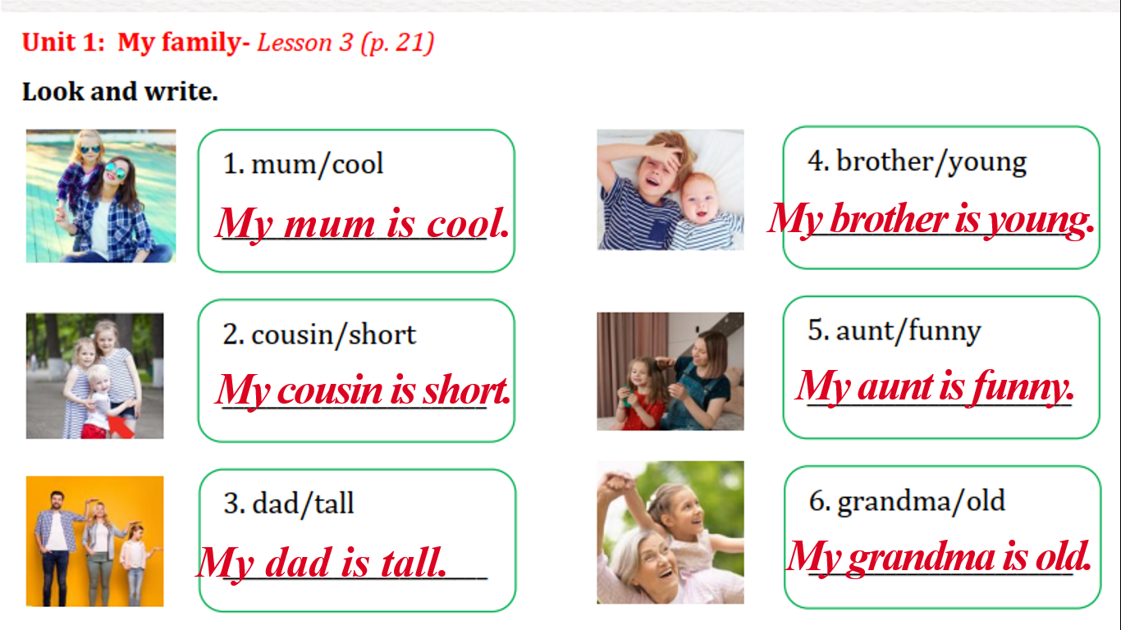  - Say goodbye | - Look and write sentences.  - Say goodbye.
_______________________________________________
UNIT 1. FAMILY
Lesson 13. Task 4, 5, 6
Period 16
I. OBJECTIVES:
1. Knowledge:
- Review words of family members
- Learn and use new structure: You’re …,We’re…, They’re …
2. Competences:
- English competences: Students will be able to use the grammar structure to describe their family members and the other people.
- Common competences: Students will have opportunity to develop the creativeness in drawing their own family and describe them in the text.
3. Qualities:
- Students will be friendly and confident in communicating with friends.
II. EQUIPMENT AND MATERIALS:
- Basic things: Student’s book, printed handouts/ pieces of papers
- Advanced things: PPT, projector/interactive whiteboard/laptop/TV.
III. LESSON PROCEDURE:
Activity 1: Warm up (5 minutes)
Teacher’s activities | Student’s activities
- Greet students.  Movement Game: Challenge: 2 at once  -Let the sts follow the instruction  -Have the students do two things at once.  Examples: tap their heads and rub their stomachs, clap their hands and stand on one foot, snap their fingers and nod their heads, do jumping jacks, etc.  Lead in: Memory game  -Divide class into 2 teams-Boys and Girls  -Let the sts watch and read about Peter’s family  -Let the sts to remember all about Peter’s family  -Call each member of 2 teams to take turn to choose the correct answers. | - Great teacher.  - Play the game.  - Enjoy the game
Activity 2: Presentation (8 minutes)
Teacher’s activities | Student’s activities
Task 4: Listen and repeat. (Track 1.10)  - To begin, ask students to look at and underline the sentence “They’re great!” in Activity 2. Tell them that it’s the way to describe people in English, and today they are going to learn more about how to describe their family members.  - Introduce the words I, you, we, they, he, she, it by pictures. Use body language and ask some sts come to the board to explain the meaning.  - Tell students to look at the pictures and the sentences. Elicit that there is more than one person in each picture.  - Play the recording. Tell students to look at the pictures and follow the sentences with their fingers.  - Play the recording again. Ask students to repeat.  - Point to the pictures. Explain the difference between you, we and they. Tell them to look again at the sentences and notice that you, we and they all go with are or ‘re. Explain to them that are and ‘re are the same.  - Ask students to repeat the sentences and see how they might be used in the next activity. | - Follow the teacher’s instruction.  - Follow the teacher.  - Listen, point, repeat the words.  - Follow the teacher.  -Repeat.
Activity 3: Practice (10 minutes)
Teacher’s activities | Student’s activities
Task 5: Look and say  - Tell students to look at the pictures and the prompts. Read out the prompts and ask students to repeat.  - Tell students to look at the picture for question 1 and the example. Read out the example and ask students to repeat.  - Explain the rest of the task to students. Allow them enough time to practise saying the sentences individually and then in pairs. Go round the class helping students where necessary.  - Ask volunteers to read out their answers. Correct any mistakes.  Game: LUCKY WHEEL  Divide class into 2 teams-Boys and Girls.  Spin the round to get points.  Choose a number to have a question.  The ones who can answer True/false will get points.  Task 6: Listen and sing. (Track 1.11)  - Tell students they are going to learn a song.  - Ask students to look at the picture and describe what they can see. Encourage them to use English for words they know. Hold up your book and point to “Mum”. Ask a volunteer to say the word. Do the same for “Dad”, “brother” and “sister”. Point to the children and say “They’re cool!”. Encourage students to repeat. Count the people to revise numbers. Ask students to repeat.  - Play the recording and tell students to listen and follow the words with their fingers.  - Read out the song one line at a time and ask students to repeat after you.  - Play the recording again. Encourage students to sing along. Practise several times until students are familiar with the words.  - Divide students into small groups. Tell them to stand up, join hands in a circle and sing the song. | - Look at the pictures and read out.  -Work in pairs and practice speaking.  -Read out the answers.  -Answer the questions from the teacher.  - Listen and point.  - Listen and follow the teacher.  -Sing along.
Activity 4: Production (9 minutes)
Teacher’s activities | Student’s activities
- Draw a picture of family, write the name and talk about the family.  - Ask sts to come to the front and present in front of class. | - Draw and talk.  - Present in front of class.
Activity 5: Assessment (3 minutes)
Teacher’s activities | Student’s activities
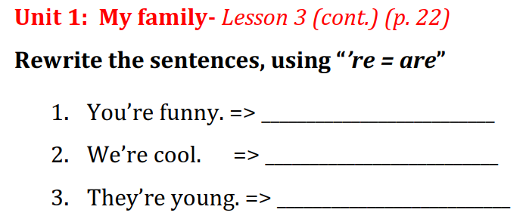  Answer:  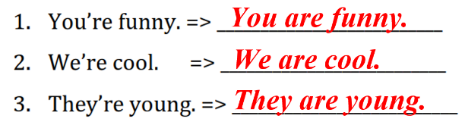  - Say goodbye | - Choose the correct answers.  - Say goodbye.
_______________________________________________

